

To Create a Robust Failsafe Process
for
Diabetic Eye Screening Wales
by
Joanne Griffiths


Supervisor: BEVERLEY HOLLAND
Second Marker: JAMES WILLIAMS

Project submitted as part of the requirements for the award of
BSc (Hons) Applied Computing
26th APRIL 2018

DECLARATION

I, Joanne Griffiths declare that I am the sole author of this Project; that all references cited have been consulted; that I have conducted all work of which this is a record, and that the finished work lies within the prescribed word limits.

This work has not previously been accepted as part of any other degree submission.

Signed : ..........................................

Date : ...............................................

FORM OF CONSENT

I Joanne Griffiths hereby consent that my Project, submitted in candidature for the B.Sc.(Hons) Applied Computing degree, if successful, may be made available for inter-library loan or photocopying (subject to the law of copyright), and that the title and abstract may be made available to outside organisations.

Signed : .............J Griffiths................

Date : ...............................................

Acknowledgement
I would like to thank Mrs Beverley Holland for her patience and guidance over the past three years, also for giving me more chances than I deserve.
I would also like to thank Mr James Williams for his interest in the project and the most useful feedback in my first Viva.
I wish to express my sincere gratitude to my Line Manager Gavin Bhakta who without him teaching, guiding, supporting and having faith in my abilities, I would never have competed this project.
Last but by no means least a huge thank you to Mr Andrew House, DESW Failsafe Officer who has helped me, explained the Failsafe Process to me and validated every SSRS Report I developed.
Abstract
This report describes the development of systems to support Failsafe processes for Diabetic Eye Screening Wales. Systems are necessary in order to ensure that patients are screened in an appropriate and timely manner.
The project will involve creating reports to support Failsafe, designing and implementing a dashboard for senior level managers to measure the organisations performance against KPI’s. A Townsend Index will also be produced to see if there is a link between Diabetic retinopathy and deprivation.
The report will discuss the pros and cons of developing the reports the reasons for the choice of software used and the problems encountered and what has been done to solve these problems.

Lastly, the report discusses the possibilities of future work that can be applied to this project.

Table of Content

Contents
CHAPTER 1- INTRODUCTION & OBJECTIVES 7
Diabetic Eye Screening Wales 7
1.1 Overview 7
1.2 Aims and objectives 8
1.1 Challenges 8
CHAPTER 2 - RESEARCH & REVIEW OF LITERATURE 11
2.1 Background 11
2.2 What is Failsafe? 12
2.3 EMIS Optomize Database 15
2.4 MapInfo 15
2.5 Tableau 16
2.6 Conclusion 16
CHAPTER 3 - RESEARCH AND/OR DEVELOPMENT METHODOLOGY 17
3.1 Introduction 17
3.2 Research approach 18
3.3 Case study 18
3.4 Research strategy 20
3.5 Data gathering method 20
3.7 Research time bound 25
3.7.1 Gantt chart 25
CHAPTER 4 - DESIGN 26
4.1 SQL 26
4.2 SSRS 26
4.3 Geographical Information Systems 27
4.4 Tableau 27
4.5 Hardware 28
CHAPTER 5 IMPLEMENTATION 29
5.1 Failsafe Process 1 30
5.2 Failsafe Process 2 33
5.3 Failsafe Process 3 34
5.4 Failsafe Process 4 35
5.5 Failsafe Process 5 36
5.6 Failsafe Process 6 37
5.7 Failsafe Process 7 38
5.8 Creating an SSRS Report 39
5.8.1 Developing a parameter 57
5.8.2 SSRS Report Security 63
CHAPTER 6 GEOGRAPHICAL INFORMATION SYSTEM AND DEPRIVATION 64
CHAPTER 7 TABLEAU 78
CHAPTER 8 FURTHER WORK 84
CHAPTER 9 EVALUATION AND CONCLUSION 86
CHAPTER 10 – REFLECTION 87
10.1 LIST OF FIGURES 89
10. 2 REFERENCES 90
Appendix 1 – List of Priorities 92
Appendix 2 – Deceased SQL Script 92
Appendix 3 _ Moved out of Area Script 92
Appendix 4 – Post Office Returns Script 92

CHAPTER 1- INTRODUCTION & OBJECTIVES

Diabetic Eye Screening Wales

Diabetic Eye Screening Wales aim is to reduce the risk of sight loss among people with diabetes through the early detection of diabetic retinopathy. Patients are screened annually using digital photography. The screening appointment involves, applying drops to enlarge the patient’s pupil then examining the back of the eyes. The service is available to all diabetic patients in Wales aged 12 and over.
Diabetic retinopathy is caused when diabetes breaks down the small blood vessels, damaging the part of the eye called the retina. Retinopathy can cause the blood vessels in the retina to leak or become blocked. It can affect people’s sight and can lead to sight loss. Diabetic retinopathy is the most common microvascular complication of diabetes and is the leading cause of sight loss in the 18-65 age population. [1]
There are two types of Diabetic Retinopathy:
- Non-proliferative diabetic retinopathy (NPDR): This is the milder symptomless form of diabetic retinopathy.
- Proliferative diabetic retinopathy (PDR): PDR is the most advanced stage of diabetic retinopathy and refers to the formation of new, abnormal blood vessels in the retina. [2]

All people with type 1 or type 2 diabetes are at risk of developing sight-threatening retinopathy. Long term poorly controlled diabetes and hypertension patients are the most at risk.
The programme links in with the Wellbeing of Future Generations (Wales) Act by working to reduce reducing the risk of sight loss in the population living with diabetes in Wales. [3]

1.1 Overview
The Diabetic Eye Screening Wales need to develop a Failsafe mechanism to identify issues with patient Care Pathways that if something goes wrong in the screening pathway; there are processes in place that will identify the problems and the solution.
Failsafe is a backup mechanism used to ensure any errors in the many screening pathway are identified and corrected before any harm occurs to the patient in addition to the usual care provided.

1.2 Aims and objectives
The Main Aim of this project is to provide systems to support all departments while following Information Governance guidelines and the Diabetic Eye Screening Failsafe procedures while interrogating/updating and maintaining the EMIS Optomize database and produce through Microsoft SQL several server-based failsafe reports to support the Failsafe Officer.
To develop a dashboard through Tableau for the Diabetic Eye Screening Wales Management Level Key Performance Indicators.
To develop a Townsend Index of the whole of Wales through a Geographical Information System called MapInfo to determine if Diabetes is more prevalent in deprived areas.
Finally, to follow the National Guidelines on Failsafe and meet with the Failsafe Group monthly to discuss development of relative SSRS reports.

1.1 Challenges
When working within the Public Health Wales the Data we store is extremely sensitive and all members of staff must follow the Information Governance guidelines. We will show how we incorporate the Information Governance while developing the SSRS reports.
Information Governance is a framework that brings together legal, ethical and quality standards that apply to the handling of information; it applies to sensitive and personal information, of both employees and patients. Known as PII Information Governance sits alongside clinical and corporate governance and focuses on ensuring that information is dealt with in a confidential and secure manner and is the responsibility of every employee. [4]
Information Governance allows organisations and individuals to ensure that personal information is efficiently and effectively handled in order to support delivery of the best possible care.
Information Governance includes the following standards and requirements:
- Data Protection Act –The data protection act was developed to protect your personal information and control how your data can be used and stored whether electronically or in a paper filing system, in different organisations. [5]

- Caldicott Report – Developed in 1997 the Caldicott report has six key principles
- Justify the purpose(s)
Every time patient identifiable information is used it must be clearly defined and justified.

- Only use patient identifiable information unless it is necessary.
Patient identifiable information should not be included unless essential for the specified purpose. Anonymised Data must be used wherever possible.
- Use the minimum necessary patient-identifiable information.
Only use where patient identifiable information where considered essential.
- Access to patient identifiable information should be on a strict need-to-know basis.
Only those individuals who need access to patient identifiable information should have access to it.
- All employees with access to patient identifiable information should be aware of their responsibilities.
Action should be taken to ensure that those handling patient identifiable information - both clinical and non-clinical staff - are made fully aware of their responsibilities and obligations to respect patient confidentiality.
- Understand and comply with the law.
Every use of patient identifiable information must be lawful. A Caldicott Guardian must be present in each organisation. [6]

- Common Law Duty of Confidentiality – also referred to as ‘judge-made’ or case law- this means that all patient/client information, whether held on paper, computer, visually or audio recorded, or held in the memory of the professional, must not normally be disclosed without the consent of the patient/client. [7]

- Freedom of Information Act - The Freedom of Information Act 2000 provides public access to information held by public authorities. [8]

- Information Sharing Protocols - Wales Accord on the Sharing of Personal Information provides a framework for service-providing organisations directly concerned with the health, education, safety, and social wellbeing of people in Wales. It concerns those organisations that hold information about individuals and who need to share that information to deliver effective services.
It is a key element of the Welsh Government-led Sharing Personal Information Project which aims to make sure public services, as well as appropriate third and private sector service providers, share personal information about individuals legally, safely and with confidence. [9]

- Information Security assurance - ISO 27001/2 Information security management (formerly BS7799) - Is the practice of assuring information and managing risks related to the use, processing, storage, and transmission of information or data and the systems and processes used for those purposes. [10]

- Records Management - Records management is about controlling records within a comprehensive regime made up of policies, procedures, systems, processes and behaviours. Together they ensure that reliable evidence of actions and decisions is kept and remains available for reference and use when needed. [11]

Other areas to think about and to take into consideration while developing and creating SSRS reports are;
Challenges | Problem | Solution
Are the SSRS reports that are being developed useful? | Weeks of work put into a report which could be meaningless. | Information Request form filled in by Failsafe officer clearly stating what is needed, what heading are wanted and why this report is beneficial to Failsafe (See Appendix C)
Is the data anonymised? If not, how can I overcome this? | Patient Identifiable Information can be leaked. | Optomize creates a Patient ID Number which is non-identifiable unless you have access to Optomize
Missing Data | The SSRS query may run and have missing data which will transfer into the report or stop the report from running altogether. E.g. a missing Diabetologist in the Active Patients (12_17) | Put in a 'where' clause in the SSRS query designer to prevent this error occurring.
Number/Percentages | A whole number might identify a single patient | Use percentages to elevate any PII getting identified
Published Reports | Reports can be published before they have had a final check. | Do not let people see reports until all checks are finalised.
Report Specific/ Permissions | Unauthorised users can see data they shouldn’t | Create permissions on the SSRS folders so only authorised people can see what they need to. Different permissions for different departments and different permissions for managers’ and staff.
Time lags | if the data isn’t complete until the very last day of the month and it hasn’t been completely uploaded and the report run the next day the report will not show a true reflection | Run the report with a time lag for instance a month behind eg. November data can be run in December
Reports misused | If a report is made available, people will assume it is correct and up to the minute, they might not be aware of any changes that need to be made or have been made that can affect the outcome, the reports could be taken to meeting not fully understood – thus giving false information. | Use up to data caveats to show what is going on with data, make sure only people who need to see the data can.

CHAPTER 2 - RESEARCH & REVIEW OF LITERATURE

The purpose of this literature review is to give a brief description of the background of Diabetic Eye Screening Wales
- Why it was developed?
- What is failsafe?
- Why we use the software, we do.

2.1 Background
Diabetic Eye Screening Wales was commissioned by the Welsh Assembly Government in July 2002 as part of a risk reduction programme and an important element of delivering the Diabetes National Service Framework (NSF). [12]
Diabetic Eye Screening is a vital area of diabetes care. People with diabetes are at risk of retina damage from diabetic retinopathy, where the small blood vessels at the back of the eye damage the retina, a condition, which left untreated can lead to sight loss.
Screening detects changes in the eye and can pick up the condition early and before the diabetic patient can noticeably see any changes in their vision. Early detection of retinopathy and urgent treatment can stop if from progressing, otherwise it becomes almost impossible to treat. Therefore, Diabetic Eye Screening was introduced.
All diabetic patients aged 12 and over and who are registered with a GP in Wales will be called annually for screening to detect diabetic retinopathy. Mobile units with cameras on board visit sites in each Local Health Board area making sure they are as close to the community as possible. A patient usually has four digital images of the eye taken after having their eyes dilated with eye drops called Tropicamide. The images are uploaded daily to DESW where a team of graders assess them.
Patients results are usually back within 6 weeks, the results will show;
- No retinopathy
- Background retinopathy
- Degrees of referable retinopathy.

If the graders detect any presence of another eye disease, e.g. cataracts they refer patients to optometrists, or urgent patients straight to the hospital eye service. [13]

2.2 What is Failsafe?

The Failsafe process will be designed to ensure that any eligible diabetic patient is in the correct care pathway with supporting documentation at any given time.

To achieve this, it is imperative that good communication is established between the patient, The GP, the Hospital Eye Service and Diabetic Eye Screening Wales (DESW) and any other stakeholder.

The programme currently has nearly 190,000 patients and 32 different Care Pathways (see below) on Optomize, The Failsafe work requires cleansing the records in each pathway and monitoring each pathway and going forward.

Current Care pathways
Awaiting response to a first strike screening invitation
Awaiting screening appointment
Digital Surveillance screening postponed
Eligible – Awaiting in care Ophthalmology
Excluded- Informed opt out
Excluded-Medically unfit
Excluded -Medically unfit (digital surveillance)
Grading –Awaiting arbitration grading
Grading- Awaiting Primary Digital Surveillance grading
Grading-Awaiting Primary grading
Grading- Awaiting referral outcome grading
Grading- Awaiting Secondary Digital Surveillance grading
Grading- Awaiting Secondary grading
Ineligible – No perception of light (NPL) in both eyes
Off Register - Deceased
Off Register – Moved out of area
Off Register – No longer Diabetic
Off Register – Seen by another programme
Off Register – Under 12 years old
Photography – Awaiting first strike photography
Photography - Awaiting photography
Post Office Return (Active)
Pre-screening - Awaiting Digital Surveillance pre-screening
Pre-screening - Awaiting first strike Digital Surveillance pre-screening
Pre-screening - Awaiting first strike pre-screening
Pre-screening - Awaiting pre-screening
Recall - Awaiting recall for Digital Surveillance screening
Recall - Awaiting recall for screening
Screening Postponed
Suspended Digital Surveillance - Awaiting Digital Surveillance screening appointment
Suspended Digital Surveillance - Awaiting response to a first strike Digital Surveillance screening invitation
Suspended HES- Awaiting in Care Ophthalmology for DR

Diabetic Eye Screening Wales screen patients annually to detect sight threatening Retinopathy and dependant on the screening results, the patients are placed to the correct pathway. Most patients are put back into the Annual Recall care pathway. However, 3% of cases are referred to Ophthalmology for Diabetic Changes and then a follow up- these patients are then suspended from further screening with DESW until they have been discharged from the Hospital Eye Screening Service (HES). [14]

Patients who are screen positive for diabetic retinopathy are referred with a referral outcome grade (ROG) that indicates the need for assessment.
This includes the following:
• R3A (active): Proliferative retinopathy
• R3S (stable): Treated proliferative retinopathy with no active lesions Referrals from diabetic eye screening to hospital eye services.
• R2: Pre-proliferative retinopathy
• M1: Maculopathy

DESW also detects Non-Diabetic Retinopathy (Non-DR) such as cataracts, which will also be referred to the Hospital Eye Services; these patients then are suspended for 10 months by DESW but will be recalled automatically if no information has come from the Hospital Eye Service. [15]

Patients who are placed into the following categories

- Medically Unfit
- No Perception of light (NLP)
- Have Opted Out
- Post Office Return
- No Longer Diabetic

are individually assessed and documentation must be obtained from their GP, The Hospital Eye Service or another Diabetic Eye Screening Programme and notes placed accordingly on their records in Optomize.

Another pathway patients can be placed is Digital Surveillance these patients require closer or more frequent screening such as pregnant patients. Pregnancy may cause a rapid increase in the progression of diabetic retinopathy. Gestational diabetes affects up to 5 per cent of all pregnancies

Pregnant patients need special care because of the risks to the mother and baby; they will be offered additional tests soon after the first antenatal clinic visit and again after 28 weeks of pregnancy.

If early stages of retinopathy are found at the first screening the patients will be offered another test between 16 and 20 weeks of pregnancy, if serious retinopathy is detected the patient will be referred straight to an eye specialist and receive laser treatment. [16]

Below is the flow chart of a pregnant patient.
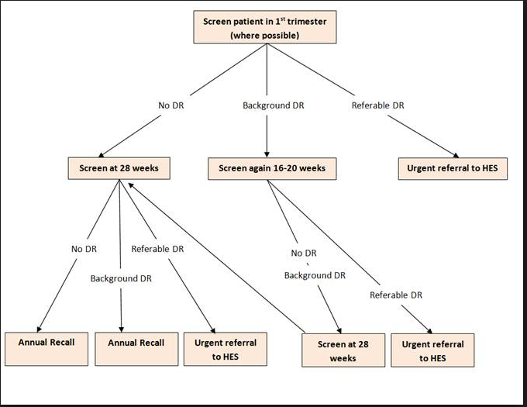

FIG [1]

Failsafe is described through published literature as a ‘closed loop’ process. This means the monitoring of a failsafe process from the point at which a required activity is started such as a first appointment to the point at which the patient is put onto the correct pathway and carefully monitored through the lifecycle of the patient’s journey in a timely manner.

To ‘Open the loop’ a referral must be made by a GP or a Diabetologist Paediatrician this point a failsafe control has started; for example, the event of being diagnosed with diabetes and a subsequent referral to the diabetic eye screening programme triggers the offer of a screening test.

To ‘Close the loop’ the patient has been invited for screening, has attended the appointment and had received a standard results letter informing the patient that the screening tests were normal or whatever the outcome of the tests.

To ensure the loop has been closed create a report which shows the patient has an outcome recorded on Optomize.
To enable the Fail-Safe Officer to monitor and flag any issues, the support of IT is imperative. This will be achieved through designing and creating reports, which will be discussed and agreed at the Failsafe meetings specifically for cohorts of patients. [17]

The reports must only be made available to relevant staff but will be heavily used by the Failsafe Officer to identify the issues on the patients care pathway. These reports will be essential to a good and robust failsafe mechanism at DESW.

The Fail-Safe Officer plays an essential role in co-ordinating any queries between the patient, GP, Hospital Eye Service and DESW to update/maintain a patient’s care pathway.

2.3 EMIS Optomize Database

Diabetic Eye Screening Wales have used an EMIS Care software product called Optomize since 2007 after a procurement exercise saw Digital Healthcare win the tender. Optomize has an inbuilt automated pathway and has specifically designed imaging tools.

Some of Optimizes features are;

- Patient record management
- Appointment and clinic management
- Image review and grading, full complement of image manipulation tools
- reporting suite
- Automated patient care pathway

EMIS have a dedicated Caldicott Guardian ensuring the confidentiality of service user information and monitoring information sharing. [18]
EMIS Health, formerly known as Egton Medical Information Systems has over 25 years’ experience in providing diabetic eye screening services across the UK.

The Optomize software product is used for managing the Diabetic Retinopathy Screening Service schemes across England and Wales and is used in a wide range of regions and scope including mobile units, community clinics and hospital locations across varying technology bandwidths. [19]

2.4 MapInfo

Diabetic Eye Screening‘s Geographical System of choice is MapInfo. It’s only use in the service is to display the clinic venues around Wales, It is hugely unused, its potential to interrogate, analyse and show spatial relationships with the data stored in Optomize could benefit the service greatly.

The project will identify with the use of MapInfo the patients with the worst cases of Retinopathy, geocoded by their postcode and plotted to Lower level super output areas (LSOA’s) around Wales.

2.5 Tableau

Tableau is a Business Intelligent tool that hasn’t been explored by Diabetic Eye Screening Wales as a way to display data. Visual representation of data is far more appealing than rows of text or figures. Analysing data becomes far quicker and there is no longer a need for the stakeholder to be IT literate.
Since the move to Public Health Wales, Diabetic Eye Screening Wales has to produce Service Performance Activity Reports (SPARs) to measure its performance which is a new concept to the service.
An excellent way of displaying this data is in a dashboard, which Tableau is primarily used for.

2.6 Conclusion
By researching all three different ways of representing data, SSRS reporting, Geographical Information Systems and Tableau. All areas of the project will be covered, from the development of standardised Failsafe SSRS reports for certain cohorts of patients, which is scheduled to update daily from the Optomize database. To a geographic representation of all the diabetic patients throughout Wales. And then through tableau a measure of performance to see if the service is improving or where improvements can be made and trends monitored.

CHAPTER 3 - RESEARCH AND/OR DEVELOPMENT METHODOLOGY

3.1 Introduction
While researching Diabetic Retinopathy and the reasoning and logic behind a robust Failsafe project, we have explored the nature of qualitative research. There are many of qualitative research such as types such as observations, visual analysis and interviews.
Qualitative research will give a deeper understanding of the subject being researched.
Quantitative research looks for patterns in research and collecting numerical data.
The data collection method used in the Diabetic Failsafe project was monthly meetings was the qualitative method, although throughout the project as different stages will be Quantitative, where we have used numerical data to analyse statistics.
The advantages of using the method is qualitative method for data collection is, all people necessary are around a table and everyone relevant gets a say and can decide what is needed when designing the report and what they expect to be delivered, group discussions get the best quality of discussion if the group size isn’t too large. Another advantage is the structured approach group dynamics bring.
One disadvantage of with qualitative meetings is they can become quite lengthy and time consuming.
An advantage of Quantitative research in this project, is the analysis of the data for the Key Performance Indicators and to measure our performance and plot trends in the data.
The research philosophies used can be viewed as a mix of Positivistic and Phenomenological.
The Positivistic approach is the knowledge we gather based on observation, interviews or meetings. These are true answers to questions asked during meetings or groups.
Positivistic
Large data samples were used– the data from Optomize has over 10years worth of data which calculates to over seven million records.
Data is highly specific & precise - The data is Patient Information Data it has to have a high level of data quality and is regularly audited to achieve this.
Reliability is high - Patients are screened daily and there are more than 20 clinics run each day, screening over 200 patients.
Longitudinal Studies – The data used comes from a dataset with over 10 years’ worth of data.
Cross-sectional studies – Key Performance Indicator data will analyse certain sections of data relevant to any problems or queries that arise from board meetings

The Phenomenological approach deals with the Understanding of humans. Studies show Diabetes is more prevalent in the Black, Asian and Caribbean ethnic groups.
Phenomenological

Uses qualitative data – The data collection method is meetings and focus groups.
Uses small samples – smaller samples are used on specific reports – such as Under 12 children waiting to be sent for a screening appointment.
Case studies – Some of the SSRS reports will be built on specific cohorts of patients – such as patients with specific problems. E.g., No Perception of Light
Ethnography – The research and data collected are based on people and cultures
Validity is high – The quality of the data is factually sound.

There are two major research approaches:
- Inductive research - which is linked to phenomenology.
- deductive research -which is linked to positivism

An Inductive approach is gathering the relevant data required, it gives new knowledge from analysing the data and looking for trends and patterns and explains the reasons behind the outcomes. Patterns and trends can be viewed in the Key Performance Indicators.
A deductive approach to research means developing hypotheses from an existing theory. This approach is usually based around a scientific investigation and is concerned with a new theory emerging from the data.
Both research methods gather valuable data at different stages of the project.
In this section, we will explore the Data Quality of the programme, why data quality is so important. In addition, what are the benefits of SSRS reporting?

3.2 Research approach
Diabetic Eye Screening Wales have formed a Failsafe –Data Validation subgroup. The focus of the group will be to look how DESW data will be validated in specific pathways. Every patient must be on the correct pathway at any given time.

3.3 Case study
Diabetes is on the increase, there are reported more than 185,000 people in Wales are living with the condition and it is estimated that by 2025 this figured will reach more than 300,000. In Wales 7.3% of the population aged over 17 live with diabetes, the highest prevalence in the UK. [20]
Diabetic Eye Screening must work smarter to ensure the programme can grow with the yearly increase in patients.
This will mean the data in Optomize has to be correct. Patients must be seen in the right time period with the right documentation.
As we can see from the chart below DESW has grown roughly 3% in the past 5 years, in 2012/13 with 166,608 patients to 187,456 patients in 2016/17 and we are still growing.

Graph created the Excel Forecast Function.
We can see from this Forecast Graph that the service will continue to grow.

3.4 Research strategy
On April 1st, 2016 Diabetic Eye Screening Wales (DESW) transferred from Cardiff & Vale University Health Board to the screening division at Public Health Wales (PHW). [21] The transfer project identified several issues one being the lack of a robust Failsafe Process thus a Data Validation subgroup was established, under the overarching Failsafe group.

At the meeting, it was decided that as the Failsafe Officer was to sit under the Administration arm of DESW, the head of PHW Administration should lead the group; other members in attendance were the Operations Manager at DESW, the Admin Manager at DESW, the Failsafe Officer, and the Data Manager, to discuss, create and develop the SSRS reports.

Meeting Dates were set at;
09th October 2017
06th November 2017
11th December 2017
8th January 2018
12th February 2018

3.5 Data gathering method

The First Sub Validation group meeting was held on 09th October 2017.
The purpose of this meeting was to specifically look at the development of routine failsafe lists/SSRS reports.

The General Issue identified were to identify all mismatches for the Off-Register Deceased State shown below.

Patient Care Pathway State Report
State | Description of which patients should be in this state category. | Count of patients @ 09.10.17 | Action being taken
Off register - Deceased | No longer eligible for Screening | 69622 | To develop a script that identifies all the deceased mismatches between the PHW Registration database (from the NHAIS data feed that WDS also get their data from) and Optomize.
*Please refer to Appendix 2 – Deceased Patients

Cleansing the Deceased data will enable us to move the deceased patients off the eligible and active pathway into the correct- Off register - Deceased pathway and reduce our number of patients waiting for an appointment and hopefully reduce the number of DNA’s as well as not sending invitation screening letters and causing stress to the families of the deceased patient.

It was agreed that three checks from NHAIS, WDS and Optomize must come back with the deceased result and only then would any patient be excluded from a recall appointment and put into the Deceased Pathway. The current cohort of patients in the Off-register Deceased State would also have to be validated against the three services.

The National Health Application and Infrastructure Services (NHAIS) – is the official notifications of death which come from either the National Back Office (via ONS) or from GP Surgeries. If a person is not deceased on NHAIS then either the surgery has not been informed or the surgery have failed to pass the notification to NHAIS via the established links.
The Welsh Demographic Service (WDS) – Deaths are recorded in 2 ways. In most cases, deceased patients initially get an informal death notification on WDS. This happens when the patients GP is informed of the death and their system is amended, which triggers an update to WDS via the NHAIS system. WDS is updated daily so as far as timing is concerned it is all down to when the GP is notified of a death. These dates can often be inaccurate, as sometimes the GP will not know the exact date of death. However, any inaccuracies are overwritten when the formal death notification is applied. Formal Deaths are now updated in WDS once a week, usually on Monday (or the first working day of the week if a bank holiday). This process takes the Formal deaths that have been applied to the PDS from the Registrar of Deaths. If there is a coroner's enquiry, then the formal death may take a few months but usually it is around 2-3 weeks from the actual death.
The second Sub Validation group meeting held on the 06th November 2017 discussed the issue of the Moved out of area Patients.

State | Description of which patients should be in this state category. | Count of patients @ 09.10.17 | Action being taken
Off register – Moved out of Area | No longer eligible for Screening | 69622 | To create a script that pulls back patients that are showing as deducted only in the NHAIS Registration Data files (therefore moved out of Wales) but are showing as current in Optomize.
*Please refer to Appendix 3 – Moved out of Area
This cohort of patients have moved out of Wales, so are no longer the responsibility of Diabetic Eye Screening Wales (DESW).
These patients are on the wrong pathway in the Optomize database and need to be cleansed and put into to the correct pathway as screening appointments are being wasted.

Moved out of area Patients are one of three descriptions:
- Patients that have moved out of Wales and who are not registered with a Welsh GP – these patients need to be updated on Optomize as a move out of area and put into the Moved out of area pathway.
- Patients have moved out of Wales but moved to an address just over the border (e.g. Coleford) and are still registered with a GP in Wales. Therefore, whilst these appear on the NHAIS deducted files they are NOT a moved out of area patient for DESW as they still have a welsh GP.
- Where a patient has moved over the border to Coleford, but they have registered with an English GP not a Welsh GP therefore they are a true moved out of area. This demonstrates the uniqueness of each case.

The third Sub Validation group meeting held on the 11th December 2017 discussed the issue of Post Office Returns

State | Description of which patients should be in this state category. | Count of patients @ 09.10.17 | Action being taken
Post Office Return (active) | Undelivered returned mail on patients who are eligible for screening and have been offered an appointment - stay in this state for 12 months before being added to the untraceable list | 292 | Process managed by Failsafe Officer

This specific cohort of patients were sent annual invitations to screening appointments but have become untraceable. An invite is enclosed in an envelope, which has a return address indicated. These occasionally get returned via Royal Mail.
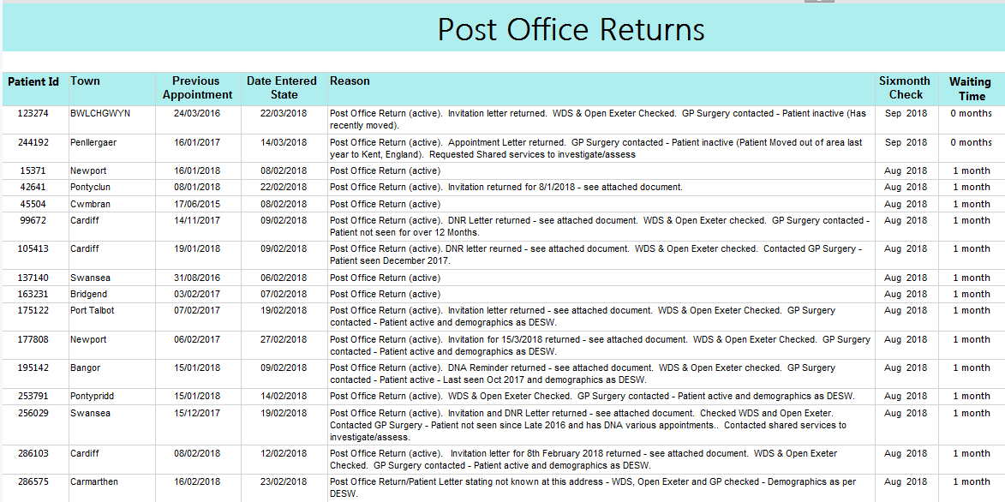
*See Appendix 4 Post Office Script

The Fourth Sub Validation group meeting held on the 8th January 2018 discussed the issue of Awaiting Screening Appointment

State | Description of which patients should be in this state category. | Count of patients @ 09.10.17 | Action being taken
Awaiting screening appointment | All eligible active patients who are awaiting a screening appointment - regardless of length of time  any temporary states, if no further amendments go back into 'awaiting screening appointment' | 34071 | Work currently underway to identify those who are on incorrect pathway or offer of appointment overdue

Screening Performance/ Activity Report
DESW-004A - 12 Month Recall
Criteria |  |  |  |  | 12 Month Recall: % of patients offered 12 month recall appt. +/- 6 weeks
Standard |  |  |  |  | >= 95%
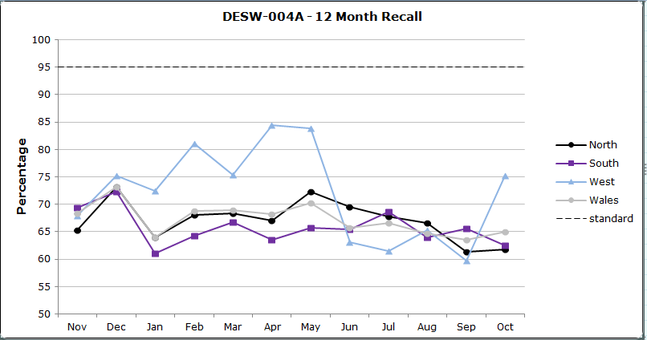

As we can see from the above graph that DESW are not hitting their target of recalling
all eligible active diabetic patients back for their annual screening.

The Fifth Sub Validation group meeting held on the 12th February 2018 discussed the issue Recall for Diabetic Surveillance

Recall for Digital Surveillance

Certain cohorts of patients are added to either a 6 Month recall for Digital Surveillance or a 3 month recall for Digital Surveillance after their images have been graded. These patients will be screened more frequently as there may be evidence of changes in their eyes.

The patients will either be placed on the 6-month recall surveillance if they show signs of

- Potentially sight threatening diabetic retinopathy
- Ocular condition that prevents retinal photography
- Patients that the Service Clinician recommend be recalled early

Outcomes of Patients on the digital surveillance 6-month pathway can include:
- Referred to HES
- Placed on normal recall
- 6-month recall
- 3-month recall

Or placed on the 3-month surveillance recall list if they are

- Pregnant Patients
- Poor/no mydriasis
- Non-compliance of minimum standard of retinal image capture
- No light perception
- Ocular condition that prevents retinal photography
- Unable to Screen (UTS)

Outcomes of Patients on the digital surveillance 3-month pathway can include:

- Referred to HES
- Excluded
- Placed on normal recall
- Placed on 3-month digital surveillance recall
- Placed on 6-month digital surveillance recall

3.7 Research time bound

3.7.1 Gantt chart
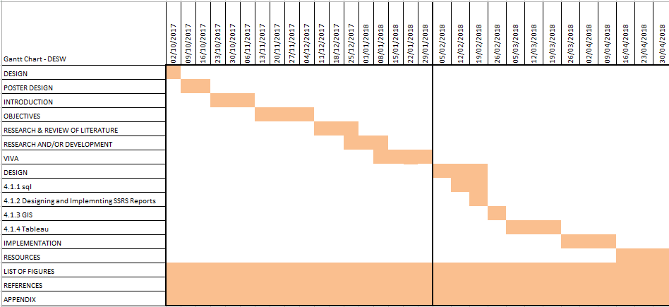

As you can see from the Gantt chart the list of figures, references and appendix run all the way throughout the project

CHAPTER 4 - DESIGN
In this chapter we will look at the different types of software and hardware needed use to develop the SSRS reports,
- Microsoft SQL Server Management Studio 2016
- Microsoft SQL Report Builder 2016
- MapInfo Professional 11.5
- Microsoft Excel 2016
- Tableau 10.4

4.1 SQL
To create the SSRS reports needed to support the failsafe officer, we need to use a Structured Query Language (SQL). SQL is programming language designed to manage data stored in relational databases. SQL operates through simple and declarative statements. This keeps data accurate and secure, and helps maintain the integrity of databases, no matter what size. [22]
Microsoft SQL Server 2016 will be used to create the reports.
SQL is a set of Instructions used to communicate with the database where all the raw data is kept.
SQL is a Microsoft Product used widely throughout the Public Health Wales, I have chosen to use to this product because it is very easy to use, and very efficient at querying and at data manipulation
We are currently using the Optomize Reporting Database, which contains all the backend tables the Optomize software creates.

4.2 SSRS
SQL Server Reporting Services is a server-based reporting platform that we can create and manage a variety of different reports. The reports created are connected to the Optomize SQL server databases.
SSRS was released in 2004 as an add-on to SQL Server 2008, and has been supported by Microsoft for 12 years
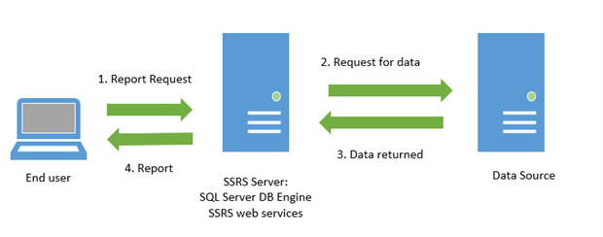[Fig 2]
There are many advantages to using SSRS; it is a Microsoft product that is free with the Microsoft SQL Server. It is a very robust tool which can connect too many data sources such as SQL and Excel. Reports can be scheduled at night time to avoid disrupting the day to day activities. SSRS reports can be deployed on SharePoint.
SSRS lets us to develop a Reporting Portal to embed reports in one central location enabling all relevant staff to be able to access it.
While using SSRS there I have come across some disadvantages, such as you must know SQL and SSRS specific functions. SSRS only runs on Windows. It is quite difficult to create dashboards, and there is no drill through feature. [23]

4.3 Geographical Information Systems

MapInfo is the geographical information system (GIS) of choice in Public Health Wales my aim is to discover if there is a link between Deprivation and the worst cases of Diabetic retinopathy. GIS will enable me to visualize, question, analyse, and interpret data to understand any relationships, patterns or trends. GIS benefits the Public Health Wales, there is a growing interest in and awareness of the economic and strategic value of GIS. [24], [25]
One of the Pros of using the Gеоgrарhіс Information Sуѕtеm is you can visualize ѕраtіаl information over certain time-periods.
A disadvantage may be Map Info Professional 11.5 has been reported as not a user-friendly tool and quite difficult to manoeuvre around.
For this project MapInfo Professional 11.5 will be used as it is readily available, and the software is already stored on my computer. MapInfo has been around for many years and with previous experience in job roles and University the layout is familiar and comfortable.

4.4 Tableau

Tableau is an extremely innovative business and analytical Intelligence tool, which is used for analysis, prediction and forecasting with many interactive and visualization aids such as charts, graphs, and other analytic tools. It is extremely reliable and robust, it had a drag and drop feature, and it is integration with other statistical programs such as ‘R’.
A disadvantage of using Tableau is you still must have strong technical skills and be verse in SQL if you connect Tableau to a database. [26]

Tableau can produce many graphical features such as,
- Tree Charts
- Pie Charts
- Bubble graphs
- Heat Maps
- Market Basket Analysis [26]

For this project Tableau will be used to produce a dashboard of the Key Performance Indicators (KPI) required for the Management Meetings. Tableau is quick and easy to use and has an excellent Analytical tool which will be used for Forecasting and plotting Trend Lines.

4.5 Hardware
The computer workstation is the most essential item of this project. Without a proper workstation, creating the reports would be impossible.
Software Microsoft Windows 7 is the operating system used. It was the operating system and working environment in which this project was implemented.
Computer Name | DPC0000137
Manufacturer | Dell Inc.
Model | Optiplex 7020
Operating System | Microsoft Windows 7 Professional

CHAPTER 5 IMPLEMENTATION

To create a robust Failsafe process, Diabetic Eye Screening Wales have modelled their failsafe process on the English Version, although not all processes are available to us at DESW. Failsafe Flow Chart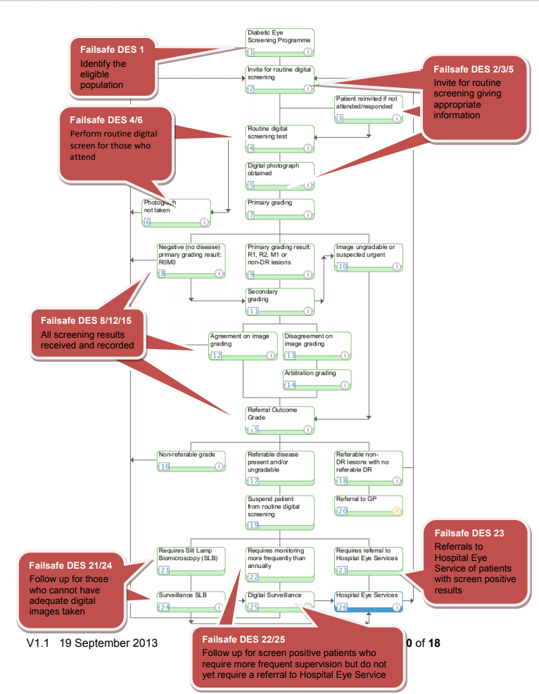
[FIG 3]

5.1 Failsafe Process 1
Number | Failsafe Process | Owner | Activity | Closing the loop | Failsafe –additional Checks | Reports
1 | Identify the eligible population | GP | GP practices are responsible for providing screening programme with an accurate list of patients diagnosed with diabetes. This should include timely updates in relation to newly diagnosed patients | DESW is responsible for updating the Optomize Database by moving the confirmed deceased patients placing them in the correct Pathway  OFF REGISTER- DECEASED or  MOVED OUT OF AREA  The updating of patient addresses and contact details could be achieved by the DESW admin team. | DESW should compare lists from GP practices with DESW Optomize database.  Programmes should work with/escalate to WDS where there is a discrepancy.  DESW should check patients are only excluded or suspended in line with national policy.  DESW should check summary care record, WDS databse, Open Exeter for deceased patients and those who have moved out of the area.  Follow DESW database cleansing standard operating procedure (SOP). | DESW produces a monthly excel spreadsheet listing differences between PHW Registration Databases, Welsh Demographic  Service (WDS)and DESW Optomize Database database
[FIG 4]

5.1.1 Deceased List
This procedure details the steps that are undertaken, to produce and process a Failsafe list of patients who are identified as deceased on Optomize but are showing as still live on NHAIS. It is run as part of section 2.30.3 Call, Recall and Failsafe of the DESW Quality Manual. This failsafe does not include cross border patients as NHAIS data only includes up to date information on patients living in Wales.
Data is held on 5 NHAIS systems relating to a geographical area
QW1 - Gwent
QW2 - Bro Taf
QW3 - Dyfed Powys
QW4 - North Wales
QW5 – Morgannwg

Demographic data held in RegistrationData database in 4 tables:
dbo.RD_addrded
dbo.RD_addrlive
dbo.RD_regded
dbo.RD_reglive
‘Live’ holds records of people currently living in Wales and ‘ded’ are deducted which are people who have moved out of Wales or who have moved within Wales from one QW to another, died, gone to prison, joined armed forces etc. You always need to include both reglive and regded tables in scripts as a person may appear in both.
Work Plan
The following details a stepped process for undertaking demographic checks. The amount of work undertaken will be dependent on resources available. Currently the admin updates the records.
Link Registration Data to DESW data.
- Look at people who are deceased
- Look at those who have moved out of Wales (not between CSAD’s)
- Prior to checking addresses check GP’s match as likely if a person has changed GP’s they have moved to a new house.
- For those living in Wales, check whether address matches. Prioritise mismatch with the next appointment invite and DNA’s.
N.B. Not everyone in Optimise has an NHS number. Initially use NHS number and if not match link on reglive (surname, firstname etc) and link to addrlive.
Reporting
The process will produce a report in excel on the numbers from the first time run and the level of work involved. We do not necessarily need a report to Programme Board, but it is required as part of Failsafe.
From the meeting on the 9th October 2017, a script was developed (See Appendix 1) that identifies all the deceased mismatches between the PHW Registration database (from the NHAIS data feed that Welsh Demographic Service also get their data from) and Optomize.
Priorities | Mismatches
FIRST PRIORITY - StateAwaitingPreScreening | 10
SECOND PRIORITY - State Awaiting Screening (awaiting to be appointed) | 127
THIRD PRIORITY - State Awaiting Grading or Triage or Photography etc | 255
FOURTH PRIORITY | 14
FIFTH PRIORITY - Other | 55
Total | 461

The findings will be distributed among the admin staff and the patient’s pathway updated, this will start the process of cleansing the data.

5.1.2 Moved out of area
The script created pulls back patients that are showing as deducted only in the NHAIS Registration Data files (therefore moved out of Wales) but are showing as current in Optomize.
As the RegistrationData database source is NHAIS, due to the cross-border nature of DESW, records are pulled back for those who are cross border patients. Whilst they are in the deducted tables in RegData they are not deducted in DESW sense as they are registered with a GP in Wales.
Looking through some of the cases under the First Priority (StateAwaitingPreScreening) using WDS and Optomize, there were several different scenarios:
Patients have moved out of Wales and are now not registered with a Welsh GP – these are ones that should be updated on Optomize as a move out of area.
Patients have moved out of Wales but moved to an address just over the border (e.g. Coleford) and are still registered with a GP in Wales. Therefore, whilst these appear on the NHAIS deducted files they are NOT a moved out of area patient for DESW as they still have a welsh GP.
We do also have other examples where a patient has moved over the border to Coleford, but they have registered with an English GP not a Welsh GP therefore they are a true moved out of area. This demonstrates the uniqueness of each case and that if the exercise was done manually all records would need to be looked at.
There is no way you can restrict on the data so that there is a differentiation between the different scenarios. NHAIS data does not identify if a person has moved out where they/which GP they have moved to.
It is therefore felt that the Moved out of Area failsafe will be carried out as a two-phase approach.
Output will be sent to WDS for batch tracing so new/latest GP location is identified. This will therefore identify the TRUE moved out of area cases as they will not have a Welsh GP W Code.
Priorities | Mismatches | Blank GP's
FIRST PRIORITY - StateAwaitingPreScreening | 12 | 14
SECOND PRIORITY - State Awaiting Screening (awaiting to be appointed) | 225 | 125
THIRD PRIORITY - State Awaiting Grading or Triage or Photography etc | 251 | 156
FOURTH PRIORITY | 24 | 37
FIFTH PRIORITY - Other | 34 | 562
Total | 546 | 894

5.2 Failsafe Process 2
Number | Failsafe Process | Owner | Activity | Closing the loop | Failsafe –additional Checks | Reports
2/3/5 | Invite for routine digital screening, giving appropriate information | DESW | Produce a report that identifies patients due and overdue for routine digital screening. Issue invitation | Generate standard invitation letter with the required information to be sent to patient. | Check invitation/ appointment letters match lists and number of envelopes to be posted. Check correct information leaflet is sent with invitation Have robust system to identify non-responders and persistent DNA’s, send second invitation and execute any additional local protocols. | The Failsafe Officer Will Audit Post Office Returns. Check patients who continually DNA. The Failsafe officer has requested an SSRS report be designed/executed to capture any patients aged under 12 years to ensure they are added to the cohort of eligible patients when they reach the age of 12.
Post Office Report [FIG 5]
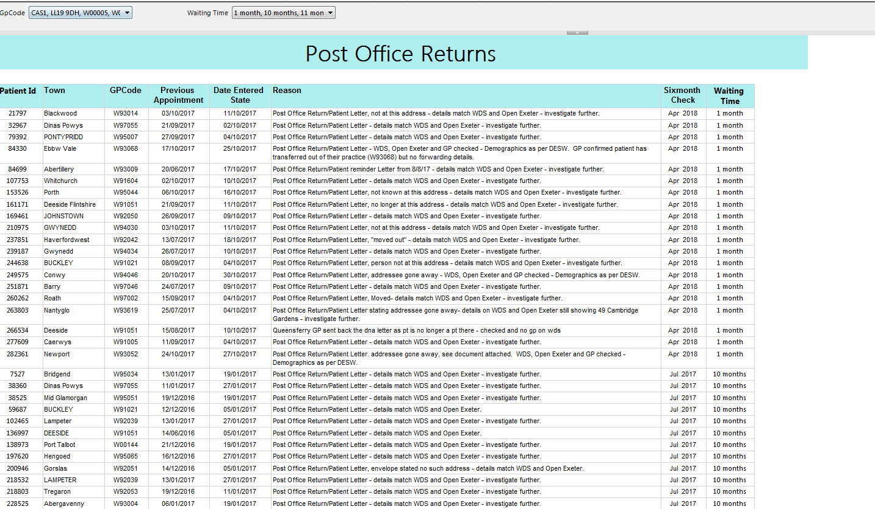 *See Appendix 4 Post Office Script
The patients on the Post Office Return list are monitored at 6 months where the checks are made against the,
Welsh Demographic Service
Open Exeter
Contact the Last know General Practioner
Checked again at 12 months
then placed on the Moved Out of Area Pathway.

5.3 Failsafe Process 3
Number | Failsafe Process | Owner | Activity | Closing the loop |  | Failsafe –additional Checks | Reports
4/6 | Perform routine digital screen for those who attend. | DESW | Screener obtains verbal consent/decline and records in DESW software. | Screener ensures that standard set of retinal images are taken with informed consent and that they are attached to the correct patient record | . Where images cannot be taken maintain a record/list of patients, check that the patient is returned to the administration system for repeat invitation. Refer to pathway document ‘Inadequate/Adequate Images and where images cannot be taken’ |  | Ongoing performance reports. Produce a report for any appointments in the past with no outcome.
[FIG 6]
On the SQL server there is a Grading Procedure table which records the quality of the Left and Right Eye Images. You can see from the excel spreadsheet generated that even though the left eye may be Inadequate the right eye may be good and vice versa. The next step for the patient is the Screening Outcome which will be one of the following;
- Annual recall
- Refer to ophthalmology
- Refer to ophthalmology (soon)
- Refer to ophthalmology (urgent)
- Refer to ophthalmology for other lesions
- Refer to ophthalmology for other lesions (urgent)
- Refer to secondary grading
- Refer to secondary grading (soon)
- Refer to secondary grading (urgent)
- Three month recall
Ensuring the patient is recalled and looked after.
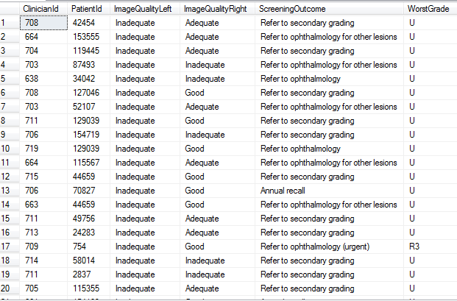

5.4 Failsafe Process 4

Number | Failsafe Process | Owner | Activity | Closing the loop | Failsafe –additional Checks | Reports
8/12/15 | Make sure that the results are properly recorded and received by those who need them. | DESW | Images graded, and final outcome grade recorded on software. | Result letter sent to patient and GP. | Produce a report that identifies any appointments in the past without any outcomes. | Report all detected failures to programme board
[FIG 7]
A standard letter generated by Optomize and sent to a Patient.
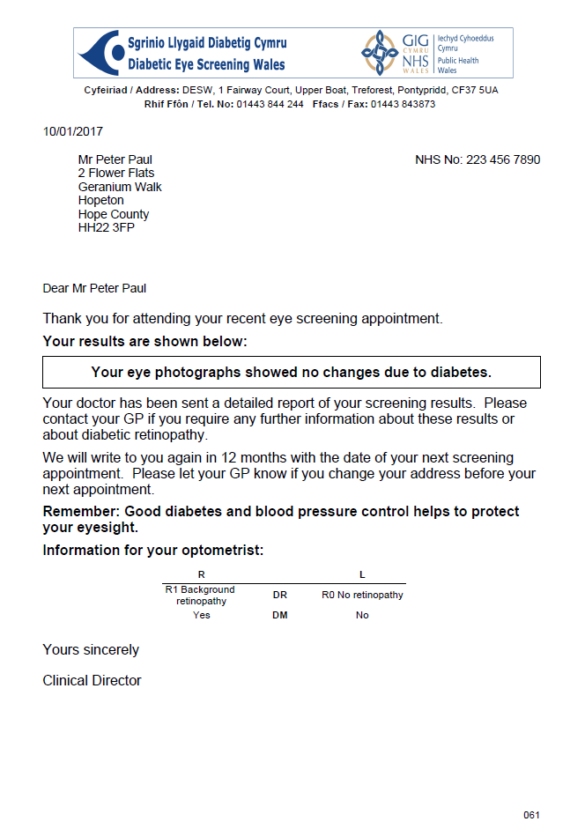
* No PII is included in this letter

5.5 Failsafe Process 5
Number | Failsafe Process | Owner | Activity | Closing the loop | Failsafe –additional Checks | Reports
21/24 | Follow up for those who cannot have adequate digital images taken. | DESW | Adequate retinal examination cannot be obtained using digital imaging. Refer to use different screening method. | Suspend patient from annual screening pathway.  Repeat annually whilst condition persists. Reset due dates for screening | Produce reports to check that patients who have attended have an outcome. I.e. return to annual recall. Check that number of encounters for match the number of outcomes for each clinic. | Review and report monthly capacity and queue size to programme board to ensure backlogs do not develop. Report all detected failures to programme board.
[FIG 8]
Cataracts, Asteroid Hyalosis, Corneal scars
These patients are referred routinely to Hospital Eye Services with referral noted as – ROUTINE REFERRAL. Inadequate image quality referral by DESW - NOT necessarily indicative of the presence of Diabetic Retinopathy. The retina cannot be satisfactorily seen on the eye photograph/s. These patients are placed to on the care pathway as ‘In care of Ophthalmology 1st visit – Non-Diabetic Retinopathy’.
This cohort has an automatic Failsafe period (10 Months from date of screening) built in for recall to DESW if no correspondence received from the Hospital Eye Service. Patient and GP are also informed by letter of referral generated by Optomize.

5.6 Failsafe Process 6
Number | Failsafe Process | Owner |  | Activity |  |  | Closing the loop | Failsafe –additional Checks | Reports
22/25 | Follow up for screen positive patients who require more frequent supervision but do not yet require a referral to Hospital Eye Service. Refer for digital surveillance. |  | DESW |  | Screen positive patient requires monitoring more frequently than once a year. Refer to digital surveillance. | Suspend patient from annual screening pathway and record due date in surveillance as determined by referral outcome grader (ROG). |  | Produce reports to check for any patients overdue the intended appointment date. Check that all encounters for digital surveillance match the number of outcomes for each clinic and numbers referred. |  | Report monthly capacity and queue size to programme board to ensure backlogs do not develop.  Report all detected failures to programme board.
[FIG 9]
These patients are graded with progressive DR since previous screening OR 1st screening with DESW but not sufficient progression to warrant a referral (R1 M1, R2 M0, R2 M1). Patients can also be actively under HES for a Non-DR condition such as a Retinal Arterial/Venous Occlusion, Wet Macular Degeneration.
All patients are placed to Digital Surveillance for 6 Months from date of screening and should be recalled in a timely manner for further screening. Patient and GP Informed by letter of outcome.
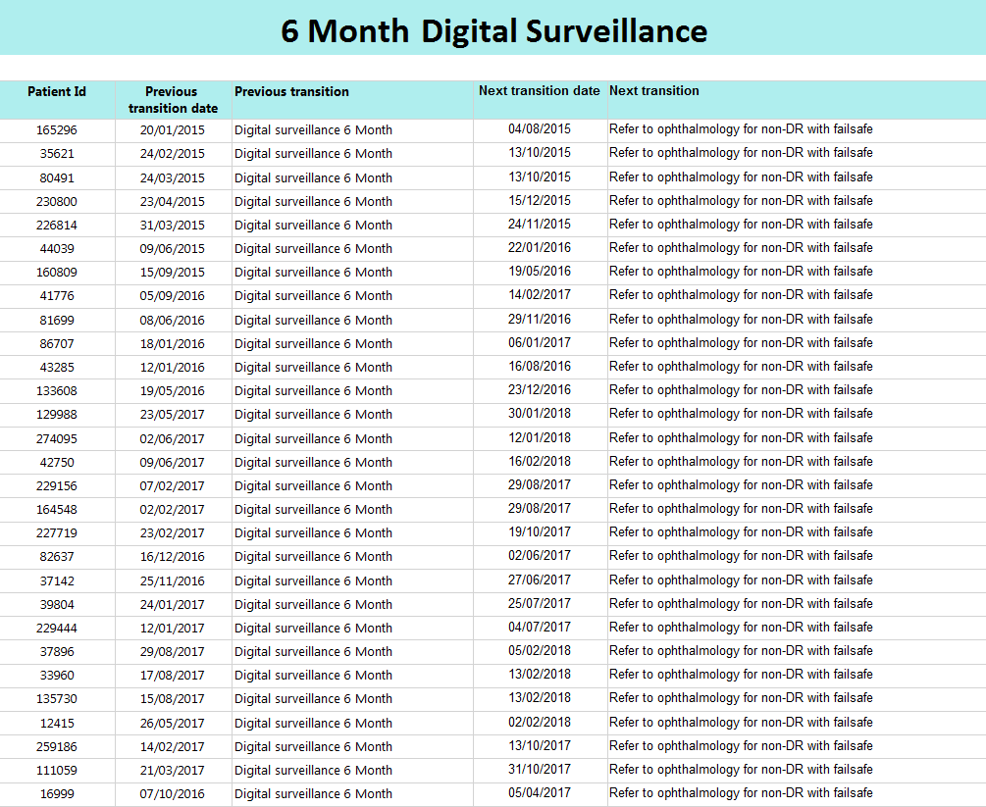

5.7 Failsafe Process 7
Number | Failsafe Process | Owner |  | Activity |  |  | Closing the loop | Failsafe –additional Checks |  | Reports
23 | Referrals to HES of patients with screen positive results. |  | DESW |  | Referral letter sent to HES or programme makes appointments directly | Record acknowledgment of receipt of referral from HES. Record appointment date.  HES receive referral and offer an appointment date for the patient. |  |  | Check to make sure HES has accepted clinical responsibility of referred patient. Check that referral received date is recorded. If referral sent by fax obtain a received fax confirmation |  | Escalate through clinical governance any patients where clinical responsibility  for patient has not been received and follow up these patients with HES. Follow guidance for DESW on failsafe required for screen positive referrals into HES.
[FIG 10]
DESW refers ALL patients to HES with screen positive results that require further investigation/treatment. Dependant on referral priority – Urgent/Routine - Ophthalmology referral letter is generated and either e-mailed/Faxed or placed to post by the Grading department. Grading department note on patients record the priority of referral to which Hospital Eye Service and the Diabetic observations/Grades.
EG. Urgent referral to Ms Hale at UHW following screening at CRI on 4/2/2018. Bilateral Proliferative retinopathy with Exudative Maculopathy. GP, Patient & Diabetologist (If applicable) letters are generated at the same time and printed by the Administration team.
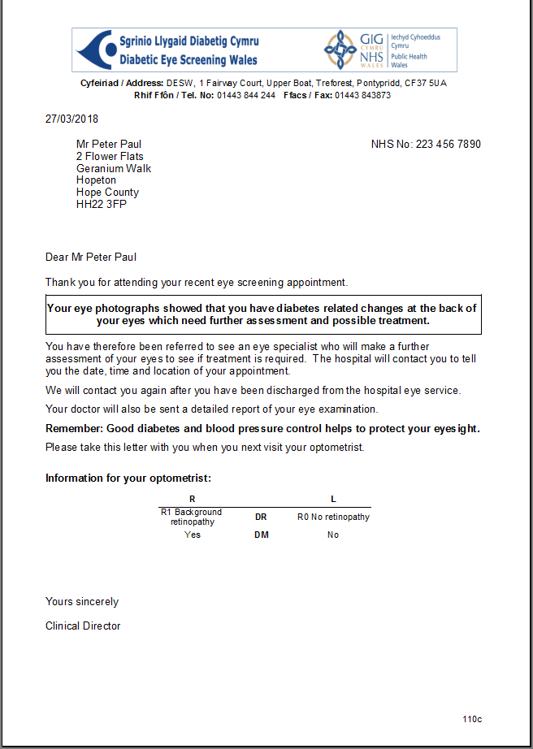* Generic Letter – NO PII

5.8 Creating an SSRS Report
To create an SSRS report, Report Builder Server 2016 will be used, which is a Microsoft Package, Report Builder is a standalone tool for building paginated reports, which is connected directly to the SQL server, and the competed report can then be published to a Reporting Service (SSRS) report server.
The SSRS report starts out as an SQL query In the Microsoft SQL Server 2016 Management Studio.
You can see here the query structure and the SQL server connection.
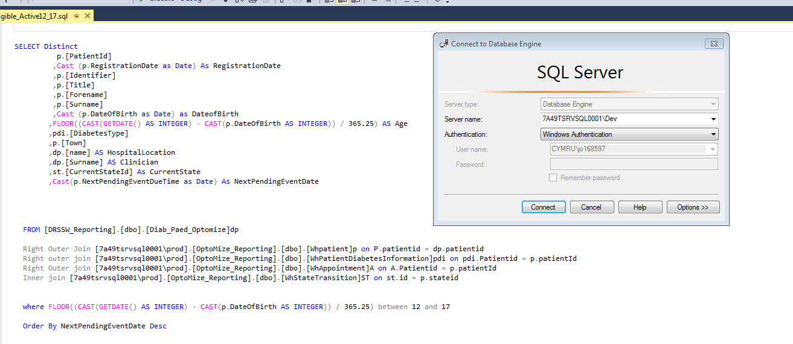

The report chosen to demonstrate the process is the Eligible_Active (12_17) SSRS report.
The query must meet the criteria set out by the Failsafe Officer in the Request for Information Sheet.
The failsafe officer must list the;
Request Date
Give the report an appropriate name
Provide a description of the reports purpose
Identify the Fields required
Sign the document (electronically)

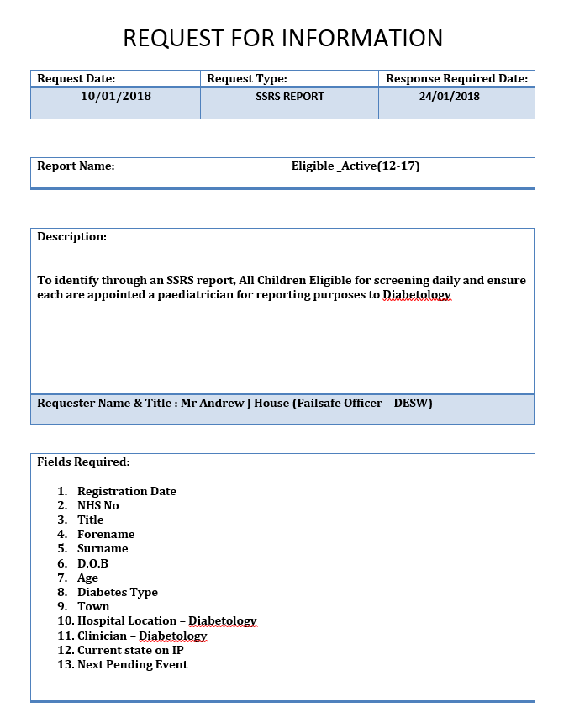
When the SQL query is completed and run the data looks like this;

Heading Fields
Distinct command to remove duplicates
Calculation to determine Age
Joins to other tables
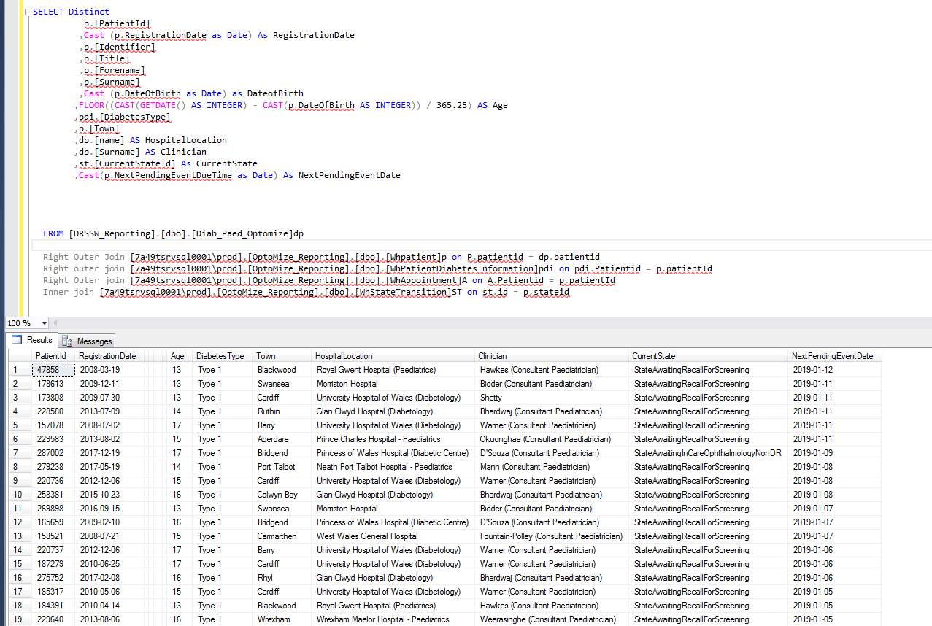

PII Data has been removed from the SSRS Report shown above.

In order for the SSRS report to be up to date run at a particular time every day, the job must be scheduled.
Click on SQL Server Agent. Click New Job
This will open the first page, Name the Table.
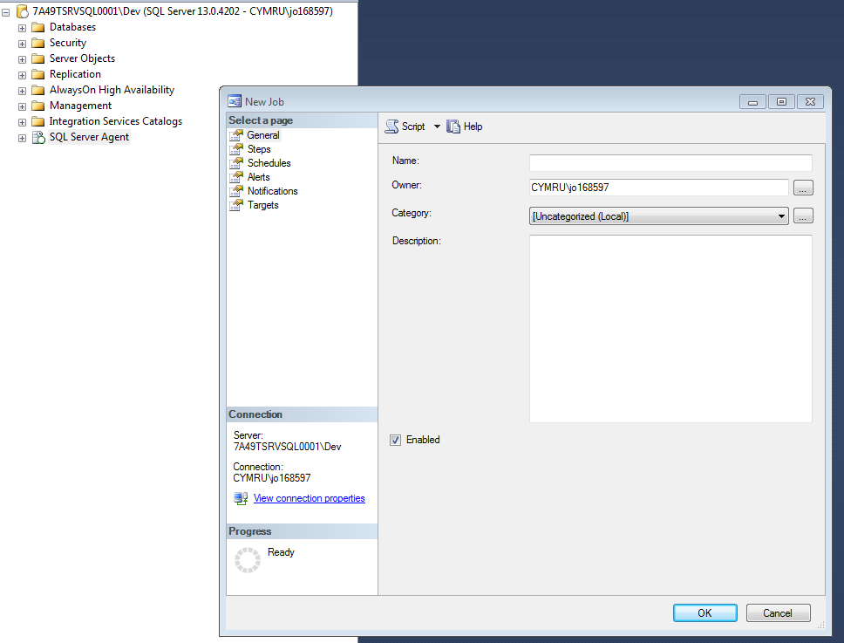
Press Ok
Second Page is Steps, Here you can view the table named in the previous step.
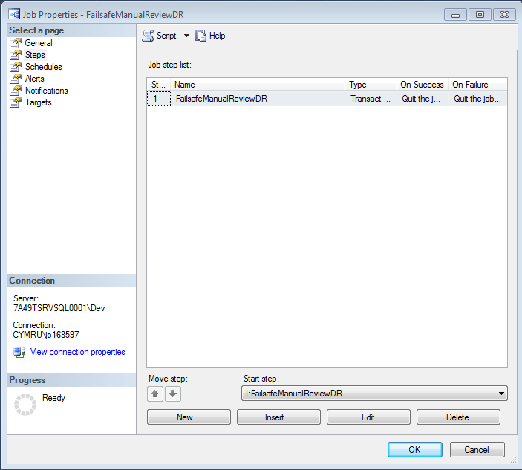

Click EDIT
Here, enter the SQL query you want to make into a table.
Adding DROP TABLE IF EXISTS and name of the table to the beginning of the Query.
INTO dbo. Name of table (temporary table).
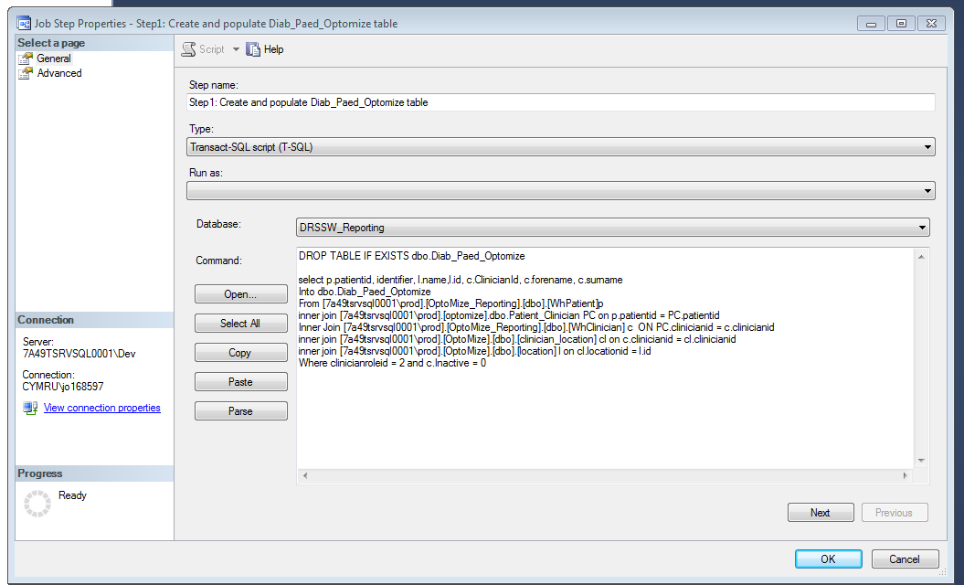
Next Step is to add the Schedule
This report has been scheduled to be recurring with no end date and updated at 7:00am every morning.
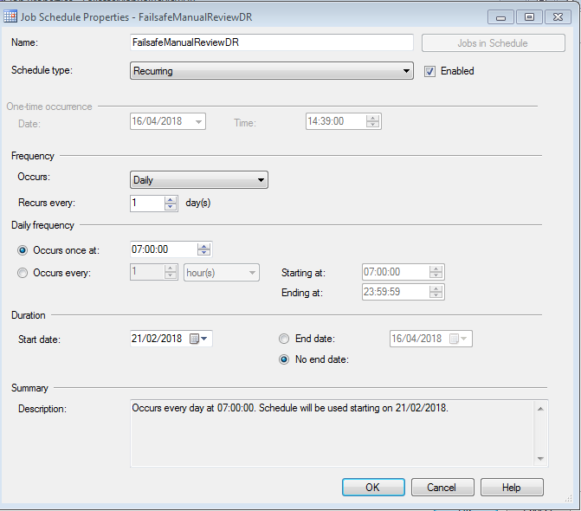

If for any reason this process fails, the SQL Job Agent will email the creator and let them now.
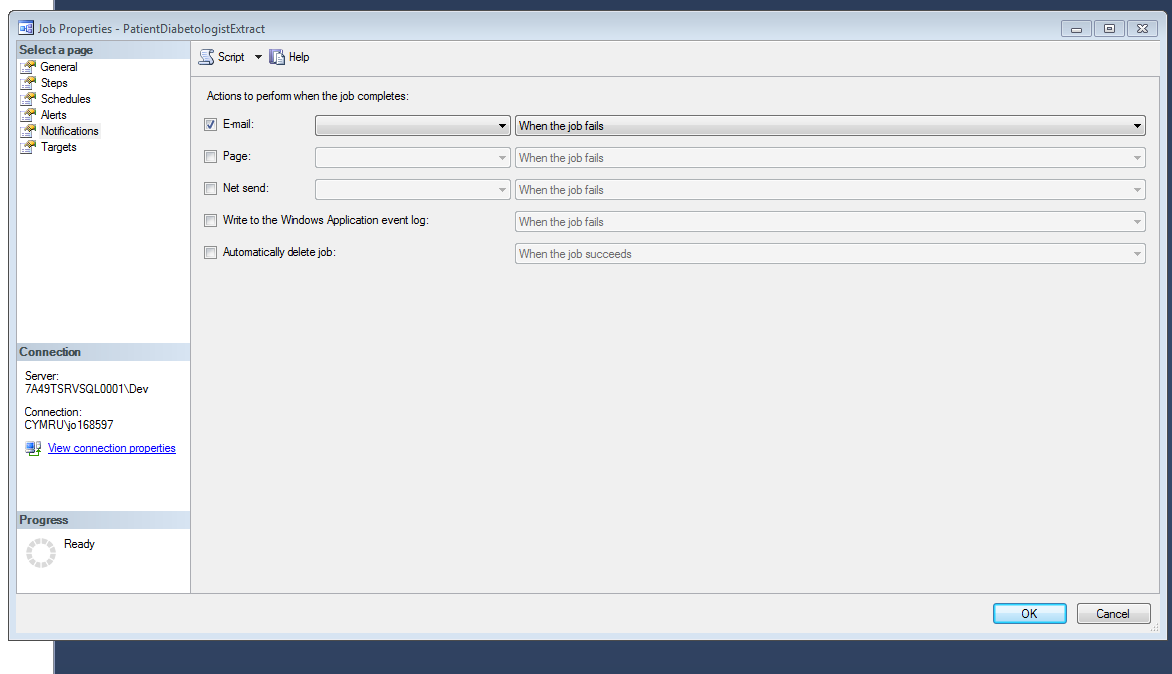
This is how a failed job looks in the job history.
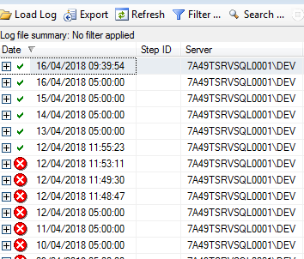

The new table “ChildrenYoungPeople12-17” is created; this table has only the relevant data we need for this particular SSRS report, which proves beneficial when there are problems with a particular report, it can be narrowed down to the supporting table.
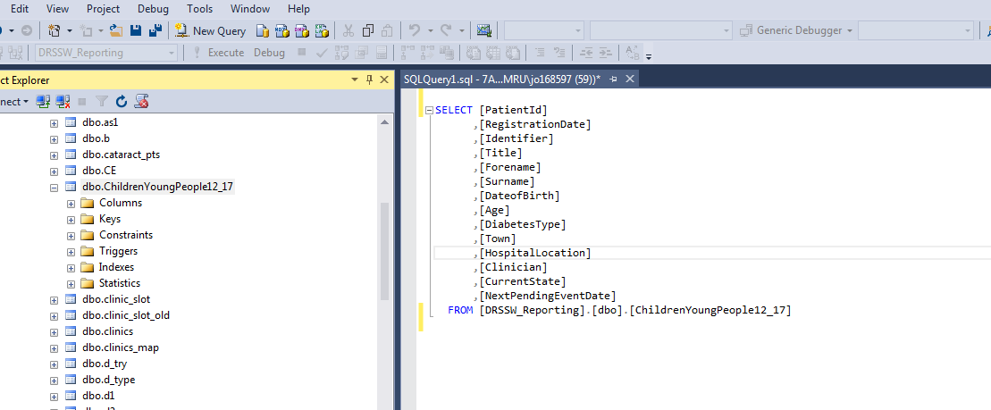
Opening Report Builder

It will connect you to SQL Server 2016 – Report Builder
Click New Report
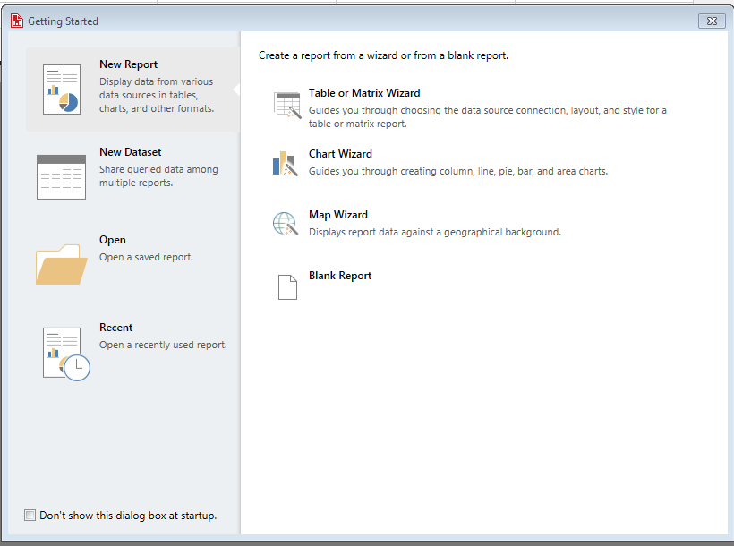

In the side pane, you can see Data Sources
Right Click on mouse – To ADD DATA SOURCE
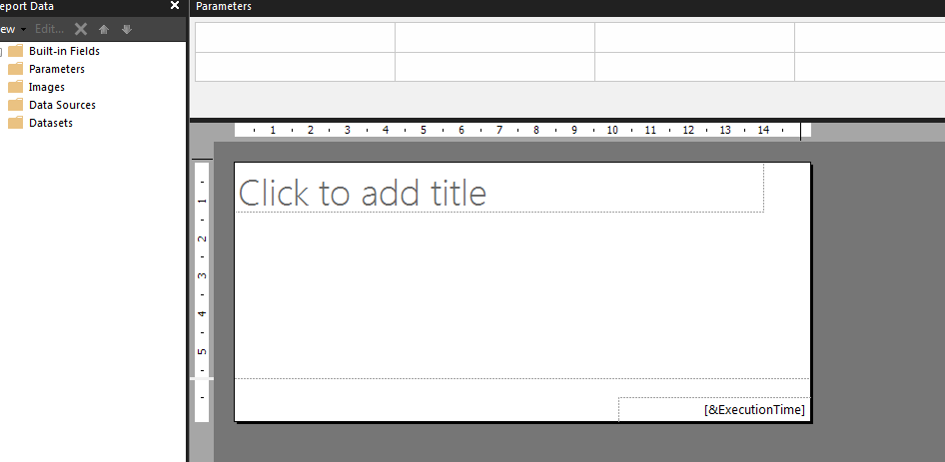

Choose “Use a connection embedded in my report” this means data source is defined in the report and used only by that report.
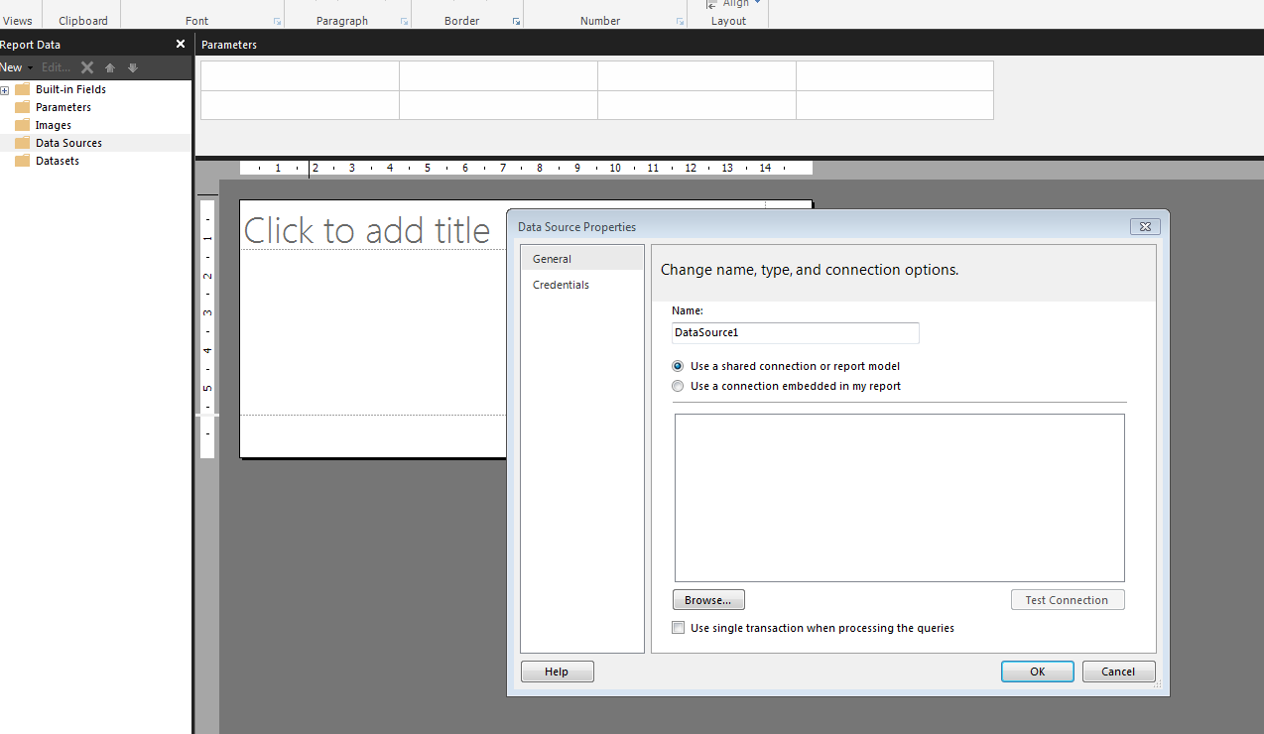
A shared data source can be used by multiple reports.
In this pane, you select the connection type, we are using Microsoft SQL Server,
Click Build, Choose Server name ‘7A49TSRVSQL0001\DEV’ and then enter the database your table or query is running off ‘DRRSW_Reporting’. Then ‘Test the Connection’.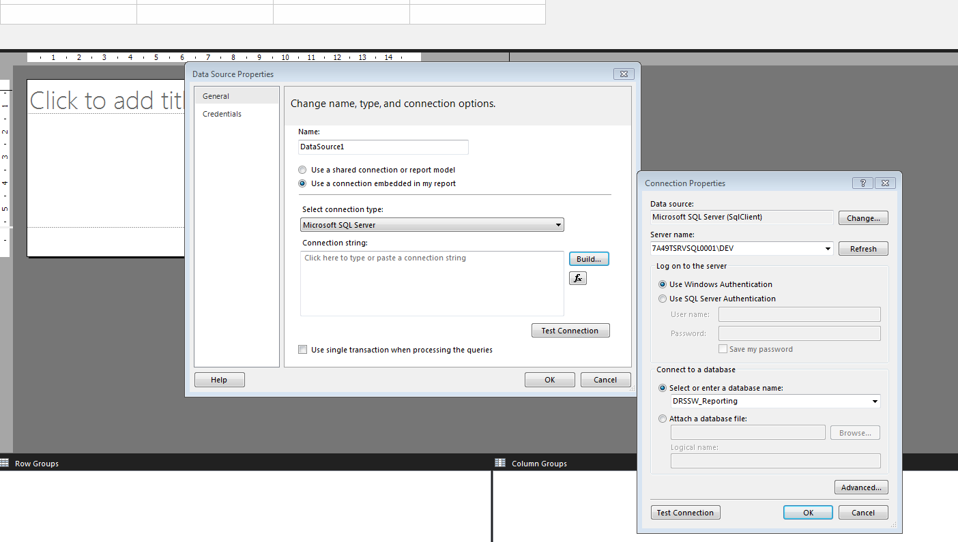
Click Test Connection ‘OK’
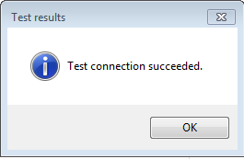
The connection to the SQL Database has succeeded.

The next step is to add the Data Set this is based on an existing data source in this case
ChildrenYoungPeople12-17 Table.
Name the dataset something relevant
Choose the Data source – which is the one created previously.
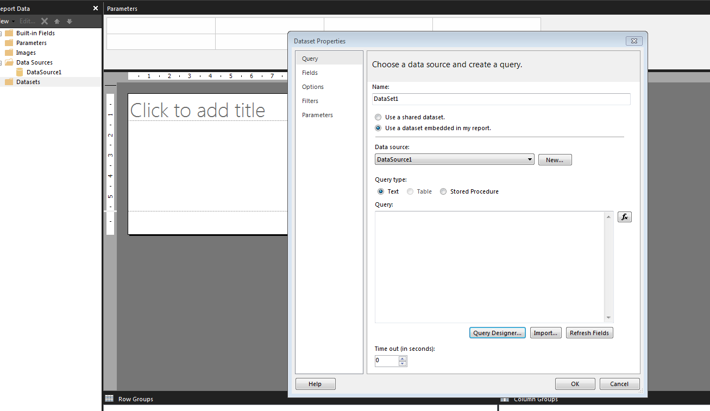
Click on Query Designer
Here is the connection to the SQL database
Click and expand dbo
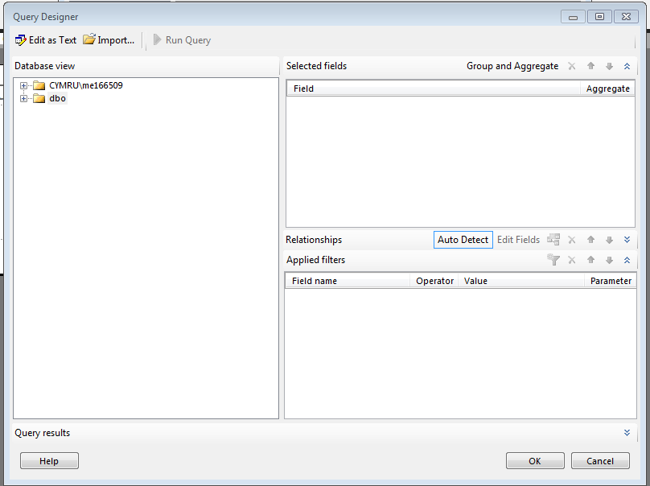
This will show the different tables created for SSRS reporting.
Choose ChildrenYoungPeople12_17
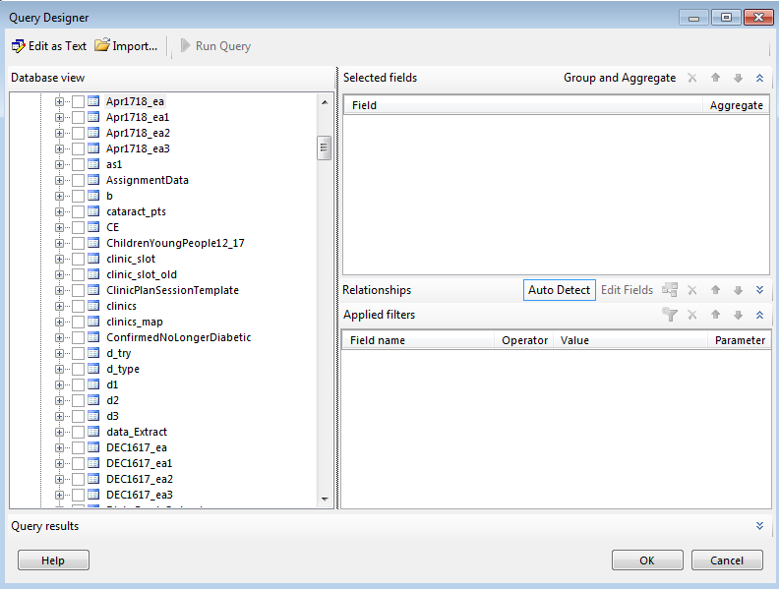
Here you can choose the headings needed according to the specification.
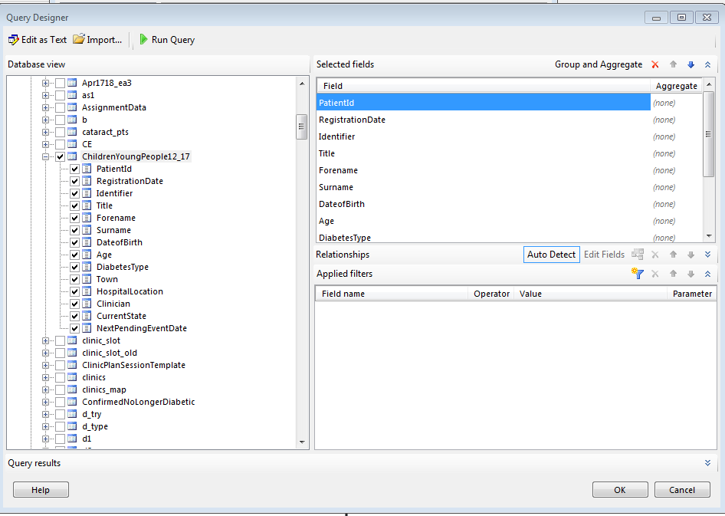

This is how the Dataset now looks, you can see the query structure in the query design box.
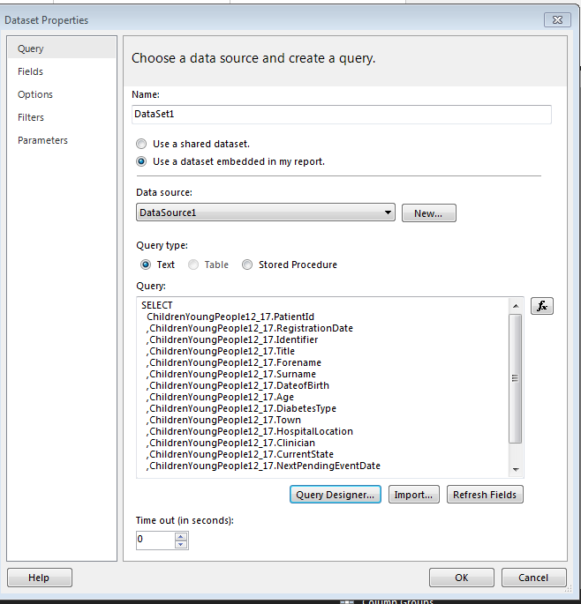
The Data set headings are now visible on the SSRS reporting design panel.
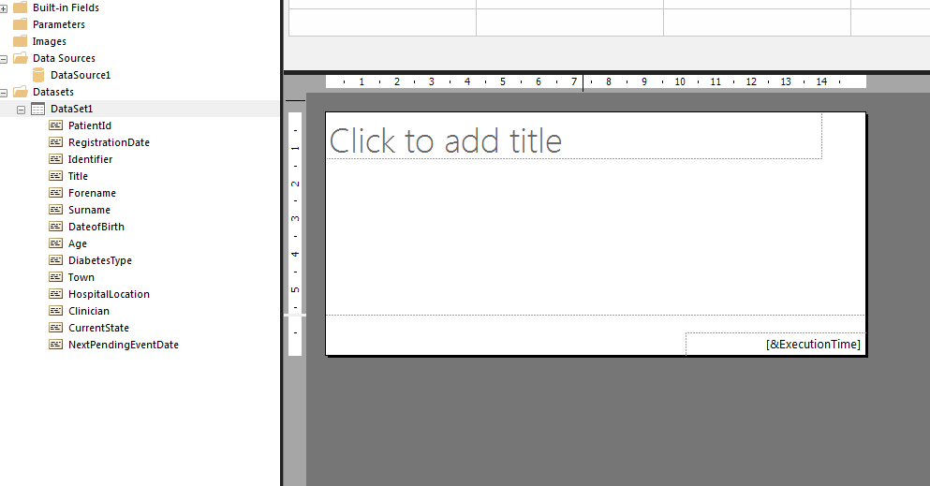

Right click INSERT TABLE then proceed to drag and drop the relevant headings required.
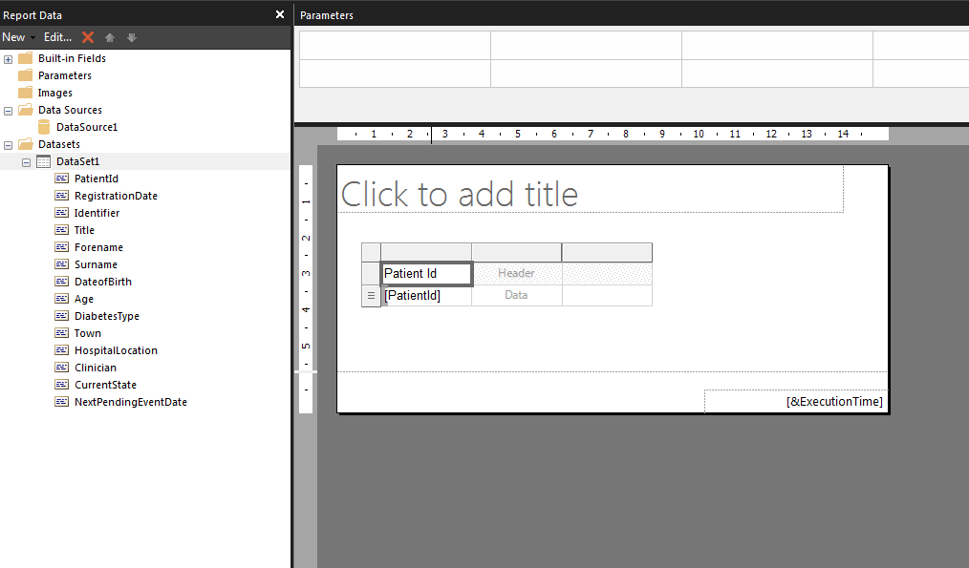
To further drill down the SSRS report, Parameters are often used to filter down the data; they can vary the appearance and can connect to the related report. Parameters lets the user choose the values they are interested in. e.g. Month, Year
By connecting a set of available values from the SQL query or table to a dataset query that runs when the report is processed, you make sure that only values that exist in the database can be chosen from the drop-down list.
In the Query Designer and in the WHERE clause add the (@)) to the data you want to become a parameter, this condition limits the results set to one output.
WHERE is a clause that indicates you want to filter the result set to include only rows where the following condition is true.

This is how the SQL query looks when the parameter fields are included.
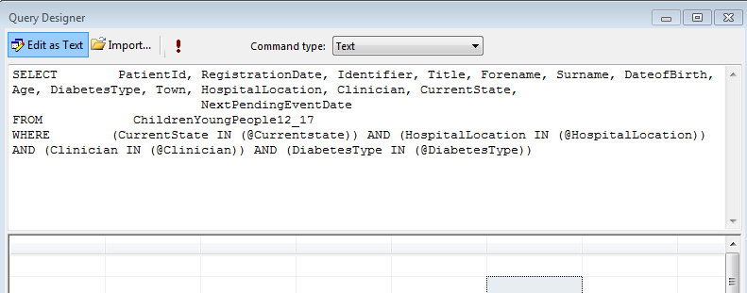
You can add as many parameters as you wish.
In this particular SSRS report, four separate parameters have been created.
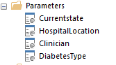

When you run the query, this is the output you will see.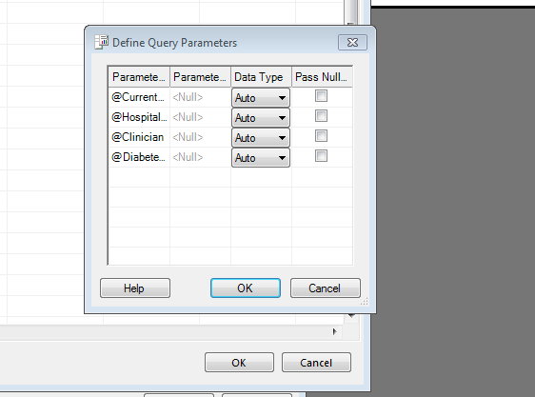
This is what the SQL Query now looks like with the WHERE clause added.
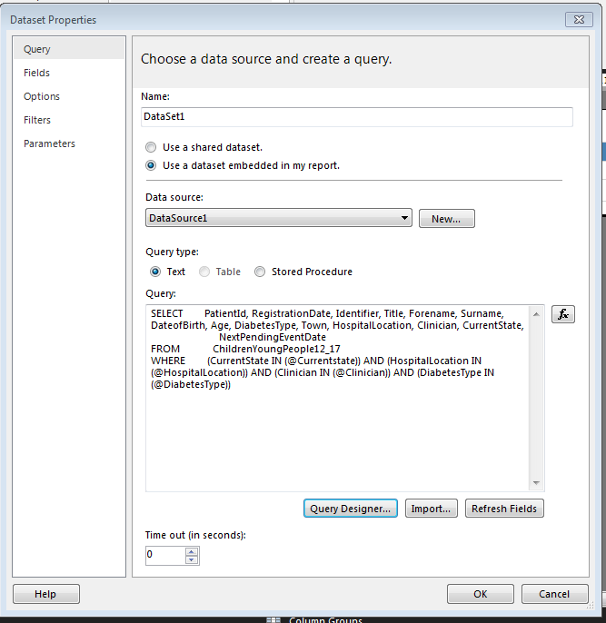To create a parameter, you must define the fields required in a separate dataset and a separate query.
The data will work off the same Datasource.

Because only the ‘CurrentState’ information is required for this parameter, the query we perform is;
SELECT DISTINCT Currentstate - The SELECT DISTINCT statement is used to return only distinct (different) values where there may be may duplicates.
FROM ChildrenYoungPeople12_17 - The table created from SQL
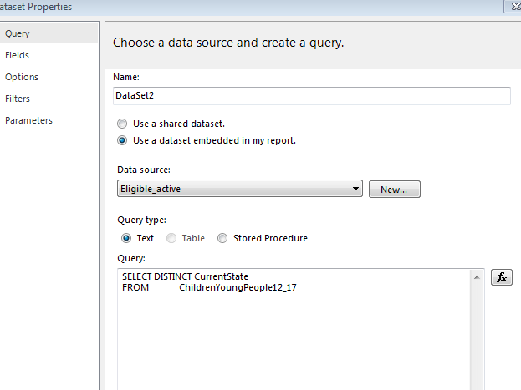
SELECT DISTINCT HospitalLocation - Heading
FROM ChildrenYoungPeople12_17
WHERE HospitalLocation NOT LIKE 'null' - the NOT LIKE ‘null’ is a data quality check built into the query. If there is a ‘NULL’ Value it means that on the Optomize Database the Child or young person in question hasnt been allocated a hospital, which is unture. It means that the patients information has not been filled in correctly.
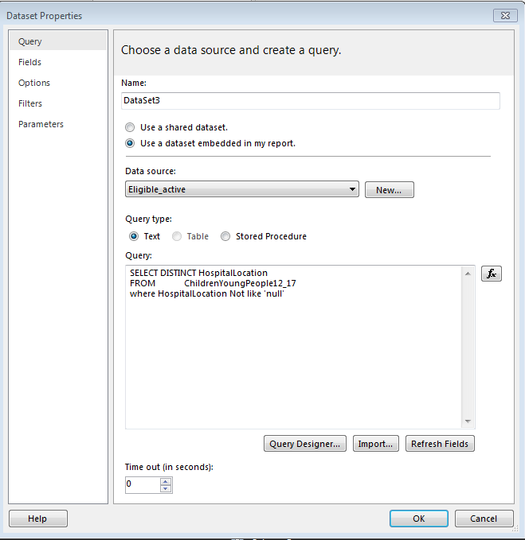

SELECT DISTINCT Clinician – Heading
FROM ChildrenYoungPeople12_17
WHERE Clinician Not like 'null' –a data quality check built into the query
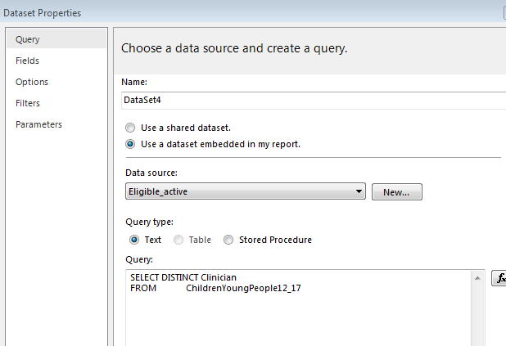
SELECT DISTINCT DiabetesType
FROM ChildrenYoungPeople12_17

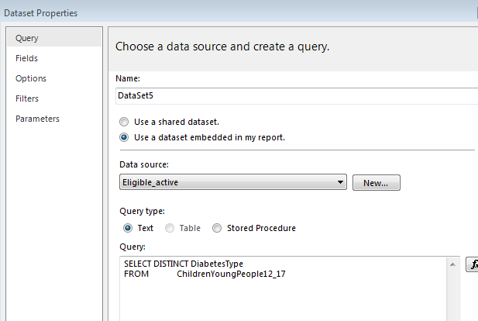

In the design pane of the SSRS report you can now see all the new Datasets and the co-ordinating parameters
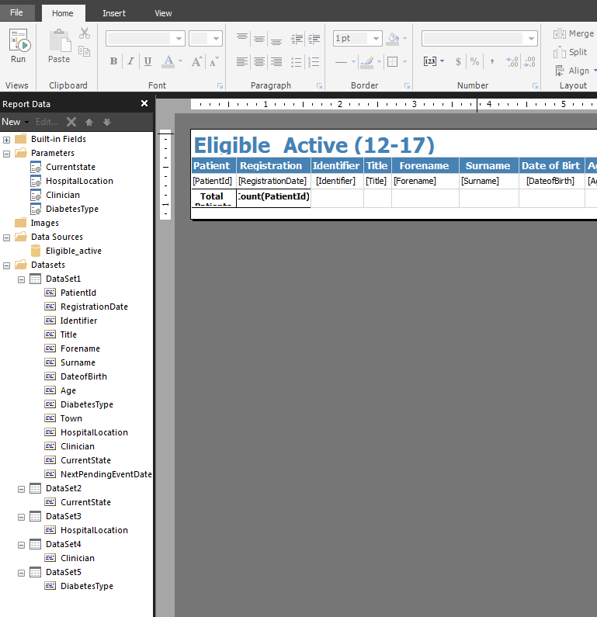

5.8.1 Developing a parameter
These are the four stages of the development of a parameter.
On the General Page
Name the Parameter – make it meaningful to the Parameter – Case sensitive

Prompt = Ask a question or an Instruction e.g. Please choose Current State.
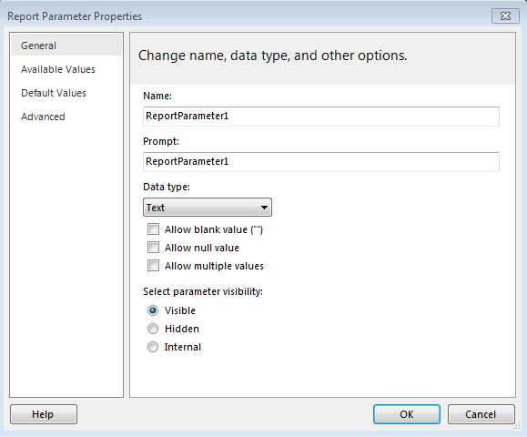
Data Type = Choose any of the following;
Text– User must type in Text
Boolean -The user selects True or False from a radio button.
Date/Time -The user selects a date from a calendar control
Integer -The user types values in a text box.
Float -The user types values in a text box.
Allow Blank Values - Select this option if the value of the parameter can be an empty string or a blank.
Allow Null Values - Choose this option if the value of the parameter can be a null.
Allow Multiple Values - Provide available values to create a drop-down list that your users can choose from, this is a good way to ensure that only valid values are used in the dataset query.

Select parameter visibility
Visible - Select this option to display the report parameter at the top of the report when it is run. This option allows users to select parameter values at run time.
Hidden - Choose this option to hide the report parameter in the report when published
Internal - Choose this option to hide the report parameter. When the report is published, the report parameter can only be viewed in the report definition.

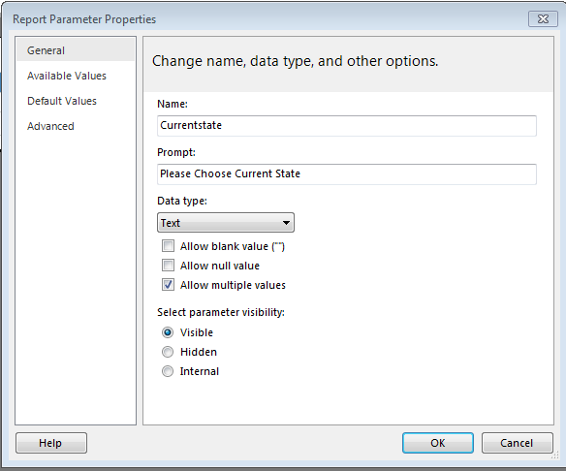
Available Values Page
To make sure a list of values is consistent among a report and subreports, you can set an option on the data source to use a single transaction for all queries in the datasets that are connected to a data source.
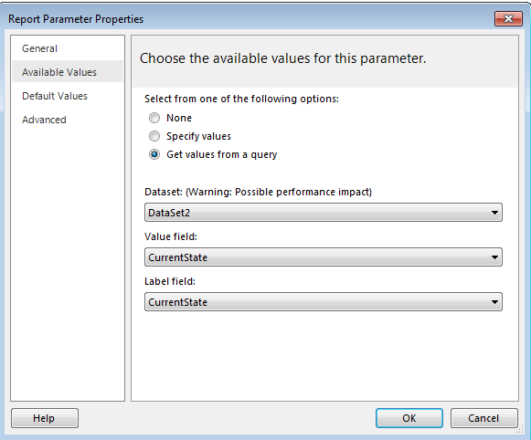

Set default values from a query or from a static list.
When each parameter has a default value, the report runs automatically on first view.
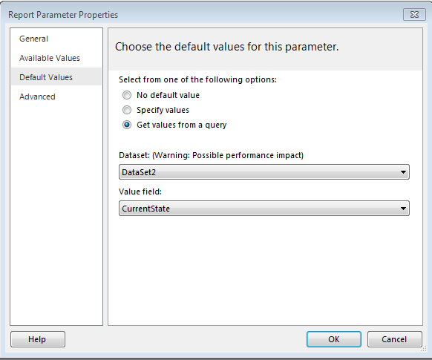
ADVANCED
Automatically determine when to refresh
Choose this option when you want the report processor to determine a setting for this value. The value is True if the report processor detects a dataset query with a direct or indirect reference to this parameter, or if the report has subreports.
Always refresh
Choose this option when the report parameter is used directly or indirectly in a dataset query or parameter expression. This option sets UsedInQuery to True.
Never refresh
Choose this option when the report parameter is not used directly or indirectly in a dataset query or parameter expression. This option sets UsedInQuery to False.
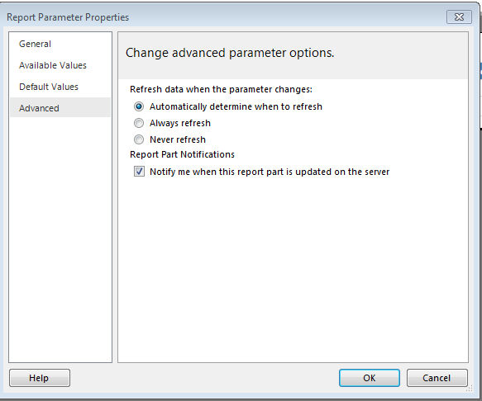

Here is the parameter pane in design view
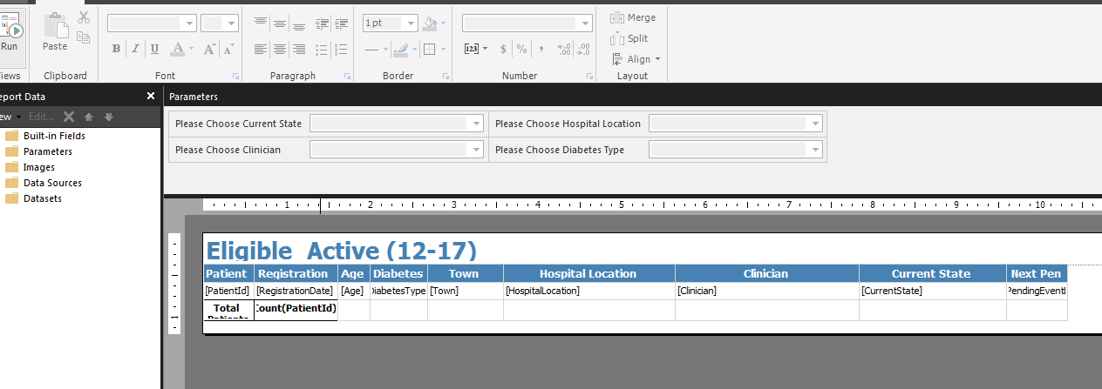
Here is the parameter pane once the report has been run
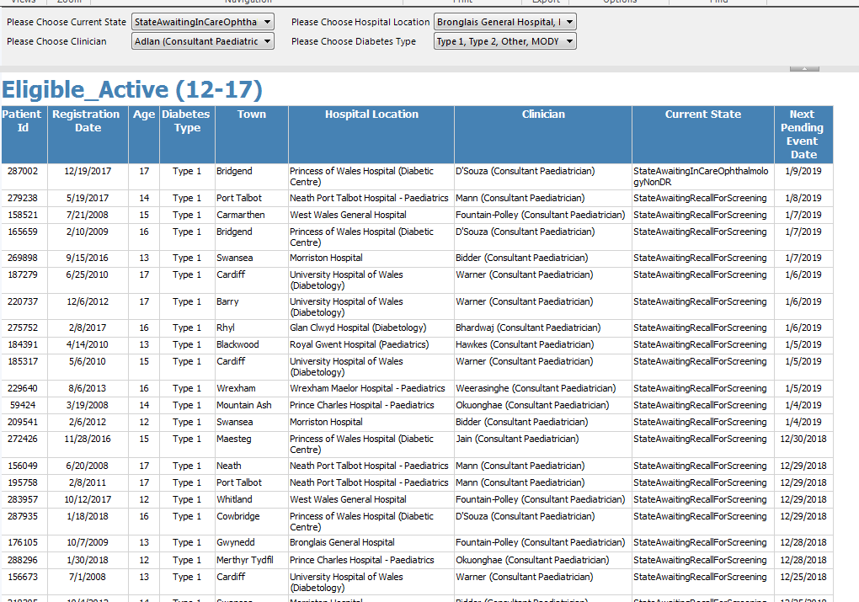

The first parameter ‘Please chose current state’ displays distinct states.
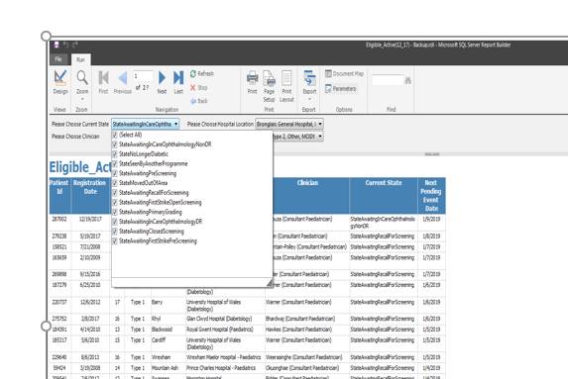
The second parameter asks ‘Please choose Hospital’
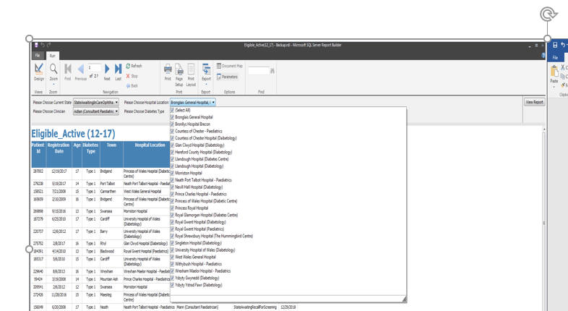

The third parameter is called ‘Please choose Clinician’.
Distinct Vales of Clinicians will be in the drop-down facility.
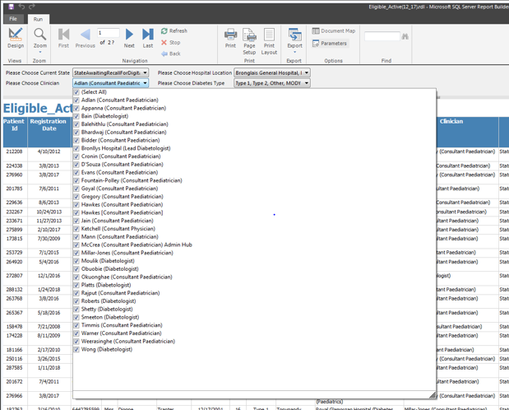
The fourth parameter is ‘Please choose Diabetes Type’.
Type 1 or Type 2, Other or MODY will be available in the drop-down box.
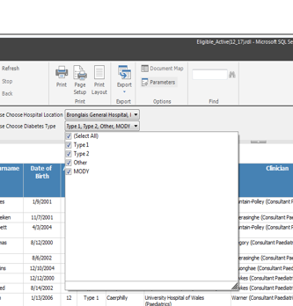
Once you have chosen your parameters Click View Report. 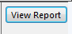
This will drill down your report to your parameter specifications.

5.8.2 SSRS Report Security
To follow the Information Governance guidelines within Public Health Wales, Security must be added to each SSRS report, only Staff / Managers who need to see the report will have access.
This can be divided into teams, departments or individuals.
Open the SQL Server Management Studio and click on Security then Logins
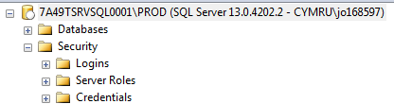
Here you can see the users who have access to SQL Servers and SSRS reports. In Public Health Wales, we use a unique NADEX Id as shown below.
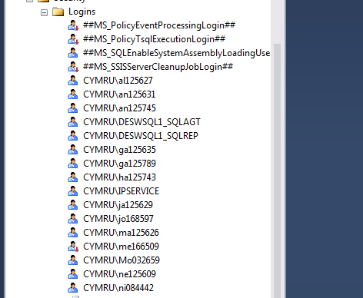
On the Reporting System, we can enforce more security and only allow specific users to view reports within certain folders thus following the Information Guidance rules.
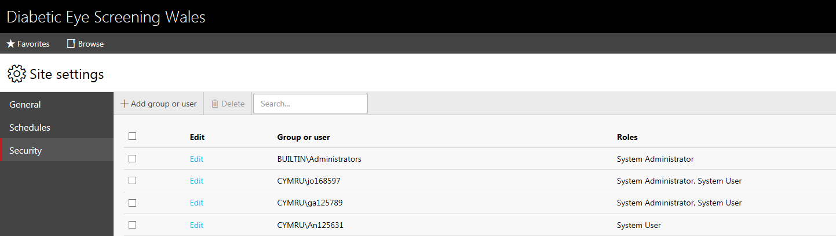

CHAPTER 6 GEOGRAPHICAL INFORMATION SYSTEM AND DEPRIVATION
The second part of the project is to investigate whether there is a link between Deprivation and the worst cases of Diabetes Retinopathy. (R3AM0) Proliferative retinopathy.
This is a current map of the DESW Clinics run around Wales.
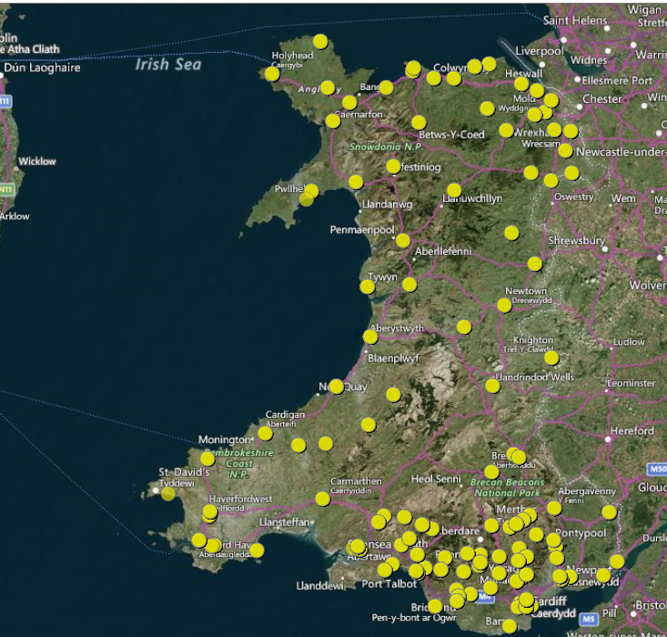
Diabetic Eye Screening Wales mapped clinics. There is also two mobile units which travel around to the rural areas and the more heavily populated areas.

Deprivation is strongly associated with higher levels of physical inactivity, unhealthy diet, smoking and poor blood pressure control. Deprivation is the result of a lack of income and other resources, which is collectively called living in poverty.

There are more cases of obesity recorded in disadvantaged communities and, it is continuing to rise. Being overweight increases the risk of chronic diseases such as cardiovascular disease and Diabetes.
As you can see from the maps below, from 2003-2005 there are no cases of BMI being over 25+.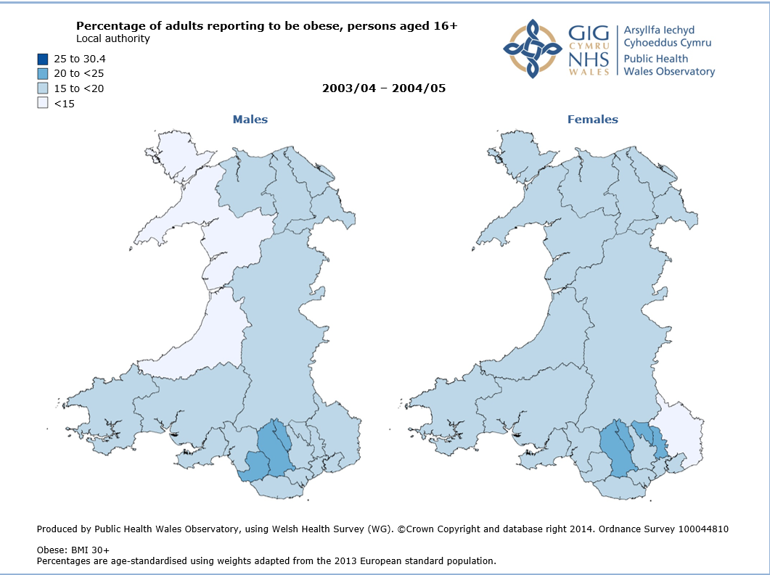
[FIG 11]

There has been a huge rise in Obesity in the highly populated areas from 2005 – 2011/12.
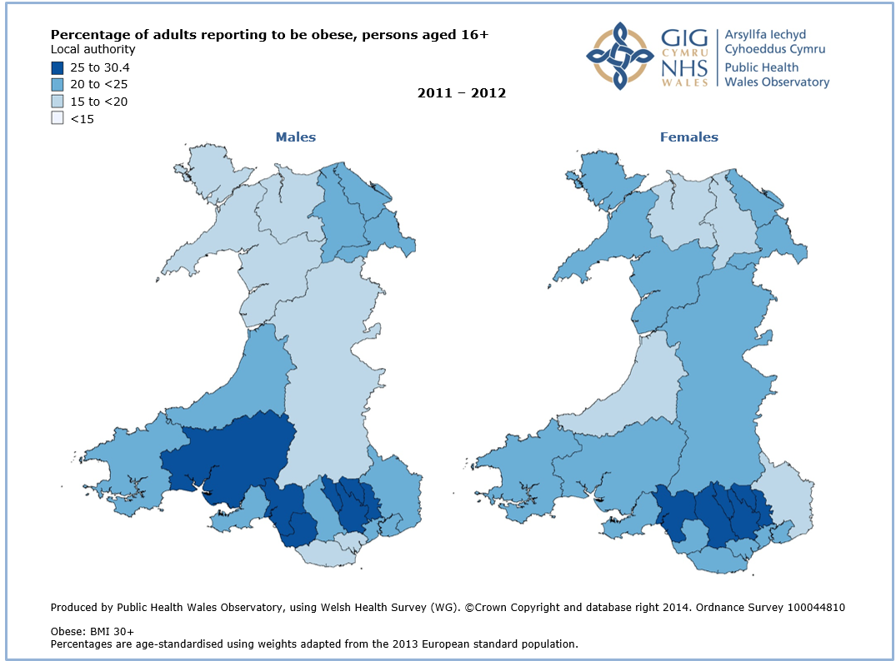
[FIG 12]
There are many ways to calculate Deprivation Scores and most were developed in the 1980’s.
Developed for Scotland by Carstairs and Morris .The Carstairs index is based on four census indicators:
- low social class,
- lack of car ownership
- overcrowding
- Male unemployment. [27]
In 1988 sociologist Peter Townsend first described the index as a measure of material deprivation within a population. The measure includes four variables,
- Unemployment (as a percentage of those aged 16 and over who are economically active);
- Non-car ownership (as a percentage of all households);
- Non-home ownership (as a percentage of all households);
- Household overcrowding.
When calculating the variables the greater the Townsend score the greater the level of deprivation. [28]
In Public Health departments and government organisations other deprivation measures such as WIMD (Wales) are often used instead.
To analyse the link between diabetes and deprivation we are using the Welsh Index of Multiple Deprivation (WIMD) 2014 data. Calculating measures of deprivation is one of the commonest uses of census data.
WIMD is the Welsh Government’s official measure of relative deprivation for small areas in Wales. It is designed to identify those small areas where there are the highest concentrations of multiple deprivation. [29]
WIMD is currently made up of eight separate types of deprivation. Each domain is produced from a range of different indicators.
- Income
- Employment
- Health
- Education
- Access to Services
- Community Safety
- Physical Environment
- Housing

WIMD is calculated for all Lower Layer Super Output Areas (LSOAs) in Wales. 1,909 LSOAs were defined in Wales with an average population of 1,600 people. [30]
1 being the most deprived and 1909 the least deprived.
Public Health Wales Observatory assists local and national partners by providing meaningful information to address public health issues, to improve health and health services and to reduce health inequalities.

We are using Map Info Professional 11.5 to collate the maps.
To plot the Map in MapInfo, we first need to extract the data from the SQL Optomize Databases.
An SQL query is designed to pull back all Welsh patients, who have had the Worst Graded Retinopathy outcomes. For this particular report only patients from 01/04/2013 onwards have been included.
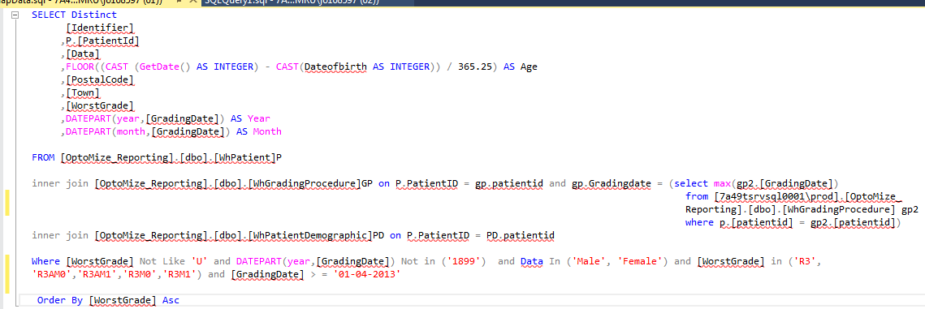
Once the SQL query has been run, below is the ouput, from this extract we can see the anonymised PatientID, SEX, *PostalCode, WorstGrade, Year, Month.
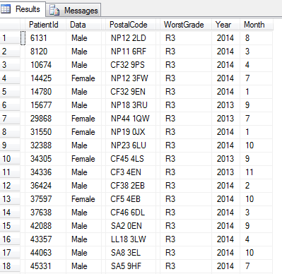*Random Postcodes have been added for Information Governance purposes.
To plot the data to the map, the data will be split by year and gender in excel spreadsheets.

The Deprivation map is located in the LSOA_2011 WalesCoast_Deprivation.TAB
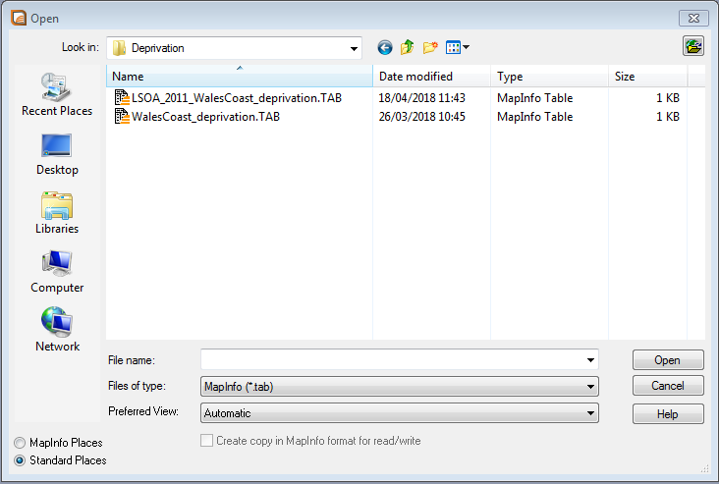

This is the Map of Wales, split Lower layer Super Outer Areas.
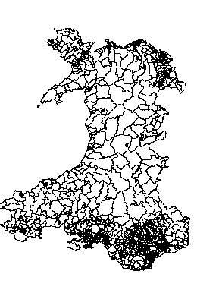
To add the Deprivation data we collected from WIMD, a thematic map must be created.

Select Map on the header bar and choose Create Thematic Map,
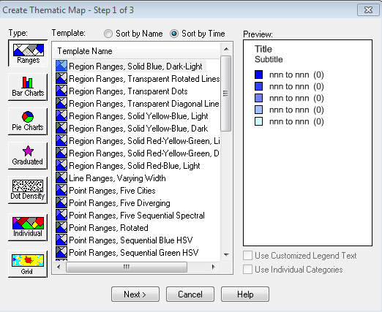
Connect the LSOA Map to the WIMD Data.
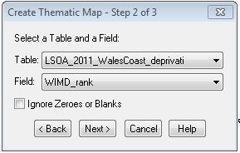
Map Info has calculated the deprivation figures from WIMD and plotted them into each LSOA.
Ranking them from least deprived to most deprived

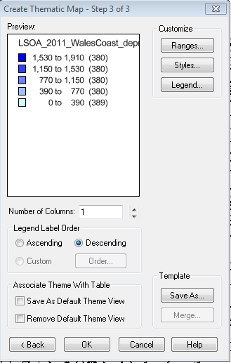
Derivation Map of Wales split by Layer Super Output Areas (LSOA)
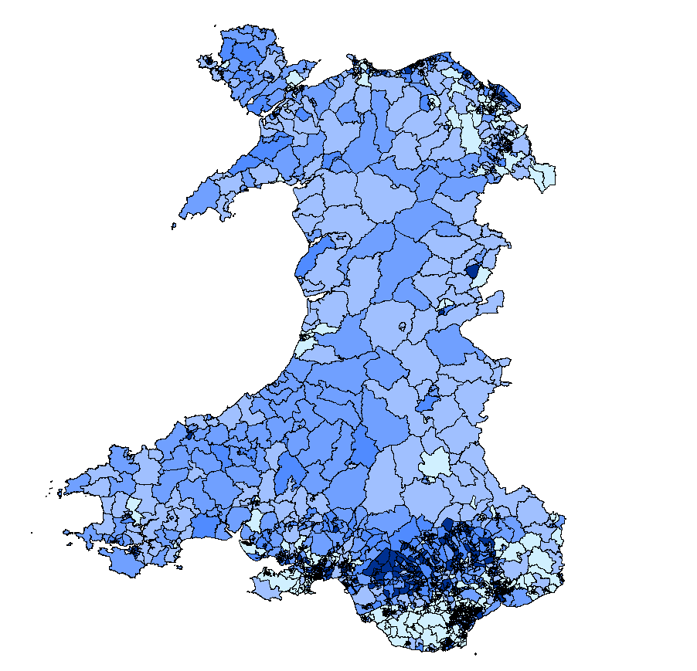
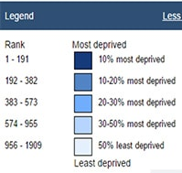
A zoomed in view shows high deprivation in certain areas North Wales. 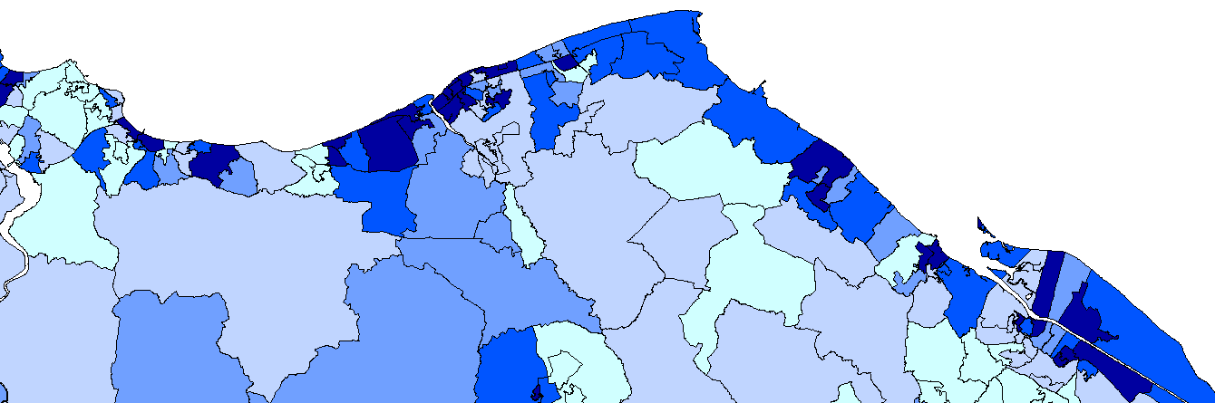
A zoomed in View shows high deprivation in certain areas South Wales, depicted by the darker area.
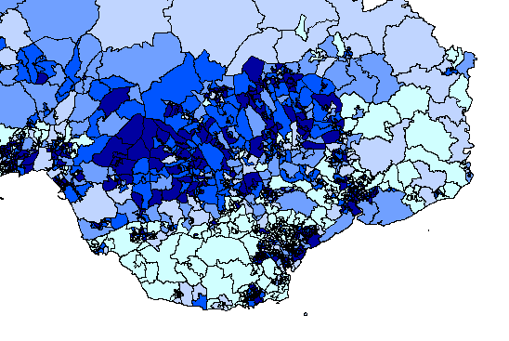

To add the data from Excel through Map info, choose OPEN
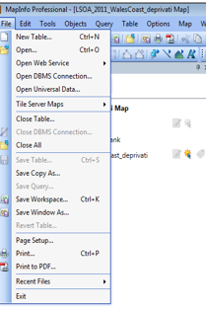
This will open all the Excel spreadsheets containing the SQL data split by year and sex.
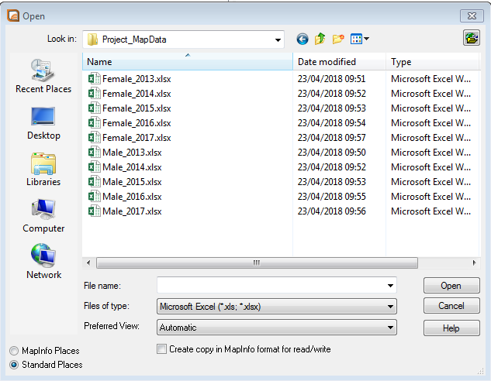
Make sure the Files of Type is Microsoft Excel.

Once the excel file has been chosen, pop up boxes will ask you for information about file.
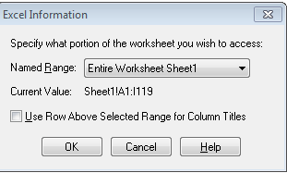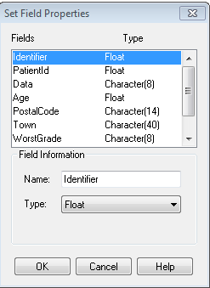
Click OK

The excel data is loaded into MapInfo.
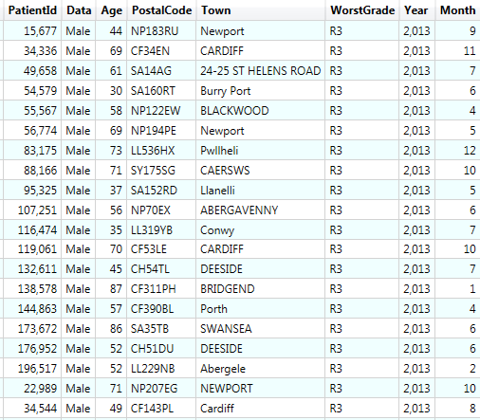
The excel data has to Geocoded
(Geocoding is the process of converting an address into spatial data and associating the exact geographical coordinates for that address).
We need to Geocode the patient’s postal code to place it on the Map.
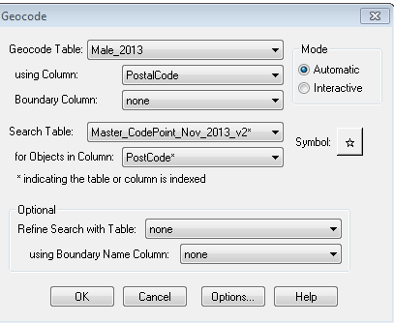
We link the excel table to a Master code point table already created
MapInfo tells us how many of the postcodes have successfully be geocoded.
The 1 that hasn’t been Geocoded is a data quality issue and will be looked at and geocoded separately.
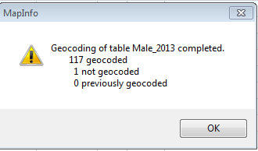
Once Geocoded the excel file now becomes a TAB file which can be added to MapInfo
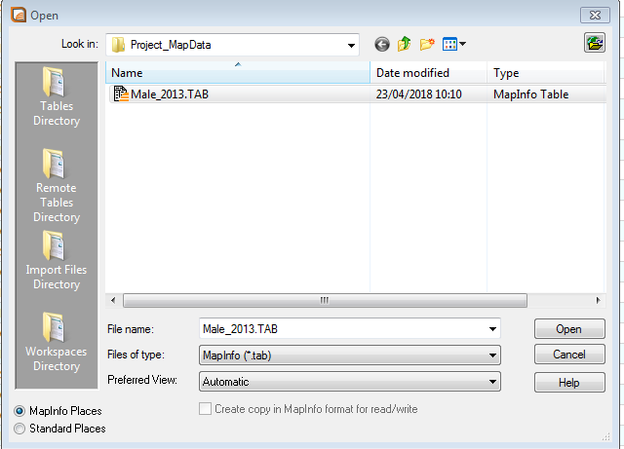
The tab file is now added to the MapInfo Layer control.
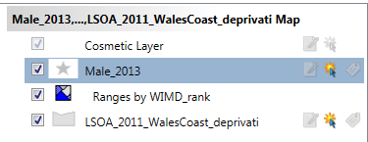
This Process must be repeated for all excel files that you want plotted on the Map.

You can already see the worst cases of Retinopathy amongst males and females are in the high deprivation areas.
MALE 2013 – 118 Patients FEMALE 2013 – 79 Patients
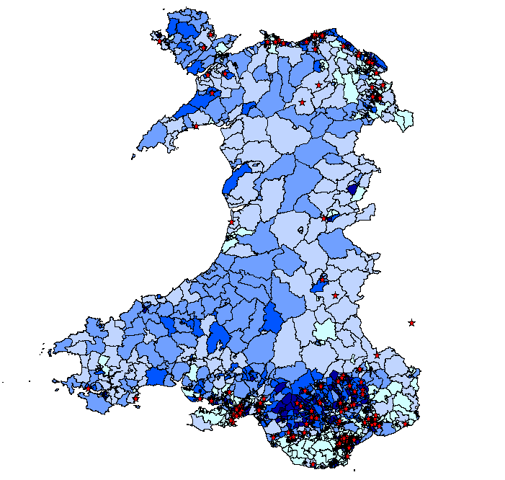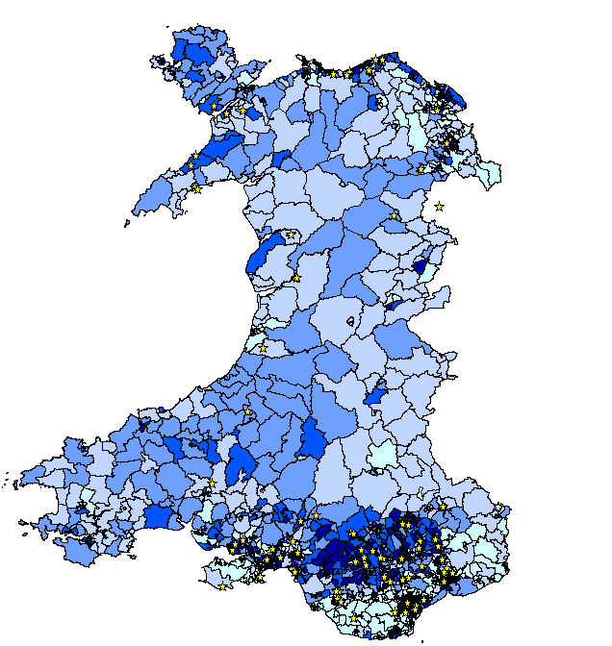

MALE 2014 – 200 Patients FEMALE 2014 – 93 Patients
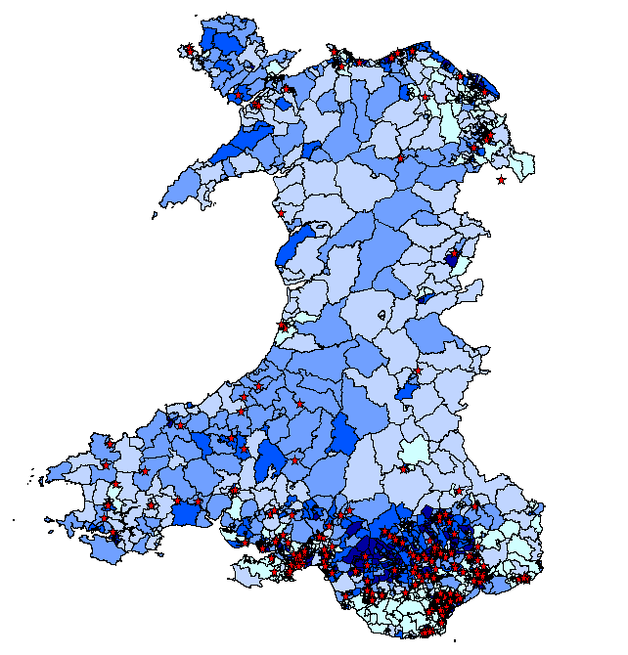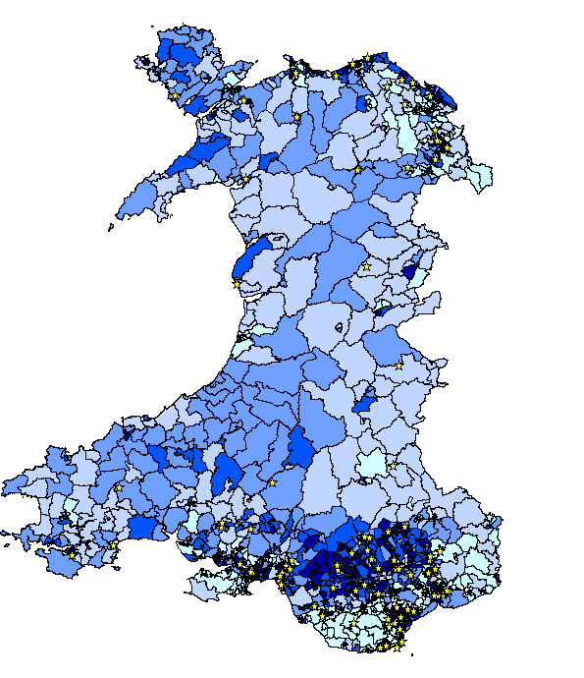
MALE 2015 – 173 Patients FEMALE 2015 – 92 Patients
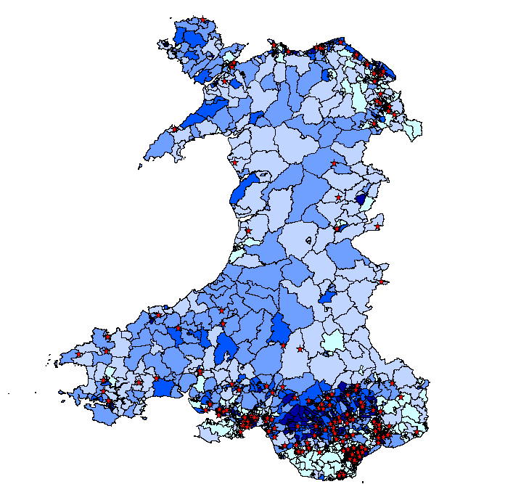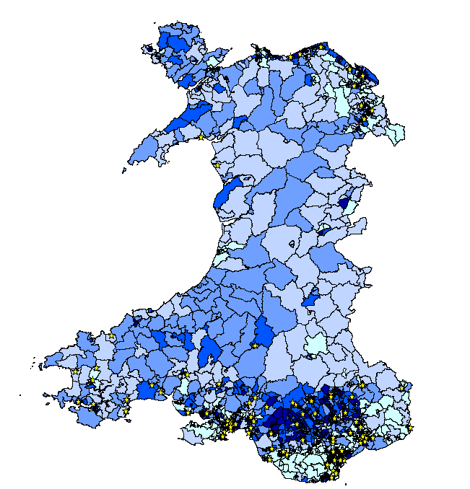

MALE 2016 – 392 Patients FEMALE 2016– 230 Patients
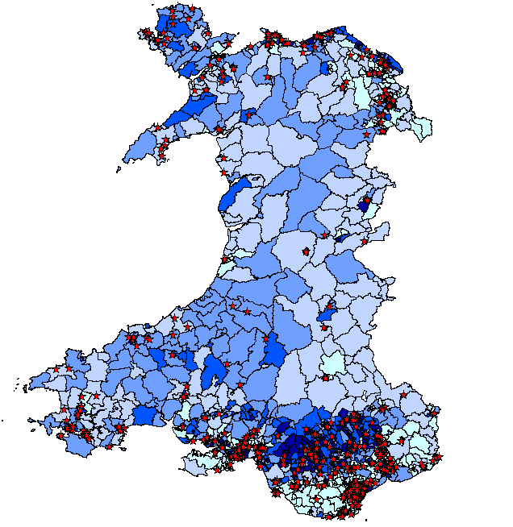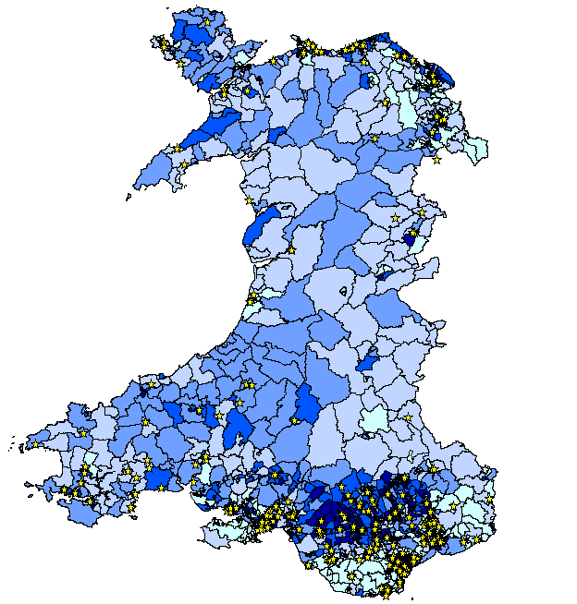
MALE 2017 – 536 Patients FEMALE 2017 – 251 Patients
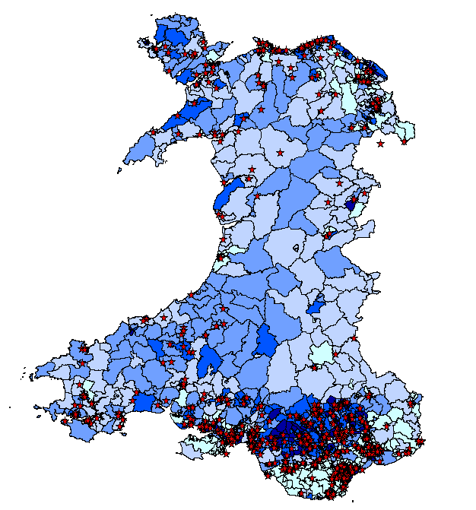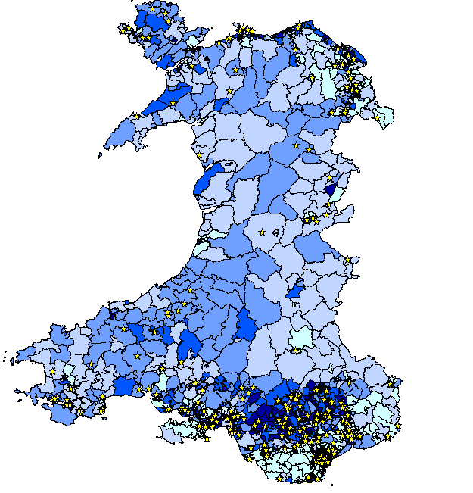
We can see from the patient data plotted on the maps that the worst cases of Retinopathy are increasing in the most deprived areas of Wales, which agrees with the Epidemiology & Community Health research report. [30]

CHAPTER 7 TABLEAU
Tableau is a Business Intelligence Tool used for data visualization. The software allows the development of interactive dashboards and worksheets to be discussed by the Public Health Executive Board. [31]
Tableau server provides a centralized location to manage all of the organization’s published data sources. You can, change permissions, add tags, delete and manage schedules in one area. Scheduling extracts and refreshes are relatively easy in tableau.
Key Performance Indicators (KPI) is a measurement of performance that will evaluate the success of Diabetic Eye Screening Wales.
Key Performance indicators must be;
- Well-defined and quantifiable.
- Communicated throughout your company and relevant department.
- Crucial to achieving your goal.
- Applicable to your Business.
Prior to Public Health Wales taking over Diabetic Eye Screening Wales the service had no measures of performance.
Service Performance Activity Reports (SPARs) have been developed to monitor the performance against agreed standards.
KPI s should be able to provide a clear snapshot of the current levels of performance. [32]
Tableau connects to any data source, it could be a Data Warehouse, Microsoft Excel or Microsoft SQL Server.
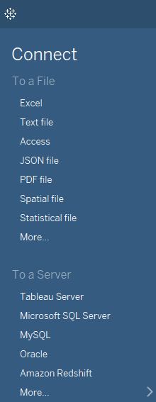
Here we have connected to our SQL server database where the SPAR data is stored.
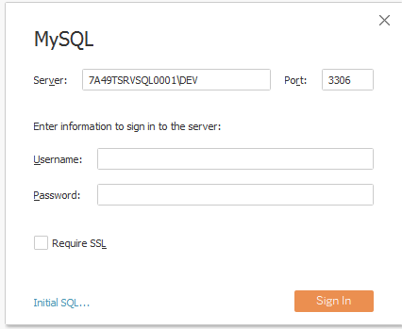
The SQL Data which generates the SPAR Data
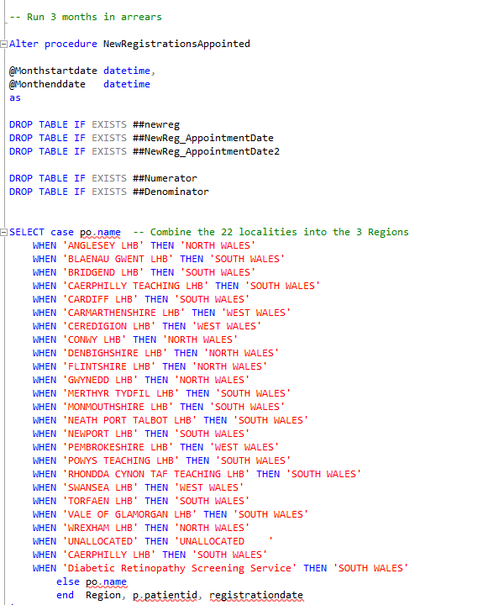
Connecting the data to Tableau
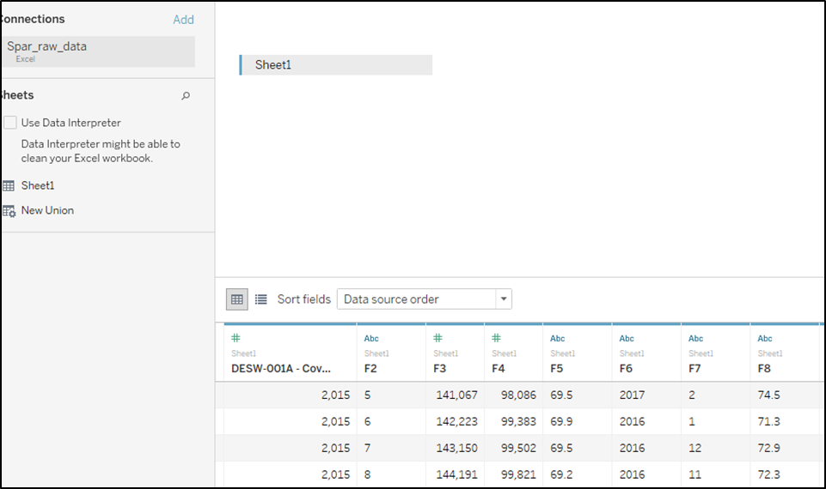

Click onto Sheet 1 and add your data from the data source.
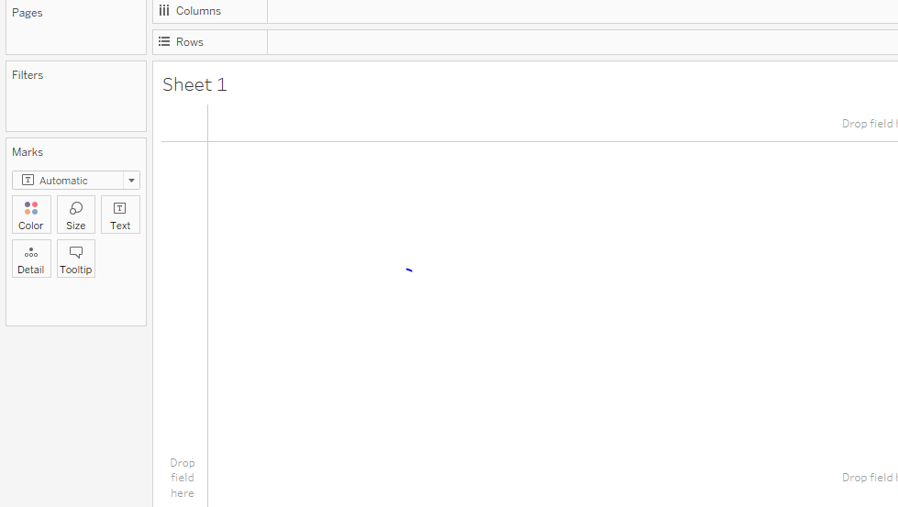
There are many varieties of maps available in Tableau
Choose the type of Map you want to create.
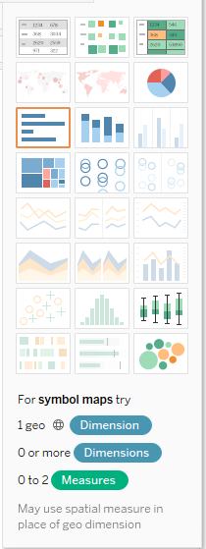
Once you are happy with the maps, create your dashboard.
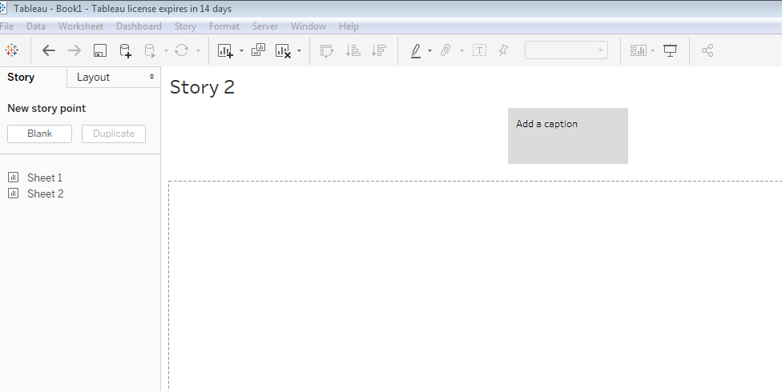
The Criteria for the SPARs are;
Referrals to Hospital Eye Service (R3A- Worst case of Retinopathy): % of eligible active patients with a positive screening result in one or both eyes referred to Hospital Eye Services within two weeks of the screen date.
The standard for Referral to Hospital Eye Service is >=95%
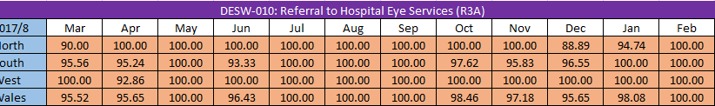
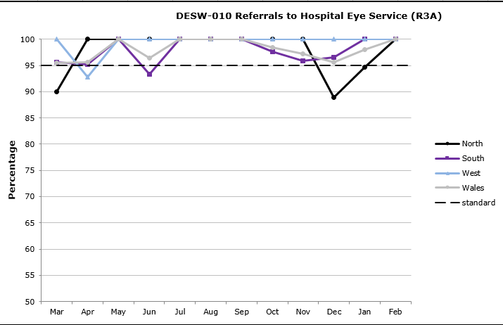
As you can see from the graph and Excel data, DESW are hitting the 95% standard for most months.
There was a slight dip in the North data in December and will be investigated.
Digital Surveillance Recall (3 month follow up): % of patients on digital surveillance who have been offered an appointment within 10% of their follow up period 3 months: +/- 1 week

The standard for Digital Surveillance Recall is >=95%.
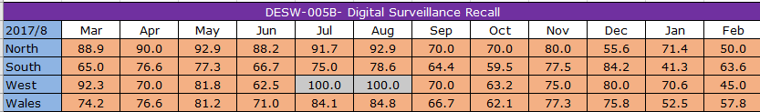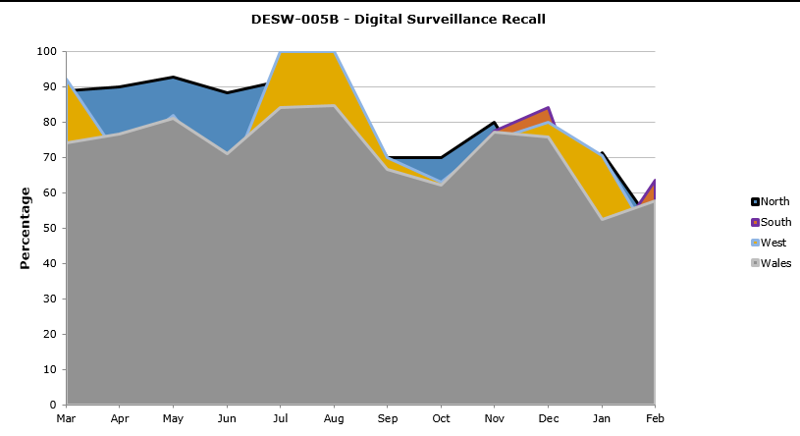
DESW are well below hitting the 95% standard.

New Registrations Appointed: % of eligible patients newly registered with DESW are offered a screening appointment within 90 days

The standard for New Registrations appointed is >=80%
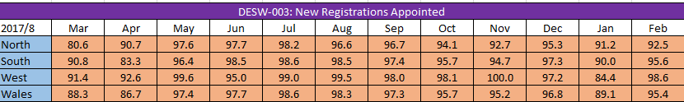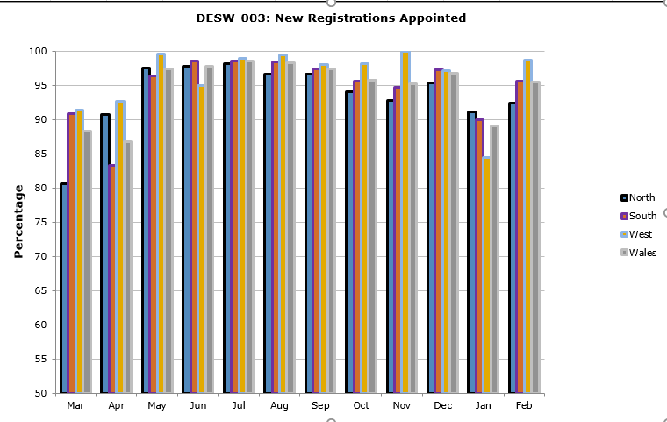
DESW are consistently hitting the standard of >= 80% most months.
12 Month Recall: % of patients offered 12 months recall appt. +/- 6 weeks
The standard for 12 Month recall >= 95%
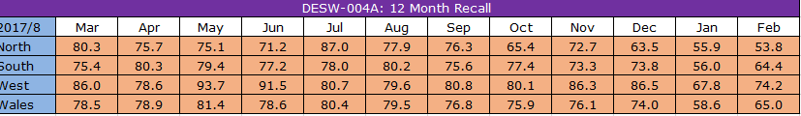
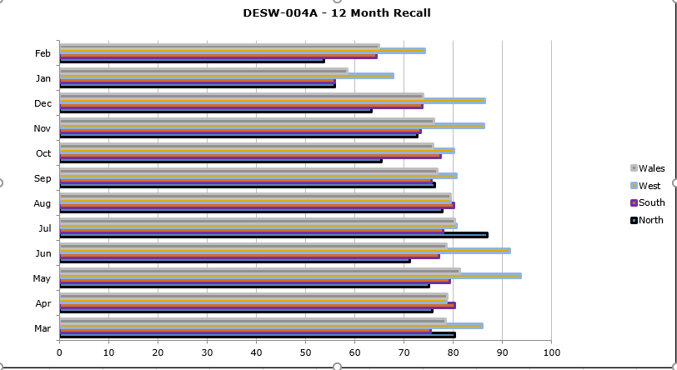
As you can see from the data, Diabetic eye Screening Wales is nowhere near hitting the 95% target of inviting patients on a 12 month recall for their screening appointment.
That is why there is an urgent need to cleanse the data in the Optomize database.
Deceased and Moved out of area patients still being invited for screening appointments, and the reasoning for moving to risk-based screening discussed in Chapter 8 Further Work.
SPAR DASHBOARD
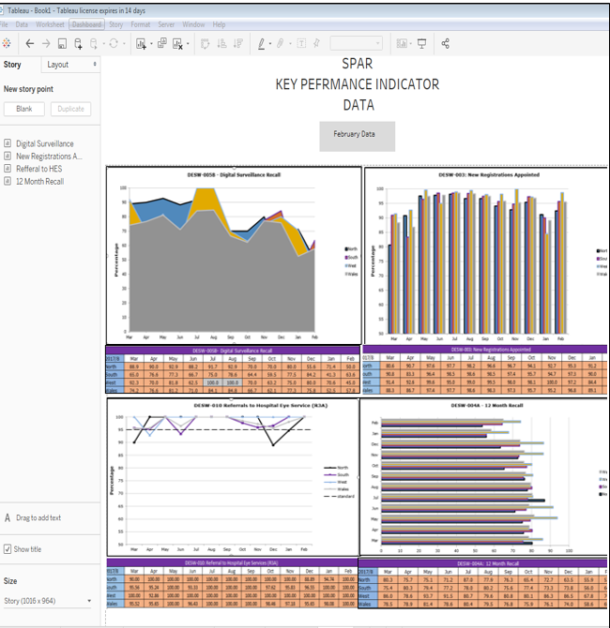

CHAPTER 8 FURTHER WORK

Although the Diabetic Eye Screening Service will continue to grow and develop for many years, there are still many improvements and advances to be made.
Hopefully future work can be implemented to further improve the project and develop the SSRS reports and the Failsafe process further.
1. The Optomize database currently in use is not fit for purpose in Wales it was been built to satisfy the English Diabetic Screening Programmes.
At Diabetic Eye Screening Wales, we have had to change our Grading Protocol to fit in with the Optomize system, which has meant missing the granularity of our grading on background Retinopathy.
E.g. The Welsh Grading standard code Retinopathy as
R01
-R01.1
-R01.2
R01

The English Grading standard code Retinopathy as
R01
R02
They lose the R01.1 and R01.2, which are important, as these grades need more care and need to be monitored more closely.

In addition, the built-in reports reflected in Optomize do not meet with the Welsh standards and definitions.
A new system needs to be developed from the ground up with heavy involvement from daily users and the IT Manager and team. This will give DESW the opportunity to meet the Welsh standards and definitions, and to give the grading team back the granularity when coding Retinopathy.
2. Build a SQL Server Database purely for SSRS reports, the current SQL Server that the SSRS reports are stored on, is also used for all adhoc requests, Spar Data and old legacy reports are still stored on there.
For ease of use, to find potential problems and to limit access to staff who can create, update and maintain these reports a stand-alone SQL Database is required as the need for more reports will continue as the service grows and more analysis is required to improve.

3. As Information Technology advances there are many new, sharper, quicker and easier ways of programming and displaying data .‘R’ is quickly replacing SSRS reports and is a more efficient software.
4. Risk based screening
Research started in 2014 studied the progression of retinal changes with a view of making informed decisions about the length of time patients should be recalled for an eye screening appointment.
This research for risk-based screening makes a compelling clinical case to appoint low-risk patients every two years, rather than the existing one-year recall.
A low-risk is defined as a patient whose last two screening encounters were either:
- For routine digital screening
- Final graded as R0M0
- Separated by at least one year of time.

Based on the Recommendation of The UKNSC recommends the following modification to the Diabetic Eye Screening Programme.

- To extend screening intervals from one year to two years in patients at low risk of developing sight-threatening retinopathy.
- People at high risk of sight loss will receive the current screening interval.
The study was the largest of its kind ever undertaken. In total 354,549 patients were observed for up to 4 years during which 16,196 patients progressed to referable retinopathy:

- patients with no retinopathy in either eye less than 0.3% progressed to either referable retinopathy or proliferative retinopathy (treatable eye disease) during a two-year period in which there were two successive annual screening episodes

- patients with bilateral background retinopathy 13 – 29% progressed to referable retinopathy and up to 4% progressed to proliferative retinopathy (treatable eye disease) in a two-year period in which there were two successive annual screening episodes.

- patients with no diabetic retinopathy at baseline a small proportion, 0.4% to 1.3%, progressed to referable retinopathy in a two-year period in which there were two annual screening episodes.

The outcome of the study indicated that it may be possible to stratify patients into groups at high and low for risk of progression to both referable retinopathy and proliferative retinopathy, according to baseline retinal criteria. [33]
Robust data and IT processes in place to ensure the safe identification and management of patients along a pathway.

CHAPTER 9 EVALUATION AND CONCLUSION

Having now reached the end of the project there is now a completed Failsafe Process in place. The project has run smoothly with the SSRS Reports being developed ahead of schedule. The delivered SSRS Reports are fit for purpose and are being used daily to make sure all eligible Diabetic patients are placed on the correct pathway and being recalled for their next screening appointment in a timely manner.

The GIS Maps have been welcomed by The Grading Manager in Diabetic Eye Screening Wales, He has requested more information mapping information to be produced for different cohorts of patients to examine trends. The Admin department have also taken an interest in the Mapping Facility and would like the clinics mapped separated by Local Health Board, so the admin staff can book appointments easier.

The Tableau Key Performance Indicators have now been submitted to The Public Health Wales Executive Board for the first time in April 2018, there is no feedback at present.

One of the main drivers in the success of this project was the communication at the monthly meetings. Having the correct people at the meetings was crucial to gaining an understanding of what information was to be included and the relevance the data has to the patients on the SSRS reports being developed. Developing good communication skills with stakeholders is sometimes overlooked when designing technical processes.

Instead of using Townsend Data, which was the original choice for deprivation, The Welsh Index of Multiple Deprivation (WIMD) 2014 was chosen. It is widely used in Public Health Wales, and easily accessible. Previous creation of a Townsend index while in University, proved quite lengthy and complicated.

CHAPTER 10 – REFLECTION
On reflection, I believe the project has met all its objectives and aims originally proposed. The project was a lot more work than first anticipated and because it was a work-based project the success of the project benefited actual eligible Diabetic Patients. Therefore, ensuring the data quality and the schedule of the project running to time was essential.
My SQL programming, Map-info, Tableau and SSRS reporting skills were relatively new, the project tested my knowledge and I believe my skills have hugely developed since the beginning of the project.
I have thoroughly enjoyed researching and developing this project. If I had to do it again I wouldn’t approach it any diﬀerently.
SSRS Reports

The process before the SSRS reports heavily relied on paper as a recording medium for outcomes. A cohort of patients was chosen, from the ‘advanced report – state history’ function within Optomize, the data would then be exported to an Excel spreadsheet which would be further filtered/sorted or by using the appointment management page in Optomize, selection was made by various drop-down boxes to create a specific cohort to audit.

This process was exceedingly labour intensive with the worksheet placed onto the all-share drive which had no security settings and could be viewed, edited and deleted by any member of staff, not meeting the Information Governance Guidelines.
The development/inclusion of SSRS enabled certain cohorts to be easily identified, monitored more closely and most importantly updated daily. Each SSRS Report was bespoke for each cohort through development and can be accessed by authorised users and therefore not reliant on any one individual.
Throughout the project I designed and developed 10 SSRS reports which has greatly helped the Failsafe Officer and supported the Failsafe Process and the service is already seeing significant reduction of numbers on specific lists.
I have introduced new technology to the service such as the Business Intelligence Tool Tableau to monitor and view the Key Performance Indicators.

GIS

I enjoyed the GIS aspect of the project I would like to investigate other projects such as researching to see if there is a link between Ethnicity and Deprivation. I believe that mapping and spatial analysis is not explored enough throughout Public Health Wales, it is a fantastic visual tool and has been well received in Diabetic Eye Screening Wales.

Tableau

I feel Tableau has so much more to offer to the service, in the short time of the project I believe I only scratched the surface on what Tableau can do to support Diabetic Eye Screening. If received well for in the Executive Board meetings, plans are being put in place to develop more Key Performance Indicators in the future.

10.1 LIST OF FIGURES
Website links were accessed between October 2017 and April 2018
Fig [1] www.diabeticretinopathy.org. http://www.diabeticretinopathy.org.uk/pregnancy.htm.[Online] Last accessed 10/11/2018
Fig [2] Diagram of how SRRS reports connect to a SQL Database.https://www.red-gate.com/simple-talk/sql/reporting-services/sql-server-reporting-services-basics-building-ssrs-reports. [Online] Last Accessed 08/11/2017

Fig [3] English Failsafe Diagram. https://www.gov.uk/government/publications/diabetic-eye-screening-programme-failsafe-procedures. [Online] Last Accessed 22/04/2018
Fig [4],[5],[6],[7],[8],[9],[10].https://www.gov.uk/government/uploads/system/uploads/attachment_data/file/395669/Failsafe_Desp_V1_1_Final_190913.pdf. [Online] Last Accessed 30/10/2017
Fig [11] Percentage of adults reporting to be Obese, persons aged 16+ 2003/4 – 2004 /5. www2.nphs.wales.nhs.uk:8080/PubHObservatoryProjDocs. [Online] Last Accessed 12/11/2017

Fig [12] Percentage of adults reporting to be obese, persons aged 16+ 2011 -2012. www2.nphs.wales.nhs.uk:8080/PubHObservatoryProjDocs. [Online] Last Accessed 12/11/2017

10. 2 REFERENCES
[1] National Eye Institute. Diabetic Retinopathy.HTTPs://nei.nih.gov/health/diabetic/retinopathy.[Online] Last accessed 17/04/2018
[2] Health line Media UK Ltd. https://www.medicalnewstoday.com/articles/183417.php. Reviewed by Daniel Murrell, MD. [Online] Last Accessed 17/04/2018.
[3] Social | well-being Assessment.http://wellbeingsite.dns-systems.net/index.php/en/social/.
[Online] Last Accessed 17/04/2018.

[4] Failsafe-NHS Diabetic Eye Screening Programme Version 1.1
https://assets.publishing.service.gov.uk/government/uploads/system/uploads/attachment_data/file/395669/Failsafe. [Online] Last Accessed 17/04/2018.

[5] Information Governance. https://en.wikipedia.org / [Online] Last accessed 30/03/2018
[6] Data Protection Act. https://www.gov.uk/data-protection. [Online] Last accessed 30/03/2018
[7] Calidcott Report -https://en.wikipedia.org/wiki/Caldicott_Report [Online] Last Accessed-10/11/2017
[8] Common Law of Confidentiality- https://www.health-ni.gov.uk/articles/common-law-duty-confidentiality [Online] Last Accessed -10/11/2017
[9] Freedom of Information Act. https://www.legislation.gov.uk/ [Online] Last accessed 01/04/2018
[10] Information Sharing Protocols. https://www.fifedirect.org.uk/topics/index.cfm. [Online] Last accessed 09/04/2018
[11] Information Assurance -https://en.wikipedia.org/wiki/Information assurance [Online] Last Accessed -10/11/2017
[12] Records management - www.nationalarchives.gov.uk/documents/...management/rm-code-guide1.pdf [Online] last Accessed - 10/11/2017
[13] What is the Diabetic Eye Screening Wales (DESW) Service? http://www.eyecare.wales.nhs.uk/drssw. [Online] last reviewed: 12/07/2016
[14] Diabetic Retinopathy Screening Services Wales (DRSSW) Project. Paper reference 30 06.http://www2.nphs.wales.nhs.uk:8080/phwpapersdocs.nsf/.[Online] last Accessed - 12/12/2017
[15] Diabetic Retinopathy screening .https://www.nhs.uk/conditions/diabetic-eye-screening. Page last reviewed: 12/07/2016.[Online] Last Accessed - 01/13/2018
[16] Diabetic eye screening in pregnancy. https://www.nhs.uk/Conditions/diabetic-eye-screening/#diabetic-eye-screening-in-pregnancy [Online] Last accessed 22/04/2018.
[17] The Failsafe Process https://www.gov.uk/government/uploads/system/uploads/attachment_data/file/395669/Failsafe_Desp_V1_1_Final_190913.pdf [Online] last Accessed -10/11/2017
[18] EMIS Optomize Database. https://www.digitalmarketplace.service.gov.uk/g-cloud/services/949819182037236 [Online]. Last accessed 27/11/2017.
[19] EMIS Health. www.EMIS Optomize Database. [Online] last accessed 27/11/2017.

[20] Diabetes diagnoses have more than doubled in 20 years. www.theguardian.com/society/2018/feb/27/[Online] Last accessed 27/11/2017.
[21] Diabetic Eye Screening Wales – move to Public Health Wales on 1 April 2016. [Thursday, 31 March 2016] http://www.wales.nhs.uk/sitesplus/888/news/40956 [Online]. Last Accessed 01/04/2018
[22] SQL (Structured Query Language). Posted by: Margaret Rouse https://searchsqlserver.techtarget.com/definition/SQL. [Online] Last accessed 27/03/2018.
[23] Managing permissions in SQL Server Reporting Services https://searchsqlserver.techtarget.com/tip/Managing-permissions-in-SQL-Server-Reporting-Services [Online] Last accessed.21/04/2018.
[24] What is GIS? Geographical Information Systems. https://www.esri.com/en-us/what-is-gis/overview. [Online] Last accessed.17/04/2018.
[25] MapInfo- Pitney Bowes. https://www.pitneybowes.com. [Online] last accessed 27/03/2018.
[26] Tableau Software: Business Intelligence and Analytics. https://www.tableau.com/[Online] Last accessed 10/04/2018.
[27] Health and Deprivation: Inequality and the North. Routledge, London. https://en.wikipedia.org/wiki/Townsend_deprivation_index.Townsend, P., Phillimore, P. and Beattie, A. (1988) Health and Deprivation: Inequality and the North. Routledge, London. [Online] Last accessed 20/04/2018.
[28] GPD Support, Deprivation.http://www.isdscotland.org/products-and-Services/GPD-Support/deprivation/carstairs. . [Online] Last accessed 19/04/2018.
[29] Welsh Index of Multiple Deprivation (WIMD) 2014. http://gov.wales/docs/statistics/2015/150812-wimd-2014-revised-en.pdf. [Online] Last accessed 20/04/2018.
[30] Diabetes prevalence and socioeconomic status: a population-based study showing increased prevalence of type 2 diabetes mellitus in deprived areas. By V Connollya, N Unwinb, P Sherriffa, R Bilousa, W Kellya http://jech.bmj.com/content/54/3/173.long. [Online] Last accessed 10/02/2018.

[31] Tableau-https://www.tableau.com/trial/tableau-software.[Online] Last accessed 03/02/2018.
[32] What is a KPI? https://www.klipfolio.com/resources/articles/what-is-a-key-performance-indicator. [Online] Last accessed 05/04/2018.
[33] Extending diabetic eye screening intervals for people at low risk of developing sight threatening retinopathy: https://legacyscreening.phe.org.uk [Online]. Last accessed 10/02/2018.

Appendix 1 – List of Priorities

Appendix 2 – Deceased SQL Script

Appendix 3 _ Moved out of Area Script

Appendix 4 – Post Office Returns Script

Appendix 1 –List of Priorities
FIRST PRIORITY are StateAwaitingPreScreening
'StateAwaitingDigitalSurveillancePreScreening',
'StateAwaitingDNAPreScreening',
'StateAwaitingDNAPreScreening2ndChance',
'StateAwaitingFirstStrikeDigitalSurveillancePreScreening',
'StateAwaitingFirstStrikePreScreening',
'StateAwaitingPreScreening',
'StateAwaitingSecondStrikePreScreening'
'StateAwaitingSlitLampPreScreening'
SECOND PRIORITY are State Awaiting Screening (awaiting to be appointed)
'StateAwaitingClosedDigitalSurveillanceScreening',
'StateAwaitingClosedScreening',
'StateAwaitingDNAScreening',
'StateAwaitingDNAScreening2ndChance',
'StateAwaitingFirstStrikeClosedScreening',
'StateAwaitingFirstStrikeOpenDigitalSurveillanceScreening',
'StateAwaitingFirstStrikeOpenScreening',
'StateAwaitingOpenScreening',
'StateAwaitingOpenSlitLampScreening',
'StateAwaitingScreening',
'StateAwaitingSecondStrikeOpenScreening',
'StateImported'
THIRD PRIORITY are State Awaiting Grading or Triage or Photography etc
'StateAlreadyCaredFor',
'StateAwaitingArbitrationGrading',
'StateAwaitingArbitrationGradingSelection',
'StateAwaitingArbitrationTriage',
'StateAwaitingDigitalSurveillancePhotography',
'StateAwaitingDigitalSurveillanceTriage',
'StateAwaitingFirstStrikeDigitalSurveillancePhotography',
'StateAwaitingFirstStrikePhotography',
'StateAwaitingInCareOphthalmologyDischargeROGGrading',
'StateAwaitingInCareOphthalmologyDischargeROGGradingSelection',
'StateAwaitingInCareOphthalmologyDR',
'StateAwaitingInCareOphthalmologyNonDR',
'StateAwaitingOphthalmologyResults',
'StateAwaitingPhotography',
'StateAwaitingPrimaryDigitalSurveillanceGrading',
'StateAwaitingPrimaryDigitalSurveillanceGradingSelection',
'StateAwaitingPrimaryGrading',
'StateAwaitingPrimaryGradingSelection',
'StateAwaitingRecallForDigitalSurveillanceScreening',
'StateAwaitingRecallForScreening',
'StateAwaitingReferralOutcomeGrading',
'StateAwaitingReferralOutcomeGradingSelection',
'StateAwaitingSecondaryDigitalSurveillanceGrading',
'StateAwaitingSecondaryDigitalSurveillanceGradingSelection',
'StateAwaitingSecondaryGrading',
'StateAwaitingSecondaryGradingSelection',
'StateAwaitingSecondStrikePhotography',
'StateAwaitingTertiaryDigitalSurveillanceGrading',
'StateAwaitingTertiaryDigitalSurveillanceGradingSelection',
'StateAwaitingTriage',
'StateDigitalSurveillanceScreeningPostponed',
'StateInCareOphthalmology',
'StateInCareOphthalmologyAwaitingSelection'
FOURTH PRIORITY
'StateNew',
'StatePOReturn',
'StateScreeningPostponed',
'StateScreeningRefused',
'StateTempLearningOrMentalDisability',
'StateTemporarilyOutOfPathway',
'StateTempPhysicalDisability',
'StateUnder12'
FIFTH PRIORITY
'StateDeceased',
'StateDischarged',
'StateMedicallyUnfit',
'StateMedicallyUnfitDigitalSurveillance',
'StateMovedOutOfArea',
'StateNoCurrentGP',
'StateNoLongerDiabetic',
'StateNPLBothEyes',
'StateOptedOut',
'StateOptedOutDigitalSurveillance',
'StatePermLearningOrMentalDisability',
'StatePermPhysicalDisability',
'StatePersistentDNA',
'StateRefusedDemogTransferButPreviouslyScreened',
'StateRegisteredBlind',
'StateSeenByAnotherProgramme',
Appendix 2 –Deceased Patients
Use OptoMize_Reporting
--DECEASED
--last run 05/09/2017

--FIRST PRIORITY are StateAwaitingPreScreening (so have already been sent an appt and were due to attend
--soon so don't continue to be booked im a clinic and DESW don't deal with them as DNA and send a DNA Letter)
select r.Public Health Walesreg as Identifier, r.forename1 as Forename, r.forename2 as Forename2, r.surname as Surname,
r.dob as Date_of_Birth, r.DeathDate as Date_Deceased, A.[addrline1] AS PreviousAddress1, a.[addrline2]AS PreviousAddress2, a.[addrline3]AS PreviousAddress3, a.[addrline4]AS PreviousAddress4, a.[addrline5] AS PreviousAddress5, CurrentstateID as Current_State,
( select top 1 startdate from [dbo].[whappointment] where patientid = s.patientid order by startdate desc) as latest_Appointment, [From] as Date_Entered_Current_state
from dbo.WhPatient p
left outer join dbo.WhStateTransition s on p.StateId=s.Id --monitors status (on pathway)
-- Will need to convert to using live state table when Claire has access from CQ2
left outer join [rytwgsrvsqlinf1\scrdata].RegistrationData.dbo.RD_regded r on p.Identifier=r.Public Health Walesreg
left outer join [rytwgsrvsqlinf1\scrdata].RegistrationData.dbo.RD_addrded a on p.Identifier=a.Public Health Walesaddr
left outer join [rytwgsrvsqlinf1\scrdata].RegistrationData.dbo.RD_reglive rl on p.Identifier=rl.Public Health Walesreg --need to include reglive as sometimes person incorrectly have a deceased date and are in regded as well as reglive
where s.IsCurrent=1 and s.CurrentStateId != 'StateDeceased' --1 is latest state (all previous states are 0), not identified as Deceased
and p.IdentifierKind in
('PUBLIC HEALTH WALESNumber',
'Hospital Number',
'Previous PUBLIC HEALTH WALESNumber',
'Temporary ID',
'RS Number')
and r.DeathDate is not null AND rl.Public Health Walesreg is null --death date entered on regded and not in reglive
and CurrentStateId in
('StateAwaitingDigitalSurveillancePreScreening',
'StateAwaitingDNAPreScreening',
'StateAwaitingDNAPreScreening2ndChance',
'StateAwaitingFirstStrikeDigitalSurveillancePreScreening',
'StateAwaitingFirstStrikePreScreening',
'StateAwaitingPreScreening',
'StateAwaitingSecondStrikePreScreening' ,
'StateAwaitingSlitLampPreScreening')
-- Slit lamp pathway not currently used by DESW - Feb 2017
order by latest_Appointment asc
-- 05/10/17 - 15 rows
--SECOND PRIORITY are State Awaiting Screening (awaiting to be appointed)
select r.Public Health Walesreg as Identifier, r.forename1 as Forename, r.forename2 as Forename2, r.surname as Surname,
r.dob as Date_of_Birth, r.DeathDate as Date_Deceased,A.[addrline1] AS PreviousAddress1, a.[addrline2]AS PreviousAddress2, a.[addrline3]AS PreviousAddress3, a.[addrline4]AS PreviousAddress4, a.[addrline5] AS PreviousAddress5, CurrentstateID as Current_State,
( select top 1 startdate from [dbo].[whappointment] where patientid = s.patientid order by startdate desc) as latest_Appointment, [From] as Date_Entered_Current_state
from dbo.WhPatient p
left outer join dbo.WhStateTransition s on p.StateId=s.Id --monitors status (on pathway)
-- Will need to convert to using live state table when Claire has access from CQ2
left outer join [rytwgsrvsqlinf1\scrdata].RegistrationData.dbo.RD_regded r on p.Identifier=r.Public Health Walesreg
left outer join [rytwgsrvsqlinf1\scrdata].RegistrationData.dbo.RD_addrded a on p.Identifier=a.Public Health Walesaddr
left outer join [rytwgsrvsqlinf1\scrdata].RegistrationData.dbo.RD_reglive rl on p.Identifier=rl.Public Health Walesreg --need to include reglive as sometimes person incorrectly have a deceased date and are in regded as well as reglive
where s.IsCurrent=1 and s.CurrentStateId != 'StateDeceased' --1 is latest state (all previous states are 0), not identified as Deceased
and p.IdentifierKind in
('PUBLIC HEALTH WALESNumber',
'Hospital Number',
'Previous PUBLIC HEALTH WALESNumber',
'Temporary ID',
'RS Number')
and r.DeathDate is not null AND rl.Public Health Walesreg is null --death date entered on regded and not in reglive
and CurrentStateId in
('StateAwaitingClosedDigitalSurveillanceScreening',
'StateAwaitingClosedScreening',
'StateAwaitingDNAScreening',
'StateAwaitingDNAScreening2ndChance',
'StateAwaitingFirstStrikeClosedScreening',
'StateAwaitingFirstStrikeOpenDigitalSurveillanceScreening',
'StateAwaitingFirstStrikeOpenScreening',
'StateAwaitingOpenScreening',
'StateAwaitingOpenSlitLampScreening',
'StateAwaitingScreening',
'StateAwaitingSecondStrikeOpenScreening',
'StateImported')
-- Slit lamp pathway not currently used by DESW - Feb 2017
order by [latest_Appointment] asc --asc as those with their last appointment the furthest away will be called first
-- 05/10/17 - 140 rows

--THIRD PRIORITY are State Awaiting Grading or Triage or Photography etc
select r.Public Health Walesreg as Identifier, r.forename1 as Forename, r.forename2 as Forename2, r.surname as Surname,
r.dob as Date_of_Birth, r.DeathDate as Date_Deceased, A.[addrline1] AS PreviousAddress1, a.[addrline2]AS PreviousAddress2, a.[addrline3]AS PreviousAddress3, a.[addrline4]AS PreviousAddress4, a.[addrline5] AS PreviousAddress5, CurrentstateID as Current_State,
( select top 1 startdate from [dbo].[whappointment] where patientid = s.patientid order by startdate desc) as latest_Appointment, [From] as Date_Entered_Current_state
from dbo.WhPatient p
left outer join dbo.WhStateTransition s on p.StateId=s.Id --monitors status (on pathway)
-- Will need to convert to using live state table when Claire has access from CQ2
left outer join [rytwgsrvsqlinf1\scrdata].RegistrationData.dbo.RD_regded r on p.Identifier=r.Public Health Walesreg
left outer join [rytwgsrvsqlinf1\scrdata].RegistrationData.dbo.RD_addrded a on p.Identifier=a.Public Health Walesaddr
left outer join [rytwgsrvsqlinf1\scrdata].RegistrationData.dbo.RD_reglive rl on p.Identifier=rl.Public Health Walesreg --need to include reglive as sometimes person incorrectly have a deceased date and are in regded as well as reglive
where s.IsCurrent=1 and s.CurrentStateId != 'StateDeceased' --1 is latest state (all previous states are 0), not identified as Deceased
and p.IdentifierKind in
('PUBLIC HEALTH WALESNumber',
'Hospital Number',
'Previous PUBLIC HEALTH WALESNumber',
'Temporary ID',
'RS Number')
and r.DeathDate is not null AND rl.Public Health Walesreg is null --death date entered on regded and not in reglive
and CurrentStateId in
('StateAlreadyCaredFor',
'StateAwaitingArbitrationGrading',
'StateAwaitingArbitrationGradingSelection',
'StateAwaitingArbitrationTriage',
'StateAwaitingDigitalSurveillancePhotography',
'StateAwaitingDigitalSurveillanceTriage',
'StateAwaitingFirstStrikeDigitalSurveillancePhotography',
'StateAwaitingFirstStrikePhotography',
'StateAwaitingInCareOphthalmologyDischargeROGGrading',
'StateAwaitingInCareOphthalmologyDischargeROGGradingSelection',
'StateAwaitingInCareOphthalmologyDR',
'StateAwaitingInCareOphthalmologyNonDR',
'StateAwaitingOphthalmologyResults',
'StateAwaitingPhotography',
'StateAwaitingPrimaryDigitalSurveillanceGrading',
'StateAwaitingPrimaryDigitalSurveillanceGradingSelection',
'StateAwaitingPrimaryGrading',
'StateAwaitingPrimaryGradingSelection',
'StateAwaitingRecallForDigitalSurveillanceScreening',
'StateAwaitingRecallForScreening',
'StateAwaitingReferralOutcomeGrading',
'StateAwaitingReferralOutcomeGradingSelection',
'StateAwaitingSecondaryDigitalSurveillanceGrading',
'StateAwaitingSecondaryDigitalSurveillanceGradingSelection',
'StateAwaitingSecondaryGrading',
'StateAwaitingSecondaryGradingSelection',
'StateAwaitingSecondStrikePhotography',
'StateAwaitingTertiaryDigitalSurveillanceGrading',
'StateAwaitingTertiaryDigitalSurveillanceGradingSelection',
'StateAwaitingTriage',
'StateDigitalSurveillanceScreeningPostponed',
'StateInCareOphthalmology',
'StateInCareOphthalmologyAwaitingSelection')
order by latest_Appointment asc --asc as those with their last appointment the furthest away will be called first

-- 05/10/17 - 368 records
--FOURTH PRIORITY are .....
select r.Public Health Walesreg as Identifier, r.forename1 as Forename, r.forename2 as Forename2, r.surname as Surname,
r.dob as Date_of_Birth, r.DeathDate as Date_Deceased, A.[addrline1] AS PreviousAddress1, a.[addrline2]AS PreviousAddress2, a.[addrline3]AS PreviousAddress3, a.[addrline4]AS PreviousAddress4, a.[addrline5] AS PreviousAddress5, CurrentstateID as Current_State,
( select top 1 startdate from [dbo].[whappointment] where patientid = s.patientid order by startdate desc) as latest_Appointment, [From] as Date_Entered_Current_state
from dbo.WhPatient p
left outer join dbo.WhStateTransition s on p.StateId=s.Id --monitors status (on pathway)
-- Will need to convert to using live state table when Claire has access from CQ2
left outer join [rytwgsrvsqlinf1\scrdata].RegistrationData.dbo.RD_regded r on p.Identifier=r.Public Health Walesreg
left outer join [rytwgsrvsqlinf1\scrdata].RegistrationData.dbo.RD_addrded a on p.Identifier=a.Public Health Walesaddr
left outer join [rytwgsrvsqlinf1\scrdata].RegistrationData.dbo.RD_reglive rl on p.Identifier=rl.Public Health Walesreg --need to include reglive as sometimes person incorrectly have a deceased date and are in regded as well as reglive
where s.IsCurrent=1 and s.CurrentStateId != 'StateDeceased' --1 is latest state (all previous states are 0), not identified as Deceased
and p.IdentifierKind in
('PUBLIC HEALTH WALESNumber',
'Hospital Number',
'Previous PUBLIC HEALTH WALESNumber',
'Temporary ID',
'RS Number')
and r.DeathDate is not null AND rl.Public Health Walesreg is null --death date entered on regded and not in reglive
and CurrentStateId in
('StateNew',
'StatePOReturn',
'StateScreeningPostponed',
'StateScreeningRefused',
'StateTempLearningOrMentalDisability',
'StateTemporarilyOutOfPathway',
'StateTempPhysicalDisability',
'StateUnder12')
order by latest_Appointment asc --asc as those with their last appointment the furthest away will be called first

-- 05/10/2017 - 47 rows

--FIFTH PRIORITY are .....
select r.Public Health Walesreg as Identifier, r.forename1 as Forename, r.forename2 as Forename2, r.surname as Surname,
r.dob as Date_of_Birth, r.DeathDate as Date_Deceased,A.[addrline1] AS PreviousAddress1, a.[addrline2]AS PreviousAddress2, a.[addrline3]AS PreviousAddress3, a.[addrline4]AS PreviousAddress4, a.[addrline5] AS PreviousAddress5, CurrentstateID as Current_State,
( select top 1 startdate from [dbo].[whappointment] where patientid = s.patientid order by startdate desc) as latest_Appointment, [From] as Date_Entered_Current_state
from dbo.WhPatient p
left outer join dbo.WhStateTransition s on p.StateId=s.Id --monitors status (on pathway)
-- Will need to convert to using live state table when Claire has access from CQ2
left outer join [rytwgsrvsqlinf1\scrdata].RegistrationData.dbo.RD_regded r on p.Identifier=r.Public Health Walesreg
left outer join [rytwgsrvsqlinf1\scrdata].RegistrationData.dbo.RD_addrded a on p.Identifier=a.Public Health Walesaddr
left outer join [rytwgsrvsqlinf1\scrdata].RegistrationData.dbo.RD_reglive rl on p.Identifier=rl.Public Health Walesreg --need to include reglive as sometimes person incorrectly have a deceased date and are in regded as well as reglive
where s.IsCurrent=1 and s.CurrentStateId != 'StateDeceased' --1 is latest state (all previous states are 0), not identified as Deceased
and p.IdentifierKind in
('PUBLIC HEALTH WALESNumber',
'Hospital Number',
'Previous PUBLIC HEALTH WALESNumber',
'Temporary ID',
'RS Number')
and r.DeathDate is not null AND rl.Public Health Walesreg is null --death date entered on regded and not in reglive
and CurrentStateId in
('StateDeceased',
'StateDischarged',
'StateMedicallyUnfit',
'StateMedicallyUnfitDigitalSurveillance',
'StateMovedOutOfArea',
'StateNoCurrentGP',
'StateNoLongerDiabetic',
'StateNPLBothEyes',
'StateOptedOut',
'StateOptedOutDigitalSurveillance',
'StatePermLearningOrMentalDisability',
'StatePermPhysicalDisability',
'StatePersistentDNA',
'StateRefusedDemogTransferButPreviouslyScreened',
'StateRegisteredBlind',
'StateSeenByAnotherProgramme',
'StateTerminalIllness')
order by latest_Appointment asc --asc as those with their last appointment the furthest away will be called first

--05/10/17 -130 row

Appendix 3 –Moved out of Area Patients Script

Use OptoMize_Reporting

drop table ##Latest_Deducted

Select r.*, p.StateId
into ##Latest_Deducted
from dbo.WhPatient p
inner join [rytwgsrvsqlinf1\scrdata].RegistrationData.dbo.RD_regded r on p.Identifier=r.Public Health Walesreg AND
r.deducteddt = (SELECT MAX(regd2.deducteddt)
FROM [rytwgsrvsqlinf1\scrdata].RegistrationData.dbo.RD_regded regd2
WHERE r.Public Health Walesreg = regd2.Public Health Walesreg)
and
((r.reason != 'O/R'
and r.reason != 'D' and r.DeathDate is null)
or (r.reason = 'O/R' and r.DeathDate is null) ----the O/R (other reasons)usually indicate a death but have in the past been used incorrect for other reasons.
)
and r.reason not like 'QW%'

/*select distinct r.Public Health Walesreg as Identifier, r.forename1 as Forename, r.forename2 as Forename2, r.surname as Surname,
r.dob as Date_of_Birth,
(select top 1 startdate from [dbo].[whappointment] where patientid = s.patientid order by startdate desc) latest_Appointment,
r.practicecd as 'Practice_Code', r.deducteddt as 'Deducted_Date'
--, l.code as WCODE_Optomize
*/

select distinct cl.*,'10' as [Record Type], s.patientid as [Record Number],FORMAT(CAST(r.dob AS DATE),'yyyyMMdd') AS DOB,'' AS [Date OF Death],'' as [Old PUBLIC HEALTH WALESNumber], r.Public Health Walesreg as NNN, r.surname as [Supplied Surname], ''[Supplied Surname Alternative],
r.forename1 as [Supplied Forename],''[Supplied Forename Alternative],
--ad.gender as SuppliedSex
(CASE WHEN ad.gender = 'M' THEN '1'
WHEN ad.gender = 'F' THEN '2'
END) AS [Supplied Sex]
/*
,ad.addrline1 as [Address Line 1]
,ad.addrline2 as [Address Line 2]
,ad.addrline3 as [Adddress Line 3]
,ad.addrline4 as [Address Line 4]
,ad.addrline5 as [Address Line 5]
,ad.postcode As Postcode */
,p.AddressLine1 as [Address Line 1]
,p.AddressLine2 as [Address Line 2]
,p.Town as [Adddress Line 3]
,p.Region as [Address Line 4]
,'' as [Address Line 5]
,p.PostalCode As Postcode

,''as [Previous Address Line 1]
,''as [Previous Address Line 2]
,''as [Previous Adddress Line 3]
,''as [Previous Address Line 4]
,''as [Previous Address Line 5]
,''as [Supplied Previous Postcode]

,(c.[Title]+' '+ c.[Forename]+' '+ c.[Surname] ) AS [Registered GP]
,[Name] AS [Registered GP Practice]
,'' as [Previous Registered GP]
,'' as [Previous Registered GP Practice]

from ##Latest_Deducted r
left outer join dbo.WhStateTransition s on r.StateId=s.Id

--left outer join [rytwgsrvsqlinf1\scrdata].RegistrationData.dbo.RD_reglive rl on p.Identifier=rl.Public Health Walesreg --need to include reglive as sometimes person are in regded as well as reglive if moved between QW's
left outer join [rytwgsrvsqlinf1\scrdata].RegistrationData.dbo.RD_reglive rl on r.Public Health Walesreg=rl.Public Health Walesreg --need to include reglive as sometimes person are in regded as well as reglive if moved between QW's
left outer join [rytwgsrvsqlinf1\scrdata].RegistrationData.dbo.RD_addrded ad on r.Public Health Walesreg = ad.Public Health Walesaddr
inner join [dbo].[WhPatient] P on s.patientid = p.patientid
left outer join [dbo].[WhPatientLocation] pl on pl.patientid = s.patientid
inner join [dbo].[Whlocation] l on pl.locationid = l.locationid
inner join dbo.WhLocationRole lr on pl.locationroleid = lr.id

Inner Join [dbo].[WhClinicianLocation] cl on cl.[from] = (select max(cl2.[from]) from [dbo].[WhClinicianLocation] cl2 where l.locationid= cl2.locationid)

Inner Join [dbo].[WhClinician]C on cl.clinicianid = c.ClinicianId

where s.IsCurrent=1
and s.CurrentStateId !='StateMovedOutOfArea'
and lr.description = 'GP practice'
and AtLocationTo = '9999-12-31 23:59:59.000'
and cl.[To] = '9999-12-31 23:59:59.000' and c.RoleList = 'General Practitioner'
and pl.LocationRoleId = 1

AND rl.Public Health Walesreg is null --death date entered on regded and not in reglive
--and s.currentstateid not in (select stateid from [7a49tsrvsql0001\dev].drssw_reporting.dbo.inactive_status)
and ( s.currentstateid in
(
-- 1st priority
'StateAwaitingDigitalSurveillancePreScreening',
'StateAwaitingDNAPreScreening',
'StateAwaitingDNAPreScreening2ndChance',
'StateAwaitingFirstStrikeDigitalSurveillancePreScreening',
'StateAwaitingFirstStrikePreScreening',
'StateAwaitingPreScreening',
'StateAwaitingSecondStrikePreScreening',
'StateAwaitingSlitLampPreScreening',

-- 2nd priority
'StateAwaitingClosedDigitalSurveillanceScreening',
'StateAwaitingClosedScreening',
'StateAwaitingDNAScreening',
'StateAwaitingDNAScreening2ndChance',
'StateAwaitingFirstStrikeClosedScreening',
'StateAwaitingFirstStrikeOpenDigitalSurveillanceScreening',
'StateAwaitingFirstStrikeOpenScreening',
'StateAwaitingOpenScreening',
'StateAwaitingOpenSlitLampScreening',
'StateAwaitingScreening',
'StateAwaitingSecondStrikeOpenScreening',
'StateImported',
--3rd priotrity
'StateAlreadyCaredFor',
'StateAwaitingArbitrationTriage',
'StateAwaitingDigitalSurveillancePhotography',
'StateAwaitingDigitalSurveillanceTriage',
'StateAwaitingFirstStrikeDigitalSurveillancePhotography',
'StateAwaitingFirstStrikePhotography',
'StateAwaitingInCareOphthalmologyDR',
'StateAwaitingInCareOphthalmologyNonDR',
'StateAwaitingOphthalmologyResults',
'StateAwaitingPhotography',
'StateAwaitingRecallForDigitalSurveillanceScreening',
'StateAwaitingRecallForScreening',
'StateAwaitingSecondStrikePhotography',
'StateAwaitingTertiaryDigitalSurveillanceGrading',
'StateAwaitingTertiaryDigitalSurveillanceGradingSelection',
'StateAwaitingTriage',
'StateDigitalSurveillanceScreeningPostponed',
'StateInCareOphthalmology',
'StateInCareOphthalmologyAwaitingSelection',
-- 4th priority
'StateNew',
'StatePOReturn',
'StateScreeningPostponed',
'StateScreeningRefused',
'StateTempLearningOrMentalDisability',
'StateTemporarilyOutOfPathway',
'StateTempPhysicalDisability',
'StateUnder12',
-- 5th priority
'StateDeceased',
'StateDischarged',
'StateMedicallyUnfit',
'StateMedicallyUnfitDigitalSurveillance',
'StateMovedOutOfArea',
'StateNoCurrentGP',
'StateNoLongerDiabetic',
'StateNPLBothEyes',
'StateOptedOut',
'StateOptedOutDigitalSurveillance',
'StatePermLearningOrMentalDisability',
'StatePermPhysicalDisability',
'StatePersistentDNA',
'StateRefusedDemogTransferButPreviouslyScreened',
'StateRegisteredBlind',
'StateSeenByAnotherProgramme',
'StateTerminalIllness' ) )
and r.Public Health Walesreg not in
(select p.Identifier
from dbo.WhPatient p left outer join dbo.WhStateTransition s on p.StateId=s.Id
left outer join [rytwgsrvsqlinf1\scrdata].RegistrationData.dbo.RD_regded r2 on p.Identifier=r2.Public Health Walesreg
where s.IsCurrent=1 and s.CurrentStateId='StateDeceased'
and r2.DeathDate is not null)

-- AND rl.Public Health Walesreg is null)*/
--order by latest_Appointment desc
order by NNN
APPENDIX 4 – POST OFFICE RETURNS SCRIPT
Select Distinct
st.[PatientId],p.[Identifier],p.[town] AS Town ,L.[code] AS GPCode ,A.[StartDate] as PreviousAppointment,st.[From] as DateEnteredStat ,[Reason]--,dateadd(Month,+6,st.[From]) ,left(dateadd(Month,+6,st.[From]), 3 ) + ' ' + substring (convert(varchar, dateadd(Month,+6,st.[From])),7,5) AS SixmonthCheck
,'WaitingTime' =
Case
When Datediff(Month,st.[From], getdate()) in ('0')--,'1','2','3','4','5','6')
Then '0 months'
When Datediff(Month,st.[From], getdate()) in ('1')
Then '1 month'
When Datediff(Month,st.[From], getdate()) in ('2')
Then '2 months'
When Datediff(Month,st.[From], getdate()) in ('3')
Then '3 months'
When Datediff(Month,st.[From], getdate()) in ('4')
Then '4 months'
When Datediff(Month,st.[From], getdate()) in ('5')
Then '5 months'
When Datediff(Month,st.[From], getdate()) in ('6')
Then '6 months'
When Datediff(Month,st.[From], getdate()) in ('7')
Then '7 months'
When Datediff(Month,st.[From], getdate()) in ('8')
Then '8 months'
When Datediff(Month,st.[From], getdate()) in ('9')
Then '9 months'
When Datediff(Month,st.[From], getdate()) in ('10')
Then '10 months'
When Datediff(Month,st.[From], getdate()) in ('11')
Then '11 months'
When Datediff(Month,st.[From], getdate()) > = '12'
Then '12 Months and Over' End

FROM [OptoMize_Reporting].[dbo].[WhStateTransition]st
Inner join [7a49tsrvsql0001\prod].[OptoMize_Reporting].[dbo].[Whpatient]p ON P.Patientid = st.patientId
Inner join [7a49tsrvsql0001\prod].[OptoMize_Reporting].[dbo].[WhLocation]l ON P.GeneralPracticeLocationId = l.locationId
Inner join [7a49tsrvsql0001\prod].[OptoMize_Reporting].[dbo].[Whappointment] A on a.startdate =( select max(a2.startdate)
from [7a49tsrvsql0001\prod].[OptoMize_Reporting].[dbo].[Whappointment] A
where p.patientid = a2.patientid and cancelled = 0 )
Where [CurrentStateId] = 'StatePOReturn' and iscurrent = 1
Order By 'WaitingTime' Asc

