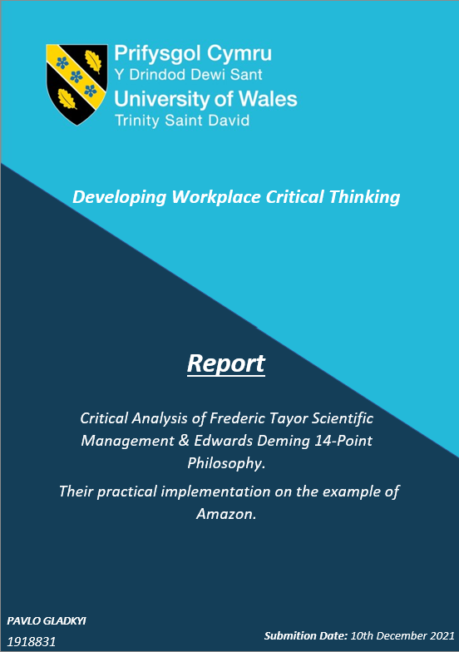

Critical Analysis of Frederic Tayor Scientific Management & Edwards Deming 14-Point Philosophy.
Their practical implementation on the example of Amazon.
Developing Workplace Critical Thinking
Report
Submition Date: 10th December 2021
Pavlo Gladkyi
1918831

Table of Contents

Table of Contents 1
Executive Summary. 2
1.0 List of Figures. 3
2.0 Introduction. 4
3.0 Classical Management Theories. 5
3.1 Topic summary. 8
4.0 Modern Management Theories. 8
4.1 Topic summary. 11
5.0 Values and beliefs. 11
6.0 Conclusions. 12
Reference List. 13

Executive Summary.

This report examines some key factors that currently influence management concepts in modern business. The research reveals a certain correlation between employees motivation, engagement and performance, and different management theories that could provide the most effective approach to achieving the highest employee performance if deployed wisely and well balanced.

Additionally, the researcher scrutinised the merits and demerits of two different management theories Frederic Tayor Scientific Management and Edwards Deming 14-Point Philosophy and their practical application on the example of Amazon.

As a result, the author concluded that both these theories have a vast deployment in the company and that Amazon is fully aware of modern trends in management and all the needed adjustments. Additionally, during the research, it was confirmed that Amazon has robust leadership principles and training strategies to ensure that these adjustments are standardised and implemented throughout the whole business.

Although that Amazon's sustainability strategy seems to be efficient, it was identified that the unsustainable transportation process increases its absolute carbon emission. Therefore, as Amazon care about its carbon footprint, it will be beneficial to find a feasible solution to resolve this problem.

As a recommendation, the report author suggests that Amazon should use an amalgamation of Classical and Modern management theories, adjust these theories to the current trends to be more flexible while managing employees, streamline the operational processes and attain the best result while moving towards a sustainable future.

1.0 List of Figures.

- Figure 1: Taylor Scientific Theory………………………………………………….1

- Figure 2: Example of Process Map Visual (PMV)…………………………………2

3. Figure 3: W. Edwards Deming's 14 Points for Total Quality Management……..3

4. Figure 4: Deming's Cycle (PDSA)………………………………………………….4

5. Figure 5: Pavlo's Gladkyi values assessment test results….…………………..…..5

2.0 Introduction.

As a part of the Developing Workplace Critical Thinking module (BMSW5101_SWAN) assignment, this formal report was created at the request of Doctor Shehla Khan - the Lecturer and Academic Ethnic Minority Liaison Officer the Institute of Management and Health.
The creator of this report used RED and Stephen E. Toulmin critical models to support arguments and streamline the report presentation to meet the assignment requirements.

The report's main objectives are to analyse the existing classical and modern management theories on the example of Frederick's Taylor Scientific Management theory and Deming's 14 Points for Total Quality Management concept. Additionally, the author will evaluate their similarities, differences, explicit merits and demerits regarding the current organisational situation and prominent modern trends.

To meet the stipulated task description, the report creator critically analysed the implementation of both of these theories at the workplace on the example of Amazon.
This multinational tech corporation is an e-commerce retailer and provides cloud computing, digital streaming, and artificial intelligence services.
With considerable investments in renewable energy sources, Amason declares that sustainability is the main focal point of the company. Moreover, the research reveals that Amazon is driven by customer obsession, passion for invention, operational excellence and long term thinking.
Furthermore, the research identified 16 leadership principles, which are the company's main core values that every employee has to epitomise and follow regardless of their hierarchical position. Additionally, the researcher states that the alignment of employees and company values is beneficial because employees will have a personal interest in the company's success, where their individual and companys' goals will be identical.
Following Barrett's values test results, the researcher discussed how his personal values and beliefs align with Amazon's organisational culture and current management practice in terms of future sustainability.

3.0 Classical Management Theories.

The 2nd Industrial revolution created opportunities for large-scale businesses to arise and thrive using mechanical innovations and the advantages of assembly lines. However, mass manufacturers did not have an efficient approach in terms of work organisation.
According to Beynon (2017), Frederic Taylor was one of the classical management theorists who identified this inefficiency and proposed his Scientific management concept to tackle this flaw. Moreover, he used a Time and motion study method to scrutinise tasks by breaking them into small jobs. The main purpose behind his idea is to find an optimal time-efficient solution to perform tasks in a more optimised, standardised way to increase productivity and simplify job roles by division of labour and the best practice replication across all workforce. Furthermore, similar to the other Classical management theory proponents, he stated that piece-rate pay is a fair practice and that paycheque is the best employee motivator (Frederick Winslow Taylor, 1972, pp.56–57).
Consequently, he provided training for overperforming employees and believed that they should be paid more. In contrast, underperforming workers were risking being fired (Organizational Communication Channel, 2016).
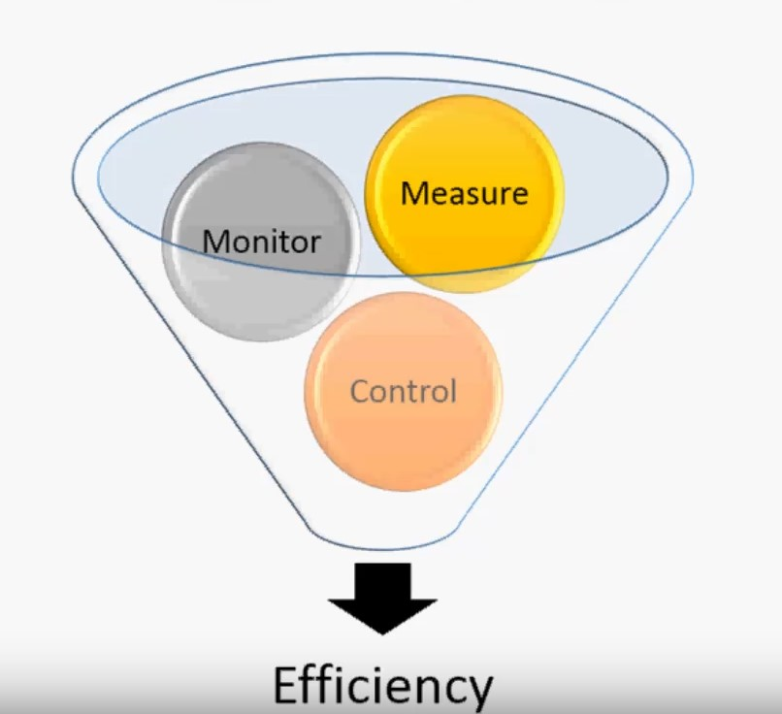

Figure 1: Taylor Scientific Theory.
Amazon's e-commerce activities imply warehouse operations, where items will be received, stored, picked, packed and shipped to the customer. This process chain of the internal customers is an excellent example of Scientific management implementation because each processes stage requires limited specific knowledge from the employee to accomplish their tasks in a timely manner to meet their targets. Moreover, as a quality, performance and safety control measure, Amazon uses standard operating procedures (SOP) to guide employees to complete tasks efficiently, correctly, and safely to clarify the best practice, reduce motion and time of the process.
Similarly to Taylor's Time and motion studies, they are created following the best scientifically identified practices that comprise minimal steps to complete the job (Henshall, 2019). In addition, different criteria will be considered when analysing each stage, such as personal protection equipment requirements, ergonomics standards or safe handling training (American National Standards Institute, Association For Manufacturing Technology and Global Engineering Documents, 2004). Ultimately, approved SOP will be implemented throughout all businesses network.

In contrast, another similar Scientific management tool – Process map visual (PMV) will only have local deployment to ensure employees follow process standards while performing their tasks (Hessing, 2013). However, the internal source states that it must also be approved by the Health and Safety Manager and Operational manager, which is much easier than the SOP approval procedure. Thus, these documents approval process intrinsically emphasises Amazon's hierarchical structure and proves a Scientific management theory application in practice.
Furthermore, to ensure relevance to the latest standard, all SOPs and PMVs will be reviewed yearly or on an add hoc basis if any further process improvement will be identified. Hence, Amazon constantly reviews its operational processes to eliminate non-value-added tasks or actions and streamline its operations to increase its performance level.

Additionally, Amazon's consistency is an excellent example of Taylorism influence, as all the fulfilment centres have identical managerial hierarchy and structure, work principles and meticulous obsession with operational standards (Dudovskiy, 2020).
Although the primary purpose of SOP and PMV is to make sure every employee can do the task, this instruction does not have a motivation point itself, as task division creates monotone, robotic work with a lack of creativity.

It is useful to consider that in addition to classical Scientific management, Amazon uses the next-level optimisation and improvement approach to be even more cost-effective – Lean management (Mallory, 2018). Nonetheless, the overriding principle remains the same. However, Lean management is a broadly expanded version of Taylor's micro-level approach (Skhmot, 2017).



Figure 2: Example of Process Map Visual (PMV).

Amazon's staff regular training is another trace of Taylorism within the organisation. The company wants all employees to follow the same standard, making them more agile, productive, replaceable (Amazon, 2019).
Furthermore, SOPs, PMVs and regular training as Taylor's Scientific management concept help Amazon achieve its duty of care values towards its employees by making risks controllable and reducing work-related injuries.

However, the aforementioned Taylorism benefits cannot stop Amazon employees discontent because Scientific management concept deployment, a priori, has some considerable demerits (Olum, 2004). Furthermore, Hastwell (2021) affirms that the Scientific management approach is dehumanising workers. Hence, the basic job instructions and monotonous work cannot fulfil their expectations and ambitions, as self-actualisation rather than a paycheque drives the vast number of today's employees.

Additionally, after the last quarter of the financial year, Amazon's seasonal workers' headcount will be reduced due to operational processes optimisation, creating temporary workforce frustration and local seasonal unemployment (Kasperkevic, 2014). Due to this fact, there is a greater likelihood that temporary employees will feel devalued and oppressed. As a result, they would not share Amazons values and believes, which will foreseeably impair their motivation and performance.

On the other hand, this seasonal employee discontent will be compensated by a positive sustainability impact because the company will save a significant amount of its finances, use fewer utility resources, and potentially reduce carbon emissions due to lower commuting.

3.1 Topic summary.

Based on the conducted research, the author of this report would like to admit that Taylorism's effectiveness for Amazon's business model is indisputable and beneficial. It provides discipline, structure, and a standardised approach, positively impacting safety, quality and productivity. However, to avoid employee frustration and job dissatisfaction Amazon should use contemporary performance theories to find effective motivation incentives to bridge Scientific management disadvantages.

4.0 Modern Management Theories.

The 4th industrial revolution significantly impacts modern business and human lives (Schwab, 2018). Technological progress brought new digital tools and methods to help organisations be more agile, sustainable, efficient and resilient. Additionally, this technological business rescaling reveals certain trends, flaws and gaps in Classical management concepts and makes companies review existing management methods to compete on the market (Albin and Foley, 1992).

On the other hand, the new technological era challenges modern companies to create favourable conditions for effective employee performance by revamping Classical management practices to increase employee engagement and motivation and achieve companies' goals and objectives cost-effectively.

According to Armstrong (2018), the main objective of any employer is to improve the performance of employees by forging the ownership boundaries, incentivising their motivation and proactive behaviour. Therefore, there is no doubt that employee motivation has also changed as a performance drive force (Gilchrist, 2019). Hence, companies must cultivate a new organisational culture and positive employee relations climate rather than concentrate solely on KPIs (Gifford, 2021). However, today, a significant amount of manufacturers, warehouses, fast food chains, couriers services and farming industries are still using Classical management theories to run their businesses (Amel, 2021). Alas, as the foregoing findings shows, Amazon is not an exclusion.

Hard to disagree with Elsey (2019) that success comes with adaptivity and a sound understanding that changes are inevitable and paramount for business development. As a result of technological progress and workforce generational change, the flaws in the Classical management approach started to be more apparent as they had one common problem – they did not value the employee's human needs.

Indeed, Modern management theories can bridge Taylorism flaws, as they emphasise the importance of human needs as a crucial motivation factor that could tangibly increase employee performance (Petriglieri, 2020).

As an innovator, Amazon can demonstrate successful implementation of the Modern management theories on the example of Edward's Deming 14-Point Philosophy (Deming, 2000, pp.23–24).
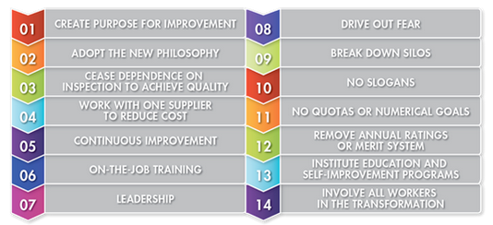
‌

Figure 3: W. Edwards Deming's 14 Points for Total Quality Management.

Deming's philosophy has an apparent advantage for Amazon in terms of deployment compared to classical Taylorism due to its flexible nature. Furthermore, Deming's points could be applied to any size or type of business.
In contrast, Taylorism is less flexible and limited to its deployment, as it misses wideness.

Again, the conceptual difference of these theories lies in the practical application field, where the main focal point of Taylorism is micro-level productivity boost, and Deming's 14 Points is whole business continues quality improvement. However, the commonalities of these theories are quite remarkable, as both management concepts use statistical control methods to improve operational processes and reduce their time by using the most effective solution. Moreover, both use on the job training to ensure everyone follows the same standard while performing their tasks.

In comparison to Taylor, Deming considers the complexity of employees motivation and believes that they are not inspired only by monetary incentives but also by a sense of belongings, personal growth and advancement, interpersonal relations and work enjoinment. Consideration of the motivation factors makes Deming's philosophy more holistic. Hence, its main focal point is quality, which needs to be integrated into every business level. On the contrary, Taylor focuses on a micro-level systematic approach related to a particular task rather than on the whole organisation.

Amazon already implemented Deming's theory and uses it in many aspects of its business by promoting its leadership principles as a value driver to enforce its peculiar corporate culture on all organisational levels (Makinson, 2021). Moreover, implemented KAIZEN philosophy as a part of Amazon's continuous improvement strategy focuses on the company's sustainability and waste reduction, employees engagement and motivation (Mani, 2009).
In addition, Amazon's consistent education and self-improvement strategies provide further carrier opportunities and strengthen employees' engagement by incentivising their ownership and trust (Amazon.com, 2020).

However, one of the critics, Baram (2021), questions Amazon's sustainability decisions regarding its services and products compared to other tech competitors. For example, according to Hobbs (2020), Amazon's current strategy focuses mainly on investments in green organisations rather than finding a sustainable, worthwhile solution to reduce its transportation-related carbon emission. Off cause, the investments will positively impact Amazon's public image, but unfortunately, they will not affect real Amazon's CO2 emission numbers.

On a positive note, research shows that Amazon Fulfilment Centres use Deming's Circle as a part of its continuous improvement strategy to enhance its processes and make them more efficient and sustainable (Amazon.com, 2021). Therefore, the latest implementation of the right-size recyclable packaging will benefit the company from a sustainability perspective and attract customers who care about global warming and climate change problems.
It also shows that Amazon takes needed steps to achieve its own net-zero carbon goals by 2040 and supports the declared values and beliefs by action.


Figure 4: Deming's Cycle (PDSA).

4.1 Topic summary.

To recapitulate, the deep dive on the report subject reveal that mixed management theories implementation is more effective in achieving both individual and organisational objectives. The obtained conclusive evidence shows that Amazon does well to balance both of the reviewed management theories. However, in relation to Sustainability, Amazon still has to focus on its processes to ensure that its declared values and beliefs reflect the real situation.

5.0 Values and beliefs.

Using Barrett's values assessment test, the researcher concluded that Amazon values and beliefs are currently aligned with the report creator values.

Pavlo Gladkyi assessment results clearly show that he is building confidence in interaction with others by taking ownership, sharing the experience, and looking to fulfil personal growth. Moreover, these personal values match Amazon's values very well because the company provides a robust learning platform for upskilling, self-development, and self-realisation that are currently the report author's main objectives. As a result, Pavlo can open its professional potential and positively contribute to company success.

Moreover, Amazon's sustainability strategy also appeals to the researcher, especially its course towards practical innovations integration in the domain of renewable energy sources and that megacorporations like Amazon can push through the new technologies that will change negative human activity impact on a planet. Certainly, Amazon still has a lot to improve in this sphere, but there is no doubt that the company is moving in the right direction.
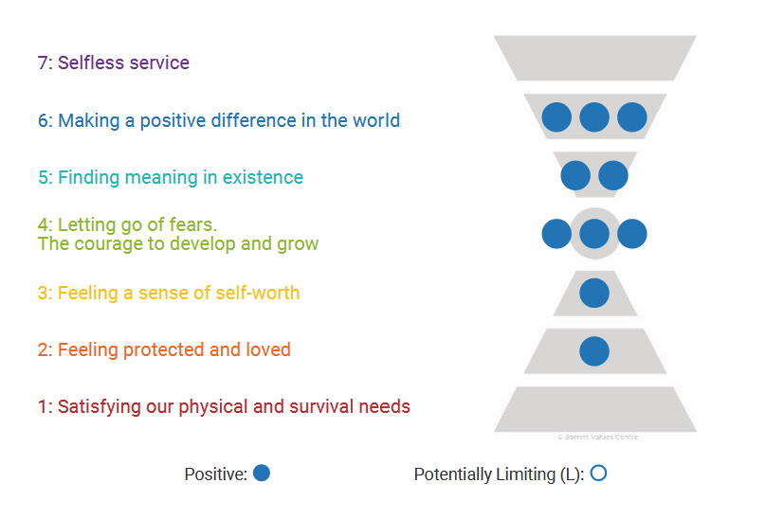

Figure 5: Pavlo's Gladkyi values assessment test results.

6.0 Conclusions.

To conclude, there is no doubt that Classical Management theories provide a fundamental base that allows businesses to create an organised structure to manage their employees and processes in the most controlled way. However, the research disclosed undeniable flaws in these theories, as they do not consider current trends and rapid changes in the organisational environment.

The solution to this problem is the implementation of modern management theories since they take into account current trends such as miscellaneous performance incentives, employees needs and expectations at work.

Amazon is an excellent example where both theories' amalgamation is practically implemented and used to achieve the best outcome. While Scientific management is used to streamline the operational processes, Deming's 14 Points for Total Quality Management helps Amazon target a broader spectrum of business aims by breaching the flaws in Taylor's concept and tangibly contributing to organisational sustainability.

Indeed, Amazon still relies on classical management practices, but at the same time, implements continuous improvement methods, which definitely will be beneficial to its internal and external customers.

As the author is driven by self-fulfilment and self-improvement values, Amazon's organisational culture and employee development programs are valuable. Moreover, the author is a proud member of Amazon, where his and the company values and beliefs are fully aligned.

Reference List.

Albin, P. and Foley, D.K. (1992). Decentralised, dispersed exchange without an auctioneer. Journal of Economic Behavior & Organization, 18(1), pp.27–51.

Amazon (2019). Training. [online] UK About Amazon. Available at: https://www.aboutamazon.co.uk/amazon-fulfilment/training [Accessed 24 Nov. 2021].

Amazon.com (2020). Our Programmes. [online] Apprenticeship. Available at: https://amazonapprenticeships.co.uk/our-programs [Accessed 29 Nov. 2021].

Amazon.com (2021). Packaging. [online] Sustainability - US. Available at: https://sustainability.aboutamazon.com/environment/circular-economy/packaging [Accessed 1 Dec. 2021].

Amel (2021). Is Scientific Management Theory Relevant in the Modern Workplace? [online] BusinessGuru.co. Available at: https://businessguru.co/scientific-management-theory/ [Accessed 23 Nov. 2021].

American National Standards Institute, Association For Manufacturing Technology and Global Engineering Documents (Firm (2004). ANSI technical report for machine tools : ergonomic guidelines for design, installation and use. New York: American National Standards Institute; Santa Ana, Calif.

Armstrong, M. (2018). Armstrong's Handbook of Performance Management. Sixth edition ed. Kogan Page Limited.

Baram, M. (2021). Amazon has "come a long way" but still faces a lot of questions on sustainability. [online] Fortune. Available at: https://fortune.com/2021/06/23/amazon-sustainability-plans-jeff-bezos-climate-pledge-esg-supply-chain/ [Accessed 6 Dec. 2021].
‌
Beynon, C. (2017). Management models and theories associated with motivation, leadership and change management, and their application to practical situations and problems. [online] Health Knowledge. Available at: https://www.healthknowledge.org.uk/public-health-textbook/organisation-management/5c-management-change/basic-management-models [Accessed 23 Nov. 2021].

Deming, E. (2000). The New economics : for industry, government, education. Cambridge, Mass.: Mit Press, pp.23–24.

Dudovskiy, J. (2020). Amazon Organizational Structure: a brief overview. [online] Research-Methodology. Available at: https://research-methodology.net/amazon-organizational-structure-2-2/ [Accessed 25 Nov. 2021].

Frederick Winslow Taylor (1972). Scientific management : comprising shop management, the principles of scientific management and testimony before the special house committee. Westport, Conn: Greenwood Press, pp.56–57.

Gifford, J. (2021). Employee Engagement & Motivation | Factsheets | CIPD. [online] CIPD. Available at: https://www.cipd.co.uk/knowledge/fundamentals/relations/engagement/factsheet [Accessed 27 Oct. 2021].

Hastwell, C. (2021). Top 5 Things Millennials Want In the Workplace in 2021. [online] Great Place to Work®. Available at: https://www.greatplacetowork.com/resources/blog/top-5-things-millennials-want-in-the-workplace-in-2021-as-told-by-millennials.

Henshall, A. (2019). 16 Essential Steps to Writing Standard Operating Procedures | Process Street | Checklist, Workflow and SOP Software. [online] Process Street. Available at: https://www.process.st/writing-standard-operating-procedures/ [Accessed 23 Nov. 2021].

Hessing, T. (2013). Process Mapping | Six Sigma Study Guide. [online] Six Sigma Study Guide. Available at: https://sixsigmastudyguide.com/process-mapping/ [Accessed 23 Nov. 2021].

Hobbs, D. (2020). Amazon Products Aren't Sustainable, Ethical, or the Most Affordable. [online] Remake. Available at: https://remake.world/stories/news/amazon-products-arent-sustainable-ethical-or-the-most-affordable-so-why-are-we-continuing-to-buy-them/ [Accessed 29 Nov. 2021].

Hogan, M. (2016). 5 Employee Feedback Stats That You Need to See. [online] www.linkedin.com. Available at: https://www.linkedin.com/business/talent/blog/talent-strategy/employee-feedback-stats-you-need-to-see [Accessed 19 Nov. 2021].

Kasperkevic, J. (2014). Homeless and working for Amazon: the trap of the seasonal job cycle. [online] the Guardian. Available at: https://www.theguardian.com/money/2014/may/04/amazon-seasonal-work-homeless-jobs-unemployment [Accessed 24 Nov. 2021].

Makinson, R. (2021). What Are The 14 Leadership Principles That Drove Amazon To Success? [online] CEO Today. Available at: https://www.ceotodaymagazine.com/2021/07/what-are-the-14-leadership-principles-that-drove-amazon-to-success/ [Accessed 29 Nov. 2021].

Mallory, R.E. (2018). Lean system management for leaders : A new performance management toolset. New York, Ny: Productivity Press.

Mani, S.M. (2009). Kaizen Philosophy: A Review of Literature. Journal of Operations Management, Vol. VIII, No. 2, 20095: The Icfai University, pp.52–63.

Olum, Y. (2004). Modern Management Theories and Practices. pp.12–14.

Organizational Communication Channel (2016). Frederick Taylor Scientific Management. YouTube. Available at: https://www.youtube.com/watch?v=vNfy_AHG-MU [Accessed 23 Nov. 2021].

Petriglieri, G. (2020). Are Our Management Theories Outdated? [online] Harvard Business Review. Available at: https://hbr.org/2020/06/are-our-management-theories-outdated [Accessed 25 Nov. 2021].

Schwab, K. (2018). The Fourth Industrial Revolution | Special Feature. In: Encyclopædia Britannica. [online] Available at: https://www.britannica.com/topic/The-Fourth-Industrial-Revolution-2119734 [Accessed 17 Nov. 2021].

Skhmot, N. (2017). The 8 Wastes of Lean. [online] The Lean Way. Available at: https://theleanway.net/The-8-Wastes-of-Lean [Accessed 23 Nov. 2021].

Zenger, J. and Folkman, J. (2014). Your Employees Want the Negative Feedback You Hate to Give. [online] Harvard Business Review. Available at: https://hbr.org/2014/01/your-employees-want-the-negative-feedback-you-hate-to-give?registration=success [Accessed 19 Nov. 2021].

