  Component One:  What are the key skills required when working in the housekeeping team? 750 words (+/- 10%)  Contribution to Overall Module Assessment: 25% | Student No: | Tatiana Raileanu  2211942
 | Module Title: | Hotel Placement-Operating Hotel Facilities
 | Module Code: | BMIH4006
 | Lecturer: | Lisa Knight
Introduction
The progress and development of the hotel industry solely depends on the adept execution of a distinct operations conducted by various professionals including housekeeping staff. Efficient time management, effective communication, and exceptional interpersonal skills are of utmost importance in this context. However, the following essay will provide an in-depth analysis of the fundamental competencies required for the employment in the housekeeping sector of a hospitality industry. A detailed account on personal reflection and experience of the student will also be elaborated while working at Premier Inn Hemel Hempstead. Moreover, the write-up will also adopt a reflective approach to scrutinise the key proficiencies that a housekeeping member must possess for successfully manoeuvring operations. This paper aims to provide a brief self-reflection on the significance of the aforementioned abilities in the hospitality industry of the United Kingdom. Subsequently, the ensuing reflexive articles will accentuate the importance of the housekeeping personnel in the hospitality industry (Rogers, 2008).
Discussion
The attainment of a position within a hotel's housekeeping team requires the integration of technical aptitudes and interpersonal competencies. However, cultivating fundamental intellectual capacities is essential for the employees involved in the household management. This is vital that personnel possess a comprehensive understanding of various methodologies and equipment (Sharma et al., 2019). The effective allocation of time is a vital element considering the work pressure to meet the deadline along with the ability to effectively prioritise tasks and execute them accordingly. Moreover, open and effective communication comprises an indispensable requirement in this domain. Additionally, the transmission and dissemination of knowledge must be recognised as a means of fostering better collaboration among members of a team. This is imperative for the workforce to exhibit a high level of efficiency in comprehending and conveying consumer inquiries and demands toother departmental staff. After the successful completion of my course, I have gained substantial expertise on many fields. This knowledge has facilitated me to attain diverse set of competencies, encompassing communication, organisation, and cognitive abilities. Thereby, it is imperative to engage in self-reflection to address personal experiences to foster a critical evaluation on the decisions I have made. Throughout my professional tenure, I was offered the opportunity to partake in an internship program at Premier Inn Hemel Hempstead. Premier Inn Hemel Hempstead Hotel is a leading brand name in hospitality establishment situated in the United Kingdom (premierinn, 2023). I was appointed as a member of the housekeeping team and charged with executing varied operational management duties pertaining to the hospitality sector (Vallen and Vallen, 2012). During of my academic program, I unfortunately encountered many significant barriers in achieving effective communication with both my peers and educators. I have diligently enrolled in several educational courses designed to enhance my competency in communicational proficiency. My expertise in the domain of time management proved to be a highly advantageous asset during my internship at Premier Inn Hemel Hempstead. I have proficiently discharged all of my assigned duties within the established timeframe to cater to the ultimate customer satisfaction. As well as fulfilling my responsibilities in housekeeping, I have also actively participated in a diverse range of activities apart from my assigned obligations. This approach had successfully with augmented my knowledge base and proficiency within the domain of the hotel sector. Furthermore, I have gained comprehension regarding the importance of maintaining safety and sanitation standards in preserving the brand's image among consumers. The significance of the housekeeping staff in the hospitality industry is indispensable notwithstanding the insufficiency of recognition attributed to their duties and obligations. Moreover, I have acquired broader perspective regarding the job tasks like the importance of cultivating physical agility to carry out the tasks (Wood, 2013).
Conclusion
The housekeeping personnel holds a crucial position within the hospitality industry, despite their duties and obligations being often disregarded. All participants involved in this research assume individual accountability for guaranteeing the safety and protection of the field of hospitality. The principal aim of their efforts is to guarantee a secure setting, devoid of any potential risks, and to eradicate all forms of disarray within the customer premises. Individuals who require lodging expect to have a pleasant and comfortable stay, which highlights the importance of a hygienic and well-managed living space alongside amenities that cater to elevated levels of customer satisfaction. A thorough understanding of the aforementioned information carries the capacity to promote career development within this industry. The reputation and status of a hotel are predominantly reliant on the quality of service that is provided. The enhancement of managerial abilities among the housekeeping personnel has the potential to increase the company's reliability and promote the acquisition of clients (Tesone, 2010).

Word Count | 754

Component Two:
Contribution to Overall Module Assessment: 25%
In this scenario – You have just been promoted to team leader for a floor within the hotel. A guest complains that on their arrival, their room had not been properly cleaned. Create an action plan and answer the following questions.

Problem | Why did it happen? | What are you going to do? | How will you prevent this from happening in the future? | What measures would you introduce to improve team effectiveness?
Messy and dirty bed | The housekeeping staff must be inattentive while cleaning the room or else the employee could not sort out the specific job role. After entering the room, if the guest finds a dirty room especially the bed, that can leave negative impact on the brand’s reputation (esg.hilton, 2023). | As the team leader, I will personally talk to the staff in charge and will interrogate about the negligence regarding the work. Afterwards I will try to figure out whether it was due to lack of dedication and then I will take necessary step to resolve the problem. Moreover, I will attend the guest personally and talk through the matter and facilitate them with additional service to compensate (Stylos and Fotiadis, 2021). | However, in order to minimise the chance of this happening again, I will make sure that proper training is given to the staff. Regardless the inconvenience and root of the problem, I will make sure that they fully comprehend the sincerity of their role and fulfil their duties on time. | As the team leader I will try to leverage such measures that will reduce communication gap exist among the staff. Clear transmission and daily reporting is however, necessary to ensure smooth mauver of the operations. I will try to incorporate collaboration tool to overcome the potential challenges and will act as a bridge so cooperation is maintained among them (restaurantonline, 2023).
Defective machines and appliances | After the guests entered the room, the first and foremost requirement is whether the equipment work properly or not. A well-equipped hotel that run efficiently induce flexibility and comfort to the customer experience (Conn, 2023). However, if the machines do not work properly like the switches, telephones or any electronic device that may create many hazards. Moreover, low internet connection or Wi-Fi facility is also one of the demands of the visitors. | First and foremost, I will call the expertise or professional to handle this specific area of requirements. Thereafter, I will attend the visitors and will try to negotiate and communicate with them to make them feel uncomfortable. Additionally, my will be to regain the reputation and trust from the respective guest, so their experience with the hotel goes well (hotelowneruk, 2023). | However, in future, being a leader, I will go myself and check if the alterations have been made properly as per the guests’ complaint. Thereafter, I will be attentive to their queries and listen to them very carefully so they do not feel unheard. This will further add a good impression of the hotel and visitors will come again if the customer service is remarkable. | I will form a team in the housekeeping department who will handle logistics and technicians who will regularly check whether every device work efficiently or amendments will be made. This will prevent any awkward encounter of the guests and they will be contented. Additionally, I will approach the higher authority to invest more on this department by highlighting the vitality to ensure seamless navigation of the operations (George and Hancer, 2019).
Unclean and unsanitised bathroom | Bathroom is one of many factors that the guests are most cautious of as well as very particular about. Unclean and dirty bathroom can be commonly found in many hotels and this can mar the customer satisfaction. The hotel may gain negative feedback and can face further loss due to this (serve360.marriott, 2023). | Being the team leader, I will investigate the matter and will conduct a meeting as soon as possible so the staff get conscious and feel responsible for the mistake. I will also apologise on the behalf of the hotel administration for the inconvenience and will promptly respond and seek for solution. I will immediately call the staff for room service as soon as possible and make amendments to showcase the dedication and responsibility of the customer service provided by the hotel (Alcalde-González et al., 2021). | I will arrange for training program where they will be given proper demonstration of how to clean bathrooms accordingly. The hotels comprise of different surface areas which necessitate different types of implementations and procedures to clean the toilets as minimum stain can hamper the brand reputation. However, as a group leader I will make sure that toilets are cleaned regularly and no stain remains on the surface disrupting the outlook of good furnishing. | I will make sure whether proper cleaning agents, equipment and chemicals are used. I will also educate the trainees to take safety measurements as many avoid toilet cleaning for health purposes but that cannot be avoidable. I will make sure that proper measures are undertaken to enhance customer satisfaction (restaurantonline, 2023).

Component Three:
Contribution to Overall Module Assessment: 50%
Your task is to create and prepare a presentation following the detailed scenario provided below.

As the floor housekeeping manager and given the recent guest complaints you need to put together a basic training presentation for your colleagues within the housekeeping team to get the best out of them, ensure that brand standard is being achieved and that Health and Safety procedures are also being followed.

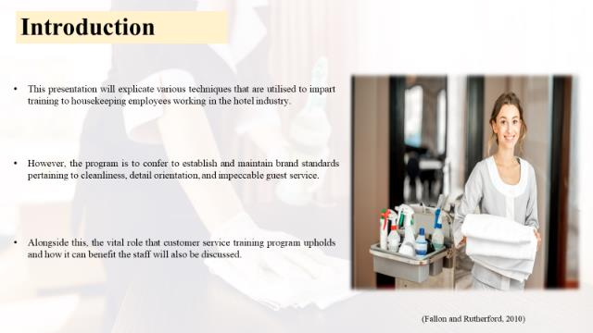

Training Notes:

Introduction

The following presentation aims at demonstrating the distinctive job roles that a housekeeping staff must exhibit. This presentation will explicate various techniques that are utilised to impart training to housekeeping employees working in the hotel industry. Effective training of housekeeping staff and members is imperative in order to ensure the success of a modern-day business. However, the program is to confer to establish and maintain brand standards pertaining to cleanliness, detail orientation, and impeccable guest service. This, in turn, enhances guests' contentment and elevates the market position of the chain and beneficial for the marketing. Additionally, it will place considerable emphasis on health and safety protocols with particular focus on educating them on appropriate techniques to handle chemicals. Alongside this, the vital role that customer service training program upholds and how it can benefit the staff will also be discussed. However, to conclude with, an employee engagement model will also be illustrated to provide basic understanding of housekeeping department.

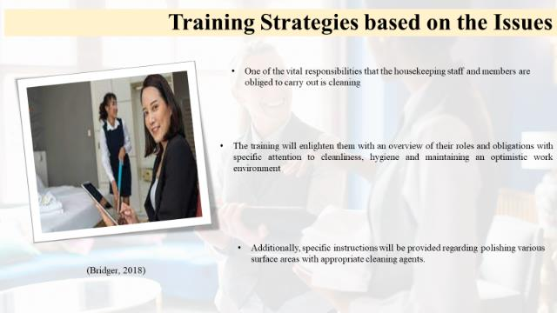

Training Notes:

Training strategies based on the issues
One of the vital responsibilities that the housekeeping staff and members are obliged to carry out is cleaning. Therefore, it is imperative that they attain sufficient knowledge regarding their duties and perform efficiently. The training will enlighten them with an overview of their roles and obligations with specific attention to cleanliness, hygiene and maintaining an optimistic work environment (Fallon and Rutherford, 2010). Moreover, the program will impart guidance on preparing accommodations, making beds and organising and replenishing supplies both prior to their arrival and after their departure. Additionally, specific instructions will be provided regarding polishing various surface areas with appropriate cleaning agents (Bridger, 2018).
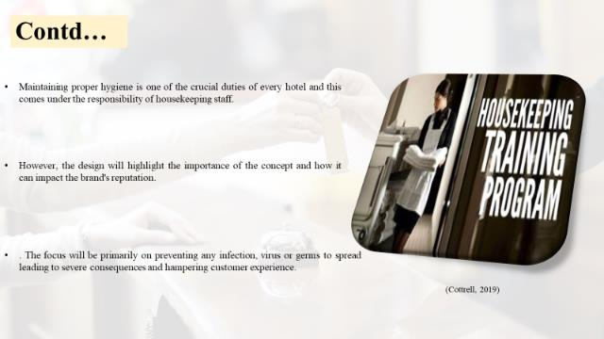

Training Notes:

Contd….
Maintaining proper hygiene is one of the crucial duties of every hotel and this comes under the responsibility of housekeeping staff. The administration has received many complaints regarding the safe and clean environment of the hotels thereby facilitating proper training is necessary. However, the design will highlight the importance of the concept and how it can impact the brand's reputation (Casado, 2012). This will make them realise the vitality of their job role inducing in them motivation and dedication to their duty. The focus will be primarily on preventing any infection, virus or germs to spread leading to severe consequences and hampering customer experience. Hence, the primary purpose is to eradicate germs from all the space in the hotel including rooms, lounges, kitchen, lobbies and other multipurpose rooms (Cottrell, 2019).
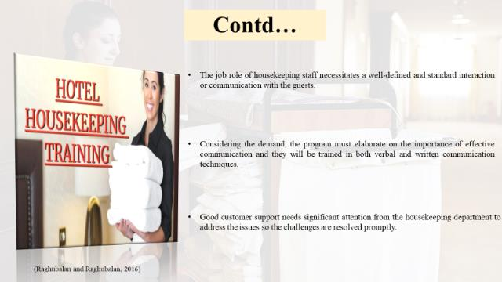

Training Notes:

Contd….
The job role of housekeeping staff necessitates a well-defined and standard interaction or communication with the guests. This part is crucial as the ultimate customer satisfaction solely depends on their service and creates a positive image. Considering the demand, the program must elaborate on the importance of effective communication and they will be trained in both verbal and written communication techniques (Raghubalan and Raghubalan, 2016). Additionally, a thorough understanding of listening skills will also be edified during their course so they attain the ability to comprehend customer queries and problems. Good customer support needs significant attention from the housekeeping department to address the issues so the challenges are resolved promptly (Quick, 2020).
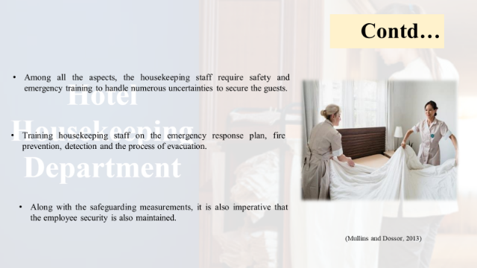

Training Notes:

Contd….
Among all the aspects, the housekeeping staff require safety and emergency training to handle numerous uncertainties to secure the guests. The training session must provide a thorough understanding of handling fires, natural disasters, medical emergencies and security incidents. Training housekeeping staff on the emergency response plan, fire prevention, detection and the process of evacuation. Furthermore, they should possess basic knowledge regarding body techniques so that they can provide initial support to any guest when necessary (Leiter and Bakker, 2010). Along with this, they must facilitate primary security service and address every trivial inconvenience to induce a secure environment for visitors. Along with the safeguarding measurements, it is also imperative that the employee security is also maintained. Following accurate protocols regarding cleanliness program is also crucial to mitigate any chance of mishap. The guests must be protected as well as the safeguard measures must be instructed to the staff to ensure their well-being as they must work with many harmful chemicals (Mullins and Dossor, 2013).

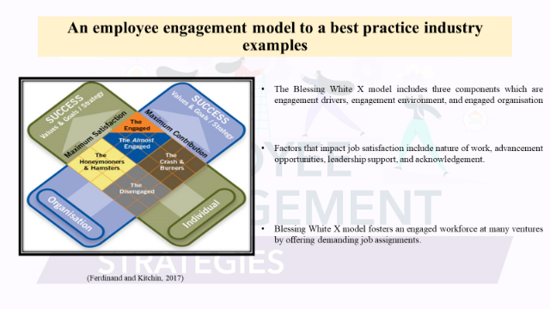

Training Notes:

An employee engagement model to a best practice industry example
Blessing White focuses on employee engagement and leadership development aand their approach centers on positivity and productivity to increase employee satisfaction. The BlessingWhite X model includes three components which are engagement drivers, engagement environment, and engaged organisation. Factors that impact job satisfaction include nature of work, advancement opportunities, leadership support, and acknowledgement. A software development company recognises the significance of employee engagement in driving innovation and meeting customer demands. BlessingWhite X model fosters an engaged workforce at many ventures by offering demanding job assignments. Every employee understands their role and impact on the organisation's aims and objective (Ferdinand and Kitchin, 2017).

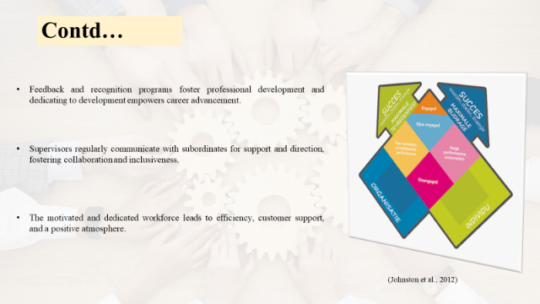

Training Notes:

Contd…

Feedback and recognition programs foster professional development and dedicating to development empowers career advancement. Training includes communication, coaching, and leadership for managerial success. However, in order to foster an inclusive workplace, prioritise open communication with team members to ensure all feel valued and heard. Supervisors regularly communicate with subordinates for support and direction, fostering collaboration and inclusiveness. Encouragement for cross-functional collaboration, knowledge sharing, and teamwork to foster originality and ongoing advancement in the workforce. Moreover. the companies have reinforced their commitment to engagement by setting employee engagement KPIs. The motivated and dedicated workforce leads to efficiency, customer support, and a positive atmosphere. This results in decreased turnover rates, innovation, and a competitive edge in the technology industry (Johnston et al., 2012).
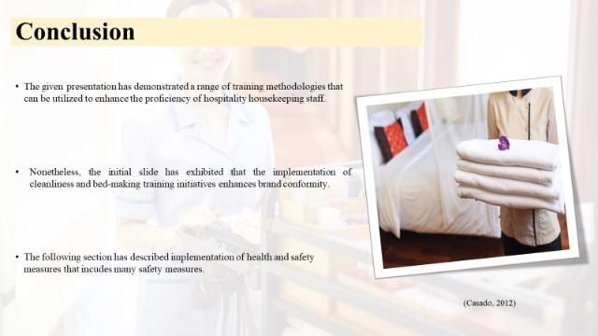

Training Notes:

Conclusion
The given presentation has demonstrated a range of training methodologies that can be utilised to enhance the proficiency of hospitality housekeeping staff. In order to achieve optimal performance and garner worldwide brand recognition, it is crucial to provide thorough training to housekeeping staff. Nonetheless, the initial slide has exhibited that the implementation of cleanliness and bed-making training initiatives enhances brand conformity. Subsequently, the next slide has elaborated upon the criticality of communication proficiency necessary for engaging the members and effectively collaborating with co-workers. After the preceding presentation slide, the subsequent one has expounded upon the subject of time-management competencies and their effect on the overall workforce protocol. The following section has described implementation of health and safety measures that includes many safety measures. These encompass the management of chemicals, utilisation of personal protective equipment, prevention of accidents, and maintenance of hygiene practices. Ensuring the enforcement of suitable protocols for promoting safety, professionalism, teamwork, and motivation among housekeeping staff is crucial within this domain. Finally, the Blessing White’s X employee engagement model was scrutinised to gain a deeper comprehension of the topic.

References

Alcalde-Gonzalez, V., Mozo, A.G. and Bustos, A.V., (2021). No clean rooms, no hotel business: Subversion tactics in Las Kellys’ struggle for dignity in hotel housekeeping. Annals of Tourism Research, 91, p.103315.
Bridger, E. (2018) Employee engagement: a practical introduction. 2nd ed. HR Fundamentals. London: CIPD and Kogan Page.
Casado, M. (2012) Housekeeping Management. London: Wiley.
Conn, T., 2023. 3 Best Practices For Leaders When It Comes To Facility Cleaning. [Online] Available at: https://www.forbes.com/sites/forbesbusinessdevelopmentcouncil/2023/02/08/3-best-practices-for-leaders-when-it-comes-to-facility-cleaning/?sh=7a08af4d73f7 [Accessed 28 May 2023].
Cottrell, S. (2019) The Study Skills Handbook. 5th ed. London: Red Globe Press.
esg.hilton, 2023. About Us. [Online] Available at: https://esg.hilton.com/ [Accessed 28 May 2023].
Fallon, M. & Rutherford, D. (2010) Hotel Management and Operations. London: Pearson.
Ferdinand, N. and Kitchin, P. (2017) Events Management - An International Approach. 2nd ed. London: SAGE Publications Ltd.
George, R.T. and Hancer, M., (2019). Housekeeping managers and the administration of housekeeping service. International journal of hospitality & tourism administration, 9(4), pp.365-383.
hotelowneruk, 2023. About Us. [Online] Available at: https://www.hotelowner.co.uk/ [Accessed 29 May 2023].
Johnston, R., Clark, G. & Shulver, M. (2012) Service Operations Management. London: Pearson.
Leiter, M. P. and Bakker, A. B. (2010) Work Engagement: A Handbook of Essential Theory and Research. Hove [England]: Psychology Press.
Mullins, L. and Dossor, P. (2013) Hospitality Management and Organisational Behaviour. 5th ed. Harlow: Pearson.
premierinn, 2023. About Us. [Online] Available at: https://www.premierinn.com/gb/en/why/force-for-good.html [Accessed 29 May 2023].
Quick, L. (2020) Managing Events. Real Challenges, Real Outcomes. London: SAGE Publications Ltd.
Raghubalan, G. and Raghubalan, S. (2016) Hotel Housekeeping - Operations And Management. 3rd ed. India: Oxford University Press.
restaurantonline, 2023. About Us. [Online] Available at: https://www.restaurantonline.co.uk/ [Accessed 28 May 2023].
restaurantonline, 2023. About Us. [Online] Available at: https://www.restaurantonline.co.uk/ [Accessed 29 May 2023].
Rogers, T. (2008) Conferences and conventions a global industry (2nd ed., Events management series). Oxford ; Boston: Butterworth-Heinemann.
serve360.marriott, 2023. About us. [Online] Available at: https://serve360.marriott.com/ [Accessed 28 May 2023].
Sharma, N., Chaudhary, N. and Singh, V. (2019) Management Techniques For Employee Engagement In Contemporary Organizations. Hershey, Pennsylvania: IGI Global.
Stylos, N., and Fotiadis, A.K., (2021). Beyond smart systems adoption: Enabling diffusion and assimilation of smartness in hospitality. International Journal of Hospitality Management, 98, p.103042.
Tesone, D. (2010) Principles Of Management For The Hospitality Industry. 1st ed. London: Routledge.
Vallen, G. & Vallen, J. (2012) Managing Hotel Operations. London: Pearson.
Wood, R. (2013) Key Concepts in Hospitality Management. London: Sage

