Name: Mia Harries
Student Number: 2304406
Course: Computer Games Design
Module Details: Narrative and World-Building
Assignment: Creating Storytelling Elements for Existing Universes

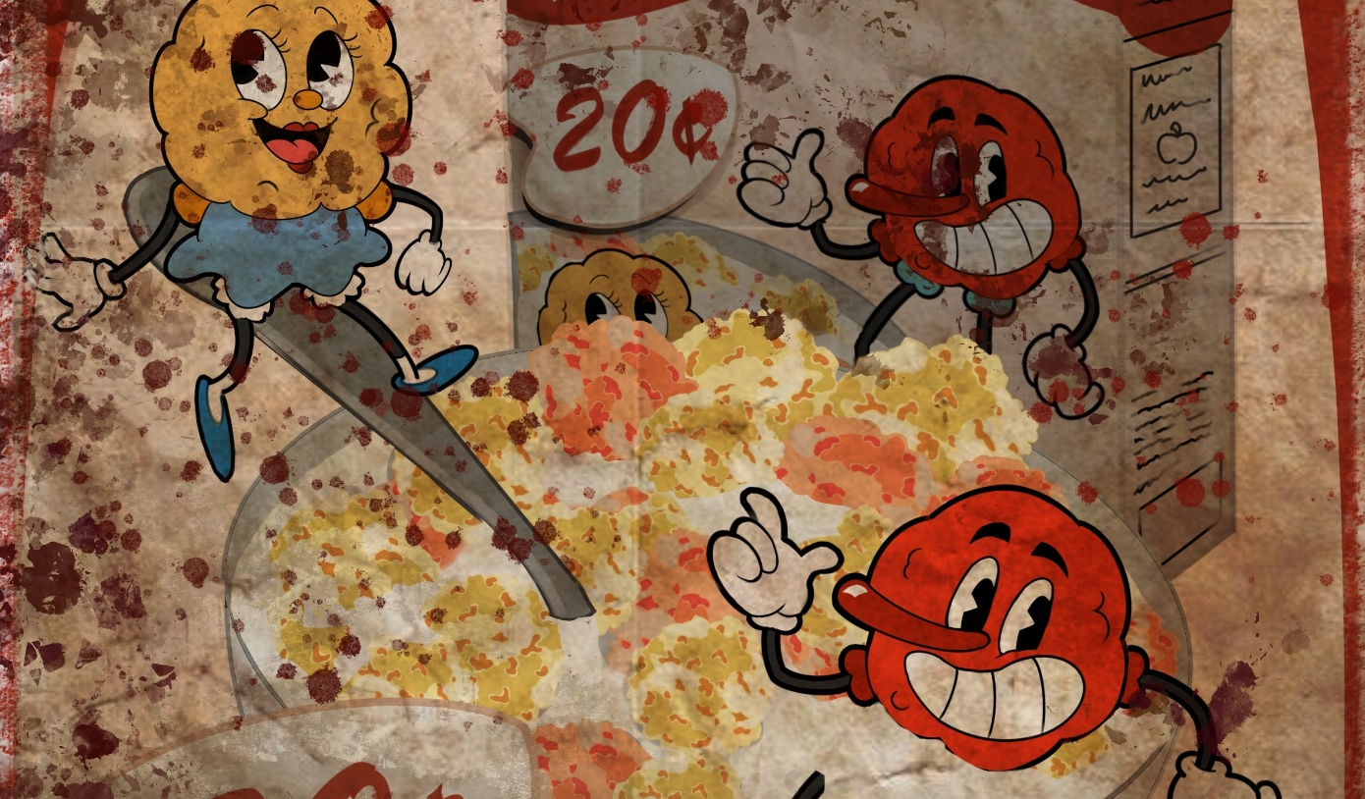

Fictional Product Creation
Mia Harries - 2304406

Summary:
The assignment is to create a fictional pre-war product within fallout’s established lore, I chose to create an edible cereal, found in fallout 4. The product is a storytelling device that uses environmental queues to portray a story to the player and enrich the game world.
Contents:
The Fictional Product + Packaging: 3
In-Game Use: 5
Promotional Advertisements 9
Brand Backstory 11
Pre-War Locations 12
Environmental Storytelling Elements / Post-War 13

The Fictional Product + Packaging:
My fictional product is a colourful kids cereal named “PloomPuffs”. The cereal comes in 2 different colours, pink and yellow and they are shaped like uneven balls with little holes within them. Because of this shape and the air within the cereal, they made a “puff” sound when they’re eaten, hence the name. Once the cereal is put with milk, because of the combined cereal it’ll turn the milk a light orange shade, something that helps to attract children to the colourful nature of the cereal. The name “Ploom” is a play on “Plum” the Latin word for the lead chemical element, which is the main underlying ingredient within the cereal.
The packaging is in a retro style, with the two mascots on the front of the colourful box, one sitting on the spoon in the bowl and the other within the bowl of cereal. On the back it includes fun facts about ‘PloomPuffs’ and their health benefits, whilst also including a detailed list of ingredients besides one important one. This is to make sure that the cereal is colourful and fun for the children to look at, whilst also being educational and not looking like a completely sugar-filled cereal that would drive away buying parents.
The mascots that represent the cereal look like the circular ‘puffs’, one is pink and the other is yellow because these are the colours lead come in, and they’re stylized in the old cartoon way that fits within the fallout 4, similar to Cappy, though I’ve made them unique in their own way so that do not look like replicas of that already famous mascot. The mascot’s names are “Plumbie” and “Leadia” a duo that will appear frequently and exclusively together, both of their names are again derived from the different words for Lead. Typically, this would feel too obvious to someone playing, but fallout is known for its irony in some of their consumable items and thus I believed it would be fitting to give them those names.
All advertisements for the cereal will follow the same style as the cereal packaging and will include both mascots, keeping it entertaining and drawing attention from children. Although when in game, these advertisements will appear much darker and ruined than described currently.
‘PloomPuffs’ were originally meant to be a healthy cereal for children, the original use of them and what they were advertised for was protecting children against radiation from the oncoming nuclear war. They’re advertised to build up a child’s immune system and shield them from this radiation. The cereal only contains minute doses of lead to slowly build up immunity over time, because lead is known to shield radiation. Unfortunately, what lead does instead is much worse, in fact it has a multitude of negative side effects such as behavioral problems, lower IQ, hearing loss which will further be incorporated into the ghouls in the game. For adults, it can cause many brain issues like memory loss, lack of concentration, irritability, and even hallucinations.

In-Game Use:
To make sure the item has in game use without being overly powerful or weak, I used an online fallout wiki forum to compare the stats I intended to give the item, with other similar items. Within the game itself the cereal will appear as the box, players can pick up and use the consumable item, it’ll make a puff sound, followed by the stats stated below. Because the cereal is made with lead, there are a few things that’ll happen to the player, first they’ll gain some RAD resistance which coincides with the fact that lead prevents radiation from penetrating to the other side. Secondly, the player will receive a slight strength buff, because of the way that lead increases irritability and aggression. The debuffs, however, come from the negative side effects of lead, the main being hearing loss and lowering IQ, so a huge drop in perception and a slight drop in intelligence fits the cereal. Its significance in the game will relate to its use to temporarily help the player resist any radiation if they consume the item.
Here I've listed the details of the item, when I consider the balancing necessary to make it realistic item within game:
Name: Ploom Puffs
Class: Food
Buffs: +15 RAD Resistance and +1 Strength for 10 Mins
Debuff: -1 INT –3 PER, remove by using toilet

Addiction: Addiction is a mechanic within fallout, and considering lead can lead to a propensity to addiction, I decided to use that to affect the player in the same way other addictive consumable in fallout do.
Risk: 5%
Duration: 1 Hour
UMON: 12
Withdrawal Effects: -1 per –1 str

In-game item screenshot + Description:
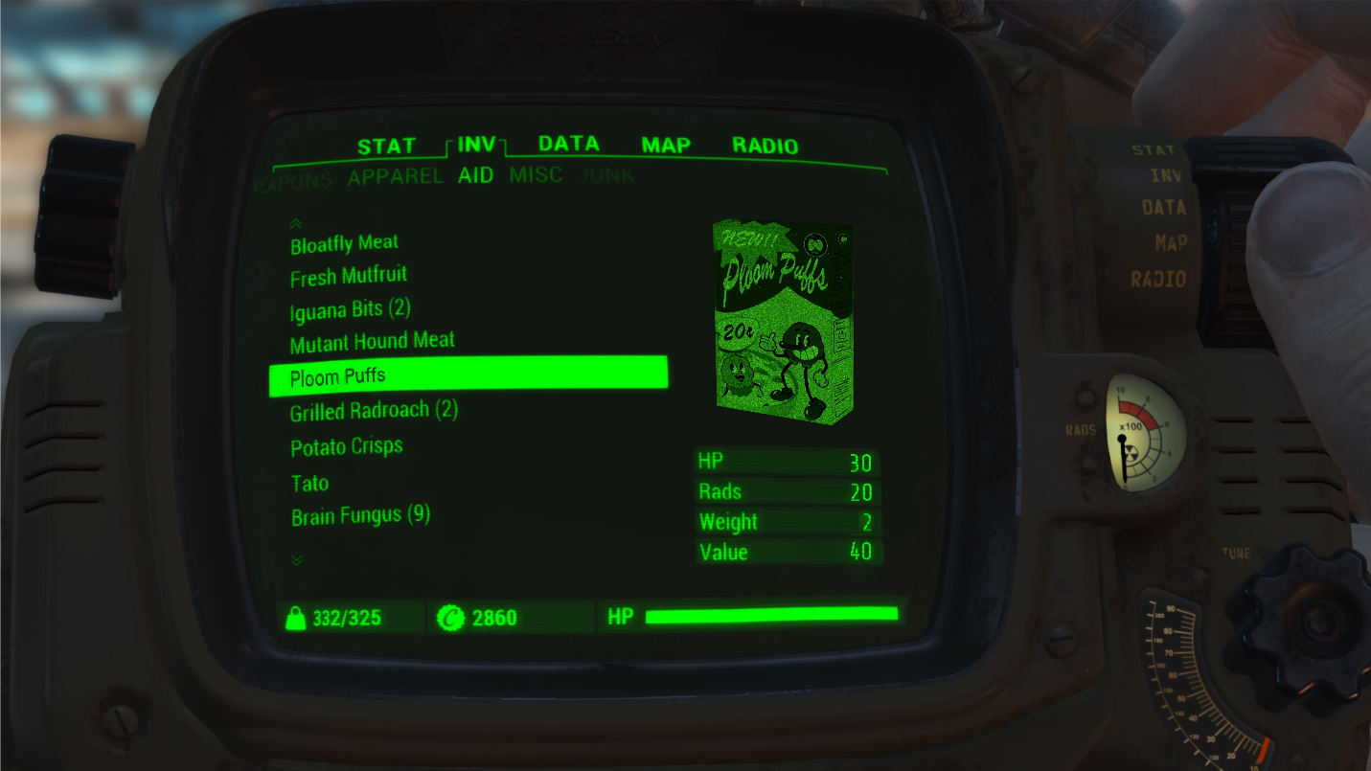
Packaging:
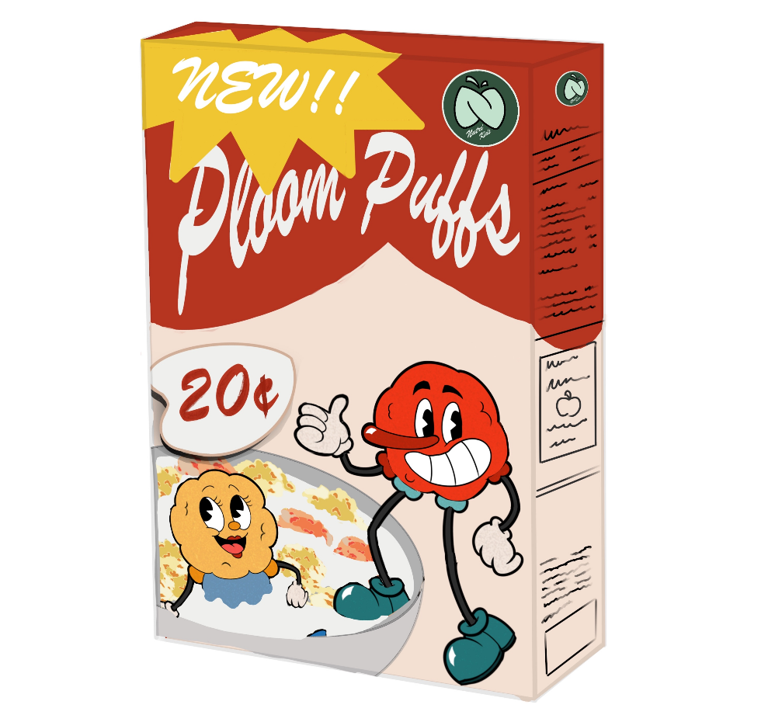
Mascots:
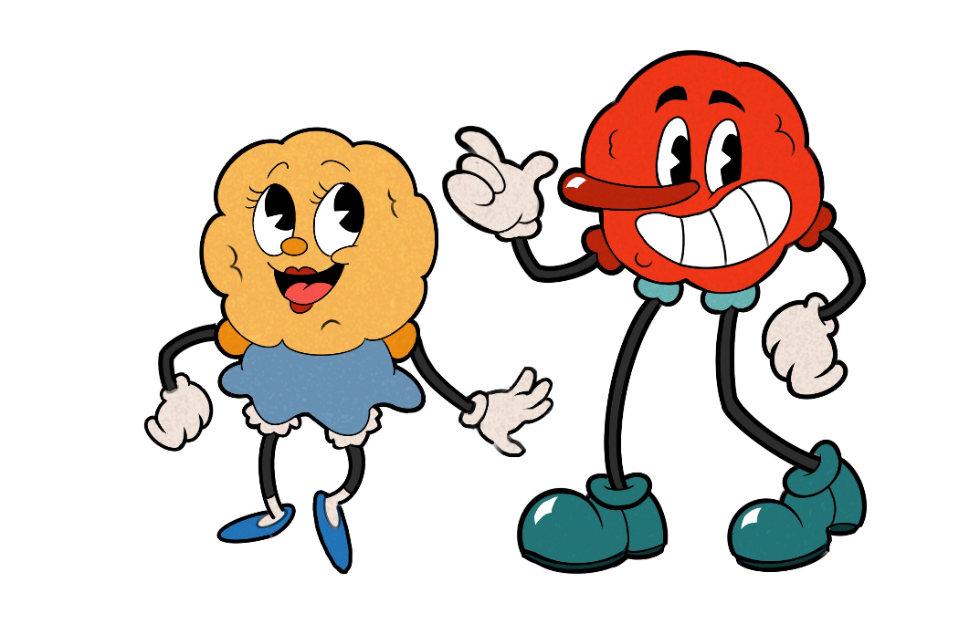
“Ploom Puff”:

Nutri Kids Logo:
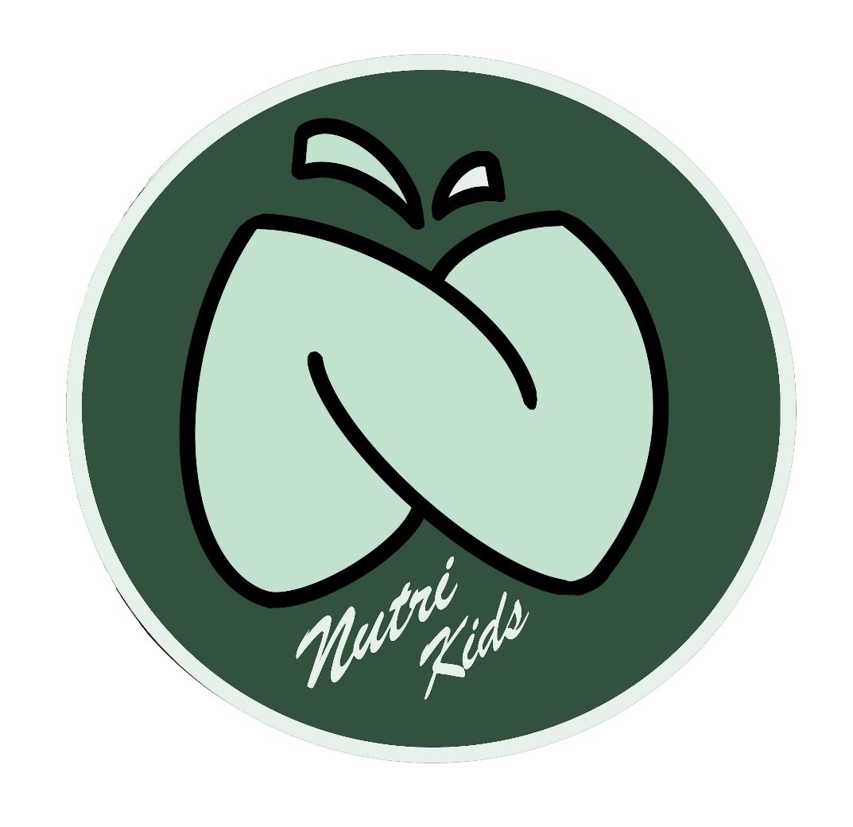

Promotional Advertisements
The cereal and the two mascots will appear in many promotional advertisements, including vintage-style posters advertising the product and an early morning advertisement for children in between breakfast shows on the television. The cereal may also appear on billboards in some of the populated towns, which include schools.
I decided to choose these 3 forms of advertisements because within the fallout universe I believe these would’ve been the most effective ways for the CEO of the company to advertise to as many children as possible and as often as possible. They all stick within the vintage style of fallout, whilst also keeping into that lighthearted and joyful theme I want the cereal to have. With similar fallout style advertisements, I created my own.

Poster:
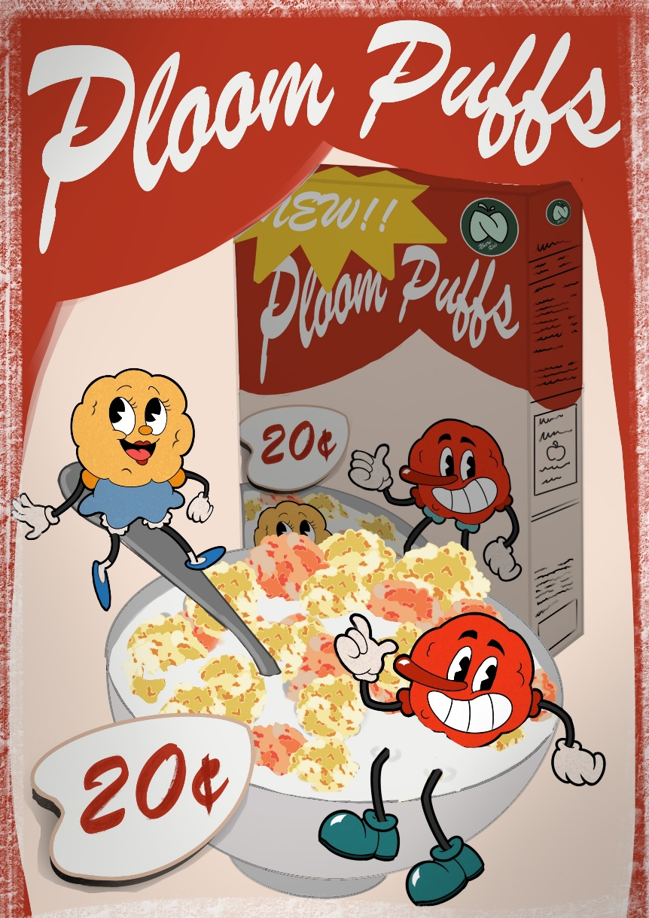
Post-War Poster
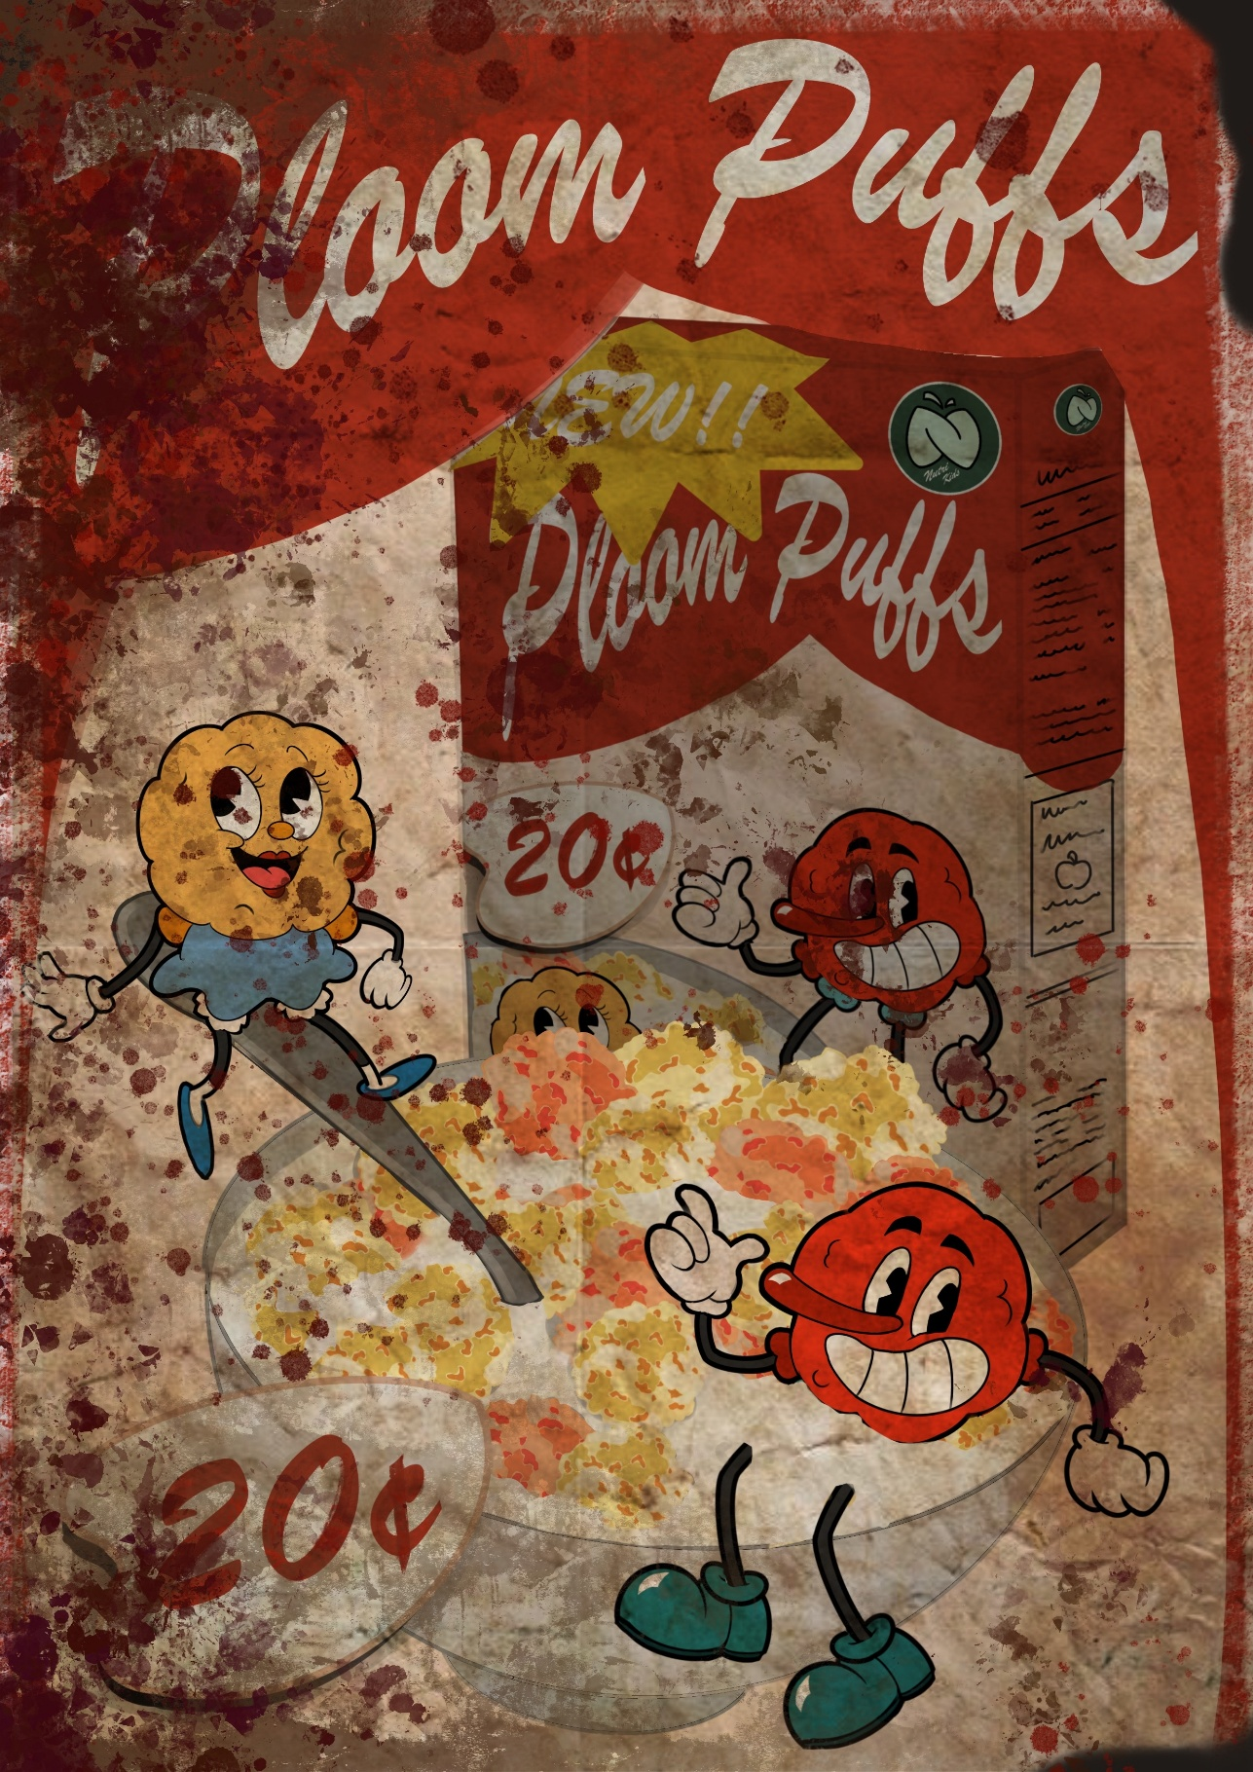

Brand Backstory
The company that sells ‘Ploom Puffs’ is ‘Neutri Kids’, they sell nutritional food products aimed towards children and more than often use fearmongering in their advertisements to sell to worried parents. It was founded in 2054, shortly before the Great war, and it was founded by Mr. Samuel Thorpe, a well know businessman and entrepreneur, but after only 12 years, due to a mix of nepotism and paranoia, he gave his role of CEO to his only son, Elliot Thorpe. Elliot Thorpe only received the company after his father’s growing concerns about the oncoming war, he wants his successor to take his place and keep the company going since now children would need their products more now than ever before. The young and arrogant CEO wanted to prove to his father that he could do his job, and better, thus coming up with this new product “Ploom Puffs”. Radiation poisoning was a grave concern amongst consumers as more fear fled the market, so taking advantage of this he decided to create a cereal that helps immunize the person from radiation. Being young and ignorant, and with a rampant saviour complex, he was hellbent on “saving the next generation” from the threat of nuclear war by feeding them this lead containing cereal to turn the children into “barriers against radiation”.
During trial and testing phases the CEO spent a lot of the time working on the project firsthand, working with different doses of lead, trialing them on rats and animals, and secretly under the surface, on people too. Due to this exposure to lead though, he himself started to feel the effects of the chemical, unbeknownst to him he was becoming more erratic, irritable and forgetting his current progress on the product. This further pushes the narrative of his delusion and full unbridled confidence that he is the saviour of the next generation of children, and that he will be able to save them all from the war. To put it short, he’s been so affected by the lead that he has suffered extensive brain damage, to the point where his colleagues and underlings are doubting his authority and sanity to successfully run the company.
Over the course of the product’s production and eventual distribution, the addictive qualities of the lead, in the small doses within the cereal, would make the consumer buy more and more, leading to increased health and brain problems despite doing what it's made for and “immunizing” the consumer. The scientists and nutrition experts, when working on the product, became acutely aware and worried at the amount of lead used in products, noticing the CEO’s irritability and short bursts of violence, they quickly tampered down their concerns out of fear. Anytime something negative about the product’s contents was brought up, the worker responsible for the concern just happened to disappear or quit without any good reason.

Pre-War Locations
Due to the advertisements and the targeting toward children these products do, this product will be found in the different schools scattered around the game. They’ll be found in cafeterias within schools, will be on shelves in grocery stores and advertised on posters in gas stations and billboards in more populated areas. Some of these locations may include the Suffolk County charter school, Malden middle school and the East Boston Preparatory school which are all within Fallout 4. In the schools especially there are boxes around, showing that children eat their breakfast here, there’s be many posters around grocery stores to show off its popularity. The product would be a popular one and because of that it’ll be something commonly seen advertised across the different areas I listed previously. When we consider pre-war, when everything is still semi functional and organized, there may be delivery trucks with the Nutri Kids company logo on the side as well to establish its significance within the game. Some other pre-war locations would include the Nutri Kids headquarters, and the labs beneath it in the Commonwealth in Fallout 4. The HQ would be bustling with staff and scientists, with statues of the mascots of the popular cereal and include many posters on other products as well. Underneath, within the labs, there’d be test subjects, animals and humans alike, restrained and being experimented on in secret, with only a limited number of people being aware of such a thing.

Environmental Storytelling Elements / Post-War
Within the game itself and within the fallout timeline the player plays within, the posters and all such advertisements would be worn and decayed if not already destroyed or ripped apart. In the schools in particular there will be ghouls there, but not regular ones, they will include ghouls that do more damage, linking to heightened aggression, and ghouls that also cannot hear if the player is nearby, only when you are in direct line of sight will they attack, this is to associate it with hearing loss that comes with consuming lead. The reason for this is because these ghouls within the schools will be the result of the “Ploom Puffs”, since it is fed in schools, the ghouls here are the children that were eating the cereal and thus suffered from the horrible side effects that follow it. Visually there’ll be blood where the ghoul’s ears used to be and dented skulls, this is to reiterate the fact of their aggression and their inability to hear has driven them mad as they’ve become these monsters. There’ll be torn open boxes scattered across the room, and “puffs” all over the floor because of its addictive quality. The same can be said about the grocery stores too, but there’d be more of the boxes there, and torn apart due to looters and addicted ghouls. Due to how common the cereal is, if there are any sealed boxes lying around the player will be able to pick it up and eat it.
The headquarters will appear destroyed, looted. The upper floor will include the CEO’s office, inside there’d be a larger ghoul dead inside with bloodied ears, a very dented skull and skin with dark bloodied scratches all over it due to the extreme pain prolonged exposure lead can cause. This ghoul is the CEO, as the player will learn as they read the terminal entries within the journal on the desk. It’ll explain the CEO’s slow descent into madness the more he worked on ‘Ploom Puffs’, believing he’d be a saviour to the next generation.
The laboratory will be slightly different from the main building, it'll be darker and dreary, with claw marks on the wall where experiments wanted to escape after having lead used on them in many high doses to make the perfect “Ploom Puffs”. But due to the CEOs own insanity and negligence, it still went to market in a destructive state. The lab will be covered in blood, cereal and on one of the desks will include a terminal from a scientist that was slowly growing more concerned about “Ploom puffs” ingredients and side effects, until they abruptly cut off because he raised his concerns.

Quest:
- Talk to Adi Tances
- Visit Nutri Kids HQ
- Collect Pre-Trial Ploom Puffs
- Return to Adi Tances
If the player comes across a cereal addicted scavenger within the Suffolk County Charter School named Adi Tances, she’s addicted and will ask the player to get her more ‘Ploom Puffs’. The ones at the schools aren't enough so she advises the player to go to the headquarters where they may have the “good stuff” - referring to older versions before they reduced the dosage of lead in the cereal. This quest is optional but if accepted will allow them to freely access the headquarters and lab beneath if they get the key from the CEO office. Once retrieved and given to Adi, she will give the player 3 boxes of the regular kind since she “doesn’t need them anymore”.

Ploom Puff Ghouls:

CEO’s terminal entries:
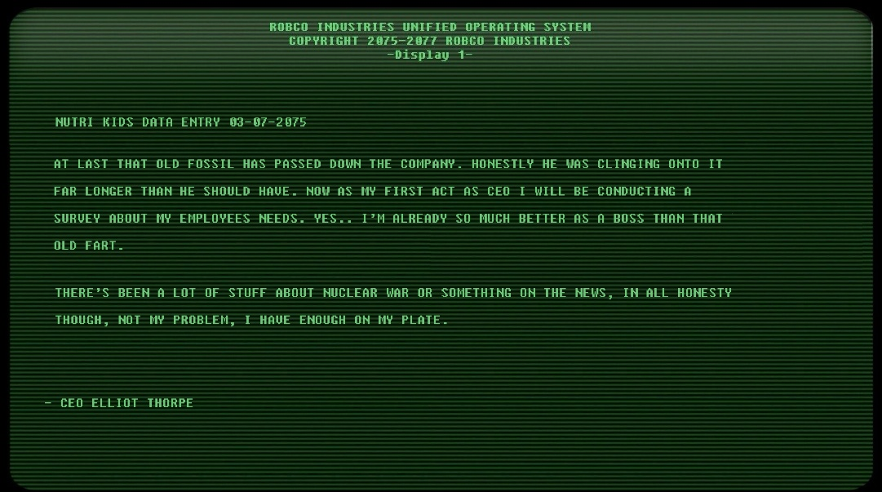
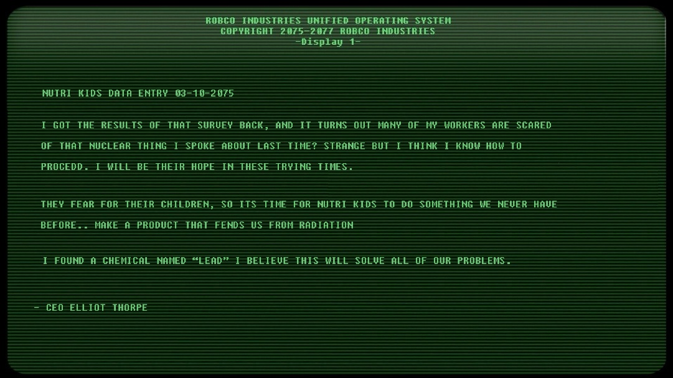
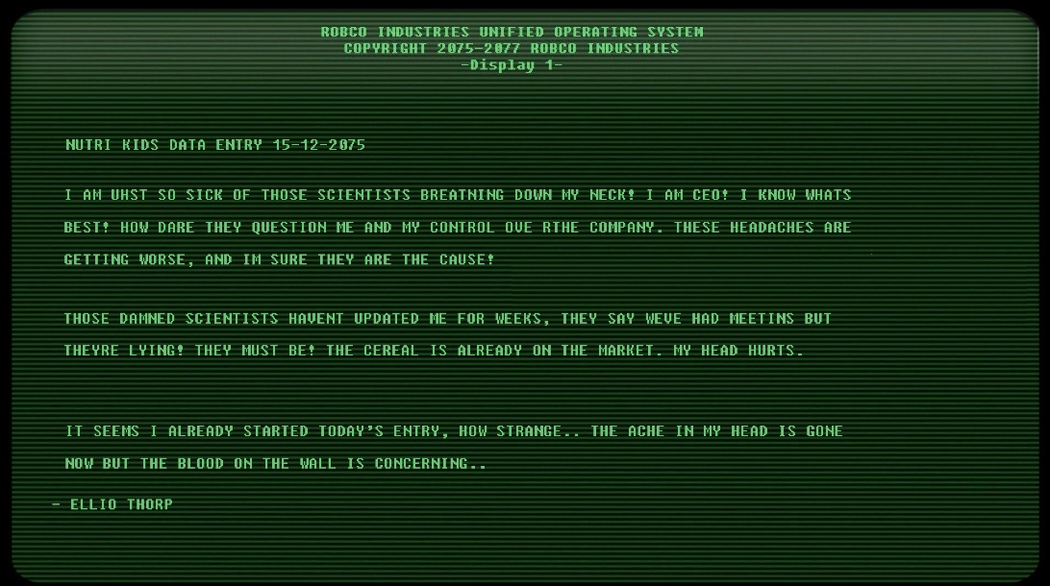
Fired scientist’s entries:
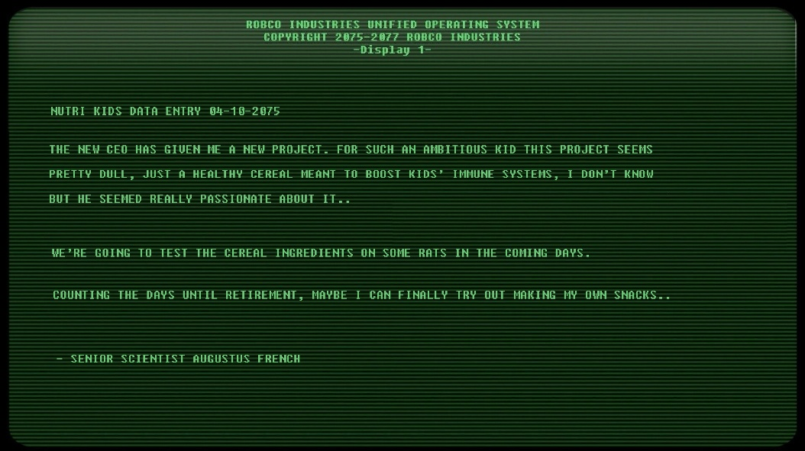
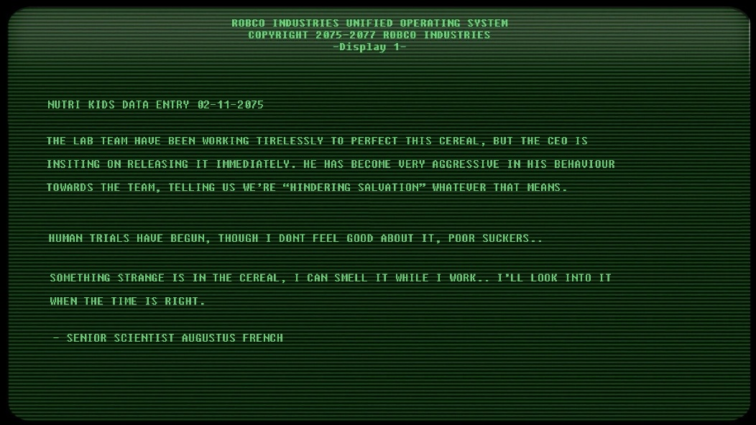
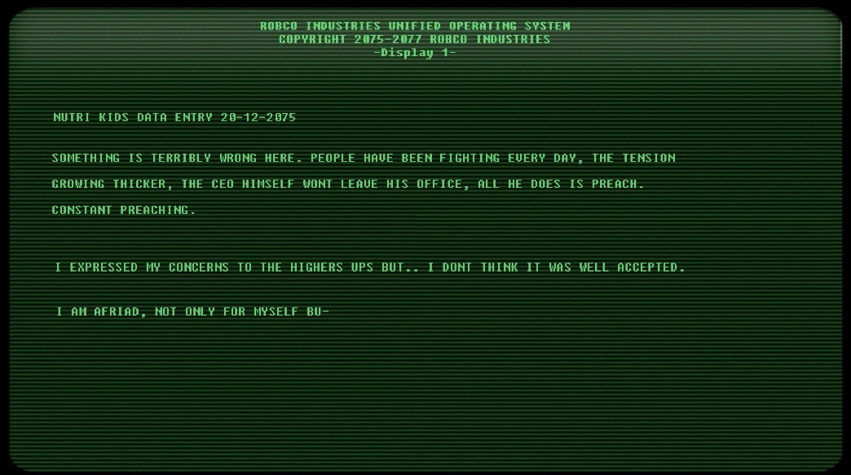
To conclude this story bible I believe I’ve successfully been able to express my product idea in a clear and effective way through various research. In the future I hope to be able to do another project like this so I may develop more skills associated with mimicking a pre-made game style since it was enjoyable and a skill I do need to grow.

