

THE ROLE AND IMPORTANCE OF QUALITY SERVICE, HOSPITALITY, AND GUEST SERVICES WITHIN THE HOTEL INDUSTRY

LAURENTIU-COSTEL POPA 2126967
HOSPITALITY AND GUEST SERVICE MANAGEMENT (BMIH4003) DWYNMEN H. THOMAS-UNSWORTH

JW MARRIOTT BUCHAREST GRAND HOTEL






CONTENTS

- Hotel History
- Hotel presentation
- Services
- Amenities
- Guest services
- Guest experience
- Conclusion and questions
- Reference list






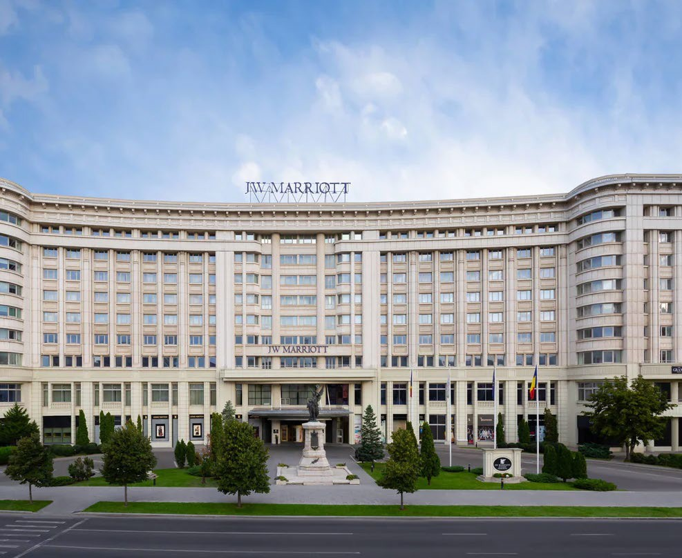
Hotel presentation

- JW Marriott Bucharest is part of the Marriott International Chain, and it combines business with luxury, but it is also family related and pet friendly
- Classed as a 5* Luxury hotel and situated in a very quiet district, JW Marriot – Bucharest Grand Hotel was open for travellers in 2000
- Very close to the Palace of Parliament and People’s Salvation Cathedral, the building was made by Ceausescu’s regime in the ’80s
- It is the only 5* hotel from the district and it attracts travellers, either for leisure or business, couples or families


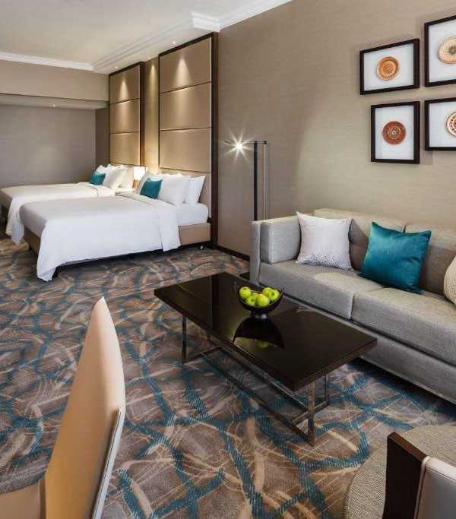
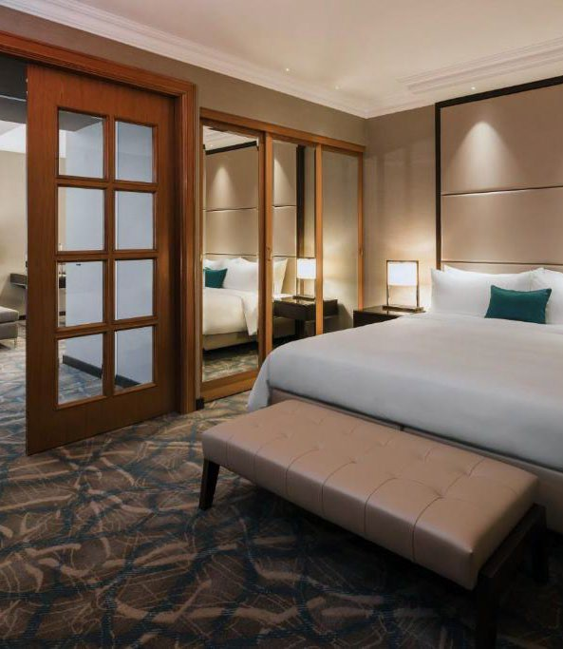
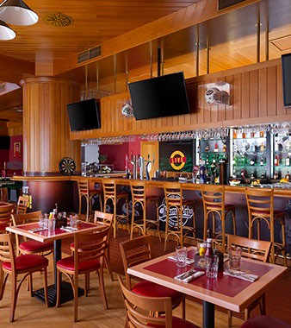


Hotel presentation
  - Travellers can combine the highest standards of services and enjoy staying in the 402 rooms, relaxing in the SPA centre and health club, shopping in a luxury area inside the hotel, and even having a drink at the casino
  - Hotel attracts customers with different facilities that come to make you feel at home and you have free access to the fitness centre, indoor pool, squash courts
  - You can enjoy a morning coffee and breakfast in the Pavilion Lounge, or you can taste the various cousins like Italian, and beef stakes, have fun in the sports bar & restaurant, sweet delights or even relax in the evening on an outdoor terrace dining

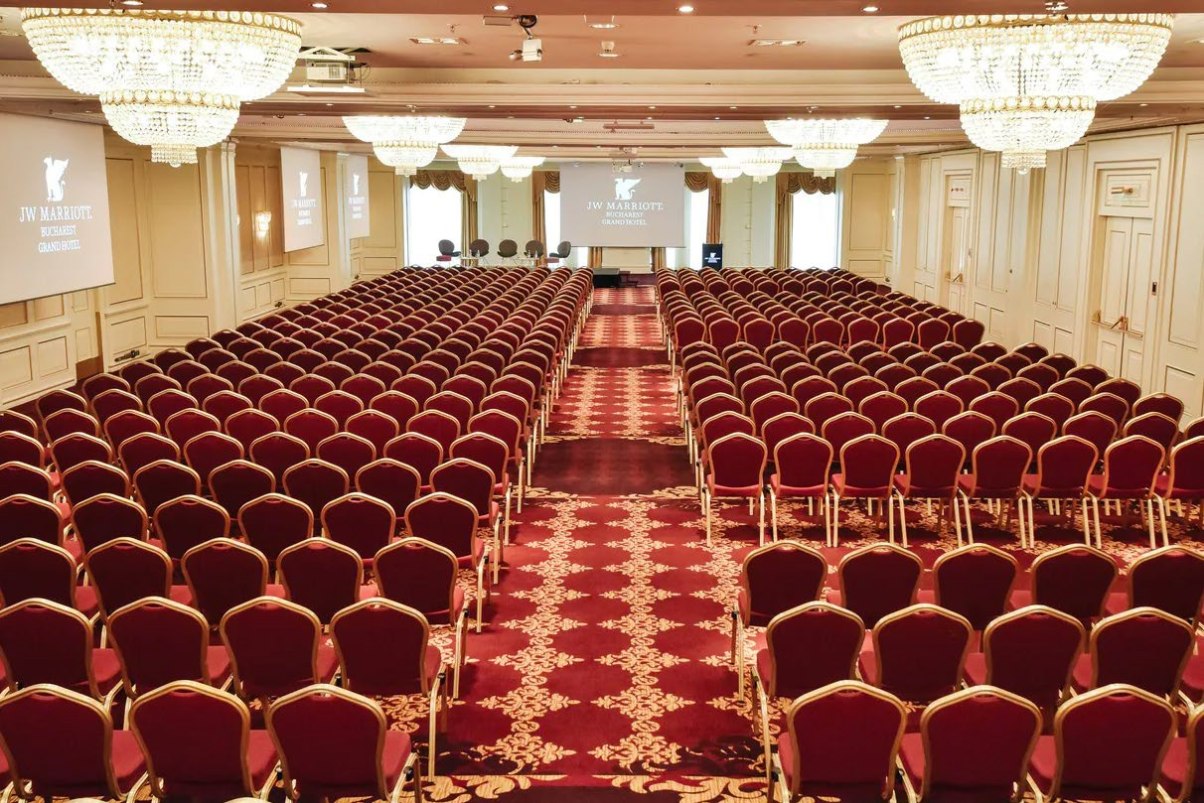
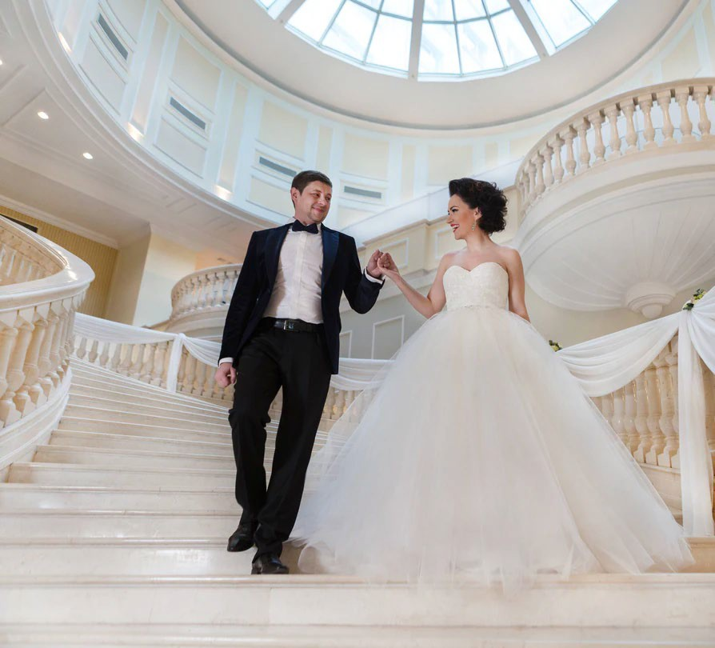

Services and facilities

- Business Centre Services: 20,000 square feet of conference space, computers, copy/fax services, overnight delivery/pickup, parcels
- Inspired Event Spaces and Exquisite Planning Services: Certified Meeting Planner, Decorator, Event lightning, Photographer, Security Guards
- Airport shuttle services
- Complimentary In-Room Wi-Fi
- Mobile check-in and Mobile key
- Exclusive member rates
- Cash and points
- At the hotel you can enjoy free wi-fi, wellness, cleaning services, business facilities
- Both international English language and Romanian languages provided
- Pets friendly(charges may be applicable)
- Wheel chair accessible

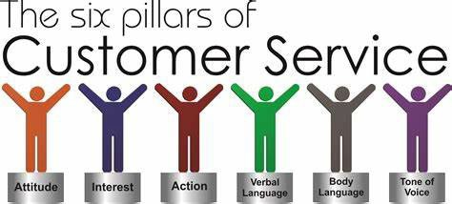

Guests Services: definition

- It is the mutual process between managers, including owners, workers and guests related variables such as mood, behaviour and emotions Maynard, & Susskind, A. M. (2019).
- According to Cherniss(2001), emotional intelligence plays a huge role in customers’ choices, when speaking about excellency in services. Managers need to pay attention to understanding employee’s needs and wants, in order to offer commitment, efficiency, and customer loyalty or innovation

Guests services at JW Marriot Bucharest



  - There are 5 types of members: Silver, Gold, Platinum, Titanium and Ambassador Elite
  - Priority late checkout until 9 P.M. with Ambassador Elite
  - Room upgrades
  - Welcome gift choice
  - Flexibility to choose your 24h stay
  - Personal assistant with your stay

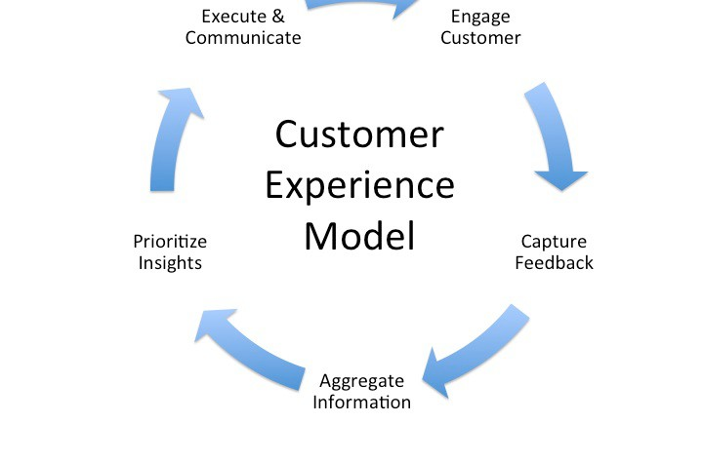

Guests Expectations and Experience

- People’s choice remains unknown for the hospitality industry when choosing the best solution for their short, mid and long stay at hotels
- Liu, et. Friends(2013) say that people are gathering information from travel agencies, friends or family to obtain information regarding booking their next hotel, a process called word-of-mouth(WOM). The process evolved with the evolution of the internet and became e-WOM, where hotels can collect data from surveys, ratings or live pictures
- At JW Marriott Bucharest, the more you stay in, the more points you are gathering and you can transform them into other services that you are interested like booking a flight, renting a car, or a new booking worldwide using cash and points service

Summary


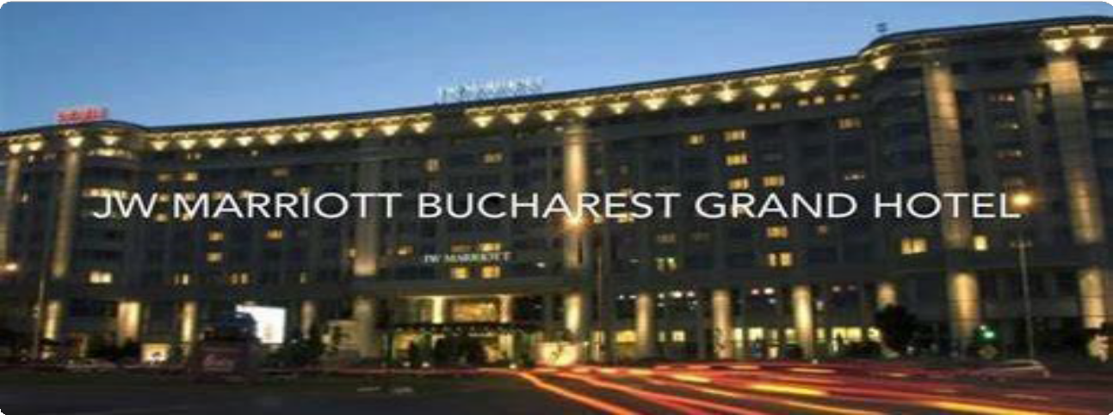
  - JW Marriott Bucharest Grand Hotel provides excellent services, in the heart of the city, and combines modern luxury and authentic appeal to enhance every moment of your stay
  - Very stylish and with an exquisite collection of culinary experience, every day in the hotel makes you feel like home

References

  - Cherniss, & Goleman, D. (2001). The emotionally intelligent workplace : how to select for measure, and improve emotional intelligence in individuals, groups, and organizations. Jossey-Bass.
  - http://www.b2bknowledgesharing.com/tag/customer-experience-model/

  - https://shaunbelding.com/six-pillars-customer-service/

  - Liu, Law, R., Rong, J., Li, G., & Hall, J. (2013). Analyzing changes in hotel customers’ expectations by trip mode. International Journal of Hospitality Management, 34, 359–371. https://doi.org/10.1016/j.ijhm.2012.11.011
  - Luxury Hotels Bucharest Romania | JW Marriott Bucharest Grand Hotel

  - Maynard, & Susskind, A. M. (2019). The Next Frontier of Restaurant Management : Harnessing Data to Improve Guest Service and Enhance the Employee Experience (Maynard & A. M. Susskind, Eds.; 1st edition.). Cornell University Press,. https://doi.org/10.7591/9781501736520

