
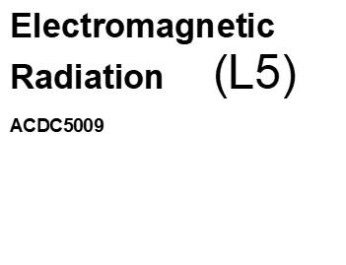


Contents
Figure table 2
Equation table 3
Tables 3
Introduction 4
Task 1a: 4
Task 1b: 7
Comparing cut off frequency results 9
Task 2: 9
Half wave dipole antenna 9
Results 12
Conclusion 12
Task 3: RADAR 12
The birth of the radar – 1930’s. 12
What is a radar 13
Traditional radar use 13
Technological advances 13
Challenges and failures 14
Societal and environmental impacts 15
potential hazards 15
Positives 15
Recent developments 15
Radars and drones 16
Example of RCs 16
Proposed improvements 17
Conclusion 17
References 18

Figure table
Figure 1, rectangular wave guide results 5
Figure 2, Cut off frequency calculation 5
Figure 3, Cut off frequency answer 5
Figure 4, Cut off frequency results 6
Figure 5, E and H field for wave guide 7
Figure 6, TEmn mode equation 7
Figure 7, Simulated Teflon results 8
Figure 8, Teflon final results 8
Figure 9, radiating surface 9
Figure 10, length equation 10
Figure 11, operating frequency calculation 10
Figure 12, S-parameter 10
Figure 13, Finished dipole design 11
Figure 14, Gain results 11
Figure 15, Listening ears, 12
Figure 16, Radar echo waves 13
Figure 17, Guinness world record 15
Figure 18, Radar cross section 16

Equation table
Equation 1, Cut off frequency calculation 4
Equation 2, Cut off frequency answer 5
Equation 3, TEmn mode equation 7
Equation 4, length equation 9
Equation 5, operating frequency calculation 9
Equation 6, Listening ears 12
Equation 7, Radar echo waves 13
Equation 8, Guinness world record 14
Equation 9, Radar cross section 16

Tables
Table 1, Field values 6
Table 2, Teflon results 7
Table 3, comparison of cut off frequencies 8
Table 4, Example RCs [9] 16
Table 5, Radar bands 17

Introduction
This report is structured into four main sections, each addressing different aspects of electromagnetic wave propagation and radar technology. The first section focuses on the design of a rectangular waveguide, incorporating mathematical, statistical, and electromagnetic principles. The second section presents a modified waveguide, featuring PEC (Perfect Electric Conductor) walls and a Teflon-filled interior, with a comparative analysis of its performance against the initial design. The third section explores the design of a half-wave dipole antenna, examining theoretical predictions and their alignment with simulated results. The final section discusses radar systems and their limitations in detecting drones, particularly due to the small size and high manoeuvrability of modern UAVs. Given the rapid rise in drone technology, traditional radar systems face challenges in effective detection and tracking. This report reviews recent advancements in radar-based drone detection, their societal and environmental impacts, and potential improvements to enhance detection capabilities in the future.
This report explores the design and simulation of a rectangular waveguide and a halfwave dipole antenna. Two waveguide configurations were analysed. Air-filled ($ɛ_{r}$=1) and Teflon-filled ($ɛ_{r}$=2.1) with results showing lower cut off frequencies in the Teflon-filled waveguide due to increased permittivity. The halfwave dipole antenna’s simulated results deviated from theoretical predictions, suggesting discrepancies due to modelling assumptions or material losses. These findings emphasize the impact of dielectric materials on waveguide performance and the challenges in achieving theoretical resonance in antenna design.

Task 1a:
The following rectangular waveguide model was designed with the following in mind.
PEC walls filled with a vacuum and the set-up frequency sweep from 2GHz to 30GHz.
Dimensions of the waveguide 23mm (a) Height: (0)6mm, Length 50mm along the Z-axis:
These dimensions where determined by (a) the 1st two numbers of my student ID, 2 and 3, (b) the 3rd and fourth number 0 and 6 divided by two. Results are shown in Figure 1.
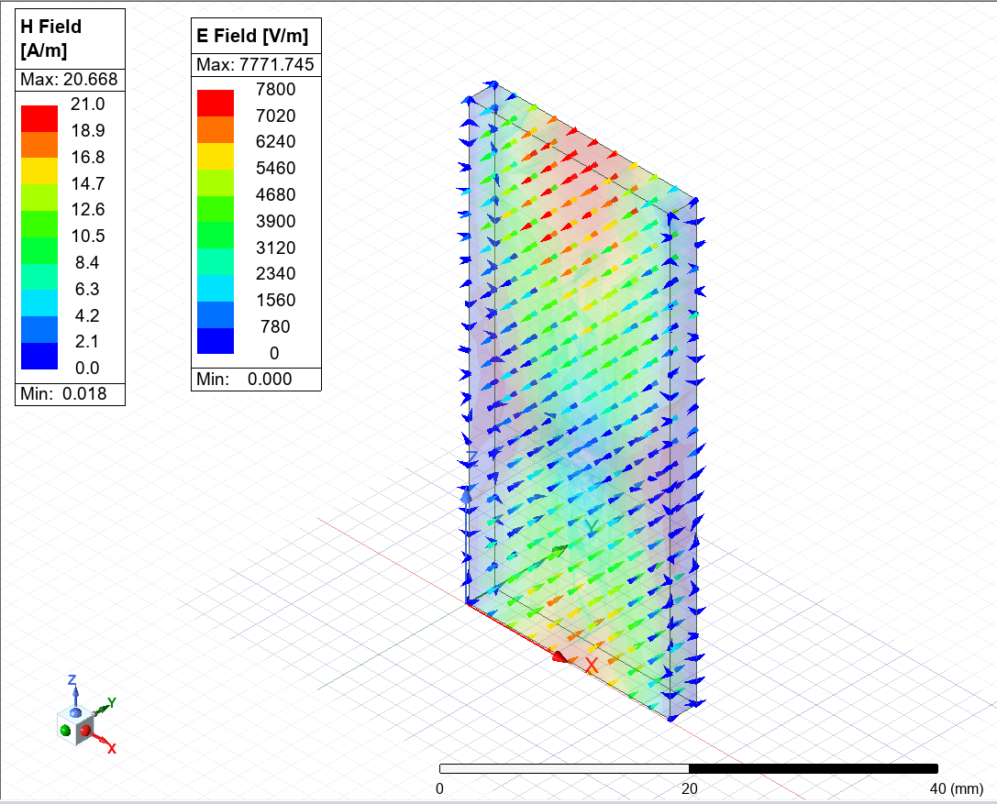
Figure 1, rectangular wave guide results

The dominant mode in a rectangular waveguide is the lowest-order mode that can propagate. ${TE}_{10}$ mode has the lowest cut off frequency, meaning it propagates first before other modes. The equation for the cut off frequency is given in Equation 1 and the answer is given in Equation 2.
$$f_{cmn= }\frac{c}{2}\sqrt{{\left(\frac{m}{a}\right)}^{2}+{\left(\frac{n}{b}\right)}^{2}}$$
Figure 2, Cut off frequency calculation
c = speed or light (3.0 x ${10}^{3}$m/s)
a = waveguide width (23mm)
b = waveguide height (6mm)
m, n = Mode indices (for ${TE}_{10}$: m = 1, n = 0)

For ${TE}_{10}:$ $fc_{10}$ = $\frac{3.0 x {10}^{8}}{2 x 0.023}$
$fc_{10}$ = $\frac{3.0 x {10}^{8}}{2 x 0.046}$
$fc_{10}$= 6.52 GHz
Figure 3, Cut off frequency answer
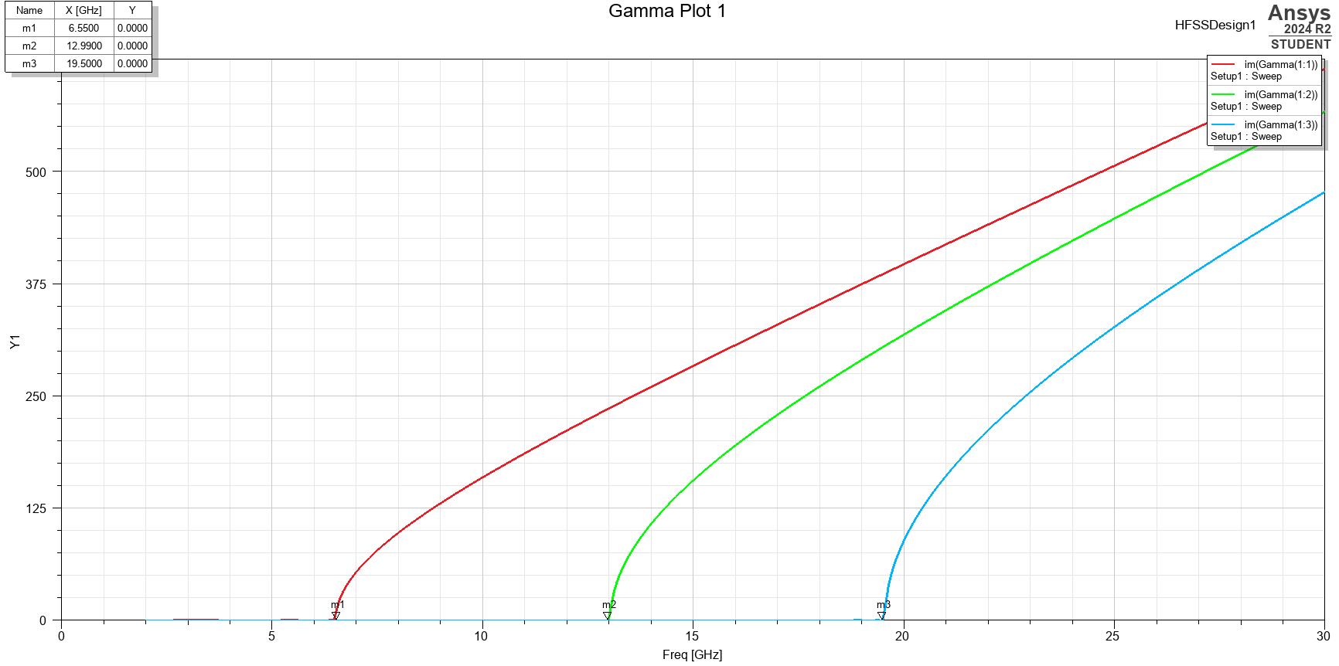
Figure 4, Cut off frequency results
The results shown in Figure 2, show a cut off frequency of 6.5500. Which is very similar to the theoretical prediction.
The cut off frequencies for the first three waveguide modes were determined using the theoretical waveguide cut off frequency equation. The dominant mode ${TE}_{10}$ ​ has the lowest cut off frequency of 6.52 GHz, meaning it is the first mode to propagate when the operating frequency exceeds this value. The next two higher-order modes, ${TE}_{20}$ and ${TE}_{01}$ ​, have cut off frequencies of 12.99 GHz and 19.50 GHz. if the frequency increases beyond 12.99 GHz, the ${TE}_{20}$ mode will also propagate, leading to multimode operation. At 19.50 GHz and beyond, the ${TE}_{01}$ mode is also supported, further increasing wave propagation.
- Mode one – Ensures efficient wave propagation at lower frequencies
- Mode two – Introduces the possibility of multimode operation
- Mode three – Further increases the complexity, potentially leading to interference or power issues.
The port field display was recorded for both port 1 and port 2. The results are shown in Figure 3, the results were as expected for ${TE}_{10}$ The results indicated successful propagation.

Figure 5, E and H field for wave guide
The magnitude of E-field and H-field is the strength (amplitude) of the electric and magnetic fields in each waveguide. The vectors are the direction and orientation of the electric and magnetic fields. Field value results shown in Table 1.
Max and min results | Magnetic field | Electric field
Max | 20.688 A/m | 7771.745 V/m
Min | 0.018 A/m | 0.000 V/m
Table 1, Field values
The results from HFSS show that the simulated electric and magnetic field distributions align with the expected. ${TE}_{10}$ mode behaviour. The electric field reaches a maximum of 7771.745 V/m at the centre of the waveguide, with a minimum of 0 V/m at the boundaries. The magnetic field has a peak value of 20.688 A/m, with a minimum of 0.018 A/m, indicating proper field propagation. The observed field patterns confirm that the waveguide is operating in the dominant. ${TE}_{10}$ mode, as expected. The theoretical analysis of the ${TE}_{10}$ mode in a rectangular waveguide confirms that the electric field exhibits a sinusoidal variation across the width, while the magnetic field follows a cosine variation.

Task 1b:
In this section, the rectangular waveguide is redesigned with Perfect Electric Conductor (PEC) walls and filled with Teflon. The waveguide maintains the same dimensions and simulation parameters.
Using the same equation as before with a slight change, instead of 2, $\sqrt{ɛ_{r}}$ is used meaning a 2.1 relative permittivity of Teflon.
$$f_{cmn= }\frac{c}{\sqrt{ɛ_{r}}}\sqrt{{\left(\frac{m}{a}\right)}^{2}+{\left(\frac{n}{b}\right)}^{2}}$$
Figure 6, TEmn mode equation
Using the equation, the results have been plotted in Table 2 for all three modes.
Mode | Results
1 (${TE}_{10}$ ) | $fc$ = 4.5200GHz
2 (${TE}_{20}$ ) | $fc$ = 9.00GHz
3 (${TE}_{01}$ ) | $fc$ = 13.48GHz
Table 2, Teflon results
The simulated results are shown in Figure 4.
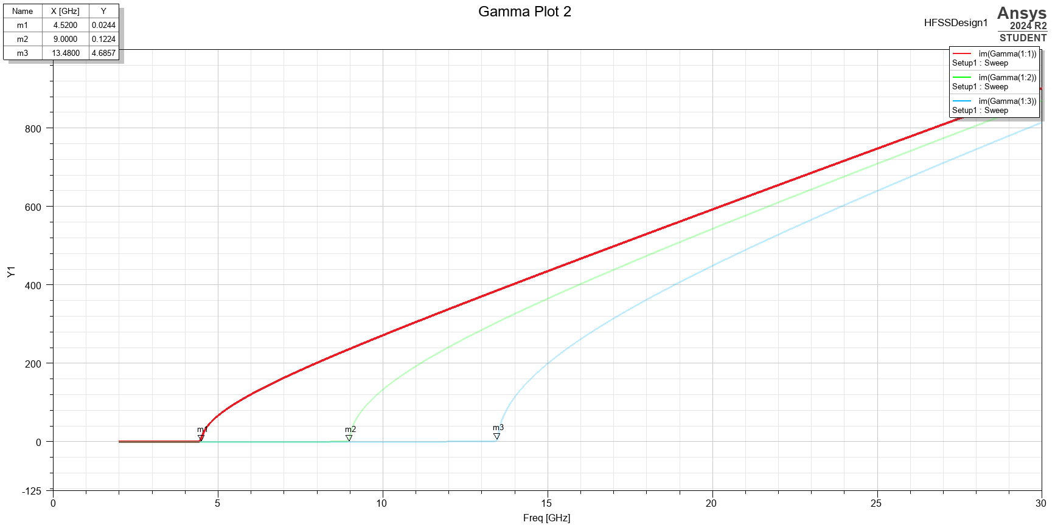
Figure 7, Simulated Teflon results
The results matched the estimated values confirming the accuracy of the waveguide. The decrease in cut off frequencies due to the Teflon filling aligns with expectations, as the permittivity increase lowers the wave velocity inside the waveguide. The simulated results from the Teflon simulation are shown in Figure 5.
Figure 8, Teflon final results

Comparing cut off frequency results
Comparing the results in Table 3, vacuum filled results in a higher cut off frequency. Teflon filled shows a drop in cut off frequencies in all modes. The dominant mode ${TE}_{10}$ shifts from 6.52GHz (vacuum) to 4.52 GHz (Teflon) a 31% reduction.
Mode | Cut off (vacuum) | Cut off (Teflon) | Difference (GHz)
1 (${TE}_{10}$ ) | 6.52 | 4.52 | 2.00
2 (${TE}_{20}$ ) | 12.99 | 9.00 | 3.99
3 (${TE}_{01}$ ) | 19.50 | 13.48 | 6.02
Table 3, comparison of cut off frequencies
The reason for the change in permittivity ($ɛ_{r})$ is due to the speed of light inside the waveguide. Since Teflon increases (2.1) permittivity the speed of light decreases, lowering the cut off frequency. Using a Teflon-filled waveguide enables wave propagation at lower frequencies, which can be beneficial for applications that require lower-frequency operation, such as reduced signal loss and controlled wave propagation.

Task 2:

Half wave dipole antenna
The following dipole antenna was designed with a radius of 1mm intended to radiate electromagnetic waves of:
Operating Wavelength (λ): 230 mm, Dipole Length (L) 115mm and Radius (r) 1 mm:
The antenna was constructed with PEC and the applied excitation through a 50Ω lumped port. To design the dipole antenna, I used the ANSYS [1] programme to execute simulations. The design was within a rectangular radiating surface shown in Figure 6.

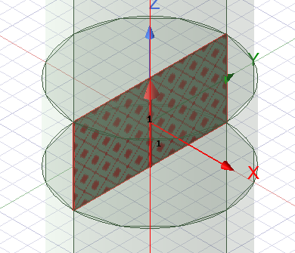
Figure 9, radiating surface

The length of the dipole is 57.5mm

$$L=\frac{λ}{2}=\frac{230}{2}=115mm$$
Figure 10, length equation
The operating frequency is 1.304GHz

$$f=\frac{c}{λ}=\frac{3x{10}^{3}}{0.23} f=1.304 x {10}^{9}Hz=1.304GHz$$
Figure 11, operating frequency calculation

S-Parameter (scattering parameter) plot, is used to analyse how much power is reflected from the antenna. The best resonance, meaning the antenna is radiating efficiently is at 7.3125GHz as shown in Figure 7.
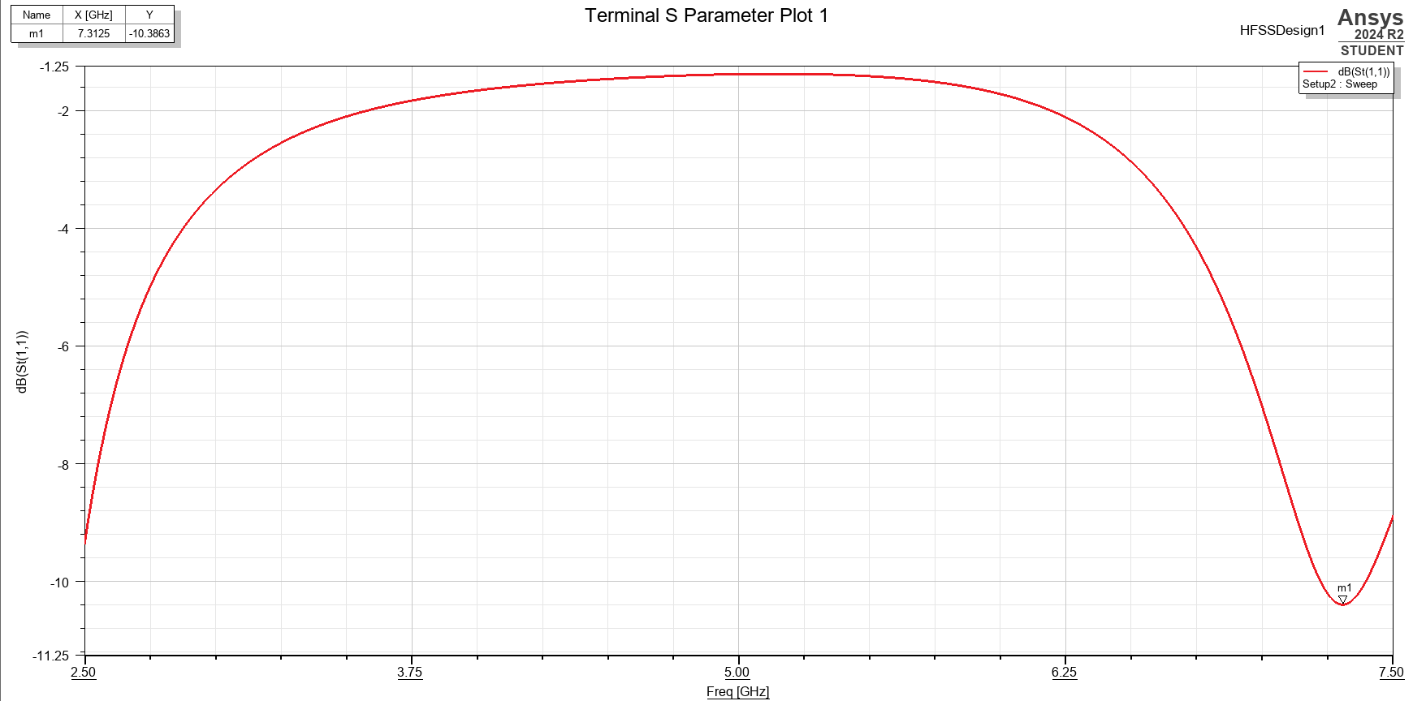
Figure 12, S-parameter

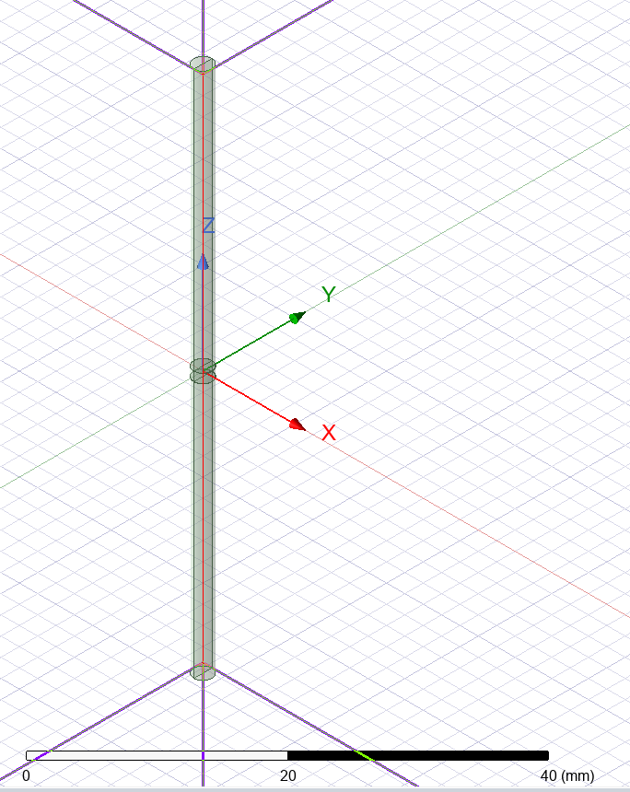
Figure 13, Finished dipole design
Figure 8 shows the final dipole design. The expected Radiation Pattern are Omnidirectional radiation pattern in the H-plane (azimuth plane, XY- plane) meaning it radiates equally in all directions perpendicular to the dipole. The pattern in the E-plane (elevation plane, XZ-plane)—meaning the strongest radiation is broadside to the antenna, with nulls at the ends.
Maximum Radiation: Perpendicular to the dipole (broadside).
Minimum Radiation: Along the dipole axis (nulls at the ends).
Polarization: Typically, linear aligned with the dipole’s orientation.
Actual results shown in Figure 9, minimum gain of -34.32 and a maximum of 5.01.
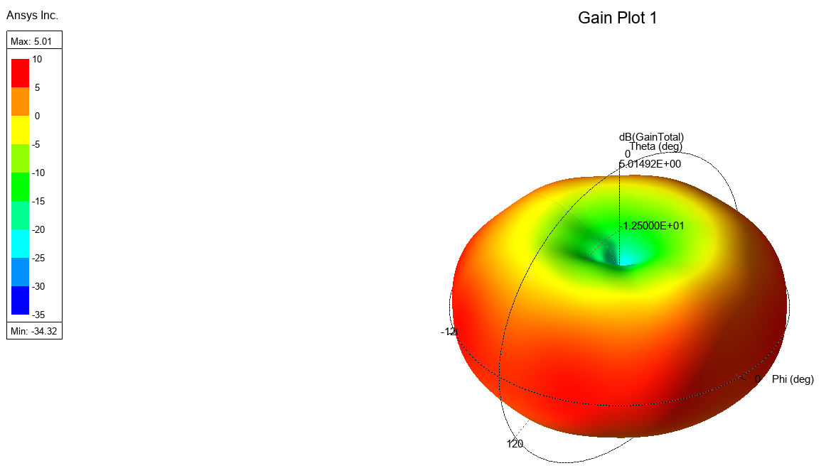
Figure 14, Gain results

Results
The expected theoretical resonance was 1.304GHz, the simulated result was 7.3125GHz. The reasons for this change may have been a scaling issue or simulation boundary conditions. If the same test was carried out again, changing the dimensions of the antenna, material settings or performing parameter sweeps could improve accuracy.

Conclusion
This study explored the design and simulation of a rectangular waveguide and half pole antenna, looking in to their electromagnetic properties. Two rectangle waveguides where made one with vacuum and one with Teflon the results showed that higher permittivity in Teflon lowered the cut off frequency. With the dominant ${TE}_{10}$ mode shifting from 6.52GHz to 4.52GHz. However, the halfwave dipole antenna’s simulated results deviated from theoretical expectations, indicating potential discrepancies due to modelling assumptions, material losses, or boundary conditions. These findings highlight the impact of dielectric materials on waveguide performance and the challenges in achieving theoretical resonance in practical antenna designs.

Task 3: RADAR
‘Listening ears’ are 3 concrete half domes found in Kent, Figure 15, provided early warning for enemy aircraft, they worked by reflecting sound from a focal point of an acoustic mirror to an operator. These where used between 1916 – 1930’s.

Figure 15, Listening ears,

The birth of the radar – 1930’s.
Experiments where conducted by Heinrich Hertz showing radio waves were reflected by metallic objects [2]. The theory behind it was that signals could ‘bounce’ off enemy aircraft highlighting them. On February 26, 1935, there was a successful demonstration of the system using a BBC transmitter while focusing on a test aircraft. After the successful demonstration, tests were conducted via towers, two wooden towers transmitting and four steel towers receiving. This became the first radar station based in Bawdsey, as World War two was starting.
In 1941 the first secret radar system was installed, starting off as temporary systems that soon moved to fixed systems. The Type 7 search radar and Type 13 height finding radar.

What is a radar
Radar (Radio Detection and Ranging) Is a system used to detect objects using waves. Electromagnetic energy travels through the air at a constant speed - approximately the speed of light (186,000 miles per second). The distance between the reflecting object and the radar site is determined by measuring the time between transmission and reception of the energy pulses [3]. These electromagnetic waves are used for recognising, tracking, and locating objects at a distance. They work of sending a wave out and observing echo’s, Figure 16. With the results you can measure size, direction of movement and speed. Radars can be used where cameras fall short, radars can “see through” the elements like fog and rain where a camera can’t, while also decreasing privacy concerns and covering a larger area then a camera can reach.
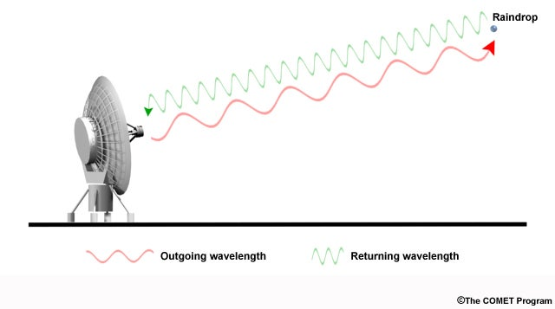
Figure 16, Radar echo waves

Traditional radar use
Traditionally radars are used for military purposes, being used to detect the enemy, in the air, land and sea. While radars are commonly thought to be used in a military context, commercially they are used in the archaeology, mining, meteorology and the automotive industries.

Technological advances
- 1916 – Listening ears invented
Look back at section “History of the radar”
- 1935 - 1st military application
A chain of early warning systems where erected along the south coast of England, with the ability of picking up enemy aircraft at 80miles away.
- 1940 – World war two meant significant improvements in radar technology
A device called the cavity magnetron, produced microwaves meaning improved accuracy and achieved greater distance.
- 1951 – Phased array
Powered by groups of antennas to create a high-gain beam, meaning more flexible scanning
- 1960 – Doppler radar
Bouncing microwave signals of a desired target and analysing the objects motion [4]
- 1978 – Colour radar, visual data
Used to determine if something is moving away or towards the radar, typically use red (moving away) and green (coming towards).
- 1980 – Transition from analogue to digital
Adding ADC (analogue to digital converters) to the front end, then processed by computers. Improving performance.
- 1995 – Synthetic aperture enhancing imaging capabilities
Used to track oil spills and icebergs as it reacts with pulse energy on physical structures.
- 2020 – Frequency modulated continuous wave radar
Short range used for distance determining. Can be used when there is more than one echo returning. Used in aircraft landing.

Challenges and failures
- Range issues
- Target type and location accuracy
- Distinguishing targets
- Interfering echoing
- Can’t track multiple objects at once
- Stealth technology
Target sizes picked up by a radar will be determined by its “cross section” measured in square meters meaning what’s seen may not be its actual size. Air-crafts cross section can differ depending if you’re looking at it broadside or not. These particular targets of interest fluctuate rapidly, with cross sections changing by a factor or 10 to 1000 in respect to the radar, after extensive research into radar results we can tell what is being echoed back. Some radars can’t make out what is a bird or drone as cross sections can be similar, so may disregard them. Drones also have the capability of flying in swarms, with Israel being the first country to use a drone swarm in combat and 8,100, being the Guinness world record as of September 2024 [5] Figure 17.
Stealth vehicles will have a “spectral signature” which varies its reflectance of material with respect to wavelengths [6].
Nuisance echo’s such as rain, meteors or birds can limit Radar capabilities. The atmosphere can form “ducts” that trap and guide radar energy around the curvature of the Earth and allow detection at ranges beyond the normal horizon [7].
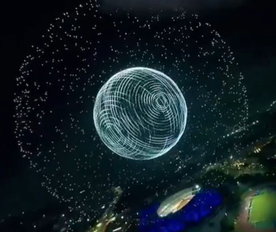
Figure 17, Guinness world record

Societal and environmental impacts

potential hazards
Radiation risk
High doses of radiation can affect the body by effecting the functionality of tissues and organs, cause vomiting or nausea or in extreme cases it can cause death. [8]

Positives
Safety navigation systems
Primarily used at sea for navigating and manoeuvring ships.
Weather forecasting
Radars are used to observe and understand weather as they can “see” inside clouds. 15-18 radars cover the whole British Isles.
Air traffic control
Ensuring safe operations of both private and commercial flights, coordinating movements and directing them for landing.
Law and enforcement
Most commonly known systems are the ones used by the police to detect speeding drivers. People also use radar to detect wither they are being picked up from a police camera. While, not illegal to own, they are illegal to use to spoof the police cameras.
Radars most known use is in defence, identifying threats such as missiles, aircraft or drones.

Recent developments
With drones becoming an increasing threat technology needs improving.

- Doppler radar
High-resolution doppler radars help distinguish birds from drones, reading signatures produced from wingbeat frequencies and blade frequency. AI analysis is being implemented along with improved frequency resolution.
- AI for radar processing
Clutter causes issues with traditional radars machine learning can help learn patterns that drones produce compared to other objects (movement patterns, size, speed). Real time processing adapts to new drone types and behaviours.
- Multi static and passive radars
Multi static - Multiple transmitters and receivers improve accuracy.
Passive radar – analyse existing signals instead of emitting its own.
Higher sensitivity capable of detecting stealth drones, lower power consumption and increased range.
- 3D radar
Provide height and range for precise tracking. Detects in lower altitudes and can track swarm attacks.
- Frequency modulated continuous radar
Continuously detects and measures frequency’s shifts to detect objects, used with slow-moving, low-altitude drones. Higher bandwidths improve detection in close ranges and can be used with thermal sensors.
- Cognitive radar systems
AI driven with adaptive waveforms by learning its environments to adjust transmission parameters. It’s self-learning, reduces false alarms and can adjust frequencies to counter stealth drones.

Radars and drones
Traditional radars use echoing waves and are used to pick up larger objects then drones. Issues become apparent when the drone’s cross section are too small, they move at a slow speed or low altitude.
$$σ=lim4πR^{2}\frac{|E_{s}|²}{{\left|E\right.}_{o}|²}$$
Figure 18, Radar cross section
$E_{0 }$ = Electronic field strength of incident wave impinging on target
$E_{s}$ = Electronic field strength of scattered wave at radar (in range R)

Example of RCs

Target | RCs in M² | RCs in dBsm
F-117A Nighthawk | 0.001 – 0.01 | -30 - -20
Nano-UAV | <0.01 | <-20
(Bird) Sparrow | 0.017 – 0.018 | -17.7 - -17.4
(Bird) Eagle | 10 - 25 | 10 -14
Walking man | 0.5 – 1.3 | -3 -0.8
Commercial quad copter | 0.032 | -15
Table 4, Example RCs [9]
Speed and altitude challenges
Drones blend into the environment and move slower than a commercial aircraft, sometimes hovering. A lot of radars filter out slow moving objects thinking they are noise clutter.

Proposed improvements
From looking at Table 4 [9]the best proposed improvements would consist of the following built into one system.
- Micro-doppler radar
Birds and drones have similar cross references, movement signatures will differ, wing flaps are irregular movements while drones have stable high frequency blade motions. Doppler analysis extract motion figures, with AI classification will distinguish the difference.

- Higher frequency bands
A higher frequency radar has better resolution and sensitivity for detecting more objects like drones. A combination of the two higher frequency radars would detect most size drones.

Radar Band | Frequency | Usage
1-2 GHz | Long range detection | Large aircraft
8-12 GHz | Medium range | Best for drones
12-18 GHz | Short range | Ideal for small drones
Table 5, Radar bands
- Multi-Static & Passive Radar for Stealthy & Low-Altitude Drones
Stealth drones can have RCs of <0.01m² and can escape traditional radars, others blend with ground clutter. Multiple receivers in multiple locations can detect small RC objects. Passive radar, to detect drones that absorb radar waves.

- 3D Radar for Precise Drone Tracking
3D radars provide altitude, range and azimuth which is much more detailed then the 2D radars that only do range and azimuth. This technology can track drone altitude and movement.

- AI & Machine Learning for Smart Target Classification
A mix of radar, acoustic and optical sensors provide multi-layer detection. Deep learning models can train on a vast amount of data. Eliminating false alarms caused by birds and clutter.

Conclusion
As drones continue to evolve in both capability and accessibility, the need for more advanced radar detection systems becomes increasingly important. Traditional radar systems, while effective for detecting larger aircraft, struggle with the unique challenges posed by drones, such as their small cross-section, low-altitude flight, and ability to manoeuvre unpredictably. Recent advancements in radar technology, including AI-driven cognitive radar, micro-Doppler analysis, and 3D radar, have significantly improved detection capabilities. These innovations enhance accuracy, reduce false alarms, and enable the tracking of stealth and swarm drones. Additionally, integrating multi-static and passive radar systems provides better coverage and sensitivity, even for low-observable targets. Despite these improvements, challenges remain, such as mitigating nuisance echoes, improving target classification, and addressing potential radiation risks. However, by combining advanced radar technologies with AI and machine learning, future systems can adapt to emerging threats more effectively. Ultimately, the continuous development of radar-based drone detection is crucial for enhancing security, protecting critical infrastructure, and ensuring safe airspace operations. With ongoing research and technological integration, radar systems will continue to evolve, offering greater precision, reliability, and adaptability in an increasingly drone-populated world.

References

[1] | “https://www.ansys.com/academic,” ANSYS, [Online]. Available: https://www.ansys.com/academic. [Accessed 18 02 2025].
[2] | A. d. r. m. RAF, “Birth of the Radar,” RAF, Air defence radar museum, [Online]. Available: https://www.radarmuseum.co.uk/history/world-war-two/#:~:text=In%20May%201935%20Watson%2DWatt,world's%20first%20working%20radar%20system.. [Accessed 05 02 2025].
[3] | C. Bloom, “Introductiont to radar,” Solutions Architect for Arrow Electronics, [Online]. Available: https://www.arrow.com/en/research-and-events/articles/introduction-to-radar. [Accessed 05 02 2025].
[4] | D. W. Wragg, “Doppler radar (Wikipedia),” A Dictionary of Aviation , 1973. [Online]. Available: https://en.wikipedia.org/wiki/Doppler_radar#cite_note-1. [Accessed 05 02 2025].
[5] | A. magazine, “Record-breaking 8,100 drones take to sky for show in China,” AV magazine , 16 09 2024. [Online]. Available: https://www.avinteractive.com/news/drones/record-breaking-8100-drones-take-to-sky-for-show-in-china-16-09-2024/#:~:text=Two%20Guinness%20World%20Records%20were,have%20broken%20Guinness%20World%20Records.. [Accessed 05 02 2025].
[6] | wikipedia, “Spectral signature,” wikipedia, 10 2023. [Online]. Available: https://en.wikipedia.org/wiki/Spectral_signature. [Accessed 05 02 2025].
[7] | M. I. Skolnik, “Factors affecting radar performance,” Britannica, 09 01 2025. [Online]. Available: https://www.britannica.com/technology/microwave-oven. [Accessed 05 02 2025].
[8] | “Radiation and health,” World health organisatoin , 07 07 2023. [Online]. Available: https://www.who.int/news-room/questions-and-answers/item/radiation-and-health#:~:text=What%20are%20the%20acute%20health,burns)%2C%20or%20even%20death.. [Accessed 06 02 2025].
[9] | C. B. W. Wolff, “Radar and electronics warfare,” in Pocket guide , Germany, Rohde and schwarz, pp. 104-105.

