

Managing Enterprise in the 21st Century

Business Plan

Please put name/logo/website of your company here

Daniel Fratczak
Student Number 2424154

Submission Date:22/11/2025
Lecturer: Charles Obinwa

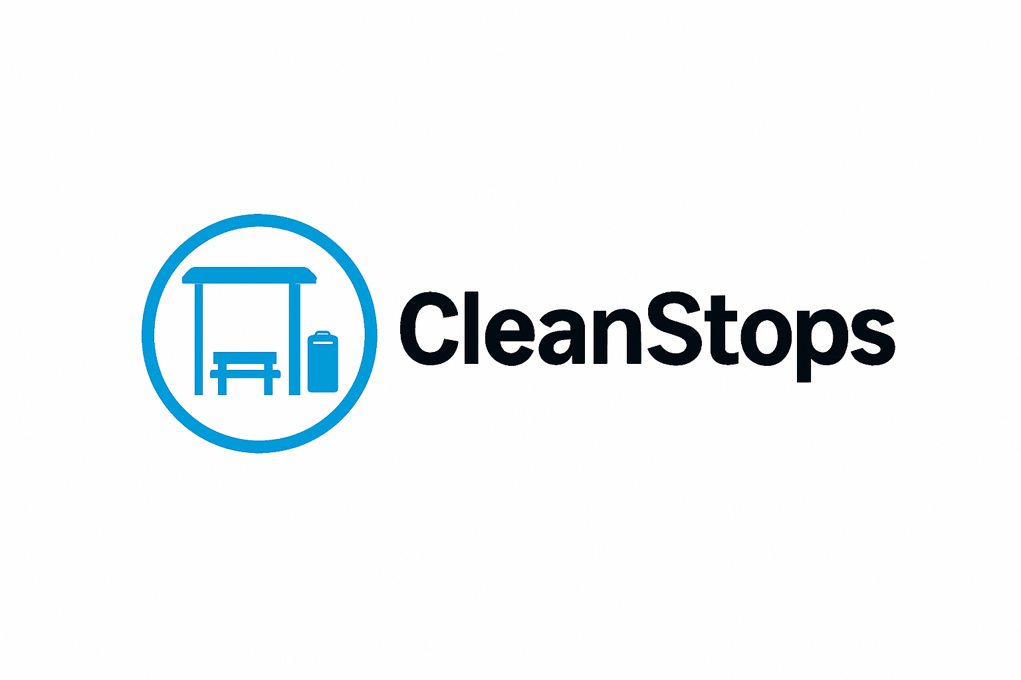
Table of Contents
Group Information 2
Executive Summary 4
Business Concept 5
Business Description 5
Product Description 5
Business Objectives (SMART Objectives) 5
Short-Term Objectives (less than a year) 5
Long-Term Objectives (less than a year) 5
Market Analysis and Marketing Plan 6
Market Analysis (Competitors, Customers, Target Groups) 6
PESTEL Analysis 6
Marketing Mix (4Ps) 6
Management Team 6
Management Team and Their Background 7
Organisational Chart 7
Key Milestones 7
Financial Plan (One Year) 7
Sources of Finance 7
Cash Flow Forecast 7
Sales Forecast 7
Cost of Production Forecast 7
Break Even Analysis 7
Operations and Management Plan 7
Production of Good and Service 7
Technology Plan 7
Human Resource Plan 7
Expansion Plan 8
Reference List 8
Appendices: 9

Executive Summary

Clean Stops Solution is a start-up dedicated to improving cleanliness and hygiene across public transport stops in London. The business provides eco-friendly cleaning and maintenance services for bus stops, train stations, and transit shelters. With public demand for cleaner and safer commuting environments increasing, Clean Stops will address this need using sustainable cleaning methods and efficient service routines.

Business concept and product/services description

The start-up focuses on high-frequency, visible cleaning at bus stops and shelters. Transport authorities increasingly need reliable contractors who can maintain cleanliness without long procurement processes or excessive costs.
Clean Stops provides scheduled cleaning, litter removal, hygiene maintenance, graffiti cleaning and visual condition reporting at public transport stops. Other services include notifying councils of damaged infrastructure, Light maintenance checks and eco-friendly product usage.
The business fulfils a need for improved safety, cleanliness and public satisfaction in London’s transport network. Local councils often outsource cleaning services, and Clean Stops offers a simple, sustainable, and cost-effective alternative.
The business operates in London and serves high-traffic locations where public hygiene has a clear impact on commuter experience.

Business Objectives (SMART Objectives)
Short-Term (Year 1)
- Secure service contracts with 50 London transport stops.
- Complete all work personally to maintain quality standards.
- Build strong relationships with 2–3 London borough councils.
- Recover start-up investment of £10.000 by the end of Year 1.
Long-Term (3-4 Years)
- Expand to 100+ stops across Greater London.
- Introduce digital monitoring tools (simple sensors, QR-based reporting).
- Hire 1–2 part-time assistants once contract volume grows.
- Develop partnerships with sustainability organisations.

Legal format and Management structure

Legal format: Clean Stops is a sole-proprietor business, the owner is responsible for all operational, administrative, and strategic functions sole trader easy to set up: registering as a sole trade is straightforward and requires minimum paperwork compered to forming a company, running as sole trade is generally cheaper, with fewer administrative and accounting expenses.

Management Team and Their Background

Owner and Operator
The business is managed entirely by the owner, who has a background in management and experience coordinating operations, handling administrative duties and overseeing service quality. This experience supports efficient planning, scheduling, financial control and communication with local councils.

Key Responsibilities
- Cleaning and maintenance work
- Customer communication
- Budgeting and purchasing supplies
- Preparing invoices and financial records
- Marketing and networking
- Planning expansion

Background and Experience
The owner brings several years of management experience, with strong skills in team coordination, scheduling, customer communication, and service quality control. This background supports effective operations, budgeting, and client management. Experience working with public-facing environments ensures an understanding of the standards councils and transport authorities expect. A personal commitment to cleanliness, sustainability, and community wellbeing drives the vision for Clean Stops.

Key Responsibilities
- Operations: Personally carry out all cleaning, monitoring, and maintenance activities at transport stops.
- Customer Relations: Communicate directly with local councils and clients, ensuring fast response times and reliable service delivery.
- Financial Management: Handle budgeting, invoicing, pricing, and cost control.
- Marketing: Promote Clean Stops to local councils and transport authorities, including outreach, networking, and maintaining a professional image.
- Quality Assurance: Maintain high cleaning standards using eco-friendly products and ensure consistent service across all stops.

Future Management Outlook
As the business expands, roles such as Operations Assistant, Maintenance Technician, or Marketing Coordinator may be added. However, during the first year, the owner will remain responsible for all aspects of business operations, ensuring close control over quality and customer satisfaction.

Organisational Structure (One-Person Operation)
Owner / Manager
│
┌──────────┬─────────────┬───────────────┬──────────────┐
Operations Marketing Finance/Admin Service Delivery
Duties Duties Duties Duties

PESTEL Analysis

Political
- Councils prioritise public hygiene → Opportunity
- Tendering processes can be slow → Threat

Economic
- Councils maintain stable budgets for essential cleaning → Opportunity
- Inflation may increase product costs → Threat

Social
- Commuters expect higher cleanliness standards → Opportunity
- Negative public feedback spreads quickly → Threat

Technological
- Sensors can support monitoring in the future → Opportunity
- Tech upgrades may require investment → Threat

Environmental
- Eco-friendly cleaning strongly supported → Opportunity
- Weather may disrupt cleaning schedules → Threat

Legal
- Workplace safety rules must be followed → Threat
- Environmental compliance increases credibility → Opportunity

Market Analysis and Marketing Plan (Segmentation, Targeting and Positioning)

Unique Selling point (USP): Our value lies in consistency, affordability, and sustainable methods.

Market Segment
The market for Clean Stops is divided into specific groups based on their roles in public transport maintenance and their interest in cleanliness, sustainability, and operational efficiency. The primary segment consists of local councils and municipal authorities in London, as they are responsible for maintaining public transport stops and have a strong interest in improving hygiene standards for residents. Public transport operators, such as bus companies and station management teams, form another key segment because they aim to enhance commuter satisfaction and meet regulatory cleanliness standards. A further segment includes private facilities management companies that oversee outsourced cleaning and maintenance tasks and may seek eco-friendly, cost-efficient solutions like those offered by Clean Stops. Geographically, the focus is on urban and suburban areas with high commuter traffic, especially locations where cleanliness contributes significantly to public perception and service quality. Psychographic ally, the business targets organisations that prioritise environmental responsibility, public health, and community wellbeing. Behaviourally, Clean Stops serves clients who require reliable, regular cleaning services and value measurable improvements in hygiene.

Industry Overview
The UK public transport industry relies heavily on contracted cleaning and maintenance providers to maintain hygiene standards at bus stops, train stations and other transit infrastructures. Since the COVID-19 pandemic, there has been a significant increase in public expectations regarding cleanliness and environmental responsibility. Local councils, including Transport for London (TfL), are under pressure to increase hygiene and reduce waste, which has created market opportunities for specialist cleaning companies that use eco-friendly products and modern, efficient systems.

Market Analysis (Competitors, Customers, Target Groups)
The primary customers are: Local councils, Transport authorities, Property management companies, Private operators of bus stops or small terminals. Primary Target Group: Local councils in London seeking outsourced cleaning and hygiene solutions for public transport stops.
Secondary Target Groups: Transport operators (e.g., bus companies) and Facility management firms maintaining public infrastructure.
These groups are ideal because they operate large numbers of transport stops and prefer long-term service contracts.

Competitors
Competitors include large cleaning contractors, general street maintenance companies, and local waste-management services. Few specialise in transport stop hygiene, which gives Clean Stops a niche advantage. Other competitors include Traditional Street cleaning contractors, Facility management companies offering broad cleaning services and Small independent cleaning businesses.
However, few competitors specialise specifically in transport-stop hygiene or use eco-friendly cleaning methods.

Competitive Advantage
- Specialised service focused only on public transport stops.
- Eco-friendly cleaning products.
- Reliable single-operator service with consistent quality.
- Lower overhead costs than large contractors.

Marketing Mix (4Ps)

Product
Eco-friendly cleaning service for public transport stops.

Price
£150 per stop per month. Clean Stops offers a subscription-style cleaning service with fixed monthly pricing:
Package:
- £150 per stop per month
- Eco-friendly cleaning products used at all locations
- Routine monitoring and reporting
- Flexible scheduling based on location needs
- Emergency cleaning available at additional cost

Place
London boroughs with high commuter density.

Promotion
- LinkedIn networking
- Council tender submissions
- Website demonstrating service quality
- Free pilot clean for 1–2 stops
- Partnerships with environmental groups

Key Milestones
Time Frame | Goal

Months 1–2 | Purchase equipment, set up branding, begin outreach

Months 3–4 | Secure 10 stops

Months 5–6 | Expand to 25 stops

Months 7–12 | Achieve full 50-stop target

Financial Plan (One Year)

Startup Cost
Description | Amount 10.000
Equipment | £3.500
Van | £3.500
Website | £600
Total | £7,600

Fixed cost
Description | Amount
Insurance | £ 350
Phone and Internet | £70
Software and Apps | £150
Total Fixed Costs per Month | £570

Variable
Description | Jan | Feb | Mar | Apri | May | Jun
Eco-friendly Cleaning Supplies | £300 | £300 | £300 | £300 | £300 | £300
Travel / Fuel Costs | £200 | £200 | £200 | £200 | £200 | £200
Maintenance & Replacement Materials | £400 | £450 | £500 | £450 | £500 | £475
Total Monthly Variable Costs | £900 | £900 | £1000 | £950 | £1000 | £975

Cashflow statement
Description | Jan | Feb | Mar | Apri | May | Jun
Fixed cost | £570 | £570 | £570 | £570 | £570 | £570
Variable cost total | £900 | £900 | £1000 | £950 | £1000 | £975
Total Operating cost | £1470 | £1470 | £1570 | £1520 | £1570 | £1545
Revenue forecast | £800 | £1300 | £1750 | £2300 | £3300 | £3700

Profit/Loss
 | -£670 | -£170 | £280 | £780 | £1730 | £2155

Founding needed 8,440

Personal Savings
This is the primary source of finance for the business. Personal savings demonstrate commitment, reduce loan dependency, and avoid interest payments.
Contribution: £10,000 (to cover start-up equipment, initial supplies, insurance and marketing).
Why suitable:
- No repayment pressure
- Keeps full ownership and control
- Ideal for a small sole-trader start-up with low initial costs

Reference List

Clean Stops internal business data (2025).
Greater London Authority (2024). Transport Infrastructure and Public Cleanliness Standards. London: GLA.
Start Up Loans UK (2024). Cash Flow Forecast Template. Available at: https://www.startuploans.co.uk
UK Government (2024). Health and Safety in Public Spaces. London: HMSO.
GOV.UK. (2024). Start a Business: Guidance for Sole Traders
Start Up Loans UK. (2024). Business Planning Templates.
Available at: https://www.startuploans.co.uk/business-guidance/business-planning-templates/ (Accessed:

Appendices:

Appendix A – Financial Charts
- Sales Forecast Chart
  - Shows monthly revenue based on 50 locations at £150 per stop.
  - Demonstrates stable, predictable income across the first 12 months.
- Cash Flow Chart
  - Visualises monthly inflows and outflows.
  - Highlights the month the business becomes cash-flow positive.
- Break-Even Chart
  - Displays fixed costs, variable costs, and revenue per stop.
  - Indicates the exact point where Clean Stops covers all operational expenses.

Appendix B – Startup Cost Breakdown
- Equipment and tools
- Eco-friendly cleaning supplies
- Insurance & licensing
- Marketing and branding
- Uniform and safety gear
- Total start-up investment required £10.000

Appendix C – Operational Documents
- Example cleaning schedule
- Sample maintenance checklist
- Client reporting form (daily condition report)

Appendix D – Market Research Summaries
- Summary tables of competitor pricing
- Overview of customer expectations
- Key opportunities identified in the London transport sector

Appendix E – Legal Compliance
- Health & Safety compliance documents
- Environmental product list (eco-certified cleaning supplies)

Appendix F – Organisational Chart
(Sole trader structure)
- Owner → Operations, Cleaning, Administration, Marketing

Appendix G – Technology Overview
- Description of eco-friendly products
- Plan for future IoT sensor implementation

Appendix H – Additional Supporting Materials
- Logo

