

Student Name : Tomas Adam
Student Number : 1917610
Module NO : BMSW4003_LON
Module Title : Digital Skills and Research Methods
Module Lecturer’s Name: Modak Koushik

_______________________________________________________
University of Wales

Digital Skills and Research Methods:
A study on the impact of Virtual Learning Environment

Contents
Abstract 5
Introduction 6
Acknowledgment 7
Aim and Objectives of the research 8
Literature Review 9
Research Methodology 12
Research Questions 13
Data Analysis & Findings 15
Conclusion 23
Bibliography 24

Figure 1 VLE is better than doing class in campus physically 15
Figure 2 What are negative impacts of VLE 16
Figure 3 Student Capable to understand all the topics easily 17
Figure 4 VLE can impact learning for student positively 17
Figure 5 Can VLE encourage student and teacher to learn independently 18
Figure 6 VLE motivate student and teachers to learn more 19
Figure 7 Students prefer to virtual learning for 19
Figure 8 Virtual learning software help educational organizations 20
Figure 9 Barriers of VLE 21

Abstract
We are used to learn the studies but understanding is difficult unless it is practiced practically. So, academic system has been gradually developed considering the priority for practical application by enabling students to do project as per their curriculum. Learning approach needs to transform giving priority to information and communication technology for teaching and learning purpose. Virtual learning environment can ensure quality solution to learning. There are many advantages of VLE and at the same time few disadvantages to implement in university or college. Most of the Universities and colleges are giving high priority on Virtual Learning Environment because students can easily access the platform at their convenient time schedule. This research is mainly conducted considering the impact of Virtual Learning Environment (VLE) for academic life. When the study materials are up to the mark that every student can easily understand then the purpose of Virtual Learning becomes successful. On the other hand, poor quality materials can not fulfill the aim of Virtual Learning. So, it is a challenging task to engage learners via online. As face to face teachers can give any lecture easily and students can be motivated easily but e-learning is a platform where effective tools and techniques are required for motivation. This research paper also gives importance on using the effective tools to motivate the student. Moodle is mostly commonly used VLE which is free to use and IT team constantly works for the development of this platform. It is free and open source for learning management system.

Introduction
Virtual learning environment is a platform where the design for teaching and learning is made in such a way with handy tools so that every student can be able to learn by using computer and internet source. VLE mainly considers all the necessary elements to ensure the map for academic curriculum. These mainly include the way to track the student, support given by online to teachers and students, ensure the way of communication like email, chatting etc. and another necessary web link for using external platform via internet. (Clarke, 2013) In VLE there is ID for teacher and student that they need to use for getting the access in online. Teachers are authorized with special modification that they can do on curriculum when necessary. There is various software like blackboard, WebCT, lotus etc. for VLE. (Research Gate, 2020)

Acknowledgment
To complete this research paper everyone cooperates with their extended hands specially all the students and teachers. I am also grateful as there are plenty of surveys conducted on this topic which helped a lot as secondary source.
I am also thankful to the authority of the University of Wales Trinity Saint David London Campus as they allow me to conduct such survey on Virtual Learning Environment.

Aim and Objectives of the research
Research Aim
The main aim of this paper is to disclose the impact of Virtual Learning Environment.
Research objectives
Objectives are as follows:
- To identify the importance of Virtual Learning Environment
- To identify alternative effective ways as learning platform
- To identify the effective tools used for e learning
- To obtain indicator that helps to understand the relation between VLEs and students’ performance.
- To identify challenges that teachers face and develop strategy to fulfill the requirements and needs.

Literature Review

In a study that was conducted on the students of University of Wolverhampton shows that students were not able to understand the class lecture and subject content. The conducted study reveals the students are not getting enough time to accomplish the lecture in a schedule limited period. They had conducted investigation where they have discovered that they are not giving concentration on studies due to lack of motivation. So, to motivate the students, the authority has created multimedia web-based technology and it is effective in promoting the performance of the students. In VLE, the students can understand lectures easily and able to complete the educational material instantly.

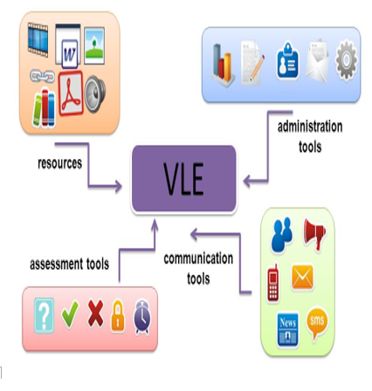
Virtual Learning Environment should be created in such a way that can ensure proper resources, assessment, administration and communication tools otherwise aim can not be achieved. (Kangasniemi, 2015) With the rising demand for digital technology enables the e learning platform more flexible for the students where many training materials and resources are easily accessible. By constant studies students can develop their skills and capabilities that increases employability skills. Almost all organizations are giving high priority on technology by using online platform. (Levy, 2015)

Self-management, problem solving capabilities, skills of people with competency such as literacy, numeracy and information use effectively with communication technology can ensure employability skills. (Yorke, 2004) Many researches have been conducted to create awareness for using VLE but there are few which gives emphasize on the factors that can lead to increase the motivation of students. Learning through VLE is very cost effective and productive. To ensure successful virtual learning training model there are elements that need to be consider for effective outcomes. These are cloud based learning management system (LMS), model of infrastructural designs and strong planning for technology uses. (Virtual Training Model, 2020)
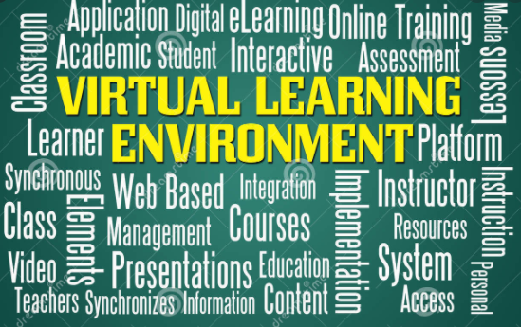
The Technology Acceptance Model (TAM), which is one of the most widely used models in the literature, was first proposed by Fred D. Davis in 1985 within the frame of his doctorate thesis as a model for testing and developing user acceptance of computer-based information systems. (Kurt, 2017)
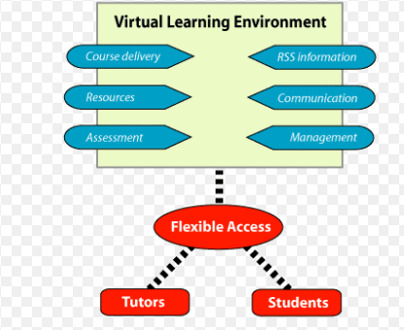
To identify the student’s behavior and attitudes toward using VLE a research was conducted with 522 students in Leeds University of UK and 510 undergraduate students of Sakarya University of Turkey. The result was very positive for the Leeds University because their students are very comfortable of VLE platform but students of Sakarya University were comparatively less positive towards using VLE platform. So, the impact of VLE is very effective for the students in UK because they accept it positively.

Research Methodology

Research design and method
This study is based on quantitative with descriptive feature where experimental research data used from secondary sources. Convenience Sampling method is also considered to conduct this study.
Sources of data
Primary and secondary sources are used for data collection.
Tools of data collection
Questionnaires are used as an effective tool for collecting primary data.
Data analysis
Data collected from Primary and secondary sources are analyzed by using excel and graphical presentation will be utilized.
Sample size
The size of data will be 100.

Ethical consideration
All participants are assured with the purpose of collecting information and ensured about maintaining confidentiality.

Research Questions
- Do you think class on VLE is better than doing class in campus physically?
-Yes
- No

- What are negative impacts of VLE?
- Communication gap
- Opportunity to ignore the study
- No lacking
- Does the student capable to understand all the topics easily on VLE?
- Yes
- No
- VLE can impact learning for student positively?
- Agree
- Disagree
- Can VLE encourage student and teacher to learn independently?
- Agree
- Disagree
- Can VLE motivate Student and teachers to learn more?
- Yes
- No
- Sometimes
- Why do students prefer for virtual learning?
- Amenity learning opportunities from home
- Cost savings
- Great source of books in online
- How does virtual learning software help educational organizations?
- To monitor the efficiency of training and education system
- Materials can easily be updated
- Lecture copies, video presentation can be easily stored
- What are the barriers of VLE?
- Face problems who can not use technology
- Physical presence required for lab activity

Data Analysis & Findings
This study is mainly focused on finding the impact of Virtual learning environment. (The Journal, 2020) To collect primary data using google form in online questionnaires were provided to the 100 respondents and all of them responded. As a secondary source there are various studies published in online considered while completing this report.

 | Yes | No
VLE is better than doing class in campus physically | 80 | 20
 | Communication gap | Opportunity to ignore the study | No lacking
What are negative impacts of VLE | 20 | 10 | 70
 | Yes | No
Student capable to understand all the topics easily | 80 | 20
 | Agree | Disagree
VLE can impact learning for student positively | 85 | 15
 | Agree | Disagree
Can VLE encourage student and teacher to learn independently | 90 | 10
 | Yes | No
VLE motivate Student and teachers to learn more | 88 | 12
 | Amenity learning opportunities from home | Cost Savings | Great source of books in online
Students prefer to virtual learning for | 60 | 20 | 20
 | Efficiency Monitor of Training | Easily updating the materials | Lecture, Video upload, presentation
virtual learning software help educational organizations | 50 | 20 | 30
 | Face problems who can not use technology | Physical presence required for lab activity
Barriers of VLE | 40 | 60
Question-1
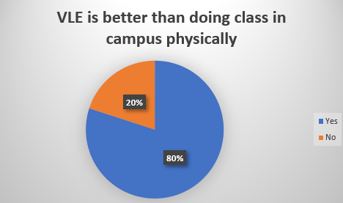
Figure 1 VLE is better than doing class in campus physically

Facing diversified challenges, we can see that almost 80% respondents prefer to do class using VLE platform. On the other hand, only 20% respondents prefer to do class by physically attending to the campus. So, we can conclude that respondents are accepting this platform very positively.

Question-2
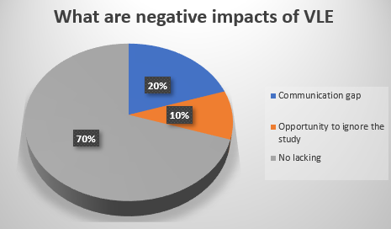
Figure 2 What are negative impacts of VLE
From the chart we can see almost 20% respondents shared VLE can create some communication gap which does not occur in face to face meet. Students can ignore to learn when the platform is used in online that 10% respondent shared. But the positive thing is 70% respondents believe that VLE does not have any issue.

Question-3
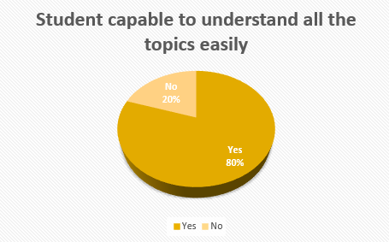
Figure 3 Student Capable to understand all the topics easily
From the above chart, it is illustrated that almost 80% of total students has responded positively and the students can easily understand entire topics in this VLE. On the other hand, comparatively less percentage of the students are unable to realize the topics which is 20%.
Question-4
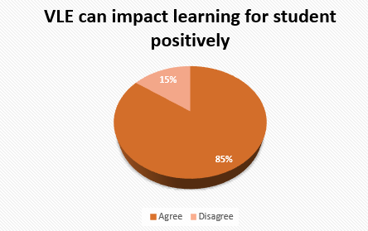
Figure 4 VLE can impact learning for student positively
The above chart expresses that there is a positive impact of the students in VLE. Most of the students are agreed on the topic of VLE can create positive impact in the learning section. Here, 85% of the students give their opinions positively. On the contrary, 15% of the students respond negatively and they are disagreed the above topic.

Question-5

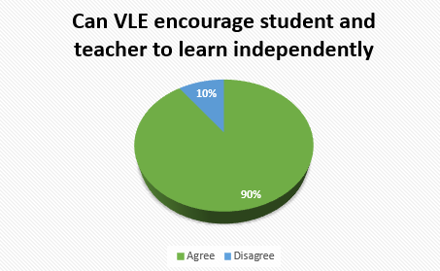
Figure 5 Can VLE encourage student and teacher to learn independently
The above chart illustrates that the students feel encouraged in learning of the VLE. Here, both teacher and students are feeling free to learn something new and 90% of the students are agreed on the topic. Only 10% of the students are disagreed in VLE.

Question-6
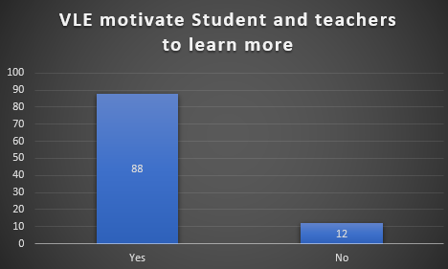
Figure 6 VLE motivate student and teachers to learn more
The above statistics shows that, most of the teachers and students are feel motivation regarding the VLE. 88% of the students and teachers are satisfied. On the other hand, only 12% of students and teachers are not satisfied of the learning of VLE.
Question-7

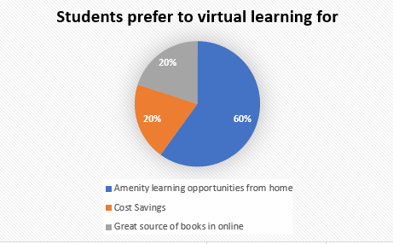
Figure 7 Students prefer to virtual learning for
The above pie-chart shows the preference record of VLE for different section. The amenity learning opportunity from home shows 60%, the savings of cost is 20% & great source of books in online is 20%. The opportunity to learn at home takes the largest section of percentage.
Question-8
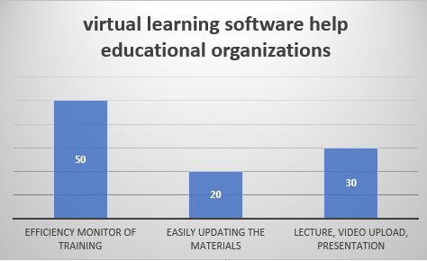
Figure 8 Virtual learning software help educational organizations
The VLE software assists in the section of training in efficient monitoring that is 50%, availability of updating learning materials instantly is 20% and uploading lectures, videos & presentation grab 30%. Majority percentage is taken by efficiency monitor of training and other updating, uploading section are taken place 2:3 of total ratio.

Question-9
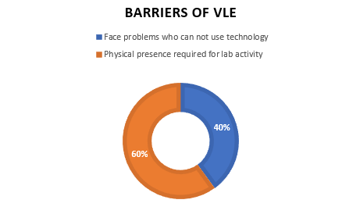
Figure 9 Barriers of VLE

The above chart reveals that some obstacles are occurred in VLE. Firstly, technological problems are faced by the users in VLE and shows 40% of total survey. Almost 60% of problems are occurred due to physical presence of doing lab function. In VLE, major problems are created by physical presence required to continue lab activity properly.

Conclusion
Students need to be motivated for e-learning studies or course because whatever the quality materials are designed to provide, they will not study unless they be motivated. In face to face class teachers do not require to worry about motivating the students but when it VLE is considered then motivation can play vital role. All in all, this study reflects that perception of students towards Virtual Learning Environment is quite positive.

Bibliography
Clarke, L., 2013. Virtual Learning Environments in teacher education: a journal, a journey. Taylor & francis Online, 22(1), pp. 121-131.
Kangasniemi, T. P. S. &. S. J., 2015. Design of Virtual Learning Environments. iJEP, 5(4), pp. 64-75.
Kurt, O. &. T. O., 2017. The acceptance and use of a virtual learning environment in higher education. Education Technology Journal, pp. 32-34.
Levy, Y. &. M. R., 2015. An assessment of competency-based simulations on e-learners’ management skills enhancements. IJELL, Volume 11, pp. 179-190.
Research Gate, 2020. Research Gate. [Online]
Available at: https://www.researchgate.net/publication/277143294_Need_of_Virtual_Learning_Environment_for_Educating_10_th_International_CABLIBER_2015_Need_of_Virtual_Learning_Environment_for_Educating_Library_Information_Science
[Accessed 18 8 2020].
The Journal, 2020. The Journal. [Online]
Available at: https://thejournal.com/Articles/1999/11/01/Virtual-Learning-Environments.aspx?Page=1&m=1
[Accessed 19 8 2020].
Virtual Training Model, 2020. Virtual Training Model. [Online]
Available at: http://www.customer-me.com/5-elements-successful-virtual-training-model/
[Accessed 18 8 2020].
Yorke, M. &. P. K., 2004. Embedding employability into the curriculum. Learning and Employability Series, pp. 30-34.

In-Class exercise:
Questionnaire Design
Student Name: _Tomas Adam Student ID:1917610 ____________________
Module Name: Digital Skills and Research Methods Term 2 Group: T2G11

Aims: This exercise is aimed to help you in questionnaire design for your assignment. Please write down your questions that you are going to use in your primary data collection. Try to have different types of questions such as yes or no question, multiple choice question, Likert scale question and open end question.

Question 1: Have you had any experience using Moodle? ?
A) Yes
B) No
C) Not sure

Question 2: Has your learning been benefiting through to Moodle?
A) Yes
B) No
C) Not sure

Question 3: Is a Moodle easy to use?
A) Yes
B) No
C) Not sure

Question 4: On scale 1-10 How do you rate learning through Moodle? 1 very good, 10 very bad
• 1
• 2
• 3
• 4
• 5
• 6
• 7
• 8
• 9
• 10

Question 5: How satisfied are you with the overall experience of Moodle?
A) Very satisfying
B) Mostly satisfied
C) Not satisfied

Question 6: What age group do you belong to?
A) 18-22
B) 23-27
C) 28-28
D) 32-36
E) 36+

Question 7: What have been the advantages and of learning through Moodle?

Question 8: What have been the disadvantages and of learning through Moodle

Question 9: What is improvement that can be make?

Question 10: Would you recommend the Moodle to your friend?
A) Yes
B) No
C) Not sure

Further questions, please list your questions below.

