The Natural Connection: Exploring the Psychological Impact of Organic Design in Human Spaces
As contemporary society increasingly shifts towards urbanization and digital lifestyles, the disconnect from natural environments has escalated, yielding significant psychological consequences. characterized by a deep reliance on nature for survival and well-being, has profoundly shaped our psyche. Yet, as concrete structures and screens replace green spaces, we risk losing touch with the innate connection that once defined us. This disconnection manifests in rising stress levels, diminished cognitive function, and emotional instability, highlighting an urgent need for restorative solutions. Biophilic design emerges as a powerful antidote, offering a revolutionary approach to reestablishing our bond with the natural world. By weaving elements of nature such as organic forms, natural materials and earthy colour pallets into our built environments, biophilic design taps into our subconscious, evoking a sense of calm and rejuvenation. This writing thoroughly investigates biophilia and its cognitive impacts on the human brain, emphasizing how biophilic design provides similar cognitive benefits and highlighting its critical significance in fostering a healthier, more connected existence. Through this exploration, we will uncover the potential of biophilic principles to enhance our well-being in an increasingly artificial landscape.
Biophilia is a concept referring to the innate human connection to nature and living systems. In the Oxford Dictionary biophilia is ‘an innate and genetically determined affinity of human beings with the natural world’ (1973). Therefore, within a general context, Biophilia is based on the ability to readily focus attention on natural stimuli, to be fascinated by nature and to connect emotionally with various life forms. The concept was coined by Harvard biologist Edward O. Wilson in the 1980s when he proposed the biophilia hypothesis in his book titled Biophilia (1984). The hypothesis proposes that humans have an ingrained biological connection to the organic realm. This bond with nature is deeply rooted in our evolutionary history, as humans have depended on the natural world for survival for millennia (Wilson, 1984). Keith Tidball (2012) in his review of the biophilia hypothesis, describes biophilia with two components, one being that humans have an “affinity for other living things” and, secondly, that this affinity is “rooted in our biology” (Tidball, 2012, p. 6). Research consistently shows that natural environments are preferred and more restorative than our current urban settings, providing significant benefits for physiological well- being.
Biophilia can also be referred to as a two-tiered process which encompasses both evolutionary and individual dimensions. It operates both as a phylogenetic process, which takes into account the evolution of human interactions with various environments and cultures over time, while also functioning as an ontogenetic process that reflects personal experiences and interactions with nature throughout an individual’s life (Berto, 2022). This is particularly relevant today, as many children are increasingly deprived of direct experiences with nature. Factors such as the covid-19 pandemic have limited outdoor activities, while the pervasive influence of technology and the overall shift toward a digital age have further contributed to this disconnect. The lack of engagement with natural environments can lead to negative outcomes, including increased stress levels, reduced attentions spans, and a decline in physical health (Yao, Zhang and Gong, 2021). Without regular interaction with nature, children may miss out on the developmental benefits that these experiences provide, such as improved emotional regulation and enhanced creativity. Addressing this disconnect is essential for fostering a healthier future generation.
For approximately 95% of our evolutionary history, humans lived as nomadic hunter-gatherers. As a result, we have developed a range of responses specifically adapted to the various wilderness environments (Bolten and Barbiero, 2020). Recent research in environmental psychology, neuroscience, and architecture increasingly focuses on the ways that organic design principles influence human emotional and cognitive responses in connection to the concept of the biophilia hypothesis. Roger Ulrich’s study (1984) on patients recovering from gallbladder surgery, revealed profound psychological, physical, and neurological impacts of biophilia on recovery. The study looked at the impacts of patients' exposure to nature, even through a window, proving to relieve tension, anxiety and discomfort. This is likely due to the activation of the parasympathetic nervous system, which promotes relaxation and recuperation. Views of nature may also reduce cortisol levels and activate brain regions involved in positive emotions (Ulrich, 1984). These findings indicate that biophilic surroundings can manipulate brain function in beneficial ways and improve general mental health, showcasing the brain's innate receptiveness to natural stimuli. This raises critical questions about how demographic factors, prior health conditions, and quality of care interact with biophilic influences on recovery, suggesting a multifaceted approach to understanding patient outcomes. Additionally, the study focuses primarily on visual stimuli, potentially overlooking the role of other senses or personal preferences in environmental response. Nonetheless, Ulrich's work has been foundational in supporting the biophilia hypothesis and is crucial in demonstrating that biophilic effects, even if subconsciously, have a profound capacity to enhance human well-being. To better understand this psychological impact of our natural environment, we can refer to the research by a landmark Swedish study by psychologist Arne Ohman in 1986. The study investigated our species' inherent tendencies to respond to natural stimuli. The participants were shown images of snakes, spiders, handguns and frayed wires. All images that propose danger. A predominant number of the participants displayed pronounced negative reaction to the subliminal exposure to snakes and spiders, while remaining largely indifferent to the handguns and frayed wires. These findings highlight an evolutionary fear of natural predators, suggesting that even in modern society, our instincts remain more attuned to ancient threats (Kellert & Calabrese, 2015). This research is pivotal in elucidating that the biophilia hypothesis, while fundamentally a theoretical framework, is also substantiated by scientific evidence regarding neuroplasticity and brain function. This underscores that the hypothesis extends beyond mere conceptualization to a grounded understanding of the biological mechanisms involved.
A significant theoretical debate among psychologists’ centres on how much perception is influences by environmental information. To process information from our surroundings, we depend on our sensory organs – our eyes, ears and nose (McLeod, 2018). We rely on our sense of sight for about 80% of all impressions we receive (Dr. Landrio & Associates, 2022), making it the dominant sense in our experience with nature. Because one-third of the brain is dedicated to visual processing, nature sceneries, particularly those with fractal patterns (repeating patterns across scales, seen in forms like tree, leaves, skin), have a distinct therapeutic effect. Exposure to fractal-rich imagery has been demonstrated to relieve stress, improve recovery, and avoid burnout, as explained by Attention Restoration Theory (ART) (Taylor et al, 2024). How natural environments can enhance human health and well-being is often explained through Attention Restoration Theory (ART). ART is a psychological framework that also proposes that natural environments can restore depleted attention resources. Three essential components of Attention Restoration Theory include directed attention, which involves the intensive focus on tasks that lead to mental fatigue. This type of attentional fatigue is crucial as it is associated with impaired decision-making and diminished self-control, factors linked to health problems such as obesity through various neural and behavioural mechanisms (Ohly et al., 2016). Restorative environments and the four mechanisms of restoration. The four mechanisms of restoration include distancing oneself from the stressor, experiencing fascination and engagement with nature, having a sense of immersion in the environment and ensuring that the setting aligns with the individual's preferences and needs. Research supports these theoretical components by demonstrating their practical significance in real-world circumstances. A Study by Hartig, Mang, and Evans (1991) discovered that vacationers who spent time in wilderness areas performed better on attention tasks post-vacation, while those in urban environments fared worse. Further trials revealed that participants who walked in natural settings after completing attention-demanding tasks also performed better than those in urban settings or passive relaxation groups. Rita Berto (2005) found that seeing restorative photographs improved attention in fatigued participants. Additionally, Tennessen and Cimprich (1995) found that university students with views of nature from their bedrooms scored better on concentration tests. Collectively, these studies provide compelling evidence that exposure to natural stimuli significantly enhances attention restoration.
Wilson (1984) states that some argue science reduces nature, stripping away its beauty and ignoring its artistic value. However, he urges a different perspective. Science is not only about breaking things down into simpler components (analysis); it also brings them together (synthesis). While science can reduce organisms to basic elements like genes and cells, it also reveals how these parts form intricate and elegant patterns at the level of organisms and societies, showing that science, like art, involves creativity and intuition (Wilson, 1984). This leads to the concept of biophilia in design. Biophilic design is a concept proposed by Kellert et al (2007) and has since been further refined and expanded. It is “the deliberate attempt to translate an understanding of the inherent human affinity with natural systems and processes—known as biophilia—into the design of the built environment” (Kellert et al, 2007, p. 3). This means an intentional integration of natural elements and principles into a built space to promote human health and well-being based on the previous concept. Biophilic design theory builds on pre-existing concepts, including restorative environments, prospect/refuge theory and traditional East Asian design principles. Restorative environments are settings that promote psychological recovery and reduce stress, enhancing cognitive function (von Lindern, Lymeus and Hartig, 2016). Prospect/ refuge theory proposed by Appleton, suggests humans have an ingrained preference for environments that offer both visibility (prospect) and protection (refuge) (Dosen and Ostwald, 2013). East Asian design principles refer to harmony with nature, balance and simplicity. It is part of a broader framework examining the human-nature relationship, positing a biological basis for the biophilia hypothesis (Gaekwad et al., 2022).
Furthermore, to comprehend biophilic design we must consider the integration of fractal patterns, earthy colour palettes and organic forms and textures that foster a sense of harmony and tranquillity, thereby enhancing overall aesthetic appeal. The fractal geometry found in natures patterns influence the fractal geometry of the brain and vice versa which may be key to why natural environments feel so restorative (Taylor et al, 2024). Research shows that the brain responds positively to patterns that balance variation and predictability. In the study by Hagerhall et al (2008), researchers found that viewing fractal patterns in nature activated brain signals associated with this calm state. However, the study lacked direct behavioural measures to confirm that this relaxed brain state translates to improved performance or mental benefits in real world tasks. This is where we can compare findings to the previously stated research of Hartig, Mang, and Evans (1991) and Tennessen and Cimprich (1995), which showed scientific evidence of the cognitive mutation related to real tasks. This reinforces the importance of thorough comprehension of the concept of biophilia to apply to our exploration of the cognitive influences of design. To unite these points, we can look to researchers Yin et al. (2018) and Mastandrea et al. (2019), who suggest that there is a neurasthenic explanation for this biophilia relationship, focusing on how our brains interact with those experiences. The self- rewarding quality of aesthetic experiences could positively influence people’s emotions. Their study investigates the impact of biophilic art compared to actual biophilia on student affective well-being. The hypothesis posits that both biophilic art and real biophilia will have similar beneficial effects on affective well-being, based on previous research. The size of sample for the study was 260, however it only received 106 legitimate responses. Most participants were between the ages 16-25. Participants were assigned to one of two conditions, a real biophilia condition (images of nature) or a biophilic art condition (art exhibiting natural elements). The Daniel's Five Factor assessment was used to assess affective well-being, which evaluated ten emotional states on a scale of 1 to 6. A survey was conducted in which participants viewed visuals relevant to their assigned condition and then rated their present emotional state. Results showed that both conditions positively affected participants, however there was no significant difference between the emotional measures (Lutrin, 2022). This research highlights the valuable insight that biophilic art can effectively serve as a substitute for authentic biophilia in providing positive cognitive benefits. This finding is crucial from a design perspective, demonstrating the artwork that evokes natural elements can possess the same transformative effects on the brain as direct exposure to nature. However, it should be noted that the study did not have a control group to test the emotion levels of those who had not been exposed to any of the biophilic images to have a clearer meaning to the results. We could extend these findings to contemporary urban cities, where the lack of natural features in highly populated places may be a contributing factor to understand why cities have increased stress, mental health issues and crime rates. Contemporary design often neglects nature, revealing that modern cities are not conductive to mental health and well-being. Biophilic designers recognise this shortcoming and are driven by a critical mission to reinstate humanities intrinsic connection to the natural world in everyday living. Our current urban surroundings do not align with the environment in which humans evolved in. This “mismatch” in our drastically different settings, may contribute significantly to the higher levels negative emotions in modern society. (Newman and Soderlund, 2015).
To grasp the context in which the term "nature" is utilized throughout this text, it is essential to consider its definition. According to the Oxford Dictionary, "nature" refers to "the material world and its collective objects or phenomena," emphasizing the characteristics and products of the Earth in contrast to those created by human civilization. Alternatively, it can denote "the creative and regulative physical power thought to operate within the physical world as the immediate cause of its phenomena." This understanding underscores the design elements that we recognize as reflections of "nature." (Little et al,1993).
Nature can be replicated by the patterning, forms, materials and symbols which according to the previously stated research, has the same significant positive benefit as real biophilia. It is now well-established that biophilic design offers significant cognitive benefits. Before examining case studies of artists who incorporate biophilic design into their work, it is essential to fully understand the key elements of this design approach. Ryan et al. (2014) have enhanced our understanding of biophilic design components through both qualitative and quantitative research, focusing on physiological and psychological aspects. There are 14 patterns within three categories labelled: Nature in the space, Natural analogues, Nature of the space. To summaries the categories, Nature in the space is the integration of physical plants, water and animals into the built environment. This could be compared to the category labelled ‘real biophilia’ in the previously discussed study by Yin et al. (2018) and Mastandrea et al. Natural analogues is a step removed from real nature. It’s the fractal patterns, materials, biomorphic forms and structural systems that evoke nature. Lastly, Nature of the space is phycological and physiological response from humans to various spatial layouts. This refers to the prospect / refuge theory of views, protected spaces, concealment and flowing forms (Ryan et al. (2014).

As I specialise in ceramics, I seek out ceramicists whose designs exemplify the principles of biophilia. One excellent example of a contemporary ceramics that significantly references nature is William Kidd (2024). His creations demonstrate how natural shapes, and organic aesthetics may be incorporated into ceramic art, embodying the concepts of biophilic design. He uses a combination of wheel throwing and hand-building techniques on low-fire red earthenware. His pieces are finished with oxide stains, underglazes, and crawl glaze, which add to the brilliant colours and textures (2014). It is evident from examining his work that he draws inspiration from natural textures and earthy colour palettes, which strongly resonate with the principles of biophilia. Kidd's designs are portrayals of seeds, fruits, and flowers however, he emphasises that his art is not an exact replica of real life forms, but rather an investigation of what may exist in an alternative, otherworldly environment.
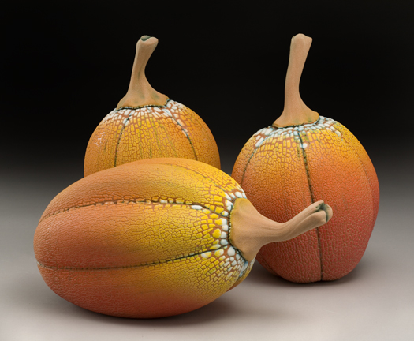
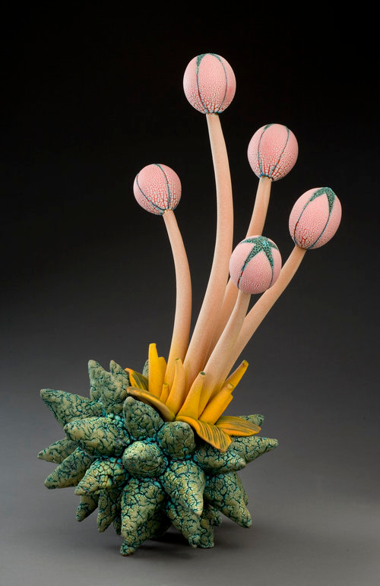
Figure 1, Unnamed artwork by William Kidd, 2014.
Figure 2, Unnamed artwork by William Kidd, 2014.

These two pieces of Kidd’s artwork (Figs.1 and 2) are examples of biophilia being used in two different ways in relation to this research, whether intentionally or unintentionally. One way to analyse the meaning and approach of the artworks is through a semiotic analysis in which Saussure’s (date) concept of the sign, which consists of the signifier and the signified is applied through the lens of Barthes’ (date) notion of the denotation and connotation. In this context, the artworks can be analysed for both their immediate visual impact: the denotation, and for the underlying links to biophilia: the connotations. Although the piece in figure one lacks a formal title, it immediately evokes images of a pumpkin or melon. This connection arises not only from the denotative level of the forms and vibrant orange hues, but also from the rich texture achieved through the use of different glazes. On a connotative level, the presence of a stem in the artwork serves as an effective signifier of growth and vitality, suggesting movement and the potential for development. Such connotations are underpinned by the research findings of Yin et al. (2018) and Mastandrea et al. (2019), who investigate the relationship between biophilia and emotional well-being using a neurasthenic lens. Since their findings imply that our brains respond positively to aesthetic experiences that resemble nature, we can assume the same cognitive response from Kidd's work. Kidd's pieces provide a visual and tactile connection to the environment, even if they are not exact replicas of nature. This is also related to the research by Ryan et al. (2014), as his work falls under the 'Natural analogues’ category of biophilic design. This supports the premise that Kidd’s art can induce positive emotional reactions, as evidenced by the investigations. Historically, humans have formed emotional associations with recognizable natural forms, which may enhance the affective response to this artwork (Bolten and Barbiero, 2020, Wilson, 1984).
In contrast, Figure Two presents a more abstract and "otherworldly" aspect of Kidd's work. Despite its non-traditional shape, which is not a direct representation of natural forms, it still evokes biophilic feelings. On a denotative level, the shape can be interpreted as a root with stems emerging, encouraging viewers to perceive it as an organic entity. This abstraction aligns with Saussure's notion that signs can operate within a system of meanings (ref) and Barthes notion meaning is formed through a set of relationships (ref). In this work the connotation of growth and plant life emerges from the viewer's interpretation of the form. On a connotative level there is the incorporation of a sense of blossoming in the sculpture, which reinforces the relationship to natural themes, emphasizing the dynamic interplay between form and the essence of life.
To summarise, the research that has been discussed and explored here, has shown that both biophilic art and direct interactions with nature can provide similar cognitive benefits. This supports the idea that Kidd's ceramics serve as a bridge to nature, producing a sense of well-being comparable to that acquired from true environmental experiences. By applying Saussure and Barthes' semiotic principles, I have shown that this can provide a better understand of how Kidd's work communicates complex relationships between form, meaning, and emotional response.

SITUATE HER IN HER TIME Lucie Rie (birth-death) is another ceramicist who draws inspiration from nature, yet her approach contrasts with that of William Kidd. While her work is more understated, it similarly evokes a sense of tranquillity through its organic forms and delicate craftsmanship.

Figure 3, Lucie Rie. Porcelain studio pottery footed bowl, c.1980, March 2017.
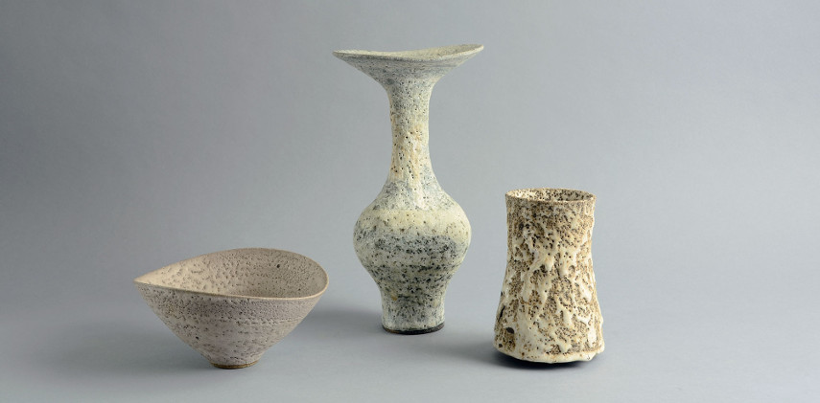
Figure 4, Lucie Rie - Untitled, installation view, 2017.

Lucie Rie’s ceramics frequently integrate shapes and designs inspired by natural elements, reflecting a sense of organic growth. In contrast to William Kidd, who prominently exhibits biophilia through sculptural elements, Rie uses various glaze techniques that create rich textures and subtle colour palettes reminiscent of landscapes. Looking at figure 4, the curvaceous shapes suggest organic forms, but it is the surface texture that truly enhances the biophilic aspects of the piece. The denotative aspect is the texture that closely resembles natural terrain, evoking the appearance of rocks like coastal erosion. On a connotative level, this tactile quality may have cognitive implications rooted in our evolutionary past, as familiar textures associated with the natural environment can evoke a sense of safety and comfort. Throughout history, our ancestors relied on their ability to recognize and navigate natural landscapes, which shaped their survival. As a result, encountering materials that mimic these textures could subconsciously trigger positive emotional responses, reinforcing a connection to the natural world and enhancing overall well-being. Her focus on surface quality enhances the viewers sensory experience, which aligns with the concept that aesthetic interactions with nature can positively impact emotional well-being. Additionally, her functional pieces demonstrate how aesthetic beauty can coexist with utility. Reinforcing the idea that well designed objects can enrich daily life while also having a connection to the natural world. Referring once again to the research by Yin et al. (2018) and Mastandrea et al. (2019), this raises the questions of whether the integration of natural analogues in functional ceramics might provide subconscious cognitive benefits in everyday use, particularly for those living in environments where exposure to nature is limited.
It's significant to recognize the profound impact of creating biophilic art from elements sourced directly from nature. Both artists primarily use clay, a material derived from the earth itself. This process not only results in aesthetically pleasing artworks but also brings the essence of the earth into design. With biophilic design, these pieces ultimately reflect nature once more, creating a harmonious cycle between the material world and the natural environment.

References
Wilson, E.O. (1984) Biophilia. Harvard University Press.
Tidball, K.G. (2012) ‘Urgent biophilia: Human-nature interactions and biological attractions in disaster resilience’, Ecology and Society, 17(2). doi:10.5751/es-04596-170205.
Berto, R. (2022). Biophilia. Ecology. doi:https://doi.org/10.1093/obo/9780199830060-0239.
Yao, W., Zhang, X. and Gong, Q. (2021). The effect of exposure to the natural environment on stress reduction: A meta-analysis. Urban Forestry & Urban Greening, 57.
Bolten, B., Barbiero, G. (2020). Biophilic Design: How to enhance physical and psychological health and wellbeing in our built environments. Visions for Sustainability, 13: 11-16.
Kellert, S. and Calabrese, E. 2015. The Practice of Biophilic Design. www.biophilic-design.com
McLeod, S. (2018). Visual perception | simply psychology. [online] Simplypsychology.org. Available at: https://www.simplypsychology.org/perception-theories.html.
Gaekwad, J.S. et al. (2022a) ‘A meta-analysis of emotional evidence for the biophilia hypothesis and implications for biophilic design’, Frontiers in Psychology, 13. doi:10.3389/fpsyg.2022.750245.
Ohly, H. et al. (2016) ‘Attention restoration theory: A systematic review of the attention restoration potential of exposure to natural environments’, Journal of Toxicology and Environmental Health, Part B, 19(7), pp. 305–343. doi:10.1080/10937404.2016.1196155.
von Lindern, E., Lymeus, F. and Hartig, T. (2016). The Restorative Environment: A Complementary Concept for Salutogenesis Studies. The Handbook of Salutogenesis, [online] pp.181–195. doi:https://doi.org/10.1007/978-3-319-04600-6_19.
Dosen, A.S. and Ostwald, M.J. (2013). Prospect and Refuge Theory: Constructing a Critical Definition for Architecture and Design. The International Journal of Design in Society, 6(1), pp.9–24. doi:https://doi.org/10.18848/2325-1328/cgp/v06i01/38559.
Hartig, T., Mang, M. and Evans, G.W. (1991). Restorative Effects of Natural Environment Experiences. Environment and Behavior, 23(1), pp.3–26. doi:https://doi.org/10.1177/0013916591231001.
Berto, R. (2005). Exposure to restorative environments helps restore attentional capacity. Journal of Environmental Psychology, [online] 25(3), pp.249–259. doi:https://doi.org/10.1016/j.jenvp.2005.07.001.
Tennessen, C.M. and Cimprich, B. (1995). Views to nature: Effects on attention. Journal of Environmental Psychology, 15(1), pp.77–85. doi:https://doi.org/10.1016/0272-4944(95)90016-0.
Taylor, R.P., Viengkham, C., Smith, J.H., Rowland, C., Moslehi, S., Stadlober, S., Lesjak, A., Lesjak, M. and Spehar, B. (2024). Fractal Fluency: Processing of Fractal Stimuli Across Sight, Sound, and Touch. Advances in Neurobiology, [online] pp.907–934. doi:https://doi.org/10.1007/978-3-031-47606-8_45.
Hagerhall, C.M., Laike, T., Taylor, R.P., Küller, M., Küller, R. and Martin, T.P. (2008). Investigations of Human EEG Response to Viewing Fractal Patterns. Perception, 37(10), pp.1488–1494. doi:https://doi.org/10.1068/p5918.
Lutrin, A. (2022). The Effects of Biophilic Art on Affective Well-Being . [online] https://open.library.ubc.ca/soa/cIRcle/collections/undergraduateresearch/18861/items/1.0421595. Available at: Lutrin_A_et_al_PSYC421_Effects_biophilic_art_2022.pdf [Accessed 10 Nov. 2024].
Newman, P. and Soderlund, J. (2015). Biophilic architecture: a review of the rationale and outcomes. AIMS Environmental Science, 2(4), pp.950–969. doi:https://doi.org/10.3934/environsci.2015.4.950.
Little, W., Henry Watson Fowler, Coulson, J. and Charles Talbut Onions (1993). The shorter Oxford English dictionary on historical principles. Oxford: Clarendon Press.
Ryan, C.O., Browning, W.D., Clancy, J.O., Andrews, S.L. and Kallianpurkar, N.B. (2014). BIOPHILIC DESIGN PATTERNS: Emerging Nature-Based Parameters for Health and Well-Being in the Built Environment. International Journal of Architectural Research: ArchNet-IJAR, 8(2), p.62. doi:https://doi.org/10.26687/archnet-ijar.v8i2.436.

Figures
Figure 1, Kidd, W. (2014). Unnamed Ceramic Sculpture. William Kidd Ceramics. Available at: https://www.williamkiddceramics.net/contact [Accessed 24 Nov. 2024].
Figure 2, Kidd, W. (2014). Unnamed Ceramic Sculpture. William Kidd Ceramics. Available at: https://www.williamkiddceramics.net/contact [Accessed 24 Nov. 2024].
Figure 3, Karaicic, N. (2017). Lucie Rie | Widewalls. [online] Widewalls. Available at: https://www.widewalls.ch/artists/lucie-rie.

