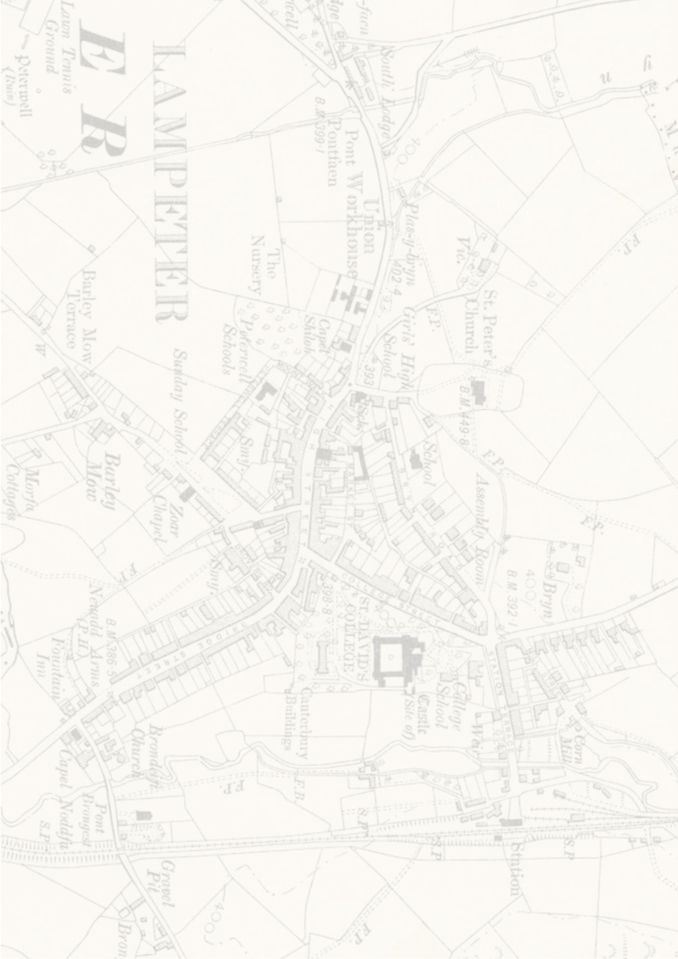
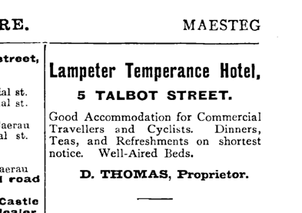
The cab swerved fluctuating bends, chugging up sharp inclines and rugged roads. Interruptions when meeting larger vehicles allowed my entertainment of the endless expanse sitting beyond the hedgerows. Releasing my grip on my weekender, I entertained gables of greenery and avian choirs in hedge-homes; relishing the changed landscape where concrete fields whittled into lanes guiding through nature’s paintings.

I headed to Lampeter for founded reason: its reign under the Evil Squire. I couldn’t fathom the unlikely link between him and a quaint rural town. My inquisitive instincts begged I journey there.
Within one unremarkable turning, we were immersed in Lampeter.
“Where did you say you’re lodging, sir?” The cabbie enquired, peeling my eyes from the small characterful shops and the locals’ joyful meandering in this whimsical haven.
“The Temperance Hotel.” I murmured.
“You’re surely mistaken, sir.”
“No. The rarity of the establishment’s engagement in its former use was communicated. However, it was the only place available.”
The cabbie scratched his chin doubtfully.

“If that’s the case, the Temperance we shall go.”
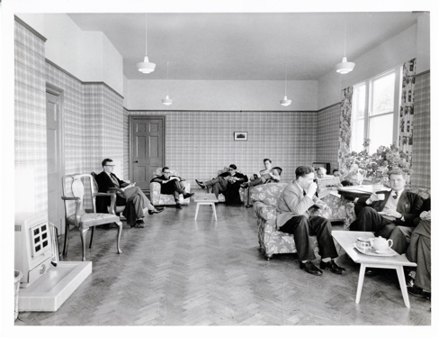
We rounded the roundabout, traversing the road overlooked by the Canterbury building. The cabbie pulled up and I took my leave. I lugged my bag to an arched doorway where my broad knock haunted the hotel like an empty casket. No one came. I knocked again. The door itself answered me, creaking open and welcoming me to warm walls papered in plaid and polished parquet.
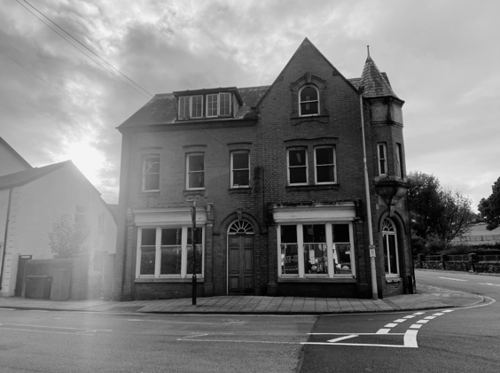
A note perched upon the side, accompanied by a key.
‘Mr Lam, upstairs room 3’ it read.
I called ‘hello’ before quietly ascending the stairs, not wishing cause of disturbance. The stairs creaked, quarrelling their polished front.
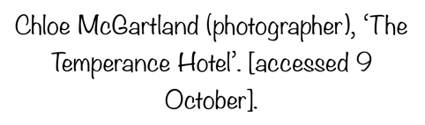
A hollow knock at my door startled my person. Receiving my caller apprehensively, the door’s opening revealed a gentleman in the hallway. He looked a person of the past, attired in a red overcoat.
“Good afternoon. Is your presence authorised here?” He droned.
“Authorised? I should hope so. I’ve been stationed here for my stay. Nowhere else proved available.”
He ran a hand through his white hair. “It’s unusual to have a visitor here. No one has stayed for years.”
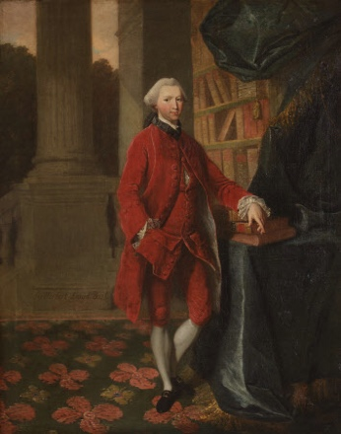
“I don’t see why! It’s a splendid building. Particularly for researching the Lord of Lampeter. I wish to walk the paths he walked and observe what he did. I won’t know what he knew, that’s factual, but I may experience what he did…now I must know, do you know where the Lampeter railway might be?”
The man nodded.

“Who are you, might you mind me asking, sir?”
“I am the Guide.” He responded.
“Have you a name?” I implored.
He responded silently.
“Well, I suppose if you guide me to the train-station, then I’m much obliged.”
“This way.” He gestured at the door. I grabbed my red notebook, anticipating observations. We marched Station Terrace, passing a small animal keep, to a quaint train station.
“Wonderful!” I exhaled, admiring the coal-black ‘LAMPETER’ lettering.
A steam-train emerged through a spectral smog.
“A steam-train of all things!”
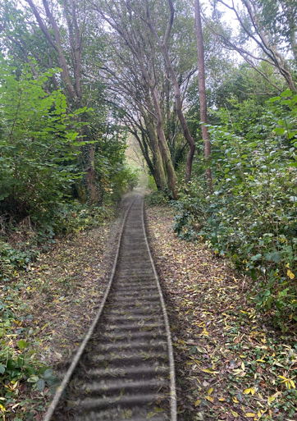
I turned to the Guide in amazement. He stared at me coldly. With his look, the smog train lunged remorselessly towards us. My eyes closed fearing its rage. On their opening, my guide had gone. Everything had. I stood on an overgrown path, reclaimed by nature. I looked around rapidly, chilled. My instincts persuaded my return to the hotel. I found Station Terrace, but empty of animal pens with bare grass replacing them. The Temperance differed too. Its red brick coat seemed dirtied by time. But it had only been half an hour. I pushed the door, standing stunned. The plaid paper had died to white paint, the floors had worn. The Guide appeared.
“The stairs hath changed!” I cried in alarm, pointing at their stripped-back attire.

My Guide frowned in silence. I concluded him a man of few words.
‘I think I’m unwell!’ I cried in confusion, running the creaking stairs to my room. Throwing my notebook on the table, I shrieked as I realised the bed had gone and my weekender now sat on a bare floor.

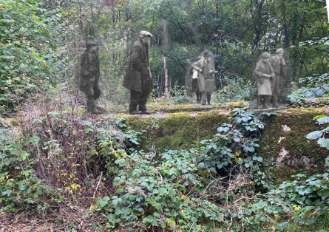
A red-coated man approached the Canterbury building, shuffling across patterned carpets and ascending the steps to the porters’ office.
“Noswaith dda,’ the porter murmured.
“Have you seen our visitor?” The man enquired.

“Visitor?” The porter raised an eyebrow.
“The one who lodged at the hotel. Odd chap, prone to spacing-out.”
“The Lions Hotel? You’d have to ask reception there.”
“Not Lions. Our hotel.”
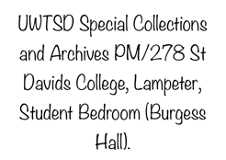
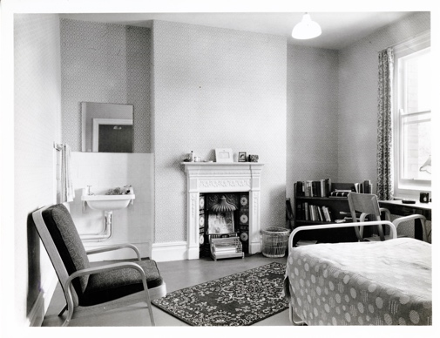
“Our hotel? Ti iawn? No one has stayed there for years, you know that.”
“But this gentleman stayed there due to no available accommodation.”
The porter’s brow furrowed.
“Just a moment.”
He returned, pale.
“What is it? Is he okay? He seemed awful spooked.”
“Oh, how do I tell you?” The porter said. ‘No one has stayed at the hotel. There’s no record of him. However, you left this there.”
Now it was the man’s turn to be pale. He was handed a small red notebook, inscribed with the name Peter.
This tale welds past and present observations of Lampeter, reflecting my personal engagement’s reflection on its present and history. ‘Gables of greenery’ metaphorically explores nature’s structures synonymously referencing ‘Anne of Green Gables’ demonstrating my personal reflection of Lampeter’s surroundings as reminiscent of the natural, unaffected landscapes found in period novels.
I couldn’t enter the hotel due to mould spore presence, allowing imaginative engagement with UWTSD archives. Interestingly, the hallucinogenic effect of spores frames the ‘hallucinogenic’ narrative.
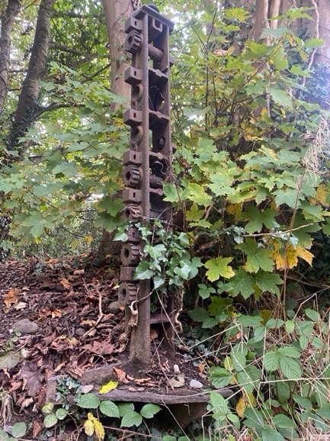
Peter’s interest in Lampeter’s squire impassions his experiences as Lampeter’s history interested me. The character’s name is Peter Lam; thus appearing as Lam, Peter bibliographically. This intentional anagram connotes his representation of Lampeter through existence and experience- representing the town’s connection with itself; experiencing time swiftly passing, as Peter Lam does in his travels. This old-fashioned formatted man in present society finds outdated online references to Lampeter’s train, reflecting a characteristically classic-natured town in a modern world.
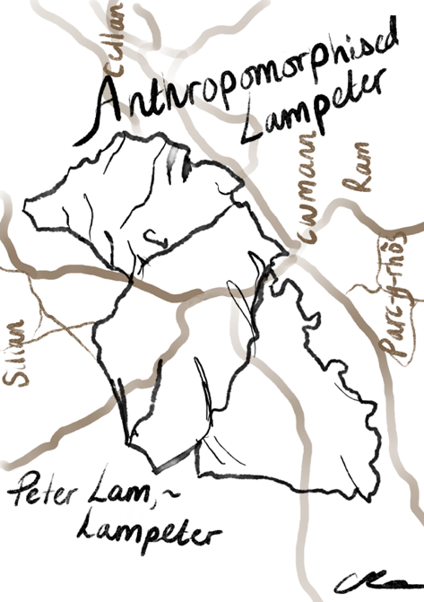
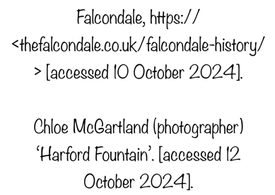
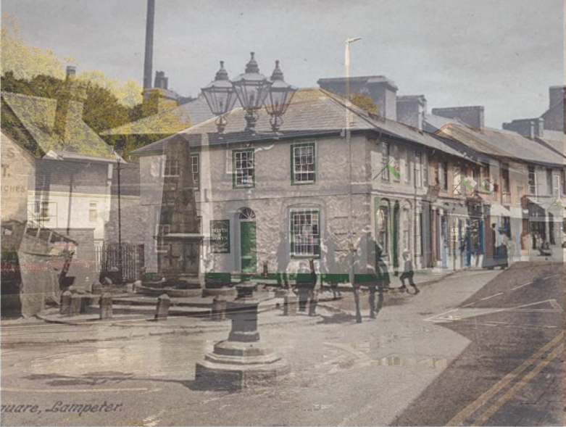

The story explores the Lampeter’s relationship between its history and current presence, allowing its historical ‘ghosts’ to walk among us; recognised and appreciated. I have combined photos of past and present Lampeter to illustrate this concept. On our Lampeter field-trip, I felt saddened at the gradual dissipation of the railway and the emptiness of a place once holding cattle, no longer recognisable in its past purpose. These places of significance to past Lampeter don’t cross the minds of many now. Learning of ghosts of the train-line and grazing animals (where car numbers would now outnumber them), allowed me to create a story exploring the absence of records eternalising everything, and the invisible eternal record of memory.

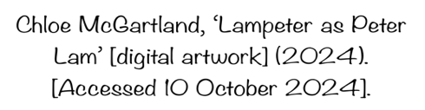

Bibliography
Ceredigion History, <https://ceredigionhistory.wales/lampeter/> [accessed 10 October 2024]
Falcolndale, <https://thefalcolndale.co.uk/falcolndale-history/> [accessed 10 October 2024]
Festrail, https://www.festrail.co.uk/welsh-highland-railway-history/#! [accessed 11 October 2024]
Flickr, https://www.flickr.com/photos/31890193@N08/14243890976 [accessed 11 October 2024]
McGartland, Chloe, Lampeter as Peter Lam [digital artwork] (2024) [accessed 10 October 2024]
McGartland, Chloe (photographer), ‘Harford Fountain’. [accessed 12 October 2024]
McGartland, Chloe (photographer), ‘Railway Remains’. [accessed 9 October 2024]
McGartland, Chloe (photographer), ‘Railway Remains 2’. [accessed 12 October 2024]
McGartland, Chloe (photographer), ‘Railway Remains 03’. [accessed 9 October 2024]
McGartland, Chloe (photographer), ‘The Temperance Hotel’. [accessed 9 October 2024]
University of Leicester, https://specialcollections.le.ac.uk/digital/api/collection/p16445coll4/id/96628/download [accessed 11 October 2024]
UWTSD Special Collections and Archives PM/277 St Davids College, Lampeter, Common Room (Burgess Hall) [accessed 15 October 2024]
UWTSD Special Collections and Archives pm/278 St Davids College, Lampeter, Student Bedroom (Burgess Hall) [accessed 15 October 2024]
Zoffany, Johann, Sir Herbert Lloyd [oil on canvas] (1750-69) <https://www.nationaltrustcollection.org.uk/object/537640> [accessed 10 October 2024]

