Geodemographic analysis using GIS software
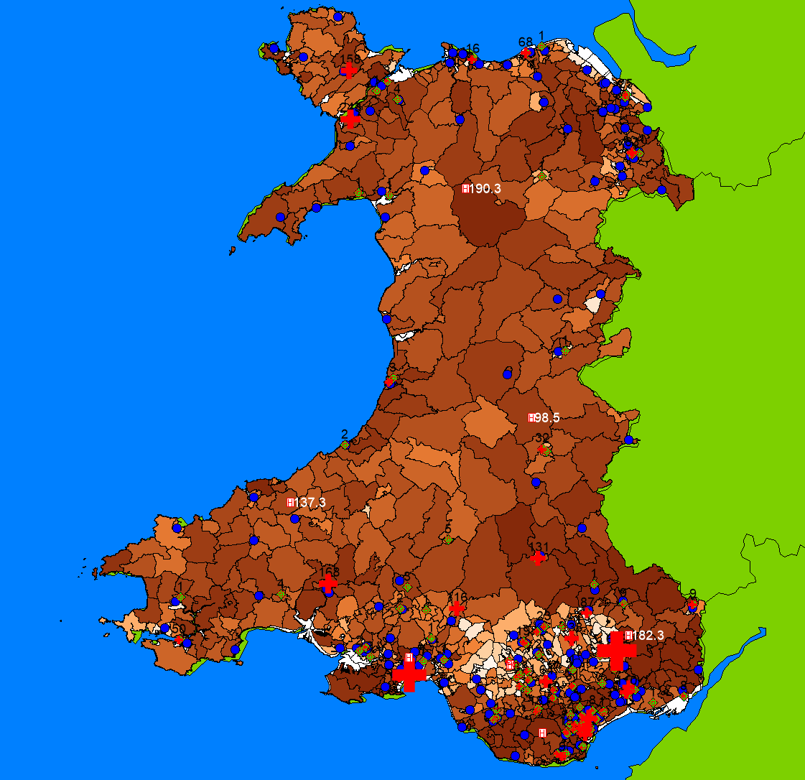
Amina Meah (2237650)

Contents
Task 1: Data Acquisition for GIS Workspace 4
Introduction 4
Types of Data Involved in Geo-Information Systems (GIS) 4
Use of Excel for Data Gathering 4
Use of MapInfo to Analyse and Visualise Data 5
Log of the Data Acquisition Process 5
Task 2: GIS Build Results and Analysis 7
Introduction 7
Thematic Mapping and Spatial Data Analysis 7
Principles of Thematic Mapping 7
GIS Data Sources and Processing 8
Data Integration and Quality Assurance 9
Spatial Analysis and Key Findings 10
Educational Deprivation vs. Drug Admissions 10
Methadone Prescription Distribution 11
Buffer Analysis: Schools and Pharmacies 12
Integration of Datasets and Spatial Queries 13
GIS Query Techniques 13
Map Interpretation Guidance 14
Discussion and Policy Implications 16
Case Study Discussion: Wales’ Spatial Dynamics 16
Methadone Access Equity 16
School Exposure Risks 17
Policy Recommendations and GIS in Practice 17
For Public Health 17
For Education Policy 17
Future GIS Enhancements 17
Limitations and Future Research 17
Data Gaps 17
Correlation vs Causation 18
Suggested Future Work 18
Community Engagement 18
Conclusion 18
References 19

Task 1: Data Acquisition for GIS Workspace

Introduction
This report focuses on the process of data acquisition and the creation of a GIS workspace for the chosen case study. This report includes a discussion on the types of data typically involved in GIS builds, the use of Excel for gathering and organising data, and the analysis and visualisation of this data using MapInfo, a well-known GIS software. Additionally, a log of the data acquisition process will be provided to track the steps taken and the datasets utilised.

Types of Data Involved in Geo-Information Systems (GIS)
Geo-information systems (GIS) typically involve two primary types of data:
- Spatial Data: Represents geographic features and their locations.
- Vector Data: Includes points, lines, and polygons. For example, points could represent the location of healthcare facilities, lines could represent road networks, and polygons could represent administrative boundaries or areas of interest.
- Raster Data: Represents continuous data, like satellite images, environmental data, or elevation data. It is typically grid-based.
- Attribute Data: Provides descriptive information about spatial data. For instance, a hospital location might have attributes such as name, type, and capacity. Attribute data is stored in tabular format and linked to spatial features.

Use of Excel for Data Gathering
Excel is commonly used as a tool for organising and cleaning data before importing it into a GIS system. The following steps outline how Excel can be used:
- Data Organisation: Excel organises data in rows (each row representing a feature) and columns (each column representing an attribute of the feature). For example, in a healthcare access study, columns might include facility name, type of facility, location (latitude and longitude), and services offered.
- Data Cleaning: Before importing data into MapInfo, it's essential to clean the data. Excel allows for the identification of missing values, duplicates, and formatting issues that may interfere with GIS analysis.
- Data Transformation: Excel can be used to format data for use in MapInfo. For instance, geographical coordinates (latitude and longitude) can be entered into Excel, and these can later be used to create point features on a map.
- Exporting Data: After organising and cleaning data, it is exported from Excel in a format (e.g., CSV or XLS) compatible with GIS software. This file can then be imported into MapInfo for further analysis and mapping.

Use of MapInfo to Analyse and Visualise Data
Once data is imported into MapInfo, the software can be used to analyse spatial patterns and visualise data effectively:
- Map Creation: MapInfo allows users to create maps from imported data, such as creating point layers for the location of pharmacies or polygon layers for administrative boundaries.
- Spatial Analysis:
  - Overlay Analysis: Combining multiple map layers to identify spatial relationships, such as analysing how healthcare access relates to population density.
  - Buffer Analysis: Creating buffer zones around points (e.g., a 1-mile radius around each pharmacy) to visualise service areas and accessibility.
  - Cluster Analysis: Identifying spatial clusters, for example, determining if there are areas with higher concentrations of health issues.
- Data Visualisation:
  - Thematic Mapping: MapInfo supports thematic maps, which use colour gradients to represent variations in data, such as disease prevalence or healthcare facility density. This makes it easy to identify regions that need attention.
  - Proportional Symbols: MapInfo allows you to use symbols whose size reflects the value of a particular attribute, for example, larger circles for larger healthcare facilities.
  - Heat Maps: Visualise areas with high or low concentrations of a certain feature (e.g., areas with high disease prevalence).
- Analysis Results Presentation: The results of spatial analysis can be presented with the help of well-designed, clear maps. These maps highlight trends and patterns that are essential for decision-making.

Log of the Data Acquisition Process
The following is a log that tracks the key steps in the data acquisition process for the GIS build:
Date | Task | Details | Software Used
01/04/2025 | Initial Data Collection | Identified relevant datasets. | Excel
02/04/2025 | Data Import to GIS | Imported all data into MapInfo. | MapInfo
03/04/2025 | Data Cleaning and Preprocessing | Cleaned missing values and standardised attribute columns in Excel. | Excel
03/04/2025 | Data Analysis (Overlay & Buffering) | Conducted overlay analysis to identify areas of methadone items being prescribed. Created buffer zones. | MapInfo
04/04/2025 | Thematic Mapping and Visualisation | Created thematic maps using colour gradients to represent high deprivation in education | MapInfo
04/04/2025 | Final Review and Export | Finalised the analysis and exported results as images and map files. | MapInfo

Task 2: GIS Build Results and Analysis

Introduction
Geographic Information Systems (GIS) play a crucial role in spatial data analysis, offering a powerful way to visualise and interpret complex datasets. This report presents the results of a GIS build focused on mapping and analysing the distribution of methadone prescriptions in Wales, alongside LSOA (Lower Super Output Area) rankings for schools and health board statistics on illicit drug use admissions. Additionally, secondary school locations have been mapped to explore potential correlations between education and drug-related healthcare data.
Thematic mapping and spatial queries were utilised to uncover trends and relationships within the data. Through GIS, various layers of information were analysed to highlight patterns, enabling data-driven decision-making for public health and education policies. The following sections discuss the key findings, methodologies, and the significance of spatial relationships in this study [1].

Hypothesis
There is a positive spatial correlation between areas of high educational deprivation and increased rates of drug-related hospital admissions in Wales. Additionally, proximity of secondary schools to pharmacies dispensing methadone may indicate areas where harm-reduction interventions are most needed.

Thematic Mapping and Spatial Data Analysis

Principles of Thematic Mapping
Thematic maps are a fundamental aspect of GIS, used to represent spatial variations in specific datasets. Unlike reference maps that focus on general geographic information, thematic maps emphasise themes such as health data, socio-economic indicators, or environmental factors. In this study, thematic mapping techniques were employed to visualise methadone prescription patterns, school performance rankings, and drug use admissions [1].
There are several key types of thematic maps used in GIS:
- Choropleth Maps: These maps visually represent LSOA (Lower Super Output Area) education deprivation, where areas with lighter shades indicate higher levels of deprivation. This provides a clear indication of where educational inequality might correlate with higher drug-related health risks.

- Proportional Symbol Maps: These maps represent the volume of methadone prescriptions by pharmacies, where symbol size directly corresponds to prescription volume. This allows for quick visual assessment of where methadone services are most concentrated.
- Point Distribution Maps: Secondary schools and pharmacies are marked as points on the map. These maps help identify areas of potential overlap and proximity between schools, pharmacies, and areas of deprivation, which can affect both student exposure to drug misuse environments and access to treatment services.
- Heat Maps (optional for future work): Heat maps could show the density of drug-related hospital admissions. These maps can highlight areas with a higher concentration of drug-related health issues, which could be correlated with educational and socioeconomic deprivation. These were not used in this study.

GIS Data Sources and Processing
The data utilised in this GIS build was collected from multiple sources, ensuring comprehensive analysis. The key datasets include:
- Methadone Prescription Data: GPS-located pharmacies dispensing methadone, with recorded prescription volumes. GP Practice Prescribing Data provides monthly prescription records at the presentation level for medicines, dressings, and appliances prescribed by GPs and non-medical prescribers in Wales. The dataset includes only prescriptions dispensed within Wales or England, excluding private prescriptions and those not taken to a pharmacy. Data is updated on the first working day of each month and covers the current and two previous financial years. Due to its large size, it requires specialised software for analysis. Proper interpretation is essential, as prescribing data should not be analysed in isolation [2].
- The Welsh Index of Multiple Deprivation (WIMD) 2019 Education: The Welsh Index of Multiple Deprivation (WIMD) 2019 Education domain measures educational disadvantage by assessing attainment, skills, and qualifications within an area. It includes indicators for both children and adults, capturing low educational achievement and lack of qualifications. Key metrics include average point scores at different educational stages, repeat absenteeism, the proportion of students entering higher education, and the number of adults (25-64) without qualifications. This data helps identify areas with significant educational deprivation, informing targeted interventions and policy decisions. WIMD ranks all small areas from 1 (most deprived) to 1909 (least deprived) [3].
- Health Board Admissions Data: Statistics on hospital admissions due to illicit drug use. The Illicit Drug Use Admission Rates dataset provides age-standardised hospital admission rates per 100,000 people for drug-related cases across Wales. Data is sourced from the Admitted Patient Care (APC) Database and the Office for National Statistics (ONS), covering Welsh residents at national, local health board, and local authority levels from 2014/15 to 2023/24. It uses European age-standardised rates and clinical codes (F11-F16, F18, F19, T40, T424, T436) to track primary or secondary diagnoses. The dataset is updated annually, with the latest publication on March 27, 2025. Changes in health board boundaries after April 2019 are reflected in the data. Confidence intervals are calculated using the Dobson method (1991) for statistical accuracy [4].
- Secondary School Locations: The All Schools Wales dataset provides the geographic locations of schools across Wales. It is compiled from multiple sources, including OS Addressbase, My Local School, the Address List of Schools, and the Pupil Level Annual School Census (PLASC). This dataset supports spatial analysis related to education, enabling the assessment of school distribution, accessibility, and proximity to other socio-economic factors [5].
Each dataset was processed in a GIS environment, where coordinate reference systems (CRS) were standardised to ensure accurate spatial alignment. Attribute tables were structured to allow for meaningful queries and analysis.

Data Integration and Quality Assurance
Data preparation was crucial for ensuring all datasets could be accurately analysed together:
- Georeferencing and CRS (Coordinate Reference System) Standardisation: Ensuring all datasets were aligned spatially using the British National Grid, allowing for consistent analysis and visualisation.
- Data Cleaning: Outliers, duplicates, and null values were removed to ensure the accuracy of the analysis. Only relevant records were kept for each dataset [6].
- Attribute Standardisation: Variable names and formats across datasets were standardised to ensure easy integration during spatial joins and analysis.

Spatial Analysis and Key Findings

Educational Deprivation vs. Drug Admissions
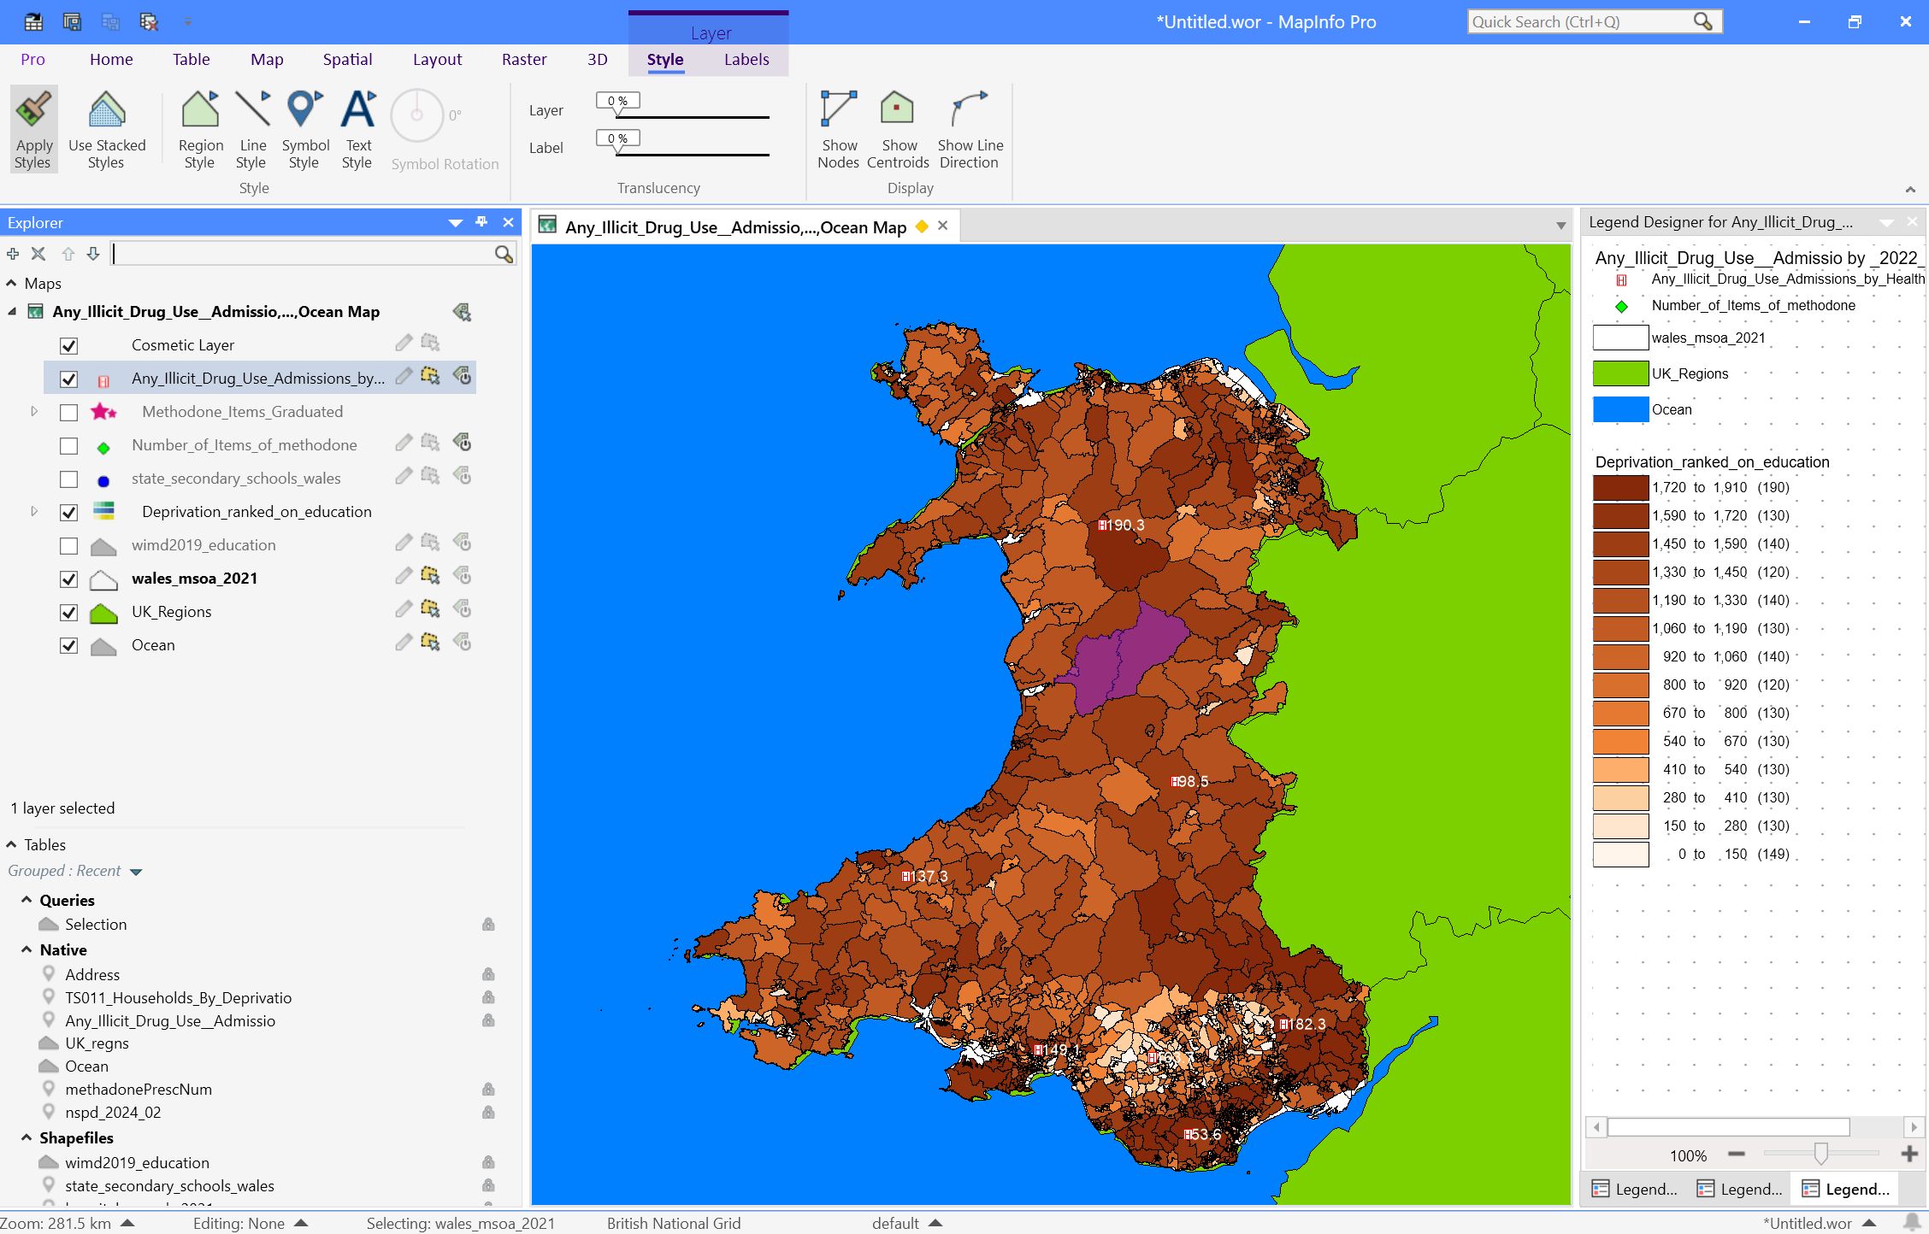Using the choropleth map for education deprivation, several key patterns were observed such as:
- Clusters of High Deprivation: Areas in South Wales, particularly the health boards of Swansea and Cardiff, show high levels of education deprivation. These regions also coincide with areas reporting high drug-related hospital admissions. The map clearly illustrates the spatial relationship between these two variables.

- Deprivation and Drug Misuse: Regions with lower educational attainment appear to have higher rates of drug misuse and associated hospital admissions, suggesting that educational deprivation may play a role in exacerbating health risks related to substance misuse.
Policy Insight:
- Interventions should prioritise regions with both high educational deprivation and elevated drug-related health issues. Educational outreach programs aimed at reducing drug misuse could be vital in areas identified as high-risk.

Methadone Prescription Distribution
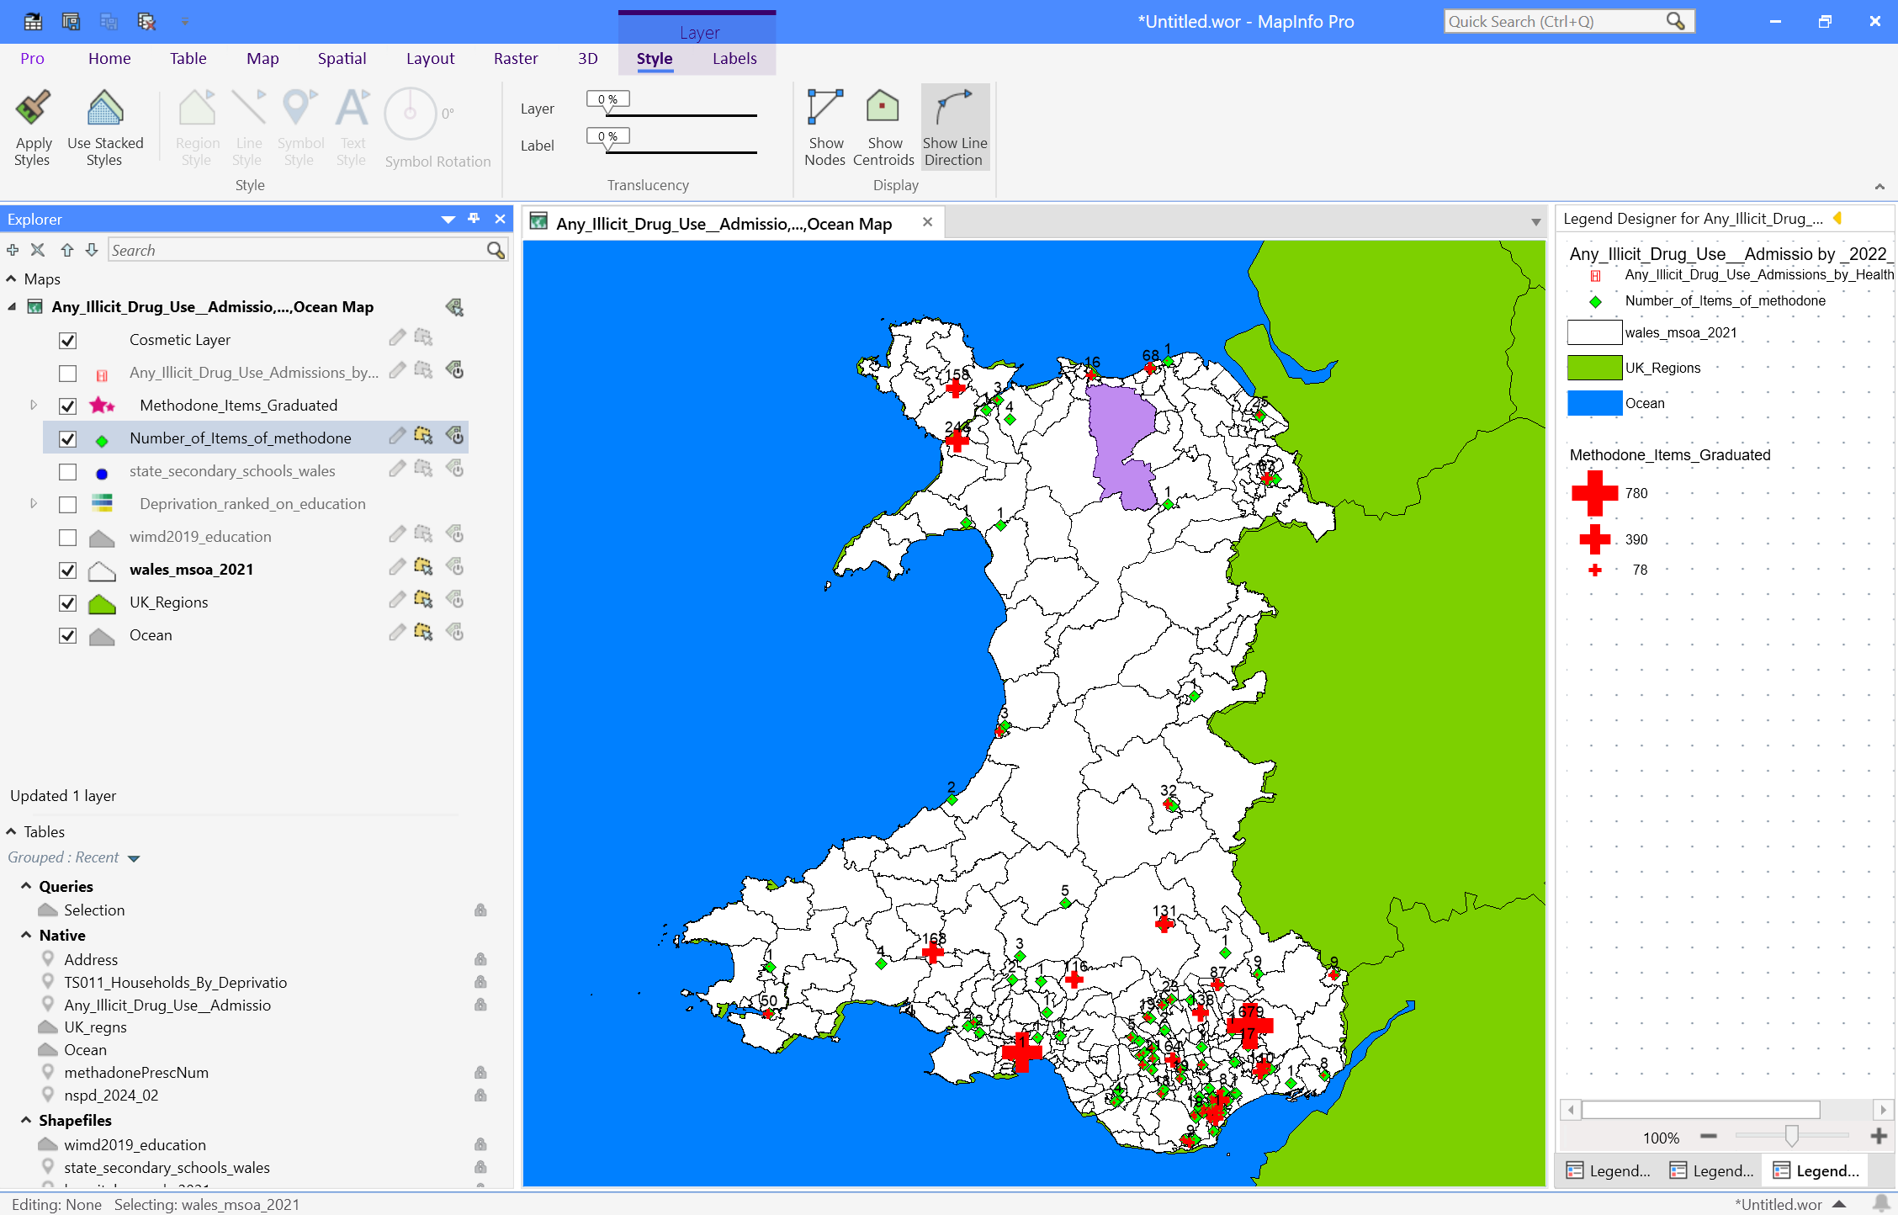The proportional symbol map for methadone prescriptions shows that:
- Urban Concentrations: Major urban centres, such as Swansea and Newport, show a high concentration of pharmacies dispensing methadone, with larger symbols corresponding to higher prescription volumes. This pattern suggests that urban areas with higher population density have more access to methadone treatment.

- Rural Gaps: Some rural areas appear underserved in terms of methadone services, with fewer pharmacies dispensing methadone, potentially due to lower population density or centralised service delivery.
Policy Insight:
- To address gaps in rural areas, the introduction of mobile methadone services could be explored. This service delivery model could be informed by GIS findings to ensure coverage in underserved regions.

Buffer Analysis: Schools and Pharmacies
Buffer analysis was used to assess the proximity of secondary schools to pharmacies dispensing methadone, which is particularly important for understanding potential exposure to environments associated with substance misuse.
- 500m Buffer: This analysis revealed that a significant number of secondary schools are within a 500-meter radius of methadone-dispensing pharmacies. This is particularly pronounced in urban areas, where both schools and pharmacies are clustered.
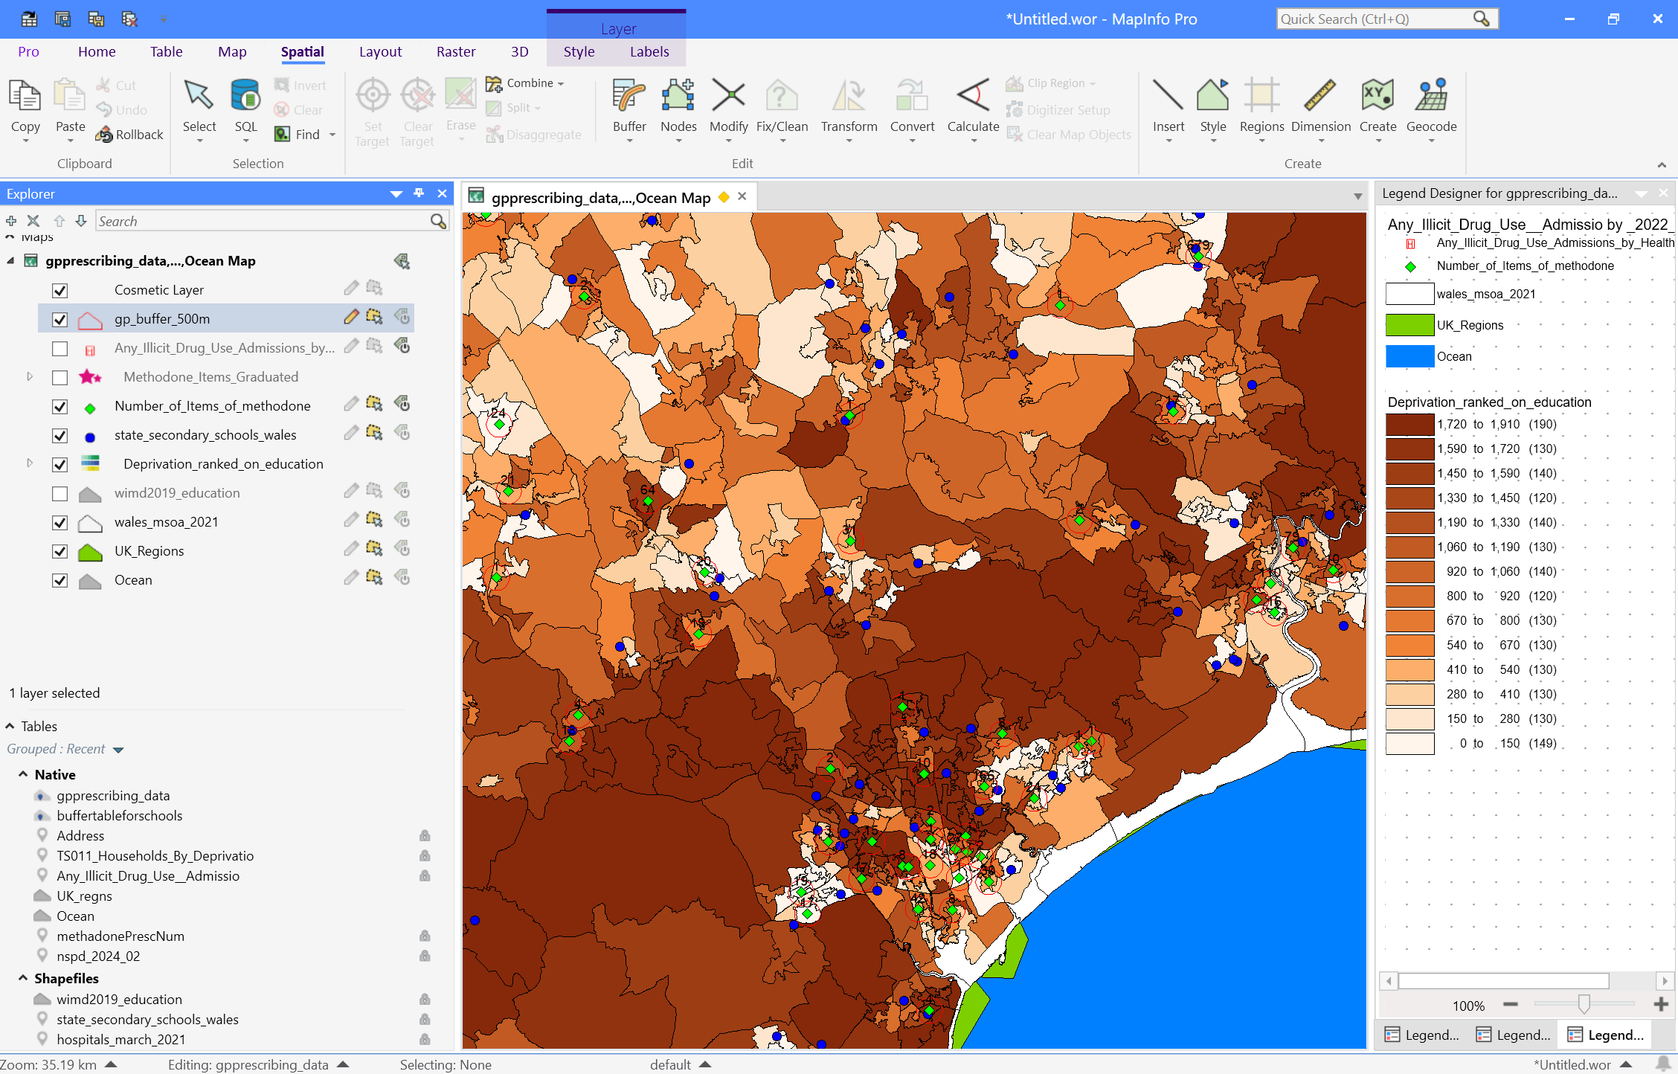
- 1km Buffer: When expanding the analysis to a 1-kilometer radius, many schools, especially those in deprived LSOAs, fall within this buffer. This extended buffer indicates that a larger proportion of students in these regions may be exposed to methadone treatment services, which could influence student perceptions and risk factors related to substance misuse.
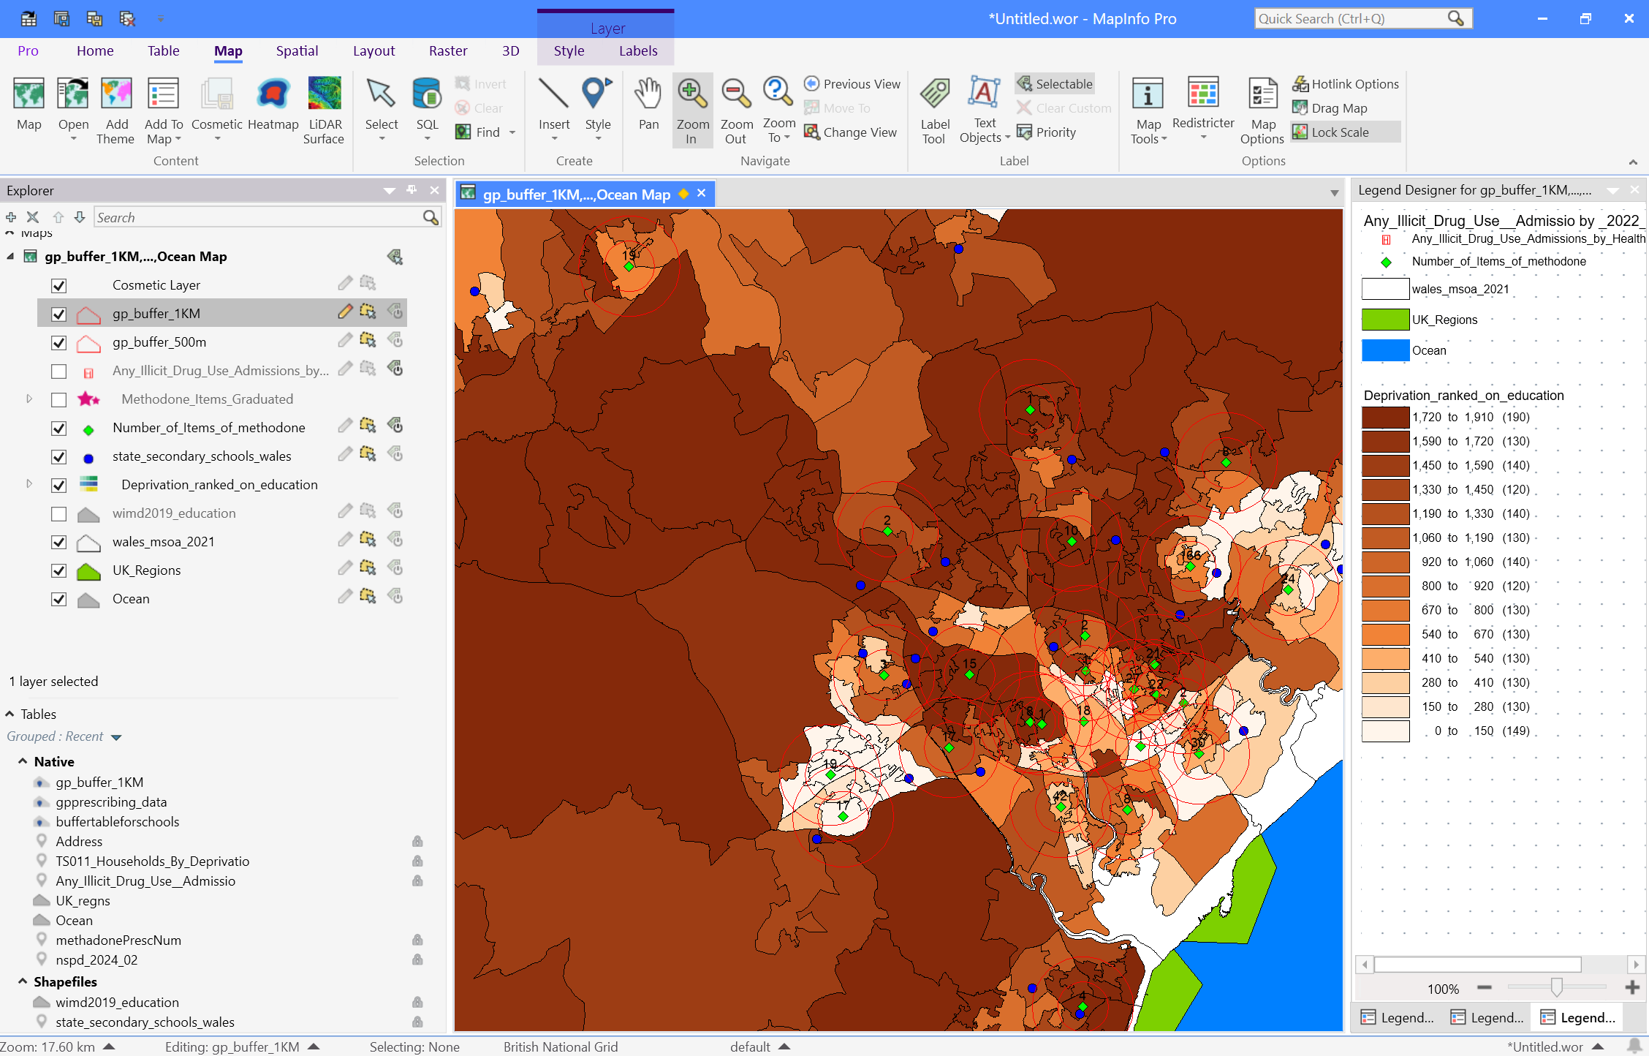

Policy Insight:
- Schools within close proximity (500m to 1km) of pharmacies, particularly in deprived areas, should be targeted for harm-reduction programs and drug prevention initiatives to minimise potential exposure to substance misuse environments.

Integration of Datasets and Spatial Queries

GIS Query Techniques
Several GIS query techniques were applied to integrate and analyse the datasets:
- Spatial Joins: The pharmacy data was spatially joined with education deprivation and drug admission data to assess proximity relationships.
- Buffer Queries: Schools located within 500m and 1km of pharmacies dispensing methadone were identified, allowing for the assessment of potential exposure risks.
- Attribute Queries: Queries were used to filter pharmacies dispensing methadone and to extract specific data related to drug admission rates by health board, enabling targeted analysis based on geographic areas of interest.

Map Interpretation Guidance
Map 1: Educational Deprivation Choropleth:
  - Lighter colours indicate areas with higher education deprivation.
  - The map helps visualise the overlap between areas with low educational attainment and high drug-related health risks.
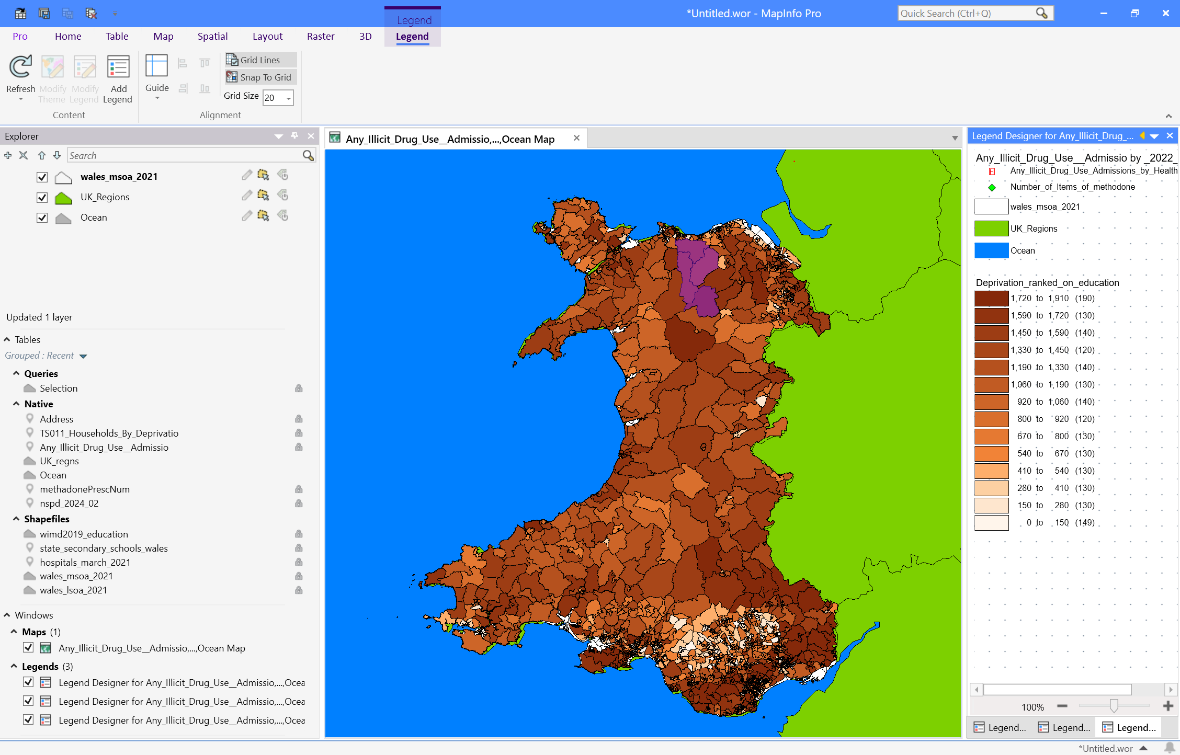
Map 2: Pharmacy Distribution with Prescription Volume Symbols:
  - Symbol size corresponds to the number of prescriptions, with larger symbols indicating higher volumes of methadone dispensed.
  - Helps assess whether pharmacy distribution aligns with population needs.
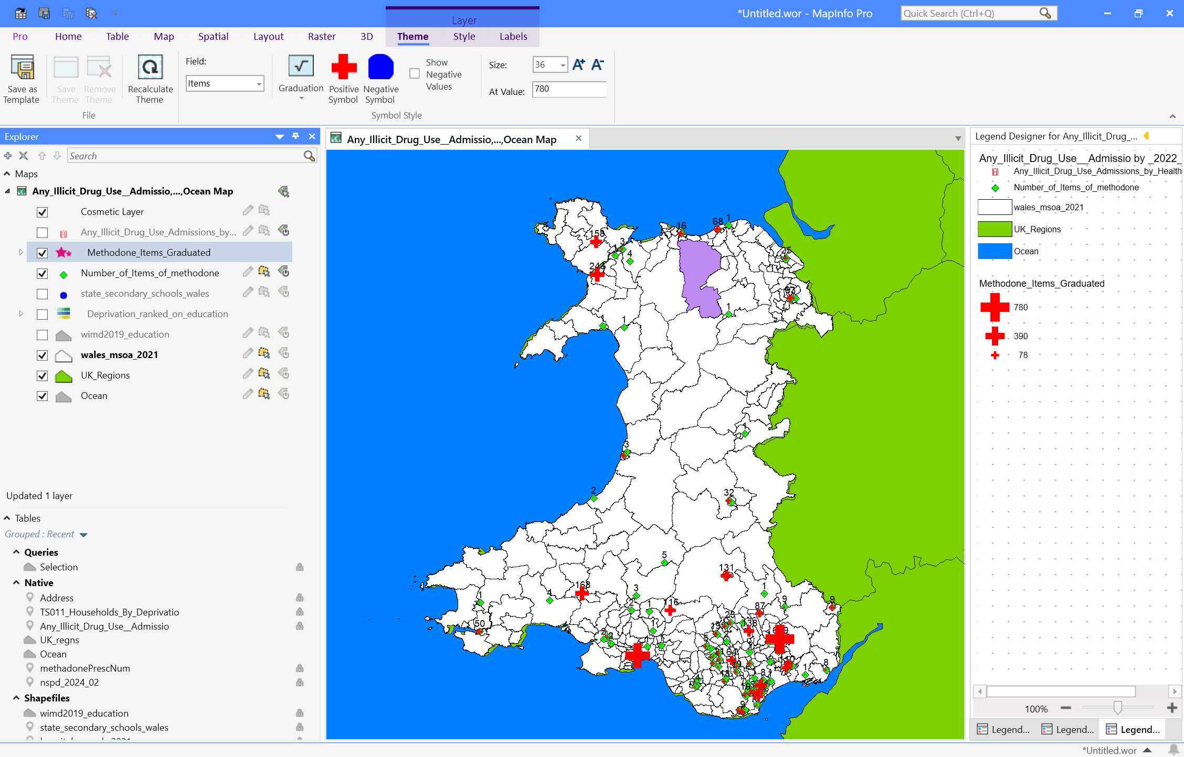
Map 3: Buffer Analysis (500m & 1km)
- Schools within the defined buffer zones are highlighted.
- The analysis provides insights into the geographic overlap between schools, pharmacies, and areas of deprivation.
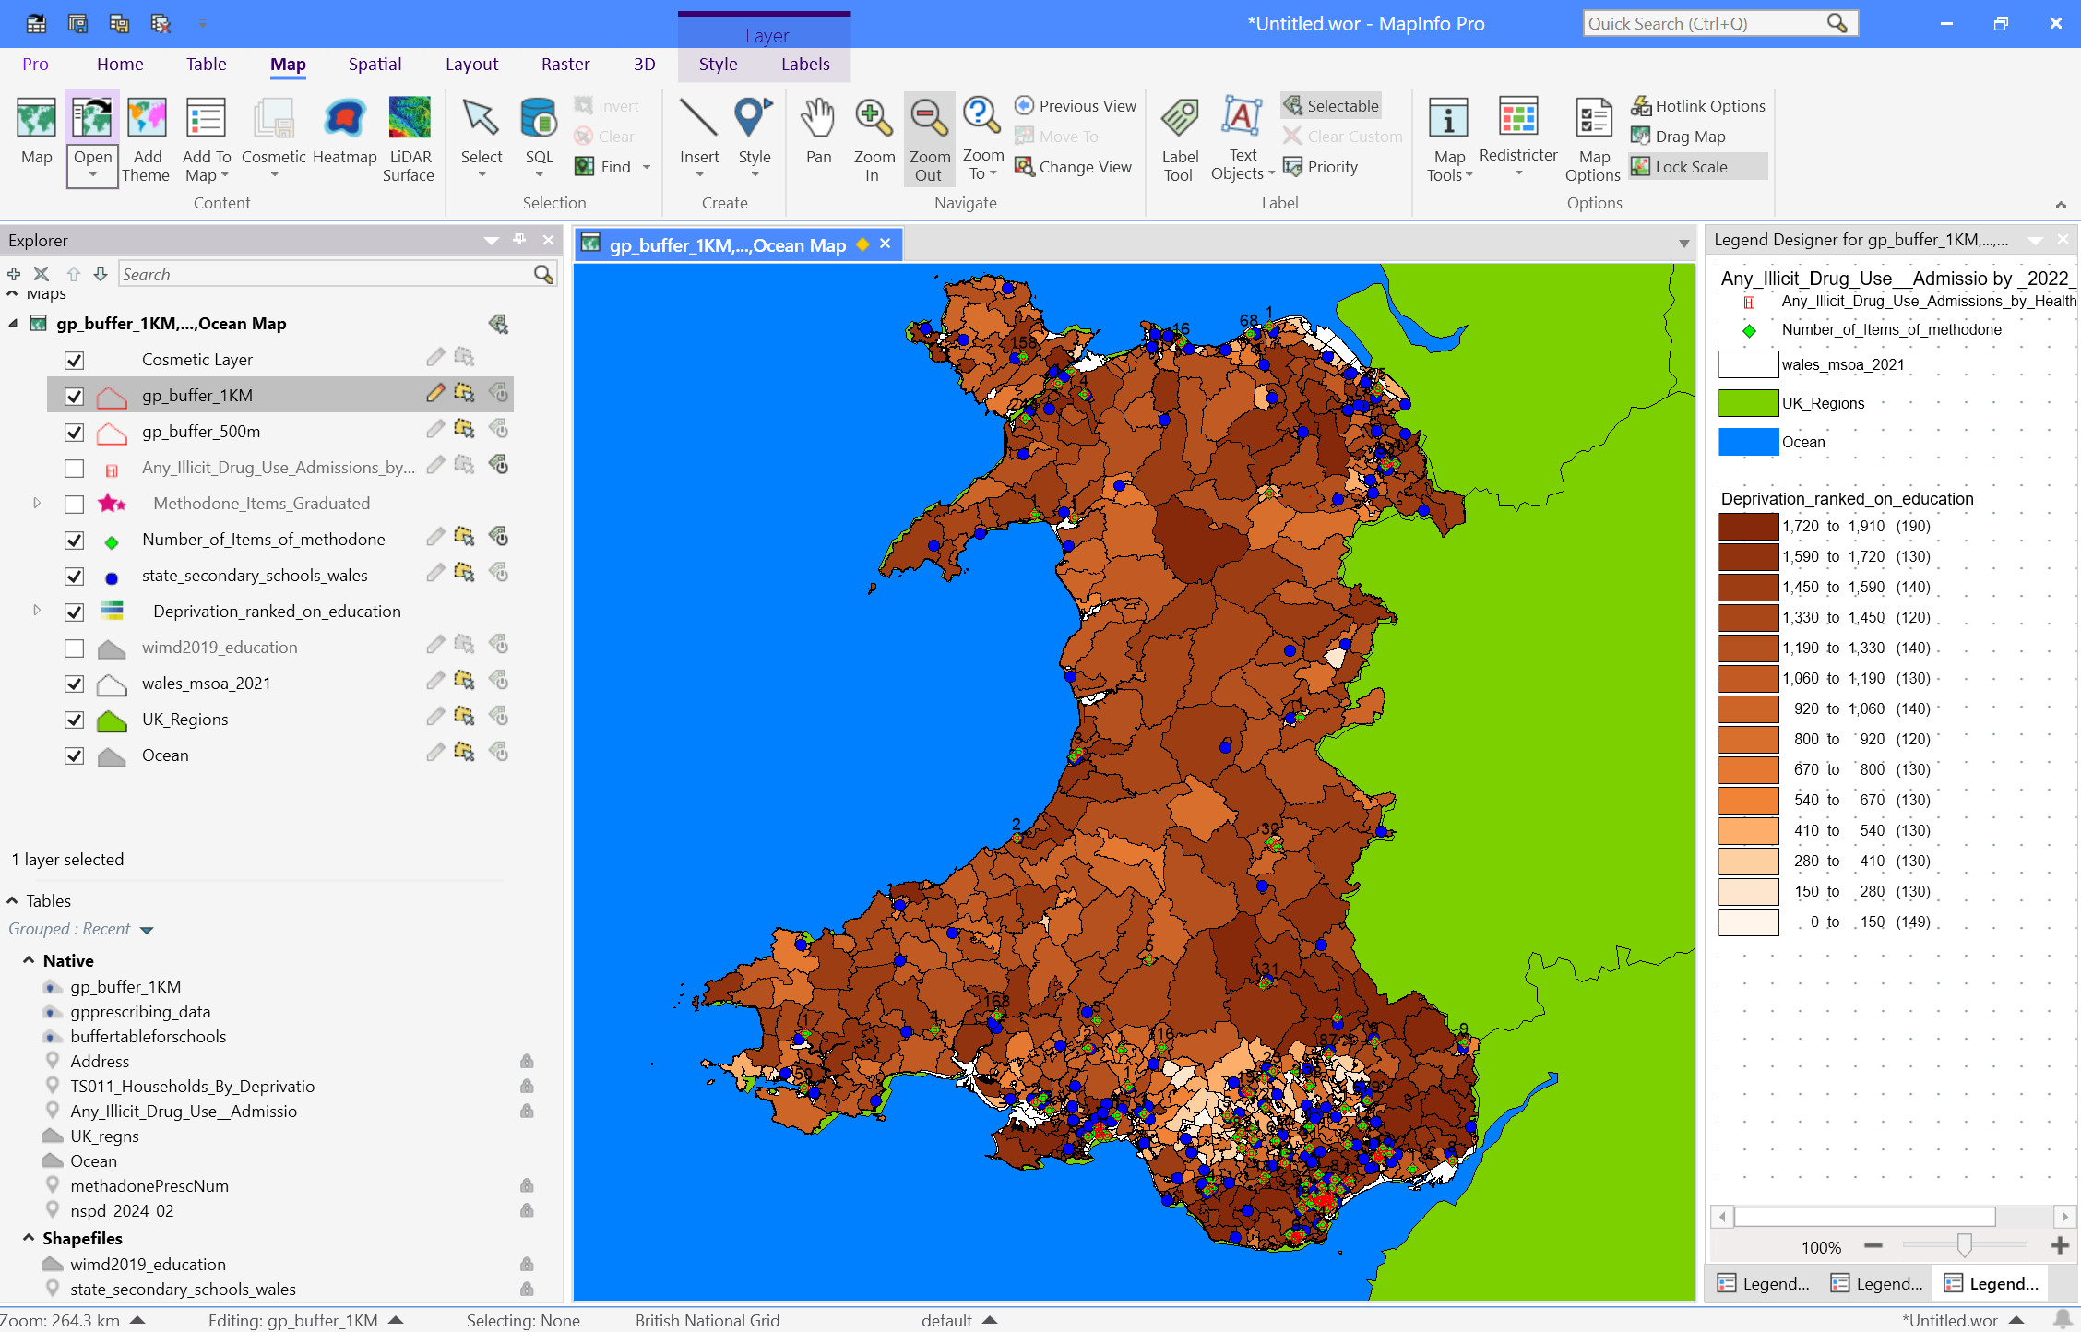

Discussion and Policy Implications
Impact of Education Deprivation on Drug Admissions
- The spatial relationship suggests that education deprivation contributes to drug misuse risks.
- Areas with lighter shades (higher deprivation) have increased drug-related hospitalisations, highlighting the importance of educational support programs.
Accessibility of Methadone Treatment
- While the presence of pharmacies near high-risk areas is beneficial, some underserved areas remain.
- Recommendation: Expanding methadone distribution services to underserved high-deprivation areas may improve treatment accessibility.
Proximity of Schools to High-Risk Zones
- Schools situated near areas with high drug-related admission rates may require additional safeguarding measures.
- Recommendation: Implement harm reduction programmes in schools within high-risk zones.

Case Study Discussion: Wales’ Spatial Dynamics
Socio-Spatial Factors in Drug Use
The report highlights how areas with low educational attainment often correlate with:
- Higher Unemployment: Low educational levels are frequently linked to higher unemployment rates, which may further exacerbate substance misuse risks.
- Limited Access to Health Services: Deprived areas may have limited access to addiction services and healthcare, leading to higher drug misuse rates.
The correlation between these socio-spatial factors is a key area for further research, particularly when considering how different socioeconomic factors may compound the risks associated with drug misuse.

Methadone Access Equity
The distribution of pharmacies dispensing methadone appears uneven, with urban centres benefiting from better service access. This is a critical finding for ensuring equitable service delivery in all communities, particularly rural or peripheral areas.

School Exposure Risks
Schools located near pharmacies dispensing methadone in high-risk areas present unique policy challenges. Ensuring that students in these schools receive adequate support and drug prevention education is crucial to mitigating potential exposure to harmful environments.

Policy Recommendations and GIS in Practice

For Public Health
- Expand Services: Extend methadone services to rural or underserved areas using mobile clinics to ensure equitable access to treatment.
- Community Health Programs: Implement health programs in areas where school and hospital admission overlaps occur, particularly in deprived regions.

For Education Policy
- School-Based Harm Prevention: Schools located near pharmacies in deprived areas should receive funding for drug prevention programs and mental health support services.
- GIS-Informed Planning: GIS can be a powerful tool in helping decision-makers allocate resources more effectively, using spatial data to target the most vulnerable areas.

Future GIS Enhancements
- Incorporating time-series data to analyse trends over time, such as fluctuations in methadone prescriptions or drug admission rates.
- Running Hot Spot Analysis and Spatial Autocorrelation (Moran’s I) tests to validate clusters of high drug admission rates and educational deprivation.
- Using geostatistical tools like kriging for interpolation, to estimate values in data gaps, especially in areas with sparse data.

Limitations and Future Research

Data Gaps
Some limitations include:
- Lack of private pharmacy data or non-dispensed prescription records.
- The education dataset reflects general deprivation and not school-specific performance data.

Correlation vs Causation
GIS mapping reveals spatial proximity and correlations but does not directly establish causality. Further research combining qualitative and quantitative data would provide stronger evidence of causal relationships.

Suggested Future Work
Integrating additional datasets like:
- Drug-related crime statistics (police data) for deeper insight into spatial crime and substance misuse issues.
- Youth unemployment data to examine its interaction with education and health outcomes.
- Accessibility to addiction services (e.g., wait times, service distribution).

Community Engagement
Visualising GIS results in interactive story maps could engage stakeholders and communities. Such tools can help raise awareness about spatial inequities and promote collective action.

Conclusion
This GIS build has revealed significant spatial correlations between methadone prescription distribution, educational deprivation, and drug-related hospital admissions in Wales. The use of thematic maps, buffer analysis, and spatial queries has provided valuable insights into where interventions might be most needed. These findings can inform targeted policy recommendations aimed at improving public health outcomes and reducing inequalities in drug treatment access across Wales.

References
[1] Maptive, “What is a Thematic Map? 6 Types of Thematic Maps,” Maptive, [Online]. Available: https://www.maptive.com/blog/thematic-map/. [Accessed: 03-Apr-2025].
[2] NHS Wales Shared Services Partnership, “General Practice Prescribing Data Extract,” NHS Wales, [Online]. Available: https://nwssp.nhs.wales/ourservices/primary-care-services/general-practice-prescribing-data/. [Accessed: 03-Apr-2025].
[3] DataMapWales, “Welsh Index of Multiple Deprivation (WIMD) 2019 - Education,” Welsh Government, [Online]. Available: https://datamap.gov.wales/maps/wimd-education/. [Accessed: 03-Apr-2025].
[4] Digital Health and Care Wales (DHCW), “Any Illicit Drug Use, Admission Rates (Age-standardised) per 100k pop, Persons, All Ages,” Data Explorer, [Online]. Available: https://public.tableau.com/app/profile/dhcw/viz/AnyIllicitDrugUseAdmissions/. [Accessed: 03-Apr-2025].
[5] DataMapWales, “All Schools Wales,” Welsh Government, [Online]. Available: https://datamap.gov.wales/layers/allschools/. [Accessed: 03-Apr-2025].
[6] Tableau, “Data Cleaning: Definition, Benefits, And How-To,” Tableau Software, [Online]. Available: https://www.tableau.com/learn/articles/data-cleaning. [Accessed: 03-Apr-2025].

