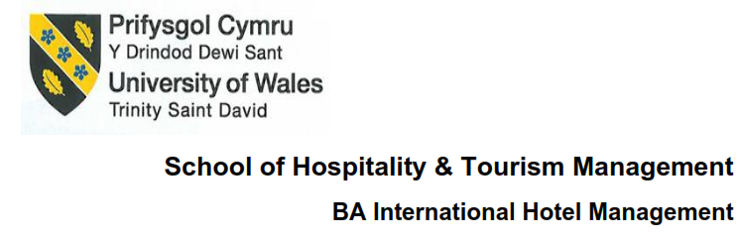
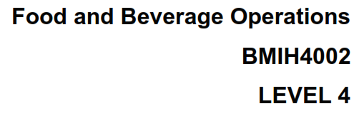
Title Assessment 1 – Student Journal
Student Name: Valeria Nistor
Student ID: 2206486
Wordcount- 818

Table of Contents
Introduction 3
Comparison of food and beverage businesses with regards to types and styles of services 3
Hard and soft skills for the company from the observation as a customer 4
Conclusion 5
References 6

Introduction
Food and beverage businesses have different types of services and styles which mainly contribute to a greater extent to the economy. This journal mainly reflects the different types of services that are offered in the industry in order to serve both domestic and international guests along with various types of hard and soft skills which are contributory and required in order to work efficiently in this sector

Comparison of food and beverage businesses with regards to types and styles of services
There are different types of services that I have experienced and learned from working in the food and beverage industry both as an employee and as a customer. There are various types of services that are offered in the food and beverage industry.
Table service: This is a kind of service where the guests come and book a table for which the restaurants charge a certain amount of money regardless of the food and other food items prices. In this case, I have experienced that the waiters and the people related to this service should have a very meek and polite attitude so that they can serve the customer in a better manner
Steak houses: These are the specialized businesses that offer various types of steaks that are served to the customer and in these businesses the service providers should be pretty experienced and skilled in the serving part because it allows them to offer different types of stylish food serving which attracts a lot of customers.
Fast service restaurants: These are the kind of businesses which are mainly developed for serving instant food and most of the menu of these restaurants is on fast food items like Burgers, Pizza and other stuff. From table and steak house, here the daily commuters tend to spend most of their food desires
Traditional Dining Places: The majority of traditional restaurants are regular eateries in the city center that lack any kind of standard or distinguishing feature. The most typical type of business, traditional restaurants, offer moderately priced food, table service, and staff with a medium level of education and experience. The same staff members also serve food and clean up after themselves. These restaurants use a variety of cooking techniques, have extensive menus, and follow good service procedures. Most businesses have all of the individual grills, stone/convection ovens, stoves, and other cooking apparatuses that can be used to prepare food in traditional restaurants.
Family-run restaurants: Compared to upscale eateries, these American restaurants are more affordable, straightforward, and simpler to cook meals and provide table service in. These establishments are typically family restaurants that offer a small selection of foods and beverages. They compete with eateries and bars that offer a limited menu of sandwiches, pizza, and hamburgers, among other foods and beverages. The bulk of meals are prepared using fresh ingredients, thus serving employees need not be experienced

Hard and soft skills for the company from the observation as a customer
There are various hard and soft skills required for serving in the food industry and these are given below.
Food service: Serving food is a pretty important skill because there are different types of people who visit the restaurants while I was working at the city restaurants and I often noted that sometimes the customers tend to become irritated when someone makes any mistake in serving food
Cleanliness: Restaurant is a very private and homely place which needs to be cleaned and I personally felt when I went to some of the restaurants as a customer, I always prioritized cleanliness in the first place. So cleanliness also helps to achieve a more hygienic environment and helps to increase the appetite as well
Communication: Talking with the guests in a restaurant often requires some specific language that will not express any bias or interpret any double meaning which could later on give birth to some confusions. As a result, I was taught certain phrases and words that would work in many critical situations and this is a very important soft skill that is required in this industry.
Time management is another important aspect as the bigger restaurant I worked at used to have a lot of guests and processing orders in such a manner so that everyone remains happy is somewhat a tiresome and critical task. In this case, I personally developed time management skills which would help me to serve the right customers at the right moment and I also ensured that my task properly keeps the guests satisfied. Some, I use certain phrases and words which helped me to make my guests mind cool and more patience.

Conclusion
So, these are some of the most required soft and hard skills for this industry which will also help to shape my future endeavors as well. Moreover, working physically allowed me to understand various real-life critical situations and enabled me to tackle such situations in a better manner

References
Alavi, S. and Toozandehjani, H. (2017). The Relationship between Learning Styles and Students’ Identity Styles. Open Journal of Psychiatry, 07(02), pp.90–102. doi:10.4236/ojpsych.2017.72009.
Balasubramaniam, G. and K, I. (2016). A Study of Learning Style Preferences among First Year Undergraduate Medical Students Using VARK Model. Education in Medicine Journal, 8(4). doi:10.5959/wimj.v8i4.440.
Bhagat, A., Vyas, R. and Singh, T. (2015). Students are aware of learning styles and their perceptions of a mixed method approach for learning. International Journal of Applied and Basic Medical Research, [online] 5(4), p.58. doi:10.4103/2229-516x.162281.
Bolliger, D.U. and Supanakorn, S. (2018). Learning styles and student perceptions of the use of interactive online tutorials. British Journal of Educational Technology, 42(3), pp.470–481. doi:10.1111/j.1467-8535.2018.01037.x.
Daouk, Z., Bahous, R. and Bacha, N.N. (2016). Perceptions on the effectiveness of active learning strategies. Journal of Applied Research in Higher Education, 8(3), pp.360–375. doi:10.1108/jarhe-05-2015-0037.
Díez-Pastor, J.F., Rodríguez, J.J., García-Osorio, C.I. and Kuncheva, L.I. (2015). Diversity techniques improve the performance of the best imbalance learning ensembles. Information Sciences, 325, pp.98–117. doi:10.1016/j.ins.2015.07.025.
Nelson, E. and Riehman-Murphy, C. (2022). Just One Textbook? Journal of Open Educational Resources in Higher Education, 1(1), pp.240–263. doi:10.13001/joerhe.v1i1.7173.
Pettersson, R. (2018). Gearing Communications to the Cognitive Needs of Students: Findings from Visual Literacy Research. Journal of Visual Literacy, 24(2), pp.129–154. doi:10.1080/23796529.2004.11674609.
Rogers, K.A. (2017). Impact of a sustained Cooperative Learning intervention on student motivation. Journal of Physical Education, Recreation & Dance, 88(6), pp.62–62. doi:10.1080/07303084.2017.1331667.
Rogowsky, B.A., Calhoun, B.M. and Tallal, P. (2015). Matching learning style to instructional method: Effects on comprehension. Journal of Educational Psychology, [online] 107(1), pp.64–78. doi:10.1037/a0037478.
Sánchez-Cardona, I., Salanova Soria, M. and Llorens-Gumbau, S. (2018). Leadership Intellectual Stimulation and Team Learning: the Mediating Role of Team Positive Affect. Universitas Psychologica, 17(1), pp.1–16. doi:10.11144/javeriana.upsy17-1.list.
Vizeshfar, F. and Torabizadeh, C. (2018). The effect of teaching based on dominant learning style on nursing students’ academic achievement. Nurse Education in Practice, 28(28), pp.103–108. doi:10.1016/j.nepr.2017.10.013.
Watson, F.F., Castano Bishop, M. and Ferdinand-James, D. (2017). Instructional Strategies to Help Online Students Learn: Feedback from Online Students. TechTrends, 61(5), pp.420–427. doi:10.1007/s11528-017-0216-y.

