Student Name: Scott Cameron
P Number: 1802058
Programme of Study: BA Graphic Design (y1)
Module: ADAD4009
Tutors name: SCOTT L SMITH & MARTIN BUSH
Word count: 1537

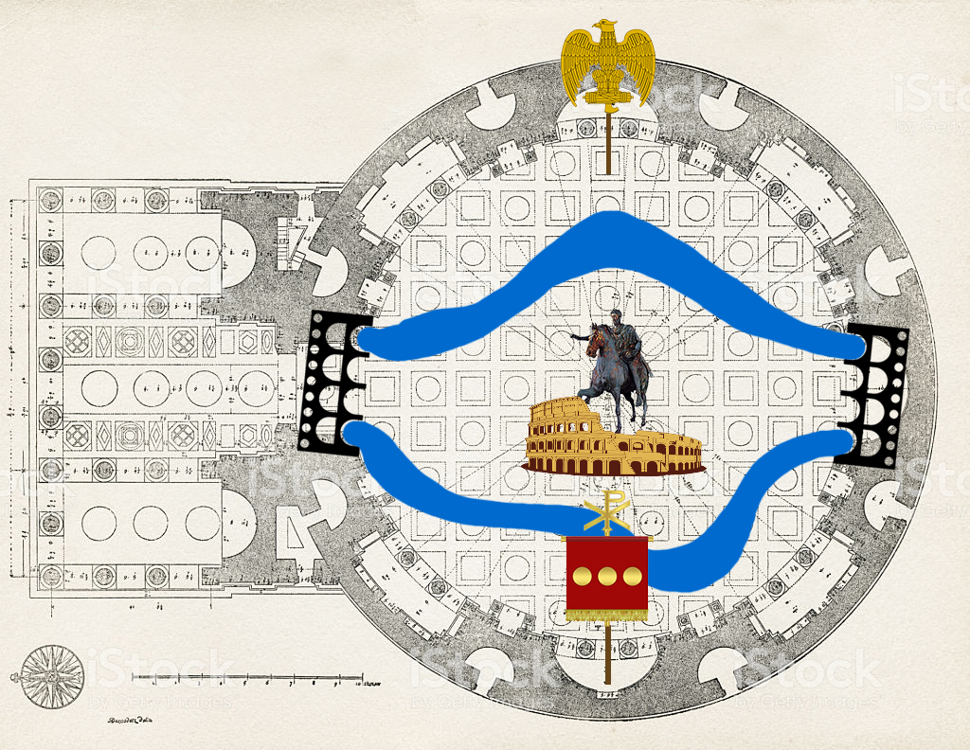

RELICS OF ROME:

When looking back in time, it’s impossible to not be amazed by the sheer grandeur and power of the

Roman Empire. It has been over 1,500 years since the fall of their reign. Much has changed since

then and, after countless hours of research, we can now look back to discover how they once lived.

Within my curation, I will aim to delve deeper into a selection of Roman relics to invoke the feeling

that the visitors could be standing within ancient Rome. This space will conjure up an atmosphere of

a time of art and culture, war and politics.

The perfect setting for this exhibition is the Pantheon in the heart of Rome. The Pantheon was

completed by the emperor Hadrian in approximately 126 AD, which ties perfectly as my curation

topics all feature certain emperors as their common denominator. This construct is regarded by

many as one of the most influential in Western Europe to this day; preserved since ancient times

and once dedicated to the gods of pagan Rome. Within my curation, religion will be one of the five

featured topics, we will see how an emperor abandoned these gods in favour of Christianity. The

topics will each feature a characteristic relic from Roman life and explain the involvement of the

emperor who characterised it. These relics have been selected to provide an impression of Roman

culture, from art to entertainment, architecture, war and religion.

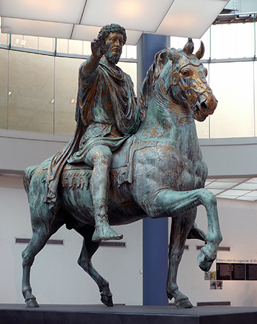
Figure 1, Bronze statue (Becker, J, 2019)

ART:
Marcus Aurelius

Art played a significant role in Roman culture. We can see this in the form of sculptures which

occupy the capital. It has been said that “emperors were in the hands of their image-makers”

(Elsner, p161, 2001). This placed great responsibility in the hands of the sculptors and one could

suggest that this made the emperors immortal, as their concrete statues – or, in Marcus Aurelius’

case, bronze - still inhabit the capital. The exhibition, therefore, would not give justice to this period

without their mention. The statue of Marcus Aurelius is characteristic of this as it glorified his

position as emperor and the power of his army during the imperial rule of Rome (Robinson, 1926).

The statue, which will be recreated to feature in the exhibition, depicts Marcus on his horse in a

pose of control and power. The exhibition will feature an information board alongside the statue

with the details mentioned in this section. This will emphasise the importance of artistic sculptures

during the reign of Marcus Aurelius.

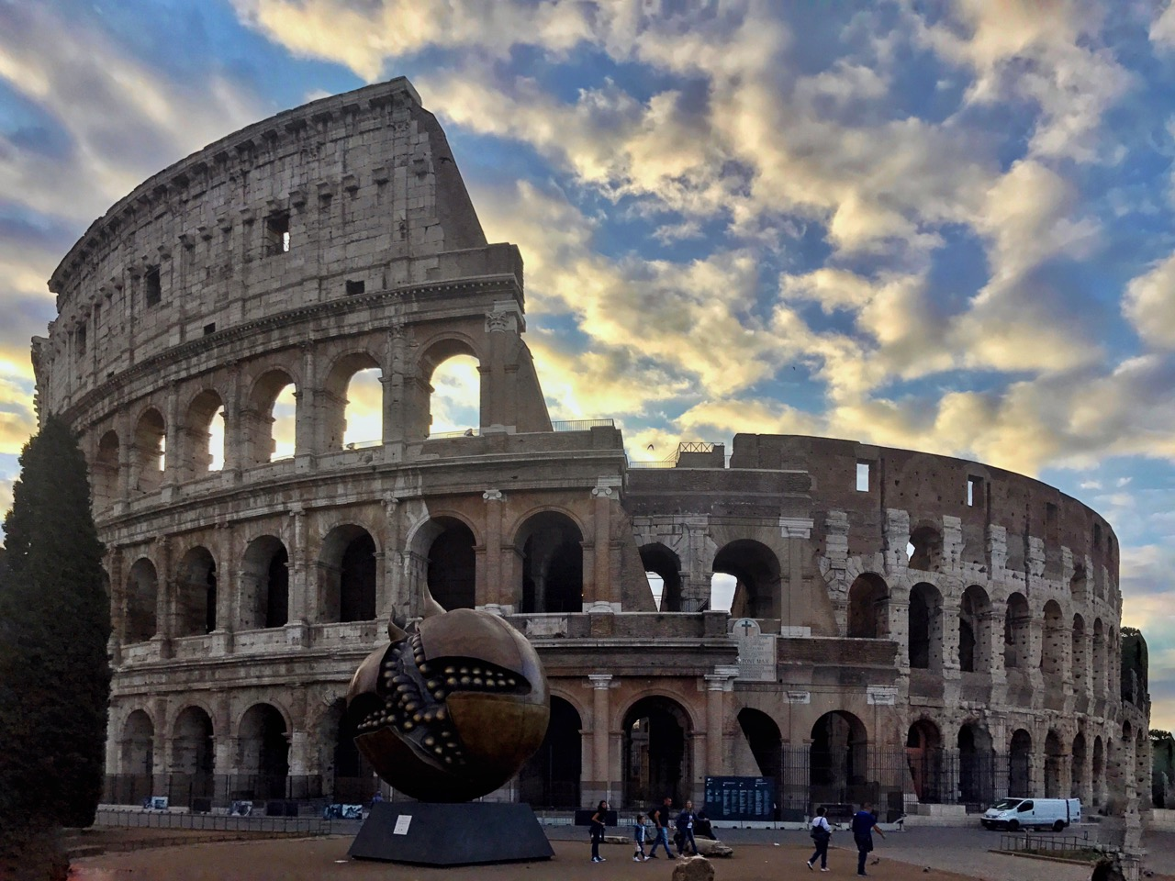
Figure 2, Colosseum, Bernard, E. (2018).

Entertainment:
Commodus

Roman history is filled with stories of how emperors entertained society with battles between

‘gladiators’ and wild animals. Most of this entertainment took place at the Colosseum. The vicious

battles acted as a means for the emperors to grow their power and influence on society. Dunkle

(2013) explains that Commodus, as emperor of Rome, fought as a gladiator against wild animals.

This is said to always have been a very predictable affair, as Commodus would fight from a position

where he wasn’t vulnerable. Furthermore, he would never fight a skilled warrior in the arena.

Despite this, he thought of himself as a ‘god’ of the arena, which is emphasised by Adams (2013)

who states that Commodus referred to the people of Rome (his spectators) as ‘The People of

Commodus’. This speaks volumes regarding his enjoyment of the spectators watching him take

victory after every battle. The brutality of this form of entertainment will be illustrated via an

architectural model of the Colosseum, depicted during one of these unfair battles – showing animals
cornered off in the arena with an approaching Commodus armed with long spears ready to impale

them at a safe distance.

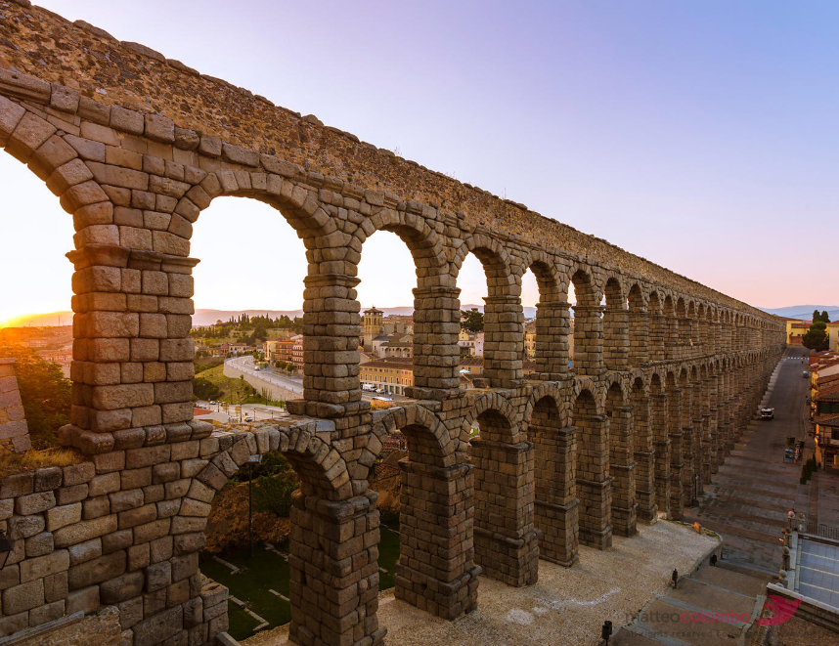
Figure 3, Aquaduct (Colombo, M.)
Architecture:
Trajan

Another characteristic aspect of the Roman empire can be seen in the buildings and structures which

still stand from their reign. The grandeur of the Colosseum is what comes to mind for most of us

when we consider Roman architecture. The importance of this building and the events taking place

there has been discussed in this commentary and, considering the breadth of the Roman empire,

there is another, more fundamental, aspect of architecture to discuss – aqueducts. In particular, the

Aqueduct of Segovia, which was built by the Roman emperor Trajan. Parker (1876) explains that

aqueducts were constructed as a means to bring water through to towns and cities controlled by

Rome, where the water would be fed into reservoirs below palaces and villas. Although most Roman

aqueducts were underground, the 823 meters of granite arches which form the Aqueduct of Segovia

were necessary to cross the natural depression in the surrounding land. This will be featured in the

exhibition as an interactive exhibit, comprising of a model of the Aqueduct of Segovia. The model

will be created from wooden segments to form the multiple arches which will be textured and

painted to replicate the aqueduct. The model will transport water from one side of the Pantheon to

the other, and give visitors the chance to control the flow of water from the source – a large tank at

the side of the exhibition. This will immerse the visitors in the space and engage their interest in

Roman architecture.

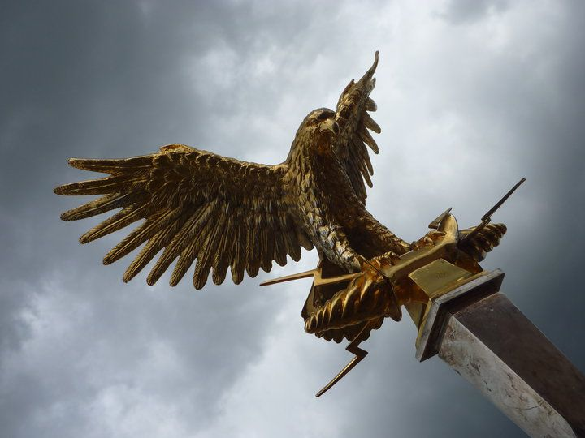
Figure 4, Aquila (Dasilva, W. 2019)

Politics:
War
Julius Caesar

Julius Ceaser was thought of as one of the greatest military commanders of all time. Despite not

being emperor, he laid the path of a thousand-year-density for the Roman Empire. He fought many

battles within Europe, along with civil wars against Senate members. Ceaser overcome many

obstacles, however, he was eventually betrayed by his close friend, Marcus Junius Brutus, on the

doors of the senate after declaring himself ‘dictator for life’.

Amongst other relics which Ceaser left in his wake, the silver eagle (Aquila) is quite prominent. Since

the foundations of the Roman Empire, the Aquila was a symbol of power, strength and immortality.

The Romans thought all other birds were in the eagle’s shadow.

The eagle was a symbol of the empire and its sheer power. It would be carried at the front of the

legion by an Aquilifer, under the watchful eye of the Legatus. Julius Caesar would consecrate the

eagle when the legion brought it back. Ceaser thought the eagle was divine and only to be touched by gods.

Throughout time, we have seen symbols used as a representation of power. The eagle is no

exception and it has been used before the Roman empire, in Byzantine. Also, long after the empire

in Nazi Germany, symbols, or what we would now call logos, hold a lot of power. Lomas (2011)

describes symbols as more powerful than the written word, as they communicate an idea or concept

by speaking to the heart, inducing an emotional, rather than intellectual, response. For this part of

my exhibition, I would like to show a full-sized Roman empire eagle lifted into the air with a pole, as

the Romans would do. There is also space in the exhibition to show the inspiration for using the

eagle from past empires all the way up to the Third Reich.

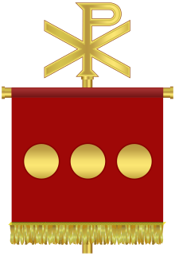
Figure 5, (ANON)

Religion:
Constantine the great

Constantine was the first emperor to convert to Christianity. He made laws that protected Christians

and also, surprisingly, had quite a liberal approach for that time by allowing for freedom of worship

throughout the empire. He did not force his new faith on his lessers. There were no punishments for

those who chose to continue to support the old pagan gods.

Constantine created the Labarum, a flag-like object used in the military by Roman soldiers. “The

name of Christ, in the form of a ligature of its first two letters, Chi-Rho was displayed in a wreath

made of precious stones and gold which topped the staff” (Holloway, p3, 2008). This relic was

regarded by Constantine to symbolise the crucifixion of Christ. A Chi-Rho staff would fit perfectly in

my curation mostly because of the location, as the Pantheon went through all of these religious

changes, from neutral beliefs of society to the times of pagan gods.

Bhaskar (2016) describes curation as the method used to select and arrange content, often from a

vast sea of information, to add value to the content by bringing the selected pieces together. This

acts to make the information overload, that we see in modern life, more accessible and easier to

consume. Obrist (2014) explains that exhibitions are a method of displaying curations and their
effectiveness at engaging visitors with their curations depends on the ‘exhibition architecture’ along

with the content that is curated. This refers to the layout of the exhibition and how the curated

content is presented in each section of the exhibition. Obrist mentions that the association between

the curated content is key for effective exhibition architecture.

The theories of curation mentioned above have been applied to my curation by selecting five

interesting relics from the countless treasures discovered from the Roman empire. The rational

behind the selection of these relics was to reveal different areas of Roman culture and the emperors

that led them. The idea to represent this as a physical object – a relic – invites the curiosity of visitors

to the exhibition by showing them, for example, a model which they can approach and explore. This

prompts the interest of visitors and gives them a snapshot of the relics of Rome and its vast empire.

Bibliography

Adams, G. (2013). The Emperor Commodus. Boca Raton: BrownWalker Press.

Anon, (2019). [image] Available at: https://upload.wikimedia.org/wikipedia/commons/thumb/9/99/Labarum_of_Constantine_the_Great.svg/220px-Labarum_of_Constantine_the_Great.svg.png [Accessed 3 May 2019].

Becker, J. (2019). [image] Available at: https://smarthistory.org/equestrian-sculpture-of-marcus-aurelius/ [Accessed 3 May 2019].

Bernard, E. (2018). [image] Available at: https://www.romewise.com/photography-tips-for-rome.html. [Accessed 1 May 2019].[

Bhaskar, M. (2016). Curation: The power of selection in a world of excess. London: Piatkus.

Colombo, M. [image] Available at: https://www.matteocolombo.com/media/7b6337ac-4712-4777-8c9e-67a9d12ee247-the-roman-aqueduct-of-segovia-at-sunrise-spain [Accessed 3 May 2019].

Dasilva, W. (2019). [image] Available at: https://www.pinterest.co.uk/pin/535083999454790878/ [Accessed 27 April 2019].

Dunkle, R. (2013). Gladiators: Violence and Spectacle in Ancient Rome. Oxon [England]: Routledge.

Elsner, J. (1998). Imperial Rome and Christian triumph. Oxford: Oxford University Press, p.161.

Holloway, R. (2004). Constantine & Rome. New Haven: Yale University Press.

Kleiner, F. (2010). A History of Roman art. Boston, MA: Wadsworth, Cengage Learning.

Lomas, R. (2011). The secret power of Masonic symbols. Beverly, MA: Fair Winds Press.

Obrist, H. and Raza, A. (2015). Ways of curating. London: Penguin UK.

Parker, J. (1876). The archaeology of Rome. Oxford: J. Parker and Co.

Robinson, D. (1926). Roman Sculptures from Colonia Caesarea (Pisidian Antioch). The Art Bulletin, 9(1), pp.5-69.

