
Effective team working for team success.


MEVISH T SHEIKH (2026547)
UNIVERSITY OF WALES TRINITY SAINT DAVID
BMSW4002-Effective team working and communication
Task1
Lecturer Mr. Dale Clarke

Table of Contents

1. Introduction 2
1. How students can develop an effective teamwork 3
3.The impact effective teamworking can have for team success. 4
Heathfield, (2021) “The team has agreed-upon procedures for diagnosing, analysing, and resolving teamwork problems and conflicts.“ 4
1. Positive Points 4
2. Negative Points. 4
4. Barriers to affecting team working. 5
1. Lack of understanding. 5
2. Distractions. 5
3. Culture and language barrier. 5
4. Lack of concentration 6
4. The type of roles that are needed to create a cohesive and effected team. 7
1. Team leader – 7
2. Supporter- 7
3. The organiser- 7
4. Idea collector- 7
5. IT technician – 8
6. Recommendation’s 9
7. Summery 10
8. References List 11
9. Appendices 12

Introduction

I will be explaining about the, barriers that can be effected within a team, Lack of understanding, distractions, lack of concentration and cultural and language barrier. Effective team working in this report, working part of a team is important for all who take part in team development to go further as a team.
how students can develop an effective team by inputting their ideas and sharing practical thoughts showing gratitude to one another. Work environment and the impact effective teamworking can have for team success. What barriers to effective team work is and the outcome of it can be. The type of roles that are needed to create a cohesive and effected team.

How students can develop an effective teamwork

Every student plays an important role in teamwork, as every student is from a different culture also have different personalities which can make a team full of ideas and can be challenging also at the same time fun depending on the level of communication with each other. Team can be described as aiming for the same goal same path, whereas a group is a group of students for example standing in the same line but going to different classes.
When working part of a team it is important that students show respect to each another they honour their ideas and encourage each other. Marlborough, (2019) “Teamwork teaches students that their voices are respected and valued”.
To start off with a healthy team, student may want to start off with a brief introduction about themselves starting of with name, why they are here? What they would like to achieve in the course? What is the student expecting from this team? It is important that students blend their ideas together and come to an agreement when working together on a project.
Now it is not necessary that students get on with different personalities the in the team, it can be a dispute between them, when a student finds themselves in a heated conversation or a situation they are uncomfortable they should try and resolve it within, if that does not work then the team should try and help each other rather than take sides and break that bond of a team, once that trust and bond is broken it can get difficult and tricky to mend that position the students had at the beginning. Being a team member it is also encouraged to be confident within, as inputting effort and bringing ideas across speaking out is important with the rest of the team. 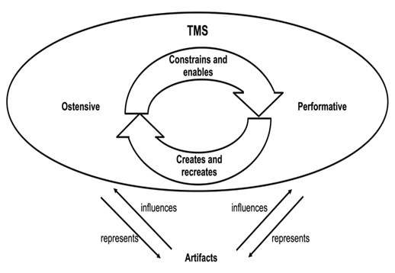Image by Pentland and Feldman, (2018)
3.The impact effective teamworking can have for team success.
Heathfield, (2021) “The team has agreed-upon procedures for diagnosing, analysing, and resolving teamwork problems and conflicts.“

1. Positive Points
Students working part of a team can bring positive vibes within the team, every student has a goal to reach so they work hard to achieve their goal, students then can share their ideas so others in the team can gain knowledge on something they perhaps don’t know? Being in a team working alongside students is important to respect one another and the knowledge they share, light humour as it can keep the team on the jolly side.
Working as a team is great as students can overcome any issues that student may have as for example stress from outside of the class and the student focusing on his or her team work takes the negativity off their mind and is more focused on developing further knowledge in aiming to accomplish their goal.
Taking on responsibility is a key being able to take on role play and leadership, also encouraging each other to meet deadlines.

2. Negative Points.
Students that work part of a team could also be challenging due to disagreements within their team. There is possibilities that racist comments could be passed on, offensive language could be used by fellow students maybe even part of a banter, bullying and favouritism.
The first step would be if a student is being harassed in any form of act is to report the matter to the lecturer or the team leader depending on how upset the student is, it is unfair for any student to be tolerating any type of ill behaviour and to report the matter as soon as possible so the matter can be resolved.
Sometimes it could be a sensitive situation where the student has domestic problems and takes it out in his or her team members, which also is unfair as no one would know why the student has such upsetting comments, best result would be for the team leader to take the student on a side and ask if everything is okay, is there a reason for incident that took place? Maybe give that student a 5 minute break to get some fresh air and come back maybe even an apology.

4. Barriers to affecting team working.
Brodie, (2011), “Conflict should not be seen as a something negative but a constructive way of getting the best from everyone”.

Lack of understanding.
Working in a teal is important to have an understanding of each other and what they are talking about, in this now it is important that full concentration is needed, attention to detail can be tricky so the student needs to be focused on the smallest detail to the key points that are being said or talked about. Putting away their personal devices so it cannot be a distraction for them and can be annoying for other team members if a student is fidgeting with an object or showing no concentration. Politics in team members also is quite a common problem, where the different opinions are not understood or respected. Being part of a team also has its up’s and down’s, the down’s is bullying and gossiping or even picking on a particular student, it can then dishearten the student or other team members and teamwork can collapse.

Distractions.
Team work is all about sharing ideas listening to one and another paying attention to other students is all part of respecting each other and their opinions. Now for that 100% concentration is important to gain an understanding of what is being spoken about. When students start using their mobile devices that is a distraction and showing no respect what so ever and can be overlooked as being ignorant. Best
Option would be if all students turn their devices on aeroplane mode and put it away maybe in a bag or pocket. Sometimes being in a team we have that one chatty student member that doesn’t know when to stop and out of politeness the other students do not know how to say ‘’give it a rest mate’’ so then that can be a distraction in itself.

Culture and language barrier.
Many international students who come from different backgrounds face that culture and language barrier. It can get very difficult for other team members to maybe understand what the other student is trying to explain, in addition to the obvious difficulties of communicating with other students. It can be a concern for poor performing when asked to do a presentation of some sort. At the same time international student can also use this as an advantage for themselves blaming the language barrier the student did not understand what is being said.

4. Lack of concentration
Health is very important that all students should take care of their wellbeing, having enough sleep during the night so the students are able to concentrate at a high level, being tired can automatically make the student team member lose concentration whilst working part of a team, that input the student could of put in could be the vital piece of information that can be the last piece of the jigsaw. Sleep is very important for student to give their full attention to the team members. Eating well and on time is part of a healthy lifestyle which plays a role in concentration within teamwork. If a student does not eat breakfast and skips meals this can be taking the concentration away from what is being said in the team, hunger can take over and play with the students mind, perhaps even make the student weak, light headed and many more health issues can occur.

The type of roles that are needed to create a cohesive and effected team.

Michael Page, (2021) “To ensure that each member understands what is expected of them, define a standard of conduct for the team”

1. Team leader –
Finalises team work, solves problem’s where need be, planning next meeting and other team activities, manages the team and acknowledges any conflicts that may occur within team members. Team leader organises time management. manages time so deadlines, workload and meetings are met at certain time that has been given. Team leader is needs to be Organised and prepared for tasks and team meeting, certain tools stationary is provided to all students. Being committed to the team is important to gain the students trust and remain committed to making the team members a strong team.

2. Supporter-
Supporting other team members is encouraging them to keep going in the work and effort the students put in. Supporters intend to work well with their team members and listen to any suggestions that may help in the teams tasks. It is important for all students especially the supporter to remain calm in difficult situations and disputes. A supporter can follow instructions and offer guidance to other team members.

3. The organiser-
The organiser can arrange and have paperwork and stationary ready for all team members, organises team meetings, team events and also works alongside with the team leader. The Organiser organises all coursework, paperwork that needs to be distributed with in the team members and helps and guides students arrange and organises their work.

4. Idea collector-
Idea collector looks for creative ideas that will standout to support the other team members in the project they may be doing. The idea collector does research on finding ideas and references to support the workload the team has, The idea collector gives his or hers input and information to make the project perfect.

5. IT technician –
IT technician has an important role where he or she will be supporting all aspects on the IT side, supporting the team in any difficulties that may occur on the technical side of the team. guiding team members in using new technology .
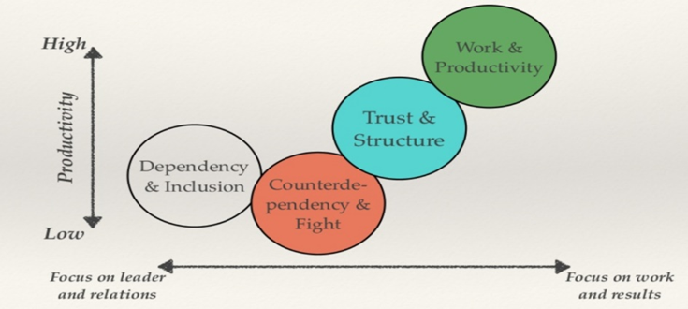
Image by Susan Wheelan. (2018)

6. Recommendation’s
The writer suggests that all students should join their team with a positive attitude, with that they are firstly confident within themselves and will be ready to bust out with ideas to share with the team members, so for this a good night sleep is important they get plenty of rest the night before as well as staying hydrated as drinking water hydrates the mind as with a healthy diet.
PeepsHR, (2018) “Each individual should have their team’s support and commitment not only when making the decision but when carrying them out”.
Firstly showing respect to one another by greeting with a smile, listening to one another in the team, guiding as a team leader and collecting team ideas to make a whole teamwork come to success. It is also recommended the team makes some form of contact within the group for example a WhatsApp group or zoom meeting on line, this way the team will form a strong bond between themselves.
TheHappyManager, (2021) “Promotes the sense of achievement, equity and camaraderie, essential for a motivated workplace”.

7. Summery

Altogether the author has come to an conclusion working as part of a team has many benefits and the students will gain a lot from working together as a team. Working on their own initiative can be great but at the same time very challenging, running out of ideas perhaps? or feeling fed up of over-thinking? Running out of ideas even unable to keep up with deadlines as there is no help or guidance apart from the tutor.
Whereas working part of a team has many advantages the student may have working in a team is meeting other students who have the same agenda aiming towards a goal helping each other to success.

8. References List
Brodie, D, (2011) Teams: The Five Common Barriers to Effective Teamwork [website] Available at: http://superperformance.com/5barriers.php (Accessed on 11th October 2021)
Heathfield, M, S, (2021) 10 Tips for better team work [website] available at: https://www.thebalancecareers.com/tips-for-better-teamwork-1919225 (accessed on 11th October 2021)
Marlborough, (2019) Four benefits of team work for students development& success [website] Available at: https://www.marlborough.org/news/~board/stem/post/four-benefits-of-teamwork-for-student-development-success (accessed on 11th October 2021)
Michael Page, (2021) Building an effective team [website] Available at: https://www.michaelpage.ae/advice/management-advice/development-and-retention/building-effective-team (Accessed on 11th October 2021)
PeepsHR, (2018) Our top 10 tips for effective team work. [website] Available at: https://www.peepshr.co.uk/resource-centre/our-top-10-tips-for-effective-teamwork/ (Accessed on 11th October 2021)
Pentland and Feldman, (2018) ResearchGate. [website] Avalable at:
https://www.researchgate.net/figure/TMS-as-generative-system-adapted-from-Pentland-and-Feldman-2008-241_fig4_239950017 (Accessed on 12th October 2021)
Susan Wheelan, (2018) Managing projects and teams. [website] Available at:
http://www.benronning.com/writing/2018/8/24/managing-projects-teams
(Accessed on 12th Oct 2021)
TheHappyManager, (2021) Why team work is important, 8 good reasons. [Website] Available at: https://the-happy-manager.com/article/why-is-teamwork-important/
(Accessed on 12th October 2021)

9. Appendices

