Carter Reid Henley
Visual Culture: AEthelstan and St. Cuthbert
Skills for Medievalists
December 7, 2020

“He won a major victory at Brunnanburh in an alliance with the West Saxons, Mercians, and Danes. This victory preserved the confidence and culture of the English, and of the royal house of Wessex now bidding for political sovereignty in Britain”

Who
St. Cuthbert
St. Cuthbert is a saint from Northumbria in Northern England. He served as the bishop of Lindisfarne from 684-686. He died less than a year later in 687. After his death, a cult formed around him which grew to be large and popular in the region. Dynastic cults were institutions in which spirituality and aristocratic power mixed, and they held some of the most important people of the time. According to the Anglo-Saxon Chronicles, Lindisfarne was founded by Saint Aidan in the seventh century Following vikinger raids, the monks of Lindisfarne left the monastery and took their beloved saint with them. “His shrine on Lindisfarne was venerated and when in 875 the monks of Lindisfarne had to flee a Danish invasion they carried his coffin on their shoulders.”
Cuthbert is considered one of the “Three Great Churchmen” by scribes of the Anglo-Saxon-Chronicles. According to the Chronicles, he converted many people to Christianity and founded new monasteries who “embodied the Rule of St Benedict.”
Bede
Bede wrote two Lives of St Cuthbert before his death in 735. “He spent his entire life at the monasteries of Monkwearmouth and Jarrow, studying – everything from classical languages to astronomy and medicine.” He continues to be an important ecclesiastical figure regarding the history of Britain.
AEthelstan
AEthelstan, first king of the English, reigned from 924-939. He was the first son of Edward the Elder, and grandson of Alfred the Great of Wessex. As a shrewd administrator, he knew the importance of winning over the church as soon as he came to power:
After establishment of the kingdom of the English ‘with a pledge and oaths’ at Eamont Bridge, near Penirth in Cumbria, on 12 July 927, King AEthelstan needed to impress all those who exercised power and exerted influence in the land. He set out to achieve this at royal assemblies, and by the distribution of gifts, including treasures, books and holy relics.
The king has been praised in writings from multiple cultural backgrounds both during and after his death. For example, The Anglo-Saxon Chronicle states that, “AEthelstan succeeded in 924 and within a few years had conquered Northumbria and became overlord in Cornwall.” AEthelstan’s military endeavors occurred smartly and swiftly. He had a keen mind and a natural ability to lead. The chronicle continues, “He was an able lawgiver and administrator, fostering unity by encouraging governors of the remoter areas to attend court.”
Medium
The image is a painting which served as the frontispiece of a copy of Bede’s Life of St Cuthbert. The facsimile was created in the 930s C.E.in England. Similar to other ecclesiastical works of the mid to late medieval period, the painting is detailed and colorful.

Significance
The image is the first known depiction of a king of England. However, the significance of this painting is much deeper than representing the first ruler of a united England. The history behind the formation of the dynastic cult of St Cuthbert and the rise of one of the most influential kings of England is critical to the understanding and appreciation of this painting.
AEthelstan’s father, King Edward the Elder, was a successful king concerning military endeavors; he nearly united England for the first time. However, he was not always popular with the church. It was rumored that Edward’s first wife, the mother of AEthelstan, was a concubine. Moreover, this would make their child illegitimate and effectively unsuitable to rule. These rumors circulated throughout Aethelstan’s childhood and into his adulthood. To make matters worse, he was sent to live in Mercia with his aunt, AEthelflaed. These actions suggest that the prince was not being groomed to rule Wessex after Edward’s passing. However, AEthelstan’s experience in Mercia was not without benefit. Due to his time spent in the Mercian court, he probably identified himself as culturally Mercian. In addition, he had a different, more communicative relationship with the Welsh than of his father. When he was thirty years old, despite efforts of Edward, AEthelstan was crowned Angolorum Saxonum Rex on 4 September, 924.
Unlike other Anglo-Saxon hegemonies, Wessex did not have the same zeal for dynastic cults like other kingdoms such as Mercia; royal religious houses in Wessex, were often a result of a connection with another kingdom that had dynastic cults. For example, Alfred the Great, AEthelstan’s grandfather, granted lands for the purpose of building the Nunnery at Shaftesbury for his daughter. Because Alfred’s wife was Mercian, it makes a great deal of sense that he would want to model this nunnery in the Merica fashion. In addition, Alfred began the construction of New Minster in Wessex, but died before its completion. His son Edward the Elder also showed little interest in bestowing land or gifts to the church. However, he did continue construction of New Minster.
Due to the fact that AEthelstan was raised in the Mercian court, he was familiar with the power of dynastic cults. For example, a cult existed in Mercia venerating the Northumbrian King Oswald despite the fact that he was killed by a Mercian King, Penda. In addition, Lady AEthelflaed and AEthelred, her husband, also established a dynastic cult to Werburh, the daughter of King Wulfhere, son of Penda, in Chester.

AEthelstan was very generous with the church. He bestowed endowments to several religious houses: Abingdon, AEthelney, Exeter, Malmesbury, Saint Mary’s, Sherborne, and Shaftesbury. Many of these religious houses who had previously criticized Edward and Alfred, praised AEthelstan well after his death.

However, the biggest difference between AEthelstan and his royal relatives was his interest in forming a dynastic cult in Wessex. He supported Cuthbertine communities in Wessex and even undertook the journey to visit the shrine of Cuthbert. According to The Anglo-Saxon Chronicle, “he sent agents to buy objects throughout Europe, especially relics, and gave and received rich gifts.” The king focused particularly on St Cuthbert, and he collected many relics associated with the saint. In addition, the formation of this cult is evident in the History of Saint Cuthbert, which was written after AEthelstan’s death.
Despite the evidence connecting AEthelstan to Cuthbert, the question of why still remains. Perhaps the king wanted to venerate a Northumbrian because that territory was in control of the Danes at that time. Perhaps by aligning himself with a saint from the land of great kings like Edwin of Bernicia, AEthelstan was taking the first step to unifying the remaining Anglo-Saxon hegemonies, as well as the kingdom of Jorvik. This strong association with a saint had not occurred in Wessex since the kingdom’s conception. Through the construction of this dynastic cult, AEthelstan developed a powerful ally that would benefit him in his quest to control all of Britannia. The Anglo-Saxon Chronicle describes him as, “intellectually curious, with a strong character.”
Second, AEthelstan was not meant to be king after Edward’s death. Due to reasons unrecorded by the scribes of Wessex, AEthelweard Aethling, younger brother of AEthelstan, was to be anointed as king following his father’s death. However, AEthelweard died mysteriously soon after Edward. Subsequently, AEthelstan was crowned king of Merica. (who had previously been a subkingdom of Wessex since the reign of Alfred.) Following this political move by the Mercians, Wessex followed suit and crowned AEthelstan king of Wessex. Because the king lacked strong political ties with the powerful nobles in Wessex, he needed to win the support of as many influential people as possible in order to protect his place on the throne. In order to succeed, AEthelstan turned to the church. As previously noted, some of the most powerful families in the region were housed in the church. By gaining their support, the king was able to ensure his grasp on power before beginning his fight to control all of the Anglo-Saxon hegemonic lands, including Jorvik.
Content
The image is the frontispiece of a copy made of Bede’s Life of St. Cuthbert. The king is crowned, wearing fine clothing.
AEthelstan is depicted giving St Cuthbert a book while visiting the saint’s shrine at Chester-le-Street in county Durham in 937. These books were among several gifts given by the king during this visit.
Audience
The audience would be a person reading Bede’s work. In addition to reading about the great English saints, one would also see the first English king depicted with Northern England’s most loved monastic figure. For those who were illiterate, this painting illustrated the piety of AEthelstan. It also represents the powerful connection between the king and the saint that was unlike any king in recent memory. The king would have served as an excellent example of both piety and charity.
Producers
The artist was most likely the scribe who copied Bede’s original text. My guess would be a Mercian or West Saxon scribe connected to St Cuthbert’s dynastic cult.
Location
It is hypothesized that the image was painted in Winchester at the same time as this version of Bede’s Life of St. Cuthbert was facsimiled.
Today, the manuscript can be found at Corpus Christi College, Cambridge.
Visual Culture
The image of AEthelstan bestowing the gifts to St Cuthbert is important for many reasons.
First, it is an illustration which quite literally depicts the church’s relationship with the throne. Second, Wessex had been without a royal dynastic cult since the days of Cerdic, making the cult of St. Cuthbert distinctive. Third, the political culture of the island changed following AEthelstan’s rise to power. Not only did he unite the weak and disparate kingdoms of the Anglo-Saxons under one umbrella, but the former kingdom of Northumbria and its Danish rulers was brought into the fold as well. Last, the cultural unification that came from the formation of the dynastic cult of St. Cuthbert is of particular importance. By bringing the Northern saint into the religious culture of Wessex, the foundation of England was made stronger.
In addition to his strong ties to the church, his successful rise to power can be interpreted as he had been ordained by God to rule all of the English. “Fiery lights appeared in the north part of the sky, and Sihtric died. King AEthelstan received the kingdom of Northumbria, and all the kings on this island were brought under his rule.”
Material Culture
The gifts given in support of the cult from AEthelstan bridged a gap that had been long broken between the church and the crown of Wessex. While Alfred and Edward bestowed gifts to the church, their contributions remained singularly focused on protecting the interest of the royal family. In contrast, AEthelstan brought relics into the region that has long since been sold off or stolen from their respective dynastic communities. By doing this, he also formed strong bonds between the crown and powerful members within the ecclesiastical realm.

Bibliography
Books
Savage, A. The Anglo-Saxon Chronicles. Surrey: Coombe Books, 1996.

Website Articles
The British Library. “Lives of St. Cuthbert, with lists of kings and bishops.” (www.BL.uk), December 12, 2020.
“St. Oswald’s Priory.” (www.visitgloucester.co.uk), December 10, 2020.

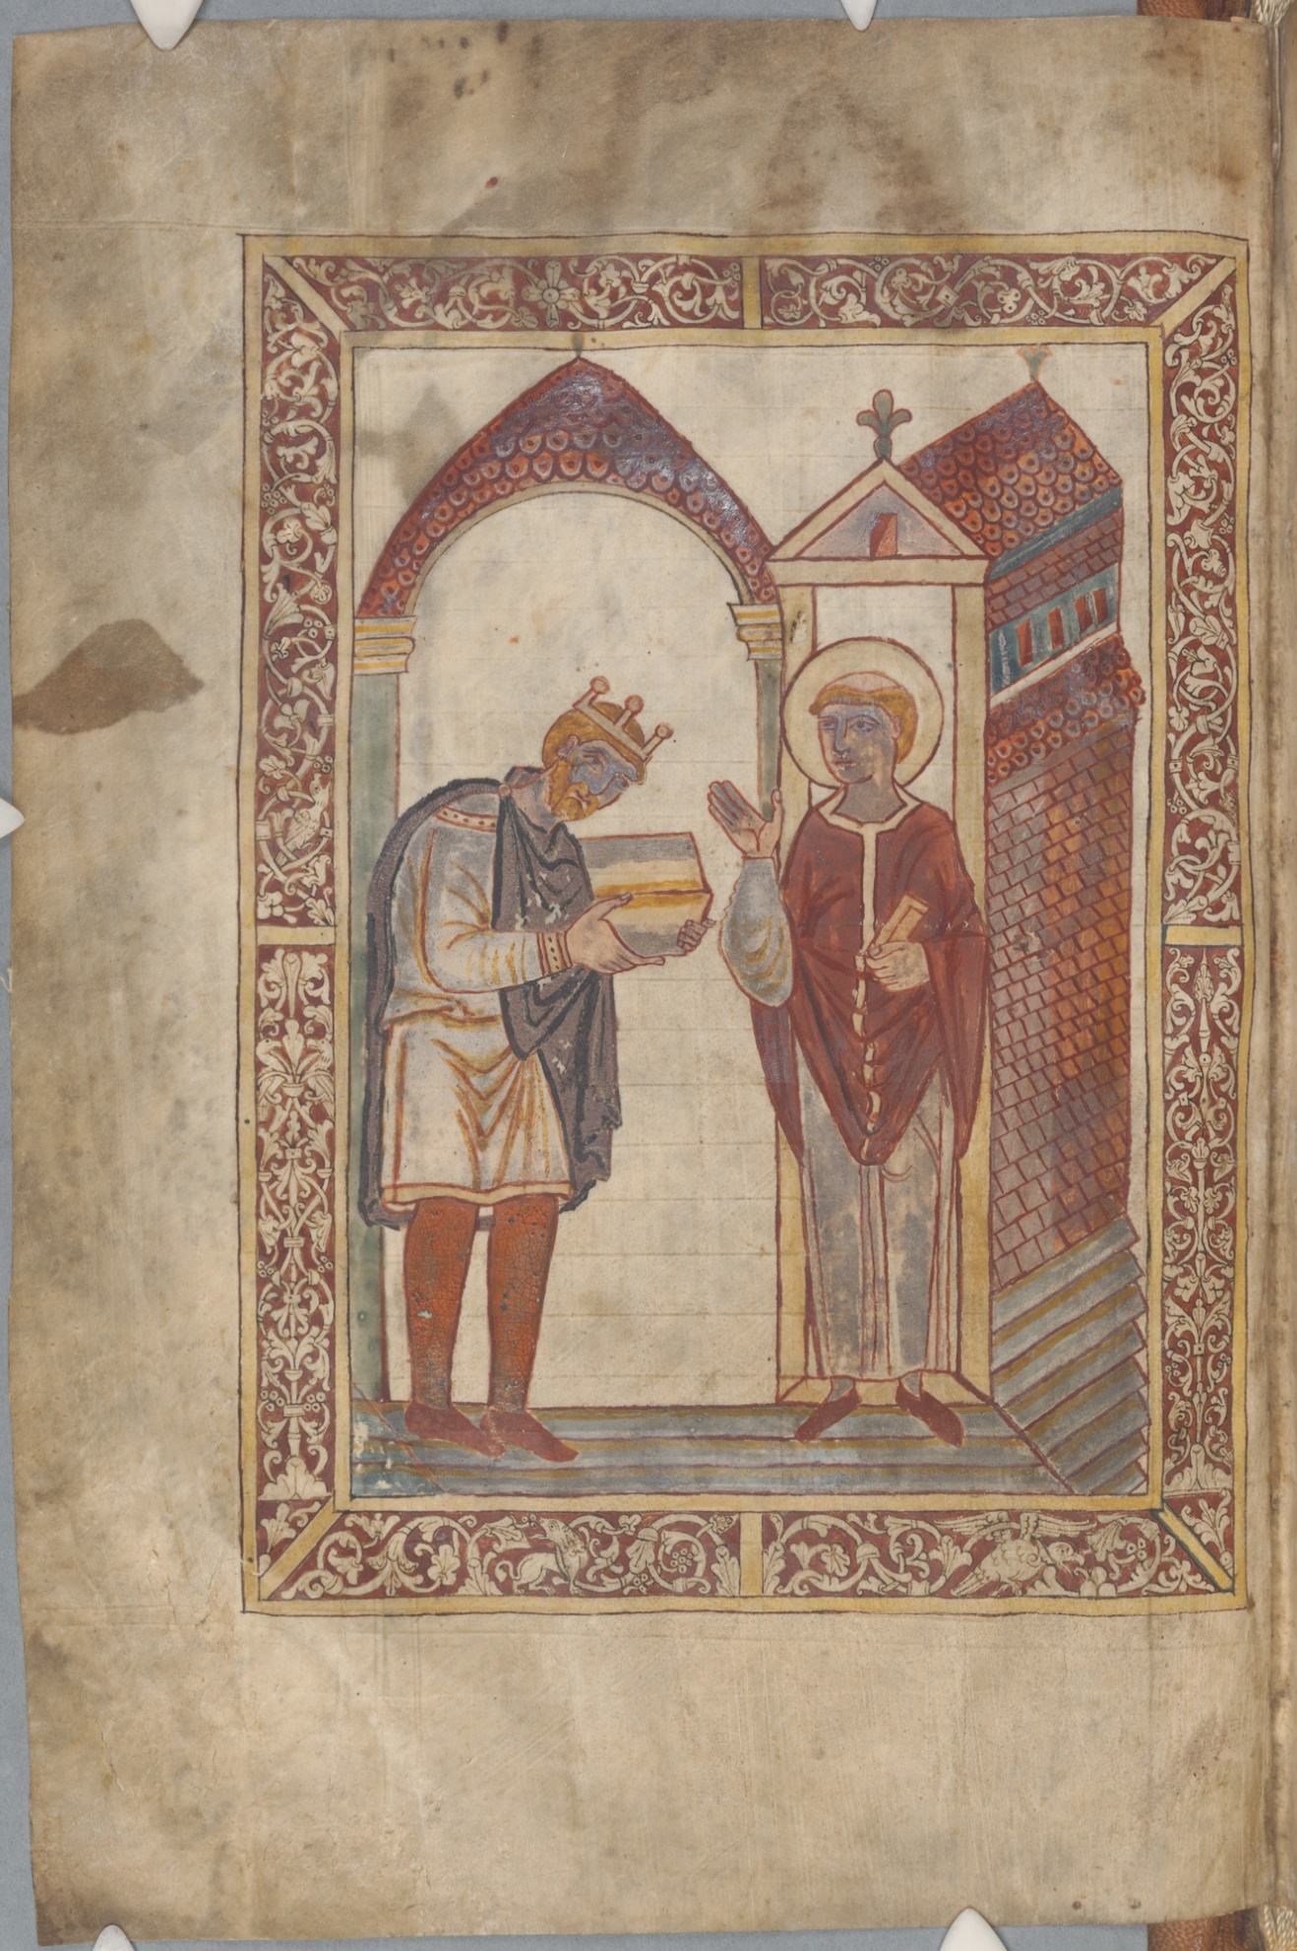

Savage, A. The Anglo-Saxon Chronicles, p. 121
Ibid, pp. 56-57
Ibid, p. 56
Ibid, p. 56
Ibid, p. 56
The Anglo-Saxon Chronicles describes Bede as being the most influential and important of the Three Great Churchman (Bede, Cuthbert, and Bishop Wilfred), pp. 56-77.
The British Library. “Lives of St. Cuthbert.” www.BL.uk.
Ibid, p. 121
The British Library, “Lives of St. Cuthbert.” www.BL.uk
“St. Oswald’s Priory.” (www.visitgloucester.co.uk). AEthelflaed and AEthelred established the cult venerating Oswald by stealing his remains from their resting place in Northumbria while on campaign. Interestingly, they are both buried at the priory built to house the remains of the stolen saint in Gloucester.
The Anglo-Saxon Chronicle, p. 121
Ibid, p. 121
Ibid, p. 120.
Ibid, pp. 120-121.
Ibid, p. 119.

