

Module Code: LCHS4003
Module Name: Introduction to Health and Social Care
Assignment Number: Component 2
Assignment Title: Importance of Communication and Record Keeping for supporting Safe and Person-Centred Care: Case study of Mrs Thompson

Module Leader: Dr Helen Parsons
Student Name: Marcel Macovei
Student ID: 2521005

Table of Contents
1.0 Introduction 2
2.0 Effective Communication in the context of Mrs Thompson’s care 2
3.0 Good administrative skills within professional practice in the context of Mrs Thompson’s care 3
4.0 Importance of working collaboratively with other professionals involved in Mrs Thompson’s care 5
5.0 Conclusion 6
References 7

1.0 Introduction
Mrs Thompson, an 84-year-old woman, has recently been discharged from the hospital after pneumonia and is at high risk of relapse and monitoring complications. She requires proactive and structured interventions and close communication with care providers. As per the view of Fowler et al. (2025), primary care helps in the early detection of mild cognitive impairment. On the other hand, Mrs Thompson has mild dementia, which affects her memory and ability to manage certain aspects of care independently, particularly medication management. The report aims to show the importance of effective communication, administrative skills and collaborative working with evidence-based practices for managing medications and cognitive support for home care settings. Thereby, this study would give an overview of the importance of person-centred communication with well-coordinated support, improving physical and emotional outcomes.

2.0 Effective Communication in the context of Mrs Thompson’s care
Effective communication is essential for preventing medical errors, ensuring accurate diagnosis and ensuring continuity of care. As per the view of Kulińska et al. (2022), communication in medical relations is usually built on trust and mutual respect among patients to improve their quality of life in emotional and social aspects. This shows that communication is a part of effective care to establish trust among the patients and even minimise medical errors. Taking the case study of Mrs Thompson, where the professional needs to adopt a person-centred approach by respecting her preferences and independence, even though dementia has affected her memory and even her understanding. This reveals that the carers need to focus on using simple language and appropriate eye contact for her to process information and respond effectively.
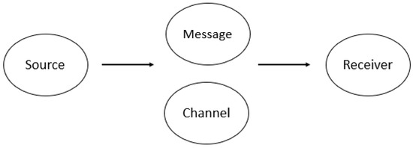
Figure 1: Berlo’s Model of Communication
(Source: Rubino et al., 2022)
As demonstrated in Berlo’s Model of Communication is based on the elements such as Source, Message, Channel, and Receiver. In the case of Mrs Thompson, the sources include the domiciliary care workers, nurses and GP involved in her care. The aspect of message shows that it should be clear, accurate and easier for her to understand. For example, the healthcare provider needs to avoid using complex medical terminology and provide her with simple explanations about the medical care plans and appointments. As per the view of Rubino et al. (2022), based on Berlo’s model, the source or the sender of information encodes the message which is needed to be communicated. Supporting the case of Mrs Thompson, verbal communication, such as easy-to-read charts and information, can be used to support her understanding.
As given in the NHS reports, studies around the world show that effective communication is important for patient safety and health outcomes (NHS England, 2021). As in this case, Mrs Thompson is the main receiver of information, and the professional needs to consider her conditions, like dementia and emotional needs, and encourage her to ask questions and bring about culturally sensitive care. In accordance with this, the guidance is supported by the Equality Act, 2010, where social care providers are legally mandated to provide reasonable adjustments to individuals with a disability, such as dementia, so that they are not substantially disadvantaged (GOV UK, 2010). Apart from that, support involvement is required in this case, such as family members and caregivers, who are active partners in treatment and care discussions for the patients. Hence, applying this model would allow the carers to demonstrate respect and empathy and ensure that Mrs Thompson feels comfortable, included, and valued based on her condition.

3.0 Good administrative skills within professional practice in the context of Mrs Thompson’s care
The health and social care sector ensures accurate documentation to maintain patients' safety and continuity of care. As given in the report, the records may be paper-based or digital, emphasising communicating the right information to the right people at the right time (Petty, 2025). Similarly, based on the NMC code, which outlines the four themes, such as prioritising people, practising effectively, preserving safety and promoting professionalism (Nursing and Midwifery Council, 2018). For instance, the case of Mrs Thompson’s missing information and the incident of being found outside without suitable clothing highlight the safeguarding and safety concerns. In this case, it requires regular monitoring and accurate documentation, which would help to reduce future occurrences. Similarly, based on the UK Data Protection Act 2018, healthcare professionals need to abide by the same to maintain confidentiality and ensure their personal information is kept safe. As given in the report, the UK Data Protection Act 2018 ensures that personal information is stored safely and used for an explicit purpose (GOV UK, 2018). This shows that the records need to be accessed by authorised professionals, as in the case of Mrs Thompson's, those requiring information to provide her care. Hence, the professionals need to follow the principles of confidentiality and secure handling of the sensitive data to protect the users' privacy.
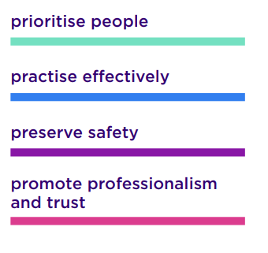
Figure 2: Dimensions of NMC code
(Source: Nursing and Midwifery Council, 2018)
Apart from that, the Care Quality Commission (CQC) often sets the fundamental standards for the care provider. As given in the reports, based on the CQC framework, good governance needs to ensure that they meet the standards and check on the quality and safety of care (Care Quality Commission, 2024). Similarly, also need to abide by the aspects of safeguarding from abuse, where individuals might face neglect, lack of independence and degrading treatment, which are looked after by the CQC. Apart from that, the Caldicott Principles ensure that the health and social care providers are helped to handle confidential patient data legally.
Accurate record-keeping is an effective method for ensuring safe and continuous care. For instance, in this case, the timely documentation of the changes would help in improving patient outcomes and ensuring good medical and social review. As per the view of Chambers et al. (2021), in recent times, data-driven technology has enhanced safety and reliability on a major scale. On these grounds, accurate and organised records would help in facilitating communication among the health care providers and coordinating care as per the patient's history.

4.0 Importance of working collaboratively with other professionals involved in Mrs Thompson’s care
Based on Mrs Thompson’s complex needs, a collaborative healthcare approach is required where her GP, community nurses, domiciliary care workers, pharmacist and local authority must work as a team for safeguarding. According to the Care Act 2014, local authorities must take initiatives to promote individual well-being, conduct need assessments and ensure safeguarding of needy individuals who are abused or neglected (GOV UK, 2014). On the other hand, a collaborative approach is helpful for preserving the needs of older adults, where informal caregivers are able to provide support in discharge planning, needing to be informed, heard, and actively engaged in decision-making (Pereira et al., 2022; Glasby and Dickinson, 2014). By following the same, Mrs Thompson must receive care with the collaboration of healthcare workers where the GP reviews prescriptions, the nurse monitors for signs of pneumonia, and the multidisciplinary team observes her daily changes and adjusts support care accordingly. As a result, the collaborative approach of care would ensure person-centred care that meets the changing needs of Mrs Thompson.
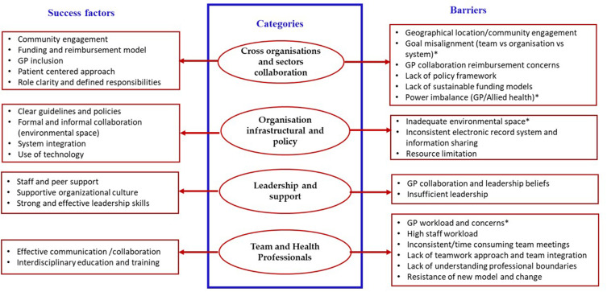
Figure 3: Role of collaboration in healthcare settings
(Source: Liang et al., 2025)
In order to facilitate collaboration and ensure the strategies are suitable for addressing the challenges to overcome this situation, the following are recommended:
- The organisation of a multidisciplinary team meeting, shared care plans, clear communication between all team members, and mutual respect is done by successful communication that leads to the development of trust and ensures success (Liang et al., 2025). Similarly, the collaboration and communication between GP, community nurse, carers and family members through a digital health system would facilitate effective care.
- However, challenges might arise regarding the protection of data and sharing information only when necessary. According to the Data Protection Act 2018, all personal data must be processed lawfully, fairly and transparently and without consent, data cannot be revealed (GOV UK, 2018). Hence, protection of health-related data must be prioritised while working collaboratively.

5.0 Conclusion
In summary, the completion of the study showed the significance of delivering safe, effective and person-centred care for Mrs Thompson through reflecting the significance of effective communication, administrative practice and collaborative working. Effective communication, as per the Equality Act 2010, ensures dignity, inclusion, and informed decision-making for the patient. Also, the usefulness of the communication model helped to understand the implications of simple words and communication techniques to ensure continuity of care, accountability and confidentiality. The professional needs to consider the personal values and preferences and ensure that she feels valued and respected. Hence, overall, care providers are responsible for professional accountability and safety for vulnerable individuals like Mrs Thompson. In order to overcome the challenges, a collaborative healthcare approach is required where her GP, community nurses, domiciliary care workers, pharmacist and local authority must work as a team for safeguarding. Finally, a collaborative understanding of legislation and effective communication assist in improving Mrs Thompson's safety, independence, wellbeing and overall quality of life.

References
Care Quality Commission (2024). The Fundamental Standards - Care Quality Commission. Available at: https://www.cqc.org.uk/about-us/fundamental-standards (Accessed 11 July 2026).
Chambers, D., Cantrell, A. and Booth, A., (2021). Rapid evidence review: challenges to implementing digital and data-driven technologies in health and social care.
Fowler, N.R., Partrick, K.A., Taylor, J., Hornbecker, M., Kelleher, K., Boustani, M., Cummings, J.L., MacLeod, T., Mielke, M.M., Brosch, J.R. and Lee, J., (2025) ‘ Implementing early detection of cognitive impairment in primary care to improve care for older adults’, Journal of internal medicine, 298(1), pp.31-45.
Glasby, J. and Dickinson, H. (2014) Partnership working in health and social care: what is integrated care and how can we deliver it? Bristol: The Policy Press.
GOV UK (2010). Equality Act 2010 Guidance Guidance on matters to be taken into account in determining questions relating to the definition of disability. Available at: https://assets.publishing.service.gov.uk/media/5a80dcc8ed915d74e6230df4/Equality_Act_2010-disability_definition.pdf [Accessed: 8 July 2026].
GOV UK (2014) Care Act 2014. Available at: https://www.legislation.gov.uk/ukpga/2014/23/contents (Accessed: 8 July 2026).
GOV UK (2018) Data Protection Act 2018. Available at: https://www.legislation.gov.uk/ukpga/2018/12/contents (Accessed: 6 July 2026).
Kulińska, J., Rypicz, Ł. and Zatońska, K., (2022) ‘The impact of effective communication on perceptions of patient safety—a prospective study in selected Polish hospitals’, International journal of environmental research and public health, 19(15), p.9174.
Liang, Z., Montgomery, J., Dingelstad, C., Koschel, A., and Redford, M. (2025) ‘Making Multidisciplinary Team-Based Care (MTBC) a Success in Primary Care: A Scoping Review’, Journal of Healthcare Leadership, pp. 681-695.
NHS England (2021). Improving communication between health care professionals and patients in the NHS in England Findings of a systematic evidence review and recommendations for an action plan. Available at: https://www.england.nhs.uk/wp-content/uploads/2021/07/SQW-NHS-England-Improving-communications-report-30June.pdf (Accessed: 9 July 2026).
Nursing and Midwifery Council (2018). The Code Professional Standards of Practice and Behaviour for Nurses and Midwives Nursing and Midwifery Council. Available at: https://www.nmc.org.uk/globalassets/sitedocuments/nmc-publications/nmc-code.pdf (Accessed: 7 July 2026).
Pereira, F., Bieri, M., del Rio Carral, M., Martins, M. M., and Verloo, H. (2022) ‘Collaborative medication management for older adults after hospital discharge: a qualitative descriptive study’, BMC nursing, 21(1), p. 284.
Petty, L. (2025). Record Keeping in Health and Social Care. Available at: https://www.highspeedtraining.co.uk/hub/record-keeping-in-health-and-social-care/ (Accessed: 9 July 2026).
Rubino, E.C., Tian, N. and Pelkki, M.H., (2022) ‘Improving communications to increase nonindustrial private forest landowner (NIPF) participation in forest certification programs: a case study in Arkansas, USA’, Forests, 13(1), p.86.

