Dalanda Diallo (2025163)

Digital Skills And research Methods
BMSW4003
Saqib Shamim

The Impact of Virtual Learning Experience of Students at University of Wales Trinity Saint David

Introduction

The aim of this report is to discuss and analyse the student’s virtual learning experience with Moodle at the university of Wales trinity saint David. First, it has been conducted a questionnaire collecting all Data needed and secondly, it was then conducted a survey asking students about their experience at the University of Wales Trinity Saint David and their experience with the use of Moodle. In this report primary data will be collected and secondary will be collected as well and then it will be compared. This report will include the questionnaire in the appendix. This report will as well discuss the meaning of virtual learning environment, when it was introduced, who use it the most and the importance of the research that has been made about technology. In fact, VLE is used as a tool to organise, manage, and deliver learning activities and content within educational institutions (the institutions will then make choices specific to the needs of their learners and staff) virtual learning environment VLE have become well established.

Virtual Learning

These present days technology has changed human life significantly in all kinds of way (Nejad, M.B. and Nejad, E.B., 2012). Schools have registered their biggest concerns from specialists in social and the economic area in the past ten years. Information has as well made a principal problem in political relations. To add more online learning is depicted as learning encounters utilising different electronic gadgets (for example Pcs, laptops, cell phones, and so forth) with web accessibility in coordinated or nonconcurrent ecological in conditions. Online learning could be a stage that make the course of schooling more understudy focused, imaginative and adaptable. Online conveyance of courses is savvy and effectively available particularly while carrying educational plan to understudies in country and far off regions. The organizations of learning have been extremely important in those past 3 years as it has been used by the clinical universities, schools for various inventive procedures to battle the emergency utilising different programming applications such as Google Classroom, Zoom, and Microsoft Teams to take online lessons to assure an education to their personnel during the pandemic COVID-19 (Marwa, et al.,2021). In fact, internet learning has been exceptional and useful since the pandemic (covid-19) has started. The disruption of regular classroom learning, and instruction has been one of the key outcomes of our response to the COVID-19 pandemic. Yet, in many respects, the shift to online learning has highlighted what is important (and what is not) in the classroom, one of the major consequences of our response to the COVID-19 pandemic has been a disruption to traditional classroom learning and instruction. Students that use a VLE can be assigned a "task" to do in classroom or from their own speed, time, and place, and they can participate in active and passive dialogues to further their knowledge (Barker, J. and Gossman, P., 2013).

What Has been learned as result of VLE?

Remote learning has meant attempting to recreate the traditional classroom online for students. In remote learning, the organisation, materials, and activities are all replicated in a different physical area. According to (Koskela, M., Kiltti, P., Vilpola, I. and Tervonen, J., 2005) Virtual Learning environments are becoming more popular. VLEs have been shown to be more successful as a teaching method than conventional lectures for a few case reports. Most schools, for example, have kept teachers and students in group class. Adjusted school schedules were followed in zoom class to replicate regular teacher-student interactions. Various teachers have used virtual lectures in novel ways and these educators should be recognized. The relevance of learning connections is emphasized in their efforts.

Can Virtual Education Benefit Online Learning platform?

Virtual learning is intended to broaden educational opportunities. It makes no attempt to imitate them. Students interact and access resources in virtual learning environments in ways they would not or could not in a physical classroom. Virtual learning is used by many educators and has been for some time. Here are some examples from the website Wearer Teachers: Virtual field trips are available, Virtual science laboratories.
Authors who authored the books perform virtual read-aloud. It is worth noting that these virtual learning links were created to demonstrate alternative ways of learning rather than to provide a new way of doing the same thing online. These links were also created before March 2020.
Virtual education not only enhances today's remote learning environments, but it also encourages new ways of thinking. Virtual learning is not an "additional" or "online version" of traditional learning. It is a "distinct educational experience." It is crucial to note that when I use the phrase "virtual learning," I am not referring to a traditional classroom activity that has been relocated online; rather, it is a learning experience integrated into the curriculum that has been specifically developed to be experienced online. It exists online, whether in a face-to-face or virtual classroom. In a virtual learning instructional sequence, students engage in core learning processes and outcomes, which will necessitate the use of various computer technologies (Debra, M., 2020).

The purpose of VLE?

Digital marketing, teaching and instruction, student participation, student information administration, messaging services, collaboration software, and true (live) teaching components are all part of a VLE. The technology and elements that are accessible determined by the platform that is selected. Some larger organizations may create their customized VLE from the ground up, including only the tools that they require. Others may elect to invest in a commonly produced alternative. This necessitates further investigation to ensure that they have the necessary instruments for the company's requirements. VLEs often begin with a limited set of tools and gradually expand in terms of usage and capabilities. This is in keeping with the students' and staff's trust and involvement (Melanie, E., 2020).

What are the requirements of VLE?

This will be determined by the requirements of the school or university. The demands of the students are frequently prioritised when creating a VLE. In such circumstances, the demands of the personnel might take priority. This could be done, for instance, to facilitate inter-departmental communication. Even though, know two Learning environments remain alike, the following are some examples of how each tool or component of a VLE could be used:
- Evaluation management’s documents: At the most basic level, it functions similarly to a laptop's files. You could include lecture notes, Documents, movies, music files, slideshows, presentations, and a variety of other resources. Data may be organised in certain channels as well as other 'pages,' like a webpage. The major goal is to ensure that the appropriate class of people have access to educational resources. Some regions, pages, and folders may be restricted to staff and students enrolled in individual courses. The VLE can be thought of as a hub for gathering information from a wide variety of sources. It makes everything more approachable yet structured.
- Education and grading: Lesson plans, assessment and progress information, and curriculum statements may all be added to the VLE. This enables staff and/or students to access them easily, as well as to use them to personalise the learning experience for individuals or groups of students.
- Student’s participation: The VLE is used to keep students engaged in their studies when they are not in class. This can happen at home or during study time. Quizzes and multimedia elements motivate students to go over the material repeatedly. Videos from YouTube and Video can be added by professors. Teachers may even be able to create their own curriculum for their pupils. They may include external content and information connections. Students will be able to quickly locate the most relevant resources for their study because of this. Pastoral information may also be used to promote wellbeing and mental health. Traditional approaches can be improved by educators to make content more accessible and participatory.
- Maintaining student’s details: The internet is used by administration to keep track of students' progress, learning support data, lectures, or course materials. A Moodle can connect automatically to other devices like a MIS (Management Information System) and learning software or apps. This makes it easier to gather all the information on the students in one spot.
- Ways of Communication: The internet feature information exchange for one or several communications. This could include internal message systems, like emailing. There could be 'live chat' features available. Teachers may be able to use the forum for instructional purposes, allowing for general discussion between staff and students. Chat rooms for student groups who are all studying the same subject.
- Teamwork software: Documents may allow numerous learners to interact by allowing them to modify the same document. To explore the core curriculum, groups can be formed. They can leave comments on other staff/students' posts. Really Simple Syndication (rss), wikis, and blogs are all options for sharing material and receiving feedback and comments on some VLEs.
- Actual instructions component: Virtual learning environments can be used to allow for real-time video or vocal communication. This allows for real-time instruction. This could also involve some type of on-screen interactivity, such as screen sharing or a virtual whiteboard.

What are the benefits of Virtual Environment?

There are numerous advantages to using a VLE. It is a site that aggregates information and resources for the user (students or staff), It allows for social contact. This is helpful when using a blended learning approach and students have time to study on their own but require assistance or materials.
Internet can also help you save money on things like printing course materials and purchasing several textbooks. Many textbook publishers now offer educational institutions low-cost subscriptions. This is done so that course materials can be added to the VLE.
When students may access their learning from wherever, a VLE can have an impact on their results. This is especially useful while pupils are studying.

How difficult is it to begin utilising virtual learning environment?

The commercially available VLEs, in general, have been developed with ease of use in mind. The VLE, on the other hand, begins as an "empty box." To begin making the VLE relevant for their pupils, the school or college must put in some effort. To get started, there are frequent opportunities to add some pre-made content packages. This makes the initial phase go more smoothly. The initial rollout of a VLE is based on training and then steadily expands over time. It is critical to begin with the most pressing needs. If communication is the most pressing need, a VLE can start with those tools. If there is a need to get resources to students, those elements can be used.

The survey

I have surveyed the students of UWTSD about their experience with Virtual learning and Moodle. It was first taken their gender and age range to start. It will be discussed the most important questions. Based on the survey below 12/12 students that have been questioned does not feel confident with distance learning. From my experience I feel the same as distance learning can be stressful sometimes. From the survey 8/12 says that their internet is not always liable. In fact, some students feel lost when doing their independent studies. Concerning Moodle, 5/12 says that is quite easy to use and understand. However, 6/12 students thinks that Moodle is complicated to access and understand and 1/12 thinks that Moodle is easy.12/12 students says that the UWTSD have been very helpful in term of assistance and materials for independent studies.10/12 students state that the lectures at the UWTSD provide support and instruct them with tutorials concerning online learning.

Conclusion

The reports have discussed what is Virtual learning what are the disadvantages, how difficult is it to begin utilising virtual learning environment and can virtual education benefit online be learning platform etc. I have discussed about the survey and given an appendix of the survey. In these present times internet is very useful for everyone and everywhere some people cannot live without VLE.

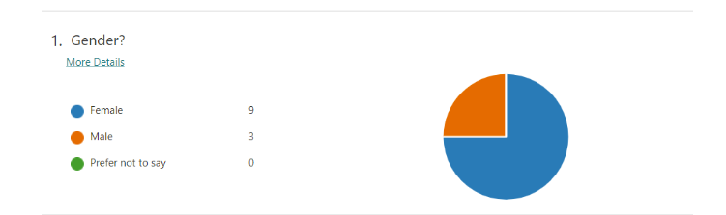

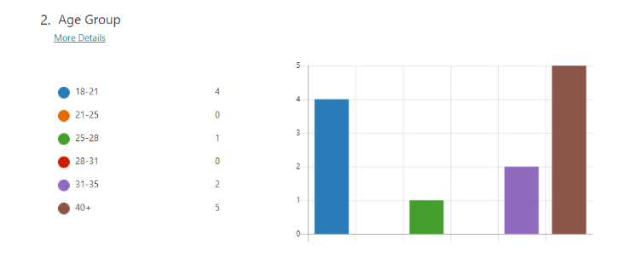

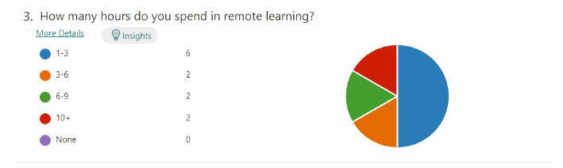
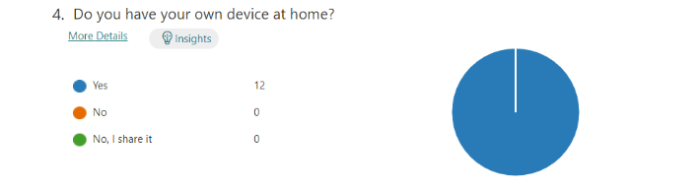
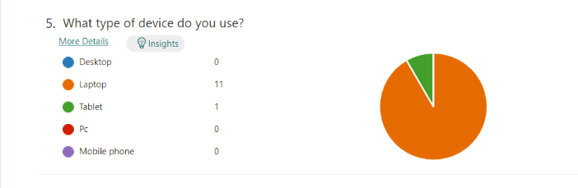
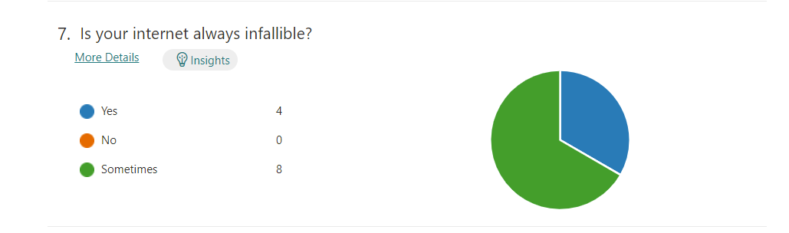
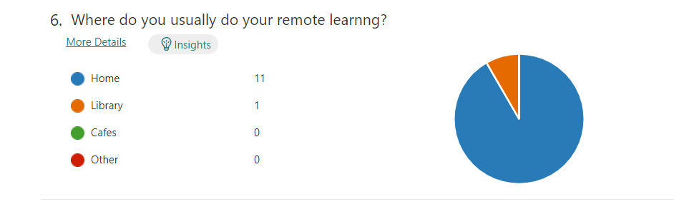

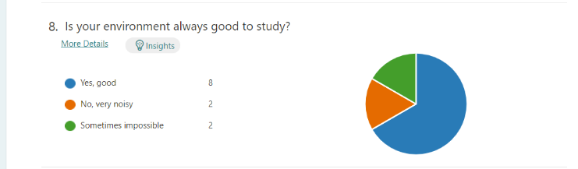

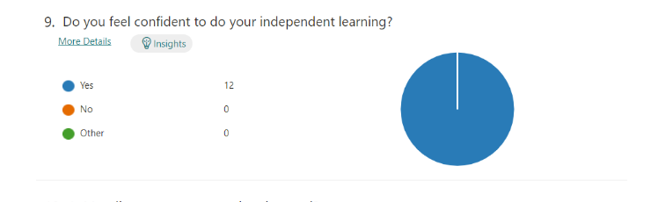

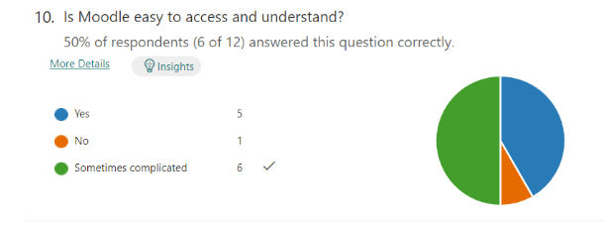

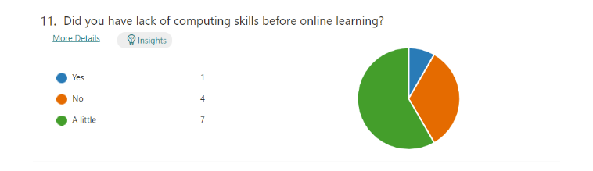

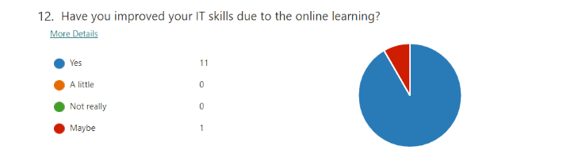

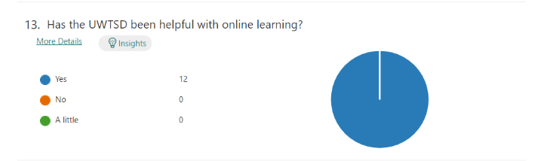

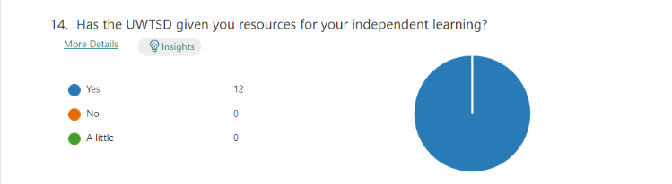

.
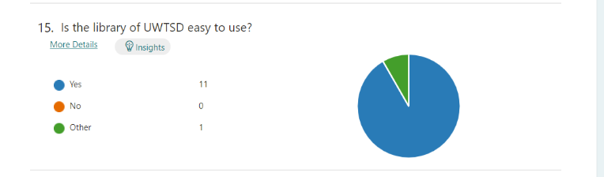

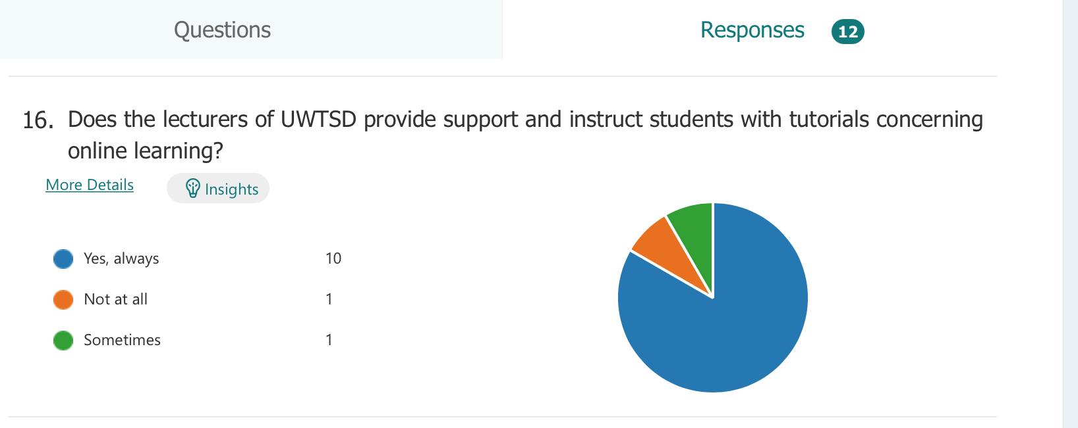

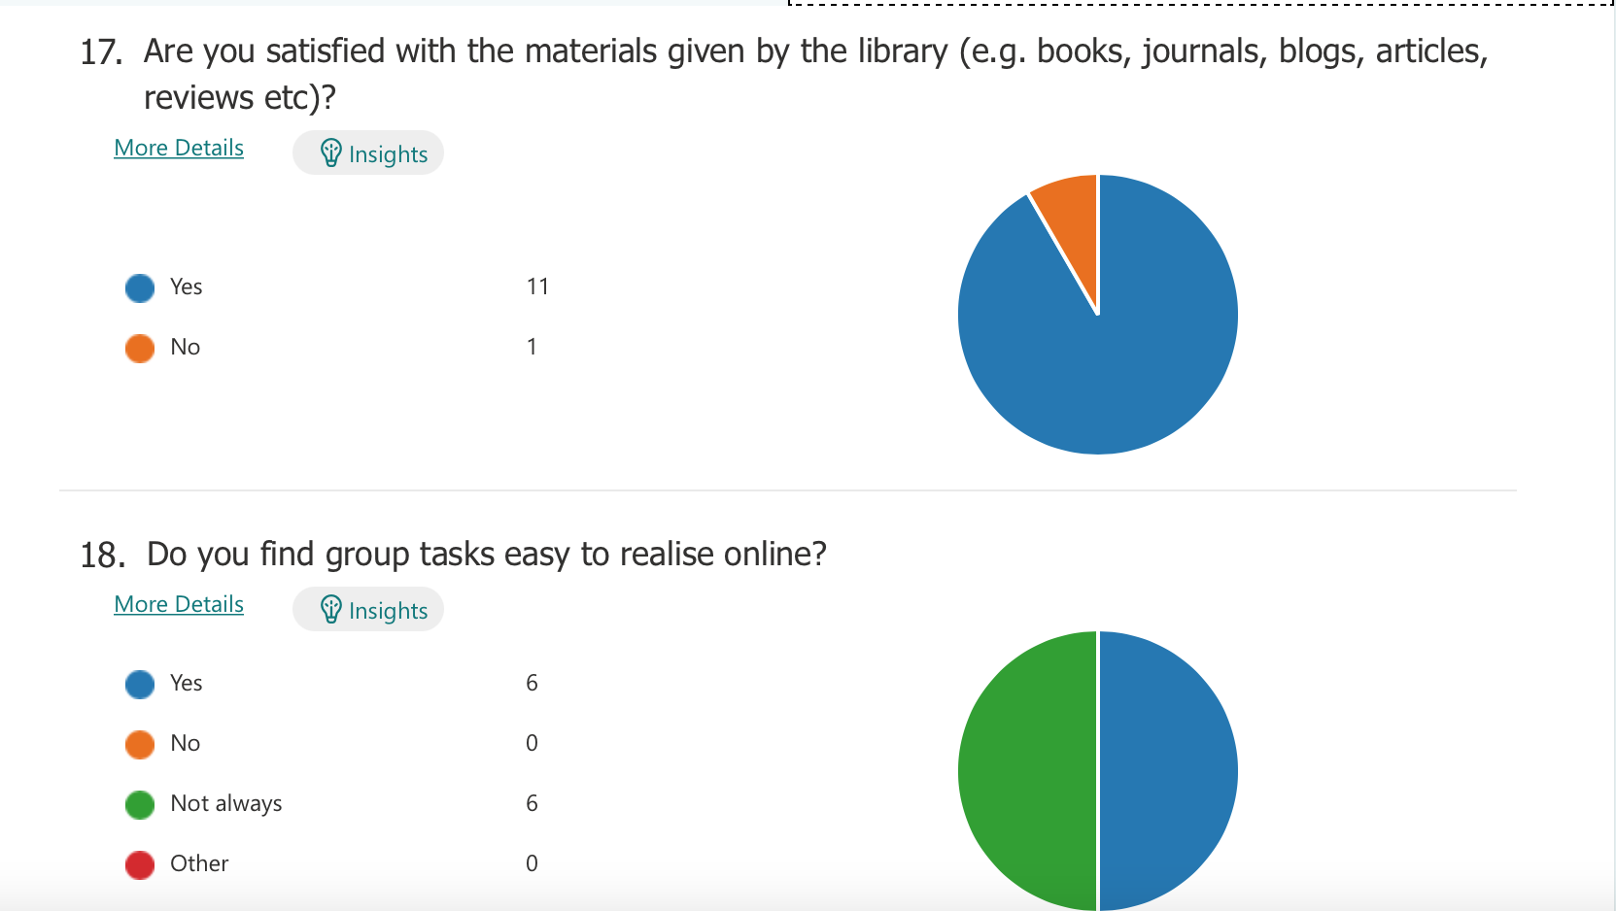

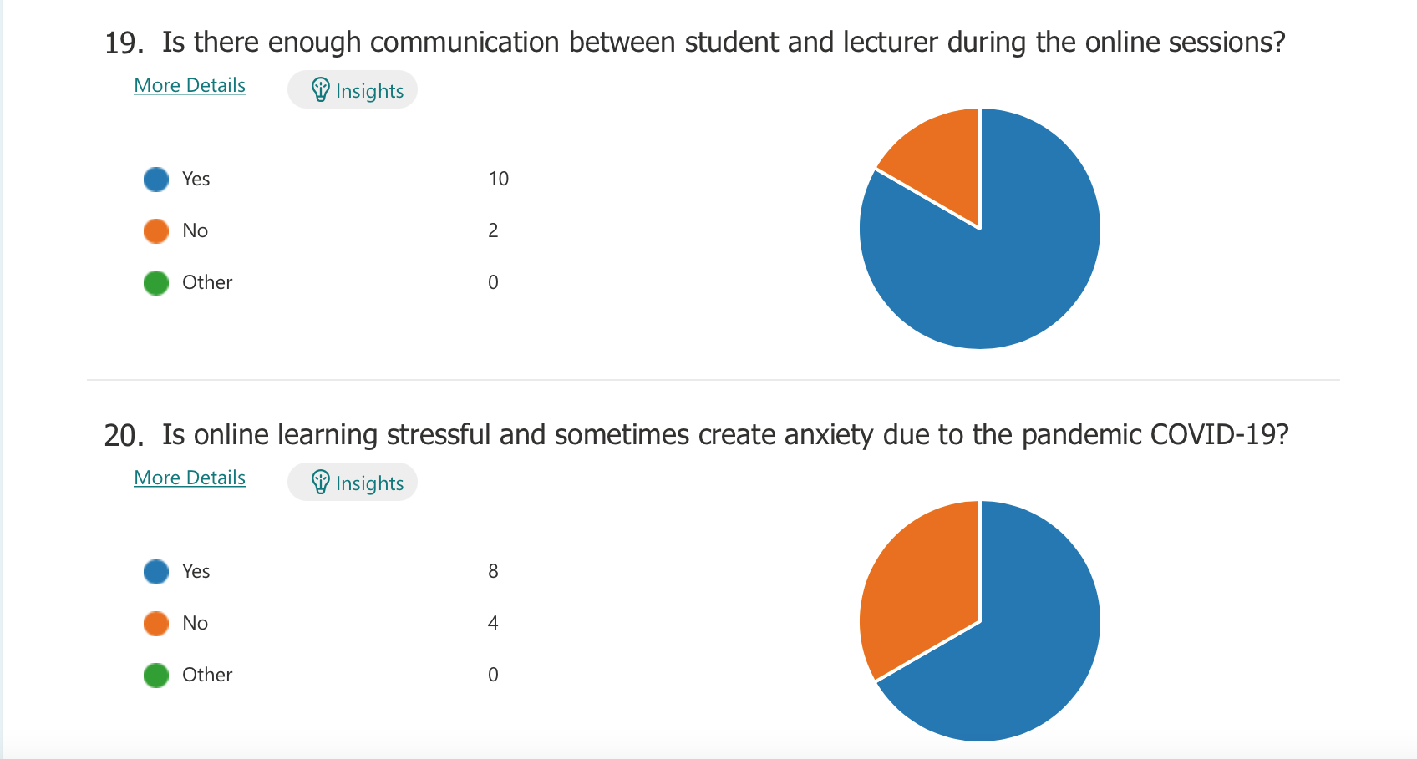

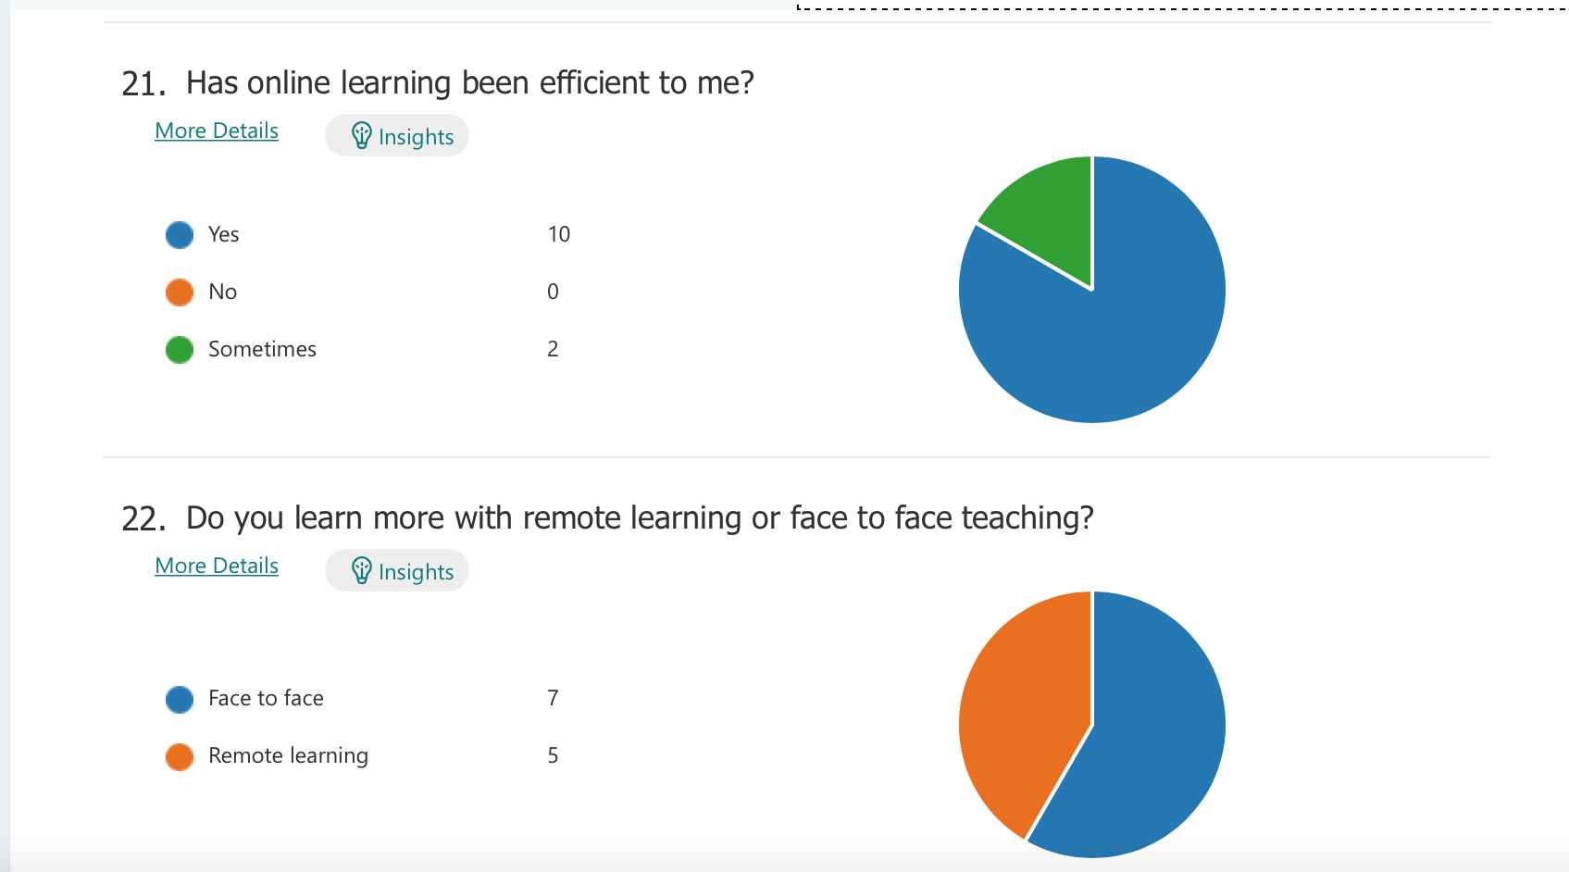

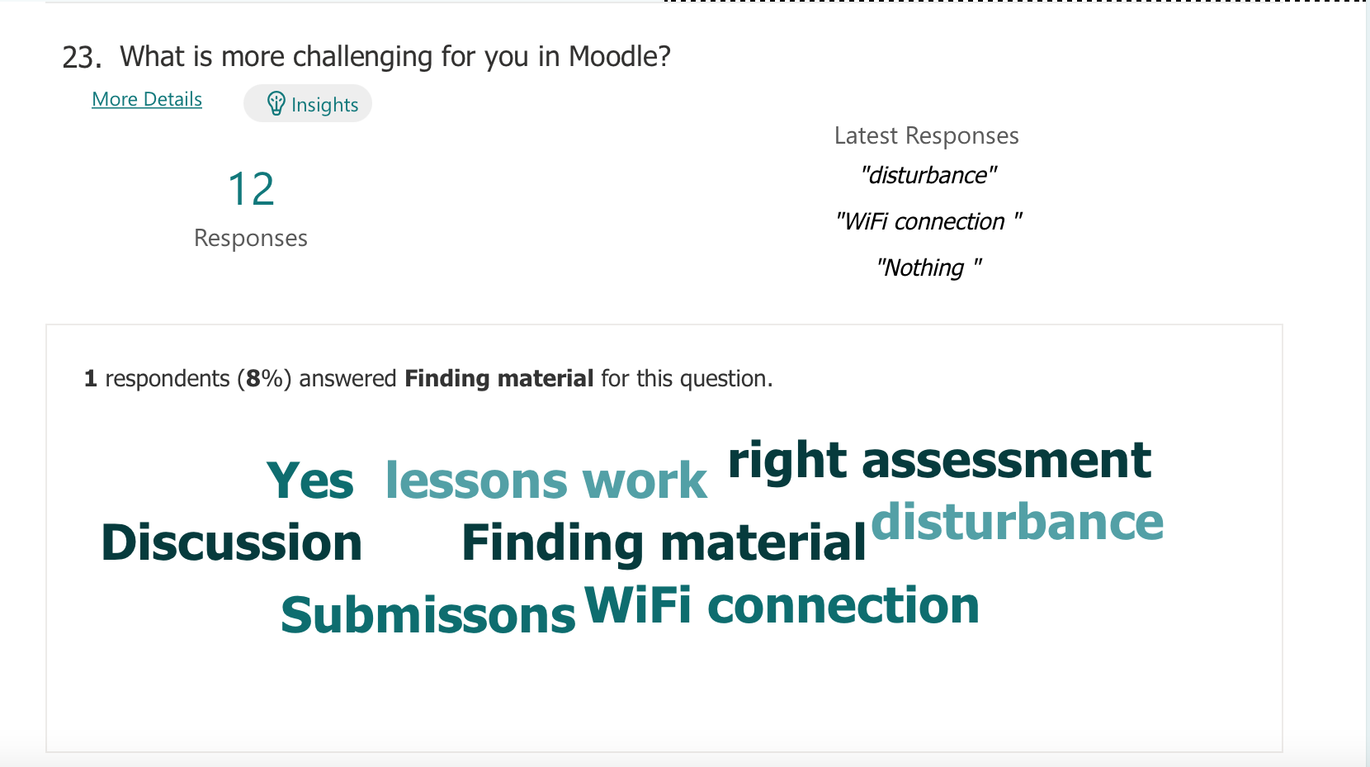

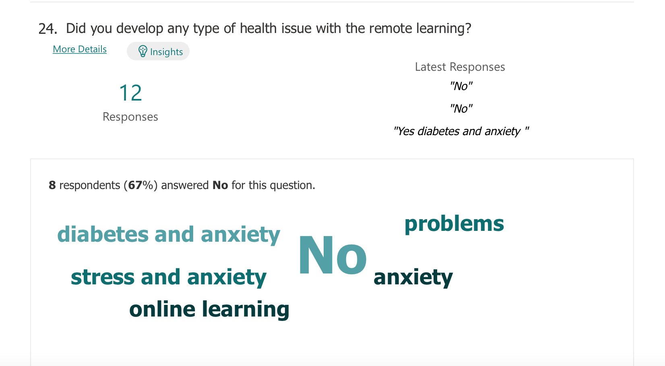

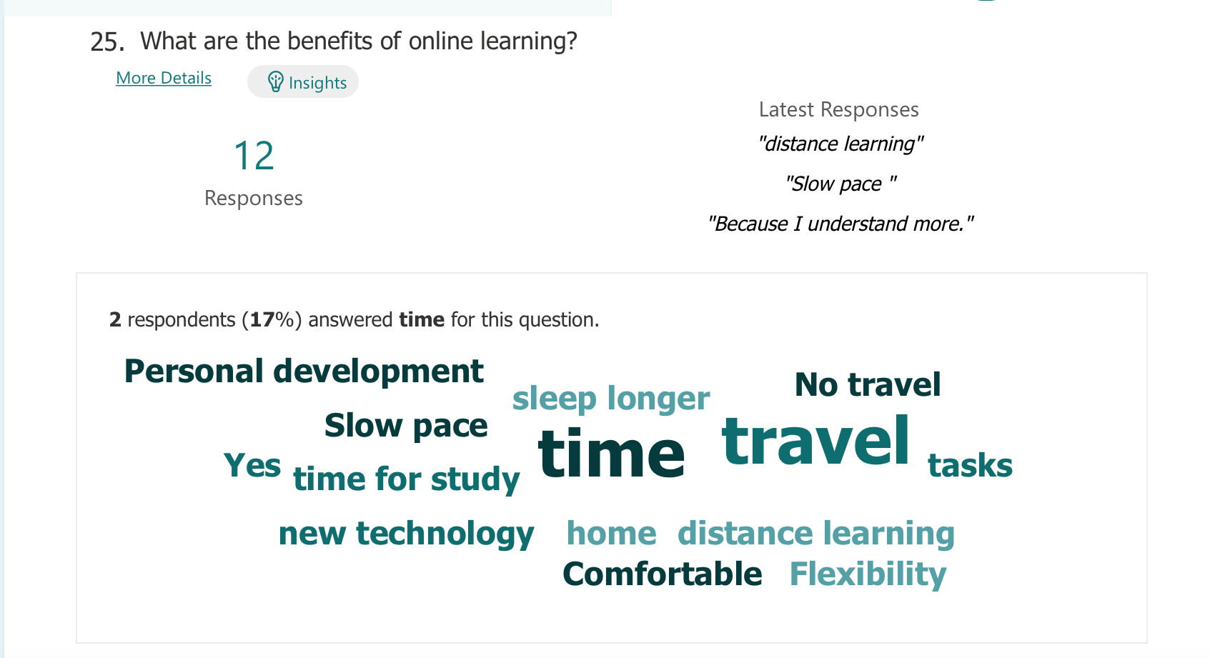

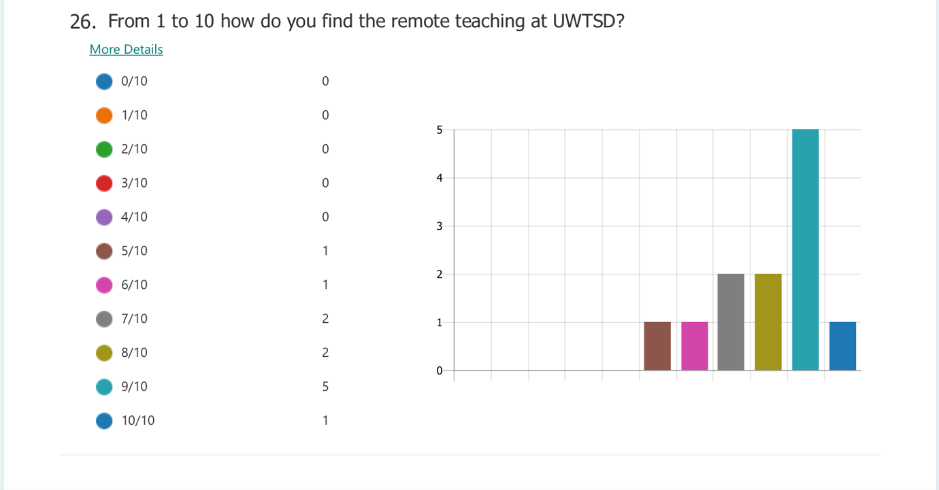
Reference list

- Barker, J. and Gossman, P., 2013. The learning impact of a virtual learning environment: students’ views. Teacher education advancement network journal (TEAN), 5(2), pp.19-38.

- Debra, M., (2020), How Virtual Learning Improves on Remote Learning, [Blog], Available at: https://www.elmhurst.edu/blog/virtual-learning/ Accessed:6th January 2022

- Dillenbourg, P., Schneider, D. and Synteta, P., 2002, September. Virtual learning environments. In Proceedings of the 3rd Hellenic conference information & communication technologies in education (pp. 3-18).

- Koskela, M., Kiltti, P., Vilpola, I. and Tervonen, J., 2005. Suitability of a Virtual Learning Environment for Higher Education. Electronic Journal of e-Learning, 3(1), pp.23-32.

Melanie, E., (2020), What is the benefit of a VLE? Available at; https://www.learningladders.info/news/what-is-a-vle/ Accessed; 6th January 2022

Melanie, E., (2020) What is a VLE (Virtual Learning Environment)? – 2021 Guide, learning ladders, Available at: https://www.learningladders.info/news/what-is-a-vle/ Accessed: 7th January 2022

- Nejad, M.B. and Nejad, E.B., 2012. Impact of E-Learning on Learning and Realizing Information Society. Research Journal of Applied Sciences, Engineering and Technology, 4(23), pp.5016-5020.

- Zalat, M.M., Hamed, M.S. and Bolbol, S.A., 2021. The experiences, challenges, and acceptance of e-learning as a tool for teaching during the COVID-19 pandemic among university medical staff. PloS one, 16(3), p.e0248758.

