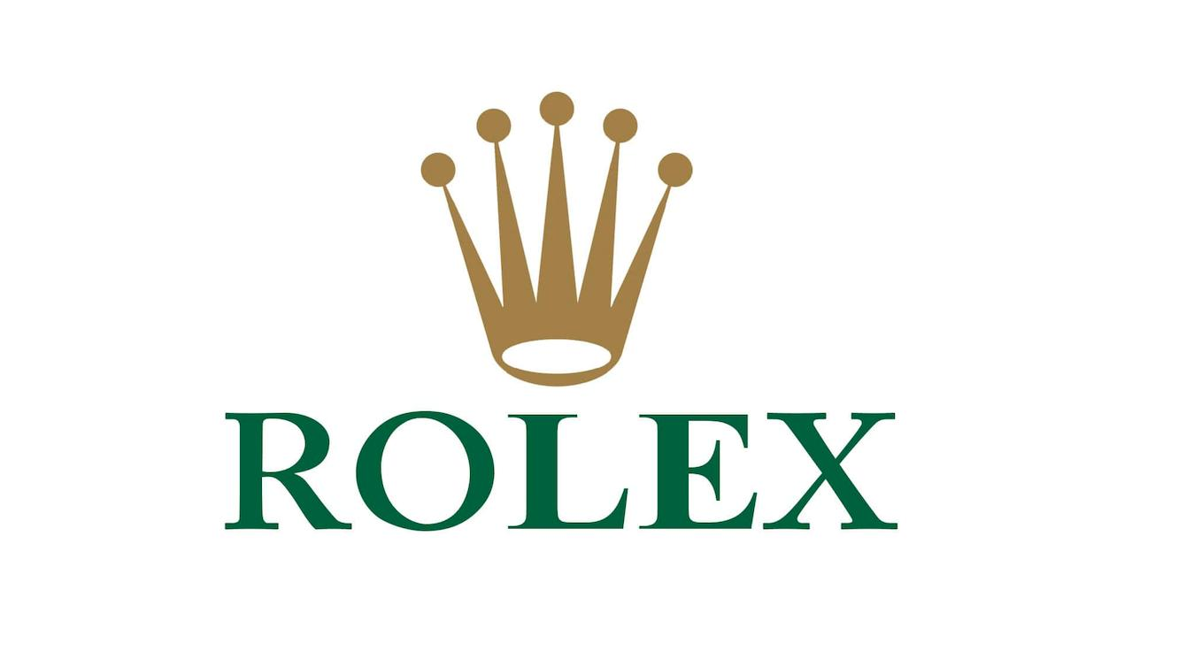

Marketing Management Assignment-2

NAME : SANDEEP DAMMALAPATI
STUDENT ID : 2214841
NAME OF LECTURER : TUSHARA BALENDRAN
MODULE NAME : MARKETING MANAGEMENT
MODULE CODE : LCM7001
ASSIGNMENT TITLE : ASSIGNMENT-2

TABLE OF CONTENTS
Question A
Introduction………………………………………………………………3
Background of Rolex…………………………………………………….3
PESTLE Analysis of ROLEX……………………………………………4
Porter’s Five Force Analysis……………………………………………..6
SWOT Analysis………………………………………………………….8
Segmentation, targeting and positioning………………………………..11
4P’s of marketing mix strategy………………………………………….13
Conclusion……………………………………………………………....16
Question B
Recommendation………………………………………………………..16
References ………………………………………………………………18

QUESTION A
Introduction
Rolex is a Swiss luxury watch manufacturer based in Switzerland. Hans Wilsdorf established the prestigious watch company Rolex in London, England, in 1905. The brand became well-known among athletes and adventurers for its durability and reputation for accurate timekeeping. As one of the most recognizable and prominent watch companies in the world today, Rolex is renowned for its fine craftsmanship, classic style, and cutting-edge technology. From world leaders to celebrities, Rolex watches are worn by everyone as a sign of accomplishment and elegance. Rolex watches are crafted from the best materials and are renowned for their excellent accuracy, toughness, and dependability. They are expertly made by hand by artisans who take great care to make every detail ideal. From traditional styles like Date just and Submariner to more modern designs like the Yacht-Master and GMT-Master II, Rolex provides a wide selection of timepieces. Each watch is made to last a lifetime and is tailored to the wearer's individual demands.
Background of Rolex
Rolex is a Swiss based luxury watch manufacturer founded by Hans Wilsdorf and Alfred Davis in London, England in 1905. The company was initially named as Wilsdorf and Davis Ltd., and its main business was importing Swiss movements and later the company registered “Rolex” as Brand name in 1908 and the company moved its operations to Geneva, Switzerland. Rolex quickly established itself as a leader in the luxury watch market, with a focus on quality, precision, and innovation. In 1926, the company introduced the world's first waterproof wristwatch, the Oyster, which revolutionized the watch industry. They continued the innovation and features such as the self-winding movements and date display on the dial. Rolex has also cultivated an image of exclusivity and luxury. The brand has a long-standing association with high-profile celebrities, athletes, and other influential personalities. "Rolex: The History of the Luxury Watch," by Time Magazine
Today Rolex is one of the most recognized luxury brands in the world, with a global network of authorized dealers and service centers with a production output of more than 10000 pieces and a revenue of USD 8.35 Billion (as of May 2022)

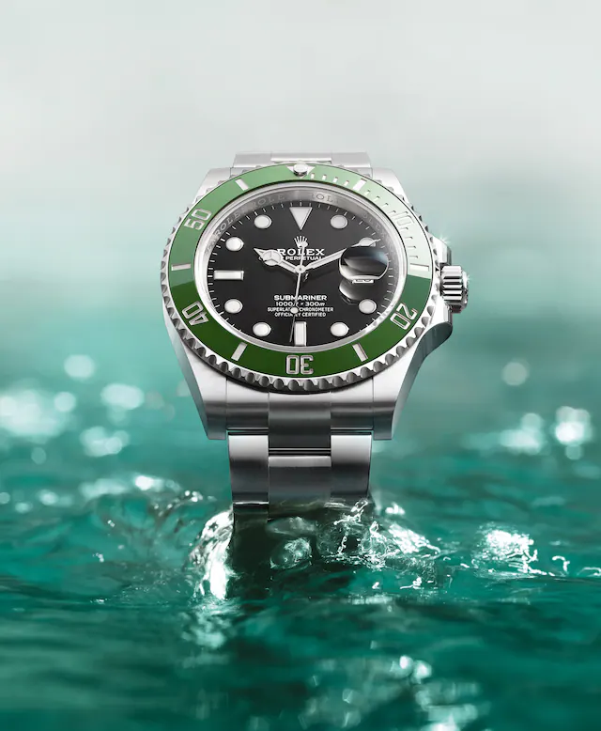
(Source: Rolex.com, Rolex Submariner)
PESTLE analysis of ROLEX
Rolex pestle analysis assesses the brand on its business tactics across various parameters. PESTLE analysis of Rolex examines the various external factors like political, economic, social, technological, legal, environmental factors.
Factor | Analysis | Impact
Political | - International sales and production costs may be impacted by trade restrictions and tariffs: Government trade restrictions and tariffs may have an impact on Rolex's production costs and overseas sales. (Source: 2021 Rolex)  - The manufacture and supply chain may be impacted by political unrest in the nations from where Rolex receives its materials: Rolex sources its components from nations like South Africa and Russia, whose political unrest may have an impact on the company's supply chain and manufacturing. (Source: Financial Times, 2021) | Negative
Economic | - Sales and production expenses can be impacted by fluctuating currency exchange rates: As Rolex gets materials and sells products internationally, fluctuations in currency exchange rates may have an impact on the company's sales and production costs. (Source: Financial Times, 2021)  - Consumer spending on luxury items may decline during economic downturns and recessions: Recessions and economic downturns may cause consumers to spend less on luxury items, which could affect Rolex's sales. (Source: The Guardian, 2021) | positive
Social | - Demand for luxury products may change as consumer preferences and lifestyles change. Demand for luxuries like Rolex watches may be impacted by changes in consumer choices and lifestyles, such as a move towards ecological and ethical products. (Source: Forbes, 2021)  - Customization and personalization are in greater demand: The need for personalized and adaptable products among consumers is rising, which can influence Rolex's product line. (Source: Business Insider, 2021) | positive
Technological | - Technology advancements may have an impact on conventional watchmaking techniques and manufacturing procedures: The traditional watchmaking techniques and production procedures used by Rolex may be impacted by technological advancements. (Source: Forbes, 2021)  - Opportunities for advancement in smartwatch and material technologies: Rolex can take use of chances for innovation in materials and smartwatch technologies to stay competitive. (Source: Statista, 2021) | Negative
Legal | - Intellectual property protection and trademark infringement are legal issues that Rolex has had to deal with. These issues can influence the sales and reputation of the brand. (Finance News, 2020)  - Rolex must abide by all applicable labor laws and regulations in the nations where it conducts business to maintain moral and just working conditions. (Source: 2021 Rolex) | Negative
Environmental | - Material procurement that is ethical and sustainable: Rolex can meet the growing demand for materials that are ethical and sustainable by using responsible sourcing techniques. (Source: 2021 Rolex)  - Rolex has made a commitment to lowering carbon emissions and addressing climate change through sustainable business practices. (Source: 2021 Rolex) | Positive
PESTLE Analysis

Porter Five Forces Analysis
The competitive environment of the company as well as the forces impacting its industry are covered by Rolex Porter's Five Forces study. The study focuses on assessing the company's position in relation to factors including the threat of new competitors, the threat of replacement products, the bargaining power of customers, the bargaining power of suppliers, and competitive rivalry.
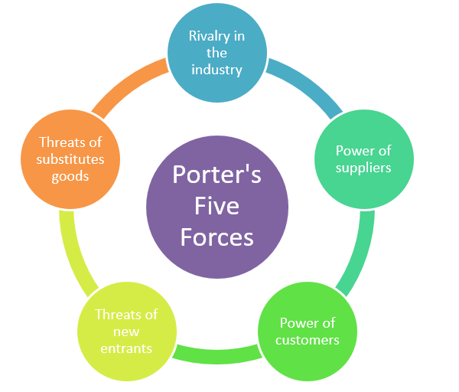
(Porter’s five forces)

Factors | Impact
Threat of New Entrants | Low
Threat of Substitutes | Low
Bargaining Power of Customers | Moderate
Bargaining Power of Suppliers | High
Competitive Rivalry | Low
Porter’s five force analysis
(Source: Self-made)
Threat of New Entrants
Rolex can benefit from its strong brand image and make money off it because of this. It took years for it to reach this position, and it will take time for any new company entering this market to acquire Rolex's reputation. Rolex has made significant efforts in R&D and innovation to attain the technology that is a critical component of this sector. The market has a significant degree of product differentiation, and consumers view Rolex items as status symbols. As a result, newcomers are at a disadvantage. In this sector, there are more stringent government rules, and new businesses must complete a few legal requirements before they can set up their manufacturing procedures. These characteristics all contribute to the threat posed by new competitors, and Rolex must not worry about this much.
Threat of Substitutes
Rolex is a luxury item rather than a must-have; consumers purchase it for the positive customer experience and sense of accomplishment it provides. This means that there are much fewer substitutes on the market. Although there are less expensive watches on the market with comparable qualities, customers tend to choose Rolex because of the brand's reputation and image. The enormous profits in this sector allow the business to enhance the quality of its offerings and raise prices for consumers. Additionally, those who are brand loyal and wish to spend on expensive timepieces will concentrate on purchasing a Rolex. This suggests that the threat posed by substitutes is minimal.

Bargaining Power of Customers
There are only a few sources Rolex uses. As a result, the enterprises have less options. Additionally, because it is a luxury item, consumers typically value quality over the cost, thus a small price difference won't bother them. Backward integration is impossible; thus customers must rely on other sources to receive these products. Rolex is always looking for ways to innovate and improve the client experience. Customers demand a superior product, a hassle-free transaction, and after-sales services because the product has a high market value. As a result, it poses a moderate threat to the bargaining power of purchasers.
Bargaining Power of Suppliers
Any supplier finds working with Rolex to be an overpowering experience, and as a result, the firm has influence over them in the market. There are numerous providers, and there is little variation in the products they provide. To avoid losing business, suppliers must meet the needs of the organization. Rolex must keep its suppliers to continue providing outstanding items to its clients. Any frequent modifications will interfere with this convenience, could harm the business, and have an impact on profitability. To ensure that it receives the raw materials at a lesser cost, Rolex must maintain a long-term relationship with its reliable suppliers.
Competitive Rivalry
All the companies that are now active in the watch industry and competing with Rolex have been around for a while and have built up a reputation and market share. These include companies like Omega, Chopard, Tag Heuer, and others who have been in business for a while and are familiar with the workings of the market. Although there aren't many competitors, those who do have a solid reputation fiercely compete with Rolex. To distinguish the business from rivals, it should prioritize innovation and enhancing the client experience. This suggests that they will keep working, which increases Rolex's intense competitive rivalry.
SWOT ANALYSIS
Strength | Weakness
- Strong brand awareness and reputation: Rolex has long been regarded as one of the most prestigious and well-known luxury brands in the world. (Forbes, 2021)  - Rolex watches are noted for their superior quality and durability due to the use of premium materials like 18-karat gold and 904L stainless steel. Rolex watches are also known for their usage of these materials. (Source: 2021 Rolex)  - Classic and enduring styles that have become standards in the industry: The Submariner and the Daytona are two examples of Rolex designs that are instantly recognizable and have evolved into industry standards. (Hodinkee, 2021)  - Rolex has a history of invention, which includes the creation of the first waterproof watch, the Rolex Oyster. Invention and technological breakthroughs are also reflected in the first waterproof watch. (Source: 2021 Rolex)  - Wide variety of models to suit various consumer interests: Rolex offers a variety of models to suit various consumer preferences, from traditional styles to athletic and contemporary models. (Source: 2021 Rolex) | - Target audience and market reach may be constrained by high prices: Due to their high price tags, Rolex watches may only appeal to a select segment of the luxury watch market. (Forbes, 2021)  - A conservative approach to design could stifle innovation and fail to reach new audiences: Some detractors claim that Rolex's conservative design stance may prevent innovation and broaden its popularity. (The New York Times, 2018)  - Long waitlists may result from insufficient production capacity for models. Due to Rolex's restricted production capacity, some of its most sought-after models may have lengthy waiting lists. 2019 (Source: CNBC)  - Some buyers may be turned off by expensive maintenance and repairs: Although Rolex watches are designed to last, they nonetheless need routine upkeep and occasionally expensive repairs. (Source: 2021 Rolex)
Opportunities | Threat
- Expansion into emerging markets to reach new consumer demographics: Rolex has the chance to reach new consumer demographics by expanding into emerging areas like China and India. (Source: Business Insider, 2019)  - Collaboration with other luxury companies to develop one-of-a-kind, limited-edition models: Rolex has worked with other luxury brands to develop special, limited-edition watches, including the Rolex x Supreme joint venture. (Source: Hypebeast, 2018 as source)  - Reaching new audiences and enhancing accessibility through digital marketing and e-commerce: Rolex may expand its market reach and enhance accessibility through digital marketing and e-commerce. (Source: Luxury Society, 2021)  - Product line diversification to include smartwatch technology: Rolex can broaden its product range to incorporate this rapidly expanding market area. (Source: Statista, 2021) | - Competition from other luxury watch companies, including Patek Philippe, Audemars Piguet, and Omega: Rolex is up against competition from other luxury watch companies that provide comparable quality and design. (Source: Business Insider, 2019)  - Fake watches could damage a company's reputation and hurt sales: One of the most frequently imitated luxury watch brands is Rolex, which can damage its reputation and hurt sales. 2019 (Source: CNBC)  - Consumer expenditure on luxury items may decline because of economic downturns and market instability: Market volatility and economic downturns may cause consumers to spend less on luxury products, which could influence Rolex's sales.

Swot Analysis of ROLEX
Advantages and Disadvantages of Swot Analysis
Advantages:
Comprehensive analysis: SWOT analysis is a thorough method that assists firms in assessing their internal and external environments. Rolex may better understand their business and industry by determining their strengths, weaknesses, opportunities, and threats.
Focus clarity: By emphasizing the most important aspects of the firm, SWOT analysis aids in bringing clarity and focus to the situation. Rolex can direct their attention and resources on the crucial aspects of their business by doing this.
Strategic planning: SWOT analysis aids in strategic planning by assisting Rolex in identifying prospective market opportunities and threats. Rolex may create strategic strategies by doing this that take advantage of opportunities and lessen dangers.
Improved decision making: Rolex may make better decisions by adopting SWOT analysis, which enhances decision-making. This is so that diverse aspects that may have an impact on the organization can be evaluated in an organized manner using SWOT analysis.

Disadvantages:
Limited perspective: SWOT analysis simply offers a momentary view of the current situation. It does not account for how dynamic the corporate environment is, and the study could easily become out of date.
Overemphasis on internal elements: SWOT analyses frequently place a strong emphasis on internal business aspects, such as strengths and weaknesses. Due to this, Rolex might neglect crucial outside elements that could have a big impact on the company, such market fluctuations.
Biased analysis: SWOT analysis is subjective, and the results may be influenced by the analyst's biases. Therefore, it is crucial to guarantee that the analysis is carried out by a neutral and objective party.
Lack of action: A SWOT analysis is only valuable if it results in implementation. The exercise is useless if Rolex does not act in response to the analysis.

Segmentation, Targeting and Positioning
Rolex splits its market into segments based on lifestyle, gender, and age differences. Rich people who cherish distinction, elegance, and correctness are catered to by business. Rolex's main customer base is men, but it also offers models for women, such the Lady Date Just and the Pearl Master. As a premium brand that represents exclusivity, prestige, and excellence, Rolex markets itself as such. The company considers innovation, fine craftsmanship, and traditional design. Rolex positions its watches as opulent status symbols that can be worn whenever. Rolex has a unique approach that focuses on maintaining exclusivity and rarity while expanding its market. The company limits production and distribution rather than oversaturating the market with its products to maintain the brand's premium positioning. Rolex strives to establish long-lasting relationships with its clients by providing exceptional customer service and a lifetime warranty on its timepieces. The corporation also makes large efforts in R&D to reinvent its products and retain its reputation for accuracy and quality. Rolex uses a range of marketing techniques, such as sponsoring significant sporting events, giving to deserving causes, and collaborating with influencers, to build brand recognition and enhance its reputation. The business has boosted its online presence with an established website and social media accounts. The Rolex firm uses a segmentation approach based on psychographic, demographic, and regional factors. (Rolex SA)
Geographic:
Rolex has a global presence with retail locations and authorized dealers in significant cities all over the world, Rolex has a presence there. In the United States, Europe, and Asia, where there is a significant concentration of wealthy people who value luxury and status, the brand is well-established. A Deloitte analysis claims that the luxury goods market in Asia-Pacific is expanding at the quickest rate and will make up 50% of the worldwide market by 2025. With retail locations in significant cities including Tokyo, Hong Kong, and Singapore, Rolex has a significant presence in the region (Deloitte, 2019).
Demographic:
Most of the wealthy, high net worth consumers buy Rolex products. Although the marketing for the company targets people of all ages, its normal target demographic is middle-aged or older adults. The bulk of Rolex owners are men, with a typical age of 51, according to a Wealth-X survey. The study also discovered that owners of Rolex had a net worth of at least $5 million and that corporate executives, entrepreneurs, and celebrities are big fans of the brand (Wealth-X, 2019).
Psychographic:
Rolex's ideal clients are, psychologically speaking, people who value opulence, elegance, and status. These people might be very interested in great art, expensive cars, and other high-end goods. They might also value craftsmanship and meticulousness, and they might regard Rolex watches' technical excellence and precision. Customers of Rolex can be motivated by a desire for exclusivity and may view the brand as a representation of their success and status. Luxury consumers are increasingly looking for one-of-a-kind and rare products, and they are willing to pay more for brands that provide the highest level of quality and craftsmanship, according to a report by McKinsey & Company (McKinsey & Company, 2020).

4 P’s Marketing mix strategy
The 4P’s of marketing mix strategies are product, price, place, and promotion.
Product strategy:
Among the famous Rolex watches available are the Submariner, Date just, and Daytona. Each watch is created utilizing premium components including 18K gold and stainless steel and is renowned for its accuracy, toughness, and quality. Additionally, Rolex offers a variety of customization choices that let buyers add unique dials, bezels, and bands to their watches. (Rolex, n.d.)
Focus on brand heritage: Rolex has a historic past that has been used to create a powerful brand identity. The company has emphasized its dedication to accuracy and quality, and its timepieces are regarded as a mark of exclusivity and elegance. Rolex has also leveraged its history to fabricate legends about its timepieces, such as the Rolex Explorer becoming the first timepiece to climb Mount Everest's summit.
Product innovation: To keep its position as the market leader, Rolex has continually reinvented and enhanced its products. The company has pioneered innovative technology, such as the Perpetual movement, which allowed watches to self-wind and completely changed the watch business. New materials have also been launched by Rolex, such as the Cibachrome bezel, which is constructed of a ceramic substance that resists scratches.
Strong distribution network: Rolex has developed a powerful distribution network to guarantee that its timepieces are accessible in a few select retail locations across the world. Additionally, the brand has opened its own shops in well-known cities, giving consumers a first-rate shopping experience that upholds the exclusivity and luxury of the brand.
Price strategy:
The high cost of Rolex watches reflects their uniqueness and high caliber. Depending on the type and features, prices can range from a few thousand dollars to hundreds of thousands of dollars. The cost of a Rolex watch ranges from $7,000 on average to over $20,000 for models like the GMT-Master II and Daytona, according to a Forbes analysis. (Forbes,2021)
Brand perception: Rolex has established a solid reputation for excellence, luxury, and exclusivity. High-end customers who are ready to spend more money on a Rolex watch are drawn to the brand because it relates to achievement, success, and status.
Product differentiation: Rolex watches are renowned for their premium components, fine engineering, and superb craftsmanship. The business makes special timepieces by using high-end components like gold and diamonds and talented artisans. The premium pricing is justified by this product distinction.
Limited availability: Rolex regulates the flow of its timepieces, resulting in scarcity and exclusivity. Because the manufacturer only makes a small number of watches each year, demand is higher, which supports the higher price.
Premium distribution: Rolex has a restricted distribution strategy that restricts the availability of its products to authorized retailers and dealers. As a result, a high-end distribution channel is opened, increasing the product's value and exclusivity.
Place strategy:
Rolex is maintained in house manufacturing with retail locations and authorized dealers in significant cities all over the world, Rolex has a robust distribution network. In important areas including New York, London, and Hong Kong, the company runs its own retail locations. It also collaborates with authorized dealers to sell its timepieces. Rolex also offers customers the ease of online buying by selling its timepieces on its website. (Rolex, n.d.)
Direct channels of distribution:
Rolex boutiques: Rolex runs its own shops in important cities throughout the globe, including New York, Paris, Tokyo, and London. These shops provide clients with a high-end shopping experience that is consistent with the brand's reputation and highlights the exclusivity and price of the goods. Due to the company's direct control over them, Rolex boutiques serve as a direct distribution channel.
Online store: Rolex offers a legitimate internet store where buyers can buy watches from the brand directly. Customers can shop safely and conveniently at the online store, which sells a variety of Rolex watches.
Indirect channels of distribution:
Authorized retailers: Rolex has a network of retailers who are permitted to sell its timepieces. These retailers are carefully chosen and are required to adhere to Rolex's criteria for client satisfaction and product expertise. Since authorized dealers buy Rolex watches from the corporation and resale them to clients, they serve as an indirect distribution channel.
High-end stores: Rolex also sells its timepieces at posh stores like Saks Fifth Avenue, Harrods, and Neiman Marcus. These merchants are carefully chosen and are required to adhere to Rolex's standards for customer care and product expertise. Due to their practice of acquiring Rolex watches from the manufacturer and reselling them to clients, high-end shops serve as an indirect distribution route.

Promotion strategy:
The marketing strategy for Rolex is centered on highlighting the brand's rarity, quality, and history. The company targets wealthy customers who appreciate luxury and status by promoting its timepieces through celebrity endorsements, sponsorships, and events. Rolex has also established a strong online presence, interacting with customers, and promoting its products through social media and its website. (Rolex, n.d.)
High-profile event sponsorship: Rolex is renowned for supporting prominent occasions including Wimbledon, the US Open, and Formula 1. On these occasions, the brand's emblem is prominently exhibited, furthering its association with quality, status, and success. Forbes said that the anticipated annual cost of Rolex's Wimbledon sponsorship is $35 million, but the corporation benefits from the exposure to millions of viewers worldwide.
Celebrity and sports endorsements: Rolex has a lengthy history of working with well-known people including tennis player Roger Federer, golfer Tiger Woods, and racing car driver Jackie Stewart. These endorsements serve to further solidify the company's reputation as a luxury brand by forging strong linkages between it and success. Rolex collaborates with groups like the National Geographic Society to support environmental causes and further its brand values.
Rolex uses print advertising in upscale magazines like Vogue, GQ, and Forbes to attract their target audience. It also uses digital advertising. The quality, craftsmanship, and uniqueness of the product are highlighted in these advertisements, which frequently include beautiful pictures of Rolex watches. Through social media, display advertising, and search advertising, Rolex also uses digital advertising to target customers. The brand's digital advertisements frequently emphasize its key principles of luxury, craftsmanship, and exclusivity while showcasing high-quality photographs of its watches.

Conclusion
The ROLEX Watches brand is a multinational company. In this report, the PESTLE analysis and SWOT analysis have been used to examine the internal factors and external factors. In addition, Porter’s Five Forces Model has been used to figure out the main competitive forces of the watch industry. Furthermore, the segmentation, positioning and target market of the company has also been mentioned. It shows Rolex has established a good marketing position in the UK and worldwide. The 4P’s Marketing mix strategy has been taken to determine the product, price, place, and promotional styles of Rolex. It can be concluded that the brand reputation and good marketing position of the watch brand Rolex helps us to achieve business goals.

QUESTION B
Recommendations

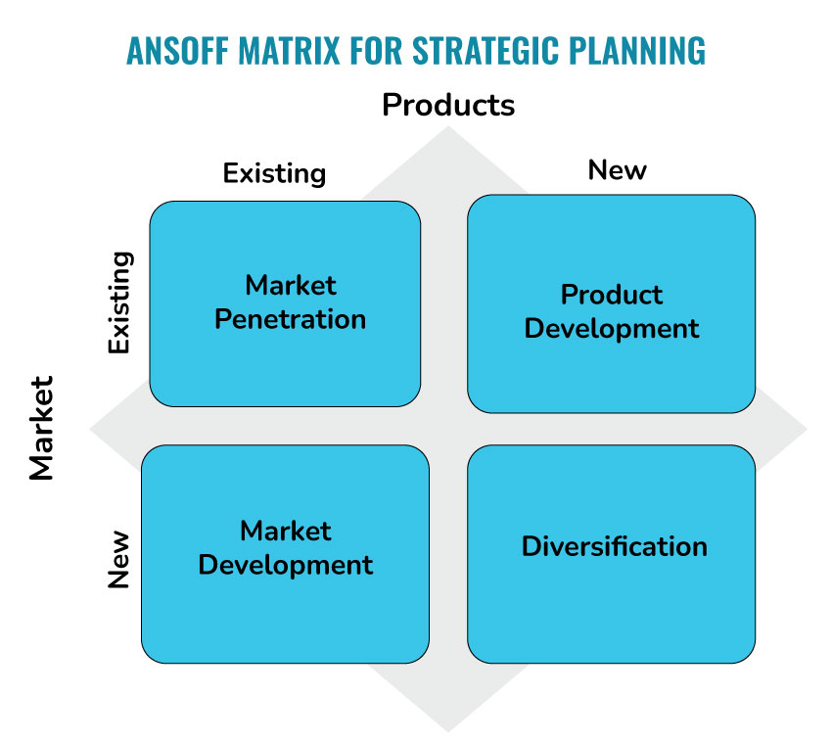
According to this report given that Rolex watches are among the costliest on the market, it's critical to know your spending limit before making a purchase. Rolex offers a variety of watches, each with distinctive characteristics and a distinctive look. Finding a model that suits your needs and preferences can be made easier by researching the various models. Purchase from a trustworthy dealer: It's crucial to purchase from a respected dealer who can offer you a warranty and guarantee of authenticity if you want to make sure that the Rolex watch you receive is genuine. Although Rolex watches are designed to last, they nonetheless need routine upkeep and occasionally expensive repairs. When thinking about buying a Rolex watch, consider these continuing expenses. Overall, a Rolex can be the best option for you if you're searching for a high-end timepiece with a distinguished past, superb craftsmanship, and iconic design. To ensure that you're getting genuine and high-quality goods, just make sure to conduct your research and buy from a trustworthy dealer. By this report, I recommend the Rolex company to use “Diversification strategy” because if they introduce to perfumes industry. So, they can get more profit in the market than now. It attracts niche markets. In “Product Development Strategy” is to improve the operation of its timepieces, Rolex could spend money on the creation of new technologies. For instance, the business might use cutting-edge sensors to track heart rate, activity level, and other health indicators. Rolex may investigate the use of new materials to improve the functionality and robustness of their timepieces. For instance, the business could test out new metals, ceramics, or composites to see whether they can increase the resistance to abrasion, corrosion, or impact. New designs: Rolex may release new models that appeal to various market segments. For instance, the business may produce watches with more cutting-edge or modern designs that appeal to younger customers, or it could provide timepieces that are more specialized for particular sports, like diving, flying, or racing. Rolex may release limited-edition timepieces with distinctive designs, components, or features. Market these limited-edition timepieces to enthusiasts and collectors who value rarity and exclusivity. Rolex may possibly think about entering the smartwatch sector. Although the business has always concentrated on mechanical timepieces, the emergence of wearable technology offers Rolex the chance to diversify its product line and appeal to a new generation of customers.

References
Forbes. (2021). Why Rolex Is The Most Reputable Brand In The World. Retrieved from https://www.forbes.com/sites/pamdanziger/2021/01/26/why-rolex-is-the-most-reputable-brand-in-the-world/?sh=2b2be8c8d955
Business Insider. (2021). Rolex watches are some of the most expensive in the world. Here's why they cost so much. Retrieved from https://www.businessinsider.com/why-rolex-watches-are-so-expensive-2019-5
Statista. (2021). Rolex's product range in 2020, by material. Retrieved from https://www.statista.com/statistics/468717/rolex-product-range-by-material/
The New York Times. (2018). Inside Rolex's $2.6 Billion Headquarters. Retrieved from https://www.nytimes.com/2018/06/29/fashion/watches-rolex-geneva.html
Rolex. (2021). Sustainable Luxury. Retrieved from https://www.rolex.org/sustainability/sustainable-luxury
Financial Times. (2021). Rolex seeks to secure supply chains as metals exports boom. Retrieved from https://www.ft.com/content/ab6a912c-c70c-41b3-b6b5-b16025c11663
The Guardian. (2021). Brace yourself for another luxury goods slump. Retrieved from https://www.theguardian.com/business/2021/feb/28/luxury-goods-slump-covid-pandemic-hermes-lvmh-chanel.
Business Insider. (2021). Luxury watchmakers are tapping into a key trend with customizable watch designs. Retrieved from https://www.businessinsider.com/luxury-watchmakers-tapping-into-customizable-watch-trend-2021-3
Financial Times. (2021). Rolex seeks to secure supply chains as metals exports boom. Retrieved from https://www.ft.com/content/ab6a912c-c70c-41b3-b6b5-b16025c11663
Forbes. (2020). Rolex Vs. The Grey Market: An Unwinnable War? Retrieved from https://www.forbes.com/sites/elizabethdoerr/2020/09/16/rolex-vs-the-grey-market-an-unwinnable-war/?sh=4409511666b5
Forbes. (2021). Why Rolex Is The Most Reputable Brand In The World. Retrieved from https://www.forbes.com/sites/pamdanziger/2021/01/26/why-rolex-is-the-most-re
Duarte, F (2015) “Segmenting and Targeting Markets” Duarte, F (2015) “Ethics & Social Responsibility” Available from: http://rolexmar100.blogspot.co.uk, (Accessed 02/01/17)
Bhasin, H (2016) “Marketing mix of Rolex” Available from: http://www.marketing91.com, (Accessed 02/01/17)
Klara, R (2013) “How Rolex Runs on Autopilot” Available from: http://www.adweek.com/news, (Accessed 02/01/17)
Altieri, P (2013) “The History of the Rolex Logo Is Exquisite” Available at: https://www.bobswatches.com/rolex-blog, (Accessed 03/01/17)
Rolex. (n.d.). The Rolex Watch. Retrieved from https://www.rolex.com/watches.html
Forbes. (2021). The Average Price Of A Rolex Watch. Retrieved from https://www.forbes.com/sites/robertanaas/2021/04/26/the-average-price-of-a-rolex-watch/?sh=6f17c94f4854
Bhasin, H (2016) “Marketing mix of Rolex”
Available from: http://www.marketing91.com, (Accessed 02/01/17)
Bhasin, H (2016) “Marketing mix of Rolex”
Available from: http://www.marketing91.com, (Accessed 02/01/17)
"Rolex: The History of the Luxury Watch," by Time Magazine (https://time.com/rolex-history/"The Brand Report: Rolex," by Interbrand (https://www.interbrand.com/best-brands/best-global-brands/2021/rolex/)"The Rolex Brand: A Case Study in Successful Brand Management," by the Journal of Business Case Studies (https://www.abacademies.org/articles/the-rolex-brand-a-case-study-in-successful-brand-management-5319.html)
"Rolex: A Guide to the World's Most Iconic Watches," by GQ Magazine (https://www.gq.com/story/rolex-watches-guide)
"The Story of Rolex," by the official Rolex website (https://www.rolex.com/about-rolex.html)
"Brand Equity Model: Understanding Keller's Brand Equity Model," by Cleverism (https://www.cleverism.com/brand-equity-model/)
"Aaker's Brand Equity Model: Building Strong Brands," by Cleverism (https://www.cleverism.com/aakers-brand-equity-model-building-strong-brands/)
"The Customer Journey: A Comprehensive Guide," by Salesforce (https://www.salesforce.com/products/service-cloud/best-practices/customer-journey-mapping/)
"Rolex: A Case Study in Luxury Marketing," by Marketing Week (https://www.marketingweek.com/rolex-a-case-study-in-luxury-marketing/)
Deloitte. (2019). Global Powers of Luxury Goods 2019. Retrieved from https://www2.deloitte.com/content/dam/Deloitte/global/Documents/Consumer-Business/gx-cb-global-powers-of-luxury-goods-2019.pdf
Wealth-X. (2019). Luxury Watches Report 2019. Retrieved from https://www.wealthx.com/wp-content/uploads/2019/10/Luxury-Watches-Report-2019.pdf
McKinsey & Company. (2020). The State of Fashion 2021: Outlook and Opportunities in the Year Ahead. Retrieved from https://www.mckinsey.com/industries/retail/our-insights/the-state-of-fashion-2021-outlook-and-opportunities-in-the-year-ahead

