University of Wales Trinity Saint David
School of Engineering

Application of Automation in Wastewater Treatment
Control and Automation
ACMA5001

Heather Came
2208198
07/04/2025
Contents

1 Introduction 1
2 Historical Development of ICA in Wastewater Treatments 3
2.1 Sensors 4
2.2 Process Controllers 5
2.3 Actuators 6
2.4 Supervisory Control and Automation 7
3 Regulatory Standards and Compliance 8
4 Advanced Technologies in ICA for Wastewater Treatment 9
5 Examples of Modern ICA Applications 10
6 Conclusion 11
7 References 12

Figure 1 - Overview of a Typical Wastewater Treatment Process (Mallik, 2018) 1
Figure 2 - SCADA Hardware in an Automated Wastewater Treatment System (Castro, 2023) 3
Figure 3 – Sensor positions in wastewater treatment plant (Maciej, 2018) 5

Abstract

Instrumentation, Control and Automation (ICA) has become a cornerstone of modern wastewater treatment, enabling facilities to operate with greater precision, reliability, and efficiency. This report investigates the evolution and application of ICA technologies within wastewater treatment facilities, tracing their development from manual processes to near-autonomous systems. Emphasis is placed on key components, including sensors, process controllers, actuators, and supervisory control systems such as SCADA, and how these interact to monitor and regulate treatment processes. The report also considers regulatory standards that underpin ICA implementation, ensuring compliance with environmental and safety requirements. Finally, emerging technologies such as artificial intelligence, predictive analysis and the Internet of Things are explored for their role in advancing automation and operational sustainability.

Introduction

Wastewater treatment is a critical service that ensures the safe processing of sewage and industrial effluent before it is returned to the environment. Historically, these processes relied heavily on manual observation and operator judgement, which made them prone to inefficiencies and inconsistencies. However, with growing populations, increasing wastewater volumes, and tighter environmental regulations, the need for more accurate, efficient, and consistent methods of control became apparent.
The adoption of Instrumentation, Control and Automation (ICA) technologies has transformed wastewater treatment operations. Through basic sensors that measure parameters such as pH and dissolved oxygen, ICA systems have evolved into fully integrated networks capable of continuous monitoring, predictive control, and autonomous operation. Components such as programmable logic controllers (PLCs), supervisory control and data acquisition (SCADA) systems, and various sensor and actuator technologies now play central roles in ensuring process stability and regulatory compliance. Figure 1 shows an overview of a basic water treatment system.

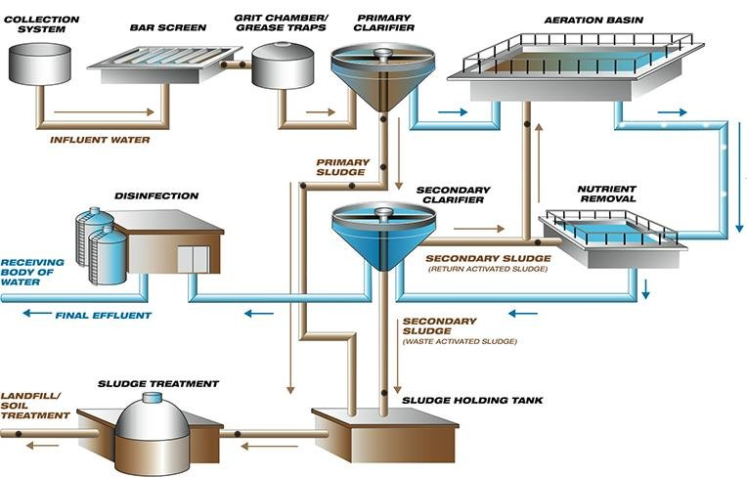
Figure 1 - Overview of a Typical Wastewater Treatment Process (Mallik, 2018)

This report examines the specific applications of ICA within wastewater treatment from a historical perspective; focusing on the development and function of sensors, controllers, actuators, and supervisory systems. It also addresses the regulatory standards that govern their use and explores what technologies are shaping the future of automation in wastewater management. By understanding both the foundational elements and future trends, this report highlights how ICA contributes to the safe, efficient, and sustainable operation of wastewater treatment facilities.

Historical Development of ICA in Wastewater Treatments

Wastewater treatment was initially manual, with operators using visual examination and taking physical samples to track chemical and physical changes. Instead of using real-time data, operators experience, and judgement was used to determine how to best modify treatment procedures. This resulted in, inefficiencies and uneven treatment quality as this approach allowed room for human error and bias (Garrett, 1998). Because of this, the need for a more efficient and a more consistent strategy became evident.
As industrialisation progressed further into the 20th century, basic sensors for parameters like pH levels, dissolved oxygen, and turbidity were introduced and utilised (Spellman, 2020). These sensors improved process monitoring and were a key milestone in the evolution towards ICA systems becoming fully automated. However, data was still recorded manually allowing for the possibility of human error and inconsistent results (Olsson, 2012).
In response to industrial growth, and rising population levels throughout the early to late 20th century, the demand for wastewater treatment capacity increased significantly. Furthermore, environmental regulations became stricter. Therefore, by the late 20th century there was a clear necessity for these systems to become further automated and reduce the room for error. Examples of technologies that were integrated at this time include programmable logic controllers (PLCs); feedback control mechanisms and supervisory control and data acquisition (Olsson, 2012).

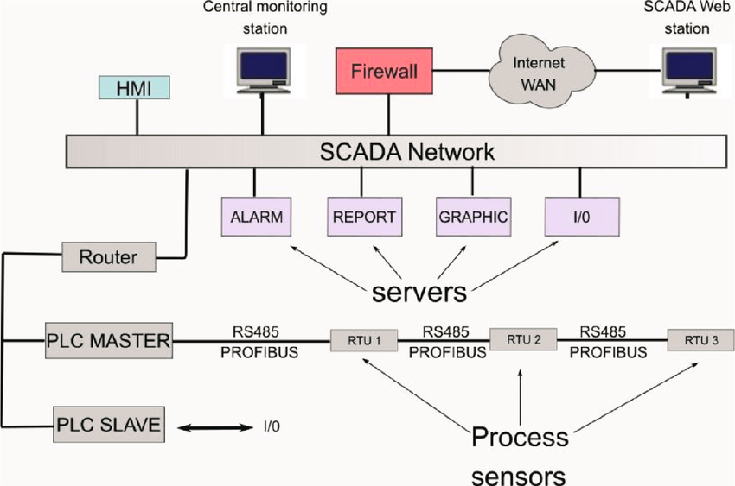
Figure 2 - SCADA Hardware in an Automated Wastewater Treatment System (Castro, 2023)
The integration of these systems enabled more precise and automated management of wastewater treatment processes. Adopting SCADA systems, as shown in Figure 2, enabled remote monitoring and improved data collection, trend analysis, and the ability to respond to anomalies in real-time, significantly improving operational efficiency (Olsson et al., 2014). SCADA systems overall improve efficiency and responsiveness to system adjustments. These developments significantly reduced reliance on operators using personal judgement and experience and therefore improved treatment consistency and quality. Having accurate data also aids in adhering to standards and regulations.
The transition from manual monitoring to ICA-based systems has continued into the 21st century, with increasing adoption of machine learning, artificial intelligence and live data analytics. This all contributes to the ongoing process to completely automate wastewater treatment systems. These modern solutions increase efficiency, reduce energy consumption, reduce operational costs, support sustainable wastewater treatment and improve compliance with regulations. Smart sensors, real-time analytics, and cloud-based monitoring have overall made wastewater treatment more reliable and efficient (Yuan et al., 2019).

Sensors

In modern day, sensors are integral to wastewater treatment facilities, enabling real-time monitoring of critical parameters to optimise treatment performance and ensure regulatory compliance. Sensors convert physical parameters into digital information and are the foundation that led to wastewater systems becoming autonomous. By continuously collecting data, sensors reduce the need for manual sampling, improve response times, and enhance overall efficiency.
There are multiple sensors used in wastewater treatment, which each fall into one of four categories (Archer, 2021):
- Sensors that measure water quality
These sensors include pH Sensors; dissolved oxygen sensors, which are crucial for supporting microbial activity; turbidity sensors to assess water clarity and suspended solids sensors which help to evaluate treatment performance.
- Sensors that monitor the movement and flow of liquids
Examples include level sensors; flow meters; pressure sensors and temperature sensors.
- Sensors that check pump performance
For example, vibration sensors detect irregularities that may indicate mechanical wear or failure as well as leak detection Sensors that alert operators to water ingress in pump housings.
- Sensors that keep track of supporting systems within the plant’s control setup
These include fuel level and battery voltage sensors used in backup generators; hydrogen sulphide sensors and electrical load sensors which monitor power usage and balance across systems. Figure 3 indicates the locations where sensors are employed, such as level sensors, stirrers, and pH electrodes.

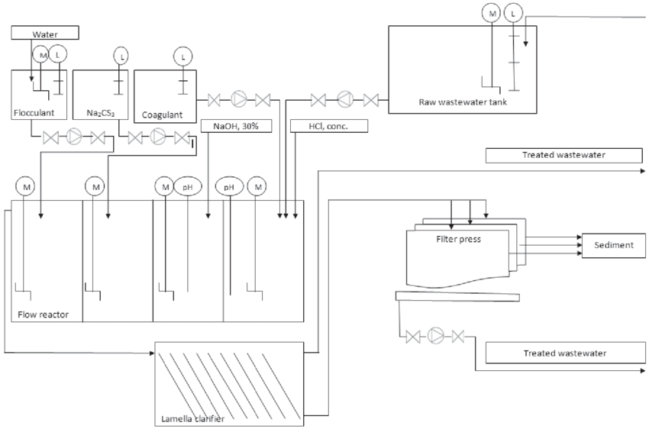
Figure 3 – Sensor positions in wastewater treatment plant (Maciej, 2018)

Process Controllers

Process controllers interpret data from sensors and make automated adjustments to optimise treatment processes. Process controllers are key to automation in wastewater treatment. The use of sensor data to make instant adjustments, reduces the need for manual input. By maintaining stable conditions, optimising energy and chemical use, and enabling remote and predictive control, they help treatment plants operate more efficiently, reliably, and autonomously (Jiaqi & Chang, 2019).
Examples include:
- Programmable Logic Controllers (PLCs): Execute control logic for various treatment stages, responding in real-time to sensor data.
- Distributed Control Systems (DCS): Provide integrated monitoring and control across large facilities, coordinating multiple treatment processes efficiently.
- Proportional-Integral-Derivative (PID) Controllers: Maintain stable process conditions by adjusting inputs such as chemical dosing and aeration based on deviation from setpoints.
- Fuzzy Logic Controllers: Handle non-linear and complex processes where conventional PID control may be insufficient (Luvera, 2023).

Actuators

Another key aspect that contributes to the autonomy of wastewater treatment systems, is actuators. Actuators are what enable the automatic and instant adjustments to be actioned based on sensor data. Actuators respond to control signals by adjusting mechanical or electrical devices, ensuring the smooth operation of wastewater treatment processes. They regulate critical processes such as flow, chemical dosing, and aeration without human intervention. Integrated with control systems, actuators respond to feedback, optimising treatment conditions in real time, improving efficiency, and ensuring consistent water quality. This automation minimises human error and enhances overall system performance. (Olsson, 2012).

Types of actuators in these systems include:
- Valves: Regulate the flow of liquids and gases to different treatment stages.
- Pumps: Control the movement of wastewater, sludge, and chemical reagents between treatment stages.
- Aerators: Maintain oxygen levels for biological treatment, promoting microbial degradation of organic matter.
- Chemical Dosing Systems: Automate the addition of coagulants, disinfectants, and pH adjusters to optimise treatment performance.

Supervisory Control and Automation

Supervisory control systems, such as SCADA, enable centralised monitoring and management of wastewater treatment processes. By collecting sensor data and issuing commands to actuators, they allow immediate, automated adjustments across the system. This reduces the need for manual intervention, improves efficiency, and supports consistent treatment quality. Operators can oversee and optimise processes remotely, making these systems key to achieving autonomous wastewater treatment (Yuan et al., 2019).
Key elements include:
- SCADA Systems: Provide simultaneous monitoring, alarms, historical data analysis, and remote operation of the treatment plant.
- Human-Machine Interfaces: Facilitate operators interacting with automated systems by showing important data and allowing manual control when necessary.
- Remote Monitoring: Enables off-site supervision and troubleshooting, reducing the need for on-site personnel while ensuring continuous operation.
- Predictive Maintenance Systems: Utilise AI and IoT to forecast equipment failures, optimise maintenance schedules and reduce operational costs and downtime.

Regulatory Standards and Compliance

ICA implementation in wastewater treatment must adhere to national and international regulations to ensure environmental protection and public health. These include:
- Environmental Protection Agency (EPA) Guidelines: Define permissible effluent limits, requiring automated monitoring and reporting (United States Environmental Protection Agency, 2019).
- European Water Framework Directive: Establishes water quality standards across EU nations, encouraging real-time monitoring and data transparency (European Union, 2014).
- ISO 14001: Provides a framework for environmental management systems, ensuring sustainable wastewater treatment practices (ISO, 2015).
Regulatory compliance ensures wastewater treatment is both environmentally responsible and safe. ICA systems must align with strict guidelines set by organisations such as the International Organisation for Standardisation, the Environmental Protection Agency and local regulatory authorities. Key parameters like pH, turbidity, and dissolved oxygen levels must be constantly monitored to meet discharge requirements (EPA, 2019).
Compliance with ISO 14001 ensures minimal environmental impact while maintaining operational efficiency (Advisera, 2015). The International Finance Corporation highlights the need for robust environmental management practices, including wastewater monitoring and treatment, to meet sustainability goals (IFC, 2024).
Regulations also mandate redundancy features in monitoring systems to prevent failures and ensure continuous operation, particularly during high-risk periods. Non-compliance can lead to legal penalties and environmental and reputational damage. ICA systems optimise chemical and energy usage, enhance compliance by providing real-time data for monitoring and reporting therefore reducing human error and improving process control.
To summarise, beyond legal obligations, adhering to standards optimises treatment efficiency, reduces waste and energy consumption and contributes towards health and safety. Automated systems continuously monitor and adjust processes, ensuring sustainability and operational cost reduction. Regulatory compliance is thus both a necessity and a driver of efficiency in modern wastewater treatment facilities.

Advanced Technologies in ICA for Wastewater Treatment

Recent developments in automation and digital technologies are transforming wastewater treatment plants into smart, self-regulating facilities. One of the most significant advancements is the evolution of SCADA systems. Modern SCADA platforms incorporate cloud computing, remote access, and Internet of Things (IoT) technologies, allowing operators to monitor and control plant operations in real time from any location. This integration significantly enhances data accessibility, fault detection, and automated response, thereby reducing reliance on manual intervention (ScienceDirect, 2024).
IoT-enabled sensors and actuators help provide more detailed data and make the system more responsive. These smart devices connect physical equipment to cloud-based platforms for continuous monitoring and predictive analytics, allowing for early detection of anomalies and process inefficiencies (Jiaqi & Chang, 2019). When paired with AI and machine learning algorithms, these systems can autonomously adjust process variables, optimise chemical dosing, and enhance energy efficiency.
In addition to digital upgrades, robotic automation is becoming more common in hazardous or labour-intensive areas of treatment facilities. Autonomous drones and underwater robots are deployed to inspect pipelines, reservoirs, and structural infrastructure (Nauert and Kampmann, 2023). These tools use high-resolution imaging and onboard sensors to detect leaks, sediment buildup, or equipment degradation which enables predictive maintenance and reduces downtime (Jenns, 2025).
Another emerging solution is the use of decentralised, AI-controlled treatment units, particularly in remote regions (Hesam Kamyab et al., 2023). These modular systems are compact, scalable, and capable of autonomous operation, making them ideal for localised wastewater management with reduced environmental impact.
Complementing these technologies is the rise of Big Data Analytics, which supports the optimisation of resource allocation and process performance. By analysing vast datasets from sensors and SCADA systems, operators can identify long-term trends, streamline operations, and improve regulatory compliance outcomes (Hesam Kamyab et al., 2023).
Together, these innovations mark a shift toward fully automated, intelligent wastewater treatment systems capable of self-optimising and adapting to real-time conditions with minimal human oversight.

Examples of Modern ICA Applications

The future of ICA in wastewater treatment is driven by emerging technologies and sustainability goals (Yuan et al., 2019). These goals include:
- Smart Water Networks: Fully integrated water management systems leveraging AI, IoT, and big data analytics.
- Fully Autonomous Treatment Plants: AI-driven plants with minimal human intervention.
- Sustainable Energy Integration: Increased use of renewable energy sources for wastewater treatment operations.
Several real-world implementations highlight the transformative power of modern ICA technologies in wastewater treatment, where automation and smart monitoring are helping to improve sustainability, reduce operational costs, and boost treatment effectiveness.
A widely cited case is Denmark’s Aarhus Water Utility, a pioneer in energy-neutral wastewater treatment. This facility integrates predictive analytics, smart automation, and AI models to control pump speeds, aeration rates, and chemical dosing based on current water quality data (Lynggaard-Jensen, 2015). As a result, it has achieved significant reductions in both energy use and carbon emissions.
A newer example demonstrating the combination of sustainability and automation is the Hyperion Water Reclamation Plant in Los Angeles, California. One of the largest facilities of its kind in the U.S., Hyperion has adopted a hybrid approach combining solar-powered monitoring stations, AI analytics, and SCADA-integrated renewable systems (Thomsen et al., 2018). These upgrades have enabled predictive maintenance, reduced greenhouse gas emissions, and lowered dependence on the main power grid.
These examples showcase how ICA technologies particularly when integrated with AI, IoT, and energy-efficient systems are reshaping wastewater treatment. They illustrate the move towards facilities that are not only highly automated but also sustainable, adaptive, and capable of operating with minimal human intervention.

Conclusion

The integration of ICA technologies within wastewater treatment has revolutionised the industry, enabling the shift from manual, labour-intensive operations to smart, automated systems. From the early use of basic sensors to today’s AI-enhanced SCADA platforms and predictive maintenance systems, the evolution of ICA has allowed facilities to respond rapidly to process changes, reduce human error, and maintain high standards of treatment quality.
Through the coordinated function of sensors, controllers, actuators, and supervisory systems, modern wastewater plants can operate with minimal human input while adhering to stringent regulatory frameworks such as ISO 14001 and the European Water Framework Directive. These technologies not only support compliance but also optimise energy and chemical usage, while reducing costs and environmental impact.
Looking forward, the continued integration of advanced technologies such as IoT networks, machine learning, and decentralised autonomous units will further enhance the autonomy, resilience, and sustainability of wastewater treatment systems. As the demand for reliable and environmentally responsible water management grows, ICA will remain key in meeting future operational and regulatory challenges.

References

Advisera (2015). ISO 14001:2015 Environmental Management Systems — Requirements with Guidance for Use. [online] ISO. Available at: https://www.iso.org/standard/60857.html [Accessed 31 Mar. 2025].
Archer, C. (2021). The 4 Types of Sensors Used in Wastewater Treatment Controls. [online] blog.wellaware.us. Available at: https://blog.wellaware.us/blog/the-4-types-of-sensors-used-in-wastewater-treatment-controls [Accessed 8 Mar. 2025].
Castro, C. (2023). Emerging Technologies in Water Treatment: Recent Advances. [online] ResearchGate. Available at: https://www.researchgate.net/figure/SCADA-hardware-architecture-for-wastewater-treatment-plant_fig11_369882328 [Accessed 3 Apr. 2025].
Dan, Q. (2025). New Breakthrough in Sustainable ultra-efficient Treatment Technology for Mainstream Municipal Wastewater. [online] Research Communities by Springer Nature. Available at: https://communities.springernature.com/posts/new-breakthrough-in-sustainable-ultra-efficient-treatment-technology-for-mainstream-municipal-wastewater [Accessed 2 Apr. 2025].
European Union (2014). EUR-Lex - 32000L0060 - EN - EUR-Lex. [online] Europa.eu. Available at: https://eur-lex.europa.eu/legal-content/EN/TXT/?uri=CELEX:32000L0060 [Accessed 31 Mar. 2025].
Garrett, M.T. (1998). Instrumentation, Control and Automation Progress in the United States in the Last 24 Years. Water Science & Technology, 37(12), pp.21–25. doi:https://doi.org/10.2166/wst.1998.0489.
Hesam Kamyab, Khademi, T., Shreeshivadasan Chelliapan, Morteza Saberikamarposhti, Shahabaldin Rezania, Yusuf, M., Farajnezhad, M., Abbas, M., Jeon, B.-Y. and Ahn, Y. (2023). The latest innovative avenues for the utilization of artificial Intelligence and big data analytics in water resource management. Results in Engineering, 20, pp.101566–101566. doi:https://doi.org/10.1016/j.rineng.2023.101566.
IFC (2024). Environmental, Health, and Safety Guidelines. [online] IFC. Available at: https://www.ifc.org/en/insights-reports/2000/general-environmental-health-and-safety-guidelines [Accessed 4 Dec. 2025].
Iratni, A. and Chang, N.-B. (2019). Advances in Control Technologies for Wastewater Treatment processes: status, challenges, and Perspectives. IEEE/CAA Journal of Automatica Sinica, 6(2), pp.337–363. doi:https://doi.org/10.1109/jas.2019.1911372.
Jenns, C. (2025). Protecting Pipelines and Platforms with Underwater Robots. [online] Offshore Technology. Available at: https://www.offshore-technology.com/features/protecting-pipelines-and-platforms-with-underwater-robots/ [Accessed 2 Apr. 2025].
Luvera, N. (2023). Process Control Systems for Wastewater Treatment • Automation Electric & Controls. [online] Automation Electric & Controls. Available at: https://automationelectric.com/process-control-systems-for-wastewater-treatment/ [Accessed 3 Apr. 2025].
Lynggaard-Jensen, A. (2015). Energy Neutral and Beyond: the City of Aarhus’ Journey Towards Wastewater Treatment Optimization. Proceedings of the Water Environment Federation, [online] 2015(18), pp.3753–3767. Available at: https://www.academia.edu/Aarhus_Journey[Accessed 5 Apr. 2025].
Maciej, T. (2018). Precipitate Heavy Metals from Industrial Wastewater Systems. [online] ResearchGate. Available at: https://www.researchgate.net/figure/Schematic-diagram-of-the-wastewater-treatment-plant-L-level-sensor-M-stirrer-pH-pH_fig1_323205478 [Accessed 12 Mar. 2025].
Mallik, A. (2018). Design and Feasibility of a Water Treatment Plant. [online] Research Gate. Available at: https://www.researchgate/Typical-waste-water-treatment-process_fig4 [Accessed 15 Mar. 2025].
Nauert, F. and Kampmann, P. (2023). Inspection and Maintenance of Industrial Infrastructure with Autonomous Underwater Robots. Frontiers in Robotics and AI, 10. doi:https://doi.org/10.3389/frobt.2023.1240276.
Olsson, G. (2012). ICA and Me – a Subjective Review. Water Research, 46(6), pp.1585–1624. doi:https://doi.org/10.1016/j.watres.2011.12.054.
Olsson, G., Carlsson, B., Comas, J., Copp, J., Gernaey, K.V., Ingildsen, P., Jeppsson, U., Kim, C., Rieger, L., Rodríguez-Roda, I., Steyer, J.-P. ., Takács, I., Vanrolleghem, P.A., Vargas, A., Yuan, Z. and Åmand, L. (2014). Instrumentation, Control and Automation in Wastewater – from London 1973 to Narbonne 2013. Water Science and Technology, [online] 69(7), pp.1373–1385. doi:https://doi.org/10.2166/wst.2014.057.
Olsson, G., Nielsen, M., Yuan, Z., Anders Lynggaard-Jensen and Steyer, J.-P. (2005). Instrumentation, Control and Automation in Wastewater Systems. IWA Publishing.
Spellman, F.R. (2020). Handbook of Water and Wastewater Treatment Plant Operations. CRC Press.
Thomsen, M., Romeo, D., Caro, D., Seghetta, M. and Cong, R.-G. (2018). Environmental-Economic Analysis of Integrated Organic Waste and Wastewater Management Systems: a Case Study from Aarhus City (Denmark). Sustainability, 10(10), p.3742. doi:https://doi.org/10.3390/su10103742.
United States Environmental Protection Agency (2019). Wastewater National Pollutant Discharge Elimination System . [online] US EPA. Available at: https://www.epa.gov/npdes [Accessed 31 Mar. 2025].
Yuan, Z., Olsson, G., Cardell-Oliver, R., van Schagen, K., Marchi, A., Deletic, A., Urich, C., Rauch, W., Liu, Y. and Jiang, G. (2019). Sweating the Assets – the Role of instrumentation, Control and Automation in Urban Water Systems. Water Research, 155, pp.381–402. doi:https://doi.org/10.1016/j.watres.2019.02.034.

