University of Wales Trinity Saint David
School of Engineering

Application of Computer Aided Engineering Processes
Structural Design and Fluid Analysis

Iestyn Webber
1901363
05/01/2023

Contents
1 Introduction 1
1.1 Aims 1
1.2 Objectives 1
2 Literature Review 2
3 Methodology 3
4 Results 4
5 Analysis 5
6 Evaluation 6
7 Conclusion & Further Work 7
8 References 8

Introduction

Aims
- To comprehensively study an assembly focusing on a particular component.
- To validate the study to demonstrate its accuracy and reliability.
- To use the above as a case study to evaluate the applicability of computer aided engineering (CAE).

Objectives
- To introduce CAE and its relevance to the study.
- To select a suitable subject of study.
- To analytically calculate the reaction of a system under load.
- To recreate the same loads placed on the system within the modelling software, comparing the two.
- To use the same software to investigate the subject of study under a complete interaction of thermal and kinematic loads.
- To compare the results with data obtained through research.
- To discuss the relevance of the case study to CAE applications.
- To assess the extent to which CAE is applicable to real scenarios.

Uses of CAE
CAE is a term encompassing a variety of methods of completing engineering processes using computer simulation. This most commonly includes the use of computer aided design (CAD) software, as well as finite element analysis (FEA). Software packages such as Ansys Workbench provide multiple CAE elements in one package, allowing for linked studies.
The benefits of utilising CAE are primarily increasing engineering efficiency. Whether it be cost- or time-efficiency, the ability to design and fully constrain a component or assembly of components is important. This allows for the ability to evaluate the abilities of the component and simulate scenarios which would require time and resources to recreate practically. It also provides an alternative to destructive testing, which can lead to useful data on the failure point of components but means the destruction of a prototype.

Literature Review
Introduction:
- Define and outline the general topic of the literature, the area of concern (environmental regulations developing and how they affect the technologies required on our cars.)
- Overall trends in what has been published about the topic (environmental restrictions are becoming much more stringent as the EU looks to decrease emissions overall). Gaps in research.
- Establish the point of view – the reason for reviewing the literature (the sources of information provide info that overlaps, this must be compared to ensure consistent data and information).

Body:
- Group studies and other literature together (all cat pieces together, all SAIR pieces together etc.
- Summarise individual studies or articles as much as possible (space denotes significance, so the Euro regs the longest).
- Provide umbrella sentences to begin, signposts throughout and “so what” summaries.

Conclusion:
- Summarise major contributions and maintain the focus established within the introduction.
- Evaluate the “state of the art” for the body of knowledge reviewed (while all cars now must work to Euro 6 regs, some cars that are much older still comply and so their technology is not as comparable).
Conclude by providing some insight into the relationship between the central topic of the literature review and a larger area of study such as a discipline or profession (this body of information is crucial to the technical development of vehicles in the immediate and long-term future, especially when seeking jobs post-graduation).

Methodology
A study involving the use of CAE software can demonstrate the applicability of such techniques by comparing the results gathered with results obtained by non-simulated methods. In this investigation, a small case study solvable by analytical methods will be carried out and recreated in a simulation, validating the use of CAE.

Creating an assembly
The component chosen to study is the piston within a cylinder. This part was selected due to its exposure to both kinematic and thermal loads and is a crucial part undergoing high loads and therefore being subject to significant wear throughout its lifespan. This component in particular was chosen to study as it is part of very important studies into the use of hydrogen as a fuel in internal combustion engines, with multiple studies into converting petrol and diesel ICEs. This would require analysis of the reaction of the component to the different forces and temperature generated by the combustion of hydrogen as opposed to more conventional fuels; creating a study simulating this is beneficial in such research.
The overall assembly used involves the gudgeon pin, piston, connecting rod and crankshaft. This assembly can simulate the response of the components during a combustion cycle, allowing for a study of the fatigue borne by them.
A combined study linking together a rigid structural study, a steady-state thermal study and a static structural study will be used. This method allows for a more comprehensive study into the assembly, as the forces exerted upon the piston along with the effects of the operating temperatures within an engine will be accounted for within the kinematic study.

Validating the model
Validation through analytical methods is used to demonstrate accuracy of the CAE process itself. An example of a study is first solved “by hand”, without use of CAE. A comparative model is then created using CAE, conducting the same study, with the results expected to match except for some minor deviances due to assumptions made by the simulation. Aspects such as the mesh size of the simulation may need to be adjusted to provide closer results.
The analytical case study chosen is into a uniform load along a cantilever beam. The study assumes the weight of the beam is negligible, therefore all forces are from the uniform loading. Deriving from the equation defining the bending moment:
$$M= -\frac{q{(L-x)}^{2}}{2}$$
Taking the equation for beam bending from the Euler-Bernoulli theory (reference):
$${El}_{y} \frac{d^{2}u_{z}}{dx^{2}} =M$$
This equation can be integrated twice to solve for displacement:
$$u_{z}\left(x\right)= \frac{qx^{2}(6L^{2}-4Lx+x^{2})}{24El_{y}}$$
Considering that at maximum displacement, distance from the fixed point (x) is equal to beam length (L), the equation provides:
$$u_{z,max}=\frac{qL^{4}}{8El_{y}}$$
A static structural study was used to solve the response of the cantilever beam in Workbench. First creating a model of the beam within Solidworks CAD software, the geometry was imported into Workbench and the forces acting upon the beam defined. The force was converted from pressure using the equation:
$$p=FxA$$
Providing a force of 137.5N.
Given the complex nature of the case study, validation by analytical methods is impossible. In this case, the results can be validated using secondary data obtained through research. This can involve either directly comparable data or data which does not directly correlate but will support results through trends.

Results

Analytical results
The results from the non-simulated study example (from the examples provided in class) will be shown first. The study repeated using Ansys will then be shown, with post-processing exporting the data to be used in a graph alongside the hand calculations to demonstrate the correlation.
The values found within table [x] were used within the analytical study of a cantilever beam. Following the methodology using equations [x – x], a solution of 157.143mm is obtained for u_{zmax}.
Measurement | Value
Modulus of Elasticity, E | 210000 MPa
Poisson’s Ratio, v | 0
Shear Modulus, G | 105000 MPa
Length, L | 1 m
Width, w | 0.5 m
Thickness, t | 0.05 m
Pressure, p | 2750 Pa

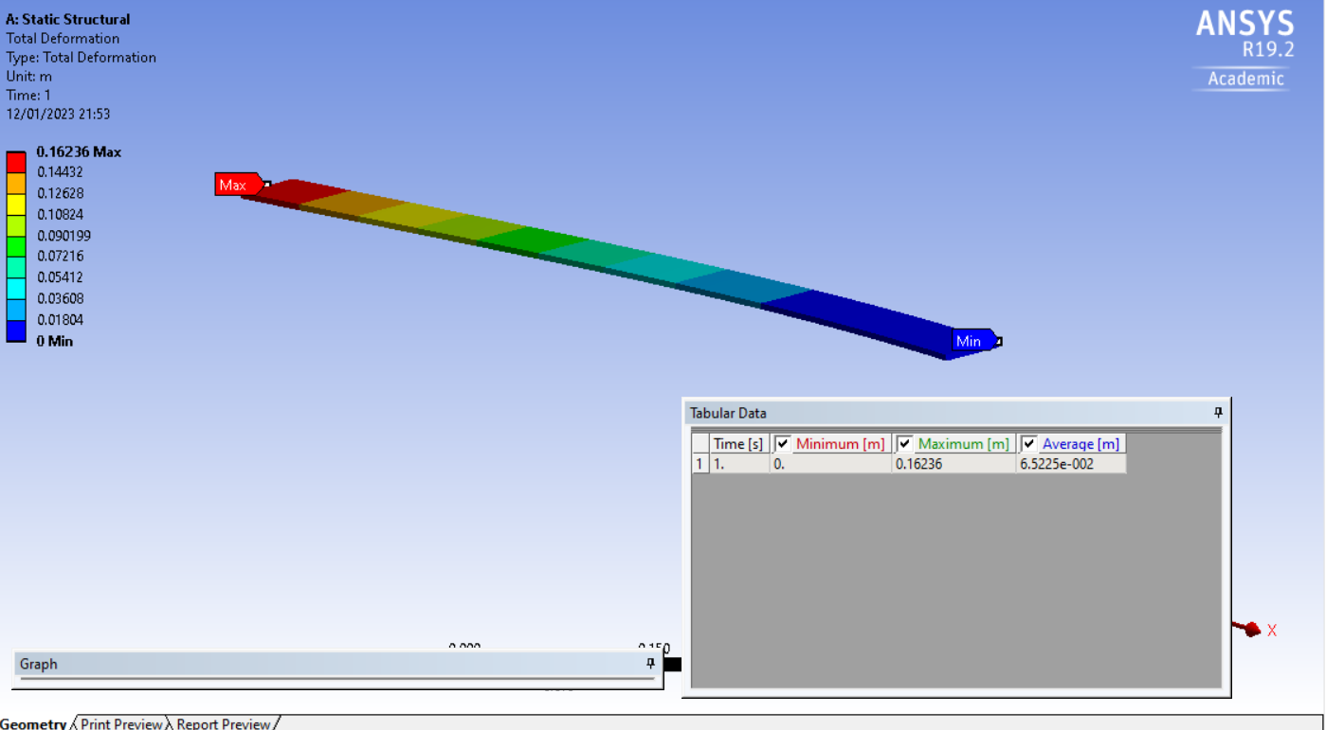
Figure 1 shows the results of the cantilever beam simulation, representing in an exaggerated manner the deformation caused by the uniform load. The result of 162.36mm is a margin of 1.6% out from the analytical figure. This could be caused by assumptions made by the simulation with regards to the material properties.

Simulation results
The results of the simulation will have to be displayed in multiple ways. Peak data (minimums and maximums) is not very useful as not only does it represent extremes rarely encountered in actual use, but it also ignores fatigue across the lifespan of a component, which is more useful to simulate. Fatigue will be needed. Post-processing will also be required to show this along with better representation of data.

Researched data
Any relevant researched data will be presented here. This could include directly comparable data, which can then be exported into charts along with primary data to show comparison. It can also include indirect data for comparison, used to validate using correlating trends. This can potentially be displayed in separate graphs, or in the same graph, as the primary data.

Analysis

Table 1 Results from Experiment
A comparison of the CAE and non-CAE initial study will show the accuracy of the simulation. Analysis will show the extent to which CAE itself is applicable in studies such as this, and consider the slight discrepancies due to assumptions, accuracy of simulation and differences in rounding.
The results of the study itself, after post-processing techniques have been done, will be analysed here: looking at the maximum and minimum values but mainly focusing on the fatigue over time as is representative of a real scenario. The results will be analysed in the context of researched values.

The researched values here will be of the expected wear and tear within an engine, as well as the pressures and temperatures seen within an engine to compare the testing conditions and validate those.

Evaluation
The
Evaluate the accuracy of the simulation compared to the expected results from researched data. Evaluate the effectiveness of the methods used to simulate – combined study, engineering data carried across, validated system, thermal data included.

Conclusion & Further Work
Conclusions:
The use of CAE is highly applicable across a wide range of engineering applications. The case study within this investigation demonstrates the ability to model engine systems; however, the method of the study could be applied to any assembly involving kinematic and thermal loads. This could even be expanded to involve further loads, providing a suitable platform with which to simulate real-world data. A key application for CAE as demonstrated in this study is fatigue and life-cycle analysis. Being able to gather data on a component’s design without the need to conduct a physical test saves both time and resources.
Further Work:
The model could be expanded to include additional external loads. It could also be further validated using a physical study, by first modelling an assembly of components and modelling their responses and then conducting a practical study into the response of the chosen component. A comparison of primary physical data allows for a study designed to be carried out under identical conditions for both, instead of the simulation being carried out to fit the measured data or vice versa.

References

