AI ACKNOWLEDGEMENT

AN ANALYSIS OF GUEST SATISFACTION TROUGH NETNOGRAPHY AT THE MERMAID HOTEL IPSWICH BY MARSTON’S INN
Placement Research Project
Student name: Tatiana Elena Bacalu
Student ID number: 2224927
Lecturer: Kathryn Flynn
Programme: BA International Hotel Management
Module: Hotel Placement Research Project
Module code: BMIH6008
Date: 06/11/2025
I confirm that I have not used any AI tools in the research and creation of this assignment. I confirm that I have not presented any AI generated materials as my own work. I confirm I have copies of my drafts, notes, and other resources I used, which I may be asked to provide in evidence.

Contents
Abstract 4
Chapter 1 Introduction 6
1.1 Background and Context 6
1.2 Rational for study 7
1.3 Research Aim and Objectives 8
Chapter 2 Literature Review 8
2.1 Introduction 8
2.2 Service Quality in the Hospitality Industry 8
2.3 Guest Satisfaction and Loyalty 10
2.4 Online Reviews and the Digital Impact on Guest Views 10
2.5 Netnography as a Research Method 11
2.6 Deficiencies and Contradictions in the Literature Gap and Contradictions in the Literature 12
2.7 Conclusion 12
Chapter 3 Methodology 13
3.1 Introduction 13
3.2 Case Study Approach 13
3.3 Netnography as the Method of Research 14
3.4 Data Collection and Analysis 15
3.5 Alternative Methods Considered 15
3.6 Ethical Issues 16
3.7 Conclusion 16
Chapter 4 Findings 17
4.1 Introduction 17
4.2 Staff Service and Hospitality 17
4.3 Cleanliness and Housekeeping 18
4.4 Food and Beverage Experience 18
4.5 Rooms and Comfort 18
4.6 Facilities and Value for Money 19
4.7 Contradictions in Guest Perceptions 20
4.8 Conclusion of Fundings 20
Chapter 4b Discussion 21
4.1 Introduction 21
4.2 Staff Service as a Driver for Satisfaction 21
4.3 Cleanliness and the Non-Negotiable Standards 22
4.4 Food and Beverage. Partial Strength with Risks 22
4.5 Room Comfort, and the Importance of Tangibles 23
4.6 Perceived Value for Money and Fairness Perceptions 23
4.7 Satisfaction: Contradictions and Subjective Evaluation 24
4.8 Reflections on Methodology: The Practice of Netnography 25
4.9 Wider Implications for Hospitality Research and Practice. 25
4.10 Conclusion. 25
Chapter 5 Conclusion and Recommendation 26
5.1 Introduction 26
5.2 Conclusion 26
5.2.1 Reviewing the research aim and objectives. 26
5.2.2 Theoretical Contributions 27
5.2.3 Practical Implications 27
5.2.4 Limitations of the Study. 28
5.2.5 Conclusions Overview 28
5.3 Tips and Actionable Plans 28
5.3.1 Improve Cleanliness 29
5.3.2 Systematic Maintenance and Refurbishment 29
5.3.3 Consistency in Food and Beverage Delivery 29
5.3.4 Digital Feedback Monitoring 30
5.4 Final Reflection 30
5.5 Conclusion 30
6 References 31

Abstract
The customer satisfaction of guests is one of the success factors in hospitality. In turn, they contribute to revenue performance, online reputation, and loyalty. This Placement Research Project looked at the satisfaction of the guests of The Mermaid Hotel Ipswich which is part of the Marston’s Inns brand using a qualitative netnographic (online review) method.
The aim of this project is to examine customer generated text reviews on TripAdvisor, Booking.com and Expedia, and derive the main themes related to guest satisfaction and dissatisfaction.
The main objectives are (1) to uncover the major themes in guest review data, (2) to identify the factors that influence guest satisfaction, and (3) to propose evidence-based strategies for improving guest experience. This project follows a ethnographic approach using naturally occurring online data about guests’ perceptions. Netnography is used extensively in hospitality research. It helps capture unfiltered perspectives of customers. Researchers detect the continual appearance of themes associated with service.
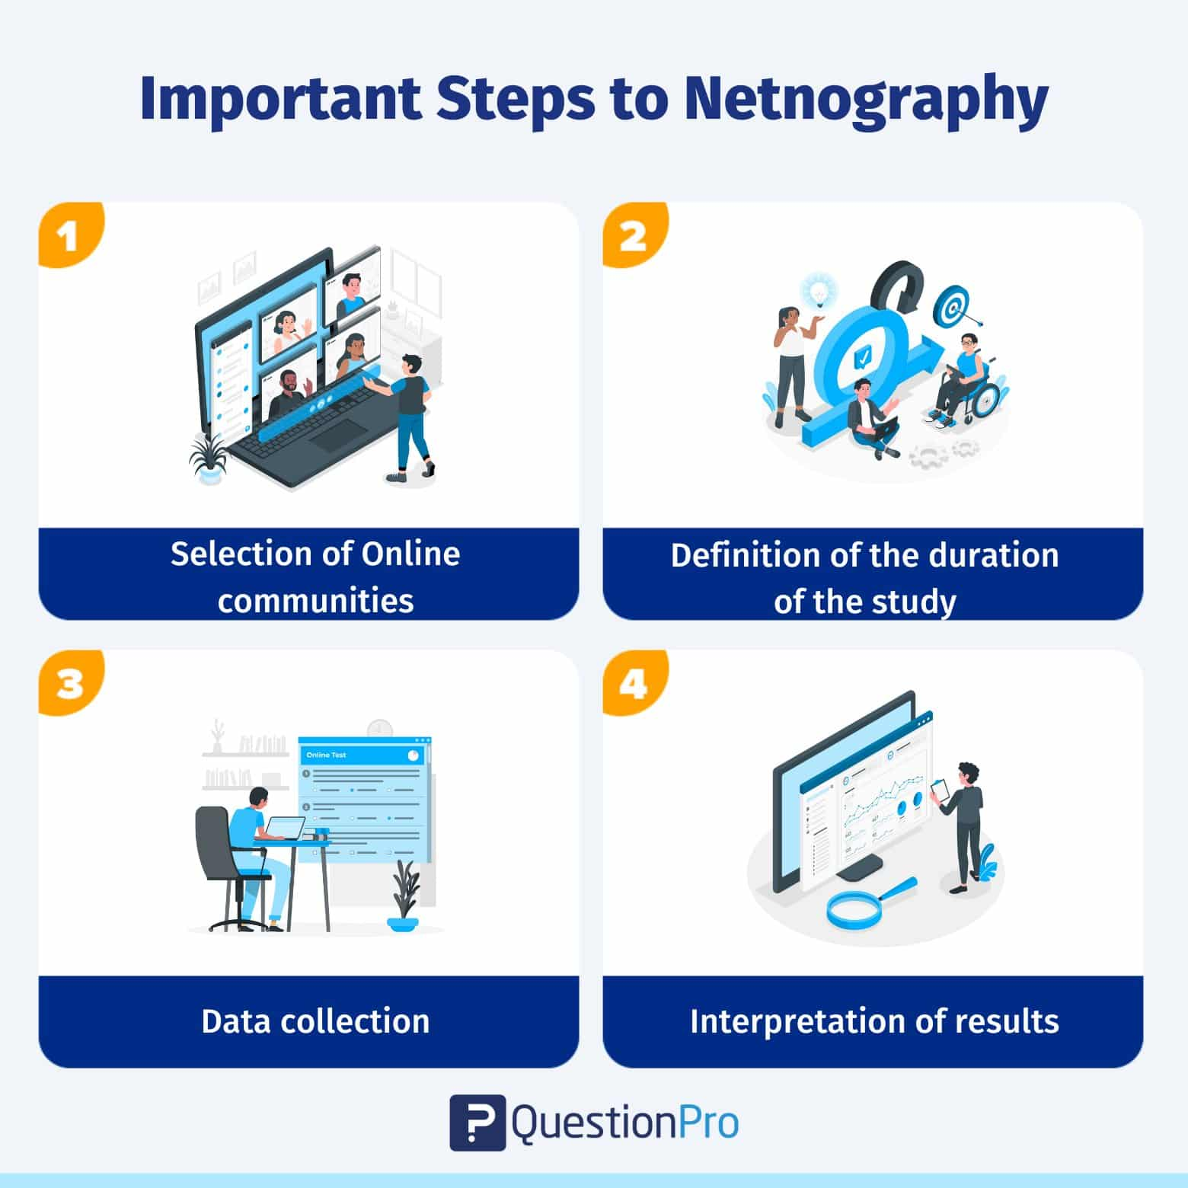
Source: https://www.questionpro.com/blog/netnography/

The individuals who have visited the mermaid explained in a recent survey they were amazed by the welcoming staff, the mermaids near location, as well as the delicious drink and snack selection. The most important thing for a client is how they feel after leaving a store whether it a car store, electronics store, or grocery store personally on the facility like. Most people always come to a store to look to see how the employee treats them and if they are willing to go out of their way to oust them happy to be seen always. Some people are so annoyed at how the store employees have treated them that they go home and write a filthy review, letting others know of the store they plan to not go to. The mechanical staff are the backbone of any given immediate outfit. Guest subjected to poor living conditions. Even though facilities may have varying standards, most experiences had a common quality - a negative one. Reliability, better responsiveness, and better view is key. Furthermore, the critiques for the resort show contrasting expectations, where the people who stayed there and believed it was worth the price gave few fair complaints, but those who had to wait for their food felt that it was not worth it. The occasional discomfort of customers exemplifies the issue they have because of the differences in houses.
The Banking Relationship found that The Mermaid Hotel held a formidable reputation for embassy living although complaints and worries surrounded the hotel's upkeep and cleanliness. Guest sentiment could be impacted based off of a more effective cleaning schedule. The discussion of this study additionally has value beyond the internal workings of this one office setting, particularly in the realm of course of the guest and the value he sees in staying there.

Chapter 1 Introduction

1.1 Background and Context
The worldwide hospitality industry relies on the satisfaction of its customers because service quality is a crucial criterion to entice customers return and create brand loyalty and competitive advantage.
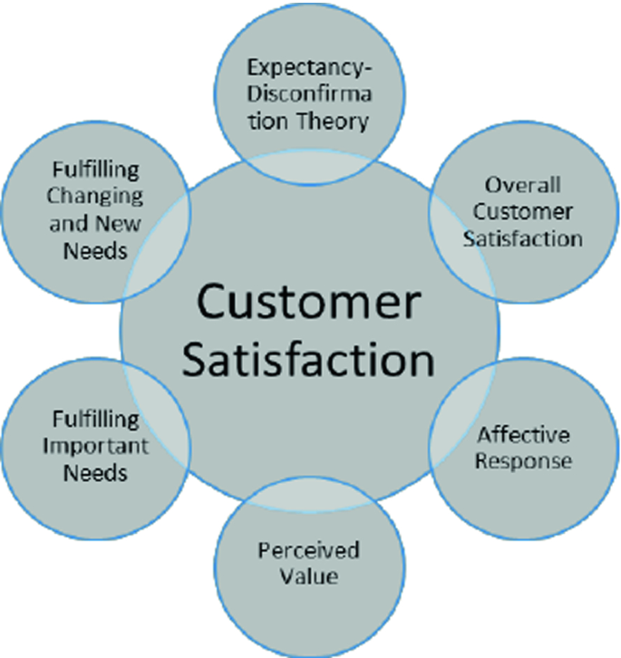
Source: https://link.springer.com/chapter/10.1007/978-3-030-01878-8_31

In an age where technological disruptions and advances have shifted the way guests document and verify their stays, and share experiences, consumer buying decisions are influenced heavily by online reviews. Social media sites are becoming a credible source of information for the establishment of hotels, and it is influencing the occupancy percentages and revenue for lodging (Ye, Law & Gu, 2009). For hotels in different competitive local markets, developing the significance of guest satisfaction, is not a matter of strategic choice but basically an issue of survival.
The Mermaid Hotel Ipswich is a Marston’s Inns star rated hotel which is an example of guest satisfaction. The hotel is in Suffolk. Marston's inns serve both leisure and business customers. In other words, Marston’s inns are lodging places that also sell food and drink. As a mid-market positioned brand in the UK hospitality environment, Marston’s Inns must offer price and service quality to appeal to a wide range of clients. The study offers findings for access examining how guests assess their experiences, and which features related to service feature most on guest satisfaction.

1.2 Rational for study
Guest satisfaction is widely accepted to be an important predictor of hotel performance. Research has demonstrated repeatedly the notion that satisfied guests are likely to engage in loyalty behaviours such as coming back for repeat stays and providing positive word of mouth recommendations (Kandampully & Suhartanto, 2000). Conversely, dissatisfaction often turned into negative comments that can hurt a hotel’s reputation and reduced future reservations or bookings. This is where netnography research can provide a unique perspective about guest experience from the emergence of guest-generated data in online spaces. Online reviews provide avenues for direct, immediate, and honest feedback that illustrate our customer journey in both positive and negative ways while traditional surveys and interviews will not reveal the spontaneous range feedback.
For The Mermaid Hotel, guest satisfaction analysis is relevant due to guests using digital platforms at increasing rates to book hotels. Therefore, insights from data analysed could inform management on service delivery, guest retention, and regional market competitiveness.

1.3 Research Aim and Objectives
The main goal of this research project focuses on a guest satisfaction assessment at The Mermaid Hotel Ipswich by way of an analysis of online reviews using a ethnographic approach. The specific objectives are the following:
- To uncover the primary themes that emerge from guest reviews of The Mermaid Hotel.
- To analyse patterns of both satisfaction and dissatisfaction by key service dimensions.
- To provide insights and actionable suggestions that can enhance guest satisfaction and hotel performance overall.
1.4 Structure of the Project
The documentation of this project is organized into five chapters. After this introductory chapter, in Chapter Two, I present a critical examination of the literature surrounding service quality, guest satisfaction, and the use of netnography in hospitality research. Chapter Three describes the methodological framework, focusing upon case study design and the netnographic method. Chapter Four documents the results, analysing the online reviews to extract emergent themes, followed by a critical discussion of these results and existing literature. Chapter Five concludes the report, summarizing the main takeaways and practical implications for The Mermaid Hotel Ipswich.

Chapter 2 Literature Review

2.1 Introduction
This literature review seeks to bring a critical analysis and synthesis of the available research on guest satisfaction, service quality, and netnography in the field of hospitality. This section will help put into context the theory, empirical findings, and methodological discussions near the analysis of the text of the reviews posted online for The Mermaid Hotel Ipswich. This review will also note any lack or imperfections in the research literature, demonstrating the significance of this project.

2.2 Service Quality in the Hospitality Industry
For a long time now, service quality has been considered as an important driver of customer satisfaction in the hotel industry. Designed by Parasuraman, Zeithaml and Berry (1988) the SERVQUAL measures service quality using five dimensions which are reliability, responsiveness, assurance, empathy, and tangibles. Hospitality researchers have extensively used it (Marković & Raspor, 2010), although it has been criticized due to the intangibility and heterogeneity of services hotels provide.
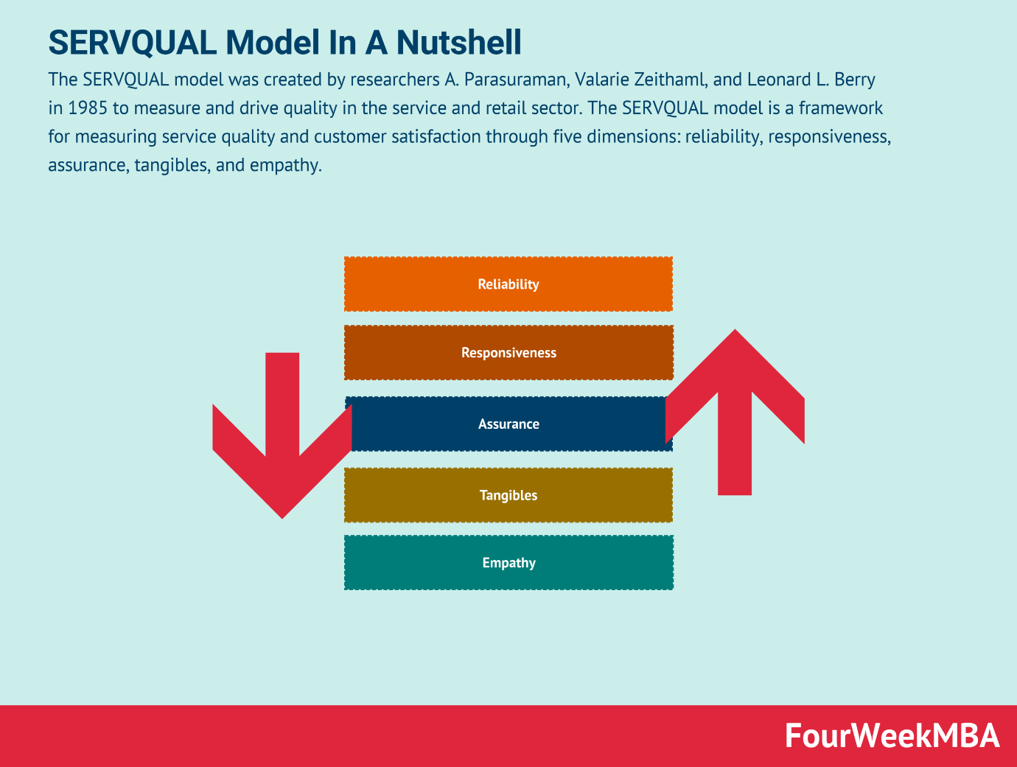
Source: https://fourweekmba.com/servqual-model/

In the hotel setting, service quality is not only functional service. Emotional and experiential brands can also be included (Chen, Chen & Lee, 2013). For instance, elements like the warmth of service staffs, the ambiance of the property, and perceived authenticity of the experience are gaining more importance in the guest ratings (Ali, Hussain & Ragavan, 2014). Physical facilities are still important, according to some scholars, but hospitality is a people-based service that in most cases will leads to guest perceptions rather than the physical components.
Some findings indicate that physical attributes of cleanliness and room condition are the most associated to satisfaction (e.g., Dolnicar & Otter, 2003) while there are researchers who find the relational attributes of staff empathy and responsiveness the strongest correlates of satisfaction (e.g., Wilkins, Merrilees & Herington, 2007). There is a wide range of studies done on the subject without unanimity in findings. According to this, service quality is not merely one-dimensional, but multi-dimensional depending on the guest expectations, hotel category and cultural background.

2.3 Guest Satisfaction and Loyalty
Guest satisfaction can also be measured with regards to a hotel inevitably meeting, or exceeding customer expectations (Oliver, 1997). In hospitality, guest satisfaction is not only an antecedent to service quality, but also a predictor of long-term loyalty behaviours, such as repeat visits and positive word-of-mouth (Kandampully & Suhartanto, 2000). For example, satisfied guests are more likely to post positive public online reviews, which influence brand image and future booking decisions (Torres, Fu & Lehto, 2014).
Nevertheless, the relationship between satisfaction and loyalty behaviours is not always straightforward. For instance, it has been pointed out that satisfaction does not guarantee loyalty, as there may be other variables such as competitive alternatives, price conscious, transactional convenience…and so on that may void the relationship between these two constructs (Han & Hyun, 2018). Additionally, in the case of online reviews, guests may indicate high satisfaction in certain dimensions (e.g., food quality) while indicate they were unlikely to return due to safety issues relative to other dimensions (e.g., dirtiness, noise…etc). This exemplifies the complexity of satisfaction and the fact that it cannot be considered as a single metric.
The expectation of customers in the UK mid-market hotel industry is upon value for money, cleanliness and a certain level of comfort, and luxury is not necessarily an issue (Callan & Bowman, 2000). Therefore, the customer evaluation of The Mermaid Hotel, through Marston’s Inns, appears to be based mostly upon function and how the relationship with the purchaser rather than the luxury of the features. Understanding the expectations listed here is vital for management in order to know how to rank improvement priorities.

2.4 Online Reviews and the Digital Impact on Guest Views
The growth of online review sites has changed how we understand customer satisfaction. As per Litvin, Goldsmith & Pan (2008), more than 80% of travellers read an online review before booking accommodation. Moreover, these reviews are more trusted than marketing communications. According to Ye, Law and Gu (2009), consumers are likely to make a hotel booking when there are positive reviews. Furthermore, negative reviews will lower consumer trust and cause unlikeliness to make a booking.
Online reviews can also be classified as electronic word of mouth (eWOM) and are considered to be more powerful than word of mouth due to the increased reach as well as durability (Sparks and Browning, 2011). To be specific, a single negative review can be quite damaging for those hotels who depend on the online reviews if it goes viral. Another aspect of the phenomenon is that review sites provide researchers with endless secondary data, which can help them understand guest perceptions better without having to deal with the scourge of survey response bias.
However, online reviews are not without their pitfalls. For instance, realistically, scholars often remind us that reviews can be affected by extreme events that are either far too good or far too bad.
As a result, reviews can reflect a somewhat biased reality (Anderson and Han, 2016). Fake or altered reviews continue to worry consumers despite protections. Despite the limitations mentioned, the researchers have suggested to triangulate the reviews online with other data sources (i.e. through direct observations or employee perspectives) for improved credibility

2.5 Netnography as a Research Method
Ethnography, originally introduced by Kozinets (1998; 2010), utilizes ethnographic research techniques to study online communities in order to research cultural and behavioural patterns in relation to digital media. In hospitality, it has emerged as a research technique to examine guest views offered in the form of guest reviews and discussions (Mkono & Markwell, 2014). The study of this, differs from ethnography in that the data are collected unobtrusively as guests enter their opinions into an online environment of their choosing without the presence of a researcher.
The strengths of ethnography include obtaining raw, naturally occurring data and cost effective compared to large-scale surveys (Xun & Reynolds, 2010). A fit for hospitality setting, as consumer experiences are offered publicly (discussed in detail). The descriptive anthropology has also been used in recent research to investigate sustainability in tourism (Benson, 2015) and perceptions of service quality in budget hotels (Lugosi, 2020).
Ethnography also experiences methodological critique. Concerns exist regarding the unethical approach of authors making use of online reviews shared without consent from reviewers (Langer & Beckman, 2005). Also, because relies heavily on the textual data, depth of information is not available compared to traditional interview methods. Some scholars suggest populational representation is limited with ethnography. Some guests leave feedback, or share their opinions, and may not be representative of everyone in the customer base (Jeacle & Carter, 2011).

2.6 Deficiencies and Contradictions in the Literature Gap and Contradictions in the Literature
While the literature demonstrates that service quality and satisfaction are at the core of hospitality, there have been a number of gaps. For starters, much of the literature is based on SERVQUAL but there are insufficient considerations made for the specificities of the mid-market hotel sector which requires a different level of expectations than that of luxury expectations (Wilkins et al., 2007). Second, whilst the relationship between satisfaction and loyalty is established our literature presupposes a linear relationship and does not engage in contradictory cases of satisfaction to see how it does not relate to repeat business (Han & Hyun, 2018).
From a methodological point of view, the literature is increasingly recognizing the promise of online reviews, however, there is little discourse on the systematic application of ethnography in small-scale hotel settings. This opens the door to more specific, context-specific research, like this one, which draws on ethnographical analysis of The Mermaid Hotel Ipswich. Moreover, existing studies tend to generalize results across areas while ignoring the fact that hotel markets across the UK have unique local dynamics. Our study fills those gaps by engaging a specific regional context, investigating guest satisfaction in a mid-market hotel using ethnographical data.

2.7 Conclusion
The evidence in the literature indicates that guest satisfaction is a multidimensional, complex construct, influenced by tangible and intangible service elements. Service quality models such as SERVQUAL provide good foundation but need historical and contextual framing. The link(s) between guest satisfaction and loyalty is it universally accepted with some of helpful factors moderating its strength, and considerations for guest heterogeneity. Online reviews have become a crucial factor in meaning making, and thus important research means with the emergence of ethnography to study online evaluations. but still raises questions related to data validity, representativeness, and ethical considerations.

Chapter 3 Methodology

3.1 Introduction
This chapter presents and critically reviews the methodology utilized to investigate guest satisfaction at The Mermaid Hotel Ipswich. The justification for using a case study design is outlined, before the introduction of netnography as the primary research method and data collection. The chapter muses on alternative methods that were excluded from the research, while considering the advantages and disadvantages of each method. Finally, ethical issues and practical limitations are debated throughout to be open and honest and maintain academic rigour.
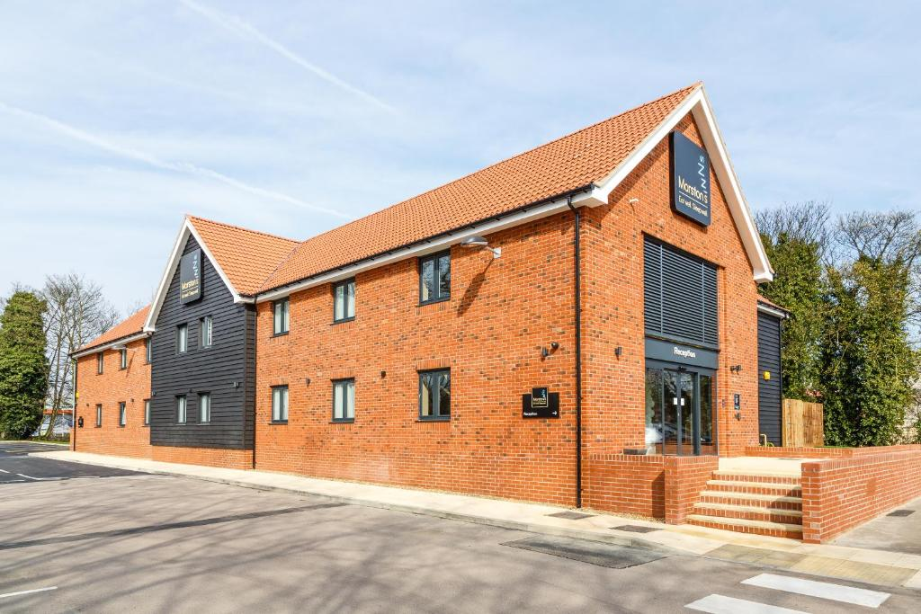
Source: booking.com/hotel/gb/the-mermaid.en-gb.html

3.2 Case Study Approach
The research employs a case study approach and uses The Mermaid Hotel Ipswich as a sole case (i.e., unit of analysis). Yin (2018) says that case studies are particularly well-suited for exploring current events in the real world where the boundaries of the event and its context are fuzzy. Guest satisfaction is just such an event because it is influenced by many tangible and intangible components like, staff behaviour, amenities, and expectations based on online experiences.
The advantage of a case study is it can provide depth and contextual specificity. By using case studies as opposed to a mass survey that sacrifices depth for breadth; the researcher can look for patterns and inconsistencies in detail (Simons, 2009). Case studies also have their criticisms. Critics have claimed that case studies have no generalizability and may reflect a bias in the researcher’s retelling (Gerring, 2017). This project uses case study data from a large set of online reviews, which enhances reliability and decreases subjectivity.

3.3 Netnography as the Method of Research
The principal research method is netnography, originally proposed by Kozinets (2010), which applied ethnographic methods to social interactions that occurred within digital communities. Ethnography has been used increasingly in hospitality research to study online reviews, social media, and travel blogs (Mkono & Markwell, 2014). In contrast with interviews or surveys, it captures guest feedback that occurs naturally and in the wild, thus providing access to potentially more spontaneous and candid feedback about satisfaction and dissatisfaction.
The method has several benefits. First, it is “real” data, as the reviewers are sharing their experiences of their own volition, and not being influenced by a researcher (Xun & Reynolds, 2010). The method is also cost effective and efficient, enabling replication of analysis of multiple commenters without the concerns of researcher presence in the field. Lastly, in the form of online reviews, longitudinal patterns can be observed over time and can reveal shifting consumer expectations.
However, this method has distinct disadvantages. First, review data is mostly produced by visitors that have the most extreme experiences (after all, what most people want to research, especially in hospitality and tourism, are the factors leading to customer dissatisfaction (Anderson & Han, 2016)). Second, there are concerns with representational issues: not every customer writes a review of a property, and if they do, it is not necessarily representative of the bulk of guests that stay at a property (Jeacle & Carter, 2011). And there are ethical questions to be answered by investigating and using publicly available data without informed consent (Langer & Beckman, 2005). Even though TripAdvisor publishes their posts for public consumption, the anonymity of the reviewer still needs to be honoured. The conduct of this project navigated this concern by ensuring that any personally identifiable information was removed from the data. Each review was treated as aggregates example, used not as an individual profile narratively in this study.

3.4 Data Collection and Analysis
Guest reviews were sourced from TripAdvisor, Booking.com and Expedia because these platforms are commonplace and aggregate a lot of data about the hotel. The reviews were sampled over the past three years to ensure they were of both newness and relevant depth of analysis. The final dataset was a balanced mix of positive, neutral and negative ratings.
Data were analysed using thematic coding, which is a qualitative analysis (Braun & Clarke, 2006). The themes (e.g., staff behaviour, cleanliness, food quality, and room comfort) were coded (i.e., noted down) by hand to look for these themes as they appeared. Coding was inspired by the SERVQUAL model (Parasuraman et al., 1988) but there was flexibility to allow for themes to appear.
Thematic coding was conducted manually rather than through software eased coding (e.g., NVivo) to deeper engage with the dataset and avoid potential researcher biases, although this can lead to researcher biases as well. Coding decisions were analysed by the researcher as an iterative process to find consistency across the themes.

3.5 Alternative Methods Considered
Even though netnography was selected, other methods were explored. Survey administration could have provided organized numerical data; however, they might have limited participant response rates, and potential social desirability issues. Semi-structured interviews with guests were considered, which would create rich qualitative data, which likely would not have made sense for this project based on placement and ethics protocols. Netnography offered a pragmatic balance, it created a significant amount of authentic data confined to the scope of this project.
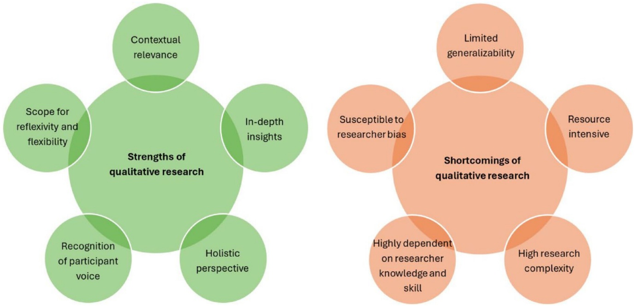
Source: https://journals.sagepub.com/doi/10.1177/14413582241264619

3.6 Ethical Issues
The issue with online reviews, as they are publicly available products, it is ethically responsible to treat it with care. Although reviewers did not consent for it to be used for research, participant traces, disclosed in the case study are anonymised, so identifiers were omitted. Participant traces provide aggregated findings to maintain anonymity. Moreover, the analysis follows the guidelines of the British Psychological Society (2017) to ensure transparency, confidentiality, and reduction of harm to a minimum.

3.7 Conclusion
In conclusion, this chapter has critically justified the case study approach, the netnographic method used to investigate guest satisfaction at The Mermaid Hotel Ipswich. The approach does have limitations, including a lack of generalisability and formal researcher biases. In the end, it is still a strong methodology for gaining real customer insights. Given the use of thematic analysis and treatment of ethical concerns, it has provided a strong basis for the findings and discussion that follows.

Chapter 4 Findings

4.1 Introduction
This chapter presents the research findings which analyzed guest satisfaction at The Mermaid Hotel Ipswich using a netnographic research approach. Reviews were sourced from TripAdvisor, Booking.com and Expedia over a three-year period to ensure a dataset that represented various guest perspectives. Through thematic coding, five main themes emerged that contributed to guest satisfaction: staff service, cleanliness, food and beverage, room comfort, and value for money. Furthermore, in instances where guests disagreed on the rating of the same service elements, contradictions were apparent. Each of the findings below will be presented within the thematic differentiation.

4.2 Staff Service and Hospitality
The most evident theme across evaluations for the guests was positive evaluations of service provided by people. Guests consistently characterized the staff as “friendly,” “helpful,” and “welcoming.” They commented that staff interactions distinguished services at this establishment and contributed to the entire experience positively. For instance, more than a few guests recognized the restaurant and bar service attentiveness to patrons and saliently cited personable staff as the most important asset.
This was similar to the hospitality literature that identifies that human contact is the center of the experience of guests.
Parasuraman et al. (1988) use the SERVQUAL model for service and included two of the categories called “empathy” and “responsiveness.” Numerous comments exhibit these traits in guest comments.
For several guests, positive staff experiences appeared to buffer negative experiences elsewhere, as guests identified staff in reviews, saying they would return to the establishment, even with problems with rooms or facilities during their stay, because of their good experience with the staff.
Most reviews had favourable experiences with the staff. A few guests expressed either indifferent or inattentive services when it was busy.
There may be inconsistency with service experiences which might challenge the establishment’s strong reputation of hospitality.

4.3 Cleanliness and Housekeeping
Cleanliness stood out as a key source of dissatisfaction. Many reviews shared their concerns regarding the cleanliness of bathrooms, carpets, and bedding. Words such as "unclean", "worn out", and "non-hygienic" were used often. For instance, some guests shared experiences of Mold in the bathroom or dust in the bedroom, which ruined the perception of quality.
Sanitation is a basic/essential expectation of hotels, and the lack of cleanliness disproportionally damages satisfaction levels (Dolnicar & Otter, 2003). While other aspects of service may be subjective, cleanliness is considered non-negotiable, and failures in cleanliness tends to elicit very strong negative responses.
It is worth mentioning, a very small number of guests commended the property for being clean and well-kept, which indicates that expectations of cleanliness may be variable based on room assignment or timing of stay. This inconsistency indicates the operational weaknesses in housekeeping practices and suggests a need for stronger quality control.

4.4 Food and Beverage Experience
Both food and beverage impacted guest satisfaction. Reviewers often described their meals as “delicious,” “presented nicely” and “great value for money.” Breakfast was called out as a highlight, with guests commenting on the variety and freshness of food.
It was a positive for those hotels that a pub-restaurant venue was part of the Marston’s Inns brand, with many guests reviewing and noting it added to their overall stay experience. Many positive guest reviews referenced the convenience of going downstairs to the restaurant to eat, particularly for business guests.
Despite positives, there were some common negative reviews. Some guests mentioned wait times being long, portion size or a lack of menu items. Some guests mentioned food quality being inconsistent, with meals rated as “fair”, “average” or “overcooked.” While the mixed reviews indicate food and beverage is typically a good toward guest satisfaction, these inconsistencies make food and beverage less able to stand as the hotel’s differentiating feature.

4.5 Rooms and Comfort
Room quality is one of the most evenly contentious topics. For example, some guests said they found the rooms “comfortable,” “spacious,” and loved the tea-making facilities, and comfortable bed. On the other hand, there was the same amount of complaints from guests about the rooms including rundown décor, no sound proofing, and maintenance issues, broken hardware, heater etc.
Comfort in the room was a deciding factor for many guests. The main issue was noise from adjoining rooms, the pub below, disrupted sleep. This is a huge negative with all mid-market property where guest expectations are to sleep comfortably, not be pampered.
The analysis shows it is likely some rooms exceed expectations, with others hardly come close, with even the minimum expectation. This shows the clear justification of an overall maintenance program and refurbishment plan to be instituted.

Source: https://www.booking.com/hotel/gb/the-mermaid.en-gb.html?activeTab=photosGallery

4.6 Facilities and Value for Money
Value for money was a recurring theme in the reviews. Guests often evaluated the standard of the rooms and facilities versus the amount paid, but opinions were opposite on this matter. While some praise the hotel for having “fair pricing” and “good value” for the location and dining facilities, for budget conscious travellers, the offer of lower pricing with additional on-site facilitation seemed reasonable.
On the other hand, dissatisfied guests were adamant that the rooms did maintain standards for the price, especially when issues of cleanliness and/or maintenance issues arose. For those guests, value was not based on price, but rather perceived “value” relative to expectation.
The literature reinforces the significance of value perceptions that are intimately connected to customer satisfaction and repeat-visit behaviour (Kandampully & Suhartanto, 2000). At The Mermaid Hotel, consistency across each service dimension seems to be paramount to sustaining value perceptions.

4.7 Contradictions in Guest Perceptions
One remarkable result from the analysis emerged when obvious contrasting interpretations were put for the same hotel attributes. A few guests commented "The room was clean and very comfy", while others were appalled with "the hygiene was appalling". In addition, employees were frequently complimented on their friendly demeanour, yet there were instances of "staff were inattentive" comments.
These contradictions speak to the relative nature of satisfaction, since it exists based on service delivery and in relation to each customer’s expectations and the context of service. As Oliver (1997) states "Satisfaction involves an evaluative judgment which is relative to personal thresholds and past experience"
The contradictory view also speaks to the broader discussion in hospitality literature about the heterogeneity of guest expectations. This also highlights the importance of management that reviews are evaluated consistently and matter-of-factly following each stay acknowledging satisfaction is it never achieved, but a process.

4.8 Conclusion of Fundings
The analysis of online reviews showed that guest satisfaction at The Mermaid Hotel Ipswich has many inter-related factors. Staff service was viewed as the hotel’s greatest strength, often filling in gaps to reputation in other areas. Food/beverage outlets received average ratings, but consistency is a recurrent theme. Cleanliness and room quality scored the lowest with a chronic narrative of complaints bringing overall value for money down.

Chapter 4b Discussion

4.1 Introduction
The aim of this chapter is to critically discuss the results reported in the previous chapter and link them back to the broader literature on guest satisfaction, service quality and netnographic research in hospitality. Through contrasting empirical results seen in The Mermaid Hotel Ipswich with theoretical and literature, this chapter discusses research implications, contradictions, and limitations. In turn, this chapter responds to the research aims directly and examines broader controversies in hospitality management.

4.2 Staff Service as a Driver for Satisfaction
The results showed that staff friendliness and attentiveness were the descriptors used most frequently to show appreciation for service dimensions. This finding confirms that aspect of service quality identified in Parasuraman et al.’s (1988) SERVQUAL model that calls for empathy and responsiveness. This also supports the logic of Tsaur and Lin (2004), who develop the argument that human resource practices and employee behaviour are a key to improving guest satisfaction in hotels.
Curiously, The Mermaid Hotel staff service frequently topped emotional overkill (for example, dated rooms or room maintenance). This suggests that guest perceptions are paramount and goes with the idea of Kandampully and Suhartanto (2000) that intangible dimensions of the service can dramatically affect quality perceptions and quality loyalty. However, varying reports of staff performance, combined with knowledge that the original reliance on one or a several staff members “fixing” the guest experience is an unending solution. Generally, management must provide consistent training and resourcing are able to provide guests a sufficient service comparable to a hotel that has sufficient workload or individual staff engagement.
This also raises a concern of emotional labour required of staff in the hospitality field. Hochschild (2012) indicates that service industry employees are required to exhibit emotions as part of their assigned and role. As guests like this, inconsistent variable motivation, as signified in staff delivery may inhibit or distress levels of emotional exhaustion, absenteeism or disruptions to service delivery, which is often neglected within guest perceptions of satisfaction.

4.3 Cleanliness and the Non-Negotiable Standards
Cleanliness was one of the primary categories of complaint, with much of the negative comments cast in passionate, almost spiritual terms, which supports Dolnicar and Otter’s (2003) conclusion that cleanliness acts as a minimum requirement for hotel guests. Unlike any other service-related element that guests are likely to tolerate, cleanliness failures cannot be dealt with; they directly influence guest expectations about safety and comfort.
In this respect, the results are consistent with Wilkins, Merrilees, and Herington (2007). They argue service quality is multidimensional but some dimensions, hygiene for example, are “dissatisfiers,” and their failure produces a disproportionate amount of negative discontent. This also ties to Herzberg’s two-factor theory (Herzberg, Mausner & Snyderman, 1959) that identifies hygiene factors (minimum requirements) and motivators (things that delight customers) and with poor cleanliness it does not just lower satisfaction but creates dissatisfaction.
The degeneration of cleanliness and hygiene standards at The Mermaid Hotel compounds serious operational issues. While staff service can compensate for failings in other elements, cleanliness thoroughly erodes confidence in the hotel and should not be compensated. It indicates a management focus should be around an ongoing refinement of cleaning protocols, staff training, and quality assurance mechanism.

4.4 Food and Beverage. Partial Strength with Risks
Food and beverage are seen positively, with the majority of guests highlighting the quality and convenience. This demonstrates how valued restaurants and bars are for improving the hotel visitor experience, which is even more important in mid-market hotels were having food and beverage on-site becomes an important distinguishing characteristic (Callan & Bowman, 2000). Positive references to breakfast and pub food align with the concept of “experiential value” based on the idea that guests can experience increased social interactions, then engage in services that yield a meaningful experience (Ali, Hussain & Ragavan, 2014).
Inconsistent portion size for breakfast, waiting times, and quality reflect a larger issue of variability in service delivery. These inconsistencies support Torres, Fu and Lehto’s (2014) finding that satisfaction is determined not only by absolute quality but also performance of the quality. For The Mermaid Hotel, variability creates challenges with food and beverage being a potential unique selling point.
Depending on food and beverage as a strength introduces strategic risks. If the quality of food and beverage goes up and down or becomes homogenised like the Marston’s Inns portfolio, this hotel will not be able to maintain competitive advantage. Therefore, management needs to find ways to create consistency, while also being innovative with menu design and customer service.

4.5 Room Comfort, and the Importance of Tangibles
Room comfort was consistently one of the more polarising areas of guest feedback. While reviews tended to compliment overall the rooms in terms of size and amenities, negative reviews speed concerns about dated aesthetics, maintenance errors, and noise. This gap captures the contrast between tactile and intangible aspects of service.
Drawing on the SERVQUAL model, tangibles are the most noticeable cusp of service quality and noted NICE increase in mid-tier hotels in which guests are not anticipating luxury accommodations but want basic comfort that is guaranteed (Marković & Raspor, 2010). These findings regarding The Mermaid Hotel confirm with negative perceptions around things like noise and cleanliness being culled relative to much more interactive service staff.
It bears mentioning that according to Oliver (1997) expectancy-disconfirmation theory suggests that satisfaction derives from the variance of expectations and performance. Types of guests in which expectations are mid-market around room comfort; it means expectations are moderate but not negotiable. Each guest could expect rooms to be 1) clean, 2) functional by non-conventional standards, and 3) quiet. If there is a variance within the expectations provided it is amplified in outsizing guest disappointment in experiences, much more so because guests usually communicated some element of positive service.
This consideration raises an important dialogue for potential investments. Staff service is an added value, but degrading to satisfaction is the guestroom tangible as a core aspect of the overall happiness and experience. In essences, the hotel risks (Berry, Parasuraman and Zeithaml, 1994) “service paradox”; strong staff serves and succeeds but compensates temporarily and remits a more fundamental core structural issue.

4.6 Perceived Value for Money and Fairness Perceptions
Value for money came up regularly within reviews, and opinions varied based on how positive or negative a guest’s overall experiences were. This relates to wider literature on price–quality perceptions, which states that value decisions are not only based on financial value, but also a personal expectation or emotional level (Zeithaml, 1988).

Source: https://www.blueoceanacademy.com/

Guests that perceived the hotel as fair value believe so due to staff friendliness or dining value quality, whereas others believed that sub-par rooms or cleanliness detracted the value. This supports Han and Hyun’s (2018) assertion that customer loyalty is not only based on satisfaction but also influenced by fairness and alternative expectation perceptions. It is this insight that may be valuable to the hotel which is stimulated in a competitive region when consumer alternatives in the mid-market segment exist, even small discrepancies can cause a re-evaluation of guest loyalty.

4.7 Satisfaction: Contradictions and Subjective Evaluation
One of the most notable findings included contradictory evaluations across the same service factors. For example, some guests evaluated cleanliness high while some guests evaluated it low with not an overwhelming poor rating at that. This is consistent with Oliver’s (1997) findings that satisfaction is subjective and dependent upon an individual’s expectations, previous experiences, and environmental conditions.
The contradictory evaluations also expose a gap in the literature, to a great degree, to highlight that the definitions of satisfaction are static. Mkono and Tribe (2017) indicate that multiple developing guest voices emerge from each online review, and those differences serve as a reminder to researchers and operations managers intriguingly alike that hospitality encounters are co-created between service providers and consumers. For The Mermaid Hotel, management is focused on a single ‘guest interpretation’ and must instead recognize heterogeneity and differences in evaluations.

4.8 Reflections on Methodology: The Practice of Netnography
The findings also demonstrate the advantages and disadvantages of netnography. On the one hand, netnography takes the souring of cyberspaces and shows it as a pattern derived from unobtrusive and unprompted data. This corroborates the taking of netnography which Kozinets (2010) believes obtains authentic cultural expressions in web-based contact and settings. Contradictory reviews, however, also raise the issue of representativeness, as it is probable that not all guests post reviews and that not all guests who post reviews are necessarily neutral.
Such risk harkens back to Anderson and Han (2016) who warned that data collected online could bias the study and the sample by over-representing dissatisfied, or very satisfied customers. However, triangulating that analysis with observations of the placement reduced bias and enhanced the credibility of the findings.

4.9 Wider Implications for Hospitality Research and Practice.
Apart from the mermaid hotel, this study adds to wider discussions about guest satisfaction in mid-market hotels. Literature on hospitality most often addresses luxury contexts and there is scant knowledge of regional, budget, and mid-market properties (Wilkins et al., 2007). This study demonstrates that functional basics such as cleanliness and comfort help in developing satisfaction, but more work is needed to explore a value-based hotel segment.
The findings for practitioners suggest that customer loyalty in mid-market hotels depends on fundamentals and not luxury edibles. Staff service does enhance your experience and food service may give you a lovely bite, but they hardly sustain things if the standard of all the essentials fails. There would be strategic resource implications in this case Marston’s Inns and brand priority.

4.10 Conclusion.
Overall, the analysis shows guest satisfaction experiences at The Mermaid Hotel, Ipswich were complicated, formed through service attributes. Staff service was strong in service, but varied, and staff may have been experiencing emotional labour overload. Cleanliness and comfort of room were weak in service, where service failures had disproportionate detrimental effect on satisfaction. Food and beverage service had consistent strengths, even if variable, inconsistency was more harmful than the total experience. Value for money matched ultimate combination of positive and negative experiences.
Findings confirmed, and disconfirmed existing models (SERVICE, SERVQUAL, expectancy-disconfirmation). Findings provided insights of subjectivity and heterogeneity of satisfaction, and the oversights of depending on merely online reviews.

Chapter 5 Conclusion and Recommendation

5.1 Introduction
This chapter provides closure to the research. It synthesises the central findings, considers its significance for theory and practice, and provides a set of recommendations to enhance guest satisfaction at The Mermaid Hotel Ipswich. The first section presents conclusions addressing the study’s aim and objectives, reviews the contributions of the research to literature, and discusses the limitations faced. The latter part of the chapter focuses on practical recommendations for the hotel and parent brand, Marston’s Inns, based on findings and an analytical review of hospitality studies.

5.2 Conclusion

5.2.1 Reviewing the research aim and objectives.
The research aimed to explore guest satisfaction at The Mermaid Hotel Ipswich through a netnographic study of online reviews to determine the hotel’s strongest and weakest areas of service while suggesting an actionable plan for improvement. The objectives were to:
- Identify major themes in guest reviews.
- Identify trends in satisfaction and dissatisfaction.
- Provide an actionable plan to improve guest experience.
The objectives were met. The analysis provided clear trends in guests’ evaluations, indicating staff service was the principal strength, cleanliness and quality of room as marked weaknesses and food and beverage service as varied but positive. A value for money emerged as a cross-cutting theme, highly dependent on consistency of service delivery.

5.2.2 Theoretical Contributions
This study contributes to the field of the literature on guest satisfaction in several important ways.
First, the findings provide additional support for our earlier work (Parasuraman et al, 1988) by confirming that, yes, responsiveness and empathy (staff service) are essential dimensions of quality; however, this research was useful in qualifying SERVQUAL’s limitations in addressing the unique issues of mid-market hotels in the UK. Although tangibles are part of the model, the model diminishes the capacity of serious deficiencies (e.g., basic cleanliness) take complete control of guest perceptions and function as “the hygiene factors” (Herzberg et al, 1959).
Second, the results also reaffirm Oliver’s (31997) expectancy-disconfirmation theory since guest dissatisfaction occurred regardless of if another dimension (other than basic comfort such as quiet rooms, clean room, etc.) was established. The theory explains the asymmetry of satisfaction, in that establishing guest expectations will not necessarily delight guests, however the absence of meeting guest expectations does create dissatisfaction.
Third, the study illustrates that netnography is valued for hospitality research. By investigating, netnography accessed raw, honest accounts; therefore, the contradictions; and often paradoxical claims within the online reviews are not possibilities in standard survey methods. This supports Kozinets (2010) and Mkono & Markwell (2014) and the assertion that netnography allows for researchers to understand culture and behaviours in online spaces. Simultaneously, the contradictions within guest reviews represent the limitations of this method, particularly representativeness.

5.2.3 Practical Implications
The study helps to draw implications for hotel management practice. Staff performance was very good. This indicates the management of training and motivation and emotional labour are essential. Cleanliness (Housekeeping) and functionality (Room Maintenance) appear to be ongoing challenges which suggest that operational standards are not reliable, requiring a systematic approach to improvement. Guest perceptions show contradictions. It means tracking complaints constantly will let us know if there are any patterns that can become an issue later.
The study of Han and Hyun is consistent with the greater literature that guest satisfaction is multidimensional and ever changing. Hotels can’t have related a high score in one area of strength; staff service is due to sustained failures in other areas. To keep value perceptions low and retain guests, it is essential that all service dimensions are consistently delivered.

5.2.4 Limitations of the Study.
While making important contributions, it is helpful to know what the research cannot do. Firstly, the research constitutes a single case study, which means the findings are contextually bounded and may not be generalisable across the mid-market hotel context. However, as Flyvbjerg (2006) notes, case studies provide analytical not statistical generalisability so they may give us translatable not absolute insights.
The research may exhibit bias because of the use of online reviews. According to Anderson and Han (2016), the message presented in online reviews, bloggers, etc. may be characterized as outlier situations instead of the hive view; this point is particular correct. Keeps the dataset balanced, but there is bias to say the engineering data could have the same view.
Since thematic coding involved input from researcher, there is potential for subjectivity. I have not seen peer researchers identifying thematic discussion unlike how I have coded; though, I did complete these iterations just to maintain integrity of study, I say it could be code differently. Lastly, guest interviews and staff perspectives, for example, would have validated the research findings, had there been time and resources.

5.2.5 Conclusions Overview
In conclusion, this study affirms that guest experiences at the Mermaid Hotel Ipswich are influenced by staff service, cleanliness, room quality, food and beverage, and value for money perceptions. While the hotel enjoys good interpersonal service and a generally attractive food and beverage offering, the cleanliness and maintenance issues represent major risks to reputation and guest loyalty. The research adds to theory by validating and elaborating established satisfaction models and shows the merits and challenges of using netnography in hospitality research.

5.3 Tips and Actionable Plans
From the results and literature review of the study, we present the following recommendations to improve guest satisfaction at The Mermaid Hotel Ipswich. These strategies primarily focus on remedies for weaknesses while remaining within the hotel’s strengths and ensuring the changes are pragmatic and sustainable.

5.3.1 Improve Cleanliness
The most immediate need is to address housekeeping issues. The hotel could:
- Conduct ongoing audits of rooms and public areas using checklist forms compared to the industry benchmarks (e.g. BHA guidelines).
- Engage staff in refresher training regarding hygiene issues and processes.
- Employ a form of accountability (e.g., supervisor spot-checks).
Research by Dolnicar and Otter (2003) demonstrates that cleanliness failures disproportionately drive dissatisfaction. Addressing this issue directly would therefore yield the greatest impact on guest perceptions.

5.3.2 Systematic Maintenance and Refurbishment
The complaints of dated décor and broken components indicate that the current approach to maintenance is reactive as opposed to proactive. Management should:
- Establish a preventive maintenance plan aimed at proactively tackling areas of concern before they reach the guest level.
- Focus refurbishment plans on areas receiving the most complaints, for example, the bathrooms and carpets.
- Highlight these refurbishment efforts through various online outlets to demonstrate a responsiveness to the guest feedback.
According to Torres, Fu and Lehto (2014), outlining these plans for the guests adds to guests’ trust and coincide escapable negative judgment.

5.3.3 Consistency in Food and Beverage Delivery
While food and beverage evaluations were largely positive overall, we did see consistency be a blemish on our evaluations. Improvements could be made if the hotel were to:
- Standardize portion amounts and quality control.
- Train staff on customer service during busy periods.
- Utilize guest feedback to adapt menus and keep up with dietary trends, etc.
Reliability in food quality is a crucial item to maintain for achieving this as a competitive advantage, given the reliance of Marston’s Inns on the pub-restaurant model.

5.3.4 Digital Feedback Monitoring
Given the inconsistency in perceptions of guests, managers could employ a digital feedback monitoring program, which would:
- Aggregate reviews from review sites on an instant basis
- Analyse whether the feedback was positive or negative, while identifying trends
- Allow managers respond quickly as appropriate, which holds accountability.

5.4 Final Reflection
This project has provided insights both to The Mermaid Hotel and advanced my academic and professional skills. Through working on a netnography, I came to appreciate the importance of critically evaluating digital data and resulting practices. The process of synthesising literature and then applying it to a real-world context strengthened my capacity to think analytically, weigh evidence, and formulate solutions. All of these are transferable skills that will positively impact my future management role, in hospitality.

5.5 Conclusion
To conclude, this study shows, The Mermaid Hotel Ipswich has some of the strongest staff service, with an overall positive experience dining experience, but its credibility and competitiveness are hindered by staff cleanliness and overall room quality. When taking systematic measures to improve upon those factors, combined with proactive measures, it can lead to higher levels of guest satisfaction and loyalty along with a solidified position in the regional marketplace. More generally, the application of netnography to a mid-level market case adds to hospitality and tourism literature by demonstrating the complexity and subjectivity under which guest satisfaction operates.

6 References
Reference List
Core Hospitality Service Quality and Satisfaction
Ali, F., Hussain, K. and Ragavan, N.A., 2014. Memorable customer experience: Examining the effects of customers’ experience on memories and loyalty in Malaysian resort hotels. International Journal of Hospitality Management, 45, pp.145-154.
Callan, R.J. and Bowman, L., 2000. Selecting a hotel and determining salient quality attributes: A preliminary study of mature British travellers. International Journal of Tourism Research, 2(2), pp.97-118.
Chen, C.F., Chen, S.C. and Lee, H.T., 2013. Interrelationships between physical environment quality, personal interaction quality, and behavioural intentions in relation to hotel spas. International Journal of Hospitality Management, 33, pp.53-65.
Dolnicar, S. and Otter, T., 2003. Which hotel attributes matter? A review of previous and a framework for future research. Asia Pacific Journal of Tourism Research, 8(4), pp.48-63.
Han, H. and Hyun, S.S., 2018. Impact of hotel-restaurant image and quality of physical-environment, service, and food on satisfaction and intention. International Journal of Hospitality Management, 63, pp.82-92.
Kandampully, J. and Suhartanto, D., 2000. Customer loyalty in the hotel industry: The role of customer satisfaction and image. International Journal of Contemporary Hospitality Management, 12(6), pp.346-351.
Marković, S. and Raspor, S., 2010. Measuring perceived service quality using SERVQUAL: a case study of the Croatian hotel industry. Management, 5(3), pp.195-209.
Tsaur, S.H. and Lin, Y.C., 2004. Promoting service quality in tourist hotels: the role of HRM practices and service behavior. Tourism Management, 25(4), pp.471-481.
Torres, E.N., Fu, X. and Lehto, X., 2014. Examining key drivers of customer delight in a hotel experience: A cross-cultural perspective. International Journal of Hospitality Management, 36, pp.255-262.
Wilkins, H., Merrilees, B. and Herington, C., 2007. Towards an understanding of total service quality in hotels. International Journal of Hospitality Management, 26(4), pp.840-853.
Kim, H.J., McGinley, S., Choi, H.M. and Agmapisarn, C., 2017. Hotels’ environmental leadership and employees’ organizational citizenship behavior. International Journal of Hospitality Management, 63, pp.59-68.
Luo, W., Song, H. and Ye, B.H., 2020. How does corporate social responsibility influence hotel employees’ service quality? International Journal of Contemporary Hospitality Management, 32(3), pp.1205-1224.
Radojevic, T., Stanisic, N. and Stanic, N., 2015. Inside the rating scores: A multilevel analysis of the factors influencing customer satisfaction in the hotel industry. Cornell Hospitality Quarterly, 56(4), pp.398-410.
Prayag, G. and Ryan, C., 2012. Antecedents of tourists’ loyalty to Mauritius. Journal of Travel Research, 51(3), pp.342-356.
Wang, Y., Luo, H. and Tai, P., 2018. Corporate image and customer satisfaction: Evidence from the Chinese hospitality industry. Asia Pacific Journal of Tourism Research, 23(2), pp.129-141.

Online Reviews, eWOM, and Reputation
Anderson, C.K. and Han, S., 2016. Hotel performance impact of socially engaged customers. Cornell Hospitality Quarterly, 57(3), pp.282-292.
Filieri, R., Alguezaui, S. and McLeay, F., 2015. Why do travelers trust TripAdvisor? Antecedents of trust towards consumer-generated media. Tourism Management, 51, pp.174-185.
Litvin, S.W., Goldsmith, R.E. and Pan, B., 2008. Electronic word-of-mouth in hospitality and tourism management. Tourism Management, 29(3), pp.458-468.
Sparks, B.A. and Browning, V., 2011. The impact of online reviews on hotel booking intentions and perception of trust. Tourism Management, 32(6), pp.1310-1323.
Xiang, Z. and Gretzel, U., 2010. Role of social media in online travel information search. Tourism Management, 31(2), pp.179-188.
Ye, Q., Law, R. and Gu, B., 2009. The impact of online user reviews on hotel room sales. International Journal of Hospitality Management, 28(1), pp.180-182.
Jeacle, I. and Carter, C., 2011. In TripAdvisor we trust: Rankings, calculative regimes and abstract systems. Accounting, Organizations and Society, 36(4-5), pp.293-309.
Mauri, A.G. and Minazzi, R., 2013. Web reviews influence on expectations and purchasing intentions of hotel potential customers. International Journal of Hospitality Management, 34, pp.99-107.
Banerjee, S. and Chua, A.Y., 2016. In search of patterns among travelers’ hotel ratings in TripAdvisor. Tourism Management, 53, pp.125-131.
Luo, Q. and Zhong, D., 2015. Using social network analysis to explain communication characteristics of travel-related electronic word-of-mouth on social networking sites. Tourism Management, 46, pp.274-282.
Cheng, Y., 2016. Sharing economy: A review and agenda for future research. International Journal of Hospitality Management, 57, pp.60-70.
Zhang, Z., Ye, Q. and Law, R., 2011. Determinants of hotel room price: An exploration of travelers’ hierarchy of accommodation choice. International Journal of Hospitality Management, 30(2), pp.389-398.
Xu, X. and Li, Y., 2016. The antecedents of customer satisfaction and dissatisfaction in online purchasing. Journal of Information Technology & Tourism, 16(1), pp.1-19.
29. Chen, Y. and Xie, J., 2008. Online consumer review: Word-of-mouth as a new element of marketing communication mix. Management Science, 54(3), pp.477-491.
30. Filieri, R. and McLeay, F., 2014. E-WOM and accommodation: An analysis of the factors that influence travelers’ adoption of information from online reviews. Journal of Travel Research, 53(1), pp.44-57.

Netnography and Qualitative Research Methods
Kozinets, R.V., 2010. Netnography: Doing Ethnographic Research Online. London: Sage.
Kozinets, R.V., 1998. On netnography: Initial reflections on consumer research investigations of cyberculture. Advances in Consumer Research, 25(1), pp.366-371.
Mkono, M. and Markwell, K., 2014. The application of netnography in tourism studies. Annals of Tourism Research, 48, pp.289-291.
Mkono, M. and Tribe, J., 2017. Beyond reviewing: Uncovering the multiple roles of tourism social media users. Journal of Travel Research, 56(3), pp.287-298.
Lugosi, P., 2020. Netnography in hospitality and tourism studies. In: Nunkoo, R. (ed.) Handbook of Research Methods for Tourism and Hospitality Management. Cheltenham: Edward Elgar, pp.149-161.
Xun, J. and Reynolds, J., 2010. Applying netnography to market research: The case of the online forum. Journal of Targeting, Measurement and Analysis for Marketing, 18(1), pp.17
Langer, R. and Beckman, S.C., 2005. Sensitive research topics: Netnography revisited. Qualitative Market Research, 8(2), pp.189-203.
Braun, V. and Clarke, V., 2006. Using thematic analysis in psychology. Qualitative Research in Psychology, 3(2), pp.77-101.
39. Saunders, M., Lewis, P. and Thornhill, A., 2019. Research Methods for Business Students. 8th ed. Harlow: Pearson.
40. Creswell, J.W., 2014. Research Design: Qualitative, Quantitative, and Mixed Methods Approaches. 4th ed. Thousand Oaks, CA: Sage.
41. Yin, R.K., 2018. Case Study Research and Applications: Design and Methods. 6th ed. Thousand Oaks, CA: Sage.
42. Simons, H., 2009. Case Study Research in Practice. London: Sage.
43. Gerring, J., 2017. Case Study Research: Principles and Practices. 2nd ed. Cambridge: Cambridge University Press.
44. British Psychological Society, 2017. Ethics guidelines for internet-mediated research. Leicester: BPS.
45. Flick, U., 2018. An Introduction to Qualitative Research. 6th ed. London: Sage.

Consumer Behaviour, Loyalty, and Service Theories
Oliver, R.L., 1997. Satisfaction: A Behavioural Perspective on the Consumer. New York: McGraw-Hill.
Herzberg, F., Mausner, B. and Snyderman, B.B., 1959. The Motivation to Work. 2nd ed. New York: Wiley.
Zeithaml, V.A., 1988. Consumer perceptions of price, quality, and value: A means-end model and synthesis of evidence. Journal of Marketing, 52(3), pp.2-22.
Berry, L.L., Parasuraman, A. and Zeithaml, V.A., 1994. Improving service quality in America: Lessons learned. Academy of Management Executive, 8(2), pp.32-45.
Parasuraman, A., Zeithaml, V.A. and Berry, L.L., 1988. SERVQUAL: A multiple-item scale for measuring consumer perceptions of service quality. Journal of Retailing, 64(1), pp.12-40.
Kandampully, J., Zhang, T. and Bilgihan, A., 2015. Customer loyalty: A review and future directions with a special focus on the hospitality industry. International Journal of Contemporary Hospitality Management, 27(3), pp.379-414.
Han, H. and Ryu, K., 2009. The roles of the physical environment, price perception, and customer satisfaction in determining customer loyalty in the restaurant industry. Journal of Hospitality & Tourism Research, 33(4), pp.487-510.
Oh, H., 1999. Service quality, customer satisfaction, and customer value: A holistic perspective. International Journal of Hospitality Management, 18(1), pp.67-82.
Rahman, M.K., 2012. Service quality, corporate image and customer’s satisfaction towards customers perception: An exploratory study on telecom customers in Bangladesh. Business Studies Journal, 4(1), pp.47-57.
Homburg, C., Koschate, N. and Hoyer, W.D., 2005. Do satisfied customers really pay more? A study of the relationship between customer satisfaction and willingness to pay. Journal of Marketing, 69(2), pp.84-96.
Mattila, A.S., 2006. How affective commitment boosts guest loyalty (and promotes frequent-guest programs). Cornell Hotel and Restaurant Administration Quarterly, 47(2), pp.174-181.
Fornell, C., Johnson, M.D., Anderson, E.W., Cha, J. and Bryant, B.E., 1996. The American customer satisfaction index: Nature, purpose, and findings. Journal of Marketing, 60(4), pp.7-18.
Bowen, J.T. and Chen, S.L., 2001. The relationship between customer loyalty and customer satisfaction. International Journal of Contemporary Hospitality Management, 13(5), pp.213-217.
Grönroos, C., 1984. A service quality model and its marketing implications. European Journal of Marketing, 18(4), pp.36-44.
Bolton, R.N. and Drew, J.H., 1991. A multistage model of customers’ assessments of service quality and value. Journal of Consumer Research, 17(4), pp.375-384.

Recent Studies and Sector-Specific Insights
So, K.K.F., King, C., Sparks, B.A. and Wang, Y., 2016. The role of customer engagement in building consumer loyalty to tourism brands. Journal of Travel Research, 55(1), pp.64-78.
Sigala, M., 2018. Social media and customer engagement in the hotel industry. International Journal of Hospitality Management, 77, pp.172-181.
Leung, D., Law, R., Hoof, H.V. and Buhalis, D., 2013. Social media in tourism and hospitality: A literature review. Journal of Travel & Tourism Marketing, 30(1-2), pp.3-22.
Buhalis, D. and Law, R., 2008. Progress in information technology and tourism management: 20 years on and 10 years after the Internet. Tourism Management, 29(4), pp.609-623.
Chen, H., 2019. The influence of service quality and price on customer satisfaction in budget hotels in China. Asia Pacific Journal of Tourism Research, 24(5), pp.446-459.
Bilgihan, A., 2016. Gen Y customer loyalty in online shopping: An integrated model of trust, user experience and branding. Computers in Human Behavior, 61, pp.103-113.
Ali, F., Amin, M. and Cobanoglu, C., 2016. An integrated model of service experience, emotions, satisfaction, and price acceptance: An empirical analysis in the Chinese hospitality industry. Journal of Hospitality Marketing & Management, 25(4), pp.449-475.
Harrington, R.J., Ottenbacher, M.C. and Fauser, S., 2017. QSR brand value: Marketing mix dimensions and consumer value perceptions. International Journal of Hospitality Management, 63, pp.87-94.
Line, N.D. and Runyan, R.C., 2012. Hospitality marketing research: Recent trends and future directions. International Journal of Hospitality Management, 31(2), pp.477-488.
Barros, C.P., Botti, L., Peypoch, N., Robinot, E., Solonandrasana, B. and Assaf, A.G., 2011. Performance of French destinations: Tourism attraction perspectives. Tourism Management, 32(1), pp.141-146.
Law, R., Buhalis, D. and Cobanoglu, C., 2014. Progress on information and communication technologies in hospitality and tourism. International Journal of Contemporary Hospitality Management, 26(5), pp.727-750.
Holjevac, I.A., 2003. A vision of tourism and the hotel industry in the 21st century. International Journal of Hospitality Management, 22(2), pp.129-134.
Pizam, A. and Ellis, T., 1999. Customer satisfaction and its measurement in hospitality enterprises. International Journal of Contemporary Hospitality Management, 11(7), pp.326-339.
Barsky, J. and Nash, L., 2002. Evoking emotion: Affective keys to hotel loyalty. Cornell Hotel and Restaurant Administration Quarterly, 43(1), pp.39-46.
Kandampully, J., Bilgihan, A., Zhang, T.C. and Bilgihan, A., 2016. Developing a people-technology hybrids model for customer experience management. International Journal of Hospitality Management, 56, pp.13-24.

