Effective Team Working and Communication (BMSW4002_LON)

Lecturer – Ejiro Esohwode

Team working operations and Effective team working consultation services for a business or organization

Group Presentation
By

Alessio Manigrasso – 2019791- Benefits of team working

Tsonyo Todorov – 2021609 - Stages of team development

Abdul Nawade Razak – 2020986 - Team roles

Corina Mihaela Balan – 2018568 - Managing conflict

Mateo Cavaliere – 2018575 - Successful team development

Slide 1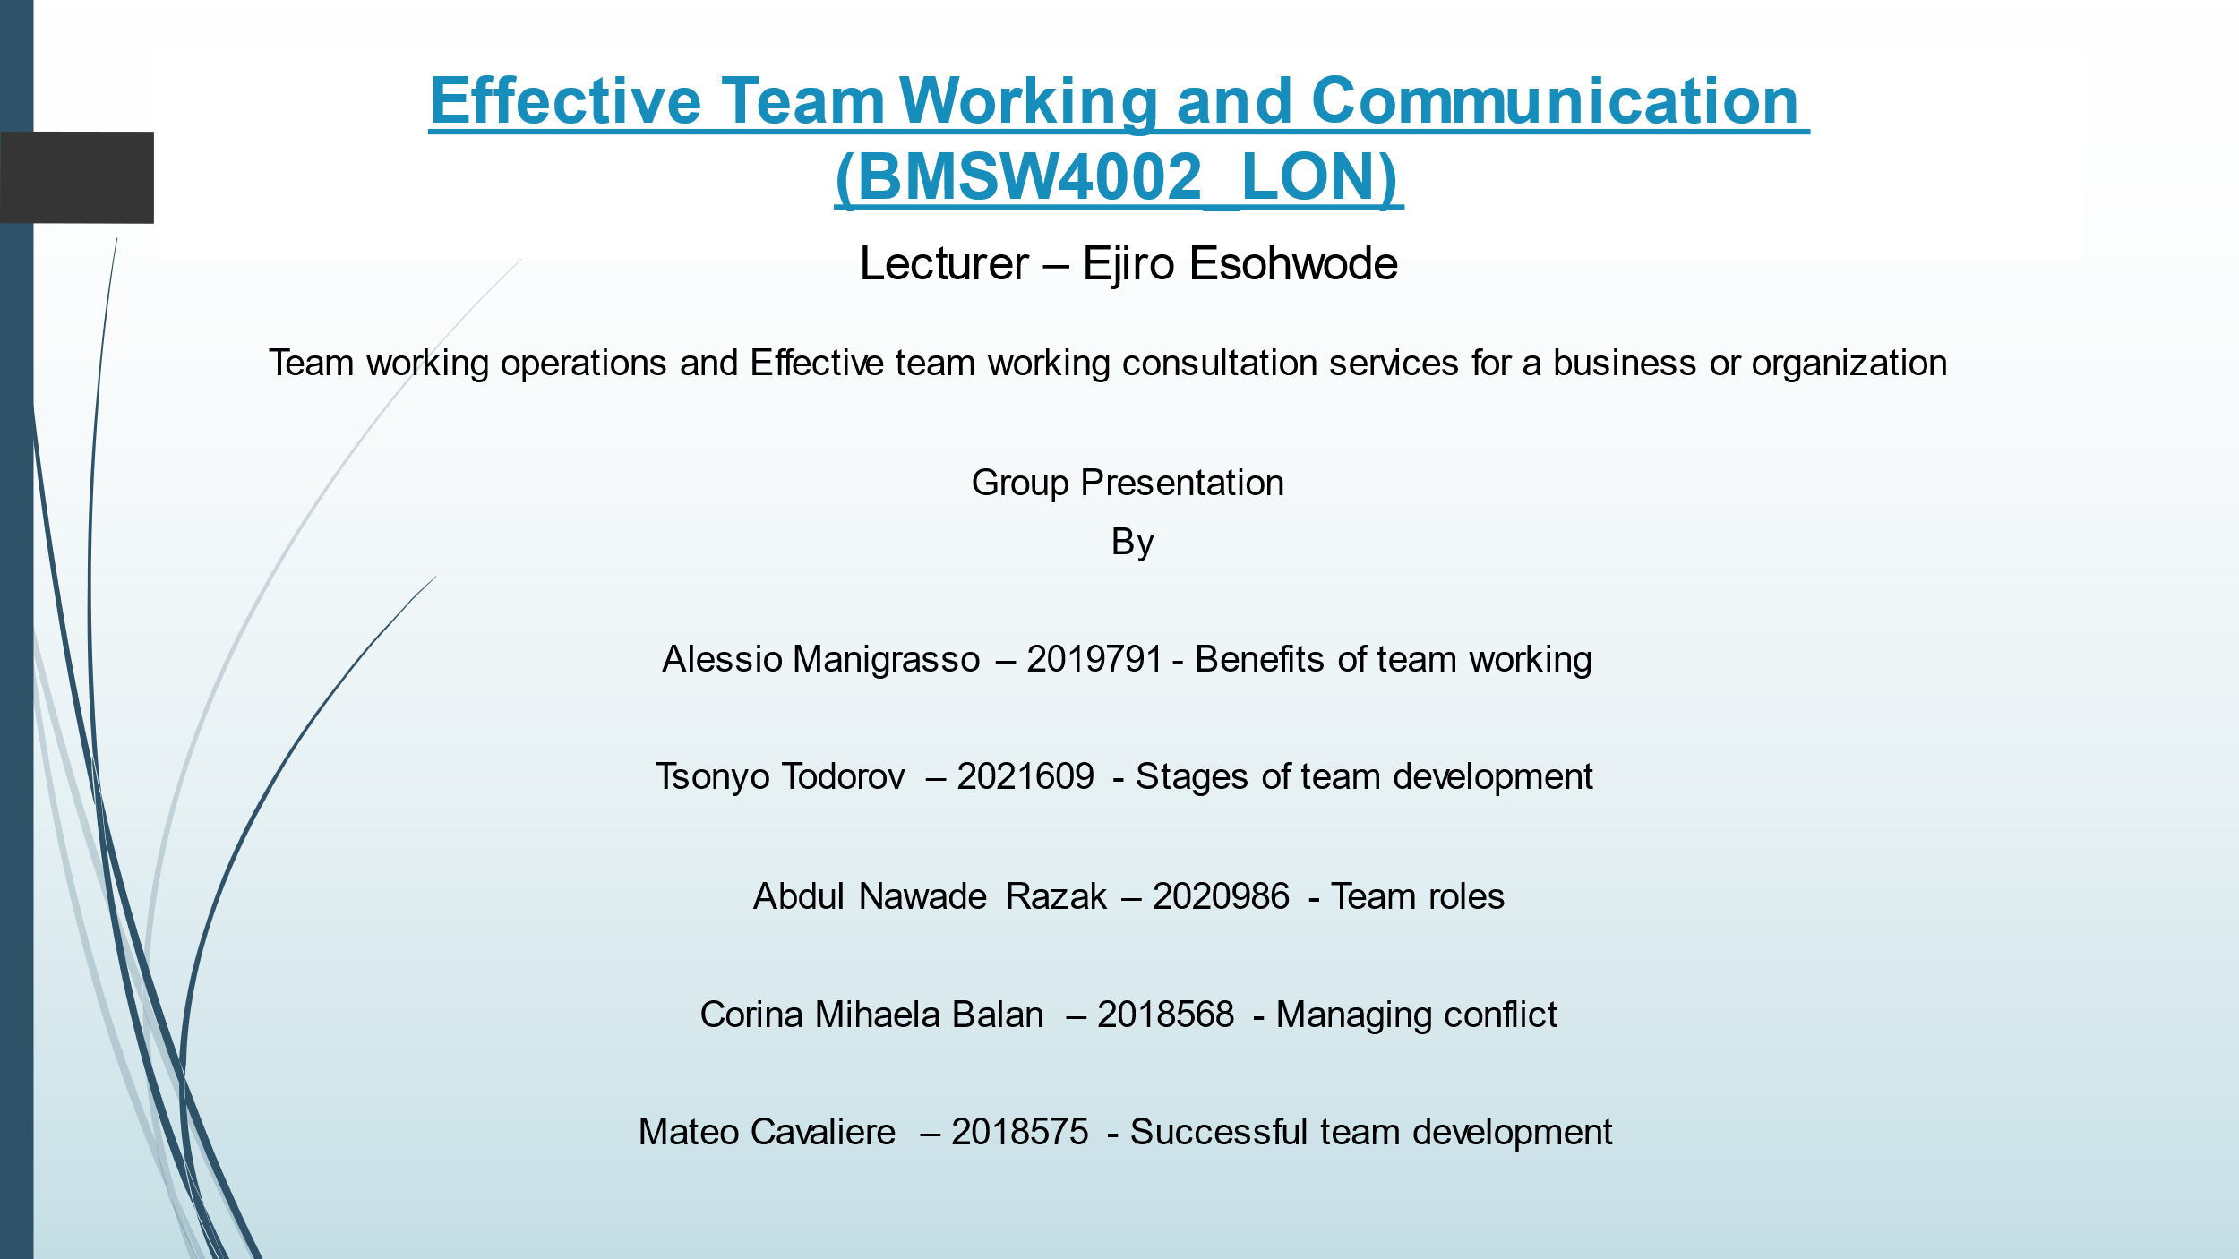
Slide 2
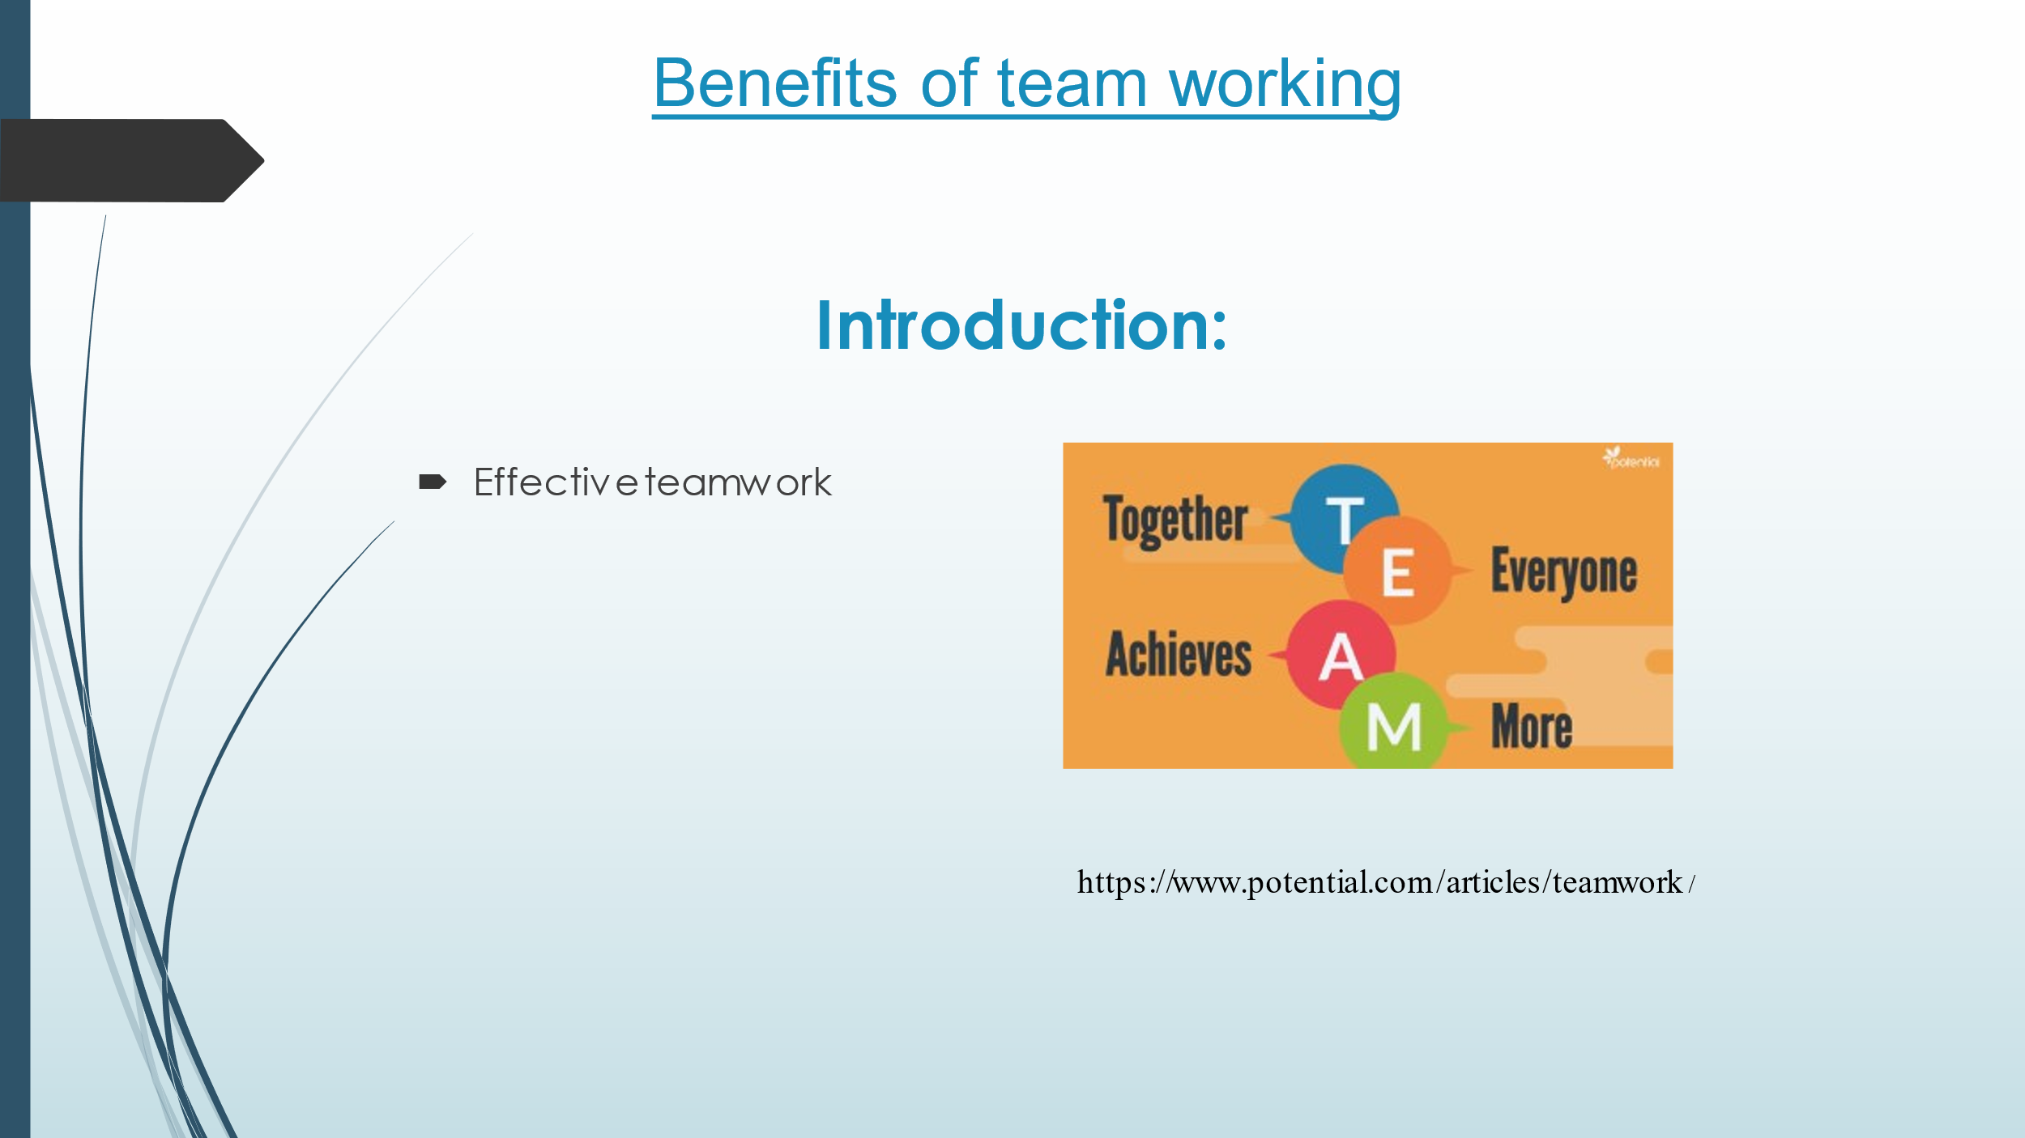
Slide 3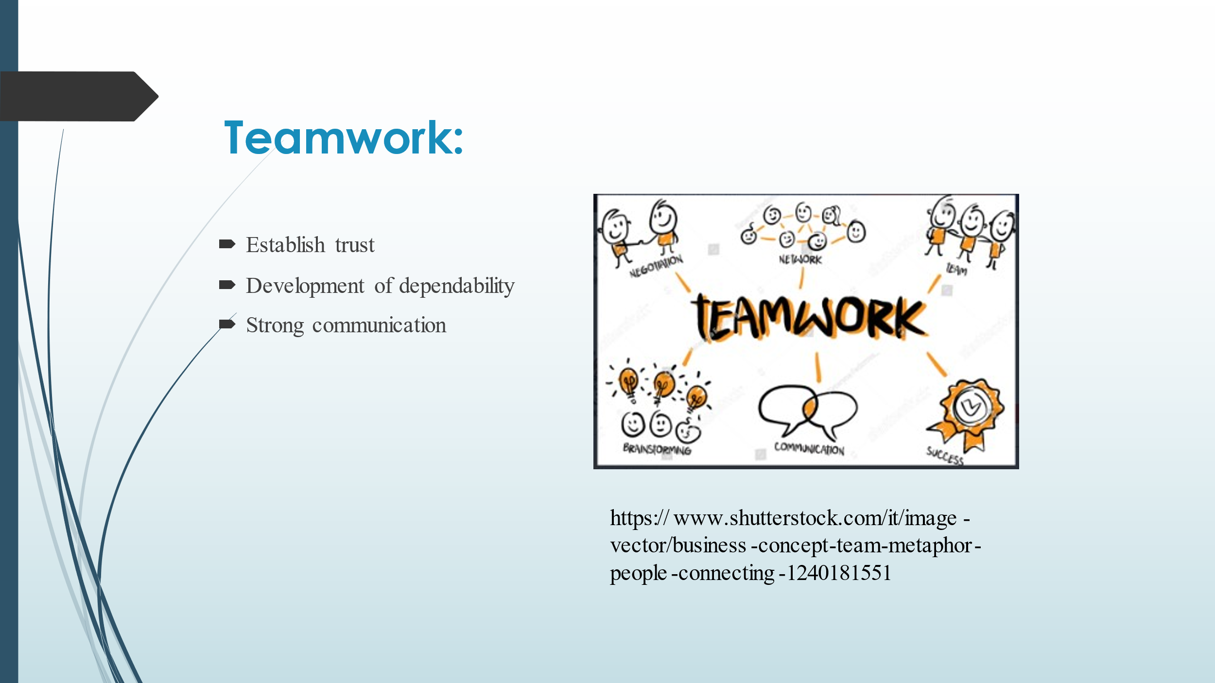
Slide 4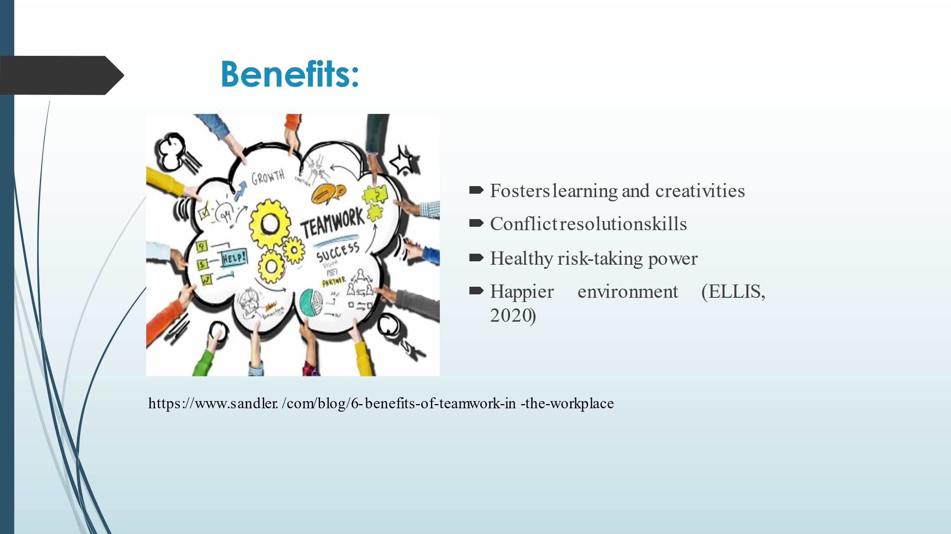
Slide 5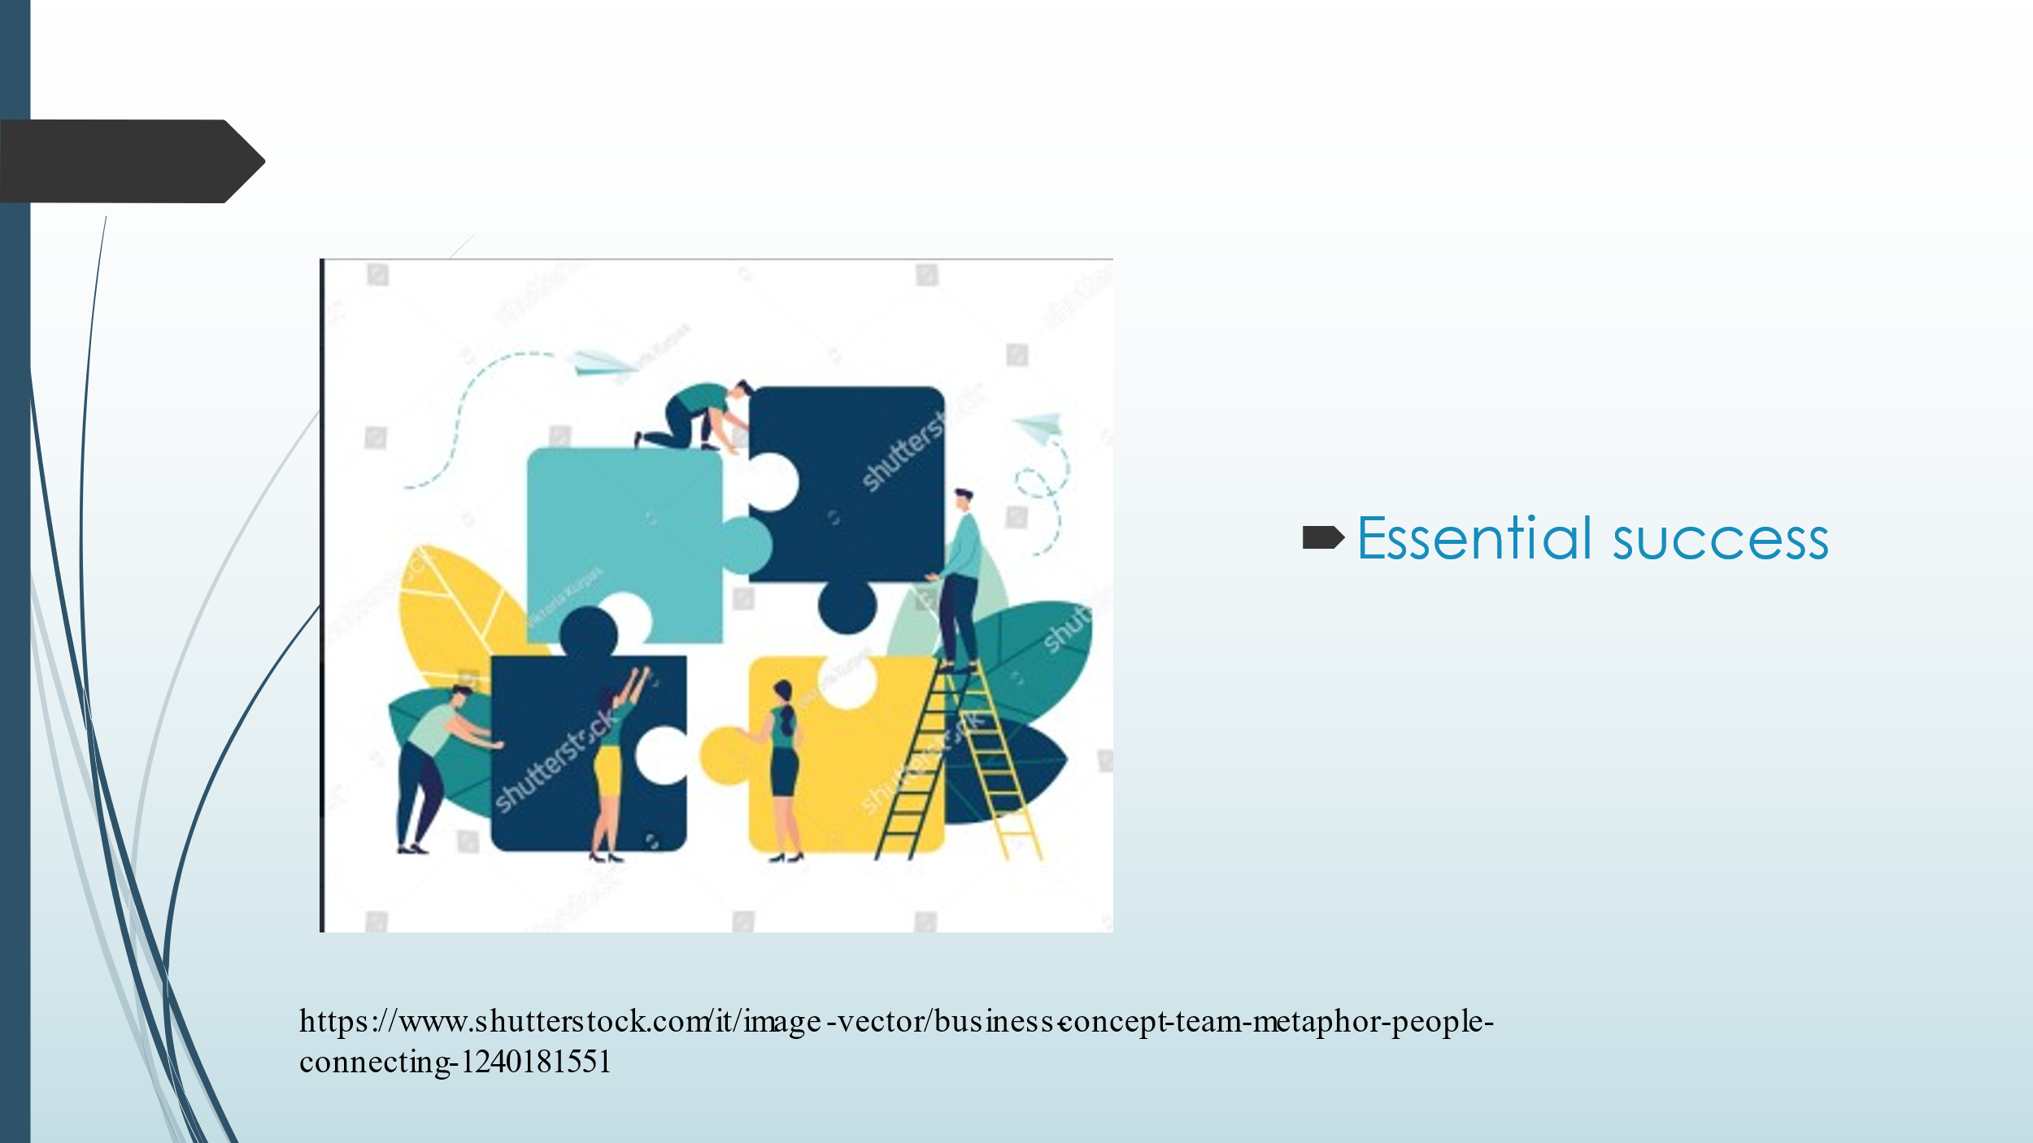
Slide 6
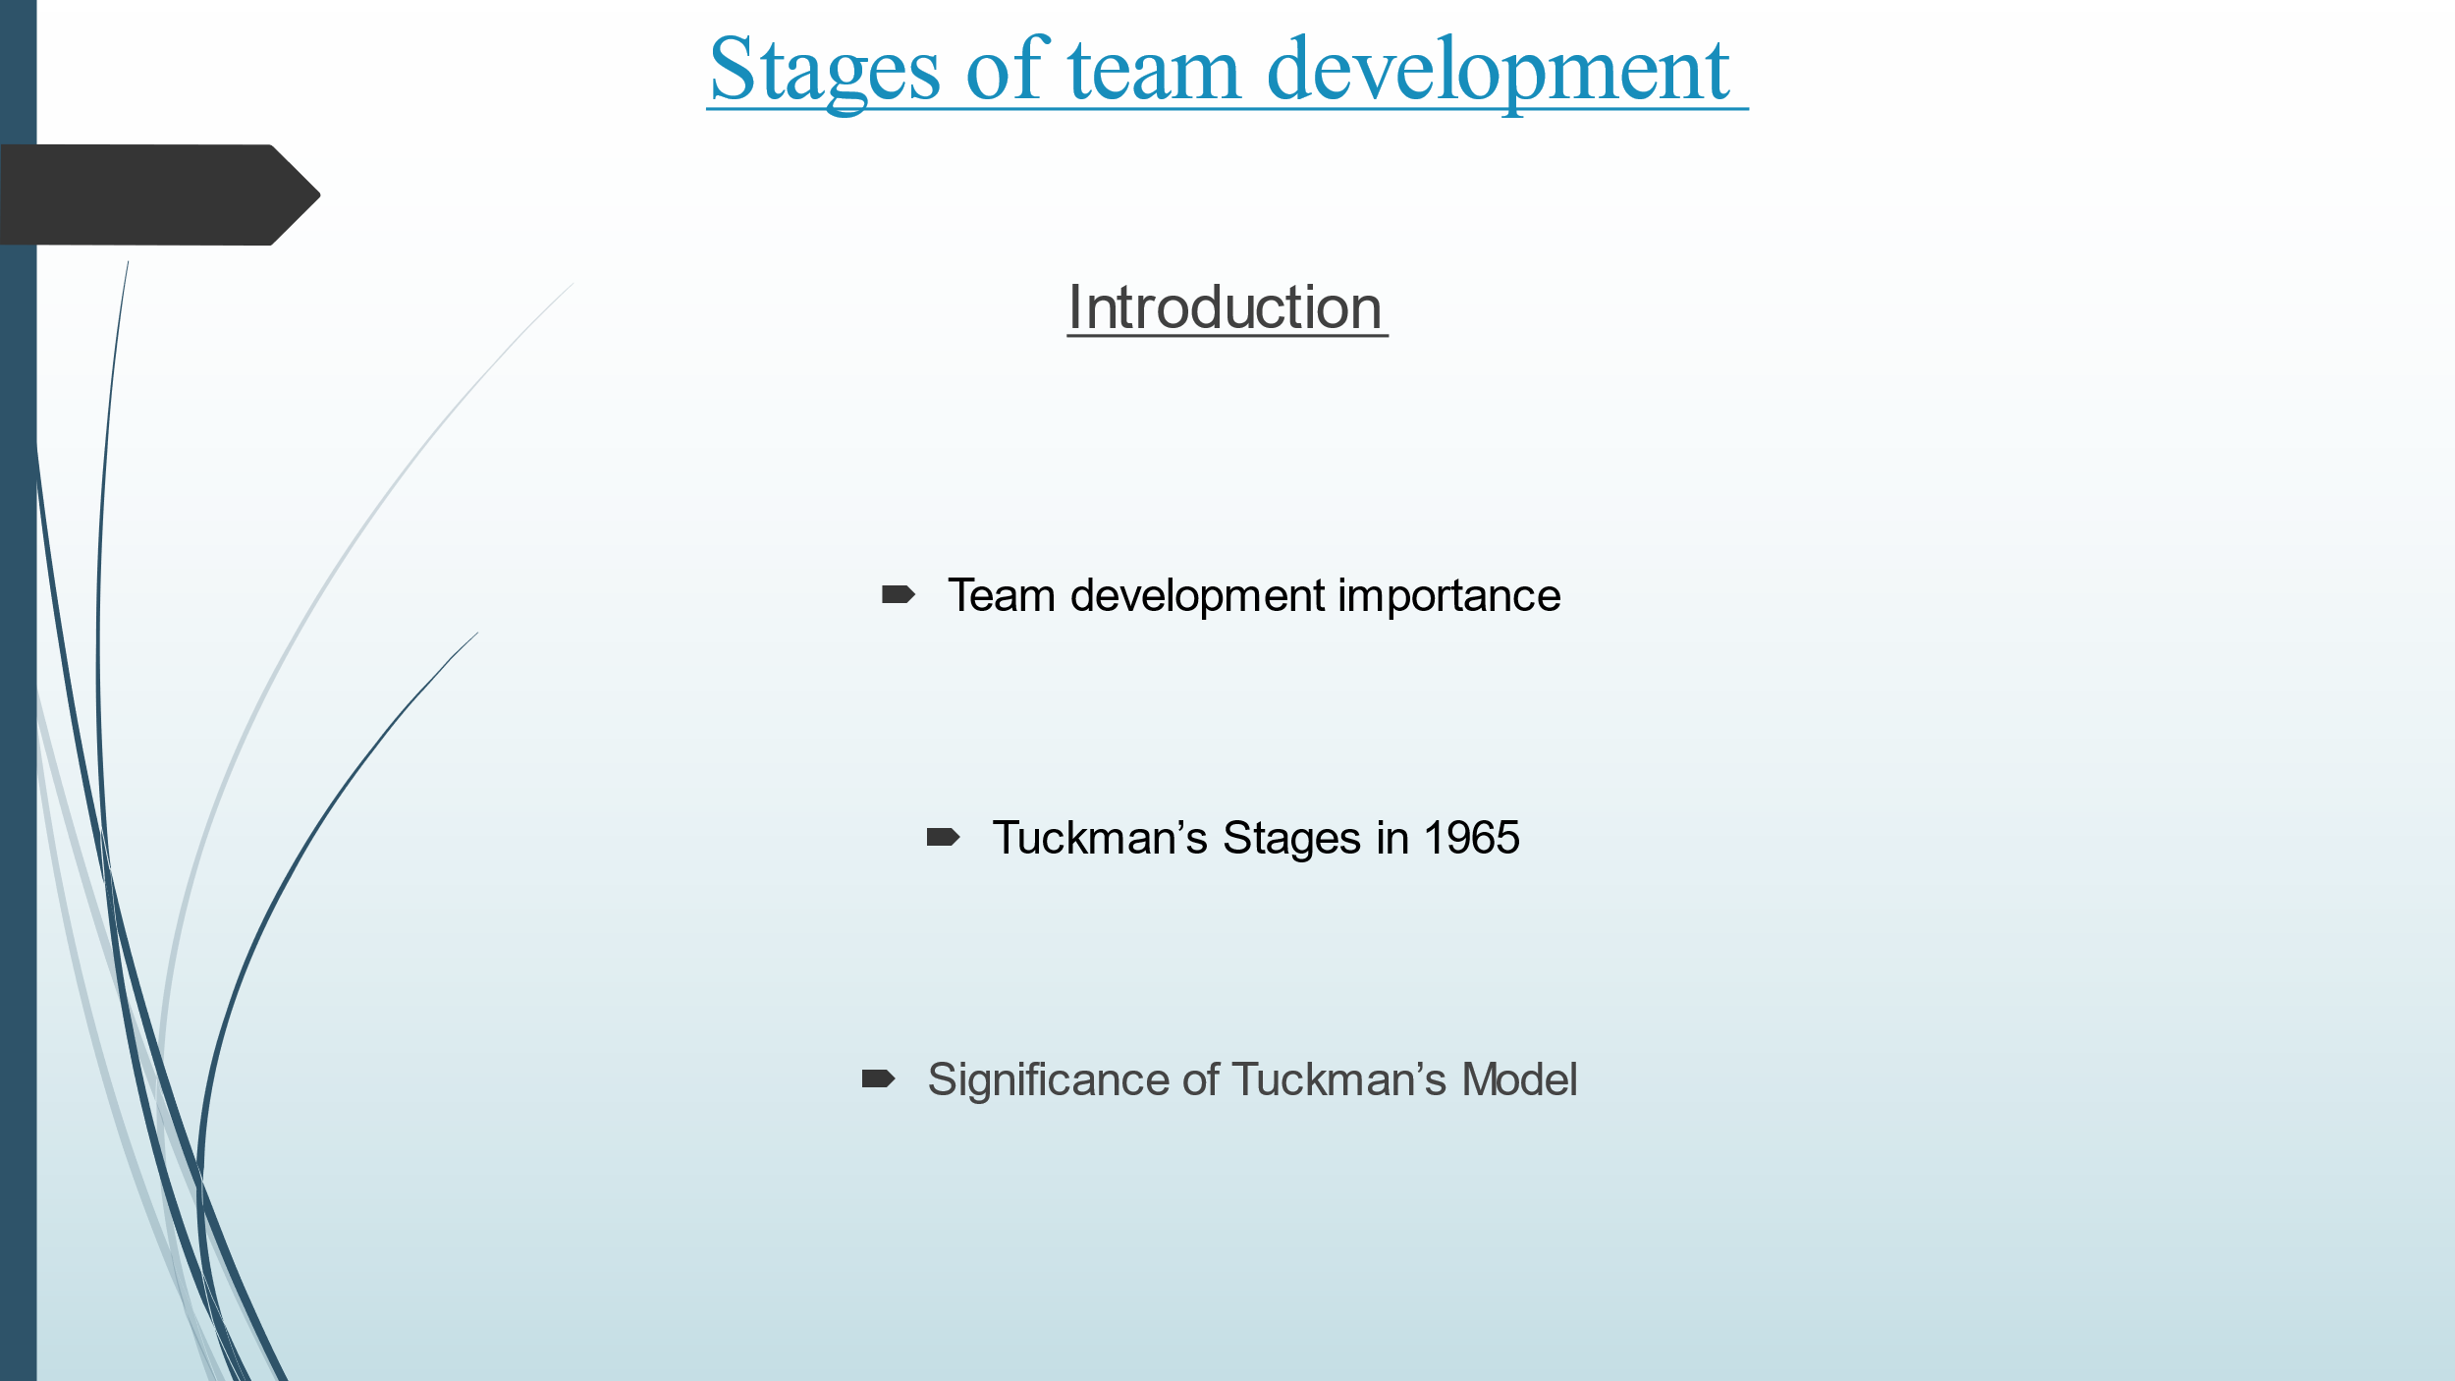
Slide 7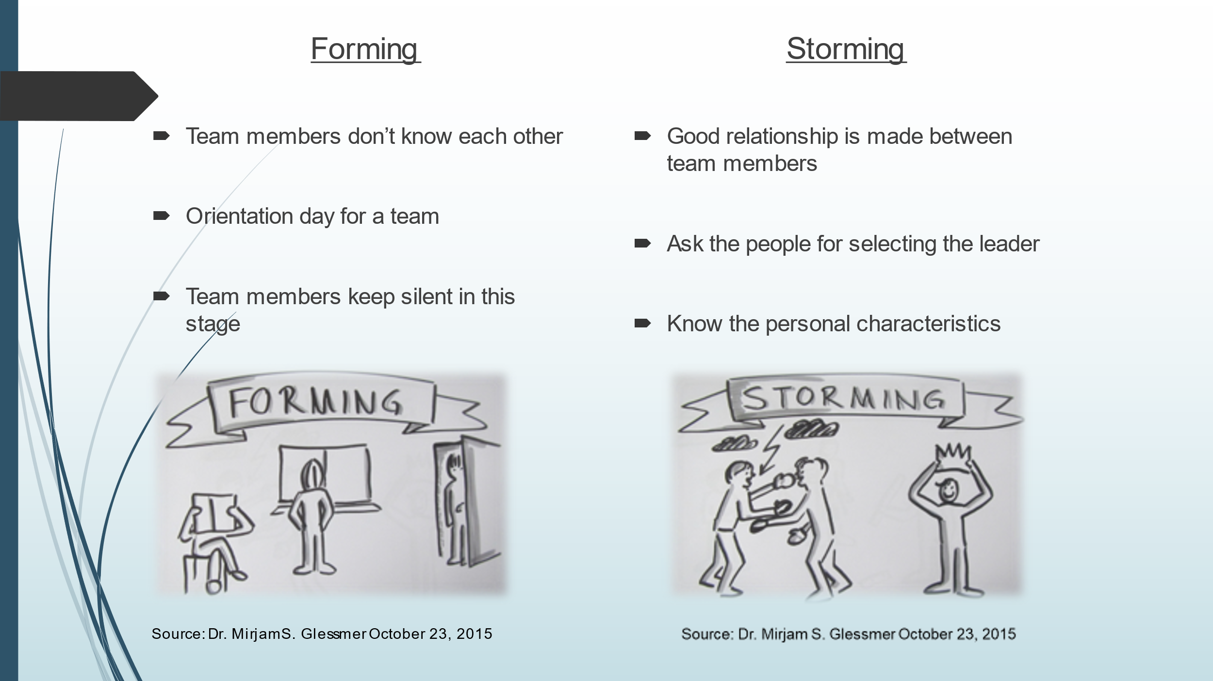
Slide 8
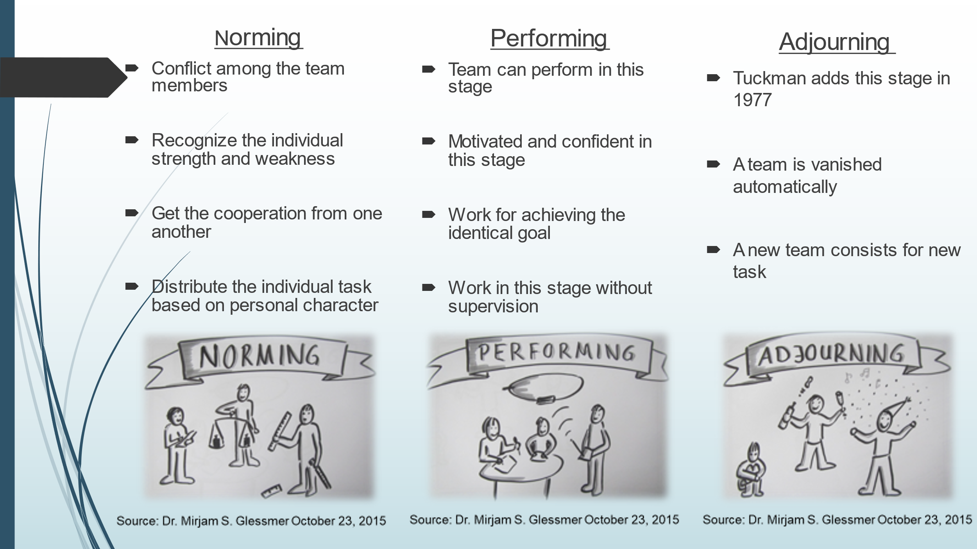
Slide 9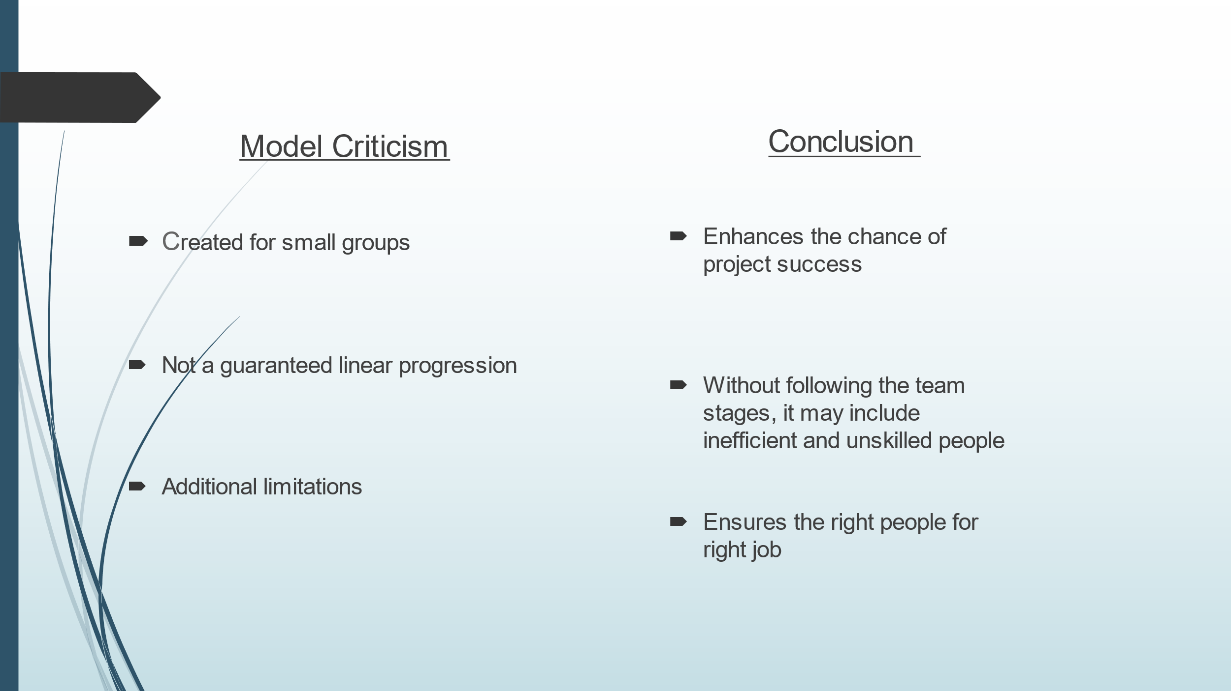
Slide 10
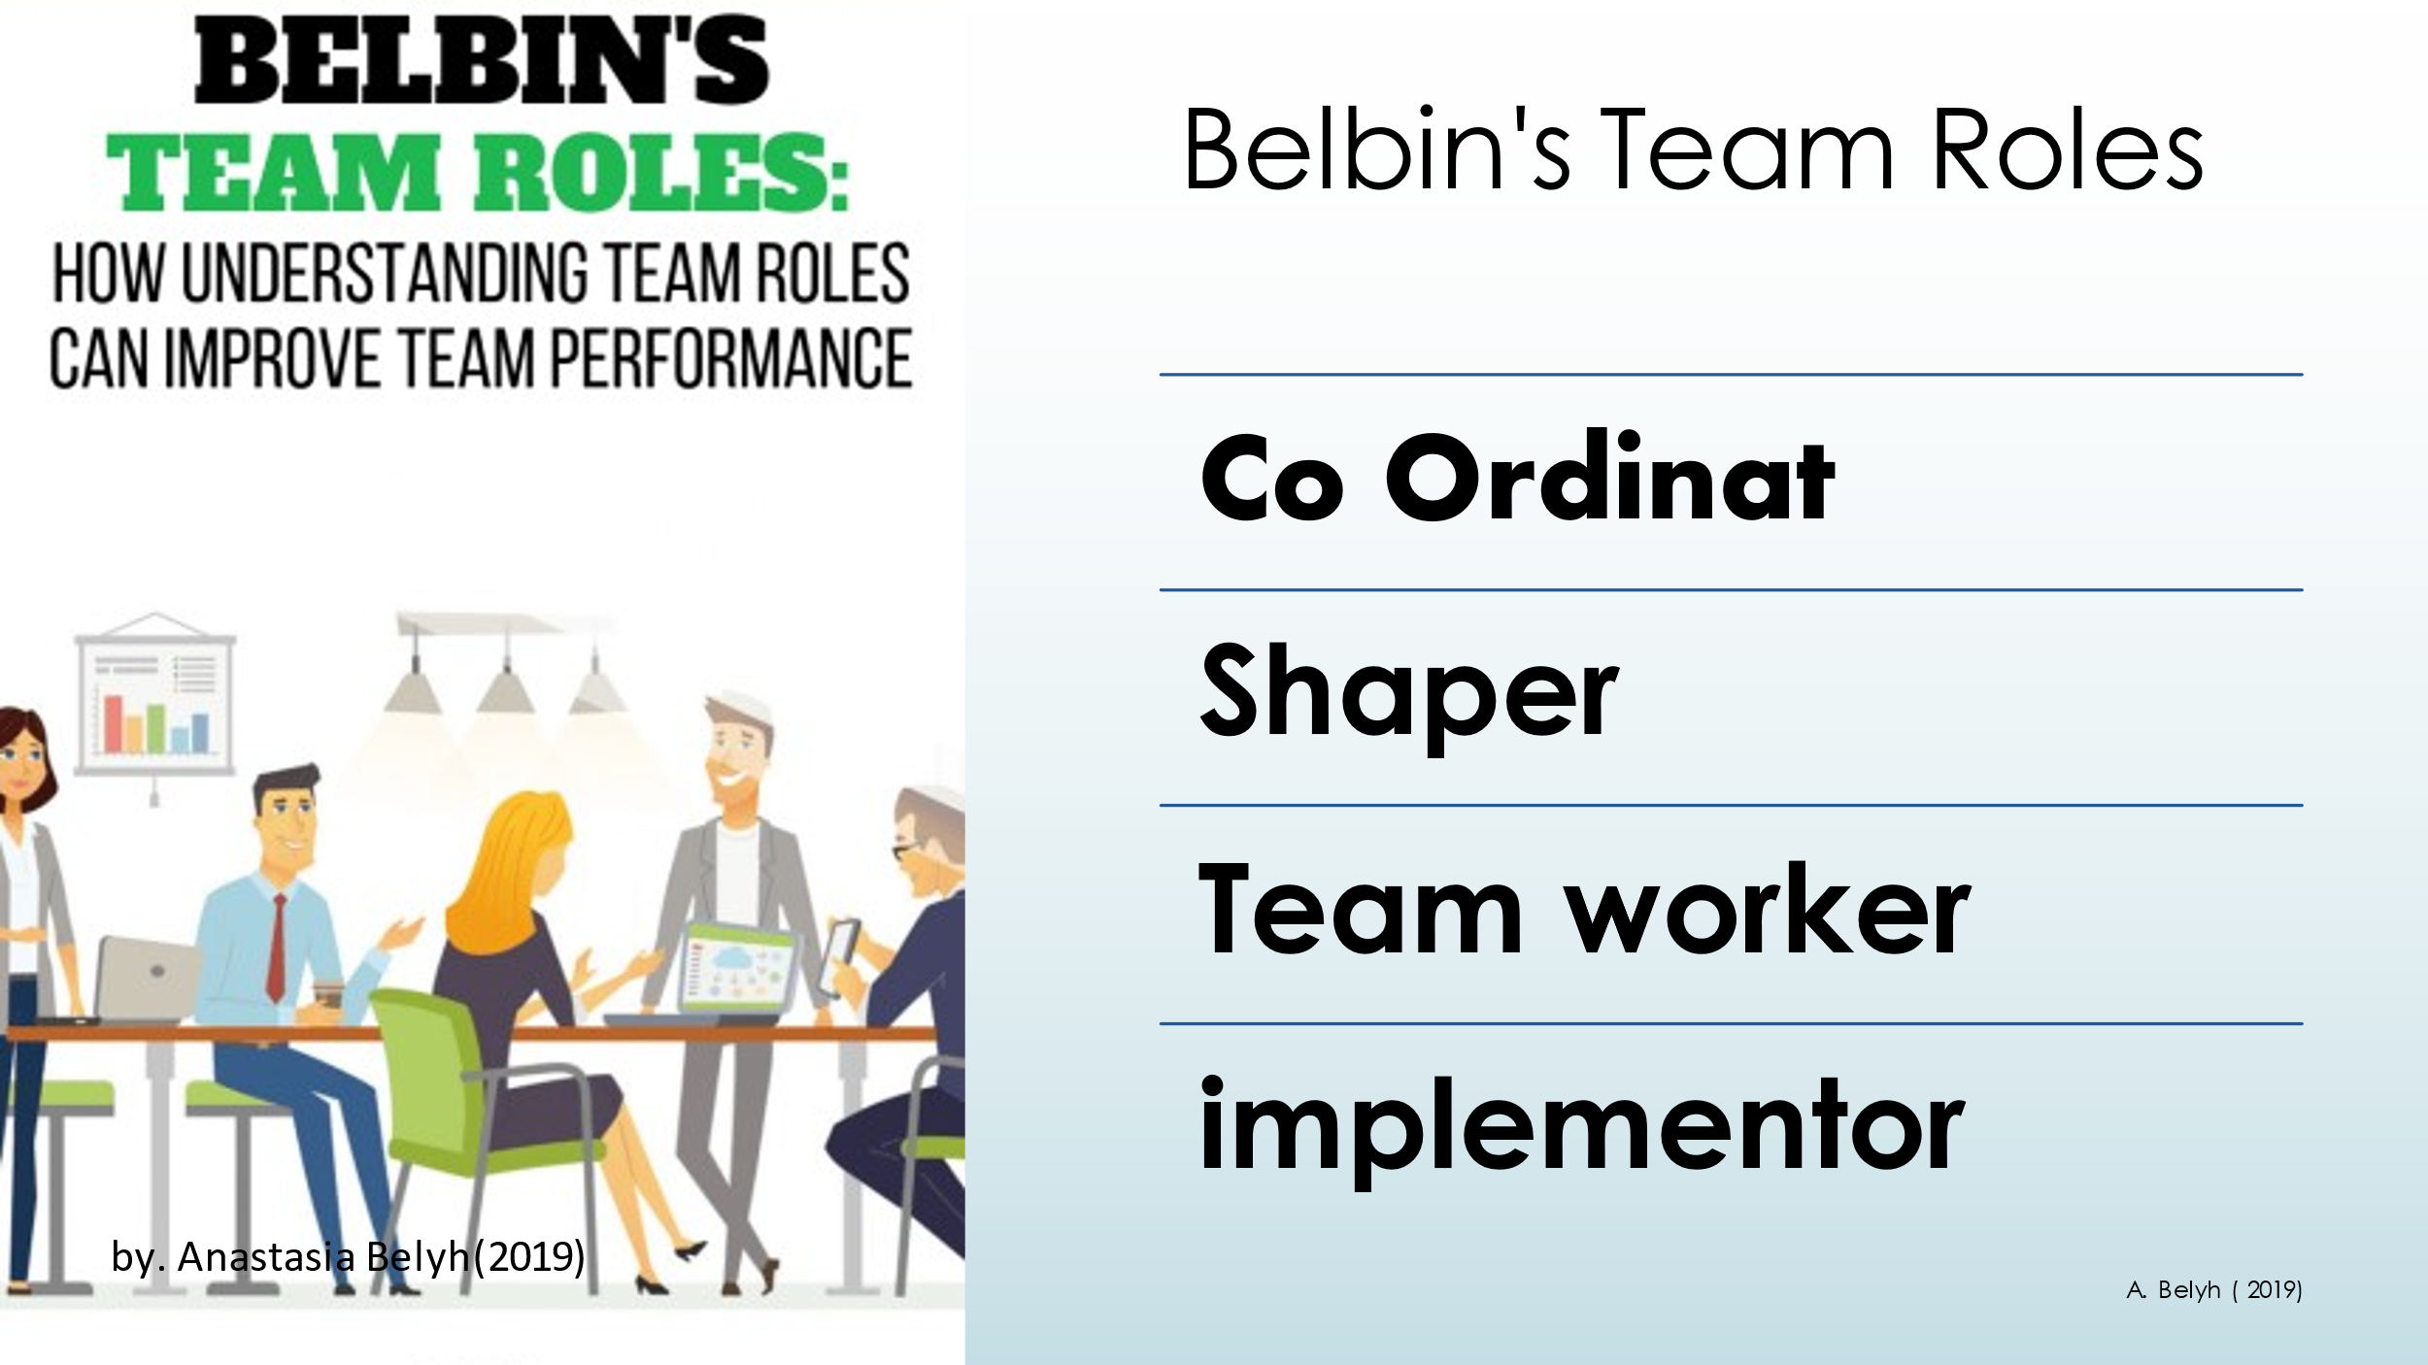
Slide 11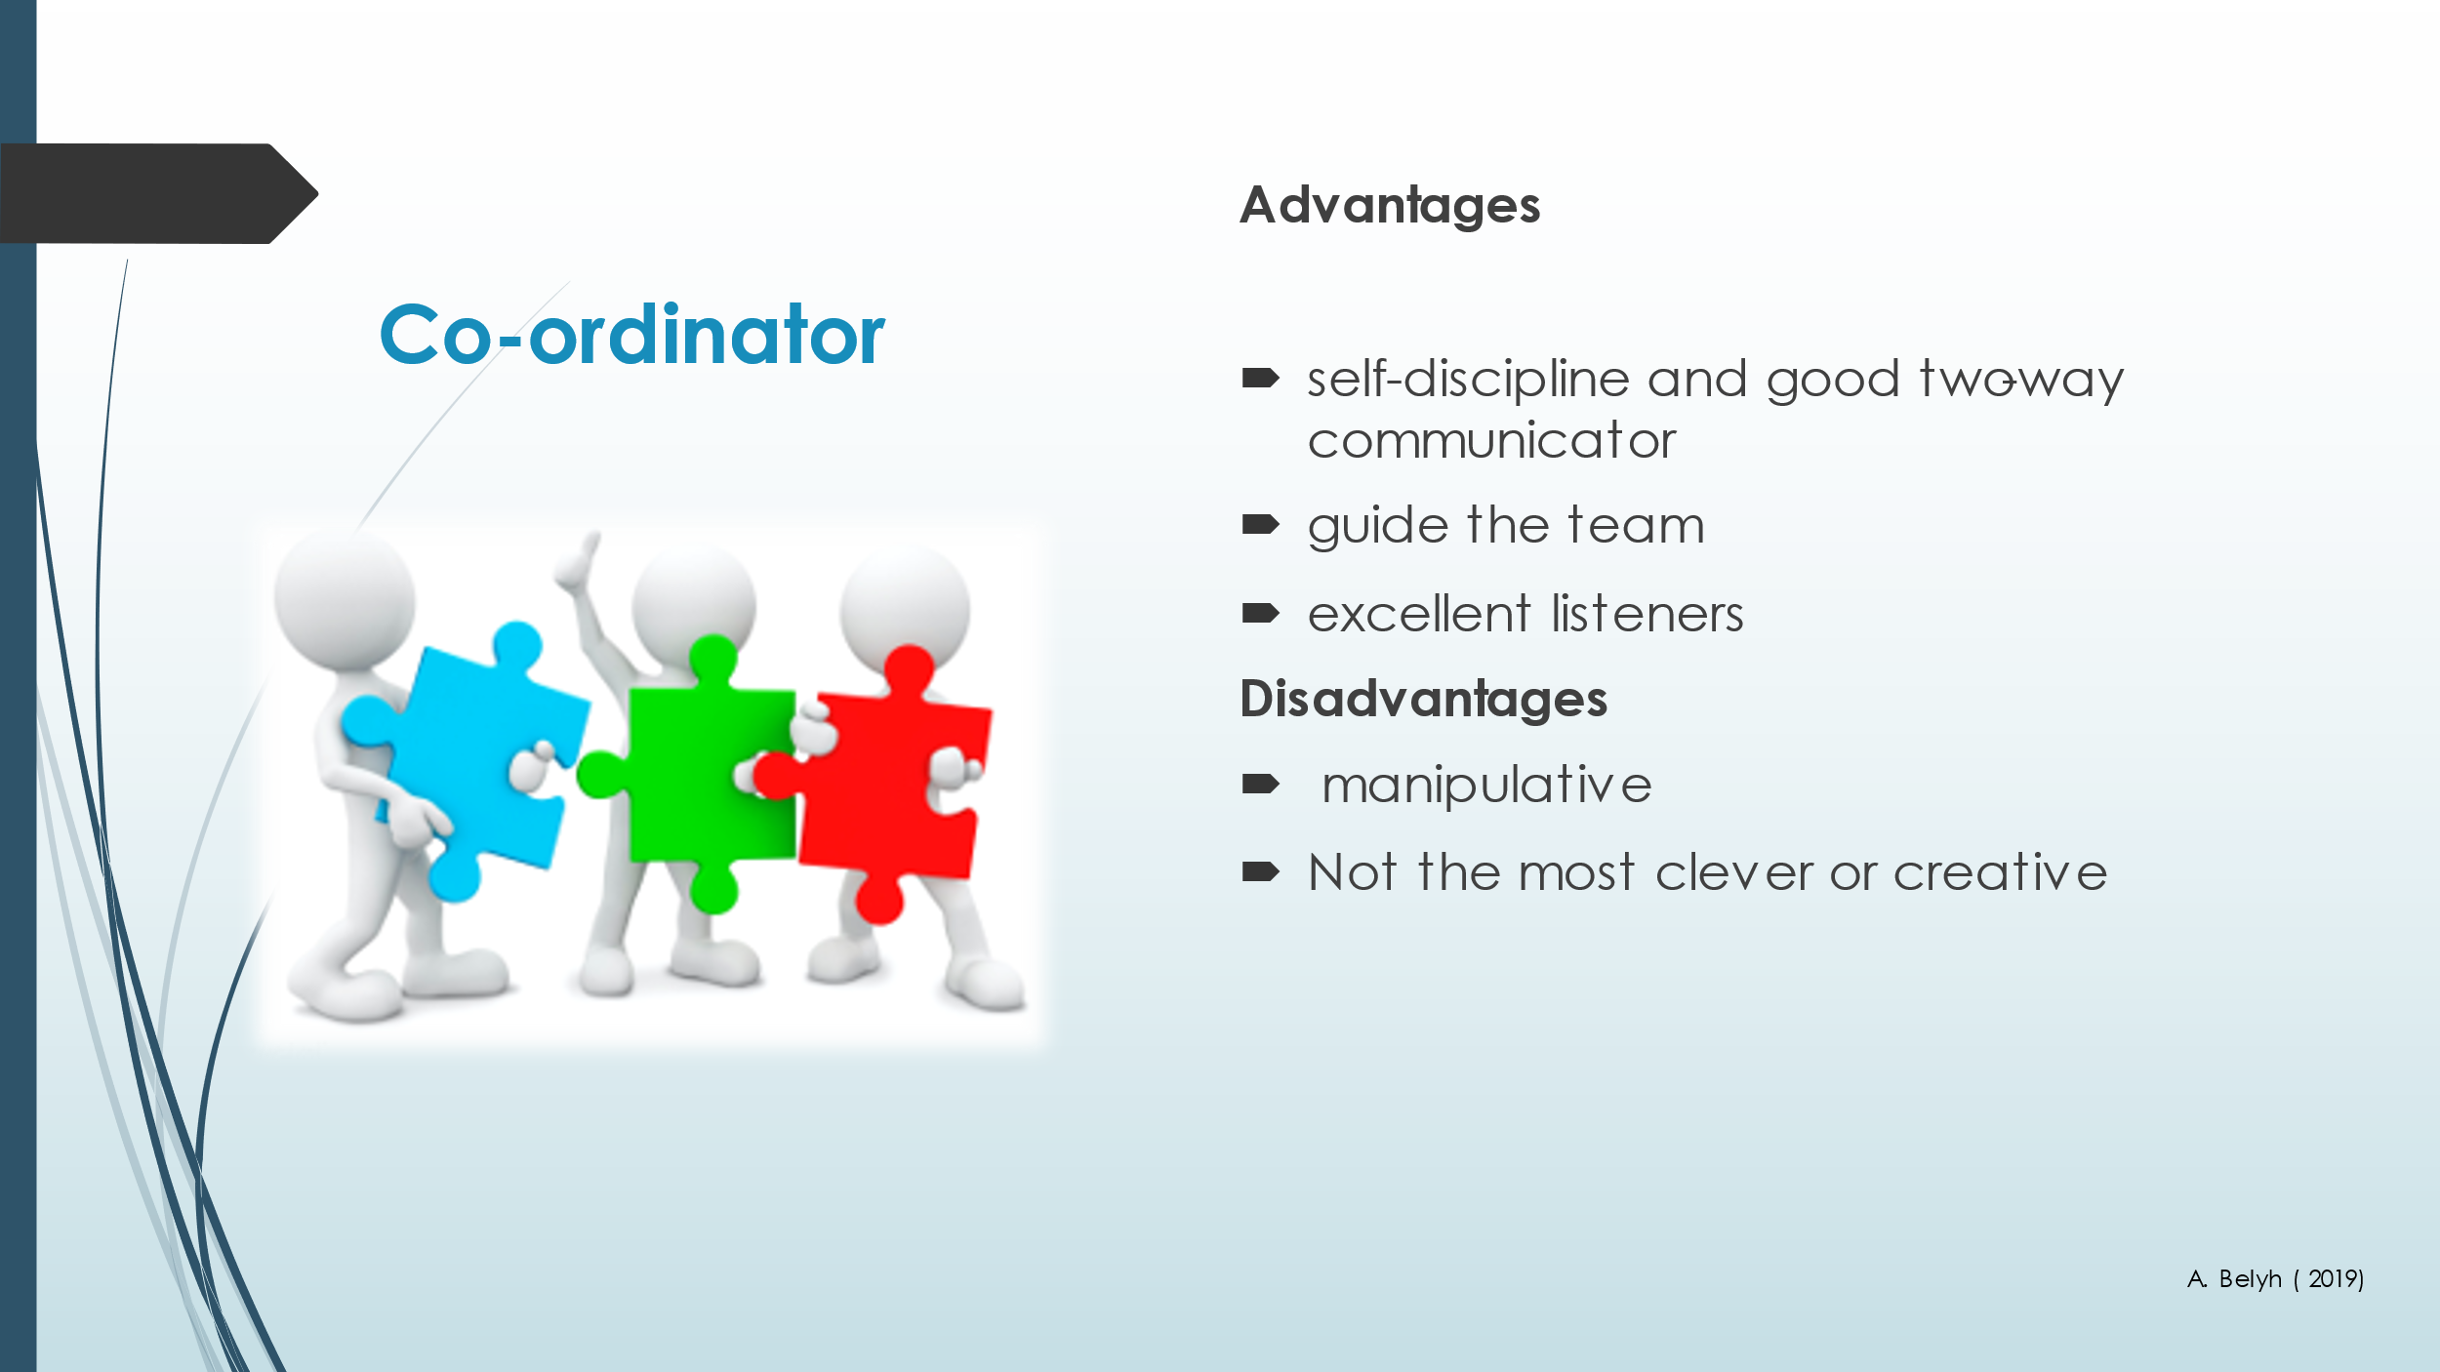
Slide 12
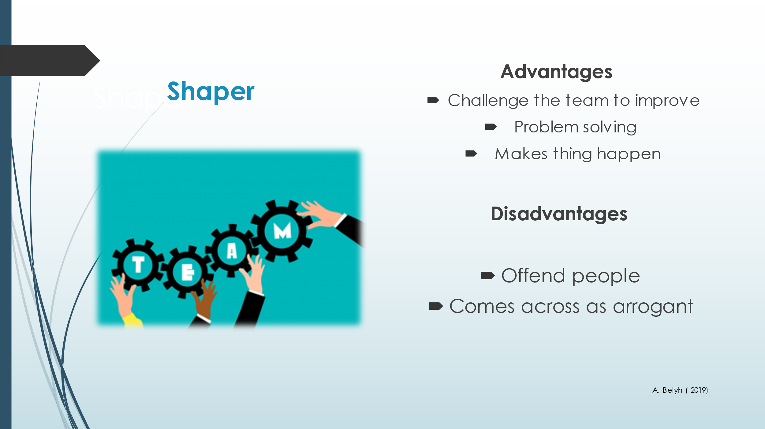
Slide 13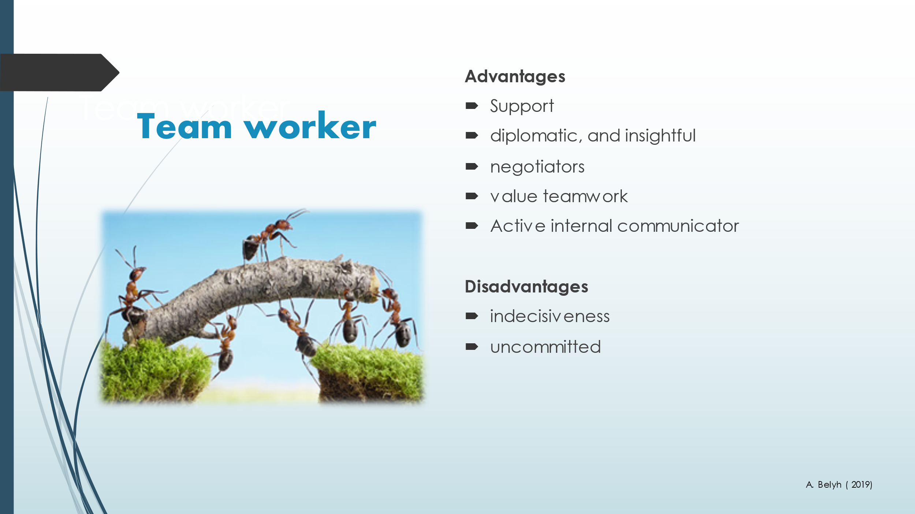
Slide 14
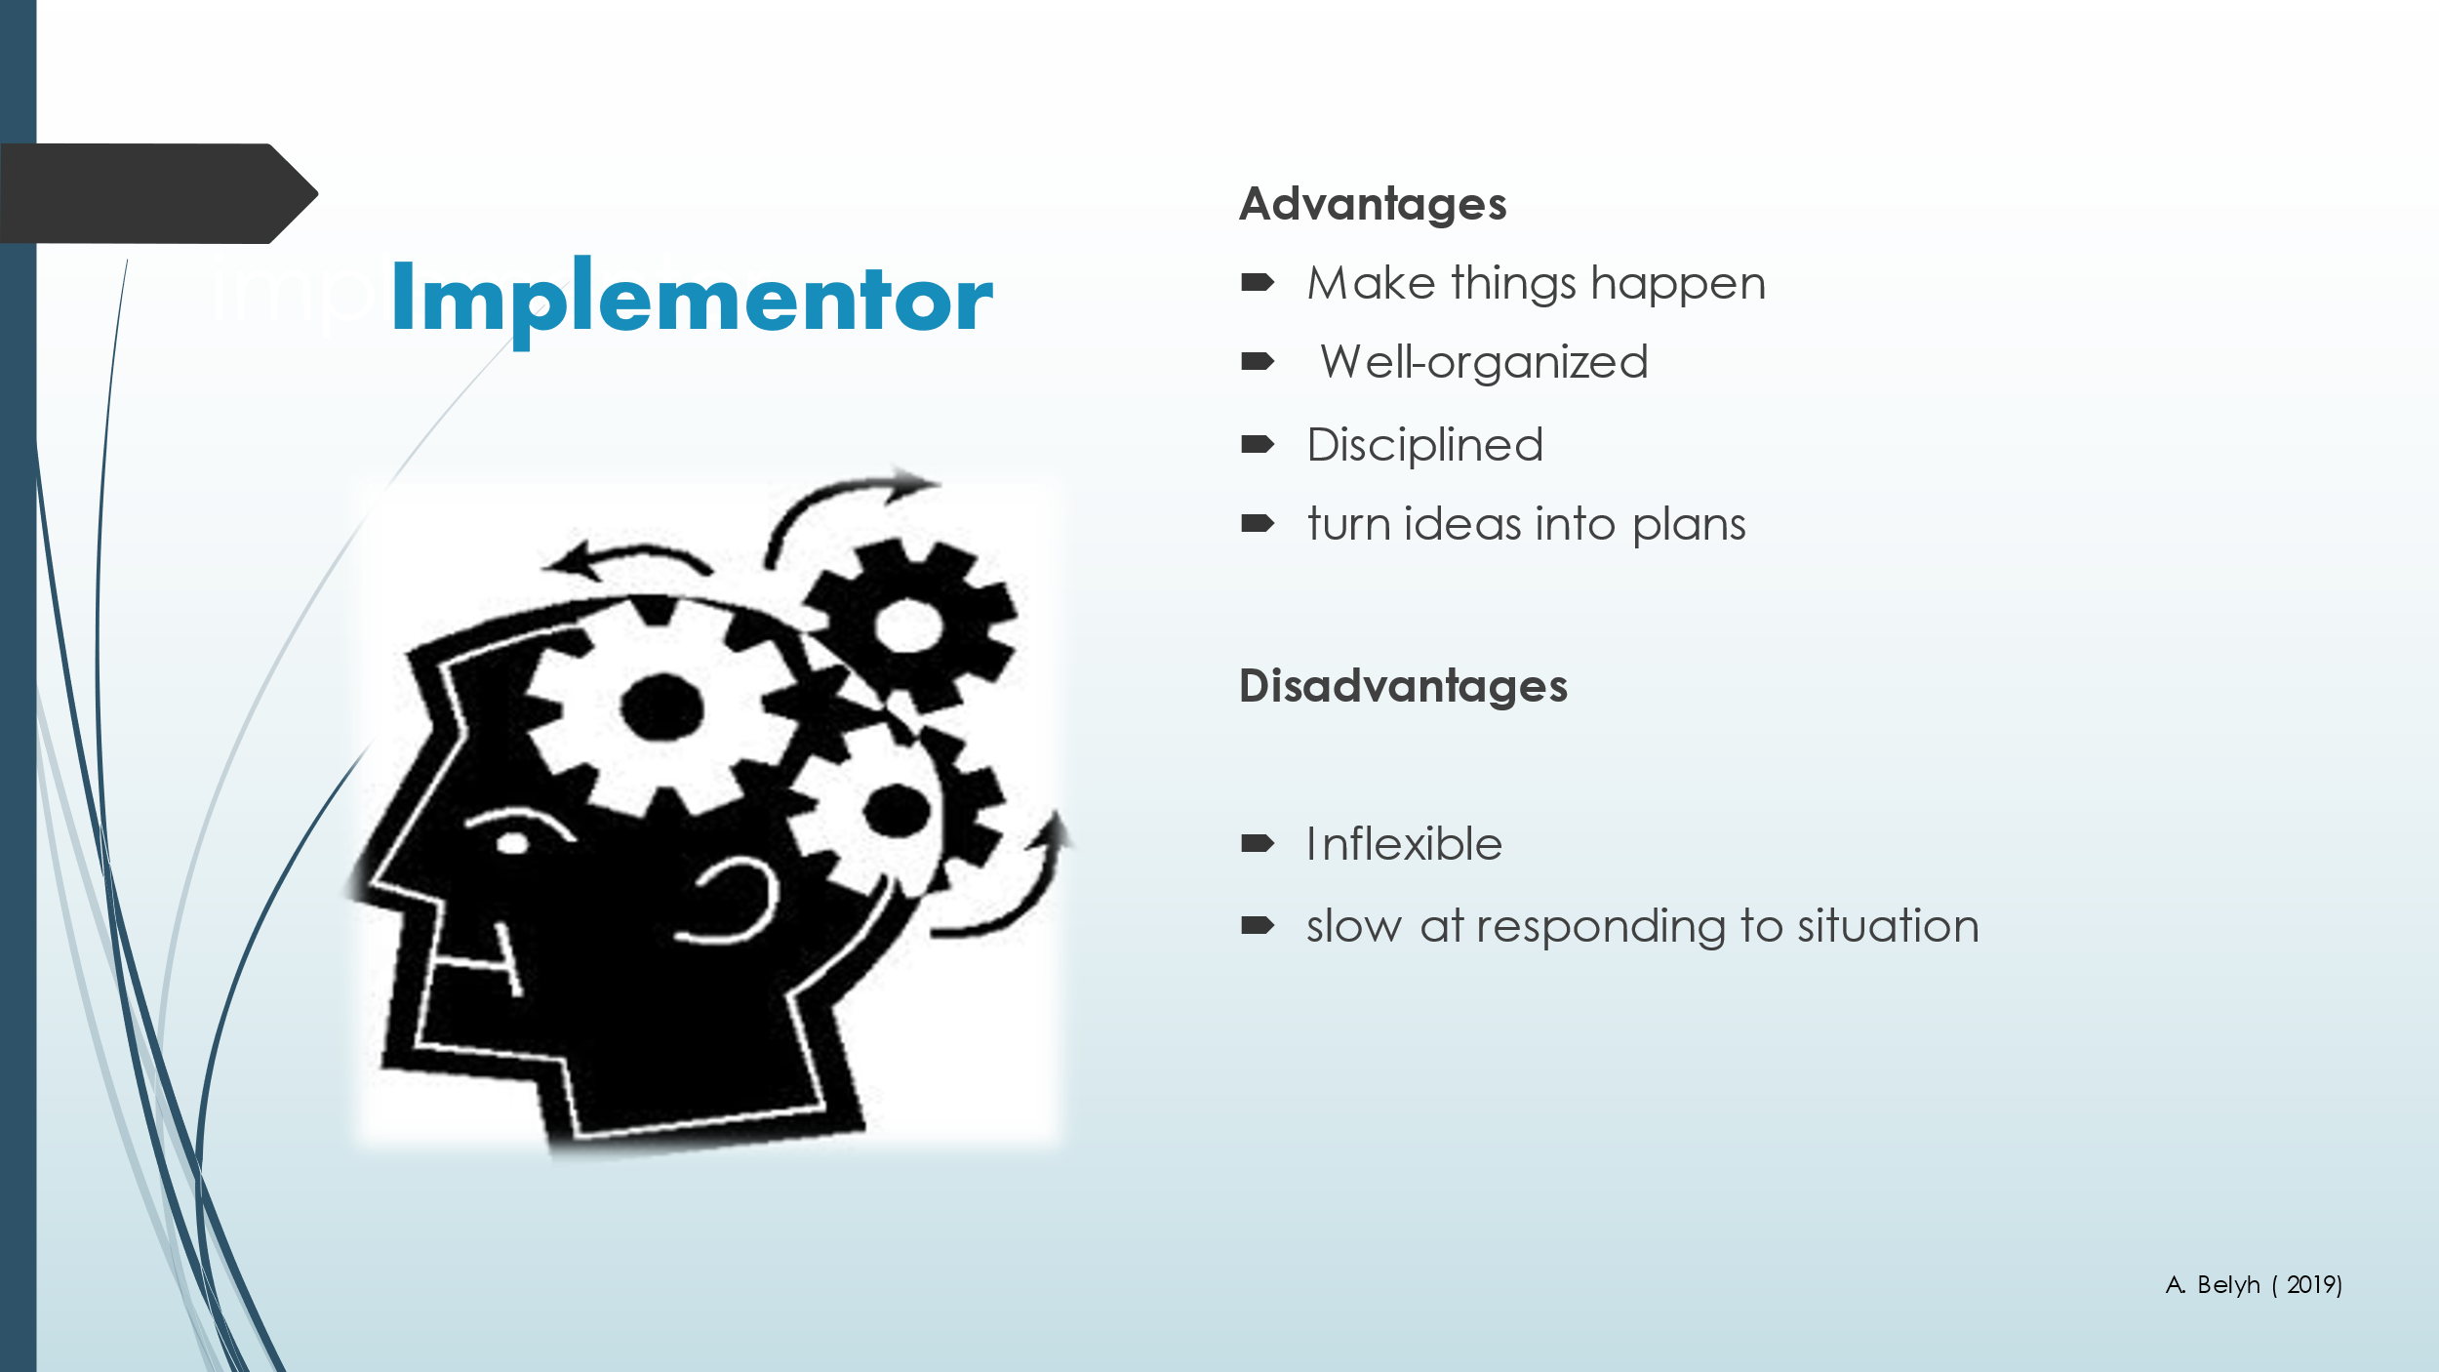
Slide 15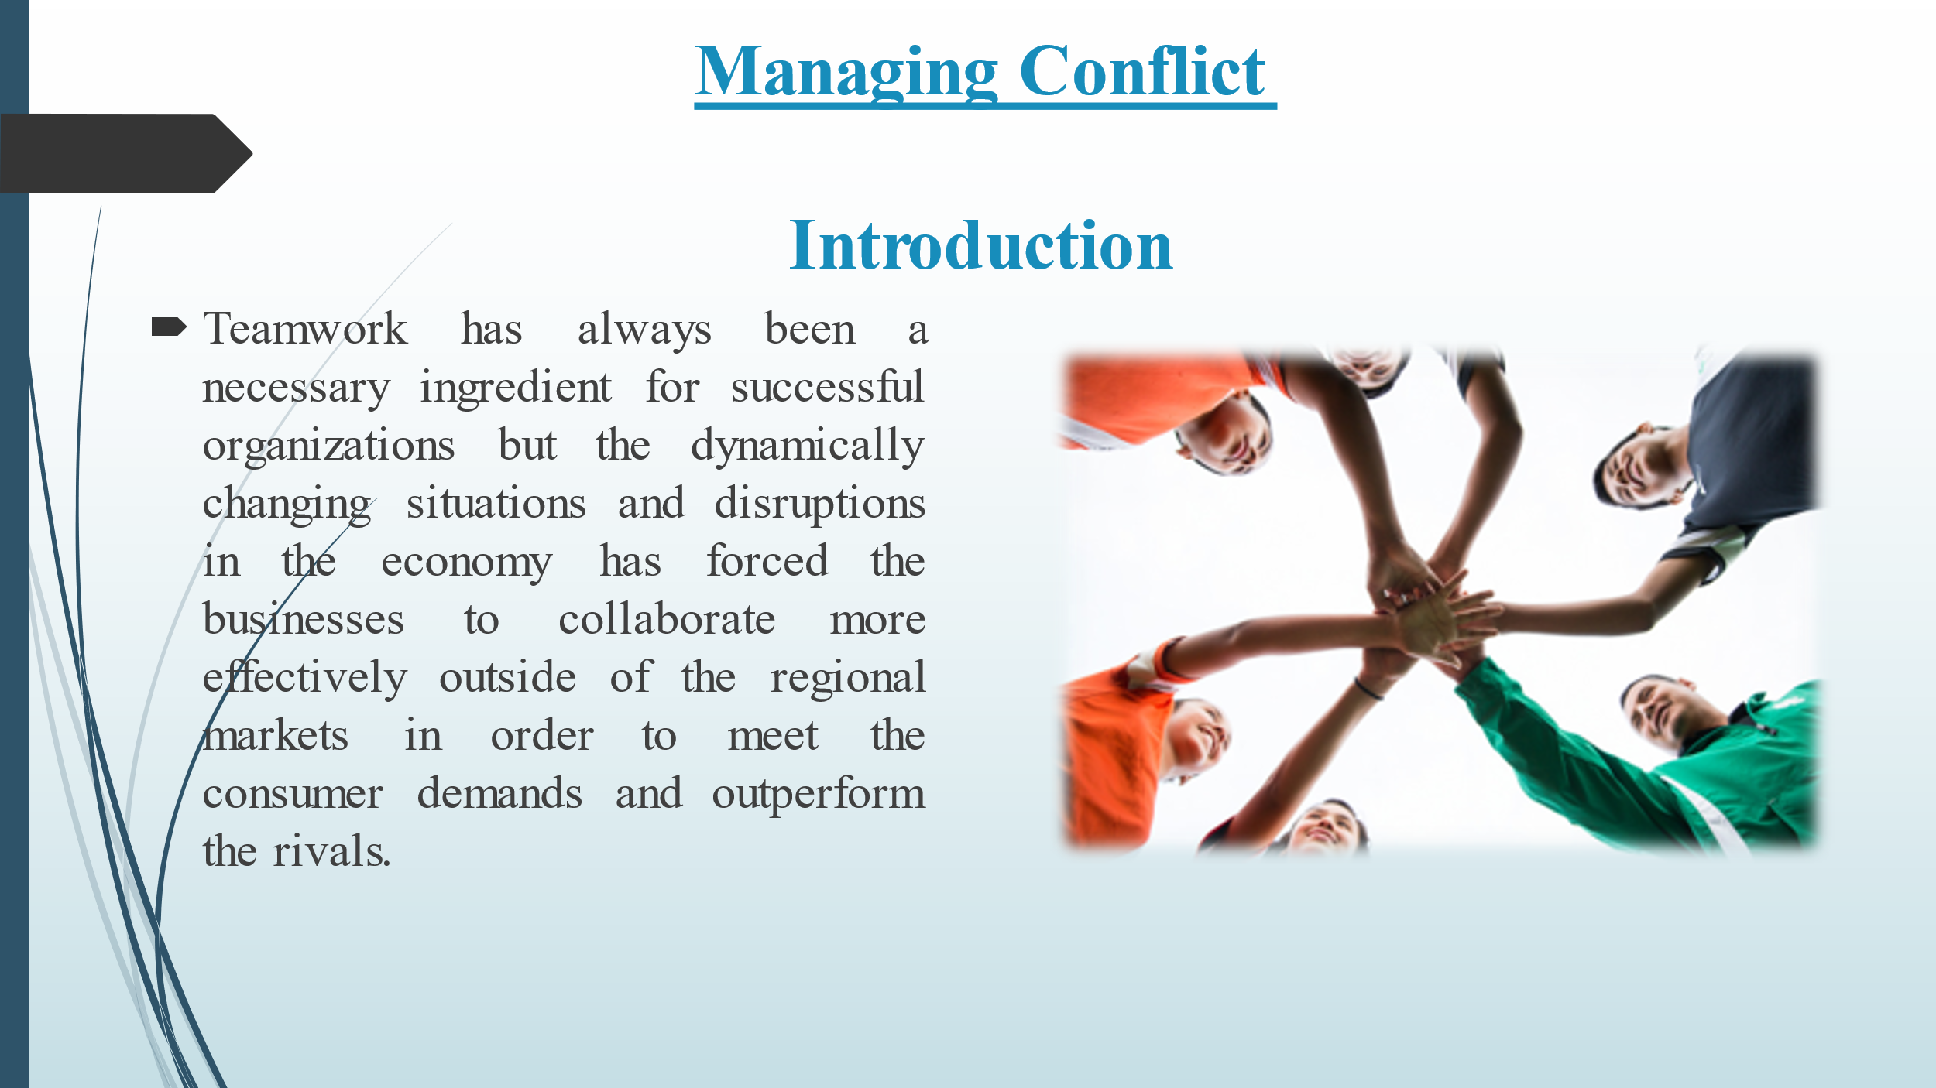
Slide 16
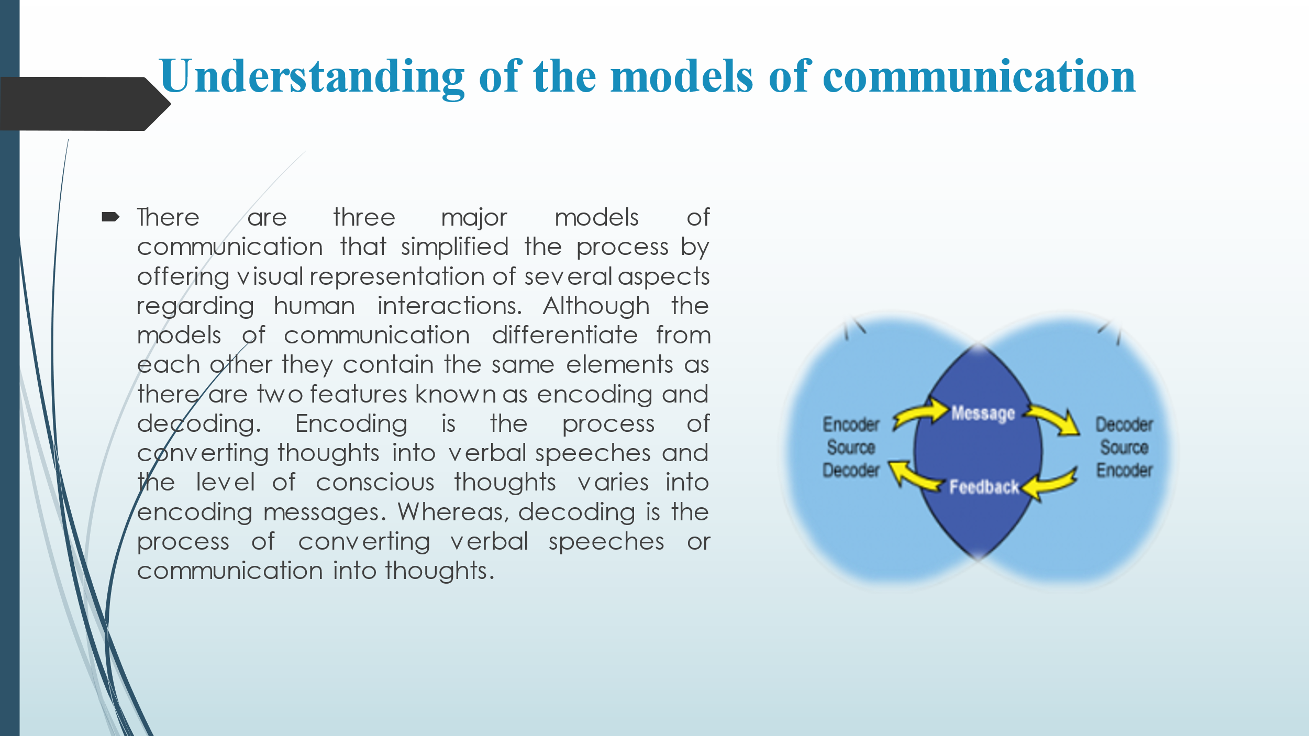
Slide 17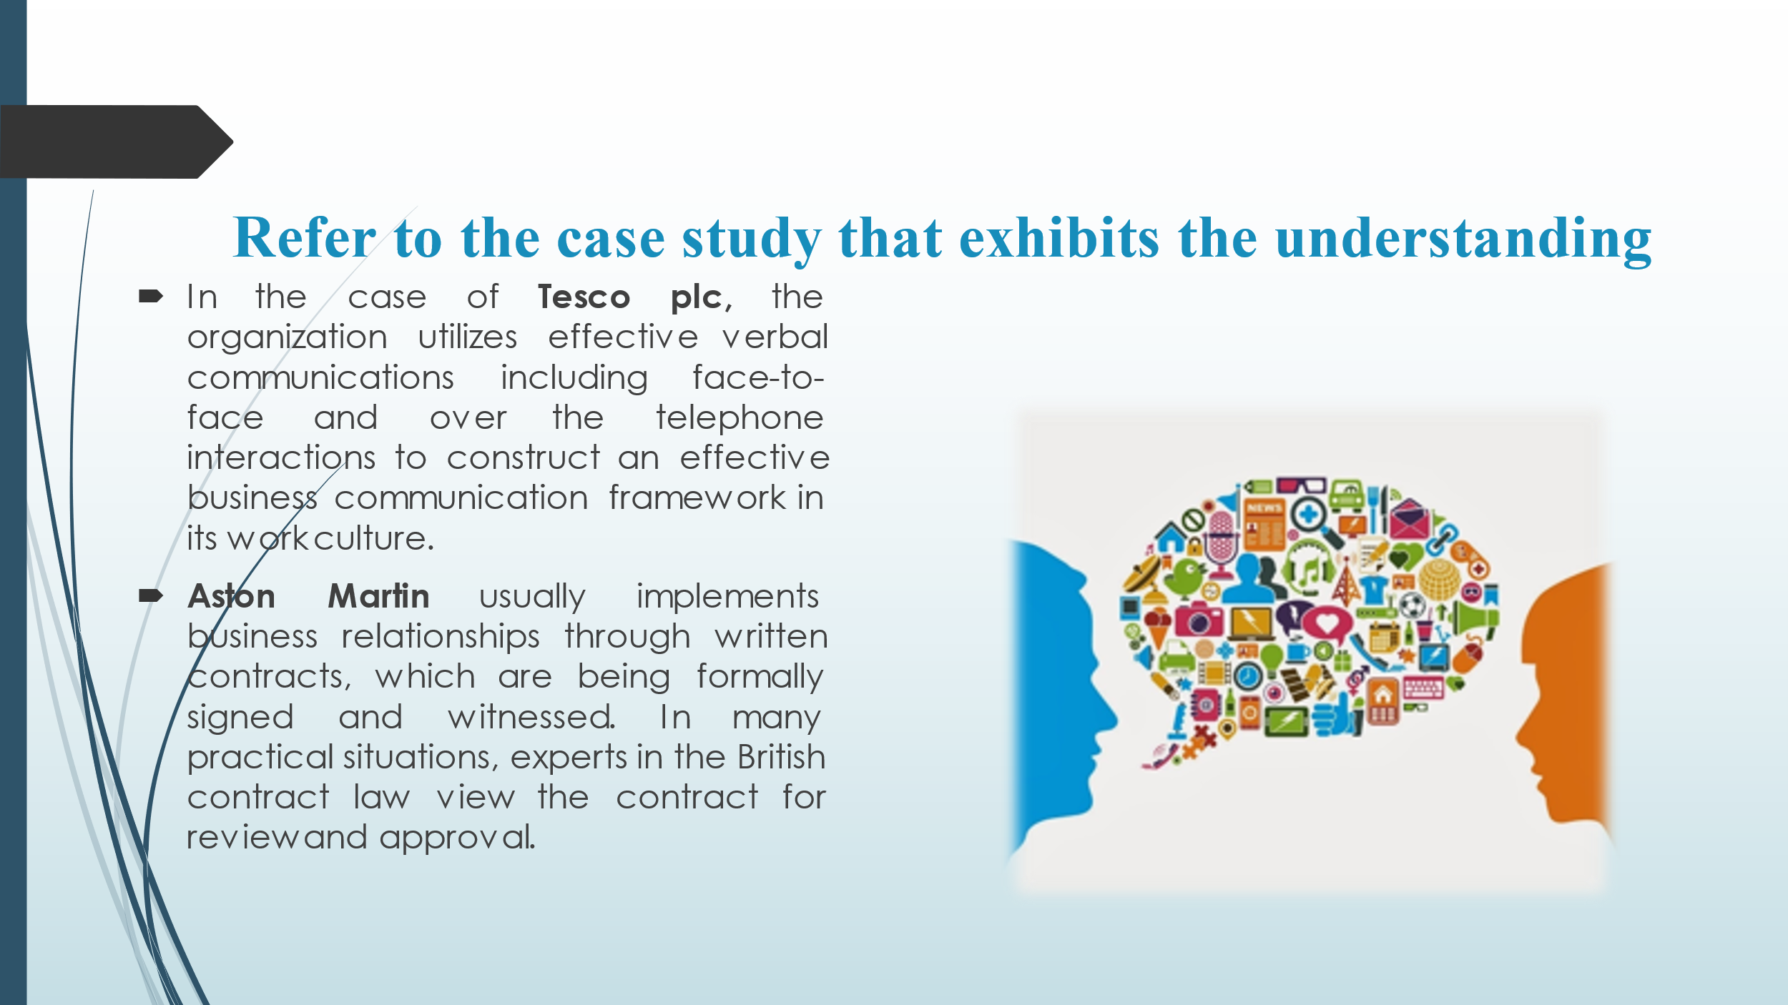 Slide 18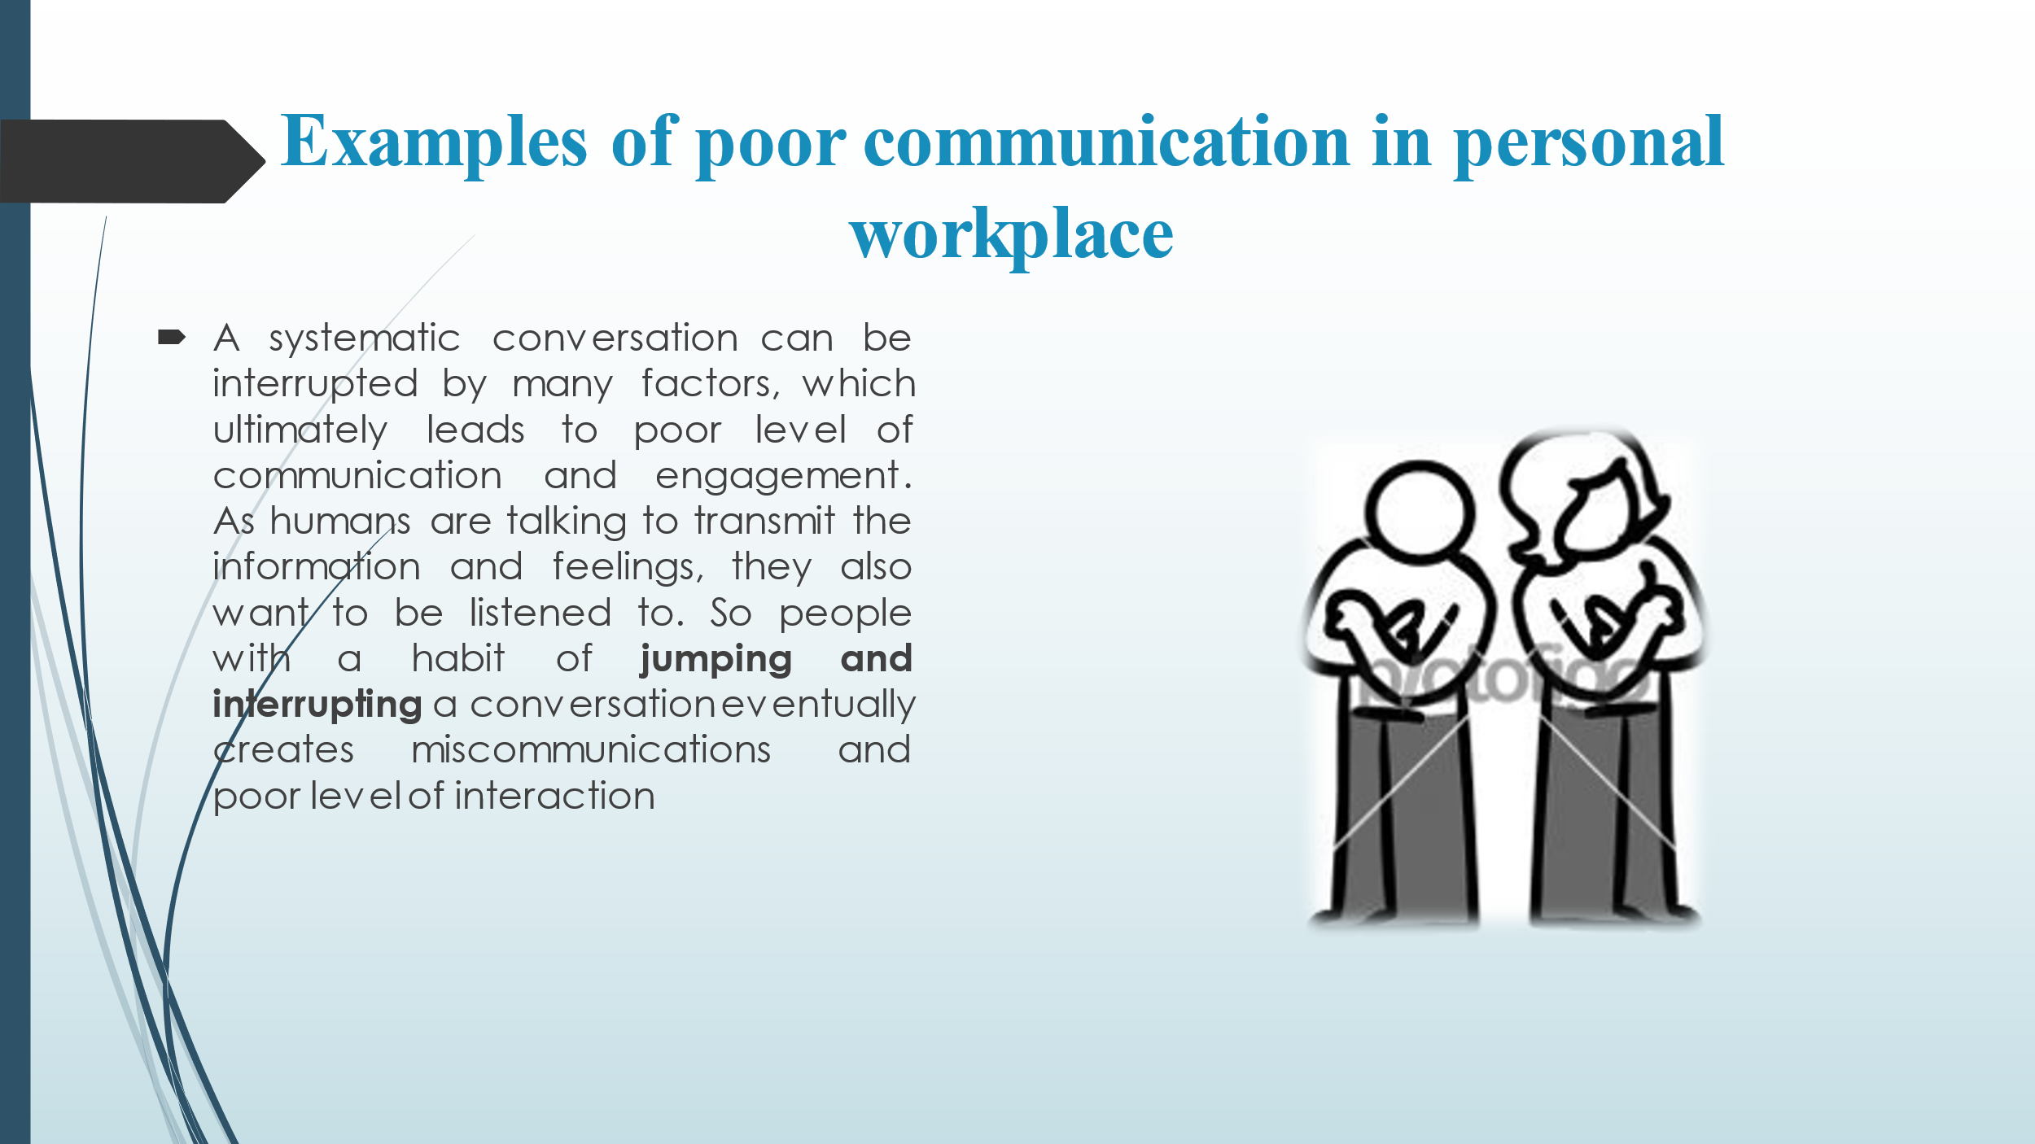
Slide 19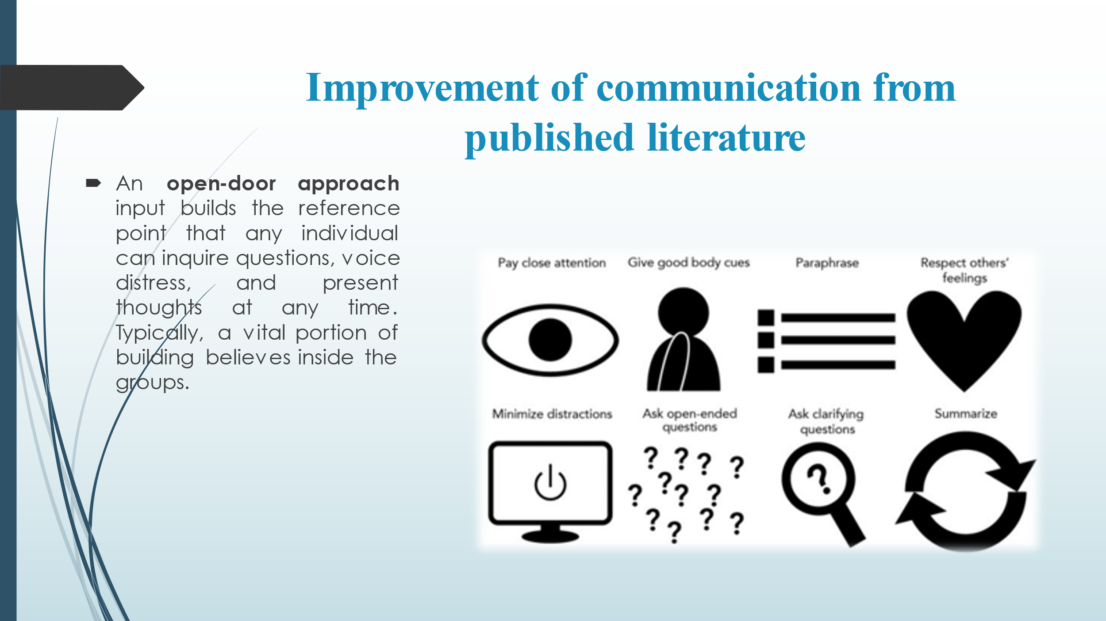
Slide 20
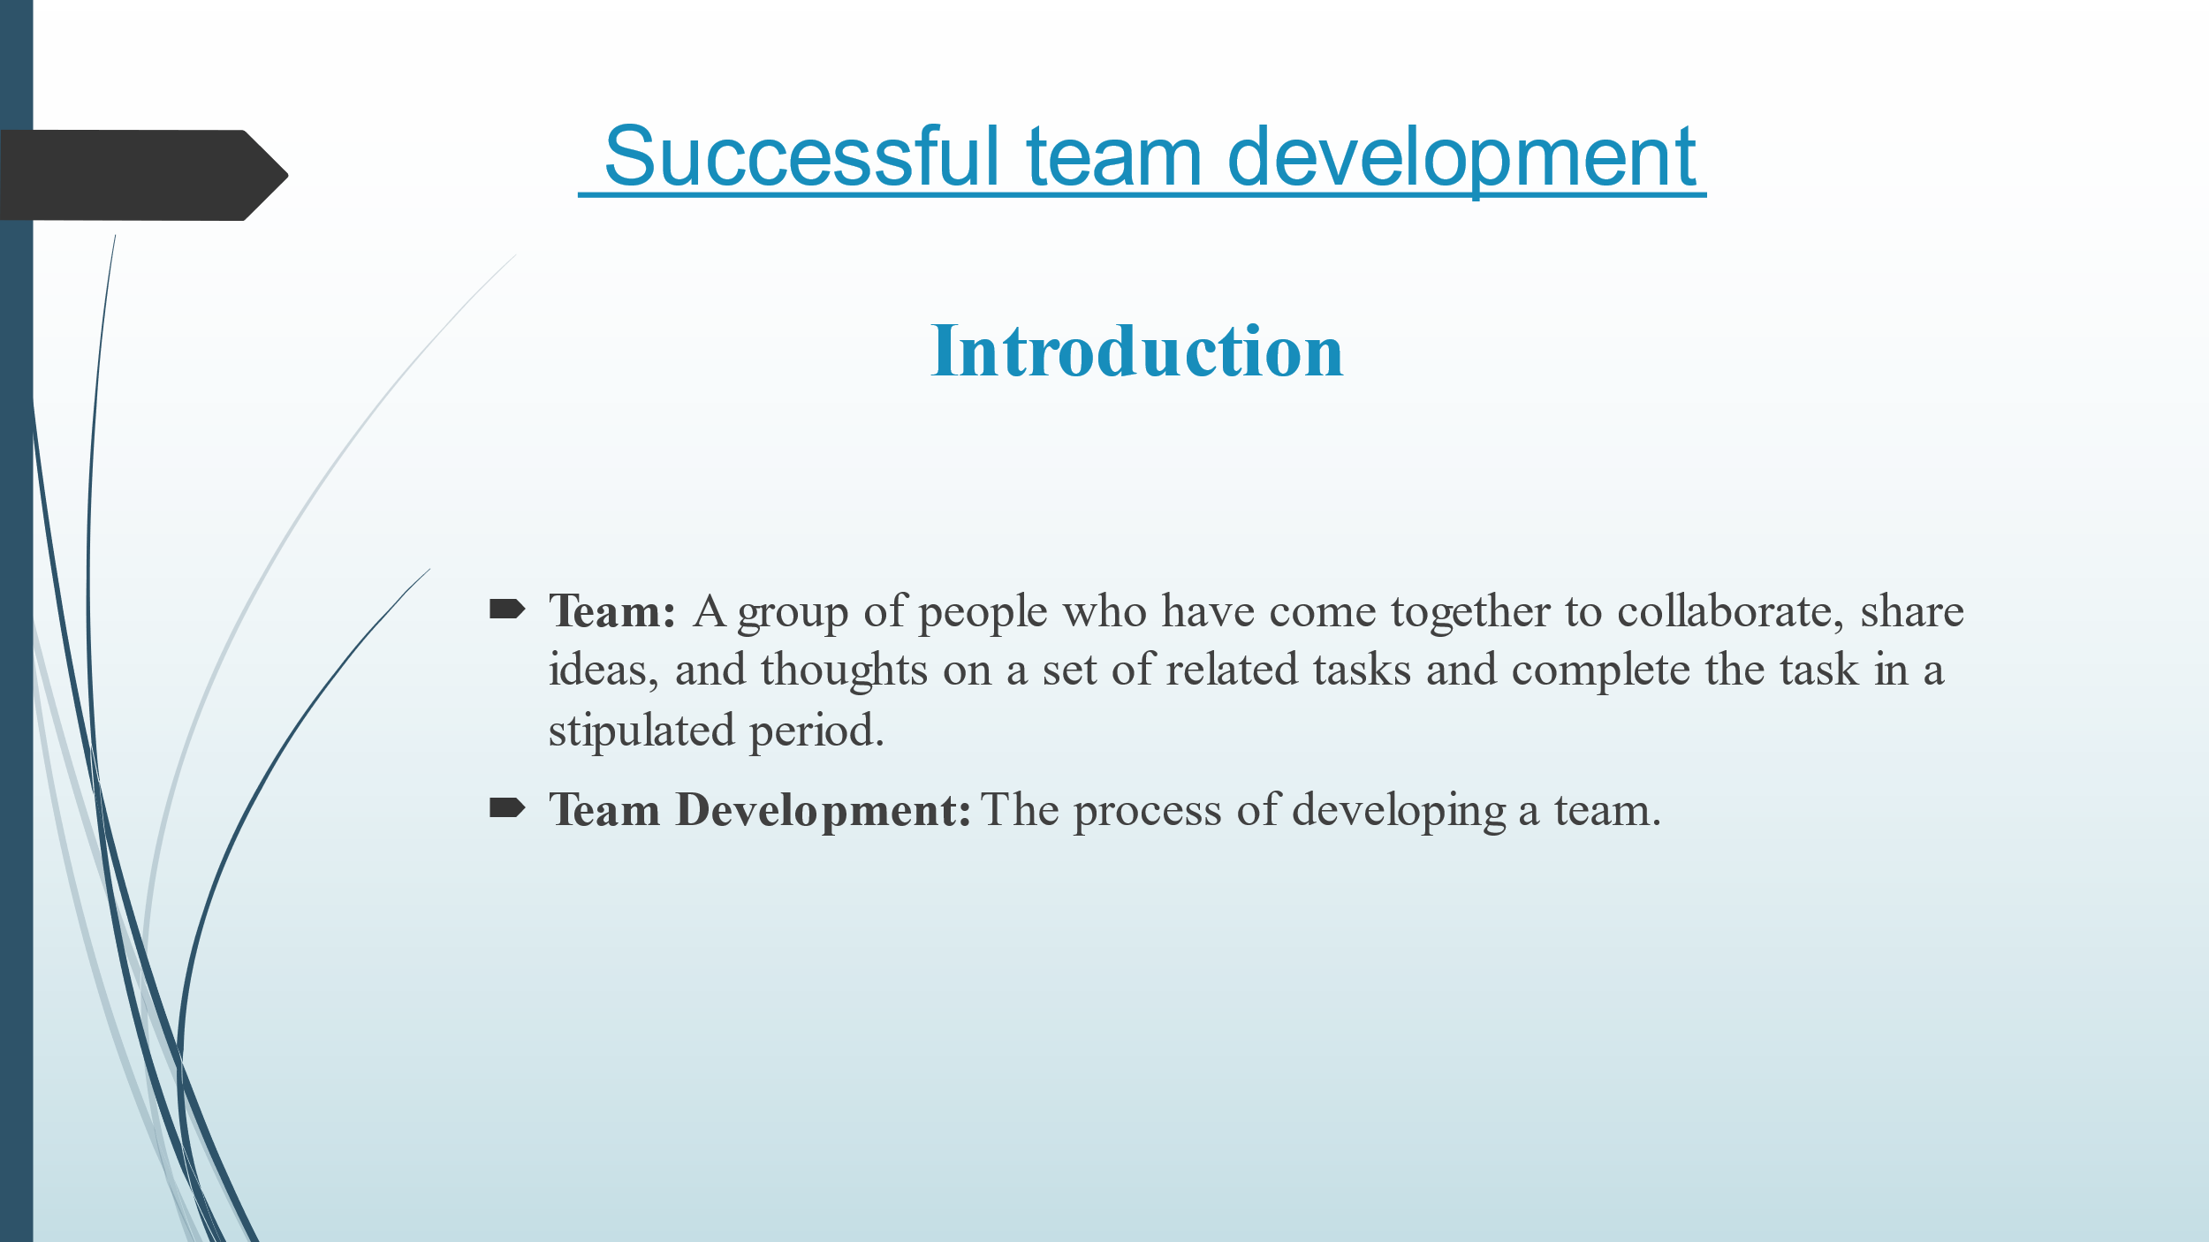
Slide 21 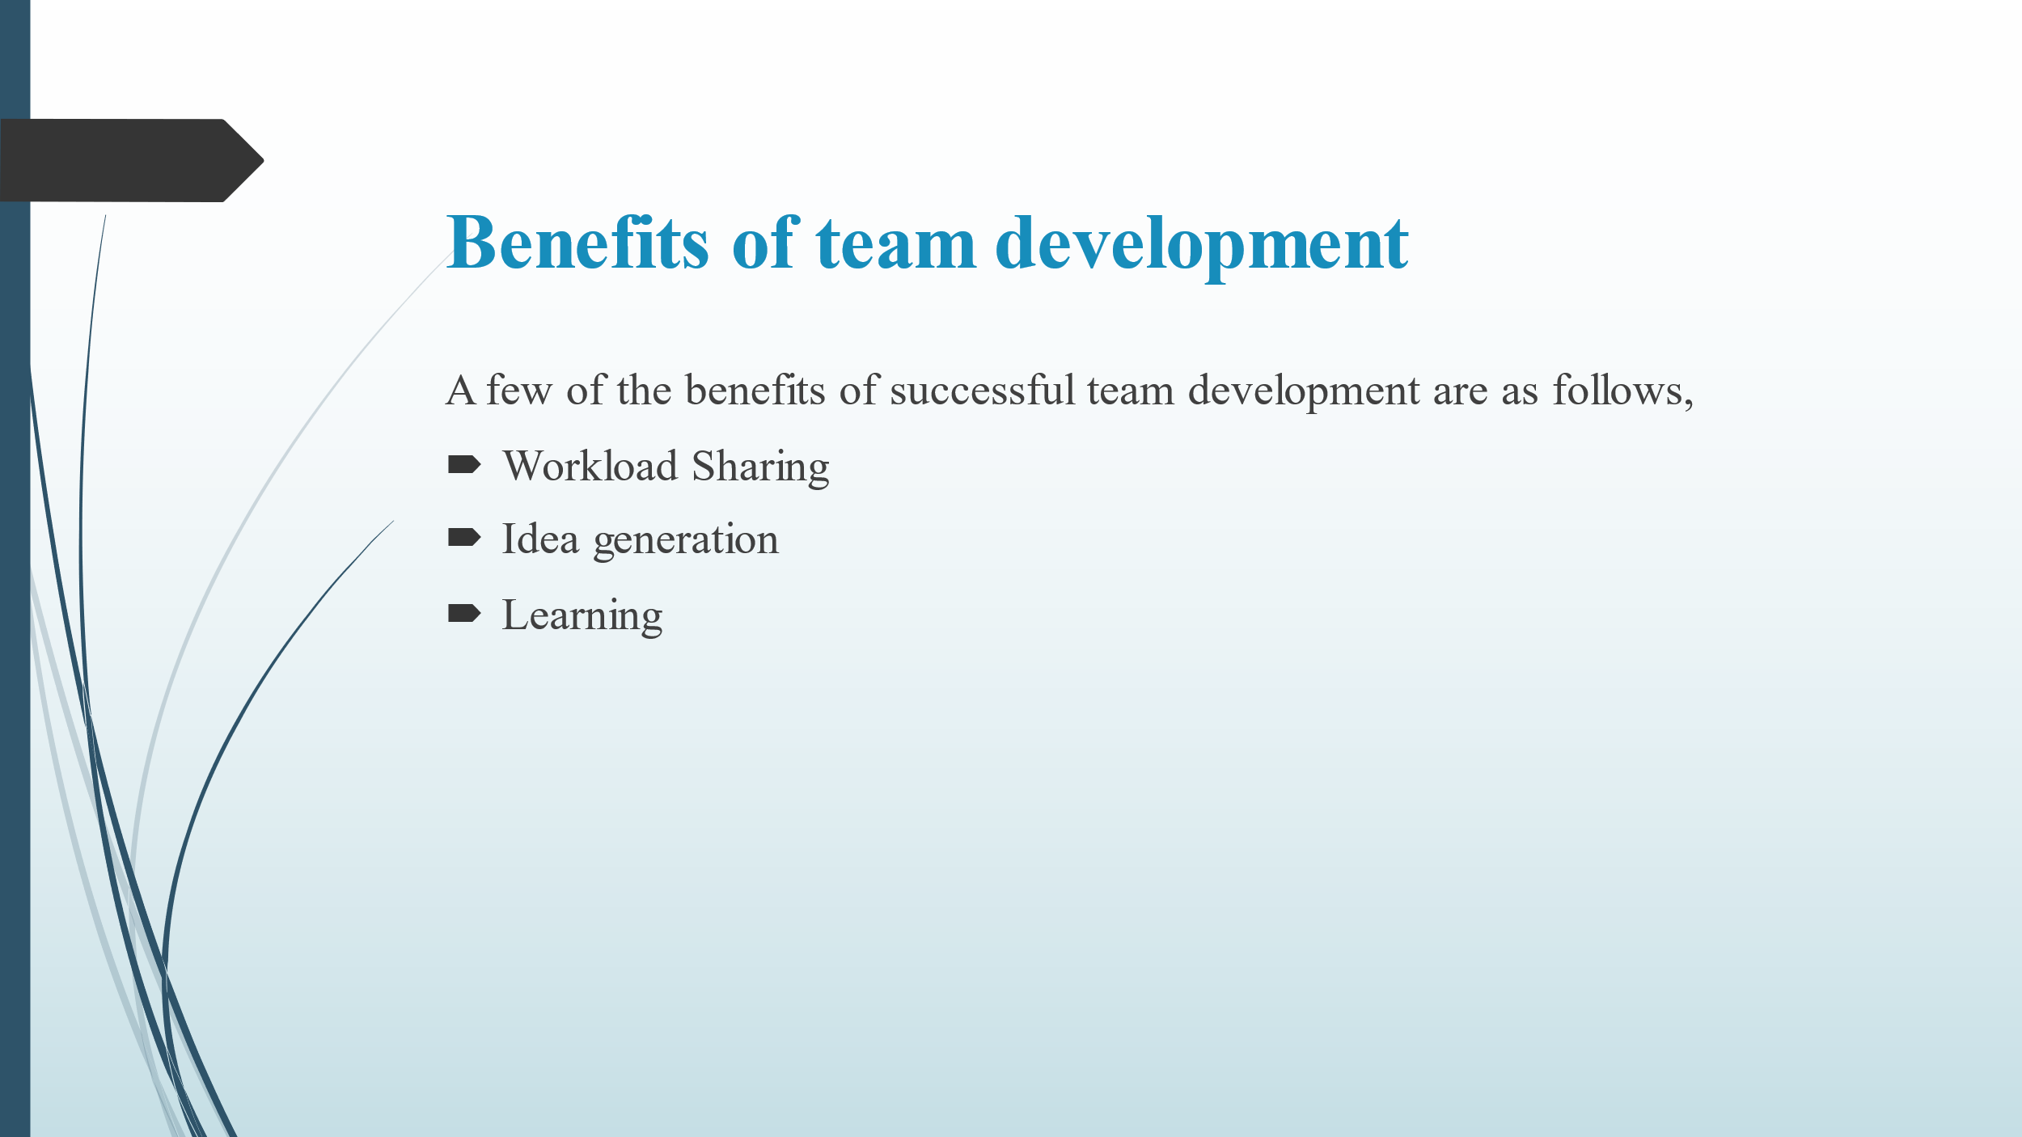
Slide 22
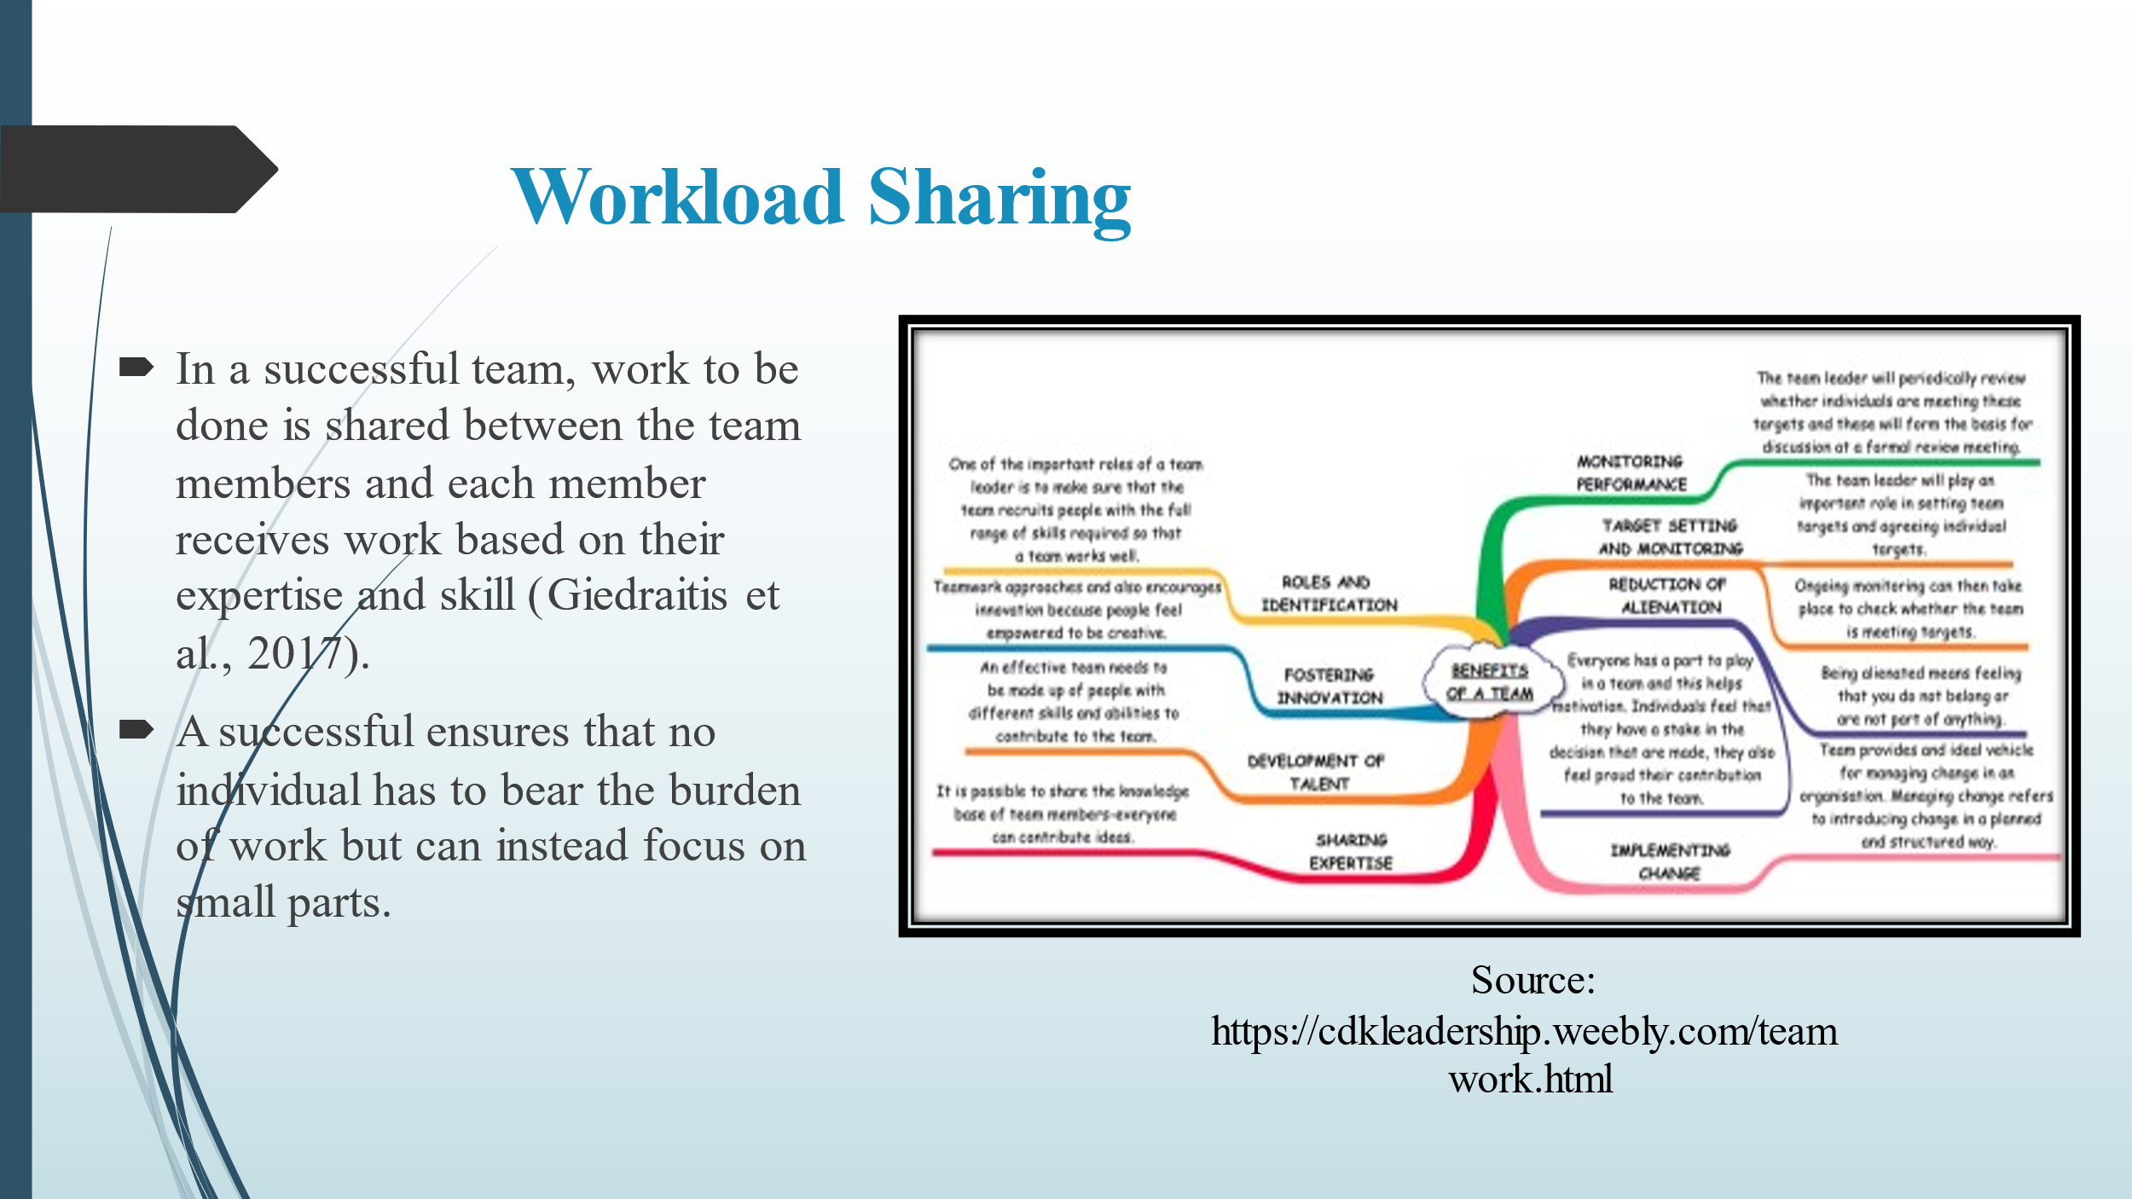
Slide 23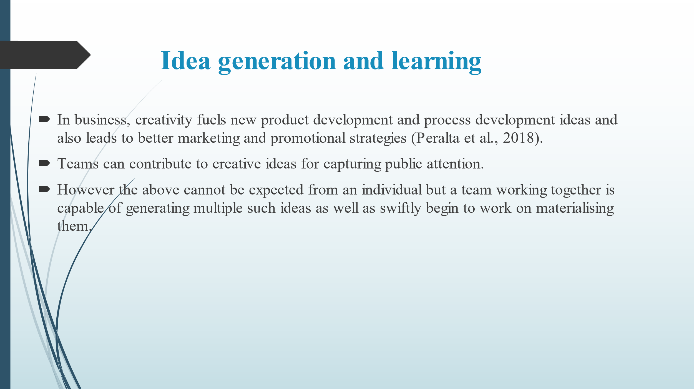
Slide 24
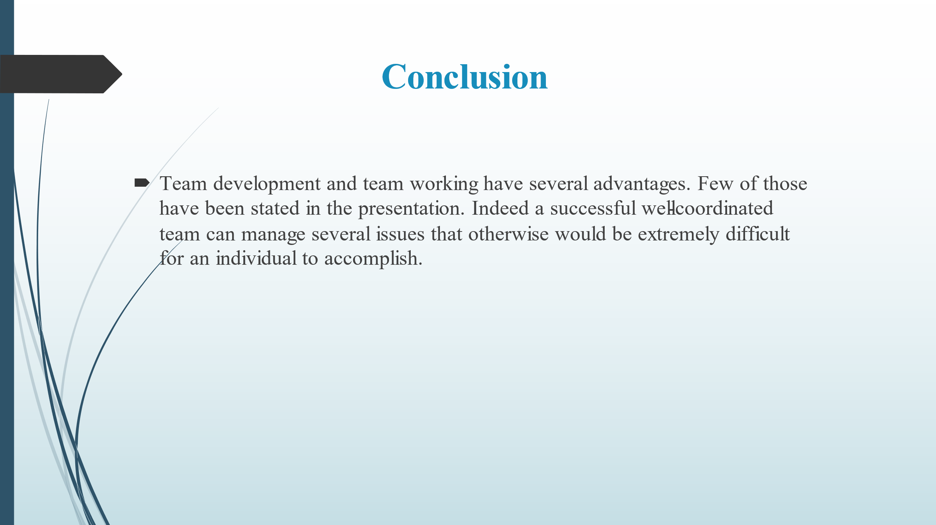
Slide 25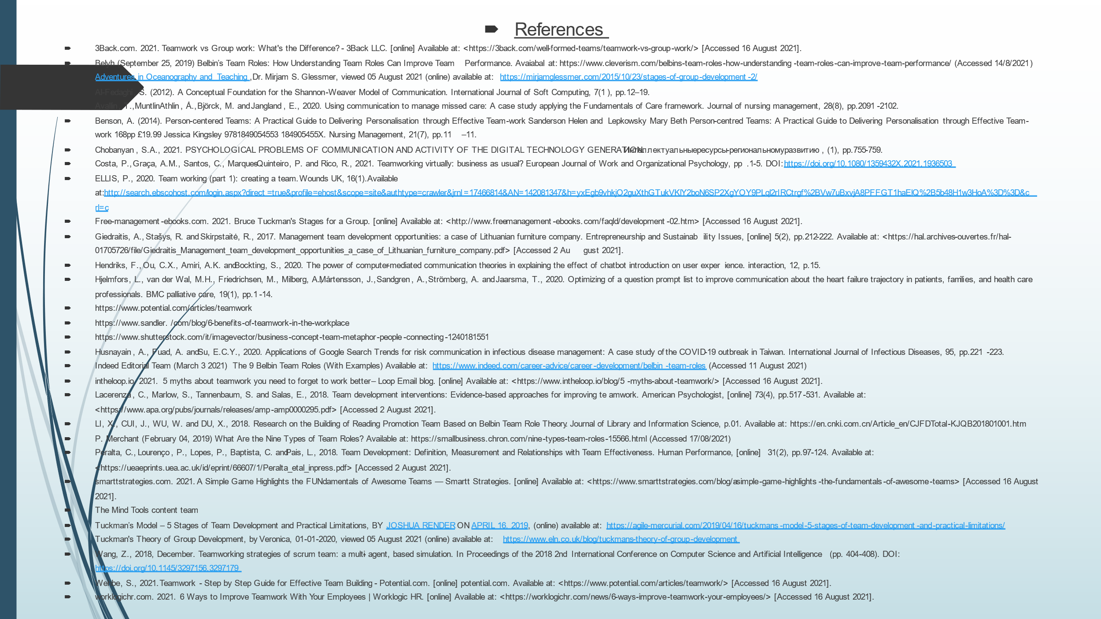
- References
- 3Back.com. 2021. Teamwork vs Group work: What's the Difference? - 3Back LLC. [online] Available at: <https://3back.com/well-formed-teams/teamwork-vs-group-work/> [Accessed 16 August 2021].
- Belyh (September 25, 2019) Belbin’s Team Roles: How Understanding Team Roles Can Improve Team Performance. Avaiabal at: https://www.cleverism.com/belbins-team-roles-how-understanding-team-roles-can-improve-team-performance/ (Accessed 14/8/2021)
- Adventures in Oceanography and Teaching,Dr. Mirjam S. Glessmer, viewed 05 August 2021 (online) available at: https://mirjamglessmer.com/2015/10/23/stages-of-group-development-2/
- Al-Fedaghi, S. (2012). A Conceptual Foundation for the Shannon-Weaver Model of Communication. International Journal of Soft Computing, 7(1), pp.12–19.
- Avallin, T., MuntlinAthlin, Å., Björck, M. and Jangland, E., 2020. Using communication to manage missed care: A case study applying the Fundamentals of Care framework. Journal of nursing management, 28(8), pp.2091-2102.
- Benson, A. (2014). Person-centered Teams: A Practical Guide to Delivering Personalisation through Effective Team-work Sanderson Helen and Lepkowsky Mary Beth Person-centred Teams: A Practical Guide to Delivering Personalisation through Effective Team-work 168pp £19.99 Jessica Kingsley 9781849054553 184905455X. Nursing Management, 21(7), pp.11–11.
- Chobanyan, S.A., 2021. PSYCHOLOGICAL PROBLEMS OF COMMUNICATION AND ACTIVITY OF THE DIGITAL TECHNOLOGY GENERATION. Интеллектуальныересурсы-региональномуразвитию, (1), pp.755-759.
- Costa, P., Graça, A.M., Santos, C., Marques-Quinteiro, P. and Rico, R., 2021. Teamworking virtually: business as usual? European Journal of Work and Organizational Psychology, pp.1-5. DOI: https://doi.org/10.1080/1359432X.2021.1936503
- ELLIS, P., 2020. Team working (part 1): creating a team. Wounds UK, 16(1).Available at:http://search.ebscohost.com/login.aspx?direct=true&profile=ehost&scope=site&authtype=crawler&jrnl=17466814&AN=142081347&h=yxEgb9vhkjO2guXthGTukVKlY2boN6SP2XgYOY9PLql2rIRCtrgf%2BVw7uBxvjA8PFFGT1haElQ%2B5b48H1w3HoA%3D%3D&crl=c
- Free-management-ebooks.com. 2021. Bruce Tuckman's Stages for a Group. [online] Available at: <http://www.free-management-ebooks.com/faqld/development-02.htm> [Accessed 16 August 2021].
- Giedraitis, A., Stašys, R. and Skirpstaitė, R., 2017. Management team development opportunities: a case of Lithuanian furniture company. Entrepreneurship and Sustainability Issues, [online] 5(2), pp.212-222. Available at: <https://hal.archives-ouvertes.fr/hal-01705726/file/Giedraitis_Management_team_development_opportunities_a_case_of_Lithuanian_furniture_company.pdf> [Accessed 2 August 2021].
- Hendriks, F., Ou, C.X., Amiri, A.K. and Bockting, S., 2020. The power of computer-mediated communication theories in explaining the effect of chatbot introduction on user experience. interaction, 12, p.15.
- Hjelmfors, L., van der Wal, M.H., Friedrichsen, M., Milberg, A., Mårtensson, J., Sandgren, A., Strömberg, A. and Jaarsma, T., 2020. Optimizing of a question prompt list to improve communication about the heart failure trajectory in patients, families, and health care professionals. BMC palliative care, 19(1), pp.1-14.
- https://www.potential.com/articles/teamwork
- https://www.sandler. /com/blog/6-benefits-of-teamwork-in-the-workplace
- https://www.shutterstock.com/it/image-vector/business-concept-team-metaphor-people-connecting-1240181551
- Husnayain, A., Fuad, A. and Su, E.C.Y., 2020. Applications of Google Search Trends for risk communication in infectious disease management: A case study of the COVID-19 outbreak in Taiwan. International Journal of Infectious Diseases, 95, pp.221-223.
- Indeed Editorial Team (March 3 2021) The 9 Belbin Team Roles (With Examples) Available at: https://www.indeed.com/career-advice/career-development/belbin-team-roles (Accessed 11 August 2021)
- intheloop.io. 2021. 5 myths about teamwork you need to forget to work better – Loop Email blog. [online] Available at: <https://www.intheloop.io/blog/5-myths-about-teamwork/> [Accessed 16 August 2021].
- Lacerenza, C., Marlow, S., Tannenbaum, S. and Salas, E., 2018. Team development interventions: Evidence-based approaches for improving teamwork. American Psychologist, [online] 73(4), pp.517-531. Available at: <https://www.apa.org/pubs/journals/releases/amp-amp0000295.pdf> [Accessed 2 August 2021].
- LI, X., CUI, J., WU, W. and DU, X., 2018. Research on the Building of Reading Promotion Team Based on Belbin Team Role Theory. Journal of Library and Information Science, p.01. Available at: https://en.cnki.com.cn/Article_en/CJFDTotal-KJQB201801001.htm
- P. Merchant (February 04, 2019) What Are the Nine Types of Team Roles? Available at: https://smallbusiness.chron.com/nine-types-team-roles-15566.html (Accessed 17/08/2021)
- Peralta, C., Lourenço, P., Lopes, P., Baptista, C. and Pais, L., 2018. Team Development: Definition, Measurement and Relationships with Team Effectiveness. Human Performance, [online] 31(2), pp.97-124. Available at: <https://ueaeprints.uea.ac.uk/id/eprint/66607/1/Peralta_etal_inpress.pdf> [Accessed 2 August 2021].
- smarttstrategies.com. 2021. A Simple Game Highlights the FUNdamentals of Awesome Teams — Smartt Strategies. [online] Available at: <https://www.smarttstrategies.com/blog/a-simple-game-highlights-the-fundamentals-of-awesome-teams> [Accessed 16 August 2021].
- The Mind Tools content team
- Tuckman’s Model – 5 Stages of Team Development and Practical Limitations, BY JOSHUA RENDER ON APRIL 16, 2019, (online) available at: https://agile-mercurial.com/2019/04/16/tuckmans-model-5-stages-of-team-development-and-practical-limitations/
- Tuckman's Theory of Group Development, by Veronica, 01-01-2020, viewed 05 August 2021 (online) available at: https://www.eln.co.uk/blog/tuckmans-theory-of-group-development
- Wang, Z., 2018, December. Teamworking strategies of scrum team: a multi- agent, based simulation. In Proceedings of the 2018 2nd International Conference on Computer Science and Artificial Intelligence (pp. 404-408). DOI: https://doi.org/10.1145/3297156.3297179
- Wehbe, S., 2021. Teamwork - Step by Step Guide for Effective Team Building - Potential.com. [online] potential.com. Available at: <https://www.potential.com/articles/teamwork/> [Accessed 16 August 2021].
- worklogichr.com. 2021. 6 Ways to Improve Teamwork With Your Employees | Worklogic HR. [online] Available at: <https://worklogichr.com/news/6-ways-improve-teamwork-your-employees/> [Accessed 16 August 2021].

