
Walsall IT Solutions - Business Plan
University of Wales Trinity Saint David


Programme: CertHE Business Skills for the Workplace
Module: LCLM4006 - Enterprise and Entrepreneurship
Component 1: Business Plan
Student Name:
Taher Mahmood
Student ID:
2427065
Lecturer:
Taonga Kaonga Sobere-Snithers
Word Count:
1597
Date of Submission:
24 October 2025

Table of Contents
Overview of the Business Idea 2
Unique Selling Point (USP). 2
Entrepreneurial Rationale. 2
Products and Services 3
Legal Format and Management Structure 4
PESTEL Analysis 5
Competitor Analysis 6
SWOT Analysis 7
Marketing Strategies 8
Digital Presence. 8
Content and Advertising. 8
Networking and Partnerships 8
Branding and Positioning 8
Funding Requirements and Start-up Expenses 9
Start-up Expenses (Month 1) 9
Cash Flow Projection (Month 1) 10
Growth and Innovation Opportunities 11
References 12

Overview of the Business Idea
Walsall IT Solutions will provide affordable, dependable, and professional IT support for small businesses, charities, schools, and individual users in Walsall and the wider West Midlands. The mission is to make high-quality IT services accessible to organisations that cannot justify the cost of a full-time IT department. Services will include maintenance contracts, system builds, cybersecurity solutions, data management, helpdesk support, consultancy, and training.

The UK business landscape highlights the need for such services. According to the Department for Business and Trade (2024), there were 5.5 million private sector businesses in the UK, with SMEs making up 99.8% of the total. SMEs dominate the West Midlands economy but often lack in-house IT resources, making them reliant on external providers. The UK Government (Department for Science, Innovation and Technology, 2025) reported that 43% of UK businesses identified a cyber-security breach or attack in the last 12 months, underlining the growing demand for cybersecurity and reliable IT systems.
Figure 1: Stock Image of bar chart

Unique Selling Point (USP).
Walsall IT Solutions will stand out by combining affordability with quality service. Unlike national IT firms, the company will be embedded locally, enabling faster response times and personalised support. Flexible contracts, data protection expertise, and transparent pricing will appeal to SMEs, charities, and schools. Longer-term objectives include securing ten SME and school contracts in the first year, achieving over 90% satisfaction, and expanding into cloud services and advanced cybersecurity packages by Year 2.

Entrepreneurial Rationale.
The idea is grounded in a clear local need. Many SMEs in the West Midlands cannot afford dedicated IT staff yet rely heavily on digital systems. By offering scalable, contract-based solutions, Walsall IT Solutions bridges this gap. The founder’s previous experience in IT field support and system maintenance provides technical competence and credibility. This background, combined with local market understanding, ensures the business can grow sustainably while responding quickly to client needs.

Products and Services
Walsall IT Solutions will offer a balanced mix of services to meet SME and individual needs:
- Maintenance Contracts: Monthly or annual plans offering proactive monitoring, updates, and priority callouts to reduce downtime (Barrow, Barrow and Brown, 2021, pp. 67-68).
- System Builds and Installations: Bespoke PCs, servers, and networks with cloud integration for hybrid working.
- Cybersecurity: Firewalls, endpoint protection, penetration testing, and staff training to counter the rising number of cyber threats (Department for Science, Innovation and Technology, 2025).
- Data Management and Backup: Cloud-based and local backup ensuring GDPR compliance and continuity for schools, charities, and SMEs.
- Consultancy and Audits: Infrastructure assessments, cloud migration advice, and lifecycle planning to optimise client systems.
- Helpdesk Support: Tiered Bronze (£200/month), Silver (£500), and Gold (£1,000) contracts, plus ad hoc work (£50-£70/hour), offering flexibility for different clients (Barrow, Barrow and Brown, 2021, pp. 72-76).
- Training: Workshops on IT basics and cybersecurity awareness, discounted for schools and charities.

This mix combines business contracts with one-off residential work, such as repairs, upgrades, and malware removal, creating multiple income streams. Advisory services will include support for charities applying for discounted licences through programmes like Microsoft for Nonprofits, fostering long-term client relationships (Barrow, Barrow and Brown, 2021, pp. 111-115).

Legal Format and Management Structure
The business will operate as a private limited company (Ltd) to limit liability and build credibility with schools, charities, and SMEs (Barrow, Barrow and Brown, 2021, p.37). This structure is particularly suitable for IT consultancy and support businesses, where client trust and data protection responsibilities are high. Limited companies are viewed as more professional than sole traders, especially when working with educational institutions and public sector clients who require formal contracts and proof of insurance.
Rationale for Ltd format:
- Limits personal liability for the founder.
- Provides a professional image for contracts with SMEs and schools.
- Allows scalability and access to investment as the company grows.
- Enhances eligibility for public sector tenders and framework agreements.
Management structure:
- Managing Director (Taher Mahmood): strategy, client relationships, and business development.
- Technical Support Engineers: remote and onsite IT services, installations, and builds.
- Administrative Support: billing, scheduling, and client records.
This lean structure keeps overheads low while remaining scalable as the company develops. As the business grows, additional roles such as Sales Executive or IT Trainer may be introduced to support marketing and client engagement.

PESTEL Analysis
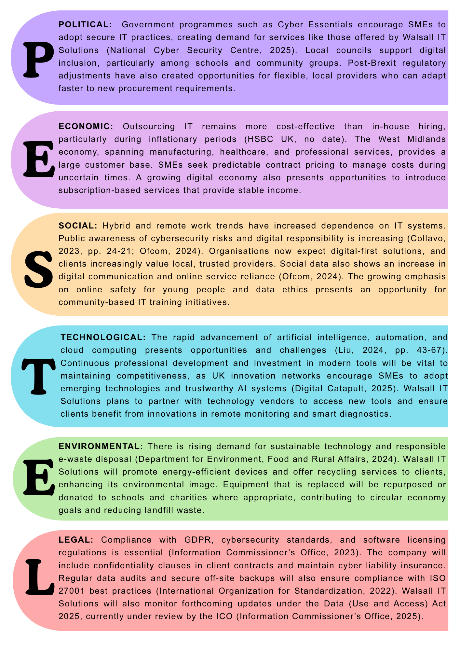
Figure 2: PESTEL Analysis of Walsall IT Solutions

Competitor Analysis
The local IT support market in the West Midlands is competitive, with several firms already offering similar services.
Direct Competitors:
- Vibrant Networks: Local managed IT, cloud, security, VoIP, and backup services.
- Computercentric Ltd.: Provides consultancy, maintenance, and bespoke software.
- Orbital10 Ltd.: Focuses on cybersecurity, data backup, and remote infrastructure.
These firms already provide many of the services planned by Walsall IT Solutions; therefore, the business will focus on specialisation, customer service, and agility to stand out.
Indirect Competitors:
- Geek Squad / Best Buy: National consumer and business IT support, often delivered remotely.
- Remote MSPs and SaaS providers: Subscription-based IT and security services available across the UK.
- Cloud service providers (AWS, Microsoft Azure, Google Cloud): Offer built-in support tools that may reduce local demand.
While these competitors offer scalability and automation, many SMEs and schools still prefer local, reliable providers for on-site assistance and trusted relationships (Ofcom, 2024).
Walsall IT Solutions will differentiate itself by combining affordable pricing, fast local response times, and personalised customer care, aligning with Mariotti and Glackin’s (2016) view that small enterprises succeed through service quality and trust rather than scale.

SWOT Analysis
This understanding of the competitive environment informs the following SWOT Analysis, which outlines the company’s strengths, weaknesses, opportunities, and threats within the regional IT services sector.
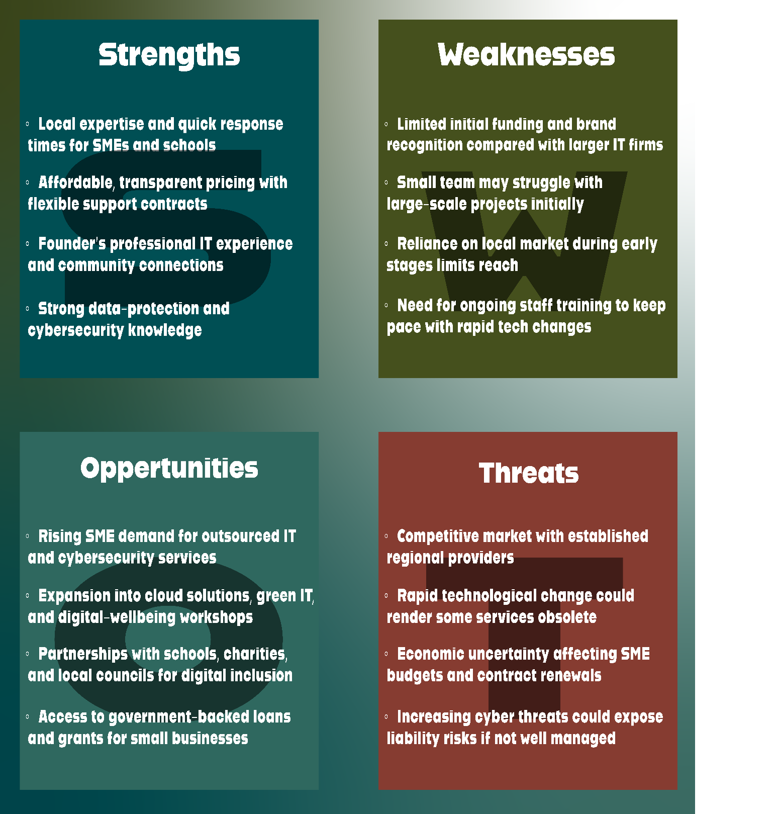
Figure 3SWOT Analysis of Walsall IT Solutions.
This SWOT analysis highlights that the company’s primary advantage lies in its local presence and affordable, professional service. By addressing weaknesses such as limited scale and focusing on training, Walsall IT Solutions can leverage growing digital demand and secure a stable position in the regional IT services market.

Marketing Strategies

Digital Presence.
A professional website will be optimised for local search terms such as ‘IT support Walsall’ and ‘West Midlands IT services’ (Bplans, no date). A Google Business Profile will help capture search traffic and reviews. Social media engagement will target SMEs on LinkedIn and the local community via Facebook and X/Twitter, featuring case studies and testimonials to demonstrate reliability and expertise.

Content and Advertising.
Monthly blog posts on topics such as ‘Cyber Hygiene for SMEs will position the company as a thought leader. A £200 monthly budget will fund Google Ads and sponsored posts. YouTube videos and newsletters will expand reach and keep clients informed.

Networking and Partnerships
Membership with Walsall Chamber of Commerce and local business networks will enhance visibility. Discounts for schools and charities will strengthen community links. Referral incentives will encourage client recommendations, as word-of-mouth remains a key driver for SMEs (Mariotti and Glackin, 2016). Attendance at regional tech expos will provide valuable networking opportunities.

Branding and Positioning
The brand will convey professionalism, trust, and affordability. Testimonials and case studies will build credibility, while consistent colours, logo design, and language will create a recognisable identity. Flyers and online adverts will reinforce visibility, and highlighting remote-first tools will highlight responsiveness and reliability.

Funding Requirements and Start-up Expenses
Funding Required Approximately £20,000 will be necessary to fund equipment, insurance, marketing, staff salaries, and initial working capital for the first month of operations. This will ensure that the business can maintain stability while building its initial client base.
Funding Sources
- Personal savings (£5,000): demonstrates founder commitment and provides a financial safety margin for working capital.
- Start Up Loan Scheme (£10,000): a government-backed loan offering low-interest and flexible repayment terms (Start Up Loans, no date).
- Early sales revenue (£2,500): projected from initial client contracts and ad-hoc IT support work.
- Potential grant support: available from organisations such as the Prince’s Trust to assist with small business start-ups (Prince’s Trust, no date).

Start-up Expenses (Month 1)
Item | £
Registration and insurance | 500
Equipment and software | 3,000
Marketing | 500
Vehicle and travel | 250
Wages (founder + part-time support) | 2,000
Contingency, training and working capital | 951
Total | 7,201
Figure 4: Start-Up Expenses Table.
Source: Authors Own
Risks such as competition, cyber incidents, or cash-flow shortfalls will be mitigated through insurance, contract-based income, and careful working-capital management. Additional funds are reserved for professional development and software subscriptions to ensure adaptability to modern technologies.

Cash Flow Projection (Month 1)
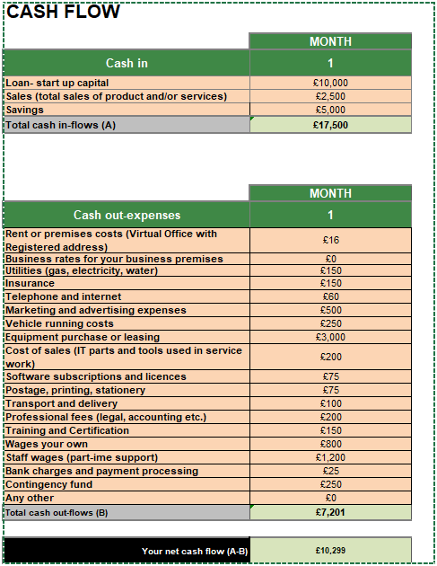
Figure 5: Month 1 Cash Flow Forecast for Walsall IT Solutions.
The forecast shows a positive net cash flow of £10,299, indicating strong liquidity during the start-up phase and the capacity to reinvest in marketing, technology, and staff training. With a solid financial foundation and positive early cash flow, Walsall IT Solutions will be well-positioned to invest in future growth opportunities and innovation.

Growth and Innovation Opportunities
Future growth will include expanding into Managed Service Provider (MSP) packages with 24/7 monitoring, developing green IT programmes using refurbished computers for schools, and partnering with local colleges to train apprentices. The company may also offer digital wellbeing and online-safety workshops for parents and schools, combining business and community benefit.
Long-term, Walsall IT Solutions aims to diversify through white-label services for smaller IT providers, supporting regional collaboration and scalability. The business will adopt recognised best practices in data security and service quality to strengthen its credibility for larger contracts. Continued investment in Research & Development will enable exploration of AI-driven monitoring tools to predict system failures, reinforcing its reputation for innovation and reliability.
By Year 3, the company plans to open a regional office to serve the wider West Midlands and recruit two additional engineers, maintaining a strong local presence with personalised service.

References
Barrow, C., Barrow, P., and Brown, R. (2021) The business plan workbook: a step-by-step guide to creating and developing a successful business. 10th edn. Kogan Page.
Bplans (no date) Sample business plans. Available at: https://www.bplans.com/sample-business-plans/ (Accessed: 21 October 2025).
Collavo, T. (2023) Foundations of social entrepreneurship: theory, practical tools, and skills. Routledge.
Department for Business and Trade (2024) Business population estimates for the UK and regions 2024: statistical release. Department for Business and Trade. Available at: https://www.gov.uk/government/statistics/business-population-estimates-2024/business-population-estimates-for-the-uk-and-regions-2024-statistical-release (Accessed: 15 October 2025).
Department for Environment, Food and Rural Affairs (2024) UK Waste Electrical and Electronic Equipment (WEEE) Regulations Guidance 2024. Department for Environment, Food and Rural Affairs. Available at: https://www.gov.uk/guidance/regulations-waste-electrical-and-electronic-equipment (Accessed: 19 October 2025).
Department for Science, Innovation and Technology (2025) Cyber security breaches survey 2025. Department for Science, Innovation and Technology. Available at: https://www.gov.uk/government/statistics/cyber-security-breaches-survey-2025/cyber-security-breaches-survey-2025 (Accessed: 16 October 2025).
Digital Catapult (2025) “How AI assurance is boosting industrial supply chain resilience.” Digital Catapult Blog, 21 July. Available at: https://www.digicatapult.org.uk/blogs/post/ai-assurance-industrial-supply-chain-resilience/ (Accessed: 18 October 2025).
HSBC UK (no date) How to write a business plan. Available at: https://www.business.hsbc.uk/en-gb/insights/starting-a-business/how-to-write-business-plan (Accessed: 17 October 2025).
Information Commissioner’s Office (2023) Guide to the UK General Data Protection Regulation (UK GDPR). Information Commissioner’s Office. Available at: https://ico.org.uk/for-organisations/uk-gdpr-guidance-and-resources (Accessed: 19 October 2025).
Information Commissioner’s Office (2025) Plans for new and updated guidance: Data (Use and Access) Act 2025. Information Commissioner’s Office. Available at: https://ico.org.uk/about-the-ico/what-we-do/our-plans-for-new-and-updated-guidance/ (Accessed: 19 October 2025).
International Organization for Standardization (2022) ISO/IEC 27001:2022 Information security, cybersecurity, and privacy protection, Information security management systems, Requirements. International Organization for Standardization. Available at: https://www.iso.org/standard/82875.html (Accessed: 20 October 2025).
Note: Accessed via ISO catalogue summary; full standard available for purchase only.
Liu, O.Y. (2024) Start-up Wolf: the Shenzhen model of high-tech entrepreneurship. Routledge.
Mariotti, S. and Glackin, C. (2016) Entrepreneurship: starting and operating a small business. 4th edn. Pearson.
National Cyber Security Centre (2025) Cyber Essentials scheme guidance 2025. NCSC. Available at: https://www.ncsc.gov.uk/cyberessentials/overview
(Accessed: 17 October 2025).
Ofcom (2024) Online Nation 2024 report: digital habits and connectivity in the UK. Ofcom. Available at: https://www.ofcom.org.uk/research-and-data/media-literacy-research/online-nation (Accessed: 18 October 2025).
Prince’s Trust (no date) Business plans. Available at: https://www.princes-trust.org.uk (Accessed: 21 October 2025).
Start Up Loans (no date) Success stories. Available at: https://www.startuploans.co.uk/success-stories (Accessed: 21 October 2025).

