- Introduction
Apex Construction group were appointed as lead consultants by University of Trinity St David (UWTSD) in October 2023. Instruction was to complete an initial feasibility study, following on to offer a comprehensive proposal of the design and delivery of a Health Centre located in Neath Port Talbot.
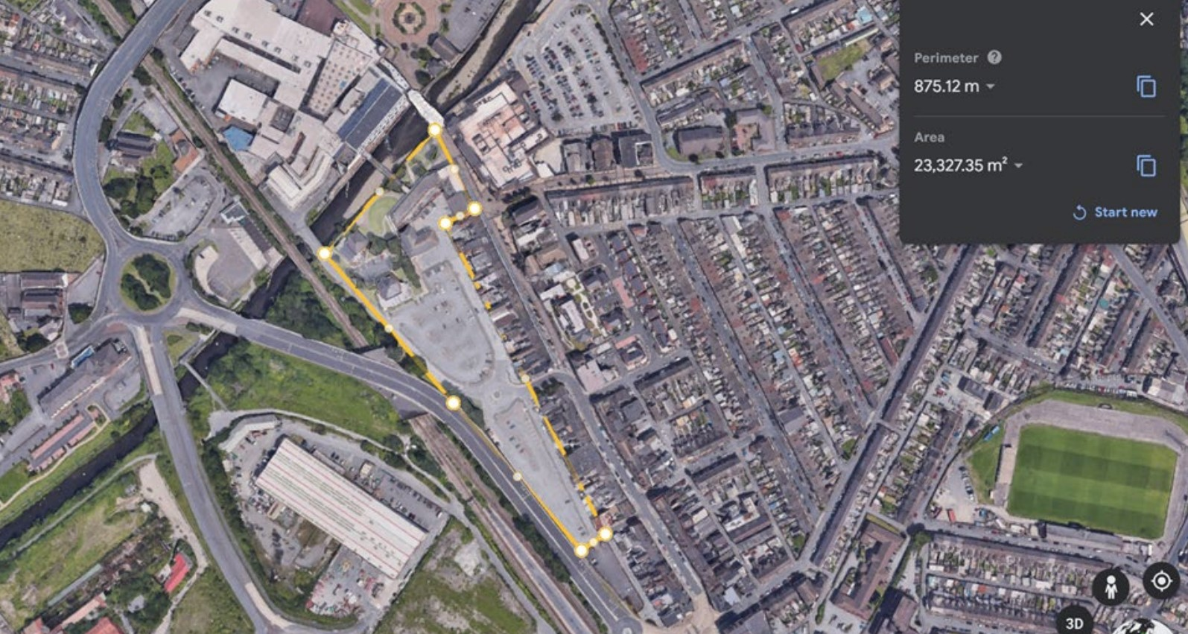

1.1 Background explaining reasons why the scheme is being considered.
UWTSD aim is to install a landmark building for the use and function, using the innovative design and engineering which allows the construction of a health centre with consideration and contribution to energy efficiency in all service provisions. The area Port Talbot is located the county borough of Neath Port Talbot with large history tied to the development of the iron and steel industry which has played a huge part in shaping the town. The aim of the project will be to encourage a range of demographic to move through the existing town and surrounding areas. The health centre will include not only a gym and spa facility, but a place where the people of Port Talbot can go and learn how to educate themselves on living a healthy lifestyle.
The health centre will help Port Talbot raise awareness in mental health but also physical health and show the importance of looking after yourself and the world we live in. By intelligently integrating elements of physical, mental, and environmental health, the structure is poised to make a significant positive impact on the locality, promoting regular returns to the site. Approximately 30 jobs catering to diverse demographics in Port Talbot will be created, spanning both skilled and unskilled positions to draw in more individuals to the area. In addition to appealing to the expanding student population, the facility will strive to cater to the entire family, offering a spectrum of services ranging from youth classes to yoga sessions for the elderly and more.
The facility is designed to be modern, incorporating ample natural light and abundant greenery to enhance the mental well-being of its users. Positioned as a standout structure in Port Talbot, it aims to showcase a forward-looking perspective while utilizing construction materials sourced locally. The goal is to minimize the carbon footprint of the building, aligning with the area's air pollution policy.
Promoting sustainable travel is of utmost importance for the building, given its location in the masterplan area, which revolves around encouraging sustainable transportation. Positioned adjacent to a cycle path, the building will feature conveniently accessible bike racks beneath the adjacent structure.
1.2 Scope of the Feasibility Study
The scope of the feasibility study outlines the existing opportunities and risks presented by the site and its closeness, considering the impact of the design and construction. An examination and detailed exploration will be carried out next. Our team will strive to visualize how the installation and ultimate product align with the client's requirements, incorporating novel and stimulating elements that may not have been explicitly outlined in the client's initial brief. Special attention will be given to ensuring the well-being of both the construction personnel and the building's end users, as well as maintaining a focus on environmental considerations throughout all phases of the project. Additionally, the study will consider costs, starting with an evaluation of initial costs and estimates, extending to maintenance and overall life expenses. Moreover, a thorough list of exclusions from the contract will be formulated to ensure clarity.
2.1 Customer Supplied Information
For the development of the new health centre, the client has stated that the new build must contain:
- Reception / Welcome Area
- Supplement Store
- Library Space
- Classroom Space
- Changing Rooms for Gym (male and female)
- Cardio Space
- Resistance Training Space
- Multifunctional Room
- Treatment Centre
- Treatment Waiting Room
- Massage Room
- Cryo Chamber Room
- Sauna
- Steam Room
- Toilets
- Rooftop Bar
- Plant Room

