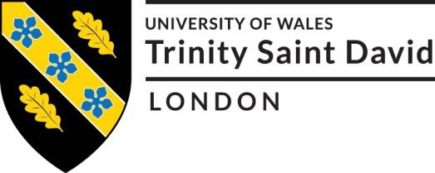

Professional Career Development BMSW005

University of Wales Trinity Saint David- London Campus

Student name: Maura Sousa
Student number: (1815905)
Teacher name: Mary March

Table of content
- Introduction
- Reflection of Role Play
- Self-evaluation
Self-motivation
Learning styles
- Personal development/ career Plan
- Conclusion
- Personal development plan

Introduction
This report will demonstrate my personal reflections and career developing plan, along with skills, understandings and knowledges that I currently hold. I come from a small town in Northern- Ireland, and where I’m from does not have many opportunities, I decided that I had to get out of my comfort zone and get new opportunities that can help me for a good future career. Therefore, I chose the UWTSD university at the London campus to continue with my studies as they welcome any kinds of students. I have chosen to study business management has it brings lots of opportunities such as contributing within organisations effectively and it also allows me to develop understandings around the business area. When I finish my course, I want to be able to leave the university with as many skills as possible to eventually fulfil my dream to work at a great job or possible an opening of my own business.
Reflection of the Role Play
Gibbs Reflective Cycle is an effective theory that helps to reflect back to events that as happened it allows you to learn and plan things that went well, not so well and can be improved the next time. (Gibbs,1988).
With the help of my lectures feedback sheet towards my role play I will be finding possible ways that I could’ve carried the interview in a more structured and positive way.
The roles of being a manager is to be able to make quick decisions and put them into practice, the ability to solve problems with a positive attitude with the implementation of conducting an organised department of success around the business area, as well as developing sales strategies and merchandising presentations.
My preparation for the interview wasn’t the best, I feel like that I should’ve did more background research about the company, I wasn’t very familiarised with the company’s history therefore, looking at my feedback I can see that no knowledge of the organization was approached, in future time I tend to spend more time researching the background of the business as it is very Important to be aware of the background story of an organisation. When my interview began, I was a bit nervous to mess up. Relevant questions about the job role and personal questions were asked, thinking and looking back I can say that I could’ve developed more my answers to give a good response to the interviewer, as my answers weren’t very detailed. Few qualities of mine were presented along with personal skills and the necessary skills for the position. In future time I intend to make notes of my personal skills that I can use for the position of being a manager and skills that are needed this will help me to develop more in answering detailed questions and having the ability to flow on when doing an interview.
Self-evaluation
Self-evaluation uses the comparison of before and current situations, it involves the learning, progress and development to determinate what needs to be maintained or still needs to be improved (Alvik,1996).
I have conducted an online quiz to see how self-motivated I am, I had to answer twelve question and within the questions at the end an automatic score calculation will appear my scores is at the middle section which is okay I’m a very self-motivated person but I should push myself more not only relying on the obvious but try new obstacles that will help me to achieve more in life.
Self-confidence and Self-efficacy- my score was fourteen out of twenty is a pretty high score but I could’ve been better I feel like that I need to focus more on my confidence and believing more in myself as I tend to push my own self down sometimes but always saying negative comments towards my failures or winnings. I need to recognise more my potentials and abilities to achieve something. Positive thinking and positive thinking about the future- my score was eleven out of twenty low score I need to be more aware of my thoughts as I have to overcome all negatives and replace them with positivity this will help me to attract a better future thinking for my own self making it easier for me to achieve anything I set to achieve. Focus and Strong Goals- it was an in between score of five of ten I feel like that I need to set myself stronger goals to make me focus and direct me into and effective goal setting to help focus into only one thing. I need to challenge myself more and get out of my comfort zone. Motivating Environment- my score was ten out of ten a great score I can say that I like to surround myself with people that remind me of my own goals, I like helping others work as a team and support others, seeing people happy with their own goals achieved. Overall I need to change some of my attitudes towards myself I feel like that I need to be more focused and have the ability of challenging myself into trying new things to see if they are going to help me on boosting up myself evaluation, allowing myself to have clear ideas visions commitments that can help achieve a respective goal that ill set to myself.
Self-motivation
Self-motivation is the ability to motivate yourself, showing the commitment to set a goal and achieving (HEA,2009).
What really motivates me is my parents, since a young I have been seeing them achieve anything they want, they work hard to ensure that anything is missing. They have started off by getting and then buying two houses one in Portugal and one in Northern-Ireland, by seeing this it really motivates me to work even harder to be able to achieve the same or more. For example, one of my plans is to be able to do the master’s degree then eventually have the mentality and the whole aspects to open up my own business.
Learning Styles
VAK is the short form for Visual, Auditory and Kinaesthetic, these are sensory modalities which then decides what’s the learners best learning style (Sreenidhi,2017)
According with the VAK learning styles questionnaire that I have done, I could see that the best way of me learning is by seeing “ visually”. When learning I to be able to see what is been explained, because I get distracted very easily therefore, I rather visualise instead of hearing or physically doing things. For example, when I was sixteen, I did a part-time at McDonald’s , on my first day the manager was explaining how to work with cashier, I suggested her to bring to till so I could see exactly what was I supposed to do because I knew that if I was only listening or following her steps nothing would get in to my mind so the best for me was seeing first then physically doing it.

Personal development/ Career Plan

In five year’s time I see myself with my degree completed, with an eventually a job or my own business, I tend to go back to northern-Ireland with the expectations of growing the employment industry rateby opening my own business then expanding it. I am a very down-to-earth person with lots of qualities one of them is that I’m a very kind, honest and caring person, sometimes I even forget about myself and think more about others. This can affect my career planning positive and negative. Negative as I tend to push more for other than my own-self and this can sometimes bring a negative impact towards my plannings. Roughly I see myself working forty hours per week. I want to be able to my own boss that’s why I intend to have my own particular business instead of working for others. I want to be able to grow physically and mentally by finding new skills new knowledge and by having the support from closed ones. If I get successful and get to open my business which is a clothing store online and a physical store if that happens and everything is well managed, I can have time to do my hobbies, which one of them is dancing. Therefore, I’m hoping that I focus well enough to be able to achieve a master’s degree, because I can be setting a goal to be my own boss without having a degree first.
Personal swot Analysis
Swot analysis is a theorical technique it evaluates the strengths, weakness, opportunities and threats of a o personal development or business activity and project wise ( Emet,2017)
Strengths
I have …
Good communication skiils
I am bilingual
Good critical thinking
Reliability
Actie
Friendly

Weaknesses
I have..
Poor concentration
Poor written communication
Timetabling

Threats
Time management
Expensive living

Opportunities
I like..
New opportunities
Socialising

Johari Window
Johari window is a technique tool that has the ability to make people have a better understanding of themselves and others.

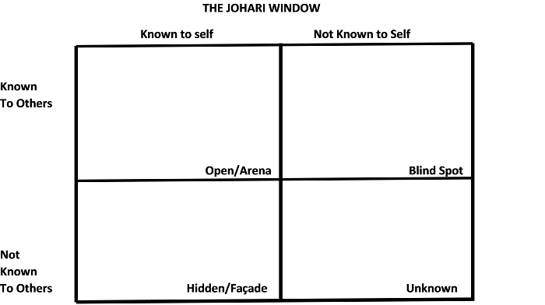
MATURE
CLEVER
Sentimental
Reflective
Calm
Quiet
Shy
Helpful
Caring
Trustworthy

Conclusion
To conclude this and reflecting I want to overcome all my weaknesses by always thinking positive. I will build a strong relation within myself so I can achieve what I want. I will have a clear and objective plan to ensure that I meet the goal of learning how to connect with my own self then achieve the goals that I will then set. I need to focus on working towards my ultimate goal and leverage my strengths by building my skills and accomplish a good successful career.

Personal Development Plan
 | Short-Term Time Frame  What do I want to  accomplish in the next  three to six months? | Mid-Term Time Frame  What do I want to  accomplish in the next  six months to two years? | Long-Term Time Frame  What do I want to  accomplish in the next  two to three years?
Section 1 - My Goals  What are my overall goals that I want to accomplish in this time period?  Example: become a Student Affairs Officer; learn computer graphics | Being able to achieve my first semester | Achieve my degree of being a Business management student | Open my own business, clothing store.  (physical and online store).
Section 2 - Skills and Knowledge to be  Learned  What specifically do I need to learn? What project do I need to work on?  Example: Student advising;  Banner; Dreamweaver; develop a procedures manual | . Problem solving  . Leadership  . Project management  . Marketing customer sales | Being able to accomplished the skills | Get the skills and develop them (practical)
Section 3 - Next Steps  How am I going to acquire the skills and knowledge? How am I going to do this project?  Example: take Dreamweaver class; do an  informational interview; set up a project outline | . Attending classes  . Research for extracurricular business classes | . Speaking with a business advisor  . Research about business advisor workshops | Being able to implement what I have learn and putting towards the opening of my business
Adapted from: http://www.hr.ucdavis.edu/sdps/forms/IDP%20Final%2010.14.11.pdf

 | Short-Term Time Frame  What do I want to  accomplish in the next  three to six months? | Mid-Term Time Frame  What do I want to  accomplish in the next  six months to two years? | Long-Term Time Frame  What do I want to  accomplish in the next  two to three years?
Section 4 - Resources  What resources do I need?  Example: free time; funding | Books  Technology | Free time | Funding  Project
Section 5 - Time Schedule  What is my time schedule? | Eight hours | Eight hours | Eight hours
When will I start? | currently | This year | three years time
When do I expect to finish? | This year | Two year’s time | Five years time
Section 6 - Completion  When have I completed each  step? | □ 2020  Date  □ 2020  Date  □ 2020  Date | □ 2022  Date  □ 2020  Date  □ 2020  Date | □ 2025  Date  □ 2025  Date  □ 2025  Date
Adapted from: http://www.hr.ucdavis.edu/sdps/forms/IDP%20Final%2010.14.11.pdf

References
Gibbs, G. (1988). Learning by Doing: A Guide to Teaching and Learning Methods. Oxford: Oxford Further Education Unit. (Accessed 25 August 2020).
Alvik, T, 1996, Self-evaluation: what, why, how, by whom, for whom: Collaborative Project Self-evaluation in School Development, Dundee, CIDREE ( Accessed 25 August 2020).
UK Higher Education Academy(HEA)2009( Accessed 25 August 2020).
Sreenidhi, K, 2017, Styles of Learning Based on Research of Fernald, Kelker, Orton,Gillingham,Stillman,Montessorri and Neil D Fleming, pp.18 (Accessed 25 August 2020).
Emet, G, 2017. Uluslararası Sosyal Araştırmalar Dergisi The Journal of International Social Research, SWOT ANALYSIS: A THEORETICAL REVIEW (Accessed 25 August 2020).

https://www.google.co.uk/search?q=johari+window+template&client=safari&channel=iphone_bm&sxsrf=ALeKk01VYn2tZYXU5z1tqFzDHAwuZrAk7Q:1599170265620&tbm=isch&source=iu&ictx=1&fir=3mm-md3Eg6Y_kM%252CfGuHLbMTV3AeJM%252C_&vet=1&usg=AI4_-kRtIKPHUKgtZHacJpKiCipK_PxNUg&sa=X&ved=2ahUKEwi7ivi8_c3rAhXO-6QKHaFCAMQQ9QF6BAgKEE4&biw=1440&bih=837#imgrc=3mm-md3Eg6Y_kM\



