Module Code - LCMB7001
Module Name- Marketing Management-Assessment 2
Format- Report
Title - Marketing Management
Student Name- Neha Sharma
Student Code- 2130314
Word Count-2000
Table of Contents

Introduction 3
SWOT Analysis 3
PESTLE Analysis 5
Porter’s Five Force Analysis 7
Role of Marketing within the Organization 8
Conclusion 9
Recommendations 9
References 10

Introduction
This report will discuss the Marketing manager of the chosen company. The chosen company in this report is Apple. This report will also cover SWOT analysis, PESTLE analysis, Porter's Five Force analysis, and the role of marketing in Apple. To make more money by satisfying customer preferences, a firm sets objectives, develops strategic documentation, takes decisions of the company, and then executes those decisions. This procedure of making money by fulfilling customer needs is known as marketing management. Thorough research is required on the part of a marketing executive to fully comprehend what exactly marketing management entails and how to enhance it for the advantage of the business. To draw customers in, marketing management relies on the following factors: product, place, pricing, and promotion.
Include PESTLE, Porter’s Five Forces and then SWOT analysis.

SWOT Analysis
Strengths | Weakness
- Apple is the most valuable brand.  - Apple is iconic all over the world.  - Apple has the top technology as compared to others.  - Dedication towards proficient research and development | - Apple is a high-priced product compared to other brands.  - Apple spends a minimum amount on promotions and advertisements.  - Tracking allegations  - Software Related Issues
Opportunities | Threats
- Consistent growth in customers  - Apple has highly qualified professionals  - Wearable smart technology  - Expansion of music streaming services | - Consequences of the Coronavirus Epidemic  - Upsurge in Competitors  - Marketplace Inclusion  - Higher China Tariffs

Strengths
Apple is ranked top by e-marketers for the tenth consecutive year, with such a $408 billion valuation. Amazon is ranked 2nd with a brand reputation of $249 billion, while MS is ranked third with a marketability of $210 billion. Apple is represented as one of the most trustworthy companies when it comes to personalizing splitting PCs and smart software products. It has several loyal, dependable users. Some of the most technological breakthroughs that have revolutionized the course were first developed by Apple (iPhones, Apple iPod, iPad). Apple invests a lot of effort in creating its products. Careful analysis and appropriate research are used to better understand customer demand and market dynamics.
Weaknesses
Apple gadgets might be thought of as a luxury because of their hefty price tags. The products are affordable for customers who have high and intermediate levels of income. Low-income consumers find it extremely difficult to buy Apple’s products (Chen, Liu and Gong, 2021). Apple recently improved its position by luring committed customers while having limited promotional resources as well. Typically, Apple's marketing strategy is reliant on its famed bigger stores. Tracking individuals undermines confidence. Apple has come under fire for reportedly using tracking websites on its products to reveal customers' precise locations. Since Apple's handsets do not support specialized software or new tech, customers are contradictory with some other handsets.
Opportunities
Apple has controlled the gadgets sector for several years. The business provides top-notch services and decreases costs for innovation that enhances customer satisfaction. Apple's scientists, coders, and graphic artists are a team of incredibly talented professionals with years of experience in marketing goods. Apple may expand its staff and consistently create new opportunities (Hill, Martelli and Kuo, 2018). In contrast to Smartwatches and AirPods, Apple has the opportunity to develop more smart wearable business units. Youthful demographics and rapidly growing economies in developing countries offer huge opportunities for growth.
Threats
China has a significant role in both Apple's supply system and manufacturing. The recent events nowadays have significantly disrupted and affected business operations. Moreover, of its total $364 billion in annual sales, approximately 18 percent came from China. Apple's sales have been significantly impacted by the outbreak and may continue to be so in the future. Despite the reality that one's brand has developed more recognisable, Apple today faces challenges from competitors (Satariano, 2022). Businesses such as Microsoft, Samsung and Dell constitute a big threat to Apple due to the advancement in technology. Other cellphone sector businesses' marketing strategy has seen a major shift. Companies like Samsung, Lenovo, and HTC are creating contemporary gadgets with the Android OS. The expense of the finished package has increased as a result of the American government upping the import duties.
PESTLE Analysis
Specifically state whether each of the PESTLE factors are favourable/unfavourable and why.
Political | An American business, Apple has gathered a considerable amount of cash and has produced tremendous revenue growth. The sales of the products of Apple have reportedly come from nations other than the United States in more than 50 percent of the cases. Due to its extremely low production costs, China is the main country producing products for Apple (Bai et al., 2019). The sales and market share of Apple in China may indeed be harmed by the huge trade tensions between the USA and China, which is a big political problem that might also imperil the future growth of the company.
Economic | Economic expansion, inflation, recession, rates of unemployment, and minimum wages are a few of the key economic variables that have an impact on Apple's performance of the company and the environment. The economic stability of established nations, the rapidly expanding economies of emerging economies, and the rising disposable income of Apple's target market are some of the significant opportunities for the company's growth. Apple's target market is primarily classy consumers because its devices are luxury goods (Yan, Bai and Shen, 2022). Since the Asian market has higher rates of expansion and significant prospects for a tech brand like Apple, it is difficult for Apple to enter there because of its premium price policy.
Social | Since it is unthinkable to imagine a world without gadgets, smartphones, new technologies, and ipads in the 21st century, Apple has solidified its hegemony in international markets (Shapiro, 2019). The next trend that affects sociocultural factors is the growing need for multimedia applications. This gives Apple a benefit since it raises demand and boosts revenue. Sales of luxury products of Apple have climbed as the average user's purchasing power has expanded globally.
Technological | Apple now offers a wider range of technological solutions to many more citizens and companies. But considering how easily technology is developing at a fast pace, Apple needs to upgrade technology and improve its products more regularly if it intends to easily beat its competitors (Yie, Zhi and Ping, 2021). The inexpensive prices of many high-tech products offered by Apple's rivals have an impact on the company's brand equity and ultimately its financial performance. For instance, companies like Lenovo maintained their position in the PC industry while Apple fell.
Legal | Adhering to privacy laws is vital in the era of the internet; therefore the state government is also applying pressure on companies like Apple, Google, and many more. In other terms, this is a threat for Apple that generates a high monitoring time and expenses and pose difficulties for items that handle confidential material. With the release of "Apple Pay," Apple penetrated the stringent regulatory field of financial services and presented the possibility of more surveillance and regulation (Liebana-Cabanillas et al., 2020).
Environmental | The majority of Apple's products are produced in China, where environmental concerns are a huge problem and could soon have an impact on costs and regulations. Apple has started creating new technological advancements as a result of producing more environmentally friendly components including CPUs, cells, and other varieties of technology that emit little radiation. The trend toward corporate sustainability offers a chance to strengthen a company's brand. Apple relies on a significant internet infrastructure, which may soon cause electricity prices to rise.

Porter’s Five Force Analysis
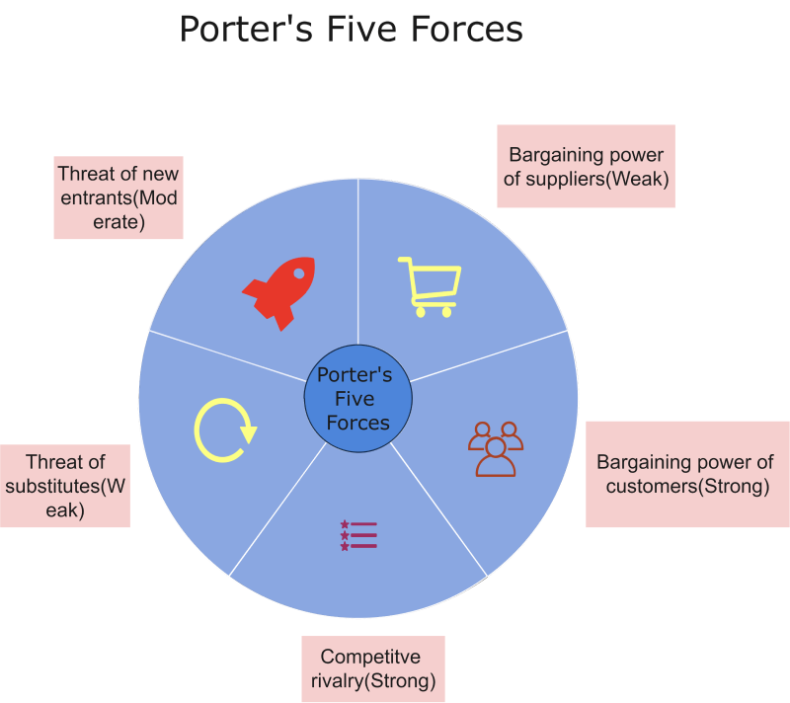
Figure 1: Porter’s Five Force Analysis of Apple
Source: (Adelakun, 2020)
State whether each of the five forces are high, medium or low and why.
Competitive Rivalry
Evaluation of rivals or competitors of Apple demonstrates that other firms like HP, Samsung, Google, and many other firms’ straightaway challenge Apple. Every competitor invests much in R&D to release the most advanced products and increase its market share. Individuals know that changing devices and system software is often a low to medium-cost move, and customers do not need to make a big investment to convert from Android to an apple or conversely. As a result, a review of Apple's rivals likewise demonstrates the intense competition in the market.
Threat of New Entrants
Porter's five forces for Apple show that the threat posed by new competitors is minimal to moderate. A large business must be established inside the sector, which is very expensive and requires funds, employees, infrastructure, and advertising and promotion. Brand identification is expenditure necessary to have a massive effect on pcs and laptops and other devices. New companies become weak due to external circumstances. But, there seem to be major firms that have the resources to enter the industry. Google, for instance, has already achieved this with items like the Nexus devices. Samsung was a newcomer once as well.
Bargaining power of suppliers
The suppliers' negotiating position is a weak force in Porter's five forces model for Apple. With sufficient supply, Apple has access to a large number of possible vendors who can offer components, processing power, packaging, and nearly every other item needed to make Apple devices. Vendors cannot afford to lose Apple's business because of the company's economies of scale. As a result, individual vendors find it difficult to enforce their demands on companies like Apple due to the medium to high total supply of resources, such as chips.
Bargaining power of customers
Personal and collective bargaining power is another force of Porter's five forces for Apple, which affects customers' power to negotiate. Since the loss of just one client has no impact on Apple's income, individuals have limited negotiation power. But group negotiating power is a significant role. Buyers can force businesses like Apple to guarantee customer delight because it is simple for them to switch brands. On the contrary hand, each customer's purchase is insignificant when compared to the business' overall revenues. But, having access to in-depth comparison data on the attributes of competing solutions gives customers the power to switch providers.
Threat of substitute products or services
The threat of alternative products is viewed as being weak in Porter's five forces model for Apple. It is a low threat as buyers currently do not identify any items that can match the features offered by the products of the Apple. Some products can be used as alternatives to Apple products. For instance, people do not need iPhones to snap pictures or make calls; they may use digital cameras or landlines instead. Due to their fewer features, these alternatives function poorly. Due to its simplicity and cutting-edge features, many customers prefer using Apple goods. Since this is the case, substitution has little effect on the firm's operations. In addition, customers rarely make substitutes.

Role of Marketing within the Organization
In the process of creating new goods, the marketing employees of Apple collaborate closely with designers and developers. It is indeed a degree of cooperation that deepens their devotion to the overall product idea, bringing the diverse talent of this team together under one common goal: making sure that everyone feels as strongly about their offerings as they do. The basic principle of Apple, according to Steve Jobs, is that consumers do not often recognize exactly what they want. As a result, the international technology corporation prefers to incorporate unique characteristics and features into their goods, making people demand Apple products, rather than undertaking marketing research to determine client desires and requirements. Apple's marketing approach uses simple but incredibly effective means of expressing the brand.
Segmentation, targeting, and positioning should be related to Apple.
The marketing mix strategies such as product, price, place and promotion should be determined.

Conclusion
Marketing management is a huge process. According to Apple's SWOT analysis; it is clear that the company's strengths and opportunities give it a competitive edge over its own weaknesses and threats. This is primarily due to the firm's good name and customer loyalty. The PESTLE Analysis of Apple discussed above in the report provides a summary of the assorted elements that affect its commercial success. This information helps in assessing how significant external business factors are to any brand.

Recommendations
Due to the company's premium pricing strategy, those with average incomes find it less appealing. Over the first two to three years after its release, as its costs are lowered, some buyers transfer to older generations of the iPhone. This shrinks the marketplace for the recently introduced products. The business should launch innovative products with reasonable costs for individuals with low and medium incomes in an attempt to broaden its client base in the future. The fact that some nations are producing inexpensive iPhone knockoffs presents the firm with additional opportunities to distinguish its product. Brighter colours could be delivered to clients by the business to appeal to those who value bright colours on their mobile devices; it would help the company to attract more target customers. Even though the business tried colours when introducing the iPhone 5c, they can change in a future model. One or two strategies from the Ansoff matrix could be related to Apple in terms of the recommendations.

References
Adelakun, A., 2020. Should Porters Five Forces have value in Businesses today. Computing for Business (BSC) Aston University Birmingham.
Bai, X., Wang, Y., Huo, X., Salim, R., Bloch, H. and Zhang, H., 2019. Assessing fertilizer use efficiency and its determinants for apple production in China. Ecological Indicators, 104, pp.268-278.
Chen, X., Liu, Y. and Gong, H., 2021, December. Apple Inc. Strategic Marketing Analysis and Evaluation. In 2021 3rd International Conference on Economic Management and Cultural Industry (ICEMCI 2021) (pp. 3053-3061). Atlantis Press.
Hill, T.E., Martelli, P.F. and Kuo, J.H., 2018. A case for revisiting peer review: Implications for professional self-regulation and quality improvement. Plos one, 13(6), p.e0199961.
Liébana-Cabanillas, F., García-Maroto, I., Muñoz-Leiva, F. and Ramos-de-Luna, I., 2020. Mobile payment adoption in the age of digital transformation: The case of Apple Pay. Sustainability, 12(13), p.5443.
Satariano, A., 2022. EU Takes Aim at Big Tech’s Power With Landmark Digital Act. The New York Times.
Shapiro, C., 2019. Protecting competition in the American economy: Merger control, tech titans, labor markets. Journal of Economic Perspectives, 33(3), pp.69-93.
Tunjungsari, H.K., Syahrivar, J. and Chairy, C., 2020. Brand loyalty as mediator of brand image-repurchase intention relationship of premium-priced, high-tech product in Indonesia. Jurnal Manajemen Maranatha, 20(1), pp.21-30.
Yan, P., Bai, X. and Shen, Z., 2022, April. Operations and Supply Chain Analysis of the Smartphone Industry: Comparing Apple and Huawei. In 2022 7th International Conference on Social Sciences and Economic Development (ICSSED 2022) (pp. 1523-1526). Atlantis Press.
Yie, C.E., Zhi, C.E. and Ping, N.T.S., 2021. A Critical Analysis of Internal and External Environment: Case Study of Apple Inc. Journal of International Business and Management, 4(10), pp.01-14.

