

Bethan Davies-Jones

Flame Test Lab Report

University of Wales Trinity Saint Davids
Ordnance Munitions and Explosives

BEng Ordnance Munitions and Explosives
Academic Year: 2024 - 2025

Supervisor: Ewa Kazimierska
February 2025

University of Wales Trinity Saint David
Ordnance Munitions and Explosives

BEng Ordnance Munitions and Explosives

Academic Year 2024 - 2025

Bethan Davies-Jones

Flame Test Lab Report

Supervisor: Ewa Kazimierska
February 2025

This thesis is submitted in partial fulfilment of the requirements for the degree of BEng Ordnance Munitions and Explosives
(NB. Remove if the degree award is based solely on examination of the thesis)

© UWTSD 2025. All rights reserved. No part of this publication may be reproduced without the written permission of the copyright owner.

Academic integrity declaration
I declare that:
- the thesis submitted has been written by me alone.
- the thesis submitted has not been previously submitted to this university or any other.
- that all content, including primary and/or secondary data, is true to the best of my knowledge.
- that all quotations and references have been duly acknowledged according to the requirements of academic research.
I understand that to knowingly submit work in violation of the above statement will be considered by examiners as academic misconduct.

Abstract
An investigation was conducted to determine whether the metal ions within an unknown substance can be found by heating it in a flame and analysing the wavelength of the light emitted. The results show that the statement is correct, and the mathematical relation between wavelength of the emitted photon and the energy of the electrons within the metal ions is discussed. The uses of flame photometry within OME are evaluated.

Keywords:
Flame test, Photometry, Spectrometry, Metal ions, Cations, Electrons, Wavelength

Acknowledgements
Thank you to Ewa Kazimierska for answering queries in the preparation of this report, and to Mark Broadhead for acting as the lab technician during the practical element.

Table of Contents
Academic integrity declaration i
Abstract ii
Acknowledgements iii
List of Figures v
List of Tables vi
List of Equations vii
List of Abbreviations viii
1 Introduction 1
1.1 Purpose of Experiment 1
1.2 Hypothesis 1
1.3 Variables and Equations 1
2 Results 1
3 Discussion 3
3.1 OME Applications 5
3.2 Limitations 6
4 Conclusion 7
5 References 8
Appendices 9
Appendix A Materials 9
Appendix B Method 10
Appendix C Image of the Original Observation Sheet 11

List of Figures
Figure 1 – Labelled visible light spectrum. 2
Figure 2 – Visual representation of an electron changing energy levels and emitting a photon [3]. 3
Figure 3 – Hand calculations showing the calculation of the energy and frequency for strontium and potassium. 5

List of Tables
Table 1 – Results for the flame test. 1
Table 2 – Visible light colour emitted by each metal ion when heated. 1

List of Equations
Equation 1 – The relationship between frequency of a photon and energy levels of an electron. Where ΔE is change in energy, h is Planck’s constant and f is frequency. 1
Equation 2 – The relationship between frequency and wavelength of a photon. Where c is the speed of light (3x10⁸ms⁻¹), f is frequency and λ is wavelength. 2

List of Abbreviations
HCl | Hydrochloric Acid
OME | Ordnance Munitions and Explosives
ICP-AES | Inductively coupled plasma atomic emission spectroscopy

Introduction

Purpose of Experiment
The aim of the flame test is to determine the metal ion within a substance, based on the colour of the flame when an unknown solution is heated in a Bunsen burner flame [1].

Hypothesis
When different substances are heated, they will emit light of different wavelengths due to their distinct electron configurations, producing colours characteristic of certain metals, which can then be used to identify the cations present in the unknown substance.

Variables and Equations
An experiment has independent, dependent and control variables. The independent variable is changed when testing, the dependent variable is measured, and the controls remain the same to ensure that the results are valid. In the flame test, the independent variable is the metal ion substance, the dependent variable is the colour of the flame that is produced when the substance is heated, and the controls are the size and heat of the flame that is used, the person determining the colour of the flame, the acid used to cleanse the wire, the surface area and mass of the sample and all other apparatus used in the experiment.
There are two equations used to analyse the results of the flame test.
Equation 1 – The relationship between frequency of a photon and energy levels of an electron. Where ΔE is change in energy, h is Planck’s constant and f is frequency.
$$∆E=h ×f$$
Equation 2 – The relationship between frequency and wavelength of a photon. Where c is the speed of light (3x10⁸ms⁻¹), f is frequency and λ is wavelength.
$$c=f ×λ$$

Results
Unknown Metal Salt | Colour of the Flame | Identity of the Metal | Wavelength of the light (nm)
DI Water | None | N/A | N/A
1M HCl | None | N/A | N/A
A | Orange | Sodium | 625
B | Lilac | Potassium | 400
C | Red / Orange | Calcium | 675
D | Red | Strontium | 725
E | Green / Blue | Copper | 500
F | Pink / Red | Lithium | 650 / 375
G | Yellow / Green | Barium | 575
H | Orange / Lilac | Potassium and Sodium | 625 / 400
Table 1 – Results for the flame test.
The metal ion was identified within the unknown substance through use of this table (provided).
Metal Ion | Flame Colour | Metal Ion | Flame Colour
Barium, Ba²⁺ | Green | Potassium, K⁺ | Purple
Calcium, Ca²⁺ | Orange | Sodium, Na⁺ | Yellow / Orange
Lithium, Li⁺ | Red / Pink | Copper, Cu²⁺ | Blue / Green
Strontium, Sr²⁺ | Red
Table 2 – Visible light colour emitted by each metal ion when heated.
The colour of the flame was visually assessed, and the wavelength deduced using a labelled image of the visible light spectrum (provided). Despite the sodium and calcium ions producing the same colour flame, it was possible to differentiate between them using a piece of blue cobalt glass. When viewed through the glass, a sodium flame is eradicated from sight and a calcium flame remains visible.
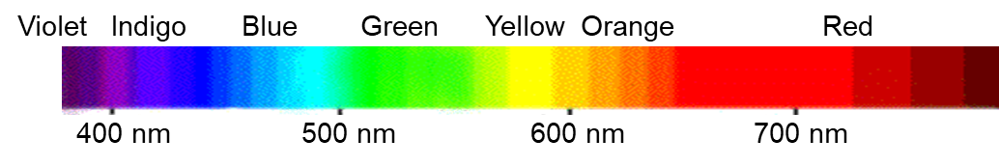
Figure 1 – Labelled visible light spectrum.
A noted pattern was the recurrence of orange light. This may have been due to contamination of the wire.

Discussion
The results obtained support the hypothesis. The light emitted from the metal ions were of varying wavelengths.
These varying wavelengths are due to the unique electron configurations of the metals [2]. When heat is applied to the ions, their electrons gain energy and become excited. They transition to a higher energy orbital, where they are unstable. When the electrons return to the ground state, the ions emit one photon per electron, which has an equivalent wavelength to the electron’s change in energy [3]. The transition of a valence electron from a higher energy orbital to a lower one is called atomic emission [4].
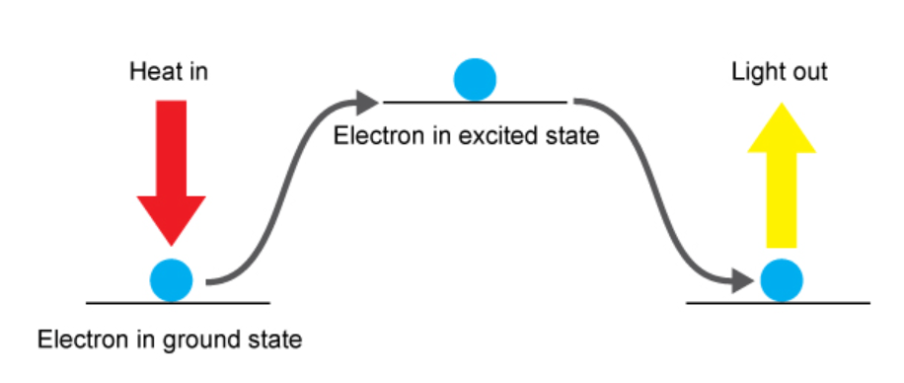
Figure 2 – Visual representation of an electron changing energy levels and emitting a photon [3].
The energy change for electrons varies depending on the element, due to their unique energy level configurations. This produces different spectra for each metal ion [2]. Emission spectra can then be used to identify an unknown substance, by analysing the wavelengths produced and calculating their respective elements [5].
The relationship between a metal ion’s unique electron configuration and the wavelength of the photons emitted is demonstrated through the combined use of Planck’s equation (equation 1) and the speed of light equation (equation 2).
$$∆E=h ×f$$
$$c=f ×λ$$
The speed of light equation can be rearranged to make frequency the subject.
$$f=\frac{c}{λ}$$
This can then be substituted into Planck’s equation.
$$∆E=\frac{hc}{λ}$$
This equation demonstrates the inverse proportionality of an electron’s energy change, and the wavelength of the photon emitted. Planck’s number and the speed of light are both constants, so the photons emitted by a metal ion with a higher wavelength will have less energy, and therefore a lower frequency.
Using these equations, and the data for strontium and potassium, the energy and frequency of both metal ions can be calculated.
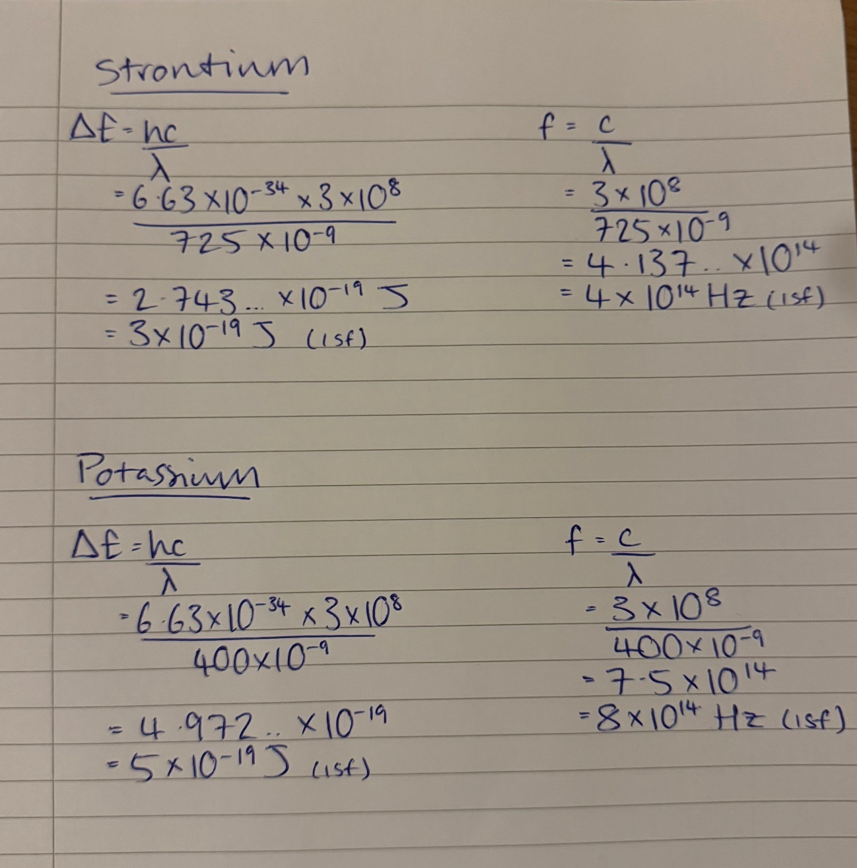
Figure 3 – Hand calculations showing the calculation of the energy and frequency for strontium and potassium.
The use of two metal ions with such different wavelengths showed that the theory from the derived equations was correct.

OME Applications
In an OME environment, flame photometry can aid in the production of various pyrotechnics, such as determining the colours of fireworks [6]. Alternatively, it could be used to identify unknown explosives, or to test the quality and purity of existing products.
An application of flame photometry in the real world would be inductively coupled plasma atomic emission spectroscopy (ICP-AES). This works similarly to flame photometry, but instead of exciting the atoms via a flame, it uses a plasma [7].
Another key difference is that photometry measures the transmission of the wavelengths of light, where spectroscopy analyses the shift in emission or absorption spectra [8].

Limitations
The results could have been more accurate if the primary form of contamination had been corrected, by using a new metal wire for each solution.
Using the human eye to determine the wavelengths was inaccurate due to colour being subjective. Instead, an optical spectrometer could have been used.

Conclusion
In conclusion, the hypothesis is correct. When heating unknown substances, light of different colours, and therefore different wavelengths, will be emitted, which can then be used to identify the metal ions in each substance.
Further research would be to remove the limitations and repeat the experiment again, to obtain more accurate results. This could be through the use of a new wire for every solution to remove contamination, or by using a spectrometer instead of the human eye to observe the colour of the flame.

References

[1] | M. J. Sanger, “Flame Tests: Which Ion Causes the Color?,” Journal of Chemical Education, vol. 81, no. 12, p. 1776, 2004.
[2] | J. Clark, “Flame tests,” Libre Texts Chemistry, [Online]. Available: https://chem.libretexts.org/Bookshelves/Inorganic_Chemistry/Supplemental_Modules_and_Websites_%28Inorganic_Chemistry%29/Descriptive_Chemistry/Elements_Organized_by_Block/1_s-Block_Elements/Group__1%3A_The_Alkali_Metals/2Reactions_of_the_Group_1_Elements/F. [Accessed 26 February 2025].
[3] | “Flame Tests Using Metal Salts,” Royal Society of Chemistry, 2025. [Online]. Available: https://edu.rsc.org/resources/flame-tests-using-metal-salts/1875.article?. [Accessed 26 February 2025].
[4] | K. W. Jackson, “Atomic Absorption, Atomic Emission, and Flame Emission Spectrometry,” Analytical Chemistry, vol. 66, no. 12, pp. 252-279, 1994.
[5] | X. Qiu, “Fire Detection Algorithm Combined with Image Processing and Flame Emission Spectroscopy,” Fire Technology, vol. 54, no. 1, pp. 1249-1263, 2018.
[6] | A. Ambekar, “Characterization of display pyrotechnic propellants: Colored light,” Applied Thermal Engineering, vol. 110, no. 1, pp. 1066-1074, 2017.
[7] | S. Pramanik, Nanomaterials and Polymer Nanocomposites, Tezpur: Elsevier, 2019.
[8] | Y. Zhou, “The relationship between photometric and spectroscopic oscillation amplitudes from 3D stellar atmosphere simulations,” Monthly Notices of the Royal Astronomical Society, vol. 503, no. 1, 2021.

Appendices

Materials
- Bunsen burner
- Heatproof safety mat
- Matches
- 1M of unknown aqueous solutions of metal salts (labelled A-H)
- Metal wire
- 1M HCl
- Deionised water
- Blue cobalt glass

Method
- Place the Bunsen burner onto the heat resistant mat.
- Turn on the gas tap and light the Bunsen with a match.
- Turn the air vent so that it is open to obtain a blue flame. (Ensure that the safety flame remains on when the Bunsen is not in use.)
- Clean the wire by dipping it into the HCl and heating it in the flame. If the flame is coloured, there is an impurity on the wire and this must be repeated until there is no colour change present.
- Dip the wire into the deionised water to remove any HCl remaining and heat it in the flame.
- When the wire is cool, dip it into one of the unknown solutions and heat in the corona of the blue flame.
- Use the cobalt glass to determine whether there is sodium included in the solution.
- Record the observations made.
- Repeat the process for every unknown solution, ensuring that steps 4 and 5 are done between each to minimise any contamination.

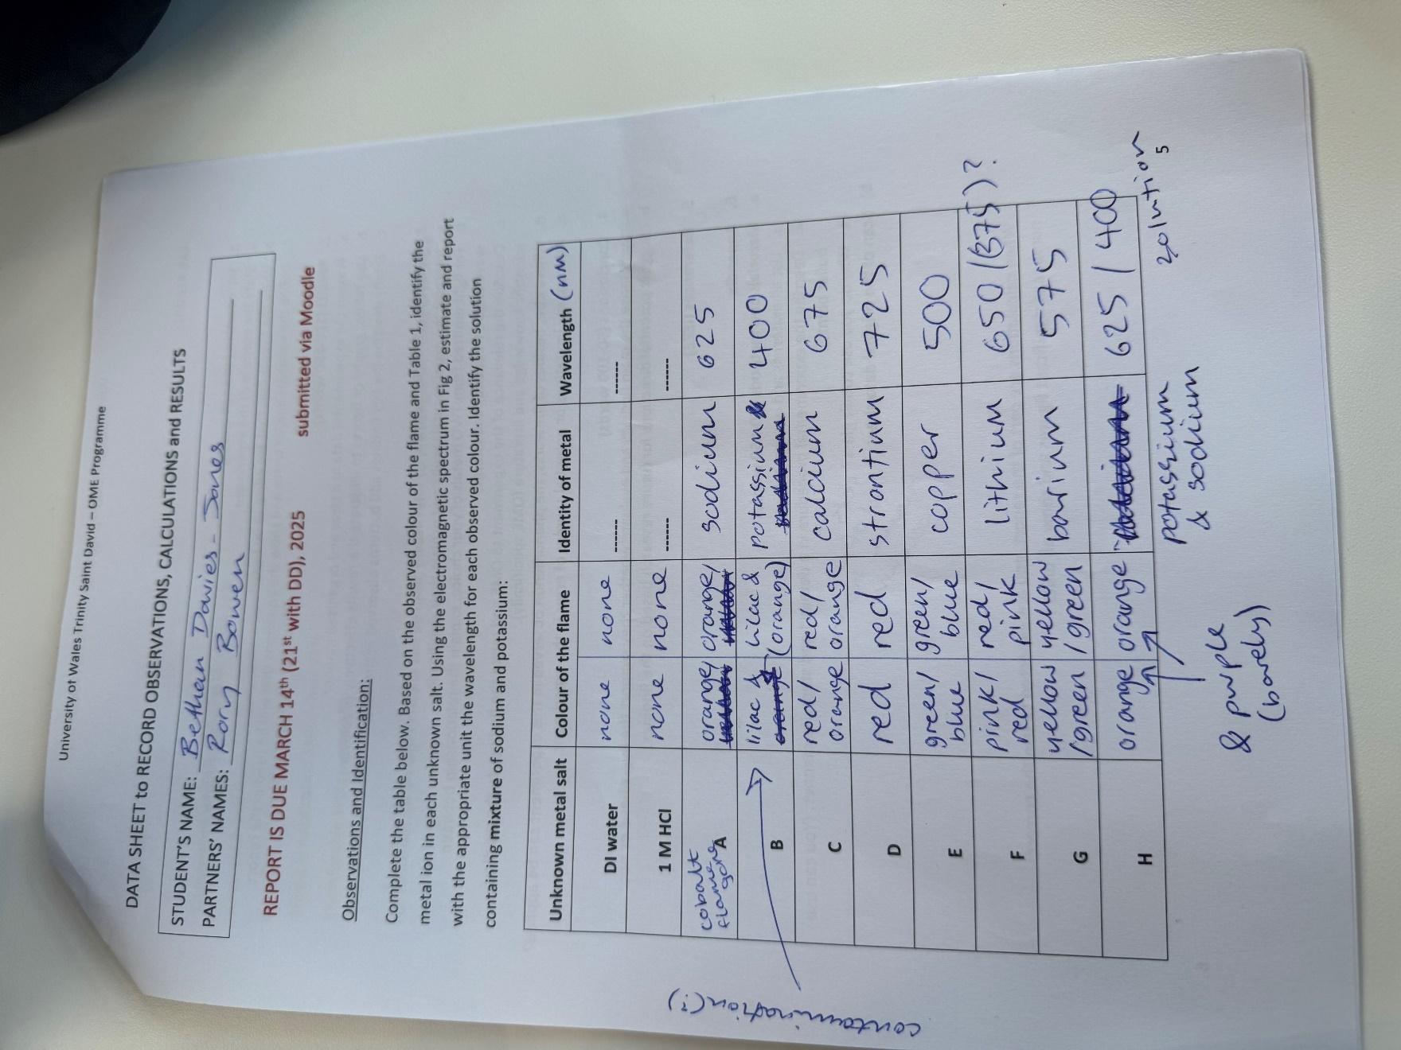
Image of the Original Observation Sheet

