To test the existence of the Stroop effect.

Abstract

The Stroop colour word test is a neuropsychological test which we use to see the ability to process cognitive interference. The design of an experiment studies the relationship between many input and output variables. Sampling is the action of retrieving a amount of participants to produce information for a research experiment. Sampling also is the action of choosing data to produce an acceptable explanation and vigorous assumptions of the public. The main finding was that individuals can recall the word the same as its ink colour faster that the words different to their ink colour. The implication of this test was to explore selective attention.

Introduction

The context of this study is to measure attention and how fast we process words. We choose to focus on one aspect of a stimulus and completely ignore others. “Selective attention is the process of directing our awareness to relevant stimuli while ignoring irrelevant stimuli in our environment.” (McLeod, 2018) This process is really important as there can be a maximum of the amount of data that can be handled at once. Selective attention is what helps us zone out insignificant information and concentrate on the most critical to us.
The cocktail party effect refers to our own ability on how we fixate on one stimulus while ignoring the others. An example of this would be while holding a conversation in a loud setting you are able to focus on the one conversation and ignore the other noises around you. However, Broadbent’s theory predicts that detecting your name while your attention is focused elsewhere should be impossible.

Broadbent proposed that you would only focus on one input and all the others are lost. He believed that all information enters an “unlimited capacity sensory buffer.” (McLeod, 2018)
Then only one input information is picked to travel “through the filter to the short-term memory” (McLeod, 2018) this filter happens to stop the information processing system being overloaded. Broadbent assumed the unattended messages were rejected by the filter early on. Selective attention is the process of while an individual can fixate on an input while simultaneously suppressing other information. “The Stroop effect reveals how the brain processes information.” ("What the Stroop Effect Reveals About Our Minds | Lesley University", n.d.) It explores how we find difficulty naming a colour when it is used to spell the name of a different colour. For example, the word brown with pink ink. “The speed of processing theory and selective attention theory explain the Stroop effect.”4 We need selective attention as it allows our brains to work more effectively. Research shows that older adults have a greater Stroop colour word interference than younger adults. “Shiffrin and Schneider proposed a theory of attention that explored the existence of automatic and controlled processes.” (SE et al., n.d.) They found “that automatic processes develop when the mapping between stimuli and responses is consistent.” (SE et al., n.d.)

Divided attention is also useful in psychology an example of this is multi-tasking like singing a song in the car while driving it. The Stroop effect would use divided attention as you are multi-tasking by looking and the word and trying to say the colour even though they are different for example seeing the word green but its colour is pink, it can be very confusing and needs a lot of thought to why it can take longer to process than words with the same colour like pink in the colour pink which would only take you a fraction of the amount of time. Divided attention can be affected by psychiatric conditions which can make these experiments a lot harder for some individuals with ADHD and schizophrenia and also people who have suffered with a brain injury.

The difference between selective attention and divided attention is that selective blocks anything other than the conversation out whereas divided attention tries to do both at the same time however, when our attention is diverted it could be less efficient and more likely to make a mistake and can slow down the brain function. Selective attention also uses an example of listening to a podcast while driving which means its focusing on one while doing the other, it allows the brain to not focus on the information that’s not important to us and just focus on what we think matters.

When we use selective attention it’s our parietal and frontal lobes that we use however a new study shows that we also use the temporal lobe for all types of attention. The working memory is also linked to selective attention as the “attention filters incoming information, allowing only relevant information into the short-term processing stores.” (Downing, 2000). the Stroop test can be quite challenging for individuals as we are used to processing the word while ignoring everything else so having to take other factors into consideration like the colour can be quite challenging.

The Stroop effect is important as it shows cognitive processes and neurocognitive architecture.

The aim of this study is to explore whether the words the same as there colour are repeated faster than the words different to their colour.

Hypothesis – the colour naming times will be significantly longer in the incongruent condition. This is one tailed.

Method

Design

The type of design used in this study is related with two conditions. The independent variable is the congruency of the words and their colours. The dependant variable is the time taken to name the colours in seconds. The two conditions are the same colour as the word presented and the different words presented to the colour.

Participants

This experiment was an opportunity sample, there was 33 participants who completed both conditions. The participants consisted of 27 females and 6 males. The age range was from 18–46-year-old undergraduates studying in west wales. All participants were naïve to the experiment. The mean age was 27.15 and the SD was 8.28.

Materials

The equipment used was a timer, pen, paper, list of words the same as their colour and a list of words different to their colour. The stimuli used a list of 15 words the same as their colour (appendices 1) and a list of 15 words different to their colour (appendices 2) chosen by the chief researcher. The words were presented on a sheet of white A4 paper with colours including pink, blue, black, green, brown, red, orange, purple, grey, yellow. The font was times new roman, and the size was 26. As we were timing how long it took us to recall the words, we weren’t given a time frame to complete.

Procedure
(See appendices 3)

Results

Table 1

Means and SD for the scores in the Stroop colour and word test.

Conditions | Mean | SD
Words the same as colour | 6.77 | 1.66
Words different to colour | 11.20 | 1.59

T-Test

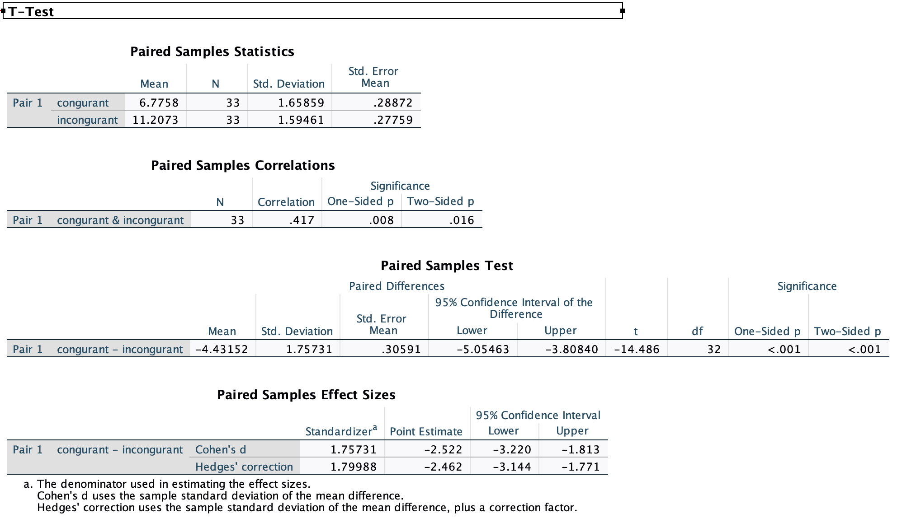

Discussion and conclusion

The aim of this study was to explore whether the words the same as there colour (congruent) are repeated faster than the words different to their colour (incongruent).
The hypothesis was the colour naming times will be significantly longer in the incongruent condition. This is one tailed. This was correct we found that it took a few seconds longer to recall the incongruent condition with all results from individuals in our experiment. This showed that we could use our diverted attention from Broadbent’s theory even though it took a few seconds longer to recall. When taking part in this experiment there isn’t many critics that come into mind there is a chance you may get the colour wrong, but you can have an unlimited amount of try’s as it is only timed but it will impact your time when it comes to finishing. The finding of this experiment is important due to the fact it provides a clear picture on how people hold selective attention. Future research suggestions would include the “dichotic listening task which is sending one message to a person’s right ear while sending a different message to their left ear.” (McLeod, 2018) Broadbent found that people didn’t cause as many mistakes by imitating back ear by ear and this way was the way they would usually repeat. “Participants reported that after the whole message has been said it is possible that the unattended message is analysed but the participants forget.“ (McLeod, 2018) a problem with all dichotic listening experiments is that you can never be sure that the participants have not switched attention to the unattended channel.” This experiment may be an issue with people who are colour blind as some of the colours may take longer for them to process which could result in a longer time compared to other when this isn’t their fault, so, if possible, their test should be adapted for their ability. There may be very unexpected results where it shows that individuals can recall the incongruent words faster than the congruent which taking our results in to consideration this would be very unlikely. In conclusion this Stroop colour word experiment found that it takes longer to process incongruent words to congruent and the average times were 6.77 seconds for congruent and 11.20 seconds for incongruent.

References

Downing, P. (2000). Interactions between visual working memory and selective attention. pubmed.gov. Retrieved 22 April 2022, from https://pubmed.ncbi.nlm.nih.gov/11202491/.

McLeod, D. (2018). Theories of Selective Attention. Simplypsychology.org. Retrieved 22 April 2022, from https://www.simplypsychology.org/attention-models.html.

SE, P., M, L., & E, H. Automatic and controlled attention processes in auditory target detection. PubMed. Retrieved 22 April 2022, from https://pubmed.ncbi.nlm.nih.gov/6460083/.

What the Stroop Effect Reveals About Our Minds | Lesley University. Lesley.edu. Retrieved 22 April 2022, from https://lesley.edu/article/what-the-stroop-effect-reveals-about-our-minds.

Appendices 1 – Words the same as there colour.

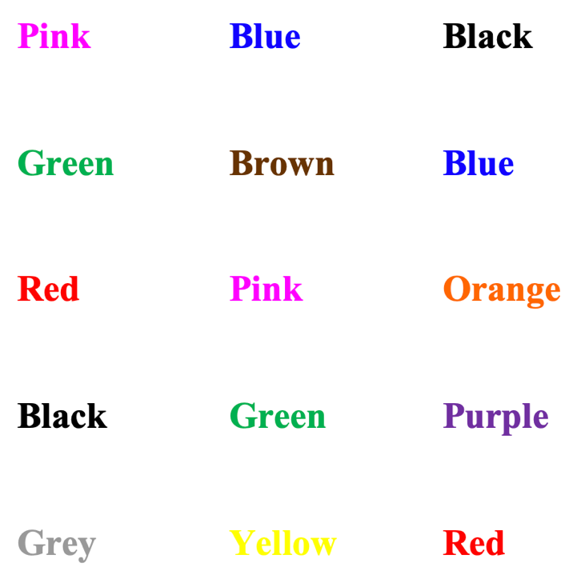

Appendices 2 – Words different to their colour.

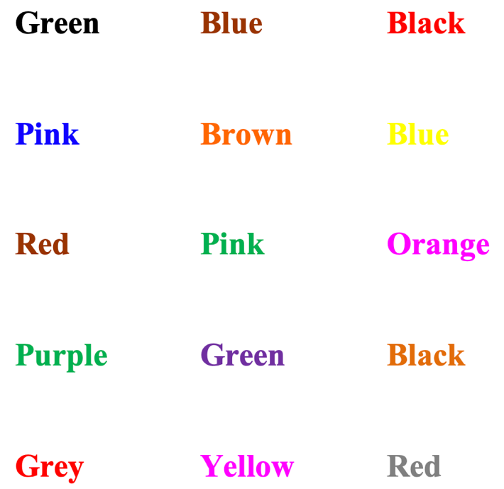

Appendices 3 – Procedures

An opportunity sample of students was used. Presumptive consent was gained.
The following instructions were presented verbally.
- Participants were put into groups of 2 or 3.
- You will take part in a Stroop colour and word test.
- Please ensure that you have a pen and paper and also your mobile phone for a timer.
- Can you all see the piece of paper in front of you?
- You will be presented with 2 coloured word lists – consisting of 15 each side.
- You will be asked to repeat the words as fast as you can while being timed.
- You will then repeat this by only repeating the colour of the word.
- The words were presented on a white double-sided sheet of A4.
- The font was Times New Roman, multi coloured, size 26.
- Participants were thanked for their participation.
- Participants were fully debriefed regarding the aim and hypothesis of the experiment.
Following the time to complete this test, raw data was analysed using a t-test on SPSS 26.

Appendices 4

Standardised instructions – the T-test showed a significant difference between the times of which te words were recalled between the words the same as the colour and the words different to the colour conditions. (T (32) =14.49, p<.001, Cohen’s d= 2.52). the effect size was large (Cohens,1998)

Information sheet

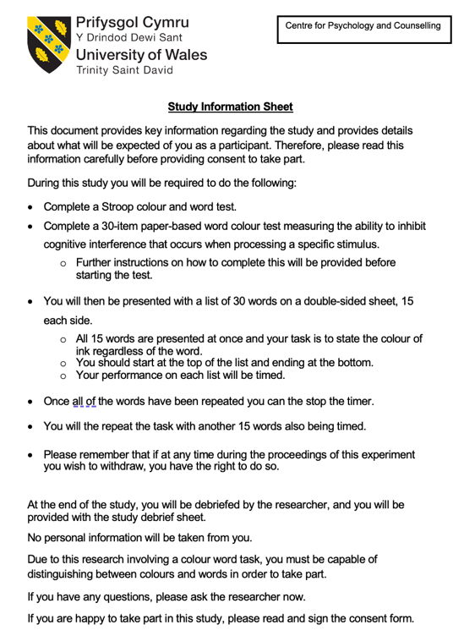

Informed consent

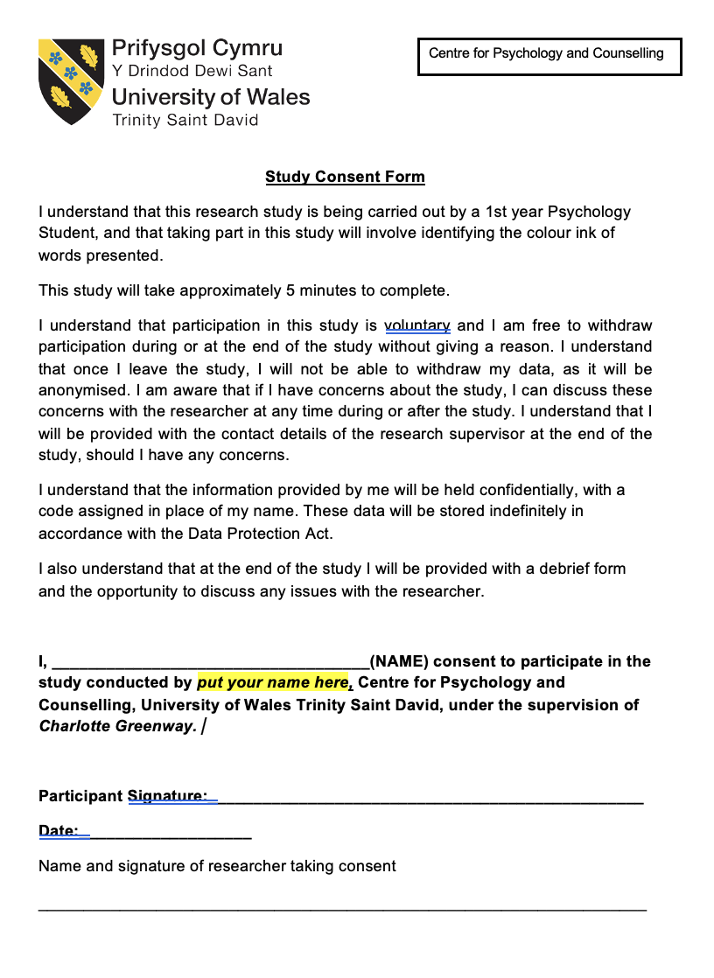

Debrief sheet
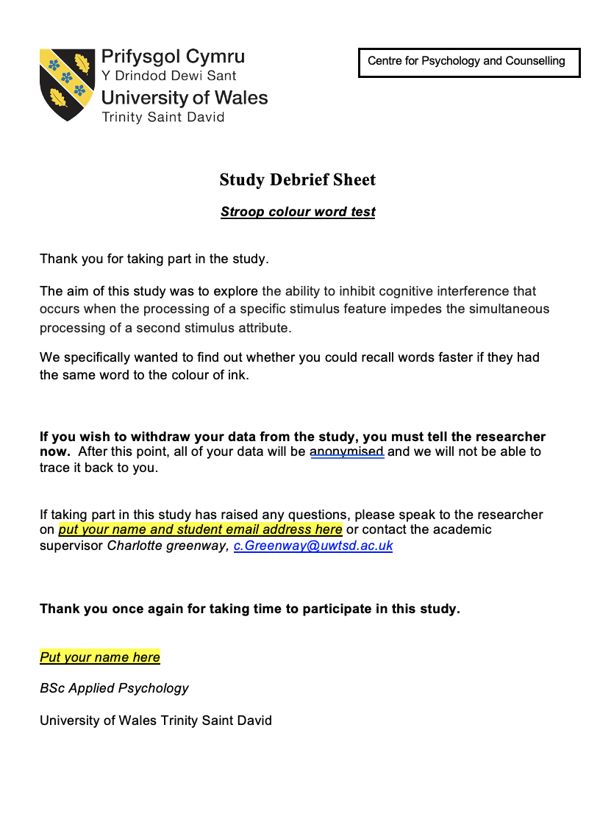

Raw data

Congruent | Incongruent
6.78 | 9.20
8.10 | 12.66
10.02 | 11.98
7.09 | 8.56
11.00 | 14.07
8.33 | 11.50
4.34 | 10.27
7.61 | 10.71
7.43 | 13.75
7.87 | 9.52
6.47 | 10.81
6.79 | 12.48
6.90 | 13.63
4.21 | 11.37
6.69 | 10.46
6.44 | 10.34
3.97 | 11.00
7.44 | 9.00
6.76 | 11.75
5.30 | 12.99
7.11 | 12.70
4.92 | 10.31
5.31 | 9.30
5.49 | 9.12
6.91 | 11.00
8.32 | 13.10
9.41 | 12.36
7.29 | 14.36
8.29 | 10.31
5.11 | 9.76
4.73 | 10.11
6.21 | 11.37
4.96 | 9.99

