

Task 2 (Report)

Module: Professional Career Development
Module code: BMSW4005
Student : Claudia Ancuta Dragan 2021166
Lecturer: Rita Ukachi-Lois

Table of Contents
Introduction 3
Importance of Career development & reflective learning 4
A personal reflection on the role play and career development 4
Skills development through reflective learning 5
Reflective learning through Gibbs reflective cycle 6
Career development planning by applying reflective cycle 6
Personal development plan 8
Conclusion 10
Appendix 1 11
Appendix 2…………………………………………………………………………………………………………………………………………13
Reference…………………………………………………………………………………………………………………………………………..14

Introduction
A review of the findings on role-playing motivation is highly recommended for anybody interested in honing their management and social abilities, as well as their ability to deal with conflict and fulfil future obligations more effectively than they already are (Finlay, 2008). It is feasible for students to improve management and negotiating skills by reflecting on the performance they made as part of earlier cooperative learning. I hope that this report will provide insight into both my involvement in the imaginary event and the general performance of our group. Details of the role play and personal development plan that resulted from it will be included in this report. In addition, I'll go into detail about my educational and professional backgrounds, as well as how I've progressed in each of them. Leading a team with increased power and responsibility is an appealing component of a profession.

‘Recruitment and Selection’

As an interviewer, I'll assume midwives are vital in the health care system. A job as a midwife will also help me grow as a person and professional. As a midwife, my main role is to care for pregnant women and their babies from conception to 28 days postpartum. During a normal pregnancy and childbirth, I will provide all necessary professional care. During the interview, I was asked five questions about my work path. The questions were asked to better understand my professional aspirations and evaluate my aptitude for the post. The inquiries were all about my personal and professional goals. When asked about my future goals, the interviewer was seeking a mature, present-oriented answer. The interviewer also enquired about my long-term retirement plans to have a better understanding of my career trajectory and preparation.

Importance of Career development & reflective learning
Professional career development is the process of offering services and activities to persons in need of a wide variety of career transitions. Reflection is recognizing what is being thought about us in our unique way. Career development includes learning activities such as job experience (Merchant Jr, 2010). Career competencies may be created as part of the advancement process. Professional development involves both personal and professional improvement. Professional development is self-improvement to advance one's career. It's often related to your current function or profession at work. Like performance assessments, it is frequently part of HR activities.

Profession development is the process of gaining new abilities to improve one's current position or seek a new career. Reflective learning techniques may help one better comprehend one's progress (Mizell, 2010). Using reflective learning allows people to own their progress and make a link between their efforts and desired outcomes. Coaching and mentoring may help facilitate reflective learning. Reflection and appraisal are important components of professional growth.

A personal reflection on the role play and career development
I am intended to play the role of midwife since it would help in several aspects of life. Again to mention, I have viable skills in this regard. The role-playing exercises I'm taking part in will allow me to hone my talents and gain experience in these areas while also improving my ability to communicate effectively with others. During my time as a job interview, I learned a lot about the process of interviewing and how to present myself professionally. Detailed awareness of the job for which you are interviewing, and the sort of company in which it is held, was also crucial.

I have a bachelor's degree in nursing and a master's degree in health and social care. I am capable of working under pressure, learning quickly, and collaborating with others. Consequently, I am confident in my ability to succeed in this role because of my strong desire to go above and beyond the call of duty. If I want to be successful in this position, I need to be able to work well with others and acquire new abilities. Learning in a complex working environment necessitates learners to be self-regulated, which means that they must take an active part in their education and dynamically alter their behavior and approach to meet learning goals (Gunteski, 2018). Reflective practice is overseen by trainees, not supervisors, in my experience as a former employee. To standardize training, I need to keep track of both my successes and failures. It's also important for me to think about my learning styles, goals, and interests. As a result of self-monitoring, people may adapt their learning style and technique utilization to meet their personal learning goals as well as professional needs (Loughran, 2002).

Skills development through reflective learning
Self-reflection is an important part of reflective learning since it allows students to evaluate their learning and experiences. Thinking back on what one has ever read, done, or learned is an important part of the reflective learning process because it helps you connect the content to your own experiences and personal goals (Husebø, 2015). Learning from one's mistakes and successes is strongly tied to the notion of deciding what one would do differently in the future based on one's past experiences.

Reflection is an important part of learning new things. Through reflection, one may better understand and explain previous events, which often leads to discoveries or ideas that can be explored in the future. It's vital to think about ambiguous circumstances and challenges (Paterson, 2013). That reflection is an important part of entrepreneurship education and an effective way to develop skills is not surprising. When choosing a career route, it is critical to place a high value on professional development. Someone with a clearly defined set of competencies may be able to successfully navigate the obstacles of a professional job. Anyone who has participated in any sort of formal education, especially one that has a self-improvement component, is likely to be familiar with the process of career planning and management that is being described. It's standard practice, but it's also really important. The ability to communicate effectively and interact with others is in high demand in any sector, regardless of the industry in which one chooses to work. Personal characteristics and how we connect with others have a significant effect on the development of these abilities. It is possible to attain personal professional goals such as promotion or becoming an expert by devoting time to improving one's abilities, such as learning a new language.

Reflective learning through Gibbs reflective cycle
One of the most well-known cycle models of introspection takes you through six phases of analyzing an experience: description, emotions, assessment, analysis, conclusion, and action plan (or a combination of these). He came up with the Reflective Cycle in 1988, and it was designed by Graham Gibbs. An important benefit of this method is that you may use it to analyze past events and learn from both the successes and failures you've had thus far.

Six phases are covered in Gibbs reflective cycle
- A narrative of what happened- Description
- Thoughts and feelings relating to the event- Feelings
- Both positive and negative aspects of the event- Evaluation
- Analyzing the event to understand it - Analysis
- What a person has learned and what they wish they had done differently in the process - Conclusion
- How one would handle similar circumstances in the future, and what modifications that would make if necessary - Action Plan

Career development planning by applying reflective cycle
When attempting to make sense of a tough circumstance, Gibbs paradigm may be of assistance to me. The fact that one is required to collaborate with others frequently may be the result of a one-time incident or the result of an ongoing pattern of behavior (Wain, 2017). Although Gibbs first proposed that it be used in recurring situations, the stages and principles may be used to one-time interactions as well as recurring situations. A more comprehensive action plan, based on a particular incident, may be developed to analyze how individuals could apply the information they have gathered in the future (Watts, 2016).

Description
When the interviewer asked me a series of questions, I was able and confident enough to answer them in full. With my qualifications, I expressed why I wanted to become a midwife and how I could honor it. After just a few minutes of questioning, I felt confident in my responses (Rodman, 2019).

Feelings
I don't recall many complications in the interview when I was the interviewee. My performance was exactly what I expected it to be. I feel I answered the questions to the satisfaction of the interviewer. However, even though we practiced several times, I still felt anxious and jittery even though I could hear a sense of serenity and serenity in my voice.

Evaluation
By being honest, I was able to convey my aspirations and objectives. I saw a lot of excellent things in this role-playing game. The role-play went nicely despite my anxiousness, which I felt was dreadful. I also found my serenity to be soothing and encouraging.

Analysis
In this circumstance, I realized how much more could have been done to enhance the role-play experience. The interviewer gave me a strict time limit, and I felt that I was fairly confident in my ability to demonstrate my role play from my point of view by stating it in a straightforward manner (Eggert, 2017).

Conclusion
During the interview, I was a little anxious, but I maintained my composure. I'm clear on what I want to achieve and how I'm going to get there. However, I am also aware of how to constructively address my shortcomings. ( please see appendix 1 and appendix 2)

Action plan
Reflecting on the role play, I think that I have received enough insight into my flaws to be able to alter them if the circumstance arises again. To achieve each of my goals, I need to grow better. When it comes to dividing up group work, for example, I plan to employ Belbin's team roles. Finally, I'll remember that speaking my thoughts may help the result if I have worried (Watts, 2016).

Personal development plan
The term "personal development plan" (PDP) refers to a tool for self-evaluation and reflective practice that is often utilized in higher academic achievement and the workplace, according to Gosling (2014). If done properly, however, it may be helpful to both personal and professional life. It helps them set clear objectives and weigh the advantages and disadvantages of their suggested solutions. Building a personal development strategy might begin with a SWOT analysis. There are four components to SWOT: strengths, weaknesses; opportunities; threats. My personal growth may be aided or hindered by looking at these four areas as a framework (Sarsby, 2016).

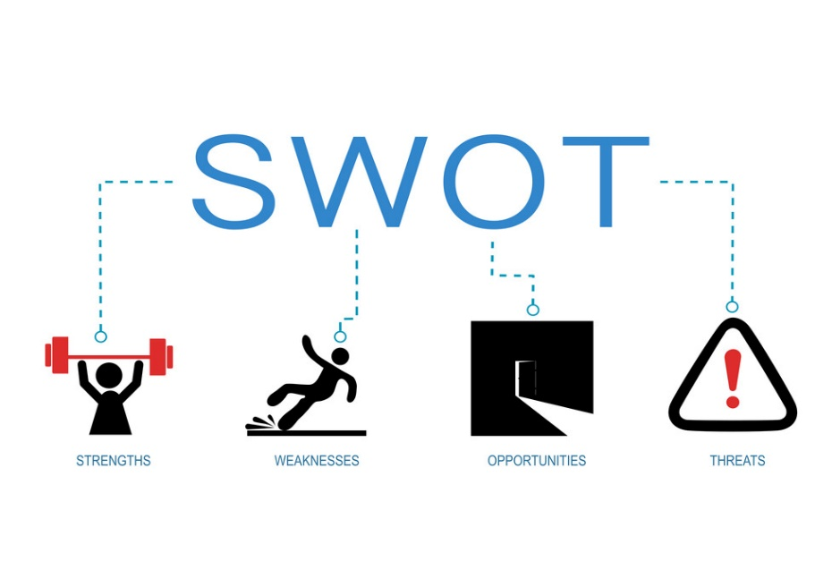
Figure: demonstration of SWOT analysis (Sarsby,2016)
Strengths
I consider my limited assortment of talents, as previously said, to be my most valuable assets, and they are also my most valuable assets. Confident, diligent, and meticulous in all that I do, I consider myself to be trustworthy and dependable in all situations and situations. At least in my perspective, I am an exceptional communicator who is capable of persuading any prospective buyer to value our products. My ability to work swiftly and efficiently increases when I am under a great deal of pressure.

Weakness
My flaws are few and far between. Even when I'm calm, I can't always keep my body language in check when I'm upset, and this is something I need to work on. When the shop is crowded, I think I become a little frustrated listening to other customers.

Opportunities
To work more effectively and build stronger relationships in the fashion sector, I need to learn new skills. In addition, completing my courses successfully will open up more job prospects for me.

Threats
I face the possibility of losing or acquiring a job as a result of the Pandemic, as well as an increase in workload owing to a lack of personnel. As a result, I am aware of the huge number of competitions that I will encounter after my degree ends and I begin my own company.

Conclusion
Role-playing is a term used to describe when two or more people act out a scene together. As an interviewer and an interviewee in a role play, you'll see how hard it is to coordinate your efforts in this report. Self-assessment, as well as a strategy for both personal and professional growth, are also discussed in this document. In addition to the importance of a person's career goals, they are also crucial since they drive them to succeed in their interest. SWOT and SMART objectives were used to highlight the importance of these techniques in building a personal development plan in this study.

Appendix 1

Job application form : Application for midwife
Student nr: 2021166
Name: Claudia Ancuta Dragan

Education and training:
- Health and social care Level 4 -University Wales Trinity Saint David , London 2021- still student
- Nursing school „Carol Davila”-Targoviste ( in Romania) 2016-2019
- Acupuncture course 2 years “Carol Davila”-Targoviste 2017-2019
- Training for Leadership Authentic Foundation 2016
- Training for Broker Door-to-door 2016
- Training Junior Achievement young Enterprise (Romani) 2014

Qualifications:
- Health and social care level 4
- Nursing level 5

Employment history
- Mitie and NHS
Name of employer:
- Mitie
Job title:
- food service

Length of time with employer: 2 years
Reason for leaving: Health problem , I was diagnosed with Fibromyalgia . So I take a breake from work to learn to live with my medical condition.

Duties: My duties in work place is: I need to be sure I give the correct food to the patients and drinks . In the morning I make the breakfast is ready in time. Clean kitchen and place order.

Supporting statement
Please tell us why you applied for this job and why you think you are the best person for the job.
I am confident that I am a good fit for this position for several reasons, but most specifically because of my dedication to going above and beyond in a job. I am committed to learning any new skills working in team to succeed in this role. For example, for my previous job as HCA , I take care or old people . This allowed me to understand is important to work in team , to understand that the patience need attention , good care . so after working with old people make me to wish to work baby’s and pregnant women

Right to work in the UK
Do you need a work permit to work in the UK? Yes

Declaration
I confirm that to the best of my knowledge the information I have provided on this form is correct and I accept that providing deliberately false information could result in my dismissal.

Name: CLAUDIA ANCUTA DRAGAN

Appendix 2
In this appendix i will talk about the 5 questions from the play role with my partner .
My dreams job is to become a Midwife

- Tell me about yourself and why you want to become a Midwife?
- Why did you choose midwifery course?
- What does a midwife do?
- Why do you want to work here?
- The last question, tell me where you see you after 2 years?

References
Eggert, M., 2017. Perfect answers to interview questions. London: Random House.
Finlay, L., 2008. Reflecting on ‘Reflective practice’.
Gunteski, A., 2018. Professional development training in special education.
Husebø, S.E., O'Regan, S. and Nestel, D., 2015. Reflective practice and its role in simulation. Clinical Simulation in Nursing, 11(8), pp.368-375.
Loughran, J.J., 2002. Effective reflective practice: In search of meaning in learning about teaching. Journal of teacher education, 53(1), pp.33-43.
Merchant Jr, R.C., 2010. The role of career development in improving organizational effectiveness and employee development. Florida Department of Law Enforcement.
Mizell, H., 2010. Why Professional Development Matters. Learning Forward. 504 South Locust Street, Oxford, OH 45056.
Paterson, C. and Chapman, J., 2013. Enhancing skills of critical reflection to evidence learning in professional practice. Physical Therapy in Sport, 14(3), pp.133-138.
Rodman, A., 2019. Personalized professional learning.
Sarsby, A., 2016. SWOT analysis. Lulu. com.
Wain, A., 2017. Learning through reflection. British Journal of Midwifery, 25(10), pp.662-666.
Watts, A.G., 2006. Career development learning and employability. York: Higher Education Academy.

