Introducing the Modern Workplace Assesment 2 – group presentation

Name: Alexandru Sebastian Melinte Student ID: 1907706
Daniel Florin Lazar STUDENT ID: 2009160
Lucian Mirica STUDENT ID: 2013041
Ionut Paul Marincu STUDENT ID: 2009079

Module Title: Introducing the Modern Workplace (LCBB4003)

Assignment Title: Introducing the Modern Workplace Assesment 2
Module LECTURE’S NAME: Dr. Gregory Cowan

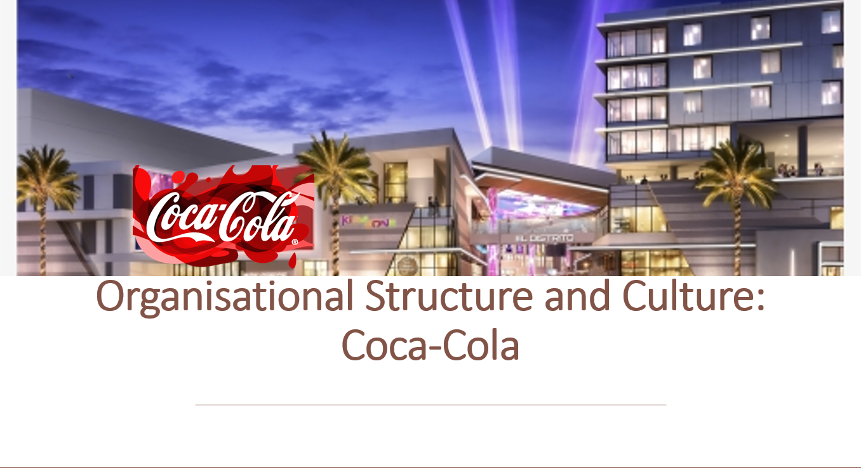

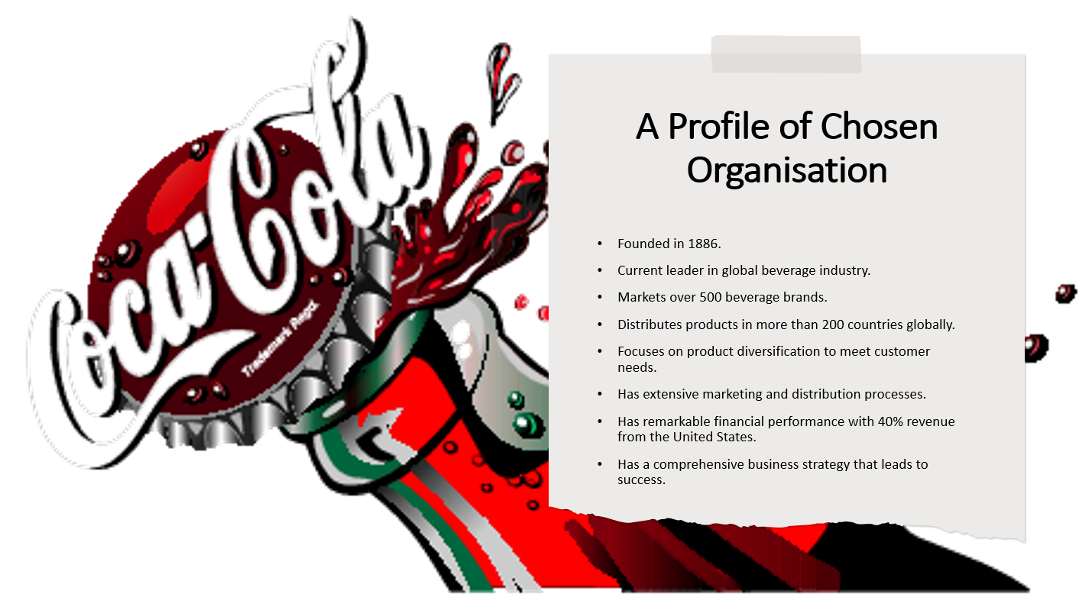

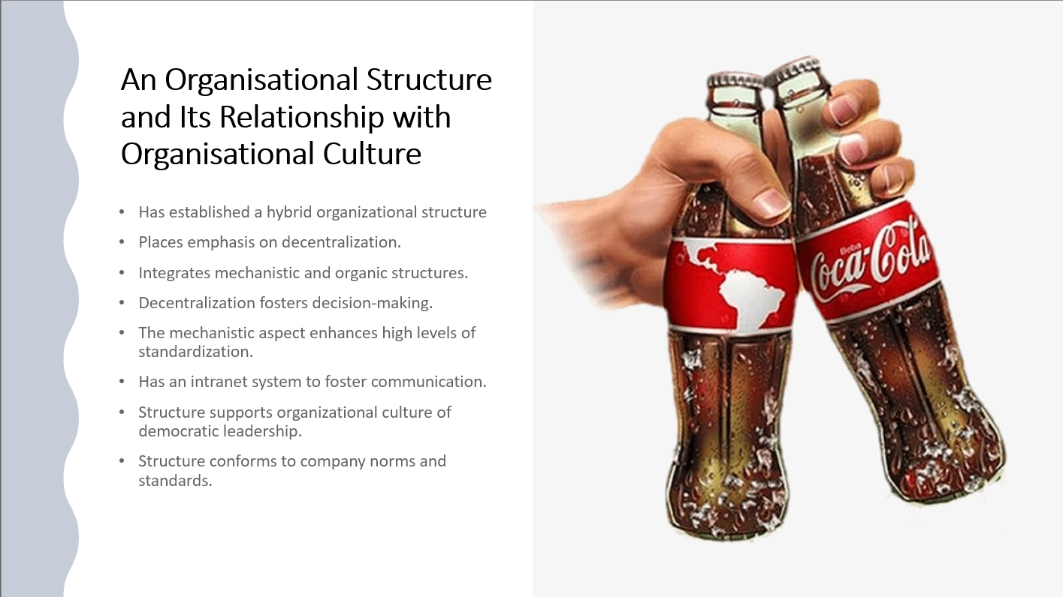

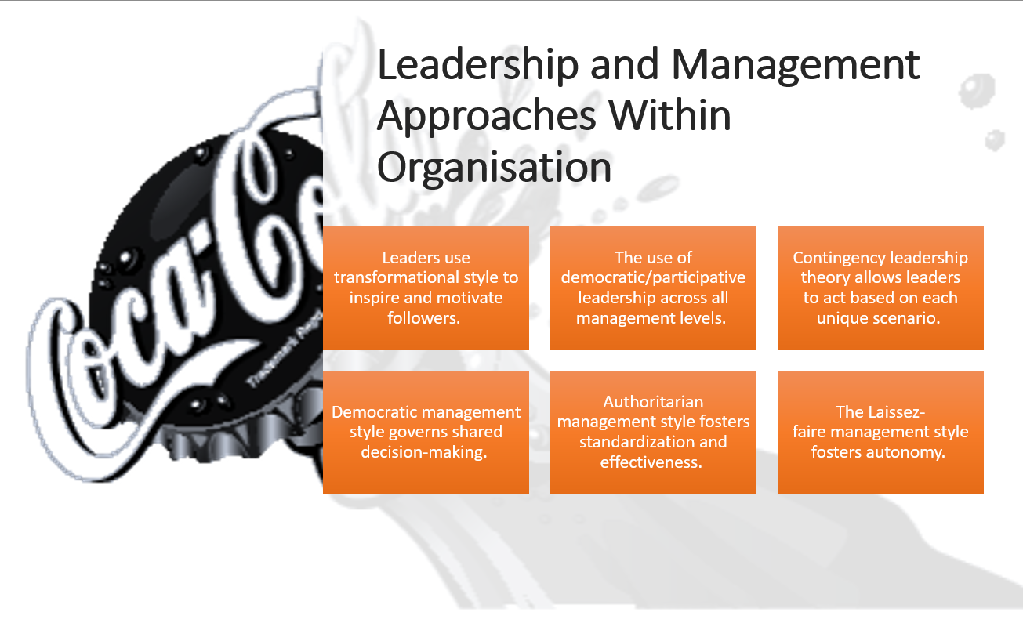

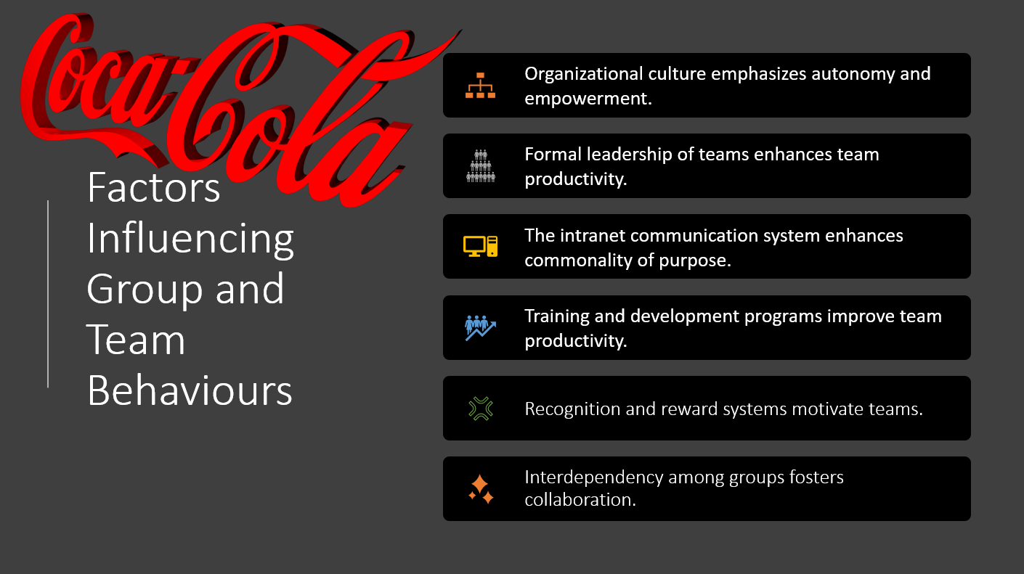

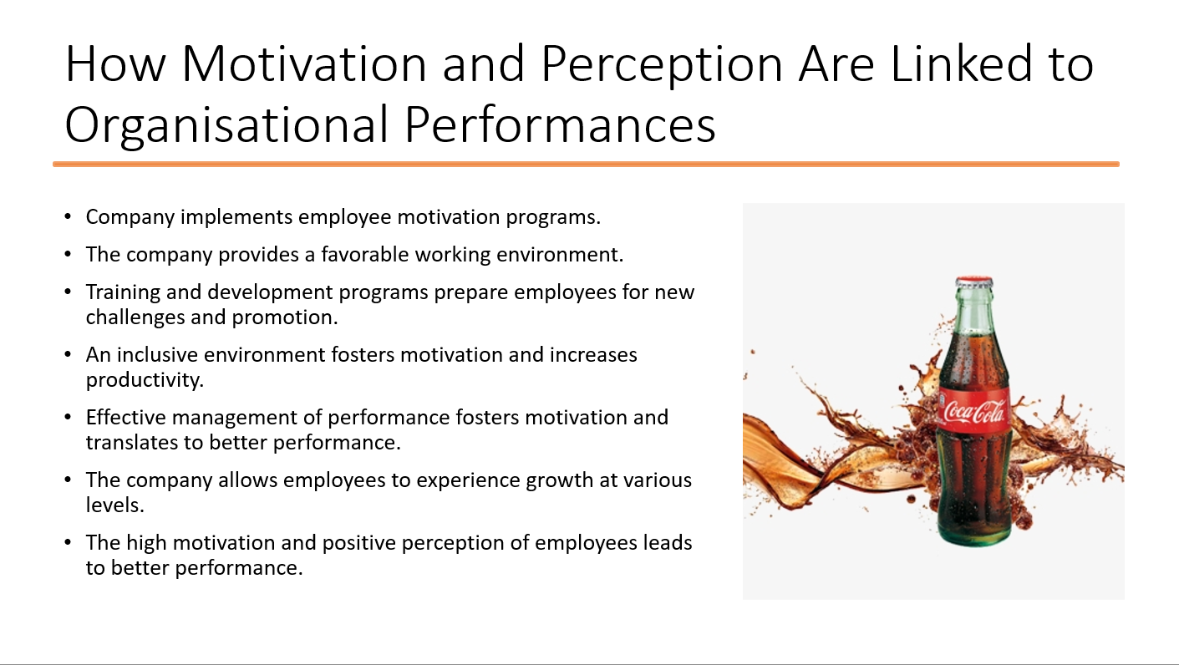

Organisational Structure and Culture: Coca-Cola

A Profile of Chosen Organisation
John Pemberton founded the first product categorised as coke in 1886 as a fountain beverage made using syrup, water, coca leaves, and an extract from kola nuts. The beverage gained popularity, which led to its availability in different drug stores in Mexico and Canada. The modern Coca-Cola company owns more than $15 billion brands and is the global leader in the manufacture and sale of non-alcoholic beverages (Hartogh, 2011). Since its foundation, the company has established an evident trademark in the United States and more than 200 countries worldwide. The company has succeeded in establishing the brand with the highest value and global recognition for its products' uniqueness. Throughout these years, Coca-Cola remains committed to providing a great diversity of products in a bid to satisfy the various desires, needs, and conform to the lifestyle choices of its customers in different parts of the world. Currently, Coca-Cola has four leading brands: Coca-Cola, Diet Coke, Sprite, and Fanta. Over the years, it has introduced other brands such as Minute Maid, Vitamin Water, and Powerade (Indeed.com, 2021). Real statistics from the company reveal that the company markets over 500 beverage brands that range from sparkling drinks, juice drinks, sports drinks, water, energy drinks, and ready to drink teas and coffees. Due to its long history and market performance, Coca-Cola has established the global greatest beverage distribution system.
The company can supply its customers across the globe with all its products through this distribution system. However, about 40% of Coca-Cola's revenue is from its American market (Indeed.com, 2021). The main vision of Coca-Cola has helped establish critical elements, namely, people, portfolio, partners, planet, profit, and productivity, to foster the achievement of sustainable quality growth. In people's context, Coca-Cola seeks to create a working environment that inspires employees to be their best. The portfolio element points to the great diversity of beverage products that the company offers to its customers in different parts of the world. In the context of partners, Coca-Cola regards its network of customer and suppliers highly and embarks on creating mutual value. In the context of the planet, Coca-Cola intends to become a significant contributor to the world's betterment through its commitment to build and support the development of sustainable communities (Hartogh, 2011). For the element of profit, the company highlights its commitment to meet the expectations of shareowners by maximising profits while paying attention to its social and moral responsibilities. The element of productivity highlights Coca-Cola's commitment to becoming highly effective and with a significant ability to exhibit remarkable growth in the industry.
The company's mission demonstrates its persistent journey towards establishing a brand that refreshes the world, inspires optimism and happiness, and helps create value and exerting dominance on society. Coca-Cola is a global beverage industry leader with an uncontested success that has seen the company continue to grow over the years. The company has remained responsive to customers' regional needs while also responding effectively to other concerns highlighted by customers over the years (Indeed.com, 2021). Coca-Cola has developed expertise in conducting extensive research that leads to the development of new products and rigorous marketing processes that have led to the global recognition of products (Vrontis & Sharp, 2003). Undoubtedly, Coca-Cola's global coverage has been because of the development of unique strategies that have helped the company to remain ahead of competitors. Despite the emergence of entrants operating in the beverage industry, Coca-Cola has continued to protect its reputation and leading position in the beverage industry. Over the years, Coca-Cola has embarked on making major acquisitions that have symbolised its strategic view of fostering growth and dominance in the market (Hartogh, 2011). Moreover, the company has entered strategic mergers to strengthen its competitive advantage in the market. For instance, in 1991, the merger between Coca-Cola enterprises and Johnstone Coca-Cola Bottling Group led to the formation of a giant company to register a more significant impact on the market. Each of these strategic moves has led to its growth over the years, giving it a better foundation to serve customers and meet their emerging needs.
Coca-Cola believes in a comprehensive business strategy guided by six critical beliefs. The first belief is that consumer demand forms the basis of all actions that the company takes. The company believes that brand Coca-Cola forms the core of its business and has a deep conviction that serving customers with a diverse range of non-alcoholic products that they can consume at different times is the most significant element in the business (Indeed.com, 2021). Coca-Cola believes in establishing remarkable marketing practices that can propel it to global leaders in marketing (Foster, 2014). The company also recognises the need for thinking and acting locally while achieving leadership as a model corporate citizen. Following these beliefs, the company delves into increasing productivity, expanding its market share while maximising profits. The number of customers keeps growing due to the extensive and well-structured marketing efforts.
Coca-Cola has exhibited significant strengths that lead to its competitive edge in the market. These include having the largest market share in the beverage industry, establishing a global distribution system, and a large customer base. Other outstanding strengths include the company's bargaining power over suppliers, successful marketing and advertising efforts, and corporate social responsibility participation. The company has continued to identify emerging opportunities such as the demand for healthy beverages, the increased consumption of bottled water, and the available opportunities in emerging markets. Through its strategic business strategies, the company has taken advantage of these opportunities to foster business growth. A critical analysis of the company's financial records reveals that Coca-Cola remains profitable despite its debts due to multiple acquisitions (Hartogh, 2011). However, the financial data reveal high levels of efficiency and low liquidity rates. The company exhibits remarkable capacities to improve its financial performance. Emerging threats from the excessive competition and reduced sales due to the demand for healthier beverages are some of the trends that have affected the company. As a result, the company has been key to explore the non-carbonated market sector after its many years of dominance in the carbonated drinks sector. Coca-Cola's future appears bright based on the most recent predictions and the company's current business strategies.

An Organisational Structure and Its Relationship with Organisational Culture
A critical analysis of Coca-Cola's organisational structure demonstrates its efforts to successfully coordinate activities and ensure that the organisation meets its goals and objectives. The concept of the organisational structure helps in understanding how various levels of corporate management exercise authority (University of Minnesota, 2016). The organisational structure of a company establishes a standard procedure that governs the establishment of operations and routines. Moreover, the structure defines the role of different employees in decision-making processes. Coca-Cola has adopted a practical approach of designing its organisational structure with a critical focus on its long-term goals and objectives. Specifically, the company focuses on achieving a remarkable decentralisation level in a bid to foster efficacious decision-making processes. Moreover, the company's organisational structure has two major divisions categorised as operating groups. The operating groups are the Bottling Corporate and Bottling Investment and have further subdivisions according to geographical locations (Business Case Studies, 2019). The overall structure of Coca-Cola seeks to provide managers at lower levels to make critical decisions regarding the effective marketing of the products within their allocated region. Both regional and local managers can participate in decision-making processes, especially when they involve changes in the market.
Coca-Cola has adopted a significant blend of both mechanistic and organic organisational models. The purpose of creating a hybrid organisational structure is to create a measure of flexibility while ensuring that the organisation continues to exhibit the desired flexibility. Contrary to most traditional mechanistic structures, Coca-Cola has remained aware that fostering decentralisation will allow for an increased level of responsiveness to market changes (Business Case Studies, 2019). Notably, high centralisation and increased standardisation are some of the defining characteristics of a mechanistic structure. For this reason, Coca-Cola has exhibited an increased awareness of the need to remain responsive to market needs because it operates in more than 200 countries while maintaining the aspect of standardisation to foster effectiveness. As a result, Coca-Cola relies on an organisational structure that is highly simplified to reduce bureaucracy and hierarchy but emphasises the significance of standardisation. Coca-Cola has established a hybrid organisational structure with its board of directors based in Atlanta, while regional managers occupy its regional offices in different parts of the globe (University of Minnesota, 2016). To enhance decision-making processes, the managers in the regional and local offices in different countries participate in surveys and interviews to improve the company's responsiveness to local needs. The regional managers occupy different corporate divisions, namely, finance, research and development, human resources, innovation, marketing, and strategy and planning. For each of these departments, the managers have the freedom to exhibit autonomy in their operations. These managers make key decisions under the guidance of the company's mission and vision statements.
The most critical element in their decision-making processes is ensuring that they comply with the top hierarchy's priorities. Coca-Cola has established an intranet system responsible for facilitating real-time communication to foster effective communication across the organisational structure (Business Case Studies, 2019). The company can achieve significant outcomes in the standardisation of its processes through the continuous flow of communication. Maintaining flawless communication has been a challenge for Coca-Cola, but the intranet system's presence has continued to serve as an important tool to enhance successful communication. The move to embrace decentralisation has obligated the company to locate its offices strategically to enhance decision-making processes. Coca-Cola's concept of a divisional structure ensures that each department remains functional and registers effectiveness (University of Minnesota, 2016). Combining the divisional concept and a measure of decentralisation constantly allows the company to achieve better outcomes in its venture to foster effectiveness. Coca-Cola exhibits a significant relationship between its organisational structure and the corporate culture. The company's focus is to establish a highly inclusive environment that fosters diversity ad that supports effective teamwork.
The corporate leaders at Coca-Cola have been keen to ensure that the organisation has adopted shared core values, belief systems, and norms that define the acceptable behaviours in the organisation. The company believes in forging successful partnerships with different stakeholders as a way of enhancing efficaciousness. One of the central tenets in the company's organisational culture is that customers are the most integral focus of the business (The Coca-Cola Company, 2021). Such a belief system has led to the improvement of different products to enhance customer satisfaction. On the other hand, employees at the company have embraced the strong belief of being the best in the industry, which has fostered high levels of effectiveness. All employees at Coca-Cola recognise the company's need to collaborate with its partners to achieve long-term objectives. Therefore, the company maintains awareness that employees need high levels of motivation to participate in achieving long-term goals. The current organisational structure creates a platform for regional and local managers to directly impact the levels of employee motivation. These managers can communicate the greater vision to employees while motivating them to participate in achieving that vision (Learn Information System, 2014). The company's organisational structure reinforces the strong organisational culture, which has constantly allowed Coca-Cola to achieve significant outcomes by maintaining a competitive advantage.
The decentralisation level in Coca-Cola's structure demonstrates the need for a participative decision-making approach, which is part of the organisational culture. The company values employees' input at the bottom level and creates a platform for them to design strategies that can translate to higher levels of effectiveness. In the long-term, the compatibility between organisational structure and culture has continued to foster the company's remarkable performance (Bock, Opsahl, George, & Gann, 2012). The company's move to support decentralisation has represented its commitment to provide a measure of autonomy and flexibility of regional and local managers. Notably, both autonomy and flexibility are characteristics of a favourable work environment that can foster motivation and productivity levels. The reinforcement of the divisional element in its hybrid structure has helped Coca-Cola to maintain a culture of efficiency due to the existing standards (Biswas, 2009). These norms and standards form a central part of the company's culture. As the company strives to improve its organisational culture, it reinforces its concept of the hybrid organisational structure, which leads to the effective sharing and exercising of authority.

Leadership and Management Approaches Within Organisation
Coca-Cola recognises the importance of establishing effective leadership, which is likely to foster the company's success. Specifically, leaders at the company have embarked on adopting efficacious leadership styles that can directly impact organisational performance. The proper leadership of the multinational company has been at the centre of its success over the years (Beer, 2020). The choice of leadership style in any organisation is a key determinant of whether the organisation can attract and retain remarkable talent. Moreover, modern-day companies are operating in an extremely competitive environment that requires strategic leaders that can utilise different approaches to foster the company's performance amidst such competition. On the other hand, the implementation and execution of a company's strategy also require visionary leaders who can utilise their charisma to motivate and inspire employees. For this reason, Coca-Cola has embraced well-selected leadership and management styles to enhance the achievement of the company's long-term goals and objectives.
The company's chief executive officer has often highlighted the role of leadership in the company in creating a favourable environment for employees and inspiring them to achieve the company's vision. In the top leadership view, the essence of leadership at Coca-Cola is to facilitate the execution of the company's business strategies. In this context, the chief executive officer has the role of providing leadership in consumer marketing, which focuses on establishing a remarkable relationship with consumers (Hartogh, 2011). The chief executive officer also undertakes commercial leadership, which comprises the multiple strategic actions that the company must undertake given its retail customers involved in selling its products. The provision of franchise leadership is an additional responsibility of the chief executive officer, which involves oversight over the relationship with different bottling partners across the globe. These areas need a remarkable level of leadership which will lead to increased productivity and efficiency. The leadership styles that Coca-Cola has adopted register an impact on overall performance. The leaders have recognised the effectiveness of transformational leadership in motivating and inspiring employees to participate in achieving organisational goals.
The basis of transformational leadership is to foster the effective implementation of change through team building, the inspiration of employees, and the development of employees through training programs (Beer, 2020). Coca-Cola's commitment to an effective leadership style has been one of the central tenets that have continued to reinforce remarkable performance over the years. Through transformational leadership, the company has established a strong corporate culture and registered higher motivation levels among employees. The leaders and managers rely on the transformational approach by providing mentorship and coaching that benefit employees at different levels. Transformational leadership has helped promote autonomy among low-level managers and create a deeper sense of responsibility. Transformational leaders use different approaches to intellectually stimulate their followers and prepare them for the achievement of the greater vision (Beer, 2020). The former chief executive officer at Coca-Cola established a platform of participative leadership, which has been a remarkable approach to ensuring that managers at different levels can make autonomous decisions and contribute towards achieving greater goals and objectives. Particularly, Kent, the previous chief executive officer, adopted participative leadership to foster the inclusion of all the managers at regional and local levels in decision-making processes.
Participative leadership focuses on strategically distributing decision-making processes through the empowerment of managers and engagement of employees. Participative leadership supports the operational effectiveness of Coca-Cola because it allows the company to remain responsive to diverse market needs. James Quincey, the current chief executive officer since 2017, has fostered the implementation of participative leadership, which has become part of the Coca-Cola culture (Beer, 2020). Quincey joined the company in 1996 and had the privilege of serving in different leadership positions before becoming the chief executive officer. His earliest interactions at the company led him to learn the basis of participative leadership under the leadership of Kent. In his own words, Quincey tries to foster "Inclusion", "Empowerment", and "Accountability" (Beverage Industry, 2018). Notably, he highlights that his focus is to grant the leadership team and employees an opportunity to make decisions while exhibiting accountability. For this reason, he is focused on reinforcing the democratic approach of ensuring that his followers work towards the implementation of the greater vision by valuing their input. These managers can register positive impacts through their participation in making decisions regarding local and regional markets.
The democratic management style has become popular in the Coca-Cola organisational culture. The emphasis on adopting the democratic approach ensures that different employees can share in decision-making processes based on their delegated tasks. The democratic management style fosters autonomy and creates a favourable working environment that challenges employees to remain accountable while embracing accountability (Hartogh, 2011). Similarly, the authoritarian management style is also a critical element of the management at Coca-Cola, which helps preserve a high level of standardisation to foster effectiveness. The authoritarian management style embarks on providing specific rules, procedures, and policies that govern the company's operations. In the long run, the combination of these leadership and management styles has helped Coca-Cola maintain its leading position in the beverage industry while keeping employees committed and motivated to participate in achieving organisational goals.
The laissez-faire' management style is also popular among Coca-Cola managers. Specifically, some regional managers utilise this approach when delegating tasks to local managers, allowing them to make autonomous decisions regarding the marketing of the products and the preferred adjustments to local market preferences. Although the local managers receive minimal instructions on making these decisions, they understand the existing key goals and objectives and use them to make decisions that foster the achievement of those goals (Beer, 2020). Additionally, this management approach gives employees a platform to support each other's professional growth as they recognise their collective capability to contribute to achieving long-term company goals. The integration of these management styles has been at the centre of Coca-Cola's success over the years. In some instances, managers rely on the contingency theory, in which the best management approach is dependent on the situation at hand. Contingency leadership theory helps leaders adopt the most favourable style depending on the unique circumstances of decision-making.

Factors Influencing Group and Team Behaviours
The Coca-Cola Company recognises the importance of reinforcing desirable group and team behaviours. Multiple factors have the potential to influence organisational behaviour in various organisations. For this reason, Coca-Cola is keen to create a favourable environment that has the potential to foster a desirable pattern of organisational behaviour. Organisational culture is one of the key determinants that have the potential to influence group behaviours (Hackman & Katz, 2010). For Coca-Cola, the organisational culture has the potential to foster desirable behaviours. A clear case of Coca-Cola's organisational culture influencing team behaviour is through autonomy and flexibility. The culture empathises on allowing managers at different levels to make autonomous decisions while exhibiting accountability. The company's culture focuses on empowering employees and creating a favourable environment to exhibit such autonomy. With such autonomy and empowerment, the company has the potential to promote the adoption of effective teamwork. The managers at different levels serve as the leaders of their teams. The culture at the company empowers them to make decisions regarding the success of their teams. In this context, the company has exhibited remarkable success in forming a strong team culture that directly influences all the employees' behaviour (Dinh & Salas, 2017). Moreover, Coca-Cola's culture embraces inclusion and diversity, elements that motivate people from different backgrounds to work together to achieve organisational goals. Each element of the Coca-Cola culture undergoes reinforcement to establish norms that govern the company's expected behaviours.
Formal leadership in an organisation is a strong determinant of group behaviours. In this context, the type of leadership adopted across the various levels of Coca-Cola management helps foster successful collaboration. Specifically, the leaders utilise transformational leadership to influence their teams to achieve greater goals. The application of transformational leadership by each team's formal leaders usually translates to increased team productivity and innovation (Chandele, 2021). Additionally, the application of democratic leadership creates a platform for all managers and employees to participate in decision-making processes. With this kind of leadership in place, it is easy to reinforce cooperation and collaboration among team members. Moreover, the leaders are responsible for developing a clear vision for the organisation that leads to the determination of short-term and long-term organisational goals and objectives. With a clear vision and goals in place, team members have a commonality of purpose, which is likely to influence group behaviours. In the context of Coca-Cola, the intranet system responsible for fostering an effective communication network leads to the communication of the vision, goals, and objectives, which influences overall team behaviours (Dinh & Salas, 2017). Without effective communication, it would be difficult to foster desirable group behaviours. Coca-Cola has established a clear passion and focus on building its brand and communicating it to all its partners.
The employees form a critical part of the company's partners that help achieve long-term goals. It is possible to reinforce team innovation, productivity, and high levels of commitment by developing a clear vision, passion, and commitment to building a strong brand. Coca-Cola provides multiple learning solutions and training opportunities that prepare the employees for more challenging responsibilities through the intranet (Hackman & Katz, 2010). The provision of learning and employee development serves to enhance teams' competencies and prepare them for higher levels of productivity. As a result, training and development programs positively influence group behaviours. Different teams undergo the required training to understand the best strategies to utilise in meeting the needs of the local market (Chandele, 2021). The approach of training and development prepares each team member to contribute positively to the overall group achievements. The development of an inclusive and diverse work environment has been Coca-Cola's approach to motivating remarkable team functioning. Additionally, the company has established a culture that fosters team rewards and recognition.
Recognising and rewarding teams may offer intrinsic and extrinsic motivation, which can foster positive behaviours. Recognising teams' achievement makes it easier for them to experience a sense of achievement and embark on higher levels of creativity and innovation. Different forms of rewards serve to enhance team members' motivation and commitment to overall organisational goals (Hackman & Katz, 2010). Coca-Cola exhibits awareness that the existing performance management systems may impact group and team behaviours. As a result, the focus is to invest in employees to contribute positively to the achievement of long-term goals. Through the performance management system, investing in employees has been Coca-Cola's approach of registering positive outcomes in enhancing its team culture. The recognition that Coca-Cola works towards establishing a successful brand is a factor that fosters cohesiveness among teams (Dinh & Salas, 2017). Based on the greater vision and mission, managers at different levels reinforce positive team behaviours by establishing a level of trust and commitment. If the company allows employees to participate in decision-making processes, it sends a clear message on the trust and value it attaches to the employees. Coca-Cola uses this approach to influence group behaviours and enhance the teams' commitment to long-term organisational goals.
The level of interdependency among groups is likely to determine the level of team productivity. Coca-Cola allows individuals with different abilities and competencies to work on tasks, an element that enhances the levels of interdependence. In the end, the groups are likely to exhibit higher productivity levels and contribute positively towards the achievement of the greater vision. The organisational structure and culture at Coca-Cola function to create the best platform for enhancing group behaviours (Chandele, 2021). The focus is to ensure that the employees perceive the workplace as a rewarding opportunity to utilise their skills, abilities, and experiences to achieve long-term goals. To emphasise this sense of satisfaction, the company has measures that allow each team to set specific goals and objectives. When the teams achieve such goals, it becomes easier for them to exhibit a greater commitment level. Over the years, the company has studied group behaviours and allowed managers to learn how to build productive teams. One of the approaches has been enhancing the mutuality of the company and employee responsibility to unite teams so that they can achieve organisational goals (Hackman & Katz, 2010). The company fosters the organisation's psychological ownership, which motivates teams to demonstrate higher levels of commitment.

How Motivation and Perception Are Linked to Organisational Performances
Motivation and perception represent important elements that can influence organisational performance. Particularly, organisations take strategic measures of promoting employee motivation and ensuring that they have a positive perception towards organisational goals (Cook & Artino, 2016). Without effective motivational strategies, employees are less likely to lose their morale and negatively perceive their work. As a result, such a state contributes to the compromised performance of the organisation. Coca-Cola has remained aware of the need to foster employee motivation and perception through different strategies. The leaders and managers have adopted remarkable approaches to fostering organisational performance through employee motivation. The Herzberg Hygiene Theory is one of the effective strategies for fostering employee motivation. The use of this theory emphasises the provision of motivating factors that can potentially influence employees' motivation. The main motivating factors include achievement, recognition, responsibility, challenge, promotion, and growth (Indeed.com, 2021). For Coca-Cola, most of these factors are in place and help foster high motivation levels among employees. Specifically, the company's culture emphasises responsibility, which involves participation in decision-making processes. As a result, such responsibility results in achievement and may lead to recognition for good work.
The leaders at Coca-Cola empower employees to take up new challenges in the workplace as they respond effectively to market changes. Over time, Coca-Cola has established a platform for allowing employees to demonstrate their capabilities in meeting organisational goals. Additionally, Maslow's theory emphasises meeting various levels of employee needs to foster motivation. The lowest levels of Maslow's paradigm include physiological needs, safety needs, and social needs (Cook & Artino, 2016). The higher levels of needs are more likely to provide employees with intrinsic motivation. The highest level comprises the pursuit of self-actualisation, which involves the use of one's full potential. Coca-Cola meets the lower-level needs by compensating employees appropriately, providing job security and benefits, and allowing them to experience psychological ownership of the company. However, its recent emphasis is to provide employees with platforms for enhancing self-esteem and realising self-actualisation. The company's current programs seek to prepare employees for personal and professional growth so that they can eventually experience self-actualisation. Cultural awareness programs and other employee empowerment programs help the company to meet the need in this hierarchy. The working conditions in a company have a direct impact on the levels of motivation.
Coca-Cola embarks on providing a favourable environment that is inclusive and recognises all employees' contribution towards the achievement of organisational goals. As a result, the favourable work environment has enhanced the levels of motivation and created a better platform for increased performance. The promotion of autonomy, flexibility, and responsibility continues to be one of the approaches that help achieve a favourable working environment (Indeed.com, 2021). The employees experience a sense of belonging and ownership of their work and receive recognition and rewards to demonstrate that they are valued and appreciated. Coca-Cola's efforts to enhance motivation and improve the perception of employees has helped in achieving long-term outcomes. Specifically, the company has talented employees that are committed to meeting organisational goals. For these employees, the favourable organisational culture, the overall work environment, and the autonomy to make decisions serve to foster a positive perception and increased motivation. Motivated employees are better placed to participate positively towards the achievement of organisational goals (Cook & Artino, 2016). With a high level of motivation, employees demonstrate an increased level of commitment to organisational goals.
Coca-Cola uses various measures to determine the level of organisational performance. Some of these measures include efficiency, productivity levels, profitability levels, overall sales, revenue generated, and position in the market. Based on these elements, Coca-Cola exhibits a remarkable performance because it is the leading beverage brand globally and continues to dominate different markets in more than 200 countries (Indeed.com, 2021). The company's overall value and worth reveal that it has been focusing on achieving new heights of success. The profitability levels still demonstrate desirable trends in organisational performance. Based on the literature, high levels of performance are dependent on employee levels of motivation. The efforts to motivate employees depend on the overall organisational culture of Coca-Cola. The company leaders have gained recognition that motivating and inspiring employees are likely to enhance their attitudes towards the work and their level of performance. Coca-Cola has multiple programs geared towards the empowerment of employees as an intrinsic aspect of motivation. The employees have an opportunity to seek advancement from one level to the other (Cook & Artino, 2016). In the context of perception, employees perceive the existing opportunities for growth, the level of autonomy, and the participation in decision-making processes as potential sources of motivation.
The concept of perception is also relevant in determining how employees view organisational goals and their sense of connection to the company. For Coca-Cola, the long-term emphasis has been to enhance psychological belonging, which is a precondition for fostering higher productivity (Cook & Artino, 2016). Undoubtedly, the company pays attention to employees' needs and strives to create multiple opportunities for growth at personal and professional levels. For this reason, employees register a positive perception of their value to the organisation and focus on meeting overall goals and objectives. Motivation and perception determine the efficiency of employees in meeting different goals and objectives. Most of the ongoing programs seek to enhance advancement to motivate employees and prepare them for future responsibilities (Indeed.com, 2021). Coca-Cola can ascertain that the efforts put in place to foster employee motivation have yielded positive outcomes inherent in its performance levels. The case of Coca-Cola exemplifies the existing relationship between motivation and productivity.
Over the years, the company has continued to invest in people, an aspect that enhances their morale and job satisfaction. Managers at different levels seek to understand employees' needs and implement approaches that can meet such needs as they strive to achieve greater milestones. Coca-Cola is committed to the constant improvement of performance by utilising employees as a source of competitive advantage. The continued investment in employees is likely to enhance overall motivation levels and create a platform for a deeper sense of ownership and belonging (Cook & Artino, 2016). As a result, the company can continue implementing new approaches for enhancing employee motivation to improve the overall performance. In the end, enhancing employee motivation will help retain talent and create more platforms for innovation and creativity.

References
Beer, M. (2020). Transfor­mational leadership requires courage. Leader to Leader, 2020(96), 33–38. https://doi.org/10.1002/ltl.20490
Beverage Industry. (2018). 2018 Executive of the Year: James Quincey President and Chief Executive Officer of The Coca-Cola Co. . Retrieved March 31, 2021, from https://www.bevindustry.com/articles/91591-2018-executive-of-the-year-james-quincey-president-and-chief-executive-officer-of-the-coca-cola-co
Biswas, S. (2009). Impact of Interaction between Organizational Culture and Organizational Structure on HR Practices. Asia Pacific Business Review, 5(2), 102–108. https://doi.org/10.1177/097324700900500208
Bock, A. J., Opsahl, T., George, G., & Gann, D. M. (2012). The Effects of Culture and Structure on Strategic Flexibility during Business Model Innovation. Journal of Management Studies, 49(2), 279–305. https://doi.org/10.1111/j.1467-6486.2011.01030.x
Business Case Studies. (2019). Creating an effective organisational structure at Coca-Cola . Retrieved March 31, 2021, from https://businesscasestudies.co.uk/creating-an-effective-organisational-structure-a-coca-cola/
Chandele, T. (2021). The Journey to Become a Learning Organization. Retrieved March 31, 2021, from https://www.shrm.org/executive/resources/people-strategy-journal/fall2020/pages/feature-chandele.aspx
Cook, D. A., & Artino, A. R. (2016). Motivation to learn: an overview of contemporary theories. Medical Education, 50(10), 997–1014. https://doi.org/10.1111/medu.13074
Dinh, J. V., & Salas, E. (2017). Factors that Influence Teamwork. In The Wiley Blackwell Handbook of the Psychology of Team Working and Collaborative Processes (pp. 13–41). Wiley. https://doi.org/10.1002/9781118909997.ch2
Foster, R. J. (2014). Corporations as Partners: “Connected Capitalism” and The Coca-Cola Company. PoLAR: Political and Legal Anthropology Review, 37(2), 246–258. https://doi.org/10.1111/plar.12073
Hackman, J. R., & Katz, N. (2010). Group Behavior and Performance. In Handbook of Social Psychology. John Wiley & Sons, Inc. https://doi.org/10.1002/9780470561119.socpsy002032
Hartogh, M. (2011). It’s Still the Real Thing: A Profile of the Coca Cola Company. SSRN Electronic Journal. https://doi.org/10.2139/ssrn.1030577
Indeed.com. (2021). The Coca-Cola Company (TCCC) Mission, Benefits, and Work Culture . Retrieved March 31, 2021, from https://www.indeed.com/cmp/The-Coca--cola-Company-(tccc)/about
Learn Information System. (2014). Organization Culture in Coca-Cola . Retrieved March 31, 2021, from http://learn-informationsystem.blogspot.com/2016/04/organization-culture-in-coca-cola.html
The Coca-Cola Company. (2021). Our Culture . Retrieved March 31, 2021, from https://www.coca-colacompany.com/careers/our-culture
University of Minnesota. (2016, March 22). Creating an Organizational Structure. University of Minnesota Libraries Publishing edition, 2015. This edition adapted from a work originally produced in 2010 by a publisher who has requested that it not receive attribution. .
Vrontis, D., & Sharp, I. (2003). The Strategic Positioning of Coca-Cola in their Global Marketing Operation. The Marketing Review, 3(3), 289–309. https://doi.org/10.1362/146934703322383471

