Build, deploy, configure and manage a Type 2 Hypervisor platform based Virtualised network

Worksheet 3: MANAGING AND MAINTAINING NETWORK RESOURCES USING NETWORK POLICY AND SECURITY PRACTICES

(ACCA5023)

University of Wales Trinity Saint David

26/02/2021

Jaromir Pauer (1801641)

Contents
Task 1 (Understanding NTFS and Share Permissions): 3
Task 2: Utilising Group Policy Management Console to better facilitate network object management. 14
Task 3: Observational Tasks 26
3 a) Explain the main differences between local permissions and file shares. 26
3 b) Describe the role of Group Policy Management in the network environment, you can use example policies in your answer. 27
3 c) Give some examples of sound ‘password’ principles in modern network environments. 28
References 30

Task 1 (Understanding NTFS and Share Permissions):

Understanding NTFS:
The user logged into the Client 1 VM as a domain administrator. A new folder was created on the C: drive of the virtual machine. It was necessary to remove the ‘Authenticated Users’ option within the properties section of the ‘Dept_Important_Docs’ folder, which had previously been created. However, the administrator was presented with an error message stating that ‘the permissions on this folder are being inherited’. This was easily fixed by disabling the inheritance option in the advanced options of the ‘Dept_Important_Docs’ folder. Subsequently, it was possible to remove the ‘Authenticated Users’ option. The screenshots outlining these actions are shown in figures 1,2 and 3.

Figure 1 - Dept_Important_Docs folder created.
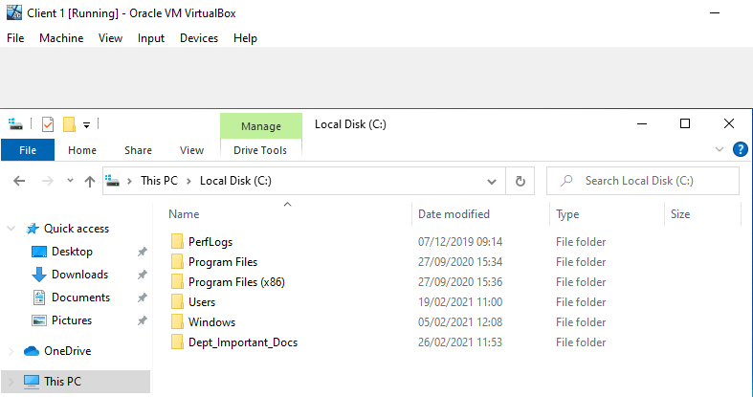

Figure 2 - Can't remove Authenticated Users.
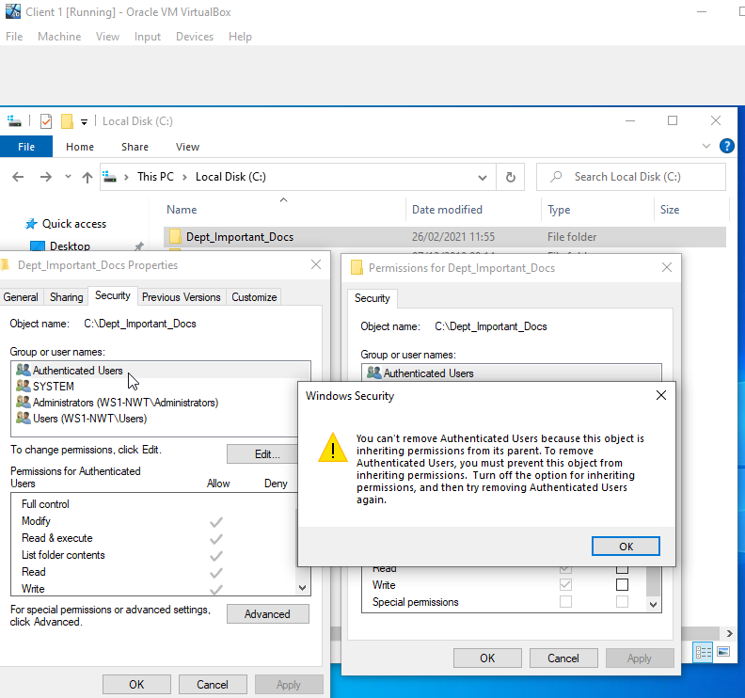

Figure 3 - Inheritance removed.
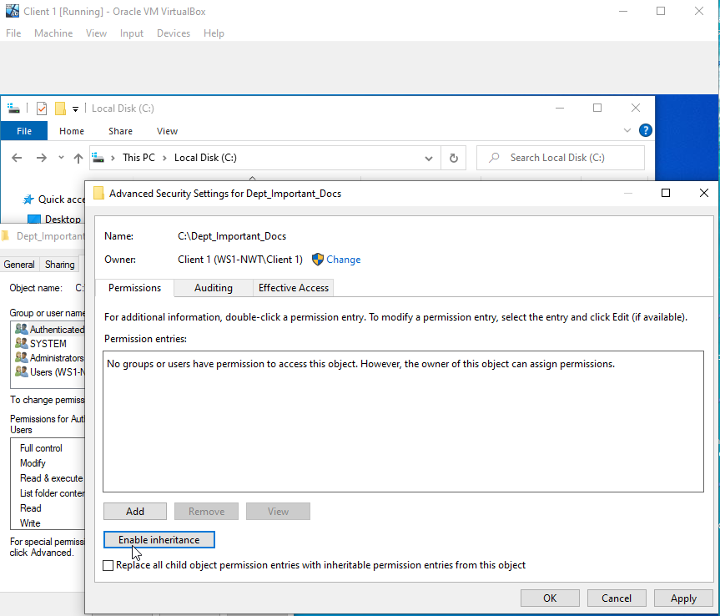

The task continued by further editing the ‘Dept_Important_Docs’ folder. At this time an administrator user account was added so that he could have ‘Full Control’ over this folder’s permissions. To check whether the settings were applied properly, it was necessary to inspect a text file within the ‘Dept_Important_Docs’ folder. This was achieved by right clicking on the file and selecting properties, which indicated that the ‘access control settings are being inherited from the folder where the file is located’. See figures 4-6.

Figure 4 - Can Now Edit Permissions for the Folder.
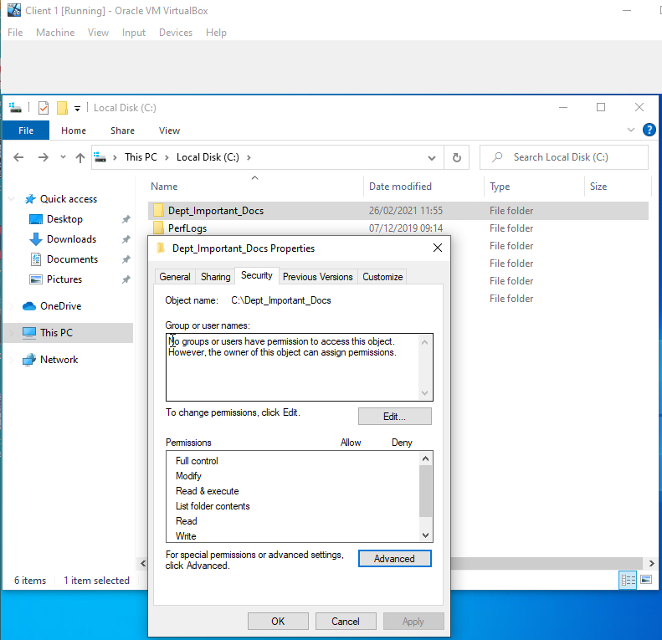

Figure 5 - Administrator Account with Full Control Added.
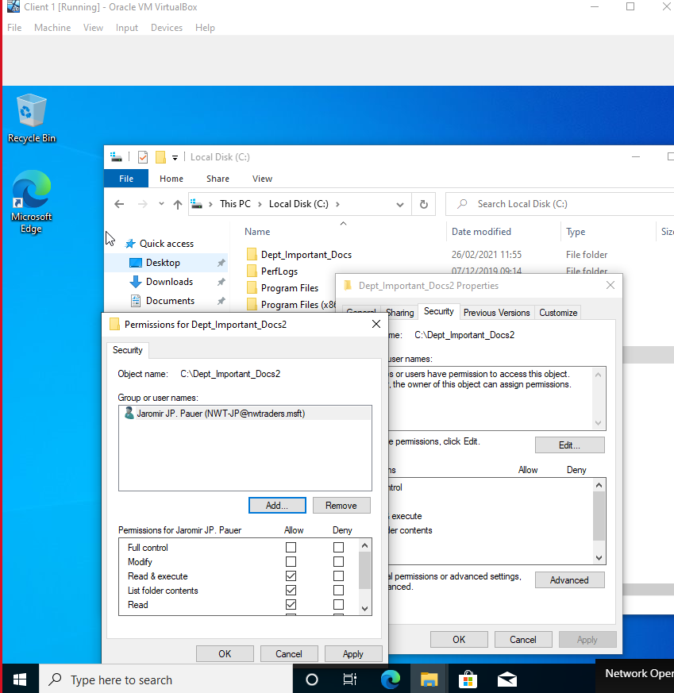

Figure 6 - File Inherits Access Controls.
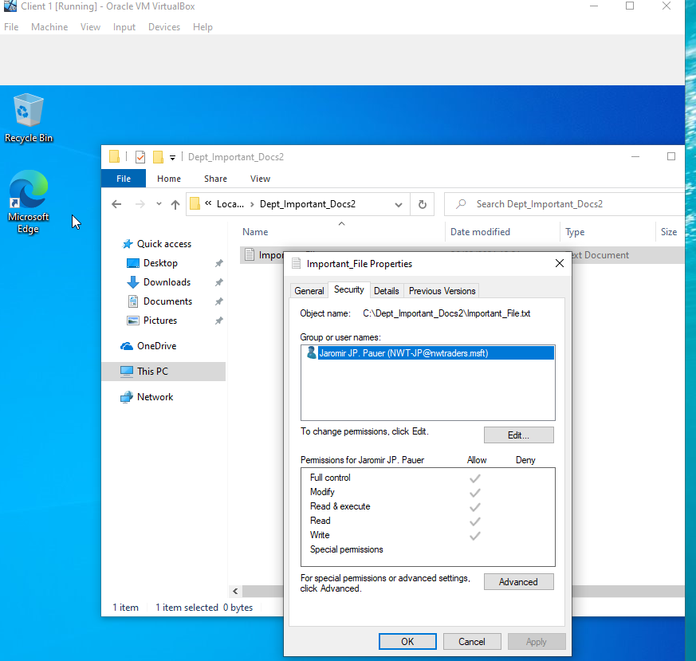

The final part of ‘Understanding NTFS’ involved adding another user, although this time the individual had very limited access. Effectively the user was only given permission to read the file(s) in this folder. To determine the correctness of this action, the file within the ‘Dept_Important_Docs’ folder was edited using an administrator account and then saved, which resulted in no difficulties. A check was also undertaken to determine whether the basic user only had the read-only permission, which was confirmed. The steps taken are shown in figures 7-9.

Figure 7 - User With Restricted Permissions Added.
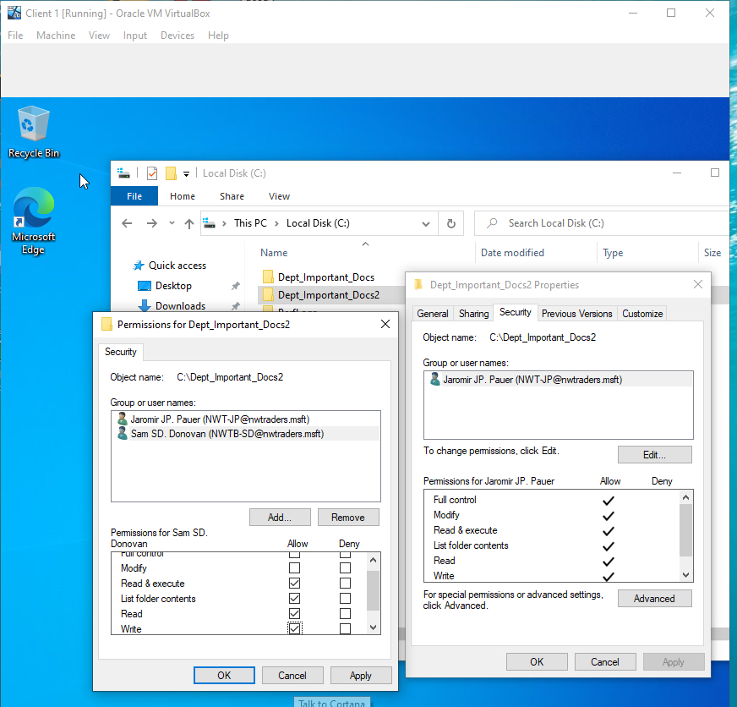

Figure 8 - File Edited with Administrator User.
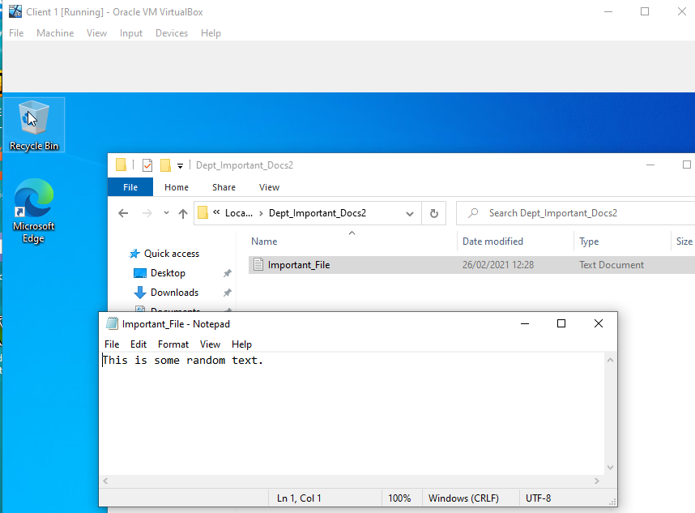

Figure 9 - Can't Edit The File as Basic User.
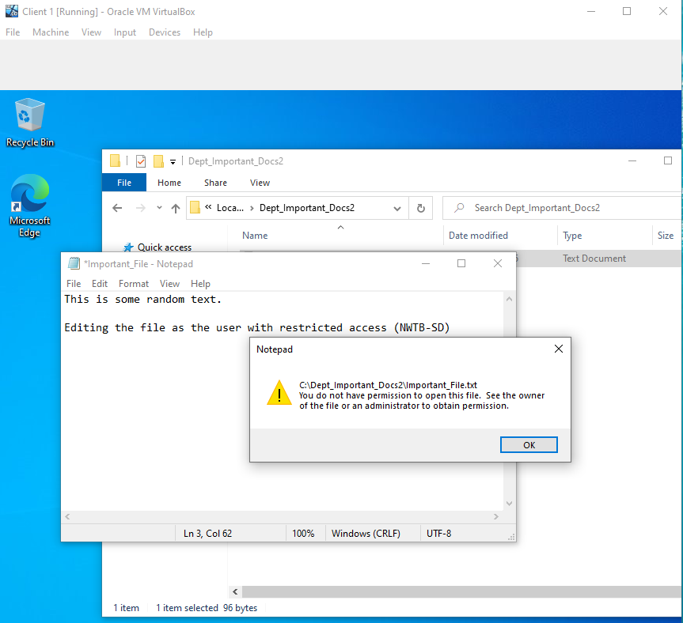

Share Permissions:
This task was initiated by creating a new shared folder in the ‘New Share Wizard’. In the ‘Select Profile’ page of the wizard, the ‘SMB Share – Quick’ option was selected. The name specified for this shared folder was ‘DeptNetShare$’. Later during the wizard process it was necessary to select the options: ‘Enable access-based enumeration’ and ‘Allow caching of share options’. The ‘New Share Wizard’ setup was then completed, as shown in figures 10 and 11.

Figure 10 - New Share Wizard Setup Progress.
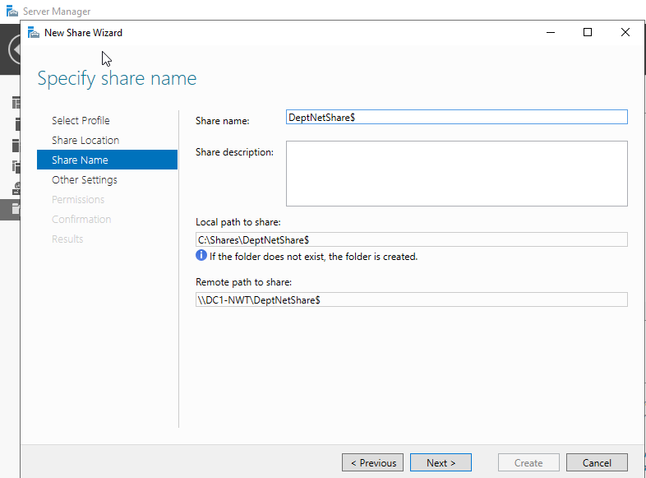

Figure 11 - New Share Wizard Completed.
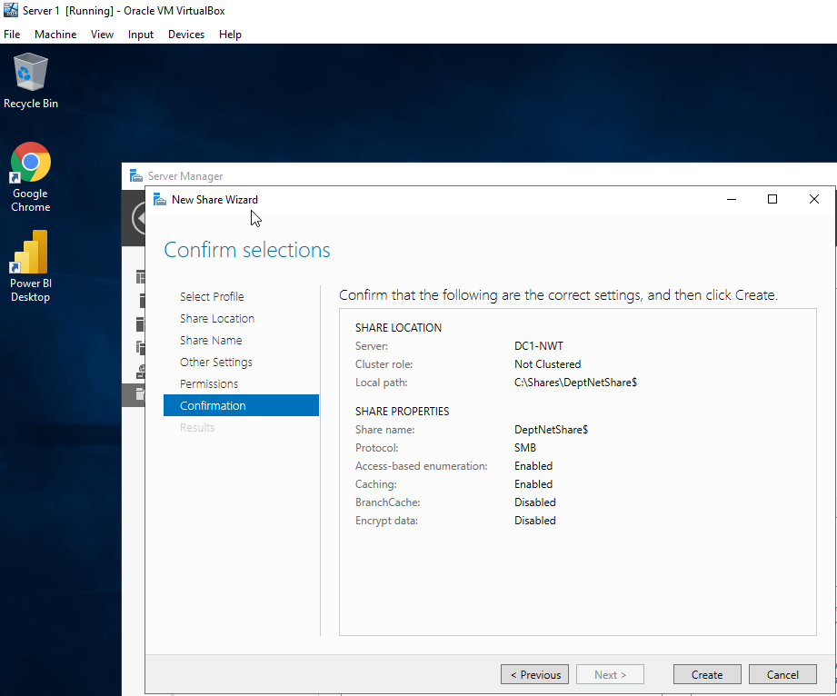

Accessing the file share/server over the network.
The final part of Task 1 was to choose ‘Map Network Drive’, where Z was selected as the default drive and the folder was then specified as ‘\\DC1-NWT\DeptNetShare$’. Subsequently, it was established that the steps taken had been completed properly, as shown in figures 12 and 13.

Figure 12 - Mapping Drive on Client 1.
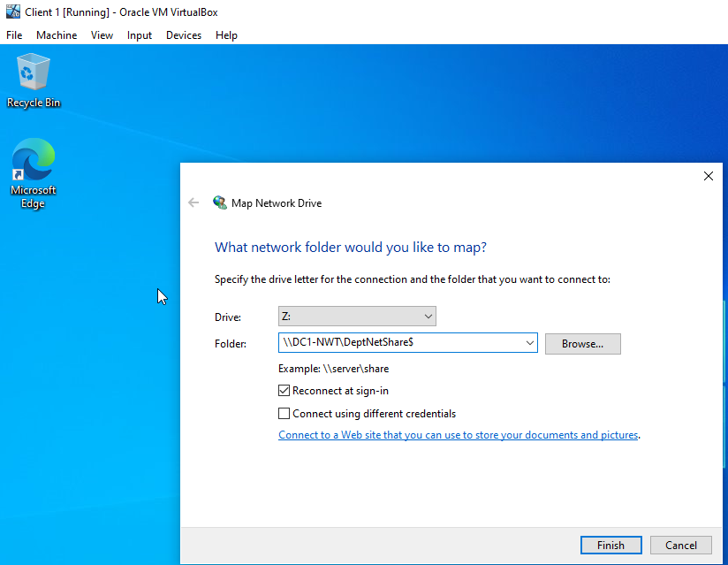

Figure 13 - Verifying Mapped Drive.
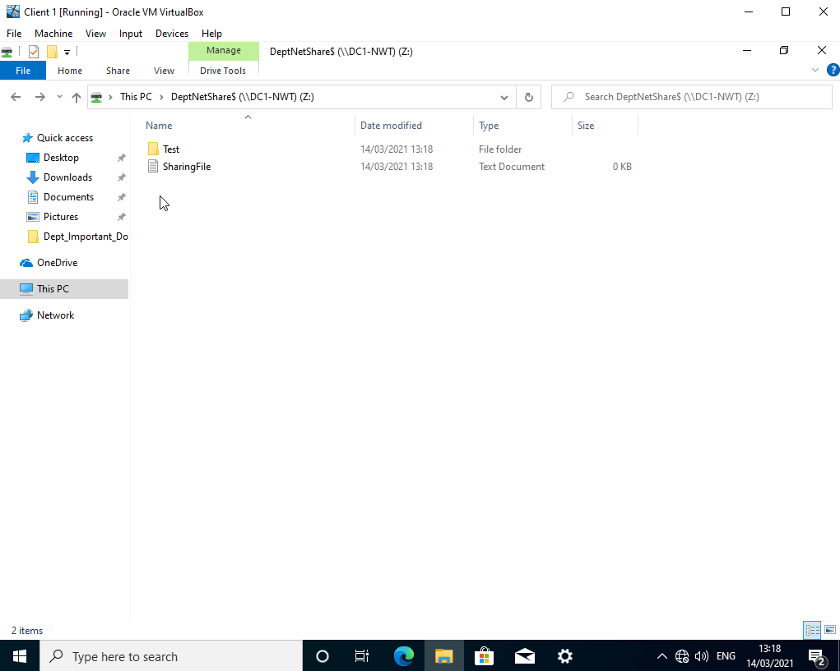

Task 2: Utilising Group Policy Management Console to better facilitate network object management.

Group Policy

GPO 1: Moderating Access to the Control Panel.
Task 2 began by restricting access to the Control Panel. Firstly, a new Organisational Unit was created and the name specified for it was ‘Non Admin Users’. Secondly, a new user account was created on the domain. A new Group Policy Object for the ‘Non Admin Users’ folder was then created and the name specified for it was ‘NoCtrlPanAccess’. The GPO was set to ‘Prohibit Access to Control Panel and PC settings’. Thirdly, in order to apply the changes it was necessary to run ‘command prompt’ and force an update on the Group Policy. This was achieved by issuing a command ‘gpupdate /force’ in the cmd.exe (command prompt). These steps are shown in figures 14-16 below.

Figure 14 - Non Admin Users created, and basic user created.
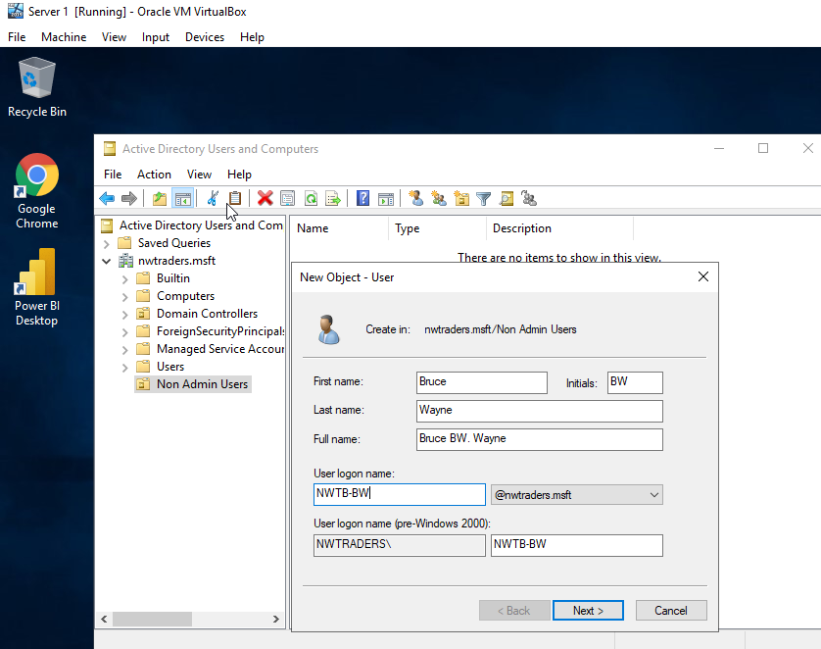

Figure 15 – GPO applied which prohibits Access to the Control Panel and PC settings.
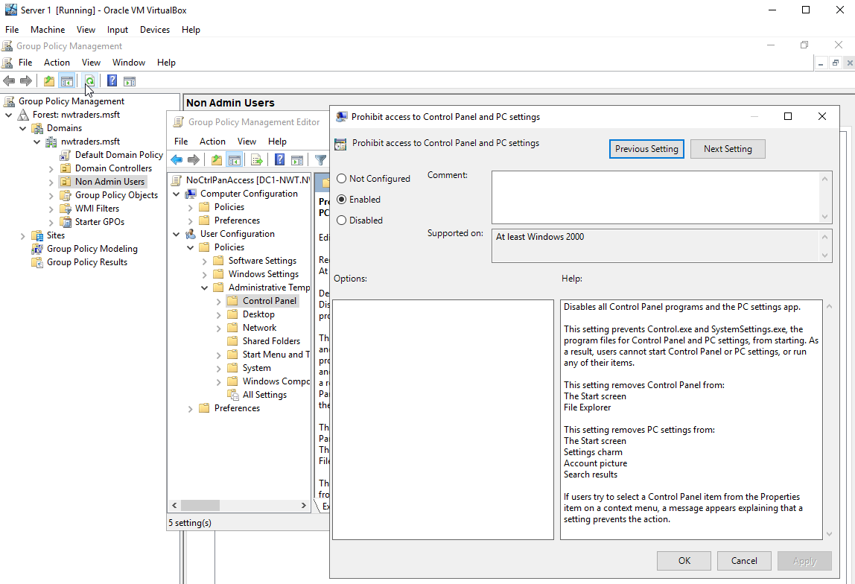

Figure 16 – running gpupdate /force command in cmd.exe
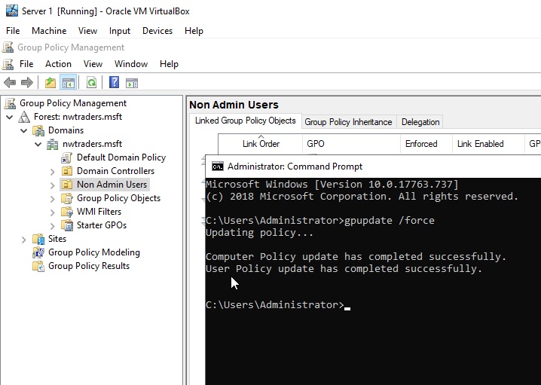

Finally, it was now possible to verify whether the policy was working properly. This was accomplished by logging onto the Client 1 VM as a basic user and trying to access the Control Panel, as shown in figures 17-18.

Figure 17 - Trying to Access the Control Panel Part 1.
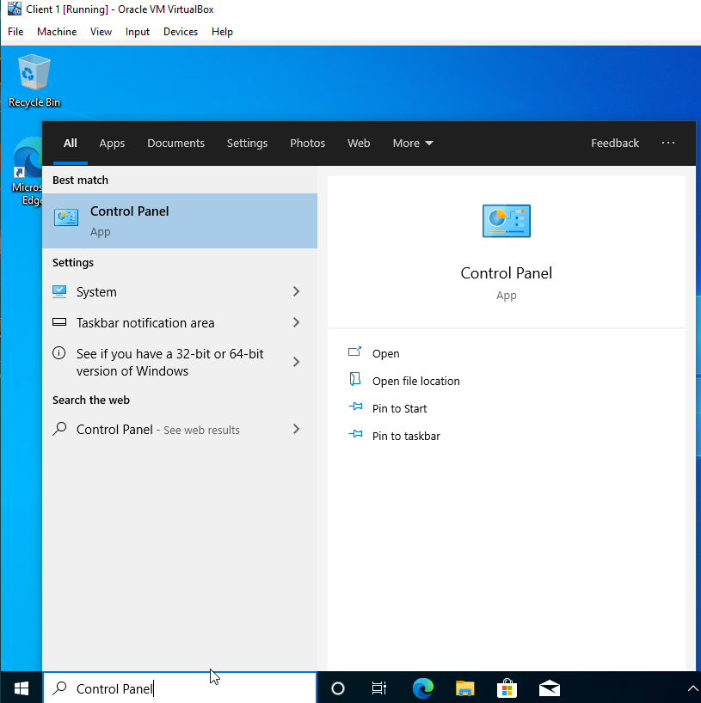

Figure 18 - Trying to Access the Control Panel Part 2.
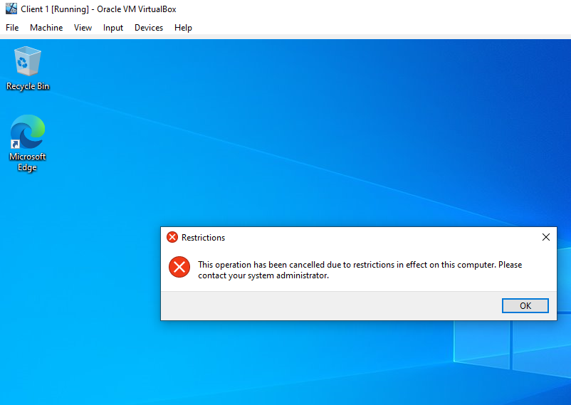

GPO 2: Removing Access to the Command Prompt.
The task was to disable access to the Command Prompt, as it can be quite a powerful tool in the wrong hands. This was achieved by creating a new GPO in the ‘Non Admin Users’ Organisational Unit, which was given the name ‘NoCmdPrmptAccess’. The option to ‘Prevent Access to the Command Prompt’ was then enabled. In order to apply the changes it was necessary to run ‘command prompt’ and force an update on the Group Policy. Subsequently, checks were undertaken to determine whether a basic user could access the command prompt. This resulted in an error message stating: ‘The command prompt has been disabled by your administrator.’ These steps are shown in figures 19-21.

Figure 19 - Preventing Access to the Command Prompt.
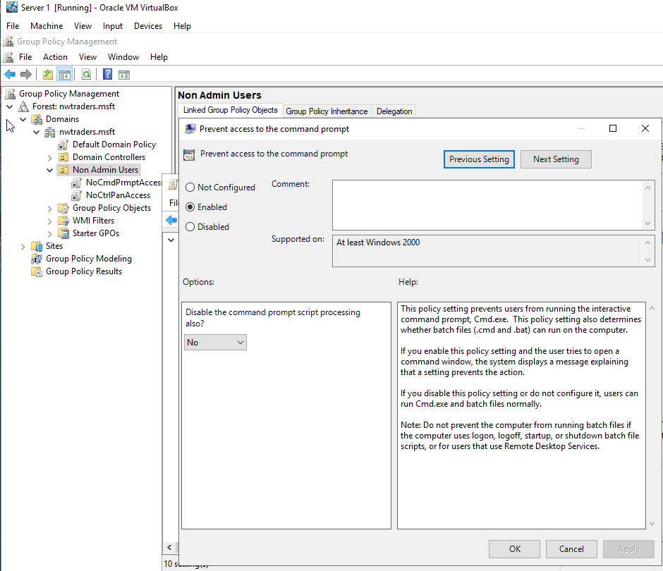

Figure 20 – Running command gpupdate /force in cmd.exe
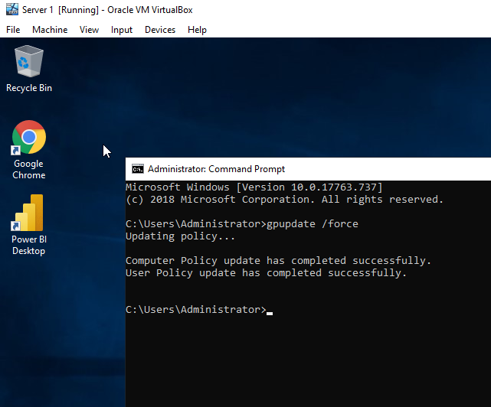

Figure 21 - Trying to Access the Command Prompt.
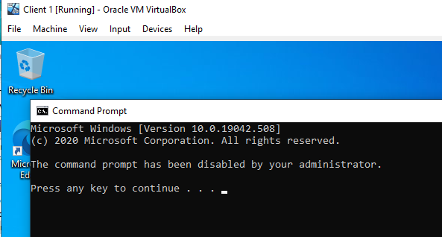

GPO 3: Restricting Access to Removable Media Drives.

The next part of Task 2 was to restrict access to the removable media drives. This was achieved by performing four actions. Firstly, a new GPO inside ‘Non Admin Users’ was created and given the name ‘NoRemDriveAccess’. Secondly, the option ‘Removable Storage Access’ was enabled. Thirdly, in order to apply the changes it was necessary to run ‘command prompt’ and force an update on the Group Policy. Finally, an attempt was made to access Removable Storage with a basic user account on Client 1 VM. This resulted in an error message stating: ‘This operation has been cancelled due to restrictions in effect on this computer’. The steps taken are shown in figures 22-25.

Figure 22 - Deny All Access to Removable Media Storage.
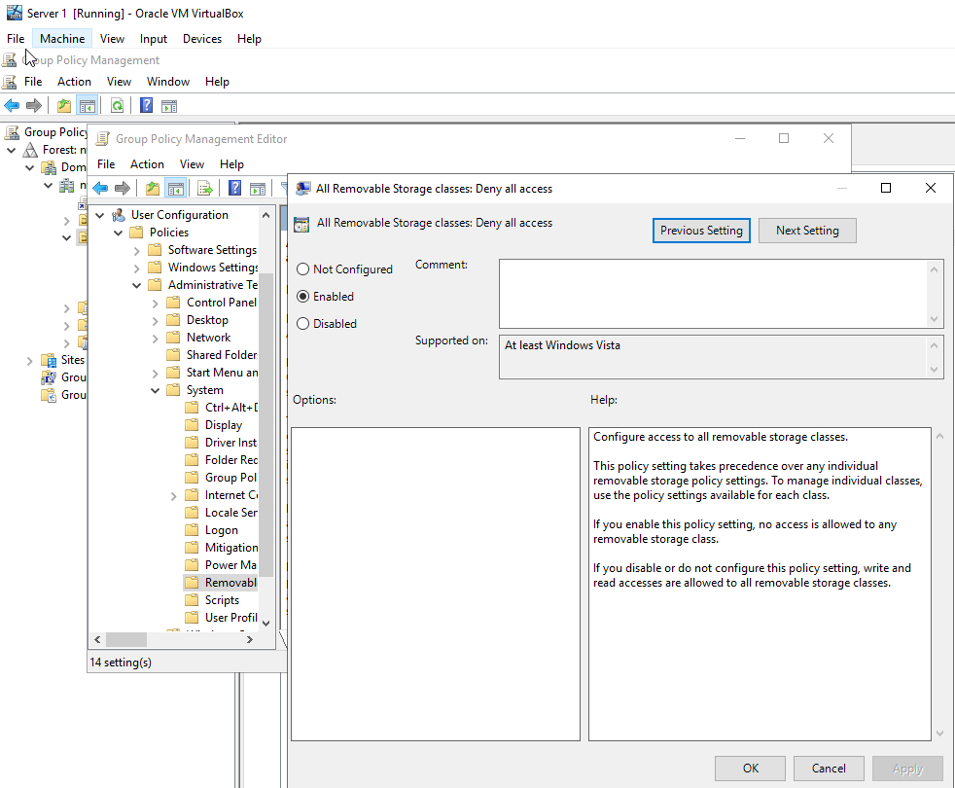

Figure 23 – Running command gpupdate /force in cmd.exe
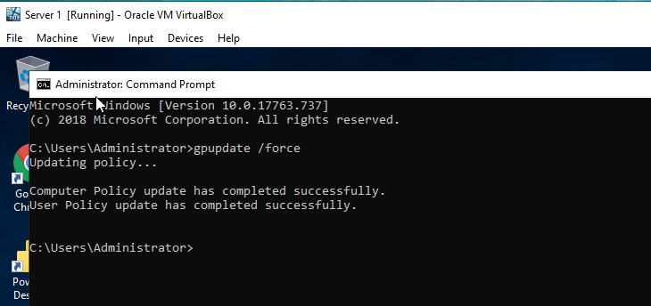

Figure 24 - Trying to Access Removable Storage Media Part 1.
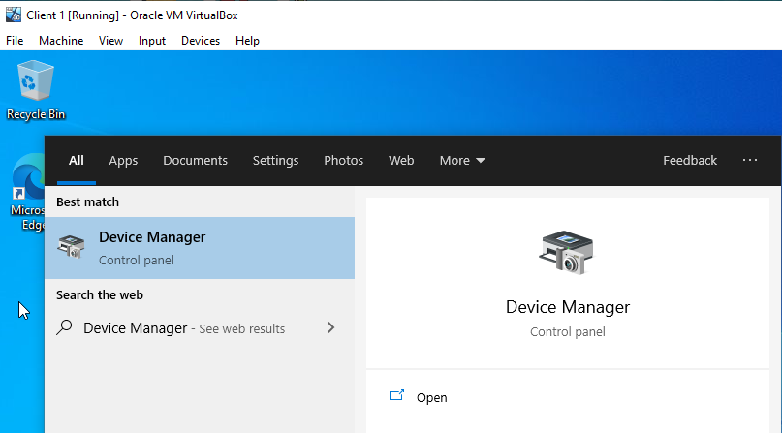
Figure 25 - Trying to Access Removable Storage Media Part 2.
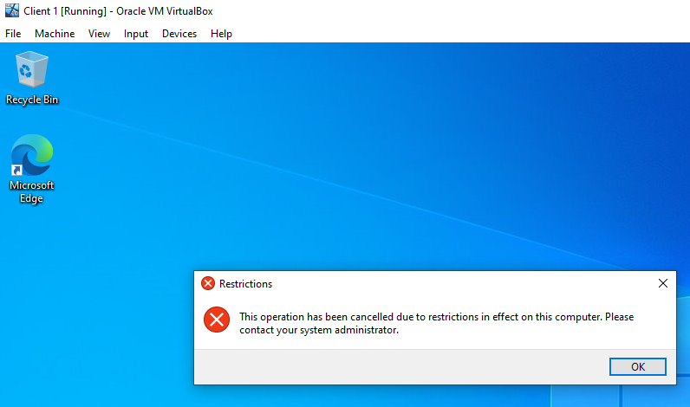

GPO 4: Restricting Software Installs.
The next part of this exercise was to restrict the user from installing any software on a domain computer. A new Organisational Unit had to be created and the name entered for it was: ‘NWClient Computers’. A new GPO was then created and the name specified for it was ‘NoUnauthSoftInstallS’. The option to ‘Prohibit User Installs’ was enabled. In order to apply the changes it was necessary to run ‘command prompt’ and force an update on the Group Policy. It was now possible to determine whether these settings had been applied properly by attempting to install software on a domain computer, which resulted in a prompt to input the administrator’s credentials. Otherwise it was not possible to complete the installation of the software. The steps followed are shown in figures 26-29.

Figure 26 - Creating New OU - NWClient Computers
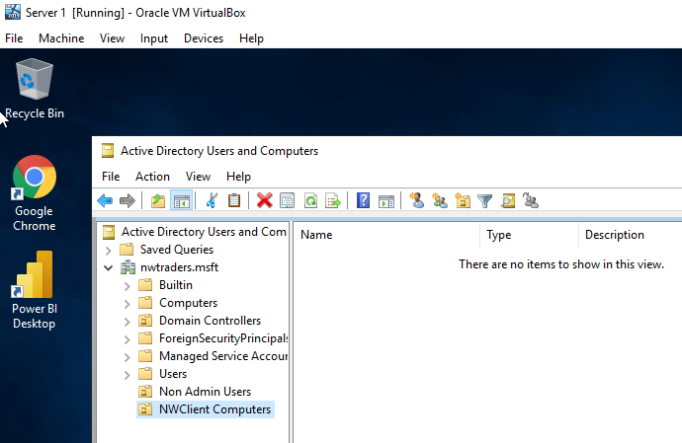

Figure 27 - GPO - Enabling Prohibit User Installs
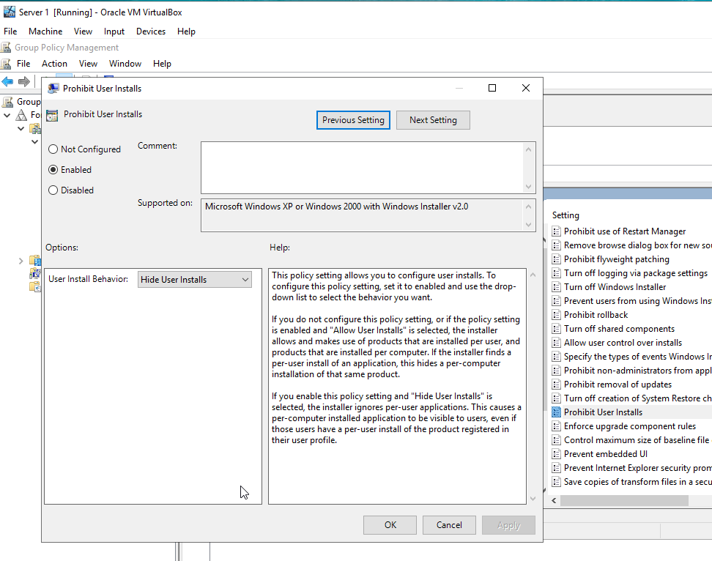

Figure 28 - Running command gpupdate /force in cmd.exe
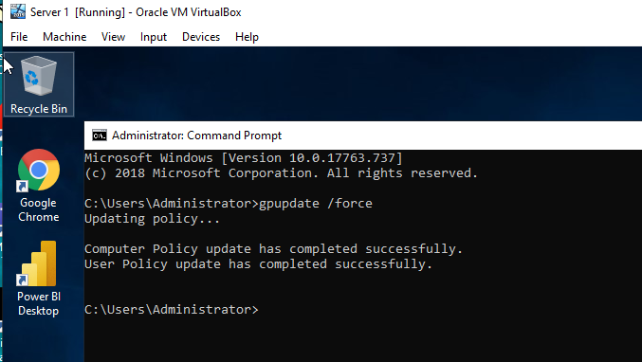

Figure 29 - Trying to Install Software as Basic User.
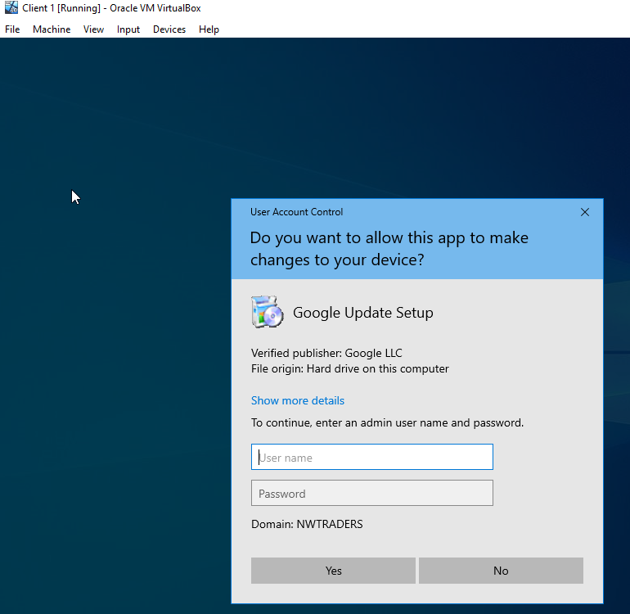

GPO 5: Enforcing Password Policy in the ‘nwtraders.msft’ domain.
The final part of Task 2 was to enforce a password policy on the ‘nwtraders.msft’ domain. This was achieved by editing the ‘Default Domain Policy’ GPO. In particular, the predefined settings were changed according to the instructions in the task 2 of the assignment. Subsequently, in order to apply the changes it was necessary to run ‘command prompt’ and force an update on the Group Policy. To determine whether this policy was working properly a new user was created and a password length of 8 was entered. This action resulted in an error message stating that ‘The password does not meet the password policy requirements’. These steps are shown in figures 30-32.

Figure 30 - Default Domain Policy - Password Policy Updated.
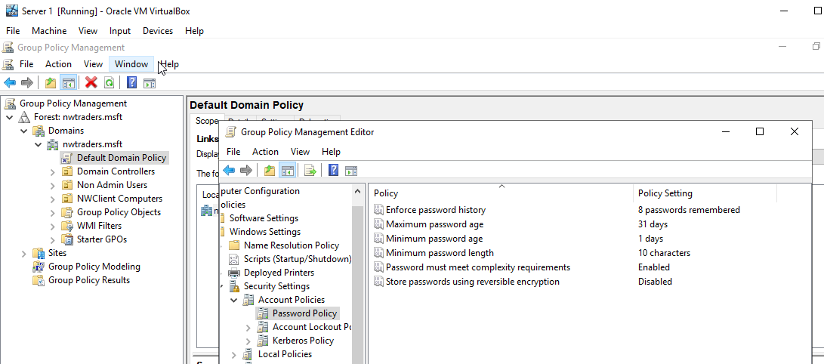

Figure 31 - Running command gpupdate /force in cmd.exe
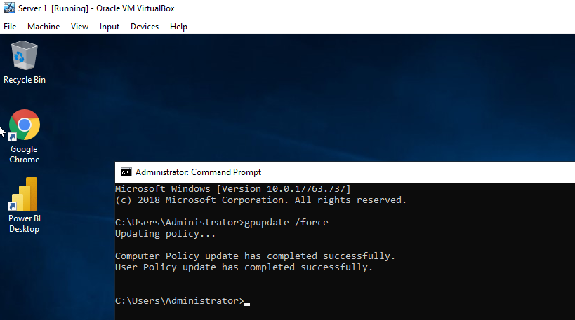

Figure 32 - Trying to Create User with shorter password than required.
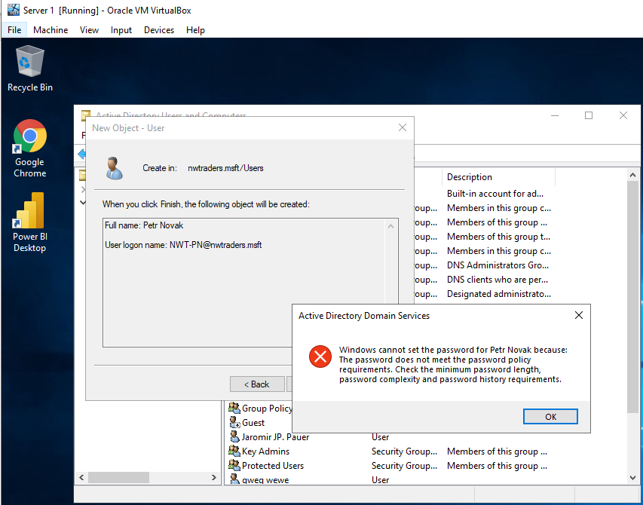

Task 3: Observational Tasks

3 a) Explain the main differences between local permissions and file shares.

Local permissions and file shares are different means of preventing unauthorised or unlawful access to sensitive or confidential information. There are however significant differences in how these two technologies set about securing data. The file share system allows administrators to control who accesses folders over the network, but it does not apply to those users who are accessing locally [1] and [2]. Whereas NTFS local permissions are deployed to manage access to information stored on the Windows NTFS file system and NTFS share permissions affect both network and local users [3]. Significantly, the types of permissions that can be granted differ depending on whether the NTFS or file share systems are being adopted. Greater granularity is possible when NTFS is deployed for it incorporates advanced and five basic types of access permissions: Full control, Modify, Read and Execute; Read, and Write. On the other hand, the file share system has only three basic access permissions: Read, Change, and Full control [3]. File share permissions apply to all files and folders in the share system, but it is not possible to granularly control access to subfolders or objects if this system is used. File share permissions have the advantage that they can be deployed if folders are being shared by means of the FAT or FAT 32 file systems, whereas NTFS cannot be used in such circumstances [3]. Additionally, file shares, in contrast to NTFS, permit an administrator to restrict the number of concurrent connections to a shared folder [3]. File share permissions are actioned within the ‘Advanced Sharing’ properties of the ‘Permissions’ settings. Whereas, NTFS permissions are actioned on the ‘Security Tab’ in the file or folder properties [3]. Generally, file share permissions are less demanding to apply and manage [2]. In circumstances where the file share system and NTFS are deployed, the most restrictive permission will prevail [2].

3 b) Describe the role of Group Policy Management in the network environment, you can use example policies in your answer.

The principal role of Windows Group Policy Management (GPM) is to enable administrators, using the Microsoft Policy Management Console (GPMC), to control the implementation and functioning of group policy objects from a central location [4]. More specifically, GPMC empowers administrators to control group policy objects in an Active Directory forest, for example, by setting the criteria for registry policies, security options, software installations and updates [5], [6], [7] and [8]. In addition to minimising administrative burdens, GPM provides administrators with information that assists them to troubleshoot issues associated with the operation of those network group policies [5] and [6]. Advantageously, GPM can be used, for example, to enforce password rules; allow remote devices to connect to a network share, or alternatively deny them access; restrict access to specific folders; add accounts to the local administrator groups and install software and updates [9].

An example of a GPM feature is the one that enables an administrator to regulate various password requirements, such as minimum and maximum password ages and the minimum number of characters that can be used to compose an acceptable password. Another example of the implementation of GPM is the facility to restrict users from installing their own software, such as applications, on the organisations equipment. This function can be particularly useful as an employee might innocently or intentionally download infected software that could comprise the organisation’s data.
A third example of the usefulness of GPM is the facility that enables administrators to disable forced system restarts, especially as these could disrupt urgent work on a computer and possibly result in the loss of important data [7] and [8].

3 c) Give some examples of sound ‘password’ principles in modern network environments.

The American NIST [10], [11] and [12], the Canadian Centre for Cyber Security [13],and the British NCSC [14] and [15], recommend the use of passwords as one means of protecting confidential data, although they all draw attention to the added advantages of using pass phrases. The NIST defines pass phrases as “a memorised secret consisting of a sequence of words or other text that a claimant uses to authenticate their identity” [10], [11] and [12].

It is possible from the official and unofficial sources to identify a number of sound password/pass phrases principles that are designed to maximise user memorability, facilitate user usage and minimise the risks of unlawful attacks.

- Pass-phrases are usually more mathematically secure than passwords [10], [11] and [12].

- Pass phrases, like passwords, should be at least 10 characters in length, but with an upper limit [16].

- Pass phrases should consist of at least 3 uncommon words separated by spaces or special characters [14], [15] and [16]. Memorisation of the words in a pass phrase can be facilitated by word associations that are unique to the user and generate images in the user’s mind [10], [11] and [12].

- Commonly used phrases should be avoided [16].

- Pass phrases, like a passwords, should be difficult for an attacker to guess [14] and [15].

- In accordance with common practice, users should ensure that pass phrases, like passwords, consist of at least two of the following: upper case letters, lower case letters, numbers, punctuation marks, conventional symbols, and spaces [16]. It should be noted, however, that NIST has now removed all password complexity from its recent guidelines [11] and [17].

- Pass phrases, like passwords, should not be changed at regular intervals as such a practice increases administrative burdens and may increase security risks [10], [11], [12] [14], [15] and [17] The better practice is to use pass phrases of appropriate length [17]. The NCSC recommends that passwords should be reset if there is reason to believe the system has been compromised, a user leaves an organisation, or an account becomes inactive [14] and [15].

- In accordance with NIST guidelines, organisations should use multi-factor authentication as part of the process of securing online communications of a confidential nature [10], [11] and [12].

- Apply lockout rules after 5 to 10 incorrect logon attempts [14] and [15].

- Apply a password/ pass phrases deny lists to deny usage of commonly used passwords/ pass phrases [14] and [15].

- In accordance with NIST guidelines, passwords/ pass phrases should be salted with at least 32 bits of data and hashed with a one way derivation function, such as PBKDF2 or Balloon [17].

References

[1] | D. Murphy, “What’s the Difference Between Share and NTFS Permissions?,” Lepide.com, 14 5 2020. [Online]. Available: https://www.lepide.com/blog/whats-the-difference-between-share-and-ntfs-permissions/. [Accessed 26 3 2021].
[2] | Dnsstuf, “NTFS vs. Share Permissions,” Dnsstuf.com, 3 4 2020. [Online]. Available: https://www.dnsstuff.com/ntfs-vs-share-permissions. [Accessed 26 3 2021].
[3] | J. Melnick, “Differences Between Share and NTFS Permissions,” Netwrix.com, 3 3 2020. [Online]. Available: https://blog.netwrix.com/2018/05/03/differences-between-share-and-ntfs-permissions/. [Accessed 27 3 2021].
[4] | S. MSP, “Group Policy Management Overview,” SolarWindsMSP, 27 1 2020. [Online]. Available: https://www.solarwindsmsp.com/blog/group-policy-management. [Accessed 27 3 2021].
[5] | R. Smith, “Group Policy Management,” Netwrix.com, 2 7 2019. [Online]. Available: https://blog.netwrix.com/2019/04/18/group-policy-management/. [Accessed 27 3 2021].
[6] | Netwrix.com, “Group Policy Best Practices,” Netwrix.com, [Online]. Available: https://www.netwrix.com/group_policy_best_practices.html. [Accessed 27 3 2021].
[7] | J. Coggins, “What is Group Policy (GPO) and What Role Does It Play in Data Security,” Lepide.com, 26 3 2021. [Online]. Available: https://www.lepide.com/blog/what-is-group-policy-gpo-and-what-role-does-it-play-in-data-security/. [Accessed 27 3 2021].
[8] | D. Murphy, “https://www.lepide.com/blog/top-10-most-important-group-policy-settings-for-preventing-security-breaches/,” Lepide.com, 5 3 2021. [Online]. Available: https://www.lepide.com/blog/top-10-most-important-group-policy-settings-for-preventing-security-breaches/. [Accessed 27 3 2021].
[9] | J. LuPiba, “The Importance of Group Policy Management & GPOs | Part 3,” Quest.com, 15 10 2019. [Online]. Available: https://www.quest.com/community/blogs/b/microsoft-platform-management/posts/it-security-revisit-group-policy-management-often-part-3-ncsam. [Accessed 27 3 2021].
[10] | NIST.gov, “Passphrase - Glossary | CSRC,” Nist.gov, [Online]. Available: https://csrc.nist.gov/glossary/term/Passphrase. [Accessed 28 3 2021].
[11] | NIST.gov, “NIST Special Publication 800-63,” Nist.gov, [Online]. Available: https://pages.nist.gov/800-63-3/sp800-63-3.html. [Accessed 28 3 2021].
[12] | M. Garcia, “Easy Ways to Build a Better P@$5w0rd,” Nist.gov, 4 10 2017. [Online]. Available: https://www.nist.gov/blogs/taking-measure/easy-ways-build-better-p5w0rd. [Accessed 28 3 2021].
[13] | Cyber.gc.ca, “Best Practices for Passphrases and Passwords (ITSAP.30.032),” Cyber.gc.ca, 9 2019. [Online]. Available: https://cyber.gc.ca/en/guidance/best-practices-passphrases-and-passwords-itsap30032. [Accessed 28 3 2021].
[14] | NCSC.gov.uk, “Password administration for system owners,” NCSC.gov.uk, [Online]. Available: https://www.ncsc.gov.uk/collection/passwords/updating-your-approach. [Accessed 28 3 2021].
[15] | I. M, “Three random words or #thinkrandom,” NCSC.gov.uk, [Online]. Available: https://www.ncsc.gov.uk/blog-post/three-random-words-or-thinkrandom-0. [Accessed 28 3 2021].
[16] | D. Stubley, “Passphrase Guidance,” 7elements.co.uk, 15 2 2015. [Online]. Available: https://www.7elements.co.uk/resources/guidance/passphrase-guidance/. [Accessed 28 3 2021].
[17] | D. Poza, “NIST Password Guidelines and Best Practices For 2020,” auth0.com, 21 1 2021. [Online]. Available: https://auth0.com/blog/dont-pass-on-the-new-nist-password-guidelines/. [Accessed 28 3 2021].

