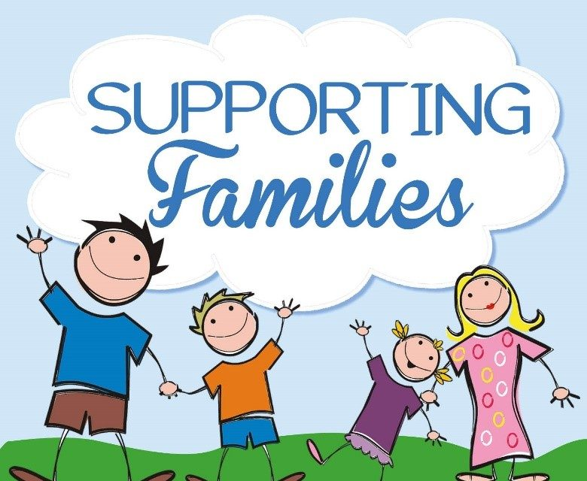

Bing (ND).

Module: Protecting and supporting families in health and social care
Module code: BMHP 5021
Component 2: Written report
Lecturer: Phillip Jones
Student: Precious Lewis 2328179
Submission date: 26th November 2025

Introduction
In 2018, the inter-agency working guidance, 'Working Together to Safeguard Children', was introduced. This guidance emphasized the importance of 'Early Help'—a system designed to proactively promote children's welfare by providing support as soon as problems emerge. Early Help can be provided at any point in a child's life, from the early years up to age 18, or beyond if they are in full-time education or training, or are unemployed and living with family (Spinks, 2023).
The Troubled Families Programme (2011) was established to offer multi-agency coordinated support to vulnerable families and those in crisis. In 2021, the programme was renamed the Supporting Families Programme to reduce stigma and encourage engagement.
The 10 Families Outcomes Framework is the national set of standards used by local authorities in England to identify, support, and measure the success of their work with vulnerable families under the Supporting Families Programme. (GOV.UK). Eligible families must include a dependent child or expectant parent and meet 3 of the 10 family outcome frameworks needs. Which are:
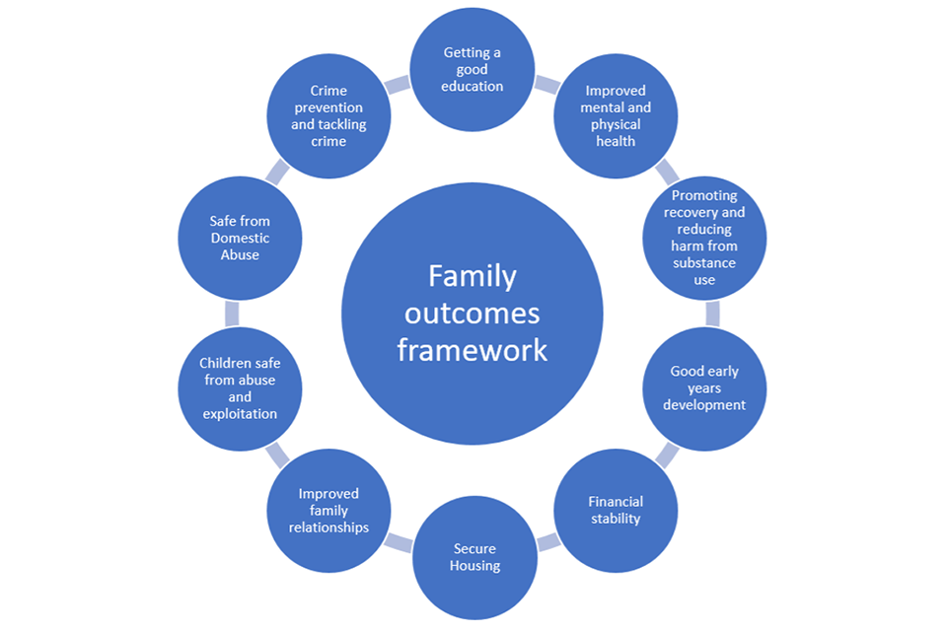(GOV.UK)

The Supporting Families Programme assists thousands of families across England by addressing a wide range of disadvantages. It adopts a holistic approach to the entire family unit, delivered by key workers employed by local authorities and their partners (Gov.uk, 2024).
Section 10 of the Children's Act 2004 states that the Local Authority is to strive to improve the well-being of children and to make arrangements to promote collaboration between the authorities and their partners. The early help programme fully endorses this guideline with the emphasis on multi-agency working to help vulnerable families to build resilience. By identifying needs and providing the right support promptly. Ultimately, establishing productive and honest working relationships with external agencies and families.
There are four key principles of the Supporting Families Programme:
- Early help/intervention
- Working with the whole family
- Multi-agency working
- Measuring outcomes and data
In this report, I will analyse the availability, accessibility, and content of Early Help online services in Leeds, Staffordshire, and Leicestershire. I will compare and contrast all three to determine which is the most user-friendly, has clear navigation tabs, and provides the most comprehensive information.
According to the NSPCC, early help is support specified for families in need of support who are suffering disadvantage. or are susceptible to poverty, Mental or physical health issues, Domestic violence, substance abuse, child exploitation, substance misuse, involvement in crime and anti-social behaviour, and poor school attendance. The government guideline, The Domestic Abuse Act 2021. States that if the child has witnessed domestic violence or abuse, they are to be treated like victims themselves, as exposure could be just as impactful on their personal development. (legislation.gov.uk,2021)
Early Help is designed to improve outcomes for those who are vulnerable or at a disadvantage and prevent problems from escalating, thereby avoiding the need for statutory interventions
. Service may include:
- Parenting support and advice
- Emotional health and well-being services
- Play and activity groups
- Mentoring for young people
- Help with communication and language development
- Support for families facing abuse, conflict, or financial difficulties
- Help with childcare, education, or employment.
(Gov.uk, 2025)
These services are in place to protect children from adverse Childhood experiences(ACEs) that can greatly impact not only the child's life but also have long-term effects into adulthood. At least half of all adults in England have experienced at least one ACE, and 10% have endured 4 or more. This is a large proportion of the population. (Liverpool, CAMHS,2025)
Partnership working significantly improves outcomes by bringing professionals, organisations, and service users together. This collaborative model facilitates the sharing of knowledge, skills, and resources, leading to coordinated, person-centred care and reducing service fragmentation.

Effective communication and shared decision-making allow partners to holistically address complex needs, resulting in improved patient experiences and efficient service delivery. Furthermore, this approach fosters innovation, accountability, and mutual learning across health, social care, and the voluntary sector. Ultimately, partnership working enhances the quality, safety, and sustainability of care (Glasby and Dickinson, 2014).

Critique Summary: Leeds Family Hubs Web Page
This critique summarizes user experience and identifies critical content gaps observed on the "Children and Families" section of the website, specifically regarding the Family Hubs page. The observations suggest a significant disconnect between the site's stated goal of ease of accessibility and its functional delivery.

1. Information Architecture and Discoverability
- Positive Initial Navigation: The initial entry point via the mobile site is described as easy, with clear category organization and illustrations.
- Sub-page Discoverability Issue: The specific content for "Family Hubs" required scrolling to find, as it was the sixth item on the subsequent page. This placement hinders immediate discoverability for a core service.

2. Critical Information Gaps (Lack of Actionable Data)
Despite encouraging users to contact or visit the hubs, the page fails to provide fundamental details for individual locations:
Missing Information | Impact on User
Email Addresses | Prevents non-urgent written contact and digital inquiries.
Opening Hours | Prevents users from complying with the page's own directive to "drop in during opening hours."
Direct Telephone Numbers | Forces users to rely on a central number or perform external Google searches to find direct contact information.

3. Geographical Accessibility and Equity Issues
The current geographical distribution of the hubs directly conflicts with the goal of ease of accessibility:
- Location Deficits: There are no hubs available in the centre of Leeds or in the northern part of the city.
- Travel Barrier: Requiring residents from the North to travel to hubs in the East or South creates a substantial burden, particularly for those reliant on public transport. This poses a significant barrier to access for the target audience (families).
- 23% of those living in Leeds are living in poverty.

4. Service Clarity and Outreach Deficits
The site does not provide adequate detail for users seeking specific assistance:
- Vague Service Offerings: There is no clear indication of what specific services are provided by each of the 7 community hubs (e.g., parenting courses, health visits, youth support).
- Service Scheduling: The times and days that specific services are available are entirely absent, making planning impossible.
- Exclusion of Outreach/Online Options: The complete lack of mention of outreach programs or online services severely impacts individuals with mobility issues, effectively excluding them from necessary support.
- No links for signposting or further information

Overall Conclusion
The website, while well-organized initially, is ultimately not user-friendly and lacks vital information required for families to successfully access and utilize the services. The geographical oversight further compromises the stated accessibility goals of the Family Hubs initiative.
Critique Summary: Staffordshire Family Hub Website
The website is bright, and the layout is simplistic and clear.

1. Information Architecture and Discoverability
- Initial Navigation Issue: There was no dedicated tab for "Early Help" on the main webpage, despite the clear layout.
- Browsing Barrier: The default setting was "most popular." The user had to consciously click "Browse Website" to access a comprehensive list of services.
- Sub-page Discoverability: Once on the "Browse Website" list, the "Children and Family Services" link was 6th on the list, but clearly visible without scrolling.
- Positive Internal Navigation: Once on the "Children and Family Services" page, "Early Help" was the 3rd item on a list of 10 categories, making it easy to find.

2. Critical Information Gaps (Actionable Data)
- Positive Content: The main page featured a brief description of the Early Help team, who they work with, and a link for further information on their focus (Families First service overview).
- Actionable Data Included: Telephone numbers and links explaining how to access the right services were provided.

3. Geographical Accessibility and Equity Issues
- This critique summary did not provide specific details on the geographical distribution of hubs or local equity challenges in Staffordshire.

4. Service Clarity and Outreach Deficits
- Service Clarity: The content is full of useful information and details for those involved in the Family First project. The description of the team and their objectives is clear.
- Overall Conclusion: The site has excellent content design once a user navigates to the specific service page, but it suffers from poor information architecture and a lack of clear signposting on the homepage. Finding the service is not easy.

Critique Summary: Leicester Family Hub Website
This page is minimalist, featuring only a list of services on the left-hand side, accompanied by small icons.

1. Information Architecture and Discoverability
- Significant Initial Barrier: There was no service in the initial list that read "Early help" or "Families First."
- Deeply Buried Content: The user had to click on "Education and Children," then scroll down a list of duty numbers, and finally click on "Social care and supporting families" (6th item on a subsequent list).
- Vague Signposting: The user ultimately found the information by clicking "Leicestershire Children and Families Partnership" (which sounded like the right path) and then saw "Early Help Partnership" listed as a subgroup further down the page.
- Overall: The most difficult site for finding the core Early Help information, requiring multiple clicks and relying on deductive reasoning rather than clear signposting.

2. Critical Information Gaps (Actionable Data)
- Positive Content: Once the correct path was found, the information was in detail and depth, explaining the partnership vision, plans, aims, and objectives.
- Key Service Highlight: The critique noted the presence of the "Holiday, Activities and Food programme (HAF)" as a valuable service, addressing both food poverty and lack of holiday experiences.

3. Geographical Accessibility and Equity Issues
- Poverty Context: The critique notes Leicestershire was ranked the 18th most deprived area in England, with 19.6% of the population being income-deprived in 2019, suggesting a slightly lower regional impact than the West Midlands or Yorkshire.
- Equity Focus: The HAF program is highlighted as a model that addresses the needs of low-income families by tackling two problems (food poverty and lack of affordable activities) at once.

4. Service Clarity and Outreach Deficits
- Service Clarity: The content clearly lays out the aims and objectives of the Children and Families Partnership and the Early Help Partnership.
- User Imperative: The critique emphasizes that because users often deal with complex issues or risk of harm, services must be easy to find and accessible to meet the needs of even the most vulnerable.
- Overall Conclusion: The information is detailed and useful once found, but the structure fails the key test of ease of access for vulnerable users.

Evaluation and Conclusion of Early Help Service Accessibility

1. Critique of Web Accessibility and Disparity
The analysis highlights a major systemic issue: the absence of a standardized web template for Early Help pages, leading to "huge disparities" across local council websites.

Key Web Accessibility Issues:
Local Authority | Ease of Use | Content/Information | Overall Weakness
Leeds | Easy to use | Lacked information (e.g., operating hours, direct contact numbers). | Functionally incomplete, despite good usability.
Staffordshire | Fair in use | Fair in content but lacked external links and signposting. | Hinders users from seeking related or external services.
Leicester | Not easy to navigate (deeply buried content). | Most useful content and information. | Poor Information Architecture despite rich content.
This variation means a vulnerable user moving between counties would face an inconsistent and unpredictable experience. The difficulty in navigating to these crucial services (even when the content is good, as in Leicester) directly contradicts the goal of supporting those "among the most vulnerable in society."

2. The Link Between Poverty, Vulnerability, and Accessibility
The evaluation strongly links the need for Early Help services to the profound challenges faced by low-income and less-educated families.

Social and Economic Context:
- Poverty and Health: Lack of educational opportunities, often linked to poverty, exacerbates mental or physical health issues (Spinks, 2023).
- Vulnerability Risks: Financial strain is linked to a higher risk of children being exploited, groomed, abused, and assaulted, or displaying negative behaviours like vandalism and bullying (NSPCC, 2024).
- National Poverty Data: High rates of relatively low income persist in the UK, affecting 21% (14.2 million people) after housing costs in 2023/24 (Commons Library, 2025). The focus on Leeds and Staffordshire is justified, as government statistics identify them both as having high numbers of children in low-income households.
The web design efforts in Leeds and Staffordshire to make pages "user-friendly" (despite their content flaws) may stem from their awareness of high levels of child poverty in the region. However, if less-educated individuals, who "lack knowledge of where services can be found" (Glasby and Dickinson, 2014), cannot easily find the information, the service's intended impact is failing.

Conclusion on Service Delivery and Investment
The government's commitment of £695 million (2022-2025) and the claim that 300,000 families have benefited over the last decade show a significant investment and belief in the Early Help concept. However, the core conclusion remains:

The accessibility and advertising of the Early Help service are the limiting factors on its success.

If the service were more easily discoverable, consistently informative, and better advertised, the number of families benefiting could significantly increase beyond the current figures. The investment in the service itself is being undermined by, a failure in Information Architecture and digital equity. Effective signposting and a standardized, mandated web template are the critical next steps to ensure the program reaches the vulnerable families it was designed to support.

References
Bing Family Engagement Frameworks - Search Images ( Accessed: 13 November 2025).
Children in low income families: local area statistics, financial year ending 2024 - GOV.UK (Accessed 19 November 2025).
Department for Education (DfE) (2023) Working Together to Safeguard Children: A guide to inter-agency working to safeguard and promote the welfare of children. London: HMSO. Available at: [https://www.gov.uk/government/collections/procurement-act-2023-guidance-documents]
Glasby, J. and Dickinson, H. (2014) Partnership Working in Health and Social Care: What is integrated care and how can we deliver it?. Second Edition. Bristol: Policy Press.
Gov.uk(2021) Exploring local income deprivation. Available at Exploring local income deprivation (Accessed 19 November 2025).
House of Commons Library, Poverty in the UK: Statistics by Brigid Francis-Devine (April 2025). Available at SN07096.pdf (Accessed: 19 November 2025).
https://www.gov.uk/government/publications/supporting-families-programme-guidance-2022-to-2025/chapter-3-the-national-supporting-families-outcome-framework. (Accessed: 11 November 2025).
NSPCC, early help and early intervention( 19 Dec 2023) Early help and early intervention | NSPCC Learning (Accessed 11 November 2025).
ONS (Office for National Statistics) (2023) ( ONS report on running out of food). Available at: [https://healthcarenutrition.org/wp-content/uploads/2024/02/HNC-ONS-Fact-Sheet-2023.pdf](https://healthcarenutrition.org/wp-content/uploads/2024/02/HNC-ONS-Fact-Sheet-2023.pdf) (Accessed: 14 November 2025).
Spinks (2023). Early help Early Help | SSS Learning(Accessed: 7 November 2025).
Supporting Families - GOV.UK (Accessed: 7 November 2025).
Welcome to Leeds | Leeds.gov.uk (Accessed: 13 November 2025)
What are adult childhood experiences(ACES)Liverpool CAMHS (2025)Tile: Useful information for further reading | Protecting and Supporting Families in Health and Care (BMHP5021_BIRM) | Home (Accessed: 11 November 2025).

