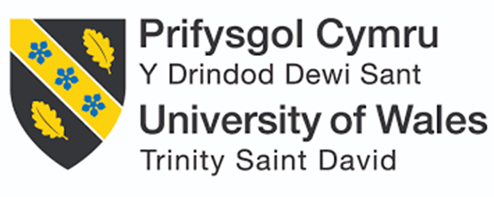
Student Name: Mitwa Ghanshyamsinh Gohil
Student Id: 2431076

Module Name: International Marketing : Principles and Practices
Module Code: LCMB7026
Lecturer’s Name: Tushara Balendran (London)

Work Count: 6770

Contents
1. Introduction 3
2. Brand Overview 3
2.1 Starbucks Global Profile 3
2.2 Starbucks Operations in India 3
2.3 Starbucks Operations in the United Kingdom 4
3. Comparison of the Socio-Cultural Context of India and the United Kingdom Using the PESTLE Framework 4
3.1 Political Factors 5
3.2 Economic Factors 5
3.3 Social Factors 5
3.4 Technological Factors 5
3.5 Legal Factors 6
3.6 Environmental Factors 6
Cultural Dimensions 6
4. Comparison of STP Strategies of Starbucks in India and the UK 8
VALS – Starbucks India vs UK 8
4.1 Segmentation in India 9
4.2 Segmentation in the UK 9
4.3 Targeting Comparison 9
4.4 Positioning Comparison 10
4.5 Comparative Analysis 11
5. COMPARISON OF MARKETING MIX STRATEGIES (7Ps) 11
5.1 Product 12
5.2 Price 13
5.3 Place 13
5.4 Market Entry 14
5.5 Promotion 15
5.6 People 15
5.7 Process 16
5.8 Physical Evidence 16
6. EVALUATION OF PERFORMANCE OF MARKETING STRATEGIES 17
6.1 Sales Performance Comparison 17
6.2 Market Share Overview 17
6.3 Customer Engagement Indicators 18
6.4 Brand Awareness Indicators 18
7. Evaluation Of Marketing Ethics Practice 19
7.1 Ethical Considerations in India 19
7.2 Ethical Considerations in the United Kingdom 20
7.3 Critical Evaluation 21
8. Recommendations And Conclusion 21
8.1 Strategic Recommendations 21
8.2 Concluding Remarks 23
References 24

Introduction
This report discusses the importance of international marketing so that organisations can effectively conduct their business in different global markets through cultural, economic and regulatory adaptation of strategies to the different markets. Starbucks has been chosen as the target of the present study because it has very high global presence and competence to strike an equilibrium between standardised branding and local adaptation that makes it a very suitable as an object of comparative study (The Strategy Institute, 2024). India and the United Kingdom have been selected because of the difference in the socio-cultural attributes, economic statuses, and consumer lifestyles advantageous in providing a case study in determining how international marketing programs vary with the market (WorldData.info, 2024). The report will include brand overview, a comparison on the socio-cultural analysis, a discussion on STP strategies and marketing mix strategies, performance and ethical practices, and in conclusion strategic recommendations and a structured summary.

2. Brand Overview

2.1 Starbucks Global Profile
Starbucks Corporation in Seattle, USA, in 1971, is the largest chain of specialty coffeehouses in the world, and a major global trademark in the beverage industry. As of 2023, the company has more than 38,000 stores across the globe and is operating in more than 80 countries, with each outlet serving millions of customers on a daily basis (Starbucks Coffee Company, 2025). Starbucks has a strong reputation of providing premium coffee, crafted beverages, bakery and lifestyle items, as a third place between home and work where customers can unwind and socialise whilst working. It has established its brand identity as a company that has a commitment to quality sourcing, ethical trade practices, sustainability initiatives as well as customer experience (Starbucks Coffee Company, 2025).

2.2 Starbucks Operations in India
In 2012, Starbucks entered India in a joint venture with Tata Group as Tata Starbucks Private Limited. This alliance created the potential of the brand to take advantage of local market insight and supply chain network of Tata. Starbucks has more than 50 cities with more than 390 outlets in different states of India such as, Mumbai, Delhi, Bengaluru and Hyderabad, among others, as of 2023 (Starbucks Coffee Company, 2024). The Indian operations give focus on localisation through launching products that are inspired by the region like the Masala Chai Latte, Filter coffee and the vegetarian food varieties that will meet the local taste preferences.

2.3 Starbucks Operations in the United Kingdom
Starbucks started operations in the UK in 1998 and has since grown to have a strong presence with nearly 1,000 outlets in the country. The business activities in the UK operate in a highly competitive coffee retail market with the brands like Costa Coffee, Pret A Manger and Caffe Nero being strong competitors (Starbucks Coffee Company, 2023). The stores in the UK are placed strategically in high streets, transport centres, business areas and drive-through areas that are targeted at busy commuters, students and businesspeople.

3. Comparison of the Socio-Cultural Context of India and the United Kingdom Using the PESTLE Framework
The socio-cultural environment of a particular country is one of the factors contributing to consumer behaviour and that which affects marketing techniques (Francis, 2025). The analysis of the macro-environment in India and in the United Kingdom through the PESTLE framework will allow a systematic analysis of the conditions of the macro-environment that influence the activities of Starbucks in the two countries and pinpoint the way cultural and structural peculiarities influence marketing modification (Makos, 2024).
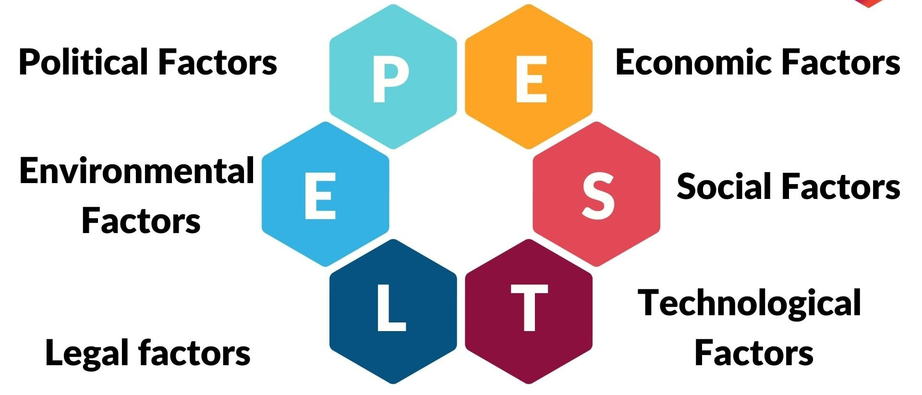
Figure 1: PESTLE Framework (Source: Goggle Images)
3.1 Political Factors
The UK is a stable democratic government with well-established regulatory mechanisms that encourage transparency and systematic governance and this affects the uniform business operations in the retail sector and hospitality industry (Cairney et al., 2024). India, in its turn, is a democratic country with higher levels of regional policy variance, bureaucracy and political interferences in foreign companies (Verma, 2025). These imbalances affect the consistency of operations of Starbucks especially in licensing, tax and location approvals.
3.2 Economic Factors
The economy of the UK is high-income and the consumer spending capacity within the country is very high, which allows it to spend more on high-quality coffee products and lifestyle experiences (Ahmed et al., 2016). On the other hand, India is indicative of a fast developing but less price-insensitive market with a high level of income discrepancies (World Bank, 2025). Such economic differences affect the pricing policy of Starbucks as the UK is a country where it can set high prices, whereas India is the country where flexible prices are necessary, and the target directs the choice at high-income urban population.
3.3 Social Factors
Consumer expectations are highly connected with socio-cultural preferences. British consumers have a very strong culture of coffee, and this is because convenience, a regular habitual and a cafe socialisation (Rachwal et al., 2024). In India, tea still prevails, although altering lifestyles in urban areas and westernisation has promoted the culture of coffee drinks among the younger population (Weerasekera, 2024). Moreover, the cultural attitudes in India (collectivism), favour social meal sitting whereas UK society has the tendency of individualistic consumption behaviour, which influences the desired ambience in the store, products to be stocked and promotion of products.
3.4 Technological Factors
The UK shows a high level of digital penetration, a large penetration rate and usage of mobile payment technologies and smartphones, which will allow Starbucks to make a good use of digital loyalty programmes and applications-based ordering (Statista, 2025). Having experienced a rapid adoption of digital aspects, India is not without infrastructural barriers in the rural regions, yet, urban consumers have been recording growing interest in mobile-based service applications like UPI and delivery applications (Sindakis et al., 2024). This variability affects the technology-based approaches of customer engagements of Starbucks.
3.5 Legal Factors
The employment regulations of UK focus on the rights of employees, minimum wage regulation and high levels of health and safety policies in the hospitality industry (CIPD, 2022). India is a country with labour laws but tends to have inconsistency in the implementation of policies, thereby posing a threat to the operation of multinational companies (Sharma, 2021). The regulations on food safety and advertising are also not similar, which affects the labelling of products, transparency on their contents and the ethical advertising standards.
3.6 Environmental Factors
The UK has an especially high level of environmental awareness, and the impact on consumer decision-making is significant on sustainability, carbon reduction and ethical sourcing (DEFRA, 2023). Starbucks in the UK has taken a reaction in terms of marketing reusable cups, plant-based and sustainable products. On the contrary, the environmental consciousness of India is going up, but it is not a deeply embedded factor in the mass consumer behaviour (Gupta and Mehta, 2020). Environmental responsibility is however becoming a more important value by urban Indian consumers, forcing Starbucks to apply the concept of sustainability branding selectively.

Cultural Dimensions

Table 1: Cultural Dimensions between India and UK
Hofstede Dimension | India Score | UK Score
Power Distance | 77 | 35
Individualism | 48 | 89
Masculinity | 56 | 66
Uncertainty Avoidance | 40 | 35
Long-Term Orientation | 51 | 51
Indulgence | 26 | 69

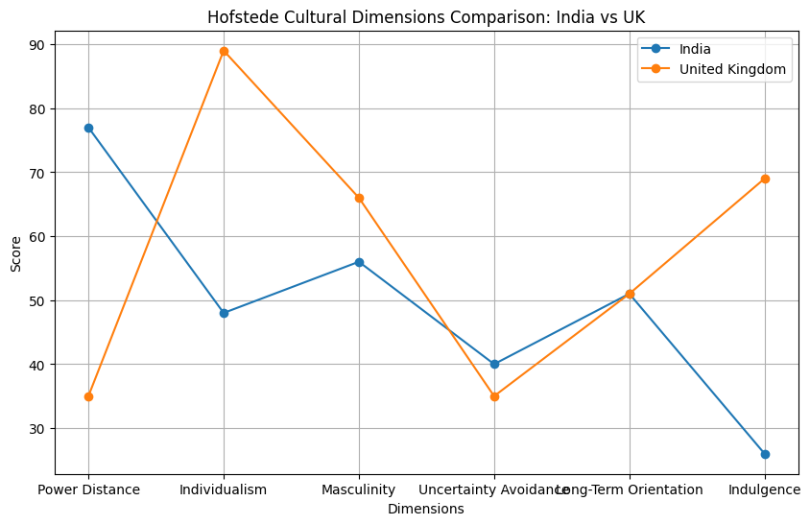
Figure 2: Hofstede cultural comparison of India and the UK (Source:Self made)

The Hofstede cultural comparison of India and the UK demonstrates valuable strategic learning on market positioning as well as some obvious strong and weak points of brands. India has a great Power Distance (77) which favours the high end and status oriented products - an advantage to luxury brands, but a disadvantage to products requiring positioning near equality or autonomy. However, conversely, the low score (35) of the UK supports the policies of accessible and transparent positioning but dampens prestige-seeking strategies (Researchomatic, 2025). The moderate level of Individualism (48) in India enabled them to use marketing with groups, but with the high score of 89 in the UK, they can use more relevant marketing. Achievement-based appeals are positive in both markets due to similar Masculinity (India 56, UK 66). The low Uncertainty Avoidance in both countries allows innovative products that are flexible but the disadvantage is that the loyalty to fixed structures will be lower. Long-term Orientation scores (51) are identical to long-term value propositions. However, it is also true that Indulgence is less at India (26) because of the stronger value-for-money branding and at the UK (69) because of the higher indulgence, which supports the campaigns more focused on lifestyle and enjoyment, but could lead to more competition among the attention-seeking of consumers (Researchomatic, 2025).
The most appropriate culture in the UK market to be operated by Starbucks is its high individualism, oriented at indulgence and convenience behaviour as it is consistent with the focus on the premium coffee consumption with a lifestyle. It has such benefits as high level of habitual demand, digital adoption and ethical awareness. One of these disadvantages is high competition which involves ongoing innovation and sustainability credibility to stay loyal and differentiated.

4. Comparison of STP Strategies of Starbucks in India and the UK
Segmentation, Targeting and Positioning (STP) is the basis of an effective international marketing strategy, as organisations should be able to understand which specific customer groups have unique needs and offer different value propositions (Kotler et al., 2019). Differentiated STP strategies are implemented in India and the UK by Starbucks to suit different socio-cultural tendencies, consumption habits and economic status.

VALS – Starbucks India vs UK
Market | VALS Category | Consumer Characteristics | Relevance to Starbucks
India | Experiencers | Young, urban, trend-driven, socially expressive | Choose Starbucks for lifestyle identity, excitement, and social visibility
India | Achievers | Career-focused, financially secure professionals | Prefer Starbucks as a status symbol and premium experience brand
India | Innovators | Confident, globally influenced, open to new ideas | Value customisation, new beverages, international brand standards
UK | Thinkers | Rational, informed, value stability and knowledge | Choose Starbucks for consistent quality, trust, and reliability
UK | Believers | Practical, habit-driven, tradition-oriented | See Starbucks as a familiar, routine coffee destination
UK | Innovators | Trend-conscious, ethical lifestyle adopters | Value sustainability, customisation, and digital convenience

4.1 Segmentation in India
In India, Starbucks has employed the major use of demographic, psychographic and geographic segmentation to appeal to its niche premium customers. The brand is geared towards middle and upper-middle-income customers who are usually aged between 18 and 40 and include young professionals, corporate workers and students of universities and colleges (Srikanth, 2023). Psychographically, Starbucks divides Indian customers according to their lifestyle goals, modernisation and connection with the global culture, making its stores a token of social standing and urban chic (Thomas et al., 2025). These customers are after dining with experience and they view Starbucks more as a high-quality lifestyle brand and not as a coffee retailer.

4.2 Segmentation in the UK
Conversely, Starbucks in UK uses wider segmentation tactics because coffee culture and frequency of consumption are much higher. The brand is demographically wider and includes students and working people aged between 18-55, focusing on convenience and regular usage (Adilo, 2025). The UK Starbucks have psychological segments where the lifestyle needs like portability in work, practicability, healthiness, and moral consciousness are used to segment the market (Statista, 2023).
In the UK, geographic segmentation is not limited to the large cities, as suburbs and transport centres also serve the needs of commuters requiring their service fast (CIPD, 2022). Behavioural segmentation looks at the aspects of considered habits, in which coffee is depicted as a necessitating and not luxury consumption. The British consumers are also increasingly demanding sustainable and ethically sourced goods, which shape the segmentation of Starbucks to environmentally conscious consumers (DEFRA, 2023).

4.3 Targeting Comparison
Starbucks uses a focused target strategy in India, mainly targeting high-income urban buyers who interpret the brand as a symbol of high-quality products and international status (Rao, 2022). It is focused on aspirational customers who consider Starbucks as a status and are ready to spend top amounts of money on experience-driven consumption. Such selective targeting is symptomatic of the price-sensitive mass market in India where Starbucks would be slotting into a niche market to stay selective.
On the other hand, Starbucks in UK uses differentiated targeting, in which several consumer segments targeting is adopted. They are office workers who have to go to fast restaurants, students who want to find social work places and consumers who are environmentally aware and choose ethical brands (Mintel, 2023). The UK market will enable Starbucks to concentrate on a larger customer group since there is greater toleration towards high-quality coffee as a normal way of life. This differentiation allows Starbucks to boost its sales volume and market coverage at the level of brand prestige (Kotler et al., 2019).

4.4 Positioning Comparison
Positioning refers to the way a brand is seen in the minds of consumers compared to their competitors (Keller, 2020). In India, Starbucks is poised as a aspirational worldwide ways of existence as it provides high quality cafe service which portrays modernity, luxuriousness and social status. It positions its brand in exclusivity, experience, and international standards, which makes it stand out compared to the local coffee shops and roadside cafes (Tata Starbucks, 2023). Premium positioning is supported by the pricing and the ambience.
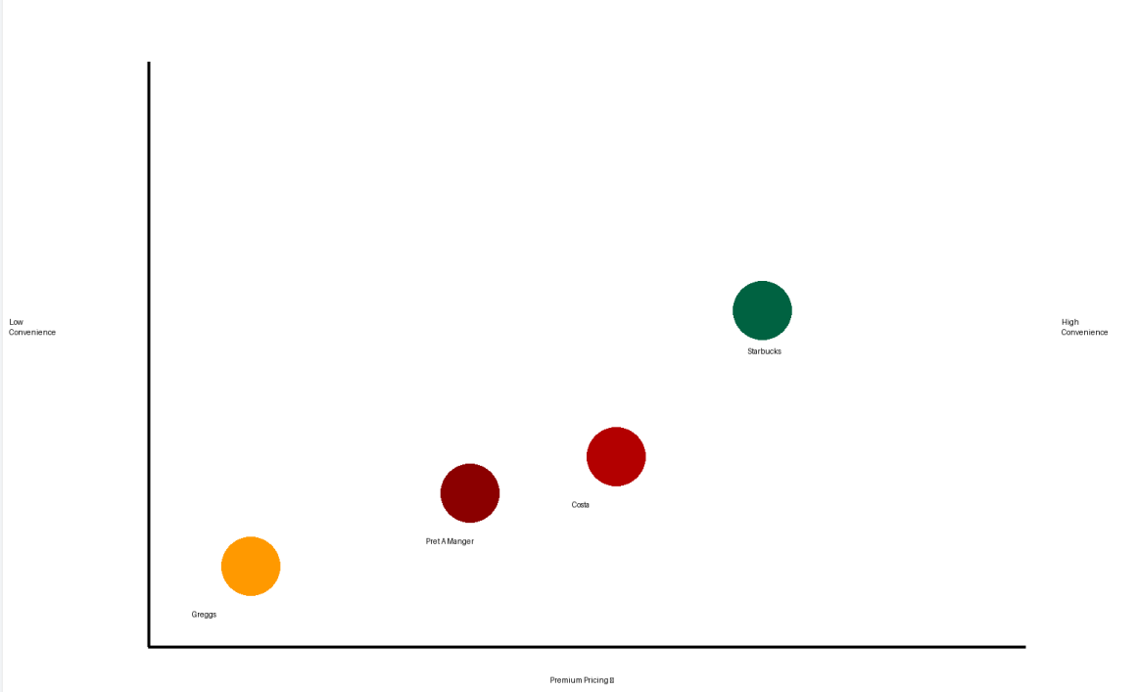
Figure 3: Perceptual Map (Source:Selfmade)
Starbucks is placed as a well trusted, convenient and ethically sound coffee brand in UK that incorporates lifestyle and functionality. Though retaining the premium image, it is positioning as a daily coffee shop, competing with Costa Coffee and Pret A Manger to be consumed on a daily basis (Mintel, 2023). The position focuses on sustainability, ethical procurement and customer comfort, which is consistent with the increasing demands of corporate social responsibility by UK consumers (DEFRA, 2023).

4.5 Comparative Analysis
The STP strategies demonstrate some major differences between the two markets. Starbucks targets exclusivity, aspiration and social prestige in India, which means a small but high-valued customer base. In the UK, it is concentrating on the area of access, convenience, and habitual consumption and puts it in the wider mass market. These strategic variations are cultural orientation, economic structure and consumption patterns in either state (Kumar and Singh, 2021).
Moreover, the culture in India is collectivist and facilitates the concept of socialisation in groups at coffee shops, whereas the culture in the UK is individualistic, where efficiency and consumption of speed are promoted. Starbucks successfully modifies its STP approach to these contextual differences, which would allow gaining competitive advantage and customer loyalty in the two markets (Gupta and Mehta, 2020).

5. COMPARISON OF MARKETING MIX STRATEGIES (7Ps)
The marketing mix offers a methodical approach to assessing the variations in how Starbucks packages its strategic products in various foreign markets. Though the brand is still consistent worldwide, Starbucks varies every aspect of its 7Ps to meet the expectations of the local consumers, the economic realities and the local taste in India and the United Kingdom.
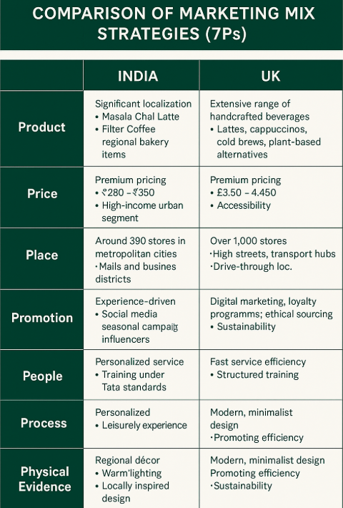

5.1 Product
Starbucks provides a wide variety of handmade beverages such as lattes, cappuccinos, cold brews, Frappuccinos, seasonal and more and more plant-based options in the UK. Lucas (2024) claims that more than 40 percent of the drinks sold are dairy-free, which includes oat and almond milk, which is highly sustainable and healthy. The breakfast pastry services, sandwiches and protein boxes are also in the menu as they are consistent with the fast paced life.
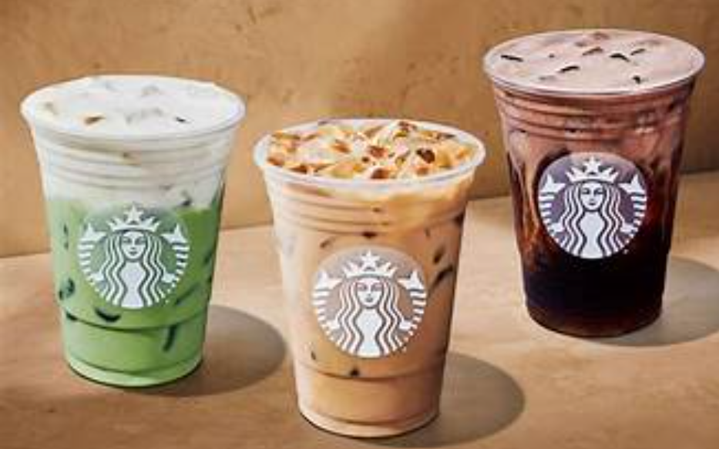
Figure 4: Starbucks UK

Starbucks India, on the contrary, embraces great localisation. There are products like Masala Chai Latte, Filter Coffee and bakery products that are introduced to meet the taste preferences of Indians. The menu is tailored to the local flavour profiles (approximately 60 percent) (Ghosh, 2025).

5.2 Price
Starbucks will use high-end pricing in the two markets but at different price-setting frameworks. £3.50 to £4.50 is the average price of a latte in the UK and can be purchased by people with middle-income who have high disposable income. Statista (2023) reports that on average, the consumers in the UK spend £14 weekly on buying coffee.
Starbucks is priced much higher as compared to alternatives in India. The average price of a latte is in £280 to £350 making the brand premium and aspirational. Average Indian consumers contribute less than ₹300/day to consumption of beverages, which means that Starbucks has only high income urban segments (IBEF, 2023). In this way the pricing strategy supports exclusivity in India and accessibility in the U.

5.3 Place
There are over 1000 Starbucks stores on high streets, train stations, airports, universities and drive-through units in the UK, which reflects a strong direct distribution model based on convenience and accessibility. Approximately one-third of the UK stores are driven throughs serving commuter culture, with the delivery system provided by an indirect distribution network consisting of delivery providers and retail merchandise (Starbucks UK, 2023).
Starbucks has around 390 outlets in India, predominantly in big cities like Mumbai, Delhi and Bengaluru. The brand depends mostly on direct distribution, by utilizing the premium outlets in business districts and luxury malls with indirect distribution by Swiggy and Zomato delivery service. In contrast to the expansive scope in the UK, India focuses on quality destinations to strengthen lifestyle positioning rather than size..

5.4 Market Entry
The economic, regulatory and cultural environments in India and the UK are different, with Starbucks committing various market entry strategies in these countries. In India, local supply chain access, regulatory support and cultural legitimacy was achieved by the company conducting a joint venture with Tata Group (Kumar and Singh, 2021). The model mitigated the risks of finances and increased market acceptance. Consequently, Starbucks came into the UK in a form of direct ownership and licensing where it retained total brand control, it expanded faster and remained more flexible in a mature, high demand coffee market in the UK (Kotler et al., 2019). These differing approaches demonstrate how Starbucks can adjust its entry modes to achieve maximum growth and competitiveness.
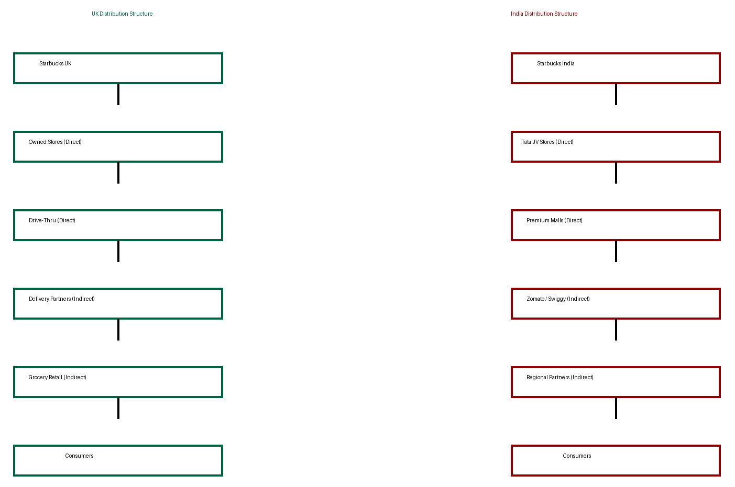
Figure 5: Distribution Structure of UK and India

5.5 Promotion
Starbucks pays much attention to digital marketing in the UK, loyalty programmes and mobile app activities. The Starbucks Rewards app has registered more than 2 million users in the UK creating 45 percent of transactions in online platforms (Statista, 2023). There is ethical sourcing and sustainability in promotional campaigns.
Promotions are experience-based, social media-oriented and seasonal campaigns, in-store events are heavily utilised in India to captivate millennials and Gen Z shoppers. Community engagement and social bonding, like campaigns like Meet Me at Starbucks are used.

5.6 People
In UK, the staff is trained on the efficiency to provide fast service with customer engagement. The UK stores hire about 15,000 partners, focusing on the structured training, policies on Customer Service Excellence and Diversity.
In India, Starbucks also spends heavily on training of the employees according to the Tata benchmarks, with the ready emphasis laid on hospitality and customised service. More than 85 percent of employees receive ongoing training every year, and these areas are connected to customer engagement, knowledge of beverages, and cultural sensitivity (Tata Starbucks, 2023).

5.7 Process
The UK concentrates on speed and digitisation. The mobile order and pay systems lower the average service time by one minute per transaction. Existence of self-service kiosks and ordering through apps facilitates efficiency.
Starbucks focuses on personalised service and relaxing experience in India. The social culture of gathering takes place when customers spend 45-90 minutes in stores. Service processes are process focused on relationship-building, rather than speed.

5.8 Physical Evidence
The UK Starbucks outlets are designed in a minimalist modern style that fosters efficiency and sustainability. The common use of recyclable materials and green-certified store designs are used (Annual Report, 2025). Indian stores are designed with decor elements of the region, strong lighting and local design to have an emotional appeal. Visual branding has got cultural aesthetics, and this has strengthened the idea of Starbucks as a practically exclusive social facility.
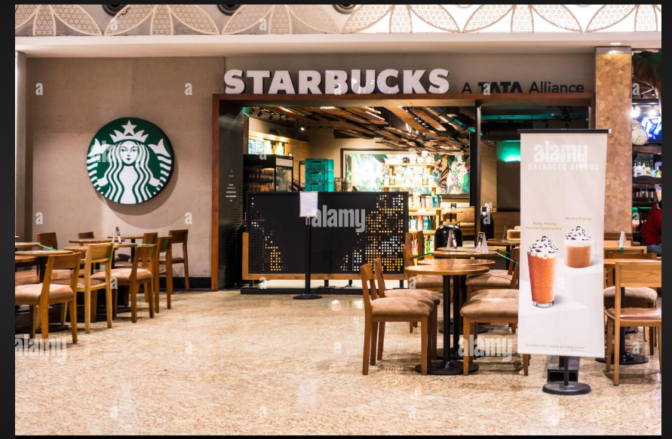
Figure 6: India Starbucks (Source: Goggle)
Generally, the marketing mix used by Starbucks portrays strategic localisation. In the UK the accent is on convenience induced consumption, efficiency and sustainability inspired consumption, but in India the accent is on experience encompassed consumption, aspiration and culture indexed consumption. These opposite strategies underscore the flexibility of Starbucks to adjust its global structure to environments with different consumers, preserving brand identity.

6. EVALUATION OF PERFORMANCE OF MARKETING STRATEGIES
To measure the success of the Starbucks marketing program in India and the United Kingdom, the critical analysis of the measurable performance indicators of sales growth, market share, customer engagement, and brand awareness should be performed. These indicators give an insight on how Starbucks has managed to align its marketing mix and strategizing on STP with the socio-cultural and economic environment in the various market.

6.1 Sales Performance Comparison
The sales performance of Starbucks in the two countries differs significantly because of the market maturity, purchasing power and consumption culture. UK is a developed market in terms of coffee and Starbucks has a stable revenue base. As Starbucks UK Annual Report (2023) indicates, the company has been able to earn over PS500 million of annual revenues, and it has experienced a steady growth due to high rates of brand loyalty and repeat purchase. The UK has well-established cafe culture that guarantees its consistent demand, allowing Starbucks to maintain a predictable quarterly growth of between 6-8 percent per year on average. Comparatively, Starbucks India is experiencing slower but strategic growth. As stated by Tata Starbucks, revenues are more than ₹1,230 crore in the FY2024, which reflects an increase of about 18 percent in comparison to last year (Annual Report, 2024). Though the number of stores and their total revenue are much lower than in the UK, the tendency of growth indicates acceptance of the premium culture of coffee by the urban Indian customer.

6.2 Market Share Overview
Within the UK, Starbucks has a market share of about 9-11% of branded coffee shop market, second only to Costa Coffee, and defeating a number of other independent chains (Mintel, 2023). It is competitive, which is anchored by its good location in areas with transport station and commercial areas. Starbucks has a strong share in the middle of the intense competition due to differentiation through digital loyalty schemes and sustainability branding.
Starbucks market in India is relatively fragmented with local tea vendors controlling the market alongside some new rising cafe chains like Cafe Coffee Day. Starbucks has a market share of approximately 5-6% in the structured cafe market which makes it a premium niche player, rather than a market leader (Mintel, 2023). It is not established in most of the non-metro cities, which limits its growth opportunities; however, exclusivity enhances brand prestige. The differences are evident where Starbucks strategise a leadership-through-premium approach in India and play a formidable competitor in the place of a saturated UK market.

6.3 Customer Engagement Indicators
Customer engagement is the emotional and behavioural relationship that customers have with a brand. Starbucks is highly engaged on the digital platforms in the UK. Starbucks Rewards programme has more than 2 million active users in the UK, and around 45 percent of all the deals are fulfilled through the mobile apps (Statista, 2023). The level of engagement measured by the number of app logins, redemption and social media action of loyalty programmes will also help with customer retention and repeat purchase behaviour. Starbucks UK also has high levels of website interaction with an average of 1.4 million visits every month.
Experience marketing and social media are the two main strategies that are used in customer engagement in India. Instagram followers of Starbucks India have catapulted over 400,000 and this shows a growing digital engagement with the young segments in the urban areas. The presence of campaigns, like the Meet Me at Starbucks one and promotions dedicated to specific festivals, implies emotional storytelling and social interaction (Latterly.org, 2025).

6.4 Brand Awareness Indicators
Brand awareness is one of the most important variables indicating the recognition of the market and perception by the consumer. Brand awareness is very high in the UK: according to an analysis, Starbucks reaches more than 90 per cent among urban consumers (YouGov, 2023). Recall and visibility is enhanced by the recognisable green siren logo and the presence of the store in major locations. Long familiarity and long presence of the brand have added to its brand name, as it has become a household name.
Brand awareness in India is high in metropolitan areas and low in rural and semi-urban locations. According to the surveys, urban millennial awareness is about 55-65% among the population of professionals and urban millennials (Venugopal, 2022). The brand recognition of Starbucks depends on aspirational associations, higher positioning and global exposure, but with the social media and global branding platforms.
The performance analysis indicates that the marketing strategies employed by Starbucks have done really well in the UK by exploiting convenience, habitual consumption and technological integration. Its robust system of digital ecosystems and rewards programmes contribute to the stable stream of revenue and increase brand loyalty. Nevertheless, rising competition and need of local sourced substitutes impose pressure on the sustainability of growth in the long-run.

7. Evaluation Of Marketing Ethics Practice
Marketing ethics is defined as the ethical principles and norms by which organisations interact with consumers and undertake promotional activities in a socially responsible way (Geeksfor, 2025). In the case of the world-renowned brands like Starbucks, ethical marketing becomes essential in the context of forming the corporate image, keeping the customers loyal and complying with the social norms (Pereira, 2025). This section analyses the ethical aspects in Starbucks marketing activities in India and United Kingdom, and subsequently compares them critically.

7.1 Ethical Considerations in India
One of the ways Starbucks establishes itself as a socially responsible brand in India is through giving emphasis on sustainability, ethical sourcing and community involvement. As a part of its collaboration with Tata Group, Starbucks facilitates the sourcing of coffee responsibly with the Coffee and Farmer Equity (C.A.F.E.) practices, where farmers are compensated generously and meet the environmental requirements (Wilkins, 2025). This shows ethical enterprise to supply chain transparency and fair trade. Nonetheless, there are issues of ethics in terms of prices and accessibility. The high pricing framework of Starbucks results in social exclusion where only the urban high-income earners will purchase its products, which may further strengthen the socio-economic inequality in a developing economy (Song, 2025).
The other ethical issue is cultural representation. Starbucks uses the native Indian products like Masala Chai Latte that makes them question the culture of commodifying it further, in which the local culture at small scale is transformed into a commercial interest without serving local small scale sellers (Abou et al., 2024). Although Starbucks markets such products as cultural appreciation, critics believe that Starbucks commodifies the real cultural heritage in a high-end westernised curb. In addition, the ethics of advertising come under fire. In India, Starbucks marketing campaigns tend to include promotion of luxury lifestyle messages which can instigate materialism in the minds of the young people. The image of Starbucks as an icon of high modernity can create unrealistic social comparison, especially among middle classes groups. This casts doubts on the moral issue of social responsibility and psychological manipulation to consumption behaviour. Nevertheless, Starbucks engages in community-based projects like educational programmes and farmer support initiatives. These attempts prove the means of trying to find a balance between the profit motive of the corporations and social contribution, but their extent is still weak in comparison to expenditures on marketing.

7.2 Ethical Considerations in the United Kingdom
Starbucks has come under considerable ethical criticism in the UK, especially around corporate taxation and transparency. In 2012, Starbucks faced criticism and public scrutiny on paying very low company taxes compared to the amount of revenue generated, resulting in the loss of image and reputation of the company (Reuters, 2012). This past problem still affects the perception of the brand with regard to its ethical values as Starbucks has improved its tax compliance and transparency reporting since the past.

In the UK, environmental ethics find great application as consumers are concerned with sustainability and climate responsibility. Starbucks has launched the reusable cup discounts, the removal of plastic straws and a higher production of plant-based products. Nevertheless, critics point out that even with such efforts, Starbucks remains the leading contributor to single-use packaging waste, making the question of whether its sustainability statements are truly authentic and whether the company faces a greenwashing threat (BBC News, 2024).

7.3 Critical Evaluation
Comparative assessment shows that there are different ethical issues in both markets. The ethics in India focus on the socio-economic exclusion aspect, cultural appropriation and aspirational marketing discourses that might take advantage of emotional consumption stimuli. The premium branding concept developed by Starbucks, as great as it was, has ethical implications on matters of fairness and accessibility in an economy that still faces high income inequality despite the developmental aspect (Adilo, 2025).
Ethical review in the UK entails corporate responsibility and credibility of tax and sustainability. Despite the aggressive push by Starbucks to promote the ethical positioning to consumers, the consumer consciousness and activism demands the firm to be transparent and have an impact (The Cool Down, 2025). It reveals that the ethics not only cease at the level of promotional messages but it extends to the responsibility of operations.
The morale behavior of Starbucks represents a bigger debate on how multi-nationals adapt to local morals. In India, Starbucks has no other choice but to react to inclusivity and cultural awareness; in the UK, it is the issues of transparency, environmental responsibility and corporate citizenship. Starbucks ethical position may be one that appears more reactive rather than proactive, although there are some positive actions being involved.

8. Recommendations And Conclusion

8.1 Strategic Recommendations
The review of Starbucks marketing practices in India and the United Kingdom shows that the company has experienced significant success with the help of localisation, effective brand positioning and customer focus. But the ongoing market dynamics, ethical issues and modification of expectations of the consumers suggest that Starbucks needs to improve its international marketing strategy in order to secure sustainable growth and improved competitive leverage.

Recommendation 1: Implement Tiered Pricing Strategy in India
Starbucks needs to implement a stratified price system in India to ensure wider access to the market without losing brand relevance. With the affordability of differentiated product lines come different prices, this strategy will ensure that the brand appeals to the new consumer segments within the middle-income brackets without losing its high-end status. Kotler et al. (2019) state that adaptive pricing techniques enable the company to enter the market more effectively in prospective economies and ensure brand equity. Another ethical issue that would be handled via this strategy is social exclusivity.

Recommendation 2: Expand into Tier-2 Cities with Modified Store Formats
Starbucks needs to consider expanding to Tier-2 cities with smaller store formats or express outlets to realise long-term market growth in India. This strategy would minimise the costs of operation and reach out to the increasing urban populations with rising disposable incomes. Scalable store models have already been shown to be successful in emerging markets where Tesco operates (Kumar and Singh, 2021).

Recommendation 3: Strengthen Sustainability Transparency in the UK
In the UK, Starbucks needs to enhance the clarity of sustainability communications to prevent being accused of greenwashing. This involves disclosing the data of environmental impact which are measurable like percentage of carbon reduction, reduction of waste and supply chain sustainability performance. Peattie and Crane (2005) argue that credible sustainability communication contributes to a great extent of consumer confidence, and brand commitment in the environmentally sensitive markets.

Recommendation 4: Enhance Digital Personalisation Across Both Markets
Starbucks needs to use artificial intelligence-powered personalisation applications in its mobile app to provide offers and customised messages based on behavioural information. Online personalisation becomes more customer-retaining and brand-engaging (Chaffey and Ellis-Chadwick, 2019). Although this is already well developed in the UK, the same systems must be extended to India.

8.2 Concluding Remarks
This report has critically reviewed the international marketing strategies of Starbucks by case studies on its operation in India and United Kingdom with respect to brand overview, socio-cultural analysis, STP framework, marketing mix strategies, performance evaluation and ethical considerations. The results show that Starbucks uses completely different strategic approaches in every market due to cultural, economic and behavioural differences.
In the UK, Starbucks has a mature, competitive and highly digitised market, where its strategy focuses on convenience, sustainability and habitual consumption. The brand is at the highest level of performance due to the extensive distribution to stores, loyalty schememes and online interaction, whereas the key to future development lies in sustainability authenticity and innovativeness.
Starbucks in India, on the other hand, is more premium lifestyle-positioned, aspirational branding, aimed at upscale urban buyers. On the one hand, this strategy guarantees exclusivity and prestige of the brand, on the other hand, it reduces its mass-market accessibility and scalability. To maintain a growth, Starbucks needs to modify their model to balance exclusivity and inclusivity which would guarantee long-term profits.
In conclusion, Starbucks has the capability to be very flexible on the international stage, yet the firm must prioritize strategic fine-tuning, ethical accountability and more localisation to maintain a competitive edge in the future. The suggested recommendations can offer viable actions to improve its worldwide marketing performance and to address the socio-cultural needs and ethical business practices.

References
ABITA LLC & Marketing (2024) Starbucks strategy in India: Exploring success factors from an uncharted perspective, 1XMarketing.com, 17 September. Available at: https://1xmarketing.com/news/en/world-marketing-diary-240917075856/ (Accessed: 10 February 2025).
Abou-Sabe, K. and Kaplan, A. (2024) Starbucks sued for allegedly using coffee from farms with rights abuses while touting its ‘ethical’ sourcing, NBC News, 10 January. Available at: https://www.nbcnews.com/news/us-news/starbucks-sued-allegedly-using-coffee-farms-rights-abuses-touting-ethi-rcna130393 (Accessed: 01 February 2025).
Adilo (2025) Starbucks brand positioning, Adilo. Available at: https://adilo.com/blog/starbucks-brand-positioning/ (Accessed: 02 February 2025).
Ahmed, M.E., Khan, M.M. and Samad, N. (2016) ‘Income, social class and consumer behaviour: A focus on developing nations’, International Journal of Applied Business and Economic Research, 14(10), pp. n/a.
BBC News (2024) Starbucks baristas launch strike in US, union says, 20 December. Available at: https://www.bbc.co.uk/news/articles/cevgzweexdno (Accessed: 03 February 2025).
Cairney, P., Boswell, J., Ayres, S., Durose, C., Elliott, I.C., Flinders, M., Martin, S. and Richardson, L. (2024) ‘The state of British policymaking: How can UK government become more effective?’, Parliamentary Affairs, 77(4), pp. 837–864. https://doi.org/10.1093/pa/gsae019
Carroll, A. and Brown, J. (2018) Corporate social responsibility: Ethical foundations and business impact, Oxford: Oxford University Press.
Chaffey, D. and Ellis-Chadwick, F. (2019) Digital marketing: Strategy, implementation and practice, 8th edn. Harlow: Pearson Education.
DEFRA (2023) Sustainable consumption and environmental responsibility in the UK, Department for Environment, Food & Rural Affairs. London: UK Government Publishing.
Francis, A. (2025) The social and cultural environment in marketing, MBA Knowledge Base. Available at: https://www.mbaknol.com/marketing-management/the-social-and-cultural-environment-in-marketing/ (Accessed: 02 February 2025).
GeeksforGeeks (2025) Marketing ethics: Meaning, roles, types and principles, 21 August. Available at: https://www.geeksforgeeks.org/marketing/marketing-ethics-meaning-roles-types-and-principles/ (Accessed: 05 February 2025).
Ghosh, A. (2025) How Starbucks India is brewing success with local flavors and innovation, Indian Retailer. Available at: https://www.indianretailer.com/article/food-hospitality/retail-trends/how-starbucks-india-brewing-success-local-flavors-and (Accessed: 07 February 2025).
Gupta, R. and Mehta, S. (2020) Consumer behaviour in emerging markets, Mumbai: Himalaya Publishing.
Hollensen, S. (2020) Global marketing, 8th edn. Harlow: Pearson.
IBEF (2023) Indian coffee retail market report. Indian Brand Equity Foundation.
Keller, K. (2020) Strategic brand management, 5th edn. Harlow: Pearson.
Kotler, P., Keller, K. and Chernev, A. (2019) Marketing management, 16th edn. Harlow: Pearson Education.
Kumar, V. and Singh, S. (2021) Retail expansion strategies in India, New Delhi: Sage Publishing.
Latterly.org (2025) Starbucks marketing strategy: How the coffee giant builds loyalty, Available at: https://www.latterly.org/starbucks-marketing-strategy/ (Accessed: 05 February 2025).
LegalClarity Team (2025) Is Britain a democracy? An analysis of its government, 6 August. Available at: https://legalclarity.org/is-britain-a-democracy-an-analysis-of-its-government/ (Accessed: 08 February 2025).
Lucas, A. (2024) Starbucks will stop charging extra for dairy alternatives, CNBC, 30 October. Available at: https://www.cnbc.com/ (Accessed: 18 February 2025).
Makos, J. (2024) PESTLE Analysis of India [2024 Updated], PESTLEAnalysis.com, 16 May. Available at: https://pestleanalysis.com/pestle-analysis-india/ (Accessed: 15 February 2025).
Mintel (2023) UK coffee shop industry report. Mintel Group Ltd.
Patil, P. and Wagh, V. (2012) Brand awareness among rural & urban consumers, Proceedings of Brand India: A Global Destination, Bharati Vidyapeeth’s Institute, Navi Mumbai, February.
Peattie, K. and Crane, A. (2005) ‘Green marketing: Myth, lies and the future’, Journal of Business Ethics, 62(4), pp. 357–370.
Pereira, D. (2025) Starbucks corporate social responsibility, BusinessModelAnalyst.com, 27 March. Available at: https://businessmodelanalyst.com/starbucks-corporate-social-responsibility/ (Accessed: 18 February 2025).
ProjectPractical Editorial Team (2025) Starbucks marketing strategy 2025: A case study, ProjectPractical.com. Available at: https://www.projectpractical.com/starbucks-marketing-strategy/ (Accessed: 18 February 2025).
Rachwal-Mueller, A. and Fedotova, I. (2024) ‘The impact of cultural factors on consumer behavior: A holistic model for adaptive marketing approaches’, Economics of the Transport Complex, November. DOI: 10.30977/ETK.2225-2304.2024.44.165
Rawal, T., Agarwal, S., Choudhury, T. and Pant, B. (2024) ‘Analysing the variance in brand awareness metrics of urban and rural India of flagship FMCG brands in India’, IC3SE Conference Proceedings, IEEE.
Researchomatic (2025) Hofstede and House culture analysis: UK and India, Researchomatic. Available at: https://www.researchomatic.com/Hofstede-And-House-Culture-Analysis-Uk-And-India-54000.html (Accessed: 15 February 2025).
Reuters (2024) Starbucks India to more than double store count to 1,000 by 2028, 9 January. Available at: https://www.reuters.com/business/retail-consumer/starbucks-india-arm-plans-operate-1000-cafes-by-2028-2024-01-09/ (Accessed: 12 February 2025).
Reuters (2012) Starbucks to pay UK tax after public anger, Reuters. Available at: https://www.reuters.com/article/us-starbucks-tax-idUKBRE8B50HY20121206 (Accessed: 10 February 2025).
Sindakis, S. and Showkat, G. (2024) ‘The digital revolution in India: bridging the gap in rural technology adoption’, Journal of Innovation and Entrepreneurship, 13(29). https://doi.org/10.1186/s13731-024-00380-w
Song, Y. (2025) ‘Consumer preferences and pricing: Starbucks’, Advances in Economics Management and Political Sciences, 192(1), pp. 143–152.
Srikanth, R.B. (2023) Starbucks: segmentation, targeting, and positioning, Medium, 14 March. Available at: https://medium.com/@r.b.srikanth/starbucks-market-segmentation-target-and-positioning-stp-65c714be9176 (Accessed: 10 February 2025).
Starbucks Coffee Company (2023) Starbucks celebrates 25 years of coffee in the UK and EMEA, Starbucks Stories EMEA, 7 September. Available at: https://stories.starbucks.com/emea/stories/2023/25-years-of-coffee-in-the-uk-and-emea/ (Accessed: 15 February 2025).
Starbucks Coffee Company (2024) Tata Starbucks to accelerate growth to 1,000 stores, double employment in India by 2028, Starbucks, 8 January.
Starbucks Coffee Company (2025) About Us, Starbucks. Available at: https://www.starbucks.com/about-us/ (Accessed: 11 February 2025).
Starbucks Coffee Company (2025) Our Starbucks mission, Starbucks. Available at: https://about.starbucks.com/stories/2025/our-starbucks-mission/ (Accessed: 10 February 2025).
Statista (2025) Internet usage in the United Kingdom (UK) – statistics & facts, Statista. Available at: https://www.statista.com/topics/3246/internet-usage-in-the-uk/ (Accessed: 15 February 2025).
Tata Starbucks (2023) CSR and workforce training report, Tata Starbucks Private Ltd.
The Cool Down (2025) Starbucks announces game-changing partnership that could transform its coffee, 16 December. Available at: https://www.thecooldown.com/green-business/starbucks-farmer-support-partnership-india/ (Accessed: 10 February 2025).
The Strategy Institute (2024) Starbucks International Strategy – A Case Study for Global Success, 20 September. Available at: https://www.thestrategyinstitute.org/insights/starbucks-international-strategy-a-case-study-for-global-success (Accessed: 10 February 2025).
ThisVsThat.io (2025) India vs United Kingdom – what’s the difference? Available at: https://thisvsthat.io/india-vs-united-kingdom (Accessed: 12 February 2025).
Thomas, R., Patil, P. and Rakuyio, P.F. (2025) ‘Cross-cultural consumer behavior – a case study on Starbucks in India’, International Journal of Creative Research Thoughts, 13(3), pp. 215–228.
Venugopal, P. (2022) ‘A study on brand awareness in rural markets in India’, International Journal of Research and Analytical Reviews, 9(3), p. 30.
Verma, R. (2025) ‘India’s democratic political system, economic growth and domestic security challenges’, Contemporary South Asia, 33(2), pp. 230–246.
Weerasekera, B. (2024) Tea culture in India: A pillar of tradition and economic significance, LinkedIn.
World Bank (2025) India: Accelerated reforms needed to speed up growth and achieve high-income status by 2047, 28 February.
WorldData.info (2025) Country comparison: United Kingdom / India. Available At: https://www.worlddata.info/country-comparison.php?country1=GBR&country2=IND
YouGov (2023) UK coffee consumption and brand recognition survey. Available At: https://yougov.co.uk/topics/consumer/explore/topic/Coffee

