DS 1 Template

My Screenshots/Photos
- Please add 4–6 screenshots or photos of your digital life.
- You can use your phone or laptop.
- For each screenshot, write one or two sentences explaining what it shows.

Screenshot/Photo 1
[Insert Photo/Screenshot below]
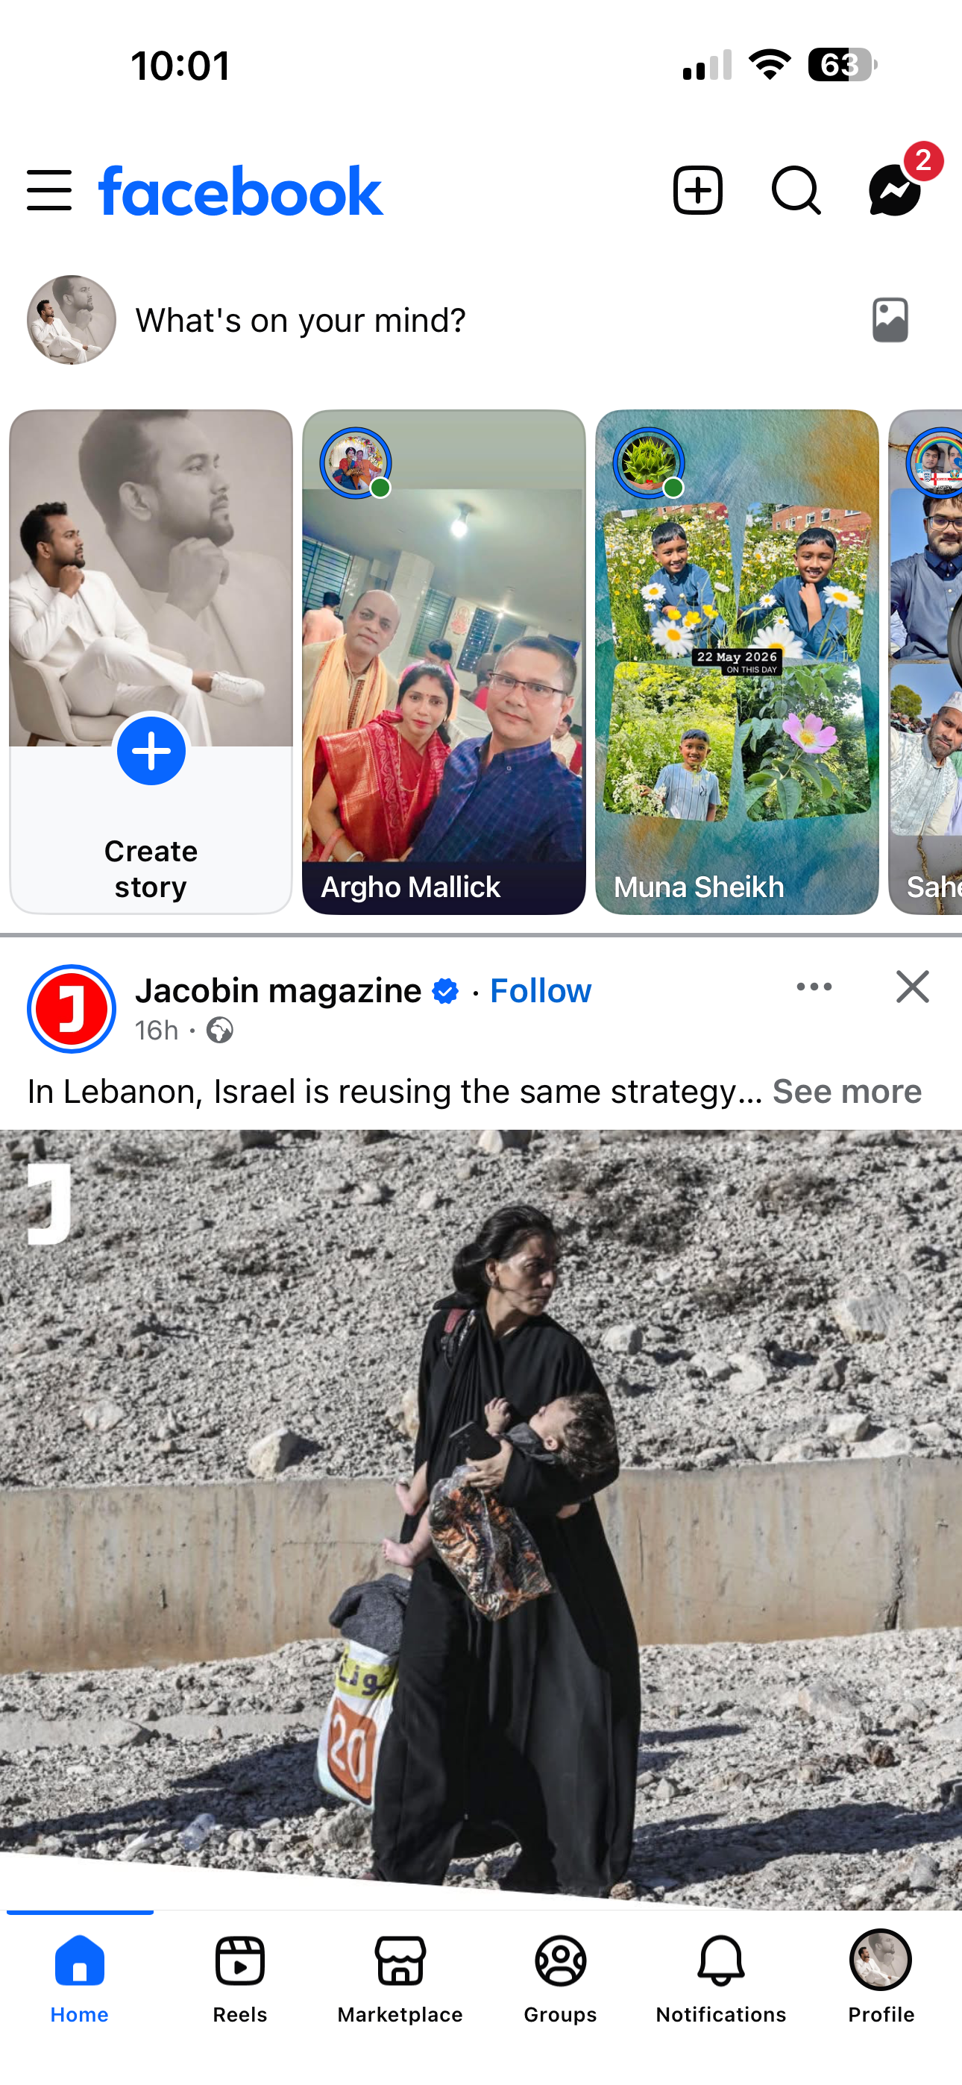
[Write what this shows of your digital life] This picture is from my Facebook page and I use regularly this for my social communication with friends, family.

Screenshot/Photo 2
[Insert Photo/Screenshot below]
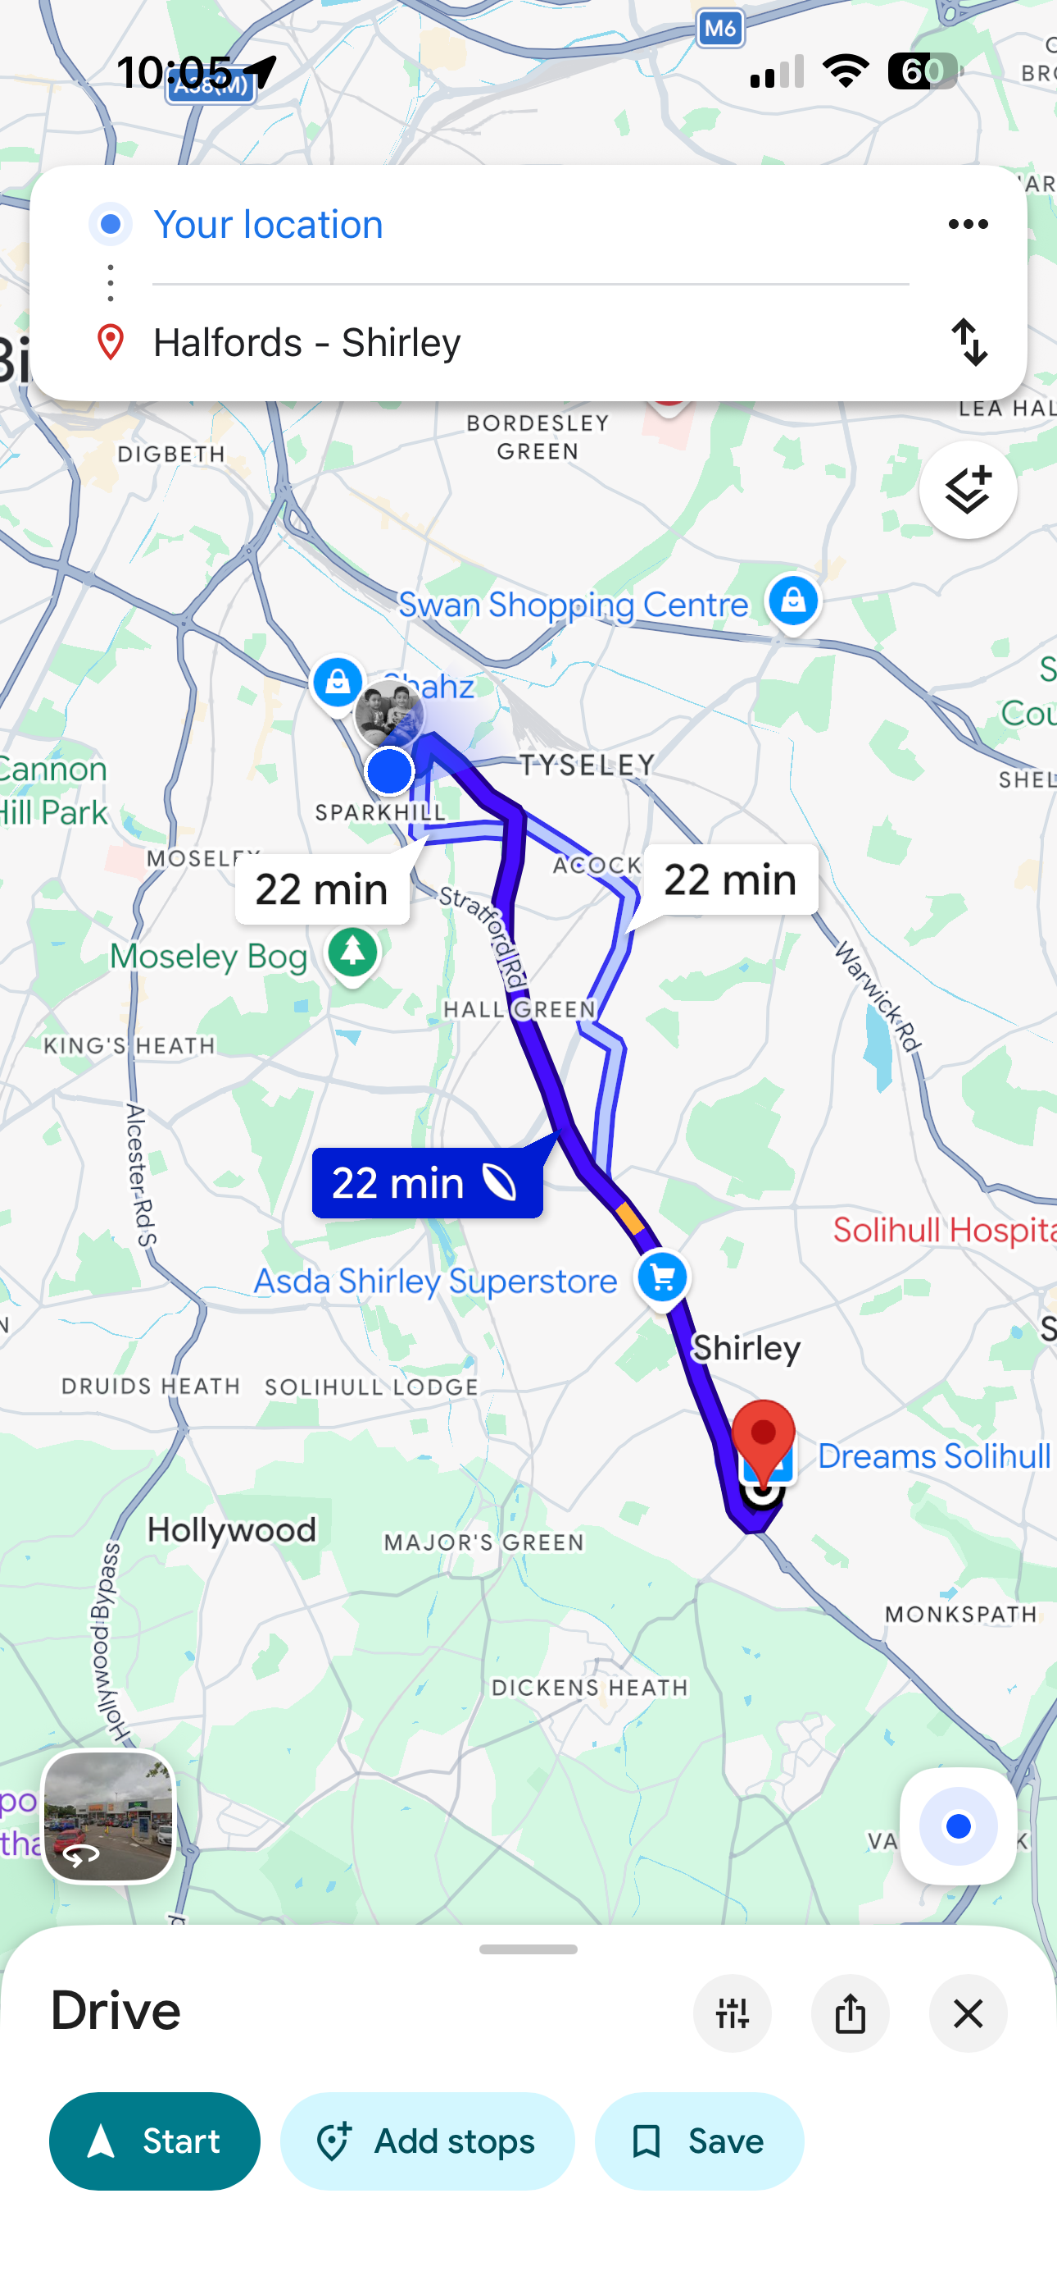
[Write what this shows of your digital life] This picture shows google map which I use almost everyday for driving.

Screenshot/Photo 3
[Insert Photo/Screenshot below]
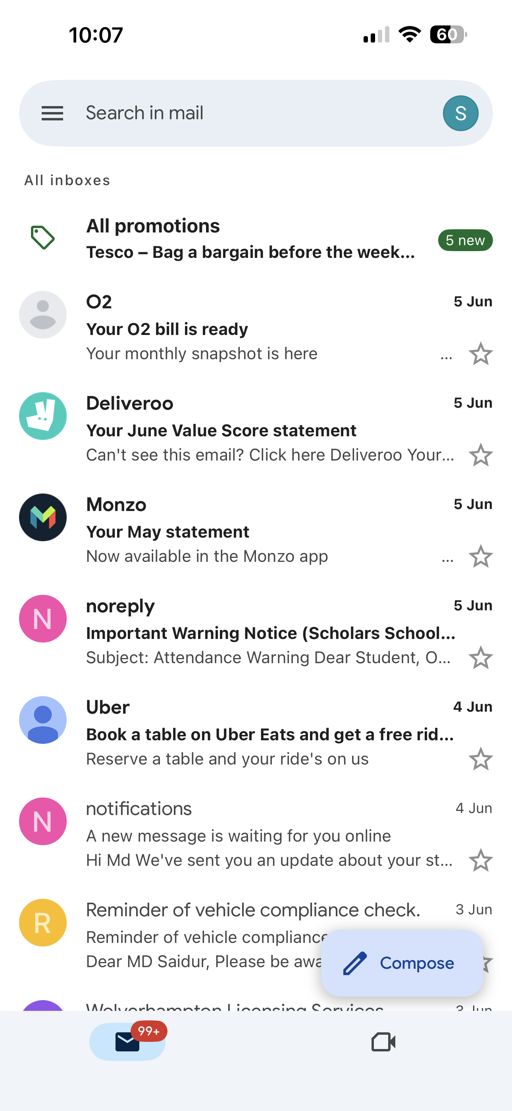
[Write what this shows of your digital life] This picture shows my email address which I use every day for my formal communication.

Screenshot/Photo 4
[Insert Photo/Screenshot below]
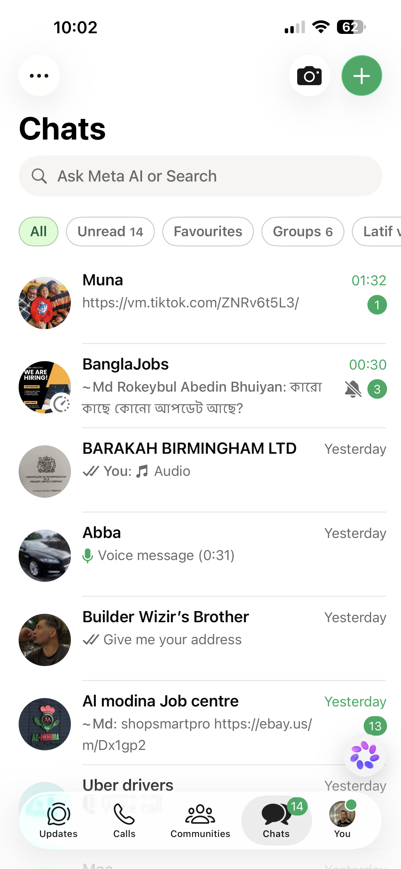
[Write what this shows of your digital life] This picture shows from my WhatsApp and I use this every day for communication.

Screenshot/Photo 5
[Insert Photo/Screenshot below]

[Write what this shows of your digital life] This picture is from my bank app and I use this for my daily life such as shopping, paying bills, getting wages from work etc.

Screenshot/Photo 6
[Insert Photo/Screenshot below]

[Write what this shows of your digital life]

My Short Reflection
- Write 5–8 simple sentences about your digital life.
- You can use the sentence starters below if helpful.
I use digital tools daily to study, communicate and find information online. I often use these tools for email, web browsers and online learning platforms. I feel confident when I use technology to complete tasks and solve problems. I want to improve my digital skills, especially in using new software and staying safe online. I sometimes feel nervous about making mistakes or protecting my personal information. I hope this module will help me become more confident with digital technology. Digital skills are important for me because they help me learn, work and connect with friends, family and others.

Sentence starters
- I use digital tools to …
- I feel confident when I …
- I want to improve …
- I often use these tools: …
- I sometimes feel nervous about …
- I hope this module will help me …
- Digital skills are important for me because …
You can write more if you want.
Submission Checklist
Before you submit, please check:
​​​ ☒ I added 4–6 screenshots
☒ I wrote short sentences for each screenshot
☒ I wrote my short reflection
☒ My work is my own
☒ My file opens correctly
​​☒ My file opens correctly

