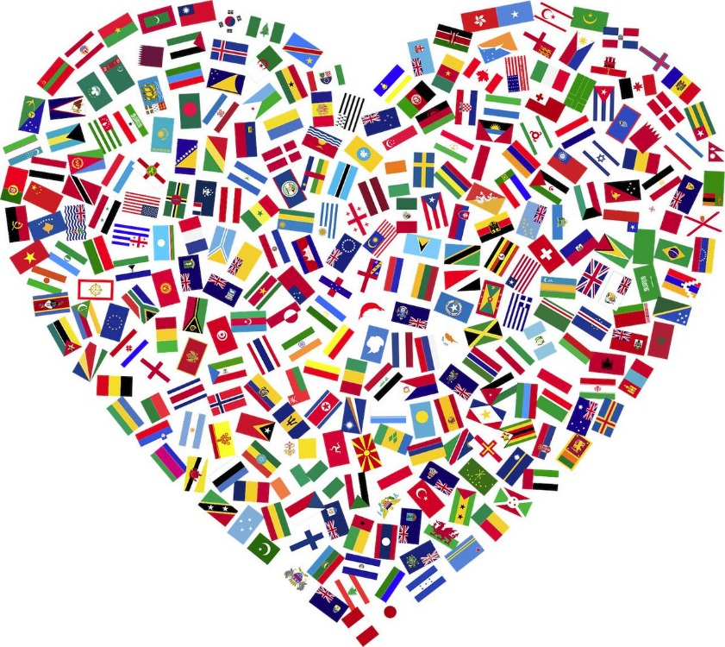

AIDE MEMOIRE FOR
HOTEL STAFF TO HELP MANAGE GUEST SERVICE
EXPERIENCES FOR THE
INTERNATIONAL VISITORS

BA International Hotel Management

Foreign Languages and Cultural Awareness

M5X01923

Lecturer:
Dr Olu Adegbite
Student name: Monuar Moni
Student number: 1818185

Table of Contents
Introduction 3
Selection of ten countries 3
Identification of cultural differences 4
Customs and behaviour differences 7
Do’s and Don’ts for hotel staff 8
Conclusion 12
References 13

Introduction
Providing training and knowledge is necessary for hotel staff to provide appropriate customer service to international visitors. Hotel providing its services to international visitors need to provide training of cultural differences to staffs so that they can appropriately satisfy the customers. In this study, ten countries have been selected to understand the cultural differences between them so that staff can meet the requirements of international visitors based on their culture. Premier Inn has been considered as a hotel that has decided to make Aide Memoire for hotel staff in order to improve guest experience. This can increase satisfaction of customers and improve the brand value of hotel as well. Do’s and Don’ts list has also been provided in the study to manage guest experience in properly by hotel staff.

Selection of ten countries
Premier Inn is providing its hospitality services in different countries such as Germany, India, UK and UAE. It has been running its business in UK for 33 years and achieved great brand value in the world (Premierinn.com, 2020). The hotel provides appropriate services and facilities to customers such as best comfortable bed, free Wi-Fi 24/7 and best food and drinks. It has more than 800 hotels in UK to meet the requirements of international visitors. The selected ten countries are United Kingdom, United States of America, Singapore, Malaysia, United Arab Emirates, Spain, Italy, Sweden, Switzerland and Turkey. Premier Inn is focusing on the cultures of the countries in order to improve customer experience and increase the brand value of the hotel around the world.

Identification of cultural differences
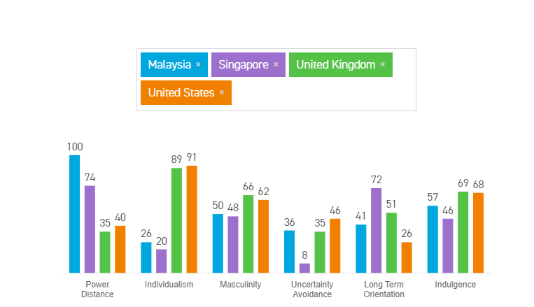
Figure 1: Cultural differences between UK, US, Malaysia and Singapore
(Source: Hofstede-insights.com, 2020)
Power Distance
Power distance is considered as extent to which people having less power accept and expect the division of power unequally. Among the ten countries, Malaysia has the highest score of power distance as their people accept inequality of powers without any question. Singapore, UAE and Turkey also have a high score of power distance (Amin et al. 2017). On the other hand, Sweden has the lowest score of this dimension. Thus, the people of the country do not believe in inequality. UK, US, Italy, Spain and Switzerland have less core of power distance.
Individualism
It is defined as the degree of interdependence. US, UK, Italy, Sweden and Switzerland are considered as individualist society. People of these countries take care of themselves and their immediate family members rather than thinking about the whole society (Helgadóttir and Dashper, 2016). On the other hand, people of Turkey, UAE, Malaysia and Singapore maintain proper relationship with each other at the time of living in a society.
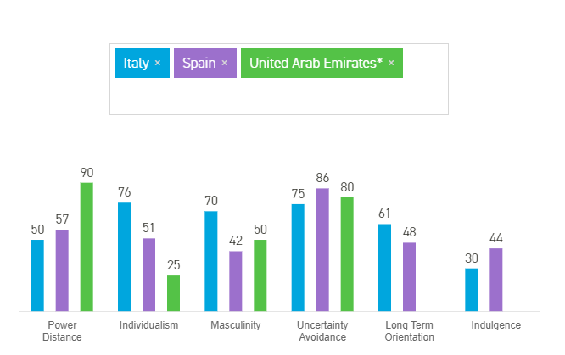
Figure 2: Cultural differences between Italy, Spain and UAE
(Source: Hofstede-insights.com, 2020)
Masculinity
It measures the values of people of a society. A country having a high value of this dimension believe that success and achievement are more important factors for providing value to a person. On the other hand, a low value indicates that people value each other based on the quality of life and care for each other. Italy, Switzerland, UK and US have a high score of this dimension, thus their people in achievement and success (Ishizaka et al. 2019). On the other hand, Sweden has a very low score of masculinity as people of the country believe in quality rather than achievement and success.
Uncertainty Avoidance
People of the country having a high value of Uncertainty avoidance believe that various rules and regulations are required to manage the lifestyle. Countries such as UAE, Italy, Spain and Turkey have many rules in the society to maintain. On the other hand, Malaysia, Singapore, US, UK and Sweden have fewer rules and regulations that are necessary to manage the life of people. Value of life is more important in these countries rather than rules and regulations.
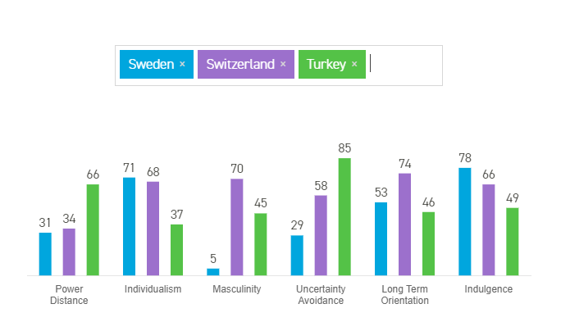
Figure 3: Cultural differences between Sweden, Turkey and Switzerland
(Source: Hofstede-insights.com, 2020)
Long term orientation
Singapore, Italy and Switzerland have a high score of this dimension. This indicates that these countries focus on future benefits more than traditional values and norms. On the other hand, Malaysia, US and Turkey have less score on this dimension (Tung, Chen and Schuckert, 2017). People of these countries focus on their values and norms more than their future career.
Indulgence
People of the countries having a high value of indulgence poses a positive attitude and optimistic behaviours of people. Sweden, Switzerland, US and UK have a high score on the dimension. Thus, it can be said that people of these countries are optimistic and have a positive attitude (Walter, Regmi and Khanal, 2018). On the other hand, people of Italy, Spain and Turkey compromise with their desire and possess pessimistic behaviour.

Customs and behaviour differences
List of countries | Customs | Behaviours
United Kingdom | People of UK believe in Naming convention, meeting and greeting to people every time and managing appropriate communication style. | Relationship is necessary for the people of UK and they use to give gift to each other in order to respect the meeting (Khalifa and Ali, 2017).
United States of America | People of US provides equal respect to male and female as there is no gender discrimination. They believe in socialization to improve their relationship with each other. | The focus on appropriate dress code, knowledge and understanding of people.
Singapore | As stated by Jiang, Ramkissoon and Mavondo (2016), people of Singapore believe in traditional culture and get appropriate satisfaction from an organisation if they get their cultural touch. | People of the country focusing on their benefits and comfortability at the time of taking any products or services.
United Arab Emirates | People of the country use to celebrate any festival in a social gathering. | They like any products or services if the employees have appropriate Cognitive and Intellectual Skills.
Malaysia | They want to be treated like a celebrity to get appropriate satisfaction from service. | People of Malaysia feel happy and worthy if they get high respect from others.
Spain | Customs of people of Spain is to celebrate any great day with a good drink. | They love to eat seafood and they can be easily satisfied by providing tasty and health seafood (Torres, Milman and Park, 2018).
Sweden | They maintain proper dress code in professional place and fantastically enjoy Christmas. | People of Sweden use to celebrate every big and small opportunity in a proper way to make them feel happy.
Italy | Italian likes a hotel if they can feel that they are at home. Their culture is more necessary for them. | Italian like less alcohol and may avoid as well.
Switzerland | Social interactions are more important for people of Switzerland rather living individually (Cetin and Okumus, 2018). | They like high privacy during their celebration.
Turkey | People of Turkey maintain traditional customs such as keeping shoes out of the room and covering themselves in a mosque. | They like tea to start a day with. Their heart can be easily won by providing them tea as per their culture.
Table 1: Customs and behaviour differences in ten countries

Do’s and Don’ts for hotel staff
For United Kingdom
Do’s | Don’ts
- Staff of Premier Inn needs to call the guests of UK by their name. | - Phone cannot be used at the time of dealing with guests.
- They need to focus on building a relationship with them by giving a gift during check out. | - Arguing with customers need to be avoided.
- Appropriate communication style needs to be maintained with UK guests. | - Personal conflicts among staff need to be avoided.
Table 2: Do’s and Don’ts of United Kingdom

For United States of America
Do’s | Don’ts
- Staff need to maintain a dress code. | - Staff are not allowed to interact a lot with guests.
- Staff need to ask the requirements of food properly before serving. | - Discrimination needs to be avoided by workers.
- Rooms need to clean in every 2 hours with permission. | - Personal issues of staff cannot be solved in the presence of guests.
Table 3: Do’s and Don’ts of United States of America
For Singapore
Do’s | Don’ts
- Rooms need to be decorated based on Singapore culture. | - Too much technical appliances cannot be present in the room.
- Staff need to build a personal relationship with the guest. | - Staff are not allowed to avoid if the bed of the rooms are not comfortable.
- They need to treat them like a celebrity and take care of every need (Okumus et al. 2019). | - Staff need to avoid talkative attitude.
Table 4: Do's and Don'ts from Singapore

For United Arab Emirates
Do’s | Don’ts
- Staff should use cognitive skills to help guests feel better. | - Food cannot be probed to guest without pre-taste.
- Happiness needs to maintained at the face all the time. | - Too much sweet dishes need to be avoided.
- Staff can ask guests if they require anything extra. | - Guests cannot be disturbed in the morning without making calls.
Table 5: Do’s and Don’ts of United Arab Emirates

For Malaysia
Do’s | Don’ts
- Food needs to prepared based on Malaysian culture. | - Discussion with guests needs to be avoided.
- Staff need to treat the guest with respect. | - Staff need to say sorry if guest faces any difficulties.
- Professional manner needs to be managed with guests (Boella, 2017). | - Staff should take permission before serving food to guests.
Table 6: Do's and Don'ts from Malaysia

For Spain
Do’s | Don’ts
- Seafood needs to be included in their breakfast. | - Food cannot be provided without a drink.
- Staff should ask gusts if they any special requirements regarding drink. | - Staff should not provide soft drink to guests.
- Cleanliness needs to be maintained properly. | - Only vegetarian food cannot be provided to guests.
Table 7: Do’s and Don’ts for visitors of Spain

For Sweden
Do’s | Don’ts
- Dress code of the staff should be managed and cleaned properly. | - Any requirements of guests cannot be avoided.
- During Christmas, special dress code should be managed for both guests and staff. | - Staffs are not allowed to delay the requirements of guests and perform their tasks.
- Communication needs to be managed properly with guests. | - Room cleanliness cannot be avoided by staff.
Table 8: Do’s and Don’ts of Sweden

For Italy
Do’s | Don’ts
- Staff need to ask guest if they need any drink. | - Alcohol should be avoided in their food.
- Guests should be provided facility as their home. | - Guests should not be disturbed again and again.
- Guests need to be asked for every meal. | - Cleanliness can be delayed if the guests do not allow.
Table 9: Do’s and Don’ts of Italy

For Switzerland
Do’s | Don’ts
- Staff need to taste food before serving to customers. | - Staff cannot enter into the guests’ room if they are out of the room.
- Staff need to provide privacy to customers. | - Staff cannot enter into the room without making a call.
- Staff need to take feedback to customers during checkout. | - Rooms cannot be cleaned if guests do not say to do it (Berezina et al. 2016).

Table 10: Do’s and Don’ts of Switzerland
For Turkey
Do’s | Don’ts
- They need to provide tea to guest of Turkey every morning. | - Staff should avoid offering soft and hard drinks to customers in the morning.
- Staff need to arrange for keeping the shoes out of the room. | - Staff should avoid entering the room with shoes.
- Rooms need to be decorated in traditional Turkish way. | - Staff should not leave empty glasses in the room.
Table 11: Do’s and Don’ts of Turkey

Conclusion
It can be concluded from the study that managing requirements of customers belonging to different cultures are necessary for Premier Inn hotel. Differentiating cultures, customs and behaviours of people can be advantageous for the hotel to improve the guest experience and increase its brand value. Hofstede cultural dimension can be beneficial for staff to different people as per their culture. Improving different skills of employees such as Engagement with literature skill, Knowledge and Understanding skill, Cognitive and Intellectual skill, practice skill and Transferable skill for life and professional practice can be beneficial in increasing customer satisfaction. Following the Do’s and Don’ts properly can be helpful for staff to meet different requirements of international visitors. Customs and behaviours of people belonging to different countries can also be helpful for hotel staff to identify their habits and meet their needs and desires properly.

References
Amin, M., Aldakhil, A.M., Wu, C., Rezaei, S. and Cobanoglu, C., 2017. The structural relationship between TQM, employee satisfaction and hotel performance. International Journal of Contemporary Hospitality Management.
Berezina, K., Bilgihan, A., Cobanoglu, C. and Okumus, F., 2016. Understanding satisfied and dissatisfied hotel customers: text mining of online hotel reviews. Journal of Hospitality Marketing & Management, 25(1), pp.1-24.
Boella, M.J., 2017. Human resource management in the hotel and catering industry. Taylor & Francis.
Cetin, G. and Okumus, F., 2018. Experiencing local Turkish hospitality in Istanbul, Turkey. International Journal of Culture, Tourism and Hospitality Research.
Helgadóttir, G. and Dashper, K., 2016. “Dear international guests and friends of the Icelandic horse”: Experience, meaning and belonging at a niche sporting event. Scandinavian Journal of Hospitality and Tourism, 16(4), pp.422-441.
Hofstede-insights.com (2020), Cultural differences, available at: https://www.hofstede-insights.com/product/compare-countries/ [Accessed on: 30th March 2020]
Ishizaka, A., Quintano, A., Labib, A. and Apostolakis, A., 2019. Do five-star hotel managers know their customers’ priorities? An AHP-Prioritised scorecard study. EuroMed Journal of Business.
Jiang, Y., Ramkissoon, H. and Mavondo, F., 2016. Destination marketing and visitor experiences: The development of a conceptual framework. Journal of Hospitality Marketing & Management, 25(6), pp.653-675.
Khalifa, G.S. and Ali, E.H.M., 2017. Managing drivers and boundaries of information technology risk management (ITRM) to increase Egyptian hotels market share. International Journal on Recent Trends in Business and Tourism, 1(1), pp.12-31.
Okumus, F., Altinay, L., Chathoth, P. and Koseoglu, M.A., 2019. Strategic management for hospitality and tourism. Routledge.
Premierinn.com (2020), Hotel, available at: https://www.premierinn.com/gb/en/why.html [Accessed on: 30th March 2020]
Torres, E.N., Milman, A. and Park, S., 2018. Delighted or outraged? Uncovering key drivers of exceedingly positive and negative theme park guest experiences. Journal of Hospitality and Tourism Insights.
Tung, V.W.S., Chen, P.J. and Schuckert, M., 2017. Managing customer citizenship behaviour: The moderating roles of employee responsiveness and organizational reassurance. Tourism Management, 59, pp.23-35.
Walter, P., Regmi, K.D. and Khanal, P.R., 2018. Tourism Management Perspectives. Tourism Management, 26, pp.49-58.

