Lyndsey Copp

Student number: 2118579

Module: Moving away from the traditional classroom- The silent digital revolution in education

ECIE6002

Blog (4 entries)

Blog 1 — Critically evaluating Wales’s Digital Competence Framework (DCF) and its contribution to learners’ digital literacy

Introduction.
Digital competence in Wales is defined as the skills, knowledge, and attitudes that enable the confident, creative, and critical use of technologies and systems—positioned alongside literacy and numeracy as a mandatory cross-curricular responsibility within the Curriculum for Wales. This reflects the policy ambition that learners apply digital skills across a wide range of subjects and real-life scenarios, not as an add-on, but as part of everyday learning and future employability. Estyn has similarly emphasised that full participation in modern society already demands high levels of digital competence, thereby strengthening the case for a system-wide focus on the progression of digital skills from the early years to Key Stage 4. The purpose of this blog is to evaluate the DCF critically, outline how its progression model works, and illustrate how it can foster authentic digital literacy within and beyond school. [hwb.gov.wales] [dera.ioe.ac.uk] [estyn.gov.wales]

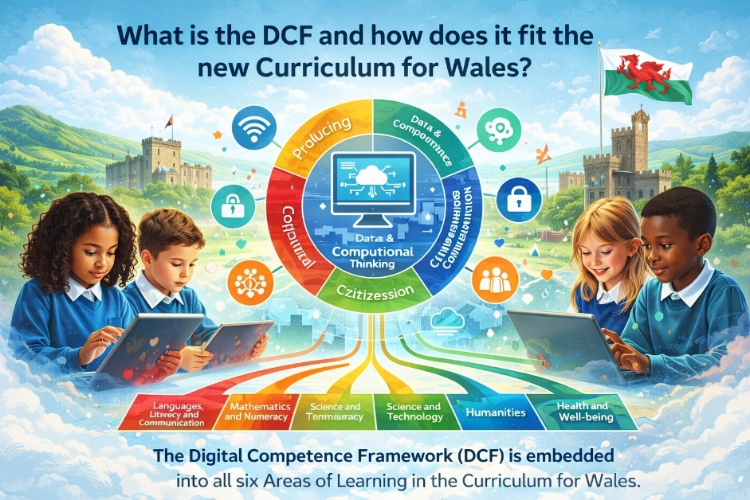
What is the DCF and how does it fit the new Curriculum for Wales?
The DCF was the first element of the reformed Curriculum for Wales to be made available and remains a key part of the updated cross-curricular skills frameworks on Hwb. Its architecture comprises four strands of equal importance—Citizenship, Interacting and Collaborating, Producing, and Data & Computational Thinking—each divided into five progression steps that align with the curriculum’s age-related expectations (approximately ages 5–16). In line with Donaldson’s Successful Futures, the framework aims to embed digital competence across all Areas of Learning and Experience (AoLEs) and to apply it in naturally occurring contexts, rather than inserting it artificially. The Welsh Government guidance is explicit that digital competence is not the same as ICT as a discrete subject; it is a transferable skillset that must be developed through authentic tasks and media across the curriculum. [hwb.gov.wales], [hwb.gov.wales] [hwb.gov.wales], [hwb.gov.wales] [dera.ioe.ac.uk]
The DCF materials have been updated to reflect the progression-based Curriculum for Wales model; schools use the non-statutory DCF guidance and spreadsheets on Hwb to plan, monitor and evidence progression in digital skills alongside literacy and numeracy. Estyn’s 2018 thematic report and subsequent commentary note that many schools are on a journey to realise the DCF, with leadership, professional learning and a clear whole-school strategy acting as key enablers. [hwb.gov.wales] [estyn.gov.wales], [estyn.gov.wales]

Strengths and challenges in the DCF: a critical view
Strengths.
- Comprehensive scope. The four-strand structure captures a broad, modern view of digital literacy—from online identity and safety (Citizenship) to collaboration and communication, content creation, and data/computational thinking—mapping well to authentic tasks across the curriculum and future workplace needs. [hwb.gov.wales], [dera.ioe.ac.uk]
- Progression clarity. The five progression steps describe increasing sophistication in knowledge, skills and dispositions. This provides teachers with a shared language for planning developmental sequencing and assessing impact over time. [hwb.gov.wales]
- Curricular coherence. By design, digital competence sits alongside literacy and numeracy as a cross-curricular skill, ensuring visibility across subjects and signalling its status in Curriculum for Wales implementation guidance. [hwb.gov.wales]
- Ethical, safe use foregrounded. The Citizenship strand embeds online safety, health and wellbeing, digital rights, licensing and ownership, and online behaviour, which is responsive to safeguarding imperatives and learners’ wellbeing in a pervasive digital world. [ysgolhenfelin.org.uk]
Challenges.
- Variability of implementation. Estyn’s reviews suggest inconsistent enactment across schools, often linked to variance in digital leadership capacity, staff confidence and the availability of high-quality professional learning. [estyn.gov.wales], [estyn.gov.wales]
- Equity and access. The DCF presumes access to devices, connectivity and software; however, local context (e.g., funding, infrastructure, home access) influences the breadth and depth of opportunities to apply the framework equitably—particularly salient during and since periods of remote learning. [hwb.gov.wales], [d6vsczyu1r...dfront.net]
- Assessment and workload. While the DCF provides progression statements, translating these into meaningful, manageable assessment practices (rather than tick-box exercises) can be challenging, especially when teachers must integrate them across subject planning and maintain authenticity. [hwb.gov.wales]
- Keeping pace with change. Guidance documents (2016/2018) inevitably lag behind emerging technologies (e.g., AI-enabled tools). Schools need iterative, locally-owned updates and professional learning to sustain relevance. [hwb.gov.wales]
Overall, the DCF’s conceptual model is robust and well aligned with the Curriculum for Wales; the core challenge is realisation at the classroom and whole-school levels, not the framework’s intent. [hwb.gov.wales], [estyn.gov.wales]

Example in focus: Citizenship → Identity, Image & Reputation (progression and practice)
Focusing on the Citizenship strand’s Identity, Image & Reputation element illustrates how the DCF sequences learning from early recognition of personal information to advanced management of online identity and privacy. The Hwb progression statements show a coherent journey: at Progression Step 1, learners distinguish between someone they know and someone they haven’t met and start recognising their information online; by Step 3, they understand digital footprints and the implications of sharing; by Step 5, they curate a positive online reputation (e.g., for employability) and can critically discuss ethical and legal considerations around data and encryption. [hwb.gov.wales]
Practical classroom applications can be wide-ranging and cross-curricular:
- Foundation Phase / Progression Steps 1–2 (Health & Well-being; Language, Literacy and Communication): Children create pseudonymous avatars and practise sharing vs. not sharing personal information through storybooks and role-play, reinforcing rules for staying safe online while building early oracy and comprehension. [dera.ioe.ac.uk], [sites.google.com]
- Upper KS2 / Progression Step 3 (Humanities; LLC): Learners conduct a digital footprint audit, comparing how search results, image metadata and privacy settings affect online presence; they compose balanced arguments on the benefits and risks of location services, citing evidence. [hwb.gov.wales]
- KS3/4 / Progression Steps 4–5 (Science & Technology; Careers & Work-Related Experiences): Pupils analyse case studies of online reputation in recruitment, evaluate platform terms & conditions, and design personal e-portfolios that evidence achievements responsibly (copyright, licensing, attribution). [hwb.gov.wales], [dera.ioe.ac.uk]
These activities integrate critical evaluation, communication, and ethical decision-making, aligning to Curriculum for Wales’s Four Purposes while cultivating transferable digital literacies. [hwb.gov.wales]

Linking school policy and “real-life” digital citizenship
At school level, effective DCF enactment typically rests on a whole-school strategy: a clear vision, a named digital leader, structured professional learning, and planned opportunities for learners to apply skills in authentic contexts (e.g., project-based learning, pupil leadership roles). Estyn highlights these as common features in schools where DCF implementation is improving pupils’ digital skills and confidence. In practice, schools often formalise this through policies for digital learning and online safety and through distance/online learning protocols that codify progression expectations, safeguarding, and equitable access—an approach localised by schools like Brynmill Primary during periods of remote learning. [estyn.gov.wales] [d6vsczyu1r...dfront.net]
The real-life payoff is tangible. The DCF’s Citizenship strand equips learners to navigate social media responsibly, manage privacy and consent, and understand intellectual property—competencies increasingly scrutinised by employers and essential for safe participation in communities. The Interacting & Collaborating and Producing strands underpin cross-subject workflows: for example, planning and co-authoring reports in science, producing multimodal explanations in humanities, or designing digital artefacts for enterprise projects. Meanwhile, Data & Computational Thinking develops problem-solving, modelling, and information literacy, helping learners interrogate datasets in geography, evaluate bias in information sources in English, or automate repetitive processes in technological contexts. [ysgolhenfelin.org.uk], [dera.ioe.ac.uk] [hwb.gov.wales] [infolit.org.uk]
The Hwb cross-curricular skills guidance explicitly encourages schools to design local curricula where literacy, numeracy and digital competence are developed and evidenced in integrated ways, with the DCF available as supporting guidance and planning tools (e.g., spreadsheets, progression summaries) to track growth across steps. [hwb.gov.wales]

Applying the DCF beyond school
A critical merit of the DCF is that it frames digital literacy as a lifelong competence. The framework emphasises transferability: learners should be able to select appropriate tools, collaborate safely, evaluate sources, and create and share content ethically in community, further study, and employment. Estyn’s analysis notes that where DCF is embedded well, pupils speak confidently about their digital work and apply a range of tools with increasing independence—behaviours that mirror demands of further learning and the workplace. [dera.ioe.ac.uk] [estyn.gov.wales]
Nonetheless, capitalising on this potential requires addressing implementation gaps—particularly staff confidence with newer technologies (e.g., AI-enabled tools for research, media creation and data analysis) and ensuring equitable access so that progression steps translate into opportunities for all learners, irrespective of socio-economic background. [hwb.gov.wales], [estyn.gov.wales]

Conclusion
The Digital Competence Framework (DCF) provides Wales with a coherent, future-focused model of digital literacy embedded across the Curriculum for Wales. Its four strands and progression steps provide a clear developmental pathway from early recognition of online identity to the critical management of reputation and to the creation, collaboration, and reasoning with data. The evidence suggests the framework’s design is sound; the challenge is enactment—sustained leadership, targeted professional learning, and equitable resourcing to ensure that every learner progresses. With deliberate, whole-school approaches, the DCF can demonstrably support learners in becoming ethical, informed, and ambitious digital citizens who can apply their skills across subjects and into life beyond school. [hwb.gov.wales], [hwb.gov.wales] [estyn.gov.wales], [estyn.gov.wales] [hwb.gov.wales]

References
- Estyn (2018). Preparing for the Digital Competence Framework (DCF). [estyn.gov.wales]
- Estyn (2019). Digital competence: Improving pupils’ digital skills (blog commentary). [estyn.gov.wales]
- Hwb / Welsh Government (2016). Digital Competence Framework guidance (original guidance). [dera.ioe.ac.uk]
- Hwb / Welsh Government (2018). Digital Competence Framework guidance – Update (June 2018). [hwb.gov.wales]
- Hwb (n.d.). Cross-curricular skills frameworks (access to DCF and LNF, progression spreadsheets). [hwb.gov.wales]
- Hwb (n.d.). Digital Competence Framework (DCF) (strand overview page). [hwb.gov.wales]
- Hwb (n.d.). Citizenship: Identity, image and reputation – progression statements (PDF). [hwb.gov.wales]
- Information Literacy Group (n.d.). Information Literacy and the DCF (data & information literacy within DCF). [infolit.org.uk]
- Brynmill Primary School (2020). Distance Learning Policy – the Brynmill Way (example of localising digital policy and progression). [d6vsczyu1r...dfront.net]

Blog2. Children & young people in a digital world: seeing the whole picture (through a Welsh lens)
“It’s not about counting minutes; it’s about the quality of digital interactions and what they displace—sleep, movement, social time.” (RCPCH; AAP)
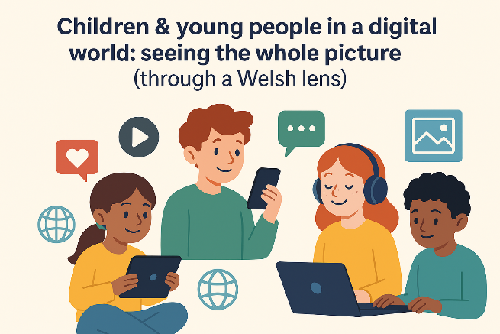
We all know the digital world is where our learners live as much as where they learn. Short-form videos, messages in group chats, and creative posts are woven into daily life. In the UK, almost all 8–17-year-olds go online regularly, creating and sharing their own content—both opportunities and risks (Ofcom, 2024). (Ofcom 2024 report) (Think-Bank summary)

A friendly theory to make sense of it all: Bronfenbrenner’s bioecological model
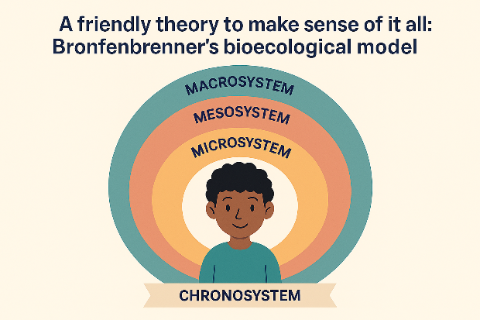
Here’s the helpful bit: Bronfenbrenner explains child development as dynamic interactions between the child and layers of their environment—microsystem (home, class, online communities), mesosystem (home–school–platform links), exosystem (regulators and platform policies), macrosystem (culture and national policy), and chronosystem (time and life transitions). Recent research even recognises virtual microsystems (social media, gaming platforms) as real developmental settings. (SimplyPsychology overview) (Frontiers review)
Why it matters for classrooms in Wales: the quality of proximal processes—the repeated, meaningful interactions learners have in those online spaces—drives growth. So, our job isn’t only to restrict but also to shape those processes through scaffolded, creative, and safe activities.

The upside: learning, creativity, voice
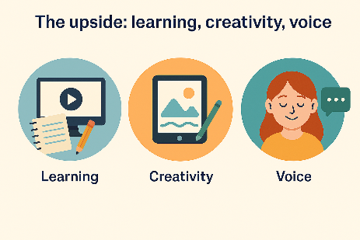
- Learning gains when tech is purposeful. Meta-analysis shows that digital technology can enhance deep learning—especially in blended approaches (offline planning, online production, and structured feedback) —with explicit guidance and collaboration. (Wu, 2023/24) (Hattie, 2023)
- Agency as producers. A substantial share of young people publishes videos or podcasts, building multimodal composition, audience awareness, and (if taught) copyright literacy. (Ofcom 2024) (National College guide)
“Design the digital tasks you actually want learners to repeat—create–review–publish cycles with peer feedback.” (Bioecological proximal processes)

The downside: risk, wellbeing and a lot of headlines
- Harm exposure, mis/disinformation, commerce. Most children will encounter some online risks (bullying, scams, harmful content). KCSIE 2025 explicitly adds misinformation/disinformation to online-safety risk categories—worth tracking even from Wales. (Ofcom 2024) (KCSIE 2025)
- Screen time—nuance beats panic. UK paediatric guidance avoids a universal “safe hour count”, emphasising quality and displacement (sleep, movement, social time), with common-sense routines such as “screens off an hour before bed.” Recent US data link ≥4 hours of non-school daily screen time with poorer sleep and more anxiety/depressive symptoms—proper caution, but context is everything. (RCPCH factsheet & guide) (CDC/NCHS data briefs, 2024–25) (AAP updated guidance, 2025)
- Mental health and social media—mixed evidence. Extensive international analyses from the Oxford Internet Institute find small, inconsistent population-level associations between internet use and psychological harm; researchers still call for better platform data to study mechanisms. (Oxford Internet Institute 2023) (TechCrunch analysis)
Takeaway: apply the bioecological lens—what matters is the fit across home routines, school safeguards, platform design, and developmental timing.

The policy layer: how the macro/exo systems support safety and literacy
- Curriculum for Wales – Digital Competence Framework (DCF). Digital competence is a mandatory cross-curricular responsibility (citizenship, online behaviour/cyberbullying, identity, health & wellbeing). It’s a whole-school endeavour, not an ICT add-on. (Hwb DCF) (DCF guidance)
- UKCIS Education for a Connected World (2020). Eight practical strands (Self-image & Identity, Online relationships, Reputation, Bullying, Managing information, Health & lifestyle, Privacy & security, Copyright & ownership) for progression EY–KS4. (UKCIS framework)
- Online Safety Act 2023 (UK). The strongest protections are for children; platforms must assess risk, enforce age verification, address illegal content, and mitigate harm. Ofcom’s children’s codes (published April 2025) set timelines and measures. (OSA explainer) (Ofcom decisions summary, 2025)

Classroom-ready moves (linked to DCF & UKCIS)
- Reputation & identity (Upper KS2/KS3).
Learners audit their digital footprint, storyboard how a post travels, and co-author a class charter on identity/reputation. (UKCIS: Self-image & identity; Online reputation. DCF: Citizenship.) (UKCIS framework) (Hwb DCF)
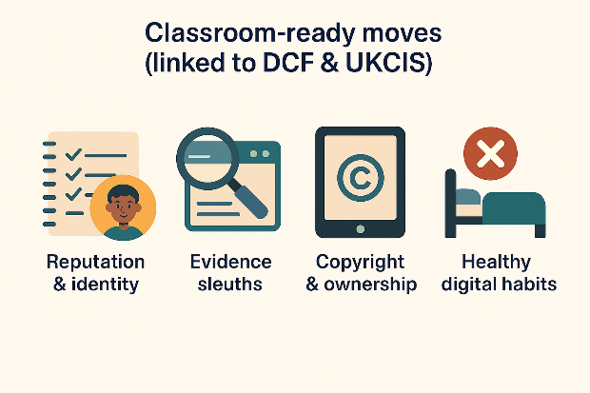
- Evidence sleuths: mis/disinformation (KS3/KS4).
Teach lateral reading, source triangulation, and bias prompts; compare a viral clip with primary data. (UKCIS: Managing online information; KCSIE 2025 risk categories.) (UKCIS) (KCSIE 2025)
- Copyright & ownership through creation (KS2).
Publish a short podcast with Creative Commons music and proper attributions; assess with a rubric including IP/permissions. (UKCIS: Copyright & ownership; DCF: Producing.) (UKCIS) (Hwb DCF)
- Healthy digital habits (FP/KS2).
Co-design class routines: device-free meals, screens off before sleep, movement breaks; explain why—protect sleep, balance sedentary time. (RCPCH/AAP guidance.) (RCPCH guide) (AAP 2025)
- Blended creation cycles (all phases).
Plan, create, review, and publish cycles (offline planning, online production, and peer critique). Evidence suggests stronger deep learning when tech is guided, collaborative, and blended. (Wu, 2023/24) (Hattie, 2023)

What this means for Brynmill Primary (practical, Wales-specific)
1) Make DCF visible in every area.
Map ongoing projects (e.g., inquiry in humanities, science investigations) to DCF Citizenship and Interacting & Collaborating so digital literacy isn’t siloed. (Hwb DCF)
2) Strengthen the home–school “mesosystem”.
Offer parent workshops that share RCPCH’s simple checklist (sleep, movement, mealtimes, co-viewing) and explain the Online Safety Act in plain language—what platforms must do, and how families can use age-assurance and reporting. (RCPCH) (OSA explainer)
3) Embed total communication online.
Extend your in-school total communication approaches into the virtual microsystem—use captions, visuals, symbols and co-regulated routines (“post, pause, check”) in Seesaw/Teams to support learners with ALN to participate safely and meaningfully. (Aligns with DCF Interacting & Collaborating.) (Hwb DCF)
4) Evidence impact, not just compliance.
Collect pupil voice, work samples, and wellbeing notes to show how digital tasks build reasoning, collaboration and safe habits—then iterate. Link lesson studies to the blended cycles that research says work best. (Wu, 2023/24) (Hattie, 2023)

Final thought
The digital world isn’t going away—and neither should our learners’ curiosity and creativity. With a bioecological mindset, Wales’ DCF as our curriculum anchor, UKCIS to shape progression, and the Online Safety Act setting clearer guardrails, we can design the right digital interactions—the ones worth repeating. That’s how we turn online spaces into genuine learning microsystems.

References (selected)
- Ofcom (2024). Children and parents: media use and attitudes report 2024.
<https://www.ofcom.org.uk/media-use-and-attitudes/media-habits-children/children-and-parents-media-use-and-attitudes-report-2024>
- UKCIS (2020). Education for a Connected World.
<https://www.gov.uk/government/publications/education-for-a-connected-world>
- Welsh Government (Hwb). Digital Competence Framework (DCF).
<https://hwb.gov.wales/curriculum-for-wales/cross-curricular-skills-frameworks/digital-competence-framework-dcf/>
- DSIT (2025). Online Safety Act: explainer.
<https://www.gov.uk/government/publications/online-safety-act-explainer/online-safety-act-explainer>
- DfE (2025). Keeping Children Safe in Education 2025.
<https://www.gov.uk/government/publications/keeping-children-safe-in-education--2>
- RCPCH (2019). Screen time guide.
<https://www.solgrid.org.uk/wellbeing/wp-content/uploads/sites/23/2019/01/rcpch_screen_time_guide_-_final.pdf>
- AAP (updated 2025). Screen Time Guidelines.
<https://www.aap.org/en/patient-care/media-and-children/center-of-excellence-on-social-media-and-youth-mental-health/qa-portal/qa-portal-library/qa-portal-library-questions/screen-time-guidelines/>
- Oxford Internet Institute (2023). No “smoking gun” mental health harm.
<https://www.ox.ac.uk/news/2023-11-28-no-smoking-gun-mental-health-harm-internet-landmark-oxford-survey>
- Wu, X-Y. (2023/24). Digital tech & deep learning meta-analysis.
<https://link.springer.com/article/10.1007/s10639-023-12307-1>
- Hattie, J. (2023). Visible Learning: The Sequel.
<https://www.taylorfrancis.com/books/mono/10.4324/9781003380542/visible-learning-sequel-john-hattie>

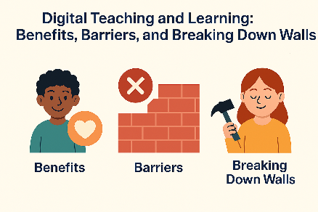
Blog 3. Digital Teaching and Learning: Benefits, Barriers, and Breaking Down Walls
“Digital learning isn’t just about devices—it’s about access, agency, and equity.”

My Role and Context
As a member of staff at Brynmill Primary School, my role involves supporting learners across multiple classrooms and year groups, including those with Additional Learning Needs (ALN). This means adapting teaching strategies to meet diverse communication, cognitive, and social needs. I work closely with class teachers, specialist staff, and families to ensure that every child can access learning in a way that suits them best.
My experience spans face-to-face teaching, blended learning, and fully digital environments. During the pandemic, digital platforms became lifelines for continuity of learning. Tools such as Hwb, Seesaw, and Microsoft Teams allowed us to maintain engagement, share resources, and provide feedback even when physical classrooms were closed. These platforms remain central to our practice today, supporting homework, parental communication, and collaborative projects.
Digital tools are now embedded in everyday teaching. For example:
- Online portfolios on Seesaw enable formative assessment and instant feedback.
- Interactive apps for phonics and numeracy make practice engaging and adaptive.
- Video conferencing supports parental engagement and multi-agency meetings without logistical barriers.
This integration has transformed teaching and learning, offering flexibility and creativity. Learners can showcase their work through multimedia formats—videos, voice recordings, and digital art—giving them a stronger sense of ownership and voice.
However, these advances also raise important questions about equity and well-being. Not all learners have equal access to devices or reliable internet at home, and some families struggle with digital confidence. There are also concerns about screen time, online safety, and the social pressures linked to digital spaces. These challenges remind us that while technology can enhance learning, it must be implemented thoughtfully, with support systems and safeguards in place.

The Benefits of Digital Teaching and Learning
1. Personalisation and Accessibility
Digital platforms allow us to tailor learning experiences to individual needs. For learners who benefit from a total communication approach, digital tools provide multimodal options—symbols, captions, voice notes, and interactive visuals. This aligns with Universal Design for Learning (UDL) principles, which advocate multiple means of representation and engagement.
Impact:
- Learners with ALN can access content in ways that suit their communication style.
- Teachers can differentiate tasks quickly, reducing barriers to participation.
Theory Link:
Vygotsky’s Zone of Proximal Development (ZPD) underscores the importance of scaffolding. Digital tools extend that scaffold—think guided reading apps or collaborative documents where peers and teachers provide real-time feedback.

2. Engagement and Motivation
Interactive platforms like Kahoot, Flip, and J2E on Hwb make learning playful and social. Gamification leverages intrinsic motivation, while multimedia tasks (videos, podcasts) enable learners to create, not just consume.
Impact:
- Increased learner voice and agency.
- Opportunities for creativity and collaboration beyond the classroom walls.
Evidence:
Meta-analyses (Hattie, 2023; Wu, 2024) show that blended learning—combining digital and face-to-face—has a positive effect on deep learning when paired with clear pedagogy and collaboration.

3. Flexibility for Staff and Families
Digital platforms enable asynchronous learning, supporting families with varied schedules. For staff, tools like Teams streamline communication and resource sharing, reducing duplication and enabling co-planning.
Impact:
- Better home–school partnerships.
- Professional learning communities thrive online, supporting teacher CPD.

The Barriers to Digital Inclusion—and How to Overcome Them
Despite the benefits, digital inclusion remains uneven. Barriers fall into three main categories:

1. Access to Devices and Connectivity
Not every family has reliable broadband or multiple devices. During lockdown, some learners relied on smartphones for all tasks—a challenge for extended writing or creative projects.
Impact:
- Learner’s risk of falling behind academically.
- Increased stress for families juggling limited resources.
Solutions:
- School-level: Device loan schemes, Wi-Fi dongles, and prioritising offline alternatives when needed.
- Policy-level: Welsh Government’s Digital Strategy for Wales and Hwb’s device provision initiatives aim to close the gap.
- Practice-level: Design tasks that can be completed offline and uploaded later; use low-bandwidth tools.

2. Digital Skills and Confidence
Access isn’t enough—learners, parents, and staff need digital literacy. Some families struggle to log in to platforms or navigate apps, leading to frustration and disengagement.
Impact:
- Learners miss deadlines or avoid tasks.
- Staff spend extra time troubleshooting instead of teaching.
Solutions:
- Training for all stakeholders: Parent workshops, learner “digital champions,” and staff CPD aligned to the Digital Competence Framework (DCF).
- Scaffolded tasks: Start simple, build complexity gradually, and provide visual guides.
Theory Link:
Bandura’s Social Learning Theory applies here: confidence develops through modelling and guided practice. Peer support and teacher modelling are key.

3. Attitudes and Wellbeing
Some parents worry about screen time or online safety. Learners may feel overwhelmed by notifications or pressured by social media norms.
Impact:
- Anxiety and resistance to digital tasks.
- Risk of unsafe online behaviour if guidance is lacking.
Solutions:
- Embed digital citizenship in the curriculum (UKCIS “Education for a Connected World” framework).
- Share RCPCH guidance on healthy screen habits—focus on balance, not arbitrary time limits.
- Promote co-viewing and family agreements around tech use.

Breaking Down Barriers: A Whole-System Approach
Bronfenbrenner’s bioecological model helps us see that digital inclusion isn’t just about the child—it’s about the systems around them:
- Microsystem: Classroom routines, teacher support.
- Mesosystem: Home–school communication and shared expectations.
- Exosystem: Local authority device schemes, platform policies.
- Macrosystem: National strategies like the Curriculum for Wales and the Online Safety Act 2023.
- Chronosystem: Rapid tech changes and life transitions (e.g., moving to secondary school).
When these layers align, barriers shrink.

What This Means for Practice
- Audit digital access and skills regularly—don’t assume.
- Plan blended tasks that work online and offline.
- Embed DCF strands (Citizenship, Producing, Interacting & Collaborating) across subjects.
- Invest in relationships—train parents, empower learners, and support staff confidence.
- Monitor wellbeing—balance screen time with movement and outdoor play.

Final Reflection
Digital learning isn’t a silver bullet—but when done well, it amplifies good pedagogy and opens doors for creativity, collaboration, and inclusion. The challenge is equity: making sure every learner has the tools, skills, and support to thrive. That means whole-school strategies, family engagement, and national policy pulling in the same direction.
“Digital inclusion is not just about hardware—it’s about human ware: confidence, competence, and connection.”

References
- Hattie, J. (2023). Visible Learning: The Sequel. Routledge.
- Wu, X-Y. (2024). Meta-analysis: Digital technology and deep learning. Education and Information Technologies.
- Welsh Government. (2022). Digital Competence Framework.
- UKCIS. (2020). Education for a Connected World.
- Ofcom. (2024). Children and parents: media use and attitudes report.
- RCPCH. (2019). Screen time guidance.
- Bandura, A. (1977). Social Learning Theory.
- Bronfenbrenner, U. (1979). The Ecology of Human Development.

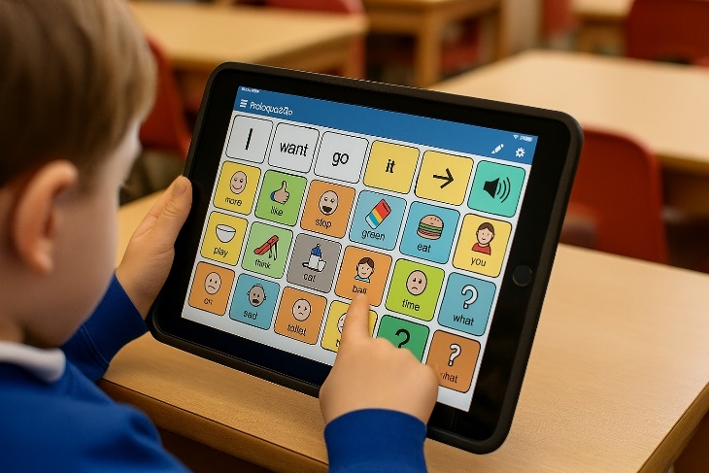
Blog 4: Reflecting on Proloquo2Go (AAC on iPad) in a Primary Classroom
Software/Hardware identified
Proloquo2Go is a high-tech Augmentative and Alternative Communication (AAC) app developed by AssistiveWare for iPad/iPhone. It’s designed to give a voice to learners who are non-speaking or minimally verbal, using symbol-based buttons and text-to-speech to support everyday communication from single requests to complete sentences. The app includes customizable grids (from 3x3 to 8x8), consistent core-word placement, multiple child/adult voices, and robust data management. Intended users range from young children to adults with autism, cerebral palsy, Down syndrome, apraxia, aphasia, or TBI.
AssistiveWare positions Proloquo2Go (and its newer sibling, Proloquo) as a widely used AAC solution; guidance on grid size and vocabulary organisation is based on internal research and design choices intended to support language development.
Historically, Proloquo2Go emerged as a portable AAC option and has been discussed in the professional AAC literature since 2009. [educationa...pstore.com] [assistiveware.com] [okabletech.org]

Learner needs (anonymised)
In our Rainbow Room at a mainstream primary, one learner (let’s call him “A”) presents with autism, limited functional speech, sensory sensitivities, and a strong interest in phones—an affinity we channel into motivation for communication. “A” benefits from a total communication approach (signs, symbols, pictures, objects) and Intensive Interaction to develop social communication and joint attention. For anonymity, I won’t include identifiable details; the focus is on the match between the tool and the profile (autism; minimally verbal; high interest in technology; needs predictable visual supports). Evidence from systematic reviews suggests AAC is effective to highly effective for teaching functional communication in minimally verbal autistic learners, with growing (though still variable) impacts on speech production. [tandfonline.com], [link.springer.com], [scholarworks.uvm.edu]

How Proloquo2Go meets “A”’s needs — with theoretical lenses
Vygotsky’s Zone of Proximal Development (ZPD) & Scaffolding.
Proloquo2Go provides a mediating tool—a cultural artefact that enables “A” to attempt communicative acts just beyond their current independent ability, while adults scaffold (modelling paths, prompting, fading). In ZPD terms, the app’s stable core-word layout and symbol speech output enable guided participation toward independent, generalised communication. [simplypsychology.org], [open.edu]
Skinner’s Operant Conditioning.
AAC relies on reinforcement: successful button presses produce audible speech and social responses (e.g., access to items, attention), increasing the likelihood that “A” repeats and expands communicative behaviours. Structured prompting with differential reinforcement (e.g., richer praise for spontaneous multi-word messages) aligns with operant principles used in classrooms and ABA sessions. [simplypsychology.org], [teachingchannel.com]
Maslow’s Hierarchy of Needs.
Reliable AAC contributes to safety and belonging (predictable, understandable communication reduces frustration and builds relationships), thereby freeing cognitive resources for higher-order learning. When “A” can express needs, preferences, and emotions, engagement increases—supporting self-esteem and progress toward self-actualisation within primary learning goals. [simplypsychology.org], [mcblogs.mo...ollege.edu]
UDL (Universal Design for Learning).
Proloquo2Go embodies UDL by offering multiple means of expression (symbol + speech), flexible access (touch, guided access, alternative access if needed), and personalisation of vocabulary to match interests (e.g., “telephone”). Designing activities around AAC aligns with UDL Guidelines and current CAST guidance to reduce barriers and increase learner agency. [pillars.taylor.edu], [cast.org]

Benefits, disadvantages, and evidence of impact
Benefits observed in practice
- Immediate functional communication. “A” can request, comment on, and participate in routines (snack, play, group time) using consistent core words, resulting in reduced dysregulation and more successful peer interactions. This mirrors findings that high-tech AAC can increase social communication and reduce problem behaviours. [neuroregulation.org]
- Language growth through modelling. Staff and peers model core phrases (“want more”, “go play”), building motor planning and vocabulary. Reviews report effective to highly effective outcomes for AAC on functional communication targets, beyond mere requesting. [tandfonline.com]
- Portability and motivation. An iPad-based system leverages “A”’s interest in devices; early AAC papers highlighted the value of portable solutions for ambulatory learners. [okabletech.org]
- Speech does not decrease. Systematic reviews suggest AAC does not hinder speech; when speech emerges, it often increases alongside AAC use. This counters a persistent myth and reassures families. [link.springer.com], [scholarworks.uvm.edu]
Potential disadvantages/risks
- Setup and consistency. Without informed configuration (e.g., too-small grids, frequent layout changes), language outcomes may suffer. AssistiveWare cautions that deviating from recommended grid sizes can reduce progress, a risk if well-meaning teams oversimplify. [assistiveware.com]
- Training demands. Effective AAC depends on adult modelling, prompt calibration, and ongoing coaching; insufficient support is associated with AAC abandonment. [educationa...pstore.com]
- Evidence variability. While many single-cases and some group studies show positive effects, reviews still call for more robust trials and broader outcome targets (e.g., commenting, social routines). [tandfonline.com], [scholarworks.uvm.edu]
Impact evidence in our setting (emerging indicators)
- Frequency of communicative acts (spontaneous requests/comments) increased across snack and play sessions; prompt levels decreased over the term. This pattern aligns with studies showing improved teaching/mending with Proloquo2Go during ABA therapy. [trace.tennessee.edu]
- Echolalia moments during circle time reduced when “A” used the device to participate with targeted phrases, echoing action-research showing reduced echolalic utterances with Proloquo2Go-mediated interaction. [files.eric.ed.gov]

Supporting 21st-century skills and policy alignment (Wales)
Curriculum for Wales – Four Purposes.
AAC-supported participation helps “A” become an ambitious, capable learner (communicating ideas; problem-solving with core words), an enterprising, creative contributor (expressing emotions/ideas), an ethical, informed citizen (voice in choices; respecting others’ needs), and a healthy, confident individual (managing feelings, building resilience). These map directly to the Four Purposes in the national guidance. [d6vsczyu1r... dfront.net], [hwb.gov.wales]
Digital Competence Framework (DCF).
Using an iPad-based AAC app develops digital competence (confident, creative, critical use of technology) as a cross-curricular skill, embedded meaningfully—not artificially—into daily learning. This is consistent with Welsh Government DCF guidance. [hwb.gov.wales], [csc-cronfa.cymru]
Statutory context.
The Curriculum and Assessment (Wales) Act 2021 underpins the framework we design around progression and inclusion; AAC is one practical route to equitable access for learners with ALN. [legislation.gov.uk]

Critical reflection & next steps
What worked well
- Anchoring vocabulary to core words and meaningful contexts (e.g., play themes) supported generalisation.
- Staff routines (always model, never test) increased spontaneous use.
Challenges
- Ensuring consistency across staff and settings (classroom vs. playground).
- Balancing prompting with autonomy—avoiding over-prompting that can reduce initiation.
Next steps
- Team training on grid consistency, aided language input, and data tracking—reducing layout changes and building shared modelling routines. (Addresses abandonment risk and leverages recommended settings.) [educationa...pstore.com], [assistiveware.com]
- Broaden communicative functions (commenting, greeting, asking for information) beyond requesting, responding to calls in the literature. [apps.asha.org]
- Compare with low-tech options (PECS/core boards) for specific contexts; research suggests both PECS and speech-generating devices can increase early communication, with some learners preferring high-tech and showing faster acquisition for specific skills. [researchgate.net], [scholarwor...lstate.edu]

References
- AssistiveWare. Comparing Proloquo and Proloquo2Go – which one is right for you? (Sept 24, 2024). https://www.assistiveware.com/blog/proloquo-or-proloquo2go
- Educational App Store. Proloquo2Go Review (Updated June 3, 2024). https://www.educationalappstore.com/app/proloquo2go
- Sennott, S., & Bowker, A. Autism, AAC, and Proloquo2Go. ASHA Perspectives on AAC (2009). https://www.okabletech.org/wp-content/uploads/2019/04/SennottBowker2009ASHAPerspectivesonAAC.pdf
- Krcek, T. E. Effectiveness of Proloquo2Go in Enhancing Communication in Children with Autism During ABA Therapy. PhD diss., Univ. of Tennessee (2015). https://trace.tennessee.edu/utk_graddiss/3345/
- Alrusayni, N. Effectiveness of Proloquo2Go in Reducing Echolalia (Action Research Proposal, 2017). https://files.eric.ed.gov/fulltext/ED577783.pdf
- ASHA Evidence Maps. Systematic Review of Aided AAC for Social-Communication in ASD. AAC 33(1), 51–64. https://apps.asha.org/EvidenceMaps/Articles/ArticleSummary/bf2476fb-ac36-4c4d-8ddc-ac17942af676
- Iacono, T., Trembath, D., & Erickson, S. Role of AAC for Children with Autism: Current Status and Future Trends. Neuropsychiatric Disease and Treatment (2016). https://www.tandfonline.com/doi/pdf/10.2147/NDT.S95967
- White, E. N., et al. AAC and Speech Production for Individuals with ASD: A Systematic Review. Journal of Autism and Developmental Disorders (2021). https://link.springer.com/article/10.1007/s10803-021-04868-2
- Patch, A. F. G., et al. AAC and Oral Language in ASD: Systematic Review. (2018). https://scholarworks.uvm.edu/items/143bf319-cc31-496b-b907-c456bdb7c9e2
- Chhavi Arora Sehgal, C., et al. Clinical Effectiveness of AAC in Minimally Verbal Children with ASD: Systematic Review. NeuroRegulation (2023). https://www.neuroregulation.org/article/view/23389
- Simply Psychology. Zone of Proximal Development (Updated Oct 16, 2025). https://www.simplypsychology.org/zone-of-proximal-development.html
- OpenLearn Create. Vygotskian principles on ZPD & scaffolding. https://www.open.edu/openlearncreate/.../Vygotskian_principles_on_the_ZPD_and_scaffolding.pdf
- Simply Psychology. Operant Conditioning (Mar 17, 2025). https://www.simplypsychology.org/wp-content/uploads/simplypsychology.org-Operant-Conditioning.pdf
- Teaching Channel. Skinner’s Reinforcement Theory in the Classroom (Jan 4, 2021). https://www.teachingchannel.com/k12-hub/blog/reinforcement-theory-classroom/
- Simply Psychology. Maslow’s Hierarchy of Needs (Mar 14, 2025). https://www.simplypsychology.org/wp-content/uploads/simplypsychology.org-Maslows-Hierarchy-of-Needs.pdf
- CAST. UDL Guidelines v2.2 (Graphic Organizer) (2018/2019). https://pillars.taylor.edu/ett-conference/1/
- CAST. Universal Design for Learning: Principles, Framework, and Practice (2024). https://www.cast.org/books-media/udl-principles-framework-practice/
- Welsh Government (Hwb). Curriculum for Wales (updates Jan 31, 2025). https://hwb.gov.wales/curriculum-for-wales
- Curriculum for Wales Four Purposes (overview). https://d6vsczyu1rky0.cloudfront.net/.../The-Curriculum-for-Wales-website-2020.pdf
- Welsh Government. Digital Competence Framework Guidance (2016/2018). 2018 PDF: https://hwb.gov.wales/api/storage/337437b8-cfe3-4305-ae32-f47ad82f3e76/digital-competence-framework-guidance-2018.pdf; 2016 PDF: https://www.csc-cronfa.cymru/api/storage/db63ef38-909c-44f5-bb2f-6555e3a539da/160831-dcf-guidance-en-v2.pdf
- Curriculum and Assessment (Wales) Act 2021. https://www.legislation.gov.uk/asc/2021/4/section/2
- Simeoli, R., et al. PECS vs SGD (2024). https://www.researchgate.net/.../A-comparison-of-PECS-and-SGD-in-ASD.pdf
- Vazquez, G. Comparing low-tech vs high-tech AAC in preschool (MA Thesis, 2022). https://scholarworks.calstate.edu/downloads/g158bs778

