Management and Organizational Behaviour
M5X01924

Student: Diana Mineva
1818542
Lecturer: Dr. Janet Green

Table of Contents
Introduction 4
1. Coherently and critically analyse the relationship between structure, culture, people and organisational performance 4
2. Critically understand the essential nature of managerial work (in terms of both functions and processes) communicate the role of leadership and furthermore, explain the variables that determine effective management and leadership 8
3. Critically evaluate the behavioural approach to management, through understanding of the factors that affect differences in individual behaviour 10
Conclusion 11
References 11

Introduction
By tracking the way in which management team fulfils different responsibilities, growth and success of an organization can be determined. Irrespective of structure, size and number of employees working under a specific organization, management team fulfils all the necessary duties like planning, organizing, taking decisions, directing other employees, etc. Apart from management team, other aspects like structure, culture, employees’ performance also help in meeting organizational objectives.
This particular report will evidently identify and highlight the relationship between an organization’s structure, people, and culture with overall performance. Variables of effective management and leadership required for an organization will be demonstrated in the next part. Behavioural approach to management will help in understanding the impact of individual behaviour on organizational performance.

1. Coherently and critically analyse the relationship between structure, culture, people and organisational performance
Structure is one of the most crucial parts for a business organization. It is important to understand the structural aspect of an organization as it forms as a sub-part under the management system. To be precise, organizational structure helps in determining responsibilities and roles to employees in a well-defined way. The whole mechanism of working within an organization is determined in a way a structure is maintained. Structure can be mainly divided into two important dimensions, horizontal and vertical. Under the horizontal structure, one supervisor/manager controls all other employees of an organization ( Jogaratnam , 2017). Vertical dimension consists of different authorial members with some individuals under supervisory position. Some other types of structure include functional, divisional and matrix. In case of functional structure, department wise responsibilities are given to employees. (Figure 1)
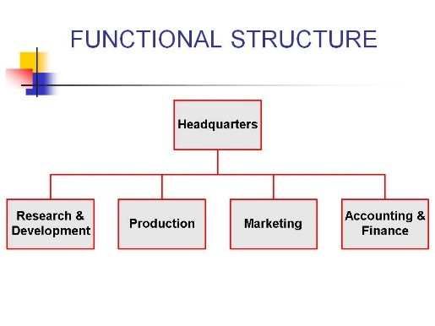
Figure 1: Functional Structure of organization
(Source: Hattangadi, 2020)
Most organizations in UK follow this structure by creating a holistic workspace. Organizational culture is maintained by allowing employees to work in such collaborative way. Norms and values are shared between employees are shared by working as per functional divisions. Irrespective of religion, ethnicity, caste, colour or gender, workers are provided training and they are encouraged to fulfil all required duties without creating any communication gap. By learning the importance of valuing each other’s’ culture, people/ employees help their peers in times of requirement. This kind of environment helps in improving organizational performance and also raises profit of the company. Functional structure also boosts employees’ confidence as responsibilities are divided equally. In a collective way, all duties are fulfilled by people and as such overall performance of an organization improves (Pedersen et al,.2018).
Divisional structure is maintained by those companies that segregate employees’ duties as per departmental requirements. People having similar skills are grouped in particular teams. (Figure 2)
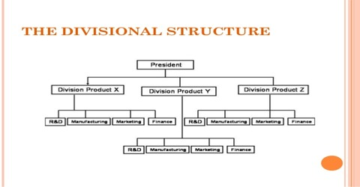
Figure 2: Divisional Structure of Organization
(Source: QS Study. 2020)
This structure has created several barriers in employee communication and people face issues while discussing about any important matter. People working under divisional structure often tend to discriminate other workers and this hampers organizational culture. Some stringent managerial system in organization allows maintaining a common culture and organized form of workplace environment is established. However, this organizational structure rarely allows people to work in a collaborative form and work division maximises discriminatory related issues. This directly creates impact on the organizational performance and lowers people’s confidence level (Aksoy, 2017).
In matrix structure, project specific teams are established and it often hampers organizational culture as skills of employees are taken into consideration for dividing team responsibilities. Without the supervision of managers, this structure tends to create constraints and conflicts between employees. Proper communication and presence of effective leaders is necessary for an organization and matrix structure may lack such aspect in many cases. (Figure 3)
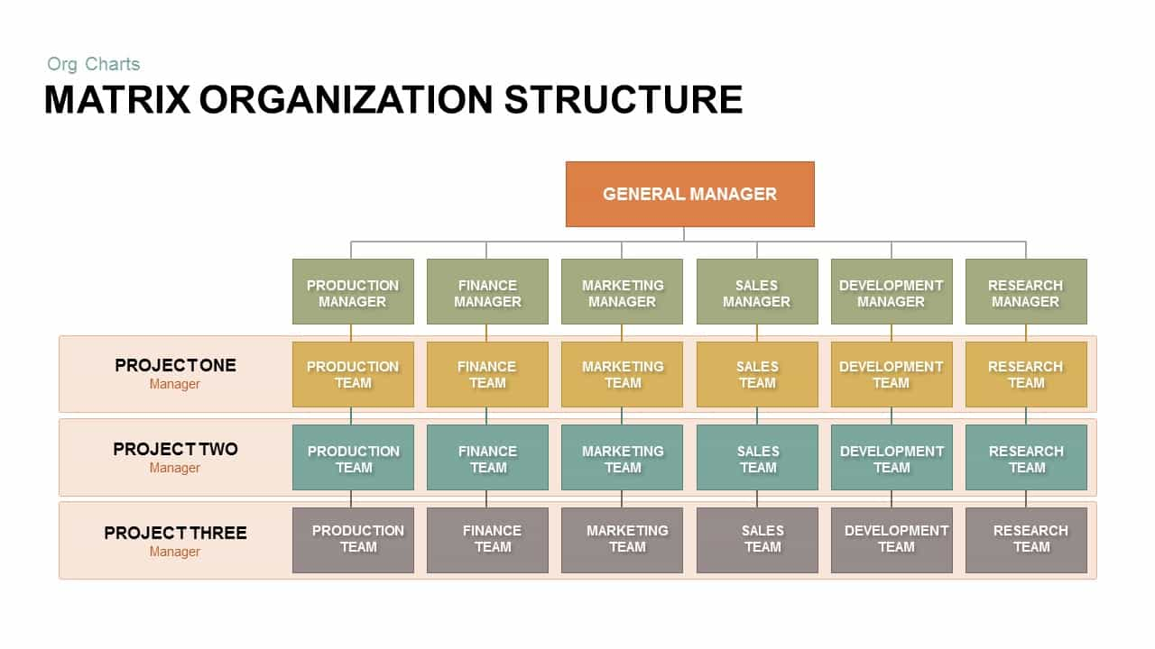
Figure 3: Matrix Organizational Structure
(Source: SlideBazaar. 2020)
If employees do not communicate and indulge in conflicts, then their performance will automatically deteoriate. An organization achieves business objectives and creates strong market foundation by maintaining equality between workers and establishing a common culture for them. Organizational culture can be also divided into four separate segments, namely, adhocracy, market, hierarchy and clan.
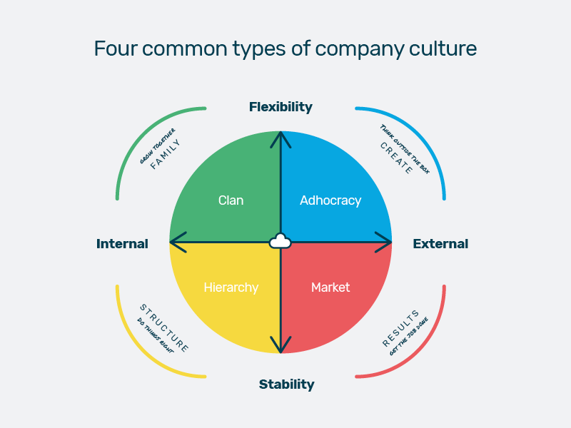
Figure 4: Four types of Organizational Culture
(Source: Benstead, S., 2020)

Adhocracy culture focuses on people’s creativity in achieving target and market culture prioritizes competitive aspects. Organizations following functional structure maintain adhocracy and market culture for gaining competitive advantage. As creativity of employees is prioritized, performance of organization improves and a competitive mind-set allows people to establish a concrete foundation of their business. Clan culture is followed by functional, divisional and matrix structure (Moore and Tully, 2018). However, lack of managerial role in matrix structured organization fail to main clan culture and this bring negative impact on performance. Hierarchical culture is mostly maintained by organizations following divisional structure. Strict control of the head supervisor helps in improving organizational performance. Therefore, relationship between structure, culture, people and organisational performance are interrelated. Based upon an organizational structure, all other aforementioned aspect depends.

2. Critically understand the essential nature of managerial work (in terms of both functions and processes) communicate the role of leadership and furthermore, explain the variables that determine effective management and leadership
Nature of Managerial Work:
Management department plays a crucial role in every business organization. By managing the tasks relating to business planning, resource and capital management, taking decisions for long-term growth and directing employees’, managers fulfil some of the major responsibilities of an organization (Meng and Boyd, 2017). They play an entrusted leadership role by overseeing departmental operational tasks and accomplishing business targets. In terms of functions and processes, managerial operational works are fulfilled by a manager through the tasks mentioned below:
- Handling administrative tasks- By receiving telephone calls, directing employees, carrying out data handling works, this task is accomplished.
- Operational tasks- Financing, sales, manufacturing, packaging, etc form part of the operational tasks and these are the functions that help in running an organization (Pietraszewski, 2020).
- Training and motivating employees- As a part of operational processes, effective training ensures higher outputs from employees. Motivated employees will be able to utilise their skill and knowledge for carrying out the operational processes.
- Enforcement of policy and establishing goals- Organizational policies helps in maintaining a strict workforce culture through which employees fulfil their functional roles under the guidance of managers. Such roles are followed as per long and short-term goals of organization (Inyang et al,.2018).
Role of Leader:
Other than managerial team roles, leaders also play a vital role in forming groups and guiding employees. Productive teams are established as a result of efficient guidance from leaders by their peers. By understanding the operational processes and organizational requirements, managers assist team leaders to adopt specific strategies that will help in guiding other members (Opoku and Williams, 2018). Leaders form communication protocols and facilitate collaboration between employees. They outline the functional responsibilities to each member and maintain reports for the completion of task by such employees. Maintenance of these reports helps them to provide accurate information to managers regarding progression of tasks and achievement of targets. Often, inconsistencies between clients’ and employees are resolved by leaders. Proper way of examining the roles played by each member in their team help them to take decisions for further improvement or changes within team. Employee biasness is highly avoided and they constantly motivate peers for improving work performance. An effective leader manages time and addresses feedbacks of their team members on a weekly/monthly basis. Thus, it can be stated that a leader not only abides by the instructions of their managers but also empowers team members for accomplishing organizational objectives.
Variables determining effective Management:
- Establishment of goals: Through the planning process, long-term and short-term goals are identified by managers of any organization.
- Resource Management: Capital and other resources are organized by managers. It helps in determining roles to each worker within a team/ entire organization (Abraham, 2019).
- Building Teamwork Culture: As goals are aligned, leaders and subordinate employees are instructed to focus on organizational vision.
Variables determining effective Leadership:
- Initiation- leaders instruct and guide their team members to follow organizational policies and meet future objectives.
- Taking strategic decisions- According to organizational policy based rules strategic decision for carrying out any task by team is taken by leaders.
- Establishing protocols- In order to engage team members, leaders form communication protocols and focus on potential growth outcomes. Monitoring and supervision of the activities of team members helps leaders to fulfil their responsibilities (McSherry and Pearce, 2016).
Presence of both leaders and managers is, thus, essential for an organization to run in a smooth way. Leaders and managers carry out all the necessary duties efficiently and their assistance to team workers helps in focussing on organization’s vision.

3. Critically evaluate the behavioural approach to management, through understanding of the factors that affect differences in individual behaviour
Behaviour and attitude of employees within an organization determines fulfilment of several growth aspects. Behavioural approach specifically identifies the aspect of behaviour/attitude of an individual and its significant impact on other associated factors. This approach mainly focuses upon individual’s perception and the effect of behaviour on other organizational activities can be easily determined with that (ElGebeily 2020). Under the behavioural approach to management, two important branches are focussed, human relation and behavioural science approach. The two branches of behavioural approach are detailed below:
- Human Relation approach- Based upon the way of communication with subordinate workers or with leaders, managers maintain a smooth relation with each one of them. However, by facing several kinds of challenges or organizational relating difficulties, behaviour of such manager changes. For instance, their way of communicating might change and this may hinder operational activities (Elfer, 2020). Balanced behavioural pattern help managers to avoid discrepancies or workplace stress. A positive workplace environment should be established by management team of an organization through which they will ensure higher outputs are generated for the whole business. Competency in human relation is required in this approach. Behaviour of managers towards their peers will determine the way of fulfilling company’s objectives.
- Behavioural Science Approach- Employee performance gets improved through motivation and proper management. This approach acknowledges that leadership skills is utmost important for meeting objectives of a management team within an organization (Schubert et al,.2018).Mind-set of every individual determines maintenance of a proper behaviour within workspace. Individual behaviours of employees create impact on organizational goals and management team must ensure that a formal work culture environment is formed. For avoiding any organizational conflict between employees, management team conduct training programs. Also, incentives and rewards are given to employees for improving performance by maintaining a formal behavioural culture.
Individual behaviour of employees within an organization helps in empowering all workers and their collective participation improves productivity (Neenan, 2017). As they achieve rewards or performance based awards, their behaviour automatically changes and it creates positive implications on entire workforce. On the other hand, ill-behaviour or rude attitude of any employee create serious issues. Constant supervision by management team helps in identifying such problems and effective resolution steps by organizing training sessions lowers the rate of these problems within workplace area. These differences in individual behaviour create large impact in an organization and management team should implement strategies to avoid negative behavioural implications on overall performance (Fells et al,.2018).

Conclusion
This report on management and organizational behaviour has discussed several aspects that form an important part of every organization. Relationship between organizational structures like functional, divisional and matrix with factors including performance, people and culture has been demonstrated in the first part. Specific roles and variables of management and leadership have been defined in the second part. And the last section has demonstrated behavioural approach to management with two important approaches, human relation and behavioural science, in details.

References
Abraham, P., 2019. The Mediating Role of Organizational Climate in the Relationship between Leadership Outcomes and Organizational Strategic Planning.
Aksoy, H., 2017. How do innovation culture, marketing innovation and product innovation affect the market performance of small and medium-sized enterprises (SMEs). Technology in Society, 51(4), pp.133-141.
Benstead, S., 2020. 4 Different Types Of Company Culture Explained. [online] Breathehr.com. Available at: <https://www.breathehr.com/blog/topic/company-culture/4-different-types-of-company-culture-explained> [Accessed 19 August 2020].
Elfer, J., 2020. The behavioural approach to gender equality: changing how we think about workplace culture. LSE Business Review.
ElGebeily, E., 2020. A behavioural approach to corporate finance: A study of the Egyptian and UK markets (Doctoral dissertation).
Fells, R., Caspersz, D. and Leighton, C., 2018. The encouragement of bargaining in good faith–A behavioural approach. Journal of Industrial Relations, 60(2), pp.266-281.
Hattangadi, V., 2020. Common Organizational Structures - Dr. Vidya Hattangadi. [online] Dr. Vidya Hattangadi. Available at: <http://drvidyahattangadi.com/common-organizational-structures/> [Accessed 19 August 2020].
Inyang, A.E., Agnihotri, R. and Munoz, L., 2018. The role of manager leadership style in salesperson implementation of sales strategy: a contingency perspective. Journal of Business & Industrial Marketing.
Jogaratnam, G., 2017. How organizational culture influences market orientation and business performance in the restaurant industry. Journal of Hospitality and Tourism Management, 31, pp.211-219.
McSherry, R. and Pearce, P., 2016. what are the effective ways to translate clinical leadership into health care quality improvement?. Journal of Healthcare Leadership, 8, p.11.
Meng, X. and Boyd, P., 2017. The role of the project manager in relationship management. International Journal of Project Management, 35(5), pp.717-728.
Moore, T. and Tully, G., 2018. Connecting landscapes: examining and enhancing the relationship between stakeholder values and cultural landscape management in England. Landscape Research, 43(6), pp.769-783.
Neenan, M., 2017. Developing resilience: A cognitive-behavioural approach. Taylor & Francis.
Opoku, A. and Williams, N., 2018. Second-generation gender bias: An exploratory study of the women’s leadership gap in a UK construction organisation. International Journal of Ethics and Systems, 35(1), pp.2-23.
Pedersen, E.R.G., Gwozdz, W. and Hvass, K.K., 2018. Exploring the relationship between business model innovation, corporate sustainability, and organisational values within the fashion industry. Journal of Business Ethics, 149(2), pp.267-284.
Pietraszewski, D., 2020. The evolution of leadership: Leadership and followership as a solution to the problem of creating and executing successful coordination and cooperation enterprises. The Leadership Quarterly, 31(2), p.101299.
QS Study. 2020. Divisional Structure: Definition In Terms Of Business Management - QS Study. [online] Available at: <https://www.qsstudy.com/business-studies/divisional-structure-definition-terms-business-management> [Accessed 19 August 2020].
Schubert, T., Baier, E. and Rammer, C., 2018. Firm capabilities, technological dynamism and the internationalisation of innovation: A behavioural approach. Journal of international business studies, 49(1), pp.70-95.
Slide Bazaar. 2020. Matrix Organizational Structure PowerPoint Template | Slide bazaar. [online] Available at: <https://slidebazaar.com/items/matrix-organizational-structure-powerpoint-template/> [Accessed 19 August 2020].

