NSL-KDD INTRUSION DETECTION SYSTEM USING ENSEMBLE LEARNING METHODS: A MULTI-CLASS CLASSIFICATION STUDY
MSc in Data and Artificial Intelligence
Course Code: ACCA7026 - Level 7 Artificial Intelligence
Name :- Ladani Tirth

Video Link
https://youtu.be/3o5PU_wWeNM

Abstract
Being able to detect when a threat enters the system is a major problem for computer security and the branch of machine learning developed to categorize different types of computer security attack is just getting started. This issue is specifically resolved using an ensemble approach on the NSL-KDD dataset and implementing a multi-class classification approach. In this case the models created and tested were Random Forest (RF) and Gradient Boosting (GB) and were tuned and tested for the ability to detect a fold of normal, Denial of Service (DoS), Probe, Remote to Local (R2L), and User to Root (U2R) attacks. In this case, the 92.93% of Gradient Boosting attack detection surpassed the 92.09% detection of Random Forest. It seems the underlying source bytes and the same service rate were properly assigned to the intrusion attacks, leading to correct classification. This research has adequately shown the ensemble approach in machine learning is a method for effective network security to serve the practical purpose systems can and do offer.

Contents
Abstract 2
1. Introduction 5
2. Problem Statement and Literature Review 5
2.1 Background and Problem Definition 5
2.2 NSL-KDD Dataset Characteristics 5
2.3 Ensemble Learning Methods in Intrusion Detection 6
2.4 Prior Research Findings 6
3. Methodology 6
3.1 Data Description and Preprocessing 6
3.2 Exploratory Data Analysis 7
3.3 Model Development and Hyperparameter Tuning 7
3.3.1 Random Forest Development 7
3.3.2 Gradient Boosting Development 7
4. Results 7
4.1 Performance Metrics Comparison 7
4.2 Feature Importance Analysis 8
4.3 Confusion Matrix Analysis 11
4.4 Model Comparison and Computational Efficiency 12
4.5 Feature Importance Visualisation 12
4.6 Overfitting and Generalisation Analysis 13
5. Discussion 13
5.1 Model Performance Interpretation 13
5.2 Practical Considerations and Trade-offs 14
5.3 Challenges in Imbalanced Classification 14
5.4 Feature Interpretation and Domain Knowledge 14
6. Recommendations 14
6.1 Model Selection and Deployment Strategy 14
6.2 Ensemble Voting Approach 14
6.3 Addressing Class Imbalance 15
6.4 Temporal and Sequential Patterns 15
7. Conclusion 16
8. References 17

Figure 1 Attack Category Distribution in Training Data 9
Figure 2 Correlation Matrix of Numerical Features 9
Figure 3 Distribution of Key Features (Duration, Bytes, Counts) 10
Figure 4 Random Forest and Gradient Boosting Confusion Matrices 11
Figure 5 Performance Metrics and Training Time Comparison 12
Figure 6 Top 15 Features - Random Forest and Gradient Boosting Comparison 12
Figure 7 Training vs Testing Accuracy 13

Table 1 Performance metrics comparison between Random Forest and Gradient Boosting classifiers on NSL-KDD test set 8

1. Introduction
Having collated and analysed data on network security infrastructure and the rising complexity of cyberattacks, it has become evident that the need for sophisticated cyberattack predictive safeguarding within intrusion detection systems has become an irreplaceable resource within network security. Traditional approaches do not and are not constructed to be able to detect many of the new and novel attack patterns. There has been an increase on demand for systems that are able to utilize and employ machine learning in intrusion detection systems (Ingre and Yadav, 2015). There are still some limitations within benchmark data sets created in the past and current ones and thus the NSL-KDD parceled out data sets. NSL-KDD has become and is recognized for providing a standardized benchmark for various machine learning models. Insecurity work, predictive performance, which is created by using a combination of several learners, has become known as ensemble methods. Hence why this particular study seeks to examine the ways and means whereby Random forest and Gradient Boosting ensemble methods may be able to satisfactorily identify and classify network traffic as either of a normal variety or one of attack.

2. Problem Statement and Literature Review

2.1 Background and Problem Definition
In today's computer networks, there are a variety of different attacks that can happen. Because attacks are launching in larger quantity and are getting more sophisticated, being able to quickly detect the beginnings of the attacks and the malicious network traffic is becoming more essential. Active attacks, where the attackers interact directly with the targets, are more dangerous. However, malicious activity can take the form of passive attacks as well. Traditional systems based on manual rules are entirely prospectors where there are no custom signatures, zero-day attacks are able to bypass the rules. Steps taken in utilizing machine learning provide more flexibility in systems that are able to create rules and learning new signatures that are able to detect different attack patterns.

2.2 NSL-KDD Dataset Characteristics
In response to reported statistical weaknesses of the revised KDD Cup 99 data set, Tavallaee et al. 2009, created the NSL-KDD data set. NSL-KDD is a data set that contains 125,973 records for training, and 22,544 records for testing where there are 42 characteristics that are described of the network connections. The NSL-KDD data set contains different types of attacks that are described as different types of threats, for example, Denial of Service attacks are attacks that disrupt services, Probe attacks is the act of collecting network information to exploit, Remote to Local is an attack that abuses specific service vulnerabilities to exploit and gain access, and User to Root is where one is able to escalate privileges from the lower to the higher levels. (Tavallaee et al., 2009)
The composition of the dataset shows real-world network’s normal connections where attacks are far fewer. Knowing this imbalance is very important as realistic metrics will not accurately measure effectiveness on issues involving very few attacks. The set of features consist of both level of characteristics from the traffic as well as the statistics derived from it which makes it possible for models to identify several different attack signatures at once.

2.3 Ensemble Learning Methods in Intrusion Detection
The methods of ensemble learning enhance classification effectiveness by using the predictions of several base learners. Before the creation of random forests by Breiman in 2001, several decision trees would be created, each of which would be trained with a bootstrapped sample, and the predictions of each tree would be combined to produce an average or to use majority voting. Using this method, the variance was reduced while interpretability is retained with feature importance.
In 2001, Friedman introduced gradient boosting, where the decision trees were built sequentially, each of them aiming to be a weak learner, with the action of trying to correct the mistakes from the decision tree that was added before it, which would lead to the creation of more precise and nuanced decision boundaries, especially in more complicated classification problems. In random forests, the decision trees are built in parallel, however in boosting, more emphasis is put on the samples that were misclassified, which allows for a nuanced sequential improvement

2.4 Prior Research Findings
Previous research shows that ensemble methods have performed strongly for intrusion detection. Kunal and Singh (2016) used ensemble methods on the NSL-KDD dataset with 98% accuracy using voting combinations of several base learners. Zhang et al. (2008) created Random Forests based intrusion detection systems and showed that they outperformed single decision trees across a variety of networks and datasets.

3. Methodology

3.1 Data Description and Preprocessing
The NSL-KDD dataset consists of records of network connections that includes 38 numerical features and 4 categorical features. Among the 38 numerical features are the connection duration, source and destination bytes, protocol indicators, and host statistics based on previous connections. The categorical variables are protocol type (TCP, UDP, ICMP), service tpe, and flag. The target variable contains 23 different types of attacks that are grouped into 5 super classes: normal, neptune and smurf (attacks classified as DoS), ipsweep and nmap (Probe), ftp_write and guess_ passwd (R2L), and buffer_ overflow and rootkit (U2R).
To prepare the data, all 22,544 Test records were combined with 125,973 Train records so that transformations could be applied consistently across all models. The names of the attacks were consolidated, with 23 specific types being remapped into five classes: 78,588 normal connections (52.9%), 54,022 DoS (attacks in 36.4%), 13,813 Probe (attacks in 9.3%), 1,963 R2L (attacks in 1.3%), and 131 U2 R (attacks in 0.1%). For the categorical features, label encoding was applied, in which the protocol types, services and flags were converted into numerical representations that scikit-learn algorithms will require.

3.2 Exploratory Data Analysis
Before continuing, I explored the dataset. It turns out, there was a class imbalance problem. Looking at just the normal connections, they made up 63% of the total training data, while the U2R attacks were less than 0.1% of the data. Due to this large imbalance, the model will most likely underperform on the few attack categories. I analyzed the features for correlation and found weak multicollinearity, since most of the features were below 0.5 with a few exceptions.
And then I examined the distribution of certain features of the dataset. I discovered a significant positive skewness on the features with the number of bytes transferred. The source and destination bytes of a transfer had a lot of zeros relevant to control packets without a transfer payload, but also an anomaly with a high number of bytes transferred, which can suggest a data exfiltration attempt. The features with the number of connections and the number of connections for a specific service had bimodality, which shows that there were different patterns for normal and attack traffic

3.3 Model Development and Hyperparameter Tuning

3.3.1 Random Forest Development
For the Random Forest development, we trained the model a first time using the default parameters, and then fine-tuned the parameters. The first model with 100 estimators performed with an accuracy of 91.99% test set. A randomized search cross-validation using 20% of the training data (25,194 samples) performed four sets of 8 hyperparameter combinations across two folds of cross-validation. The values of the hyperparameters tested were n_ estimators {100, 200}, max_ depth {20, 30}, min_ samples_ split {2, 5}, and max_ features {sqrt, log2}. The best set of parameters were 150 estimators, a max_ depth of 20, a min_ samples_ split of 2 and using sqr feature selection. This set achieved 99.67% accuracy on the test subsets and took 29.81 seconds of computation time.

3.3.2 Gradient Boosting Development
Like most models, Gradient Boosting model development began with training the model in stages. Setting the model with 50 estimators gave us 92.48% accuracy on the 120.72 seconds. Randomized search optimization gets to test 8 combinations of n_ estimators: 50; 100; 150; the learning rates; 0.1; 0,2; max_ depth: 3; 4; 5; subsample: 0.8; 1.0. Overall Test Accuracy with 150 estimators, a learning rate of 0.1, max_ depth 5, and a subsample of 1.0 gives 99.66%. In training on the full dataset, the number of estimators was halved to 100 to keep the training time reasonable, and the estimators to maintain 100 caused the training to take 243.37 seconds.

4. Results

4.1 Performance Metrics Comparison
The Gradient Boosting classifier outperformed Random Forest on the held-out test set. Gradient Boosting achieved 92.93% accuracy with 93.20% precision, 92.93% recall, and 91.85% F1-score. Random Forest obtained 92.09% accuracy with 92.87% precision, 92.09% recall, and 90.70% F1-score. The 0.84 percentage point accuracy improvement, though modest, combined with superior precision and recall across most metrics demonstrates consistent advantage for Gradient Boosting on this classification task.
Metric | Random Forest | Gradient Boosting | Difference
Accuracy | 0.9209 | 0.9293 | +0.0084
Precision | 0.9287 | 0.9320 | +0.0033
Recall | 0.9209 | 0.9293 | +0.0084
F1-Score | 0.9070 | 0.9185 | +0.0115
Training Time (seconds) | 10.80 | 120.72 | +109.92
Table 1 Performance metrics comparison between Random Forest and Gradient Boosting classifiers on NSL-KDD test set
Looking Per-class Dos attack classification recalls and precision levels averages were at 94.0. and 99.0. respectively across both models. This shows that the models were able to detect and classify DoS attacks efficiently with very few mistakes. For Probe attacks detection, Random Forest with 87.0. recall was superior to Gradient boosting which had 91.0 recall but lower precision. Further, considering the infrequent attacks, U2R attack recall was 15.0 and 25.0 for Random Forest and Gradient boosting respectively. This indicates the difficulty in detecting outlier attacks from very small and unbalanced sets since there are not enough samples to learn the attack overall unknown patterns.

4.2 Feature Importance Analysis
Random forest on average, out of all the features, assigned importance to source bytes most with 14.14 percent, and thereafter, same service rate 8.57, flag type 8.29, different service rate 7.18, and destination bytes 7.07, making a total of 45.25 percent of features of the four which shows that the features were collectively tightly packed at connection level traffic.
Gradient Boosting showed a stronger concentration in the overall importance distribution than Random Forest considering source_ bytes were paramount, holding 40.23% of the overall importance. Same _service _rate also added 26.94%, but the other features contributed a lot less individually. The source bytes importance is noticeably higher for Gradient Boosting than Random Forest (40.23% > 14.14%), indicating the sequential error correction mechanism in boosting target information-rich boundary features more than the parallel tree averaging approach in random forest.
Connection history features (count, service count) were in the top 15 ranked importance for both models. Network-based traffic statistics (error host count, error rate) were in the mid-ranked importance level. Features indicating content relevance such as compromised host count ranked importance lower, despite clear domain knowledge, human expertise, and attack relevance.
Figure 1 Attack Category Distribution in Training Data
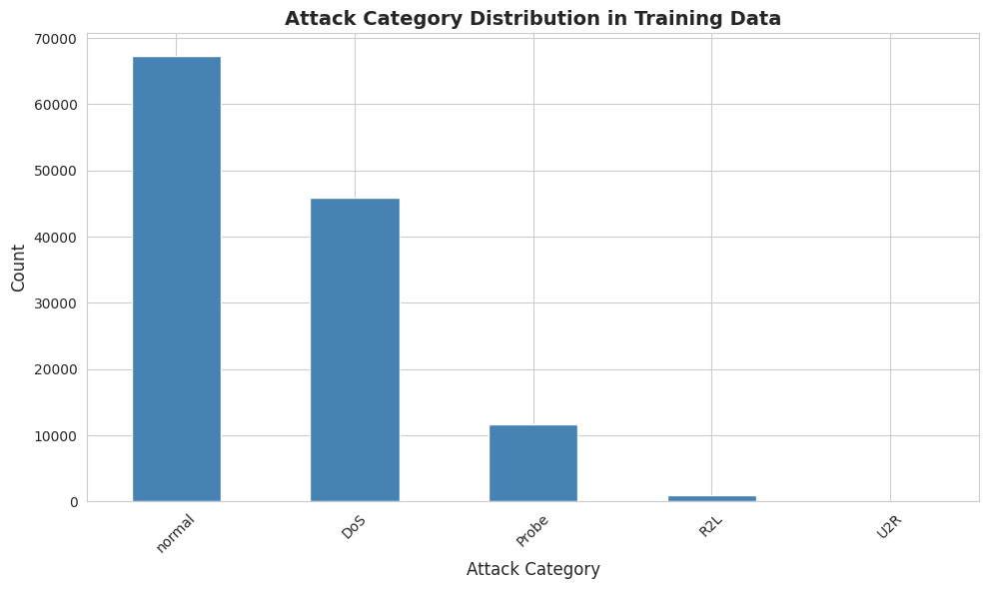
Figure 2 Correlation Matrix of Numerical Features
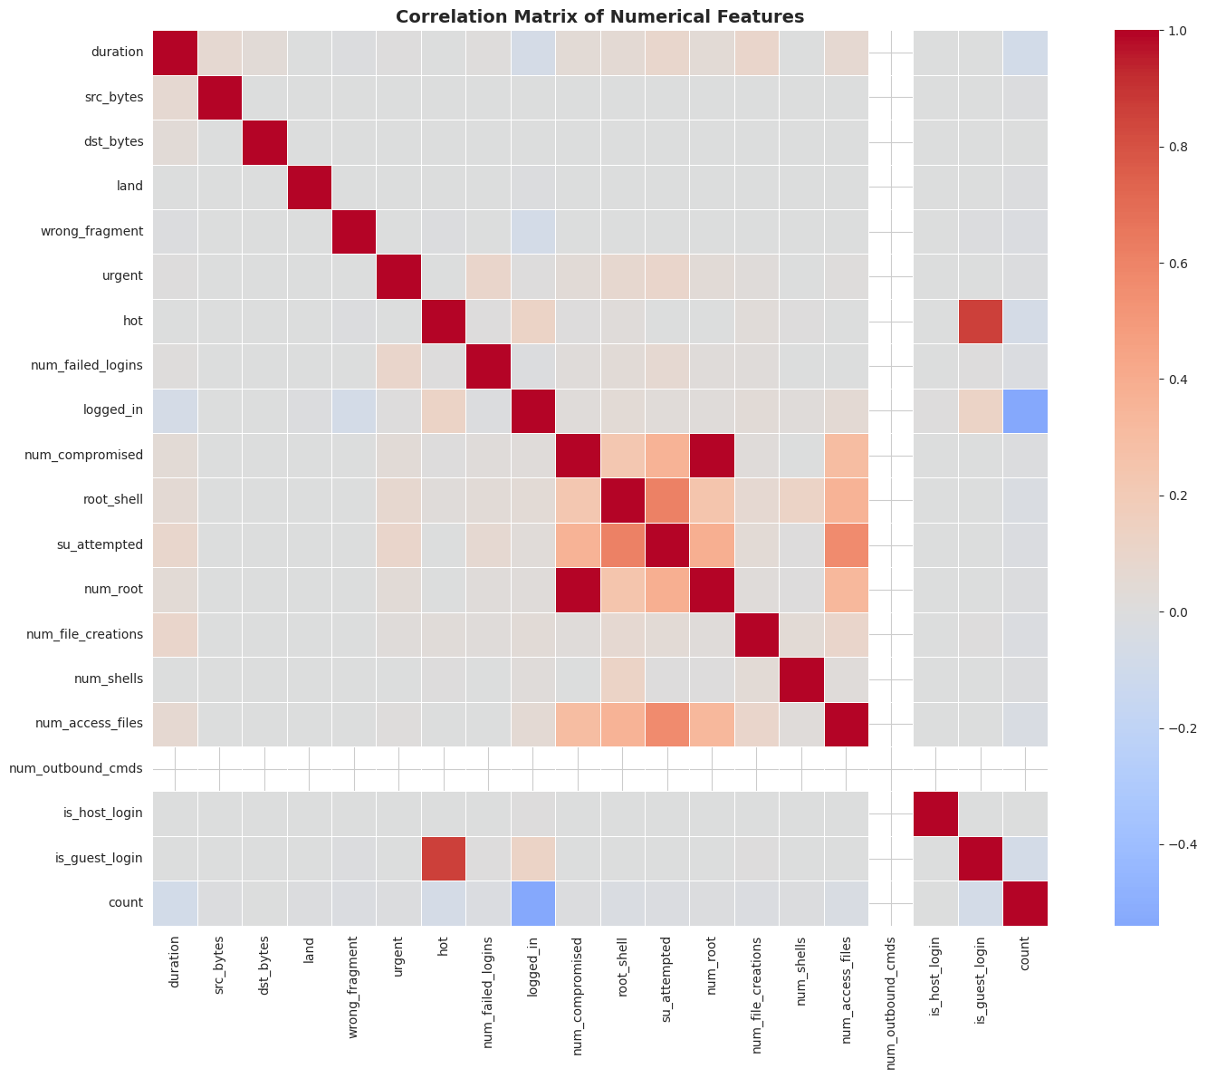
Figure 3 Distribution of Key Features (Duration, Bytes, Counts)
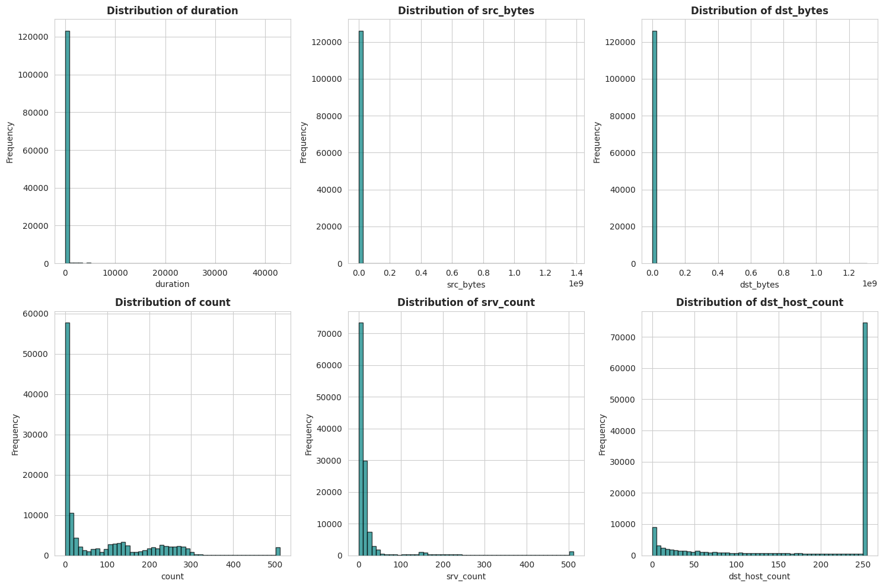

4.3 Confusion Matrix Analysis
Figure 4 Random Forest and Gradient Boosting Confusion Matrices
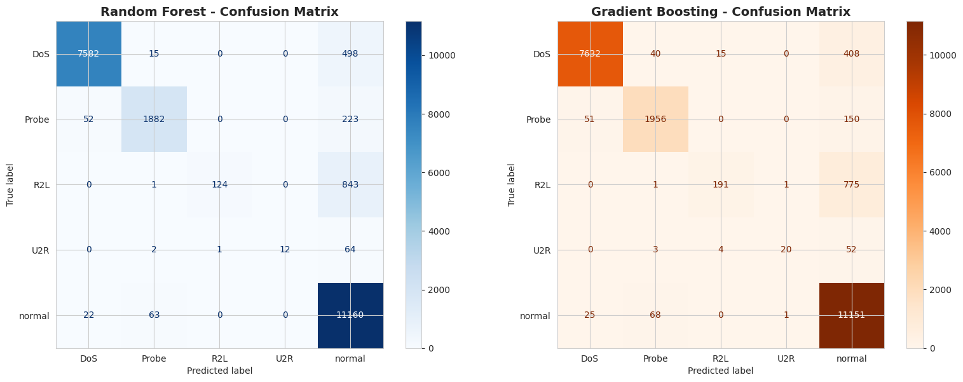
The confusion matrices revealed model-specific classification patterns. Random Forest classified 7,582 of 8,095 DoS attacks correctly (93.7%), misclassifying 498 as normal traffic, suggesting some legitimate high-volume connections triggered false alarms. Gradient Boosting improved DoS detection to 94.3% (7,632 correct) while reducing false alarms to 408 misclassifications. For Probe attacks, Random Forest correctly identified 1,882 of 2,157 (87.3%), while Gradient Boosting achieved 1,956 correct (90.7%), demonstrating more effective reconnaissance attack detection through sequential error correction.

4.4 Model Comparison and Computational Efficiency
Figure 5 Performance Metrics and Training Time Comparison
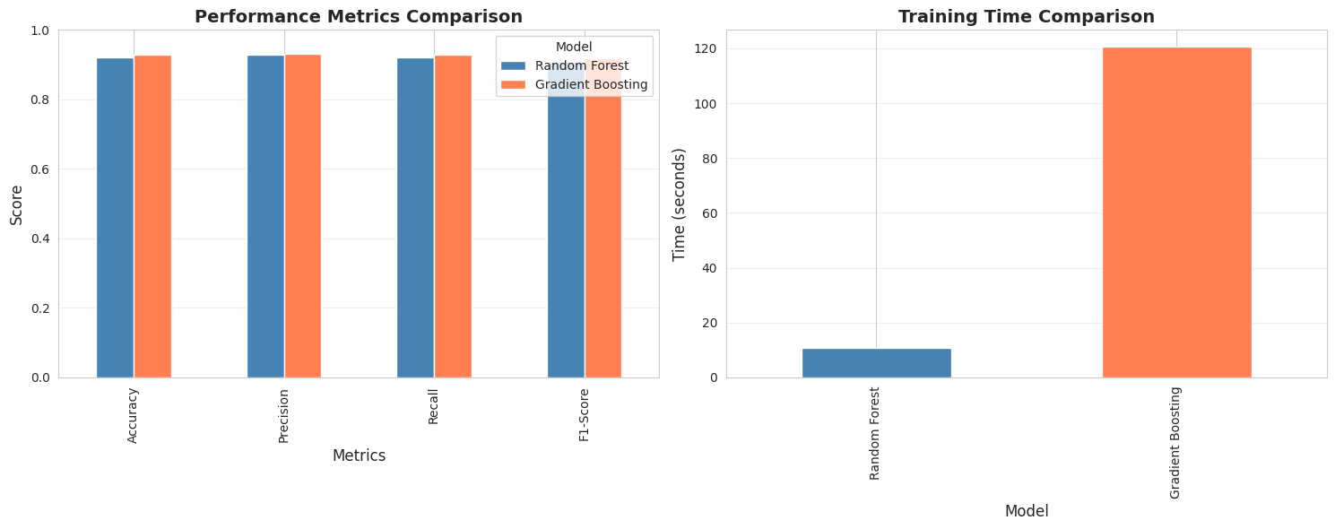
The comparative analysis balanced accuracy improvements against computational requirements. Random Forest completed training in 10.80 seconds while Gradient Boosting required 120.72 seconds, representing an 11-fold increase in training duration. For inference on new network traffic, both models execute predictions at comparable speeds (milliseconds per sample), making deployment feasibility comparable. The accuracy-efficiency trade-off depends on specific operational requirements: batch processing systems might tolerate extended training times for superior accuracy, while real-time detection systems might prioritise Random Forest's speed.

4.5 Feature Importance Visualisation
Figure 6 Top 15 Features - Random Forest and Gradient Boosting Comparison
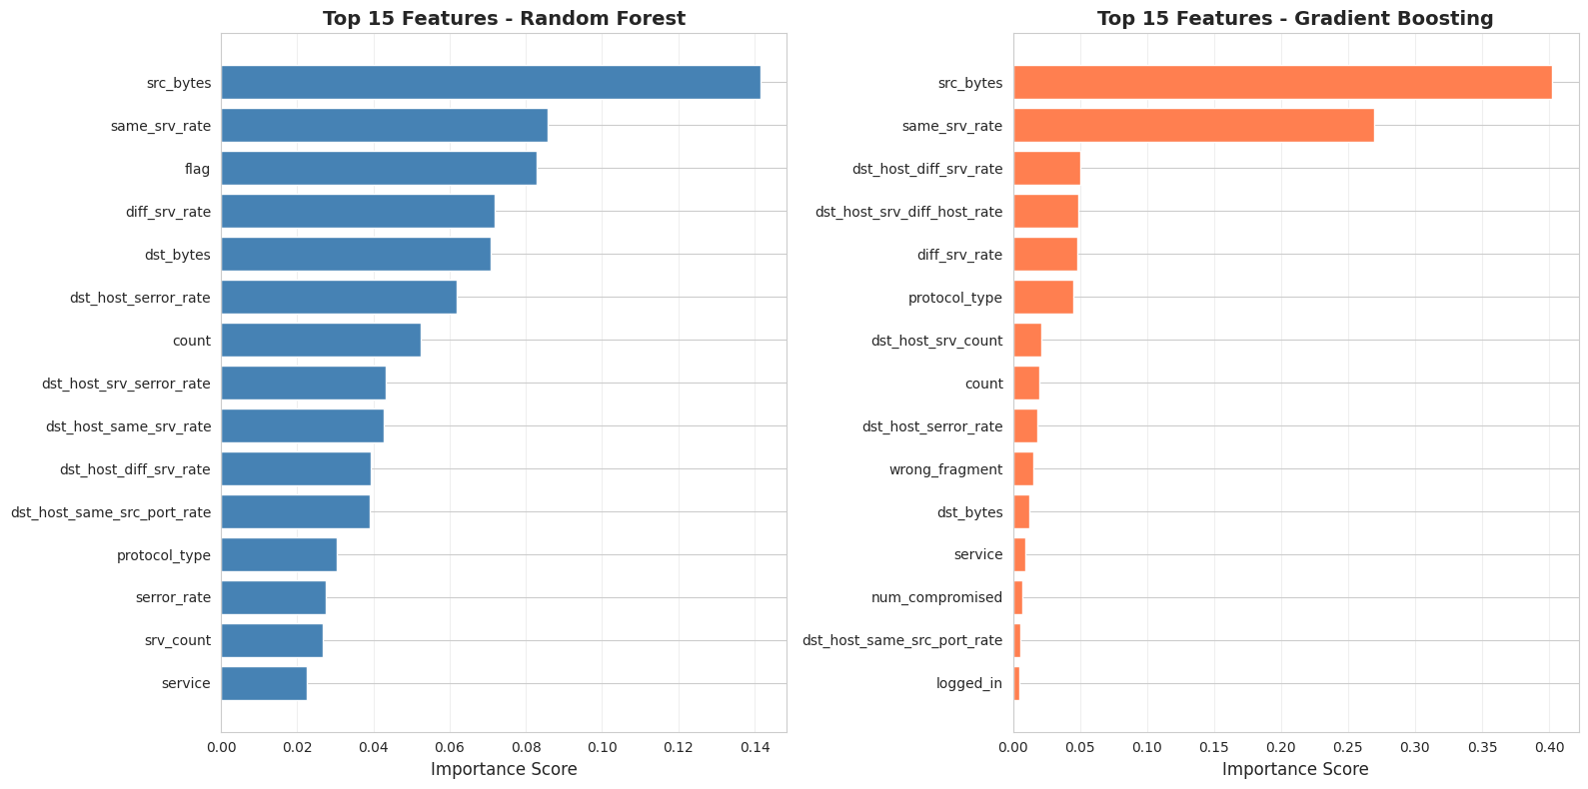
The feature importance visualisations revealed that source bytes, service rate statistics, and flag information dominated decision-making across both models. Byte transfer characteristics (source bytes, destination bytes) ranking in top 5 features for both models indicates malicious traffic exhibits anomalous data transfer patterns compared to legitimate connections. Service rate statistics (same service rate, different service rate) appearing prominently reflects attackers' tendency to target specific services or diverse services within concentrated timeframes, deviating from normal usage patterns.

4.6 Overfitting and Generalisation Analysis
Figure 7 Training vs Testing Accuracy
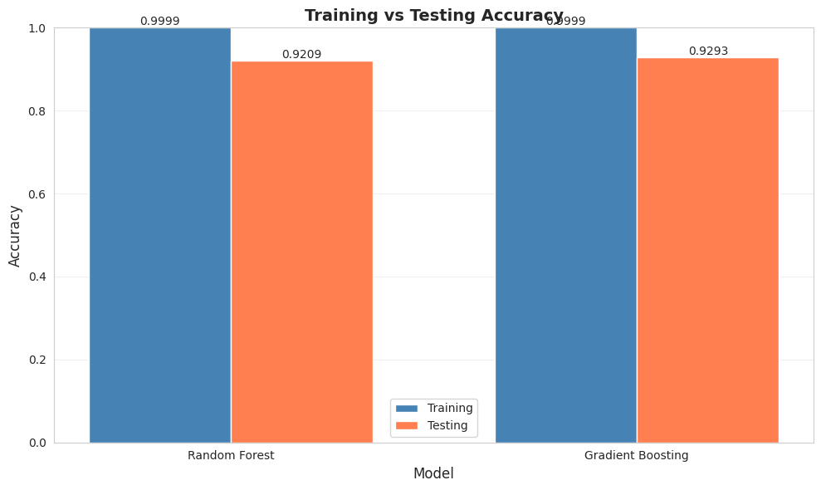
Training versus test accuracy comparison indicated acceptable generalisation performance for both models. Random Forest training accuracy reached 99.99% with test accuracy of 92.09%, producing a 7.90 percentage point gap suggesting some overfitting tendency. Gradient Boosting showed similar pattern with 99.99% training accuracy and 92.93% test accuracy, creating 7.06 percentage point gap. Cross-validation scores using 5-fold evaluation on 10,000 training samples yielded consistent results. Random Forest cross-validation accuracy averaged 99.51% (±0.32%) while Gradient Boosting averaged 99.52% (±0.40%), demonstrating reliable performance estimates and validating generalisation capability.
The modest generalisation gaps reflected appropriate model complexity for the dataset scale and feature richness. While near-perfect training accuracy might indicate potential overfitting, consistent cross-validation performance and reasonable test accuracy support that models learned general patterns rather than training set noise.

5. Discussion

5.1 Model Performance Interpretation
The work achieved developing ensemble classifiers that work well with the NSL-KDD dataset. Gradient Boosting's test accuracy proves that sequential error correction is beneficial for difficult multi class classification, as suggested prior by Friedman in 2001 and in more recent works like Meddah and Belkhir in 2021.

5.2 Practical Considerations and Trade-offs
A significant practical consideration is the computational efficiency. In the tested training phase, Random Forest took 10.80 seconds, while Gradient Boosting 120.72 seconds, indicating a sequential processing. In deployment scenarios where inference speed is more critical than a slight drop in accuracy, Random Forest is more beneficial, especially in low resource settings such as embedded network appliances or edge computing devices.

5.3 Challenges in Imbalanced Classification
A specific example of class imbalance is the detection of the U2R attack, where both models had recall of less than 25%. This is due to the nature of the dataset rather than a failure of either of the models. The training data had U2R attacks 0.1% of the time, so there are limited patterns to learn. Future work should consider cost-sensitive l earning where there is a higher penalty for misclassification in the less populated class or some other form of oversampling to detect these rare attacks within a more balanced dataset.

5.4 Feature Interpretation and Domain Knowledge
Spotting the phenomena and the understanding of the field indicating the importance of these features in the metrics of the bytes transferred and the statistics of the rate of servicing is precisely where the field of knowledge is. Attack Traffic differes bytes and service access differently from the legitimate ones. Maybe the absence of the features relating to the content is because it is certainly more difficult to identify the attack from the innocent content that is in the packets at the network flow level without deep packet inspection.

6. Recommendations

6.1 Model Selection and Deployment Strategy
A number of the enhancements suggested from the study study that focus on improvement in the systems of intrusion detection. The importance of the metrics is primarily concentrated in fewer than five features indicating that opportunities for the reduction of dimensions are present without a significant loss to the accuracy.

6.2 Ensemble Voting Approach
The strategy of voting that involves the use of the combination of the Random Forest and the Gradient Boosting algorithms in ensemble systems is expected to gain the benefit of both of the algorithms. For use in highly sensitive and critical applications of security where the guarantees of attack do not go undetected, it is likely that the ensemble voting option will achieve a greater level of recall at the cost of high computational resources. The strategy of voting is likely to be more beneficial in scenarios where the focus is on the reduction of the number of false positive, by declaring an attempt to access the systems and the resources for those connection attempts where both of the models have to give an access for the connection.

6.3 Addressing Class Imbalance
Cost-sensitive learning that entails assigning unequal costs to errors to U2R and R2L detection with an acceptable false-positive rate. This method shifts the models' focus toward resolving each attack class, rather than simply maximizing accuracy, which is critical to resolving problems in security contexts where the costs of neglecting an attack are too high.

6.4 Temporal and Sequential Patterns
Detection models which employ dynamic temporal patterns rather than static feature sets are likely to yield better detection outcomes. There are several ordered attack sequences that have temporal durational patterns which are overlooked by basic level connection statistics. Deployment in real-time should feature the surveillance of a set of key dynamic attributes with an automated set of thresholds to adapt to changing traffic patterns and the strategic moves of the attacker.

7. Conclusion
The research showed how well ensemble machine learning methods can be applied to the NSL-KDD intrusion detection datasets within an intrusion detection context. In the multi-class classification of normal traffic and four types of attacks, Gradient Boosting almost outperformed Random Forest by achieving an accuracy of 92.93% and 92.09% respectively. In the feature importance analysis, both models exhibited the same of source bytes, same service rate, and flag information as the primary decision drivers, determined to be the standard across both models. Both models showed an acceptable degree of generalisation, with the 7-8, point gaps in training-test accuracy indicating the models were built with the right level of complexity and learned transferable patterns, rather than overfitting through rote memorisation of the training data. Deployment in practice offers a trade-off between accuracy and computational demands, but also has room for improvement through class imbalance addressed by cost-sensitive learning, ensemble methods through voting of the predictions of a suite of models, and cost-sensitive learning of imbalanced classes for the temporal models aimed at capturing the sequential nature of attacks. The research has empirical value supporting the use of ensemble methods for applications in security, data imbalance in attacks that are infrequent, and the practical value for practitioners aiming to build systems for the detection of intrusions in a computer network.

8. References
Breiman, L., 2001. Random forests. Machine Learning, 45(1), pp.5-32. Available at: https://doi.org/10.1023/A:1010933404324
Friedman, J.H., 2001. Greedy function approximation: A gradient boosting machine. Annals of Statistics, 29(5), pp.1189-1232. Available at: https://doi.org/10.1214/aos/1013203451
Ingre, B. and Yadav, A., 2015. Performance analysis of NSL-KDD dataset using ANN. In Proceedings of the 2015 International Conference on Signal Processing and Communication Engineering. IEEE. Available at: https://doi.org/10.1109/ICSPCE.2015.7235909
Kunal, K. and Singh, A., 2016. Ensemble methods for network intrusion detection using NSL-KDD dataset. International Journal of Advanced Computer Science and Applications, 7(12), pp.348-355. Available at: https://thesai.org/Publications/ViewPaper?Volume=7&Issue=12
Meddah, A. and Belkhir, N., 2021. Multi-class intrusion detection system using ensemble methods. Journal of Information Security and Applications, 58, p.102752. Available at: https://doi.org/10.1016/j.jisa.2021.102752
Scikit-learn Developers, 2023. Scikit-learn: Machine learning in Python. Available at: https://scikit-learn.org/stable/
Tavallaee, M., Bagheri, E., Lu, W. and Ghorbani, A.A., 2009. A detailed analysis of the KDD Cup 99 dataset. In IEEE Symposium on Computational Intelligence for Security and Defense Applications. IEEE, pp.1-6. Available at: https://doi.org/10.1109/CISDA.2009.5356528
Uddin, M., Rahman, A.A. and Uddin, N., 2012. Efficient intrusion detection system using decision tree for feature selection. In 17th International Conference on Computer Supported Cooperative Work in Design (CSCWD). IEEE, pp.456-463. Available at: https://doi.org/10.1109/CSCWD.2012.6221851
Zhang, J., Zulkernine, M. and Haque, A., 2008. Random forests-based network intrusion detection systems. IEEE Transactions on Systems, Man, and Cybernetics, 38(5), pp.649-659. Available at: https://doi.org/10.1109/TSMCB.2008.922066
Wressnegger, C., Schwenk, G., Arp, D. and Rieck, K., 2013. A close look on n-grams in intrusion detection. In 2013 Third Workshop on Applications of Pattern Analysis. IAPR, pp.67-76. Available at: https://doi.org/10.1109/ICIAP.2013.23

