Drive-cycle Requirement
Specifications

Yujian Liu
2304817
MSc Automotive Engineering
28/04/2024
ACFA7007 Hybrid Powertrain and Control

Abstract
This paper analyzes the current technological challenges of electric vehicles with short range and long charging times. The potential of hydrogen-based fuel cells as an effective alternative is presented, and the application of fuel cells in light-duty vehicles and hybrid systems is specifically analyzed to assess their efficiency. In addition, the article discussed in detail a hybrid system retrofit case combining a battery system with a fuel cell, using the Tesla Model 3 as an example. The energy consumption and range performance of the retrofitted vehicle was verified by simulating a WLTP driving cycle. It is shown that the hybrid system is able to meet existing vehicle performance standards while potentially increasing range and maintaining similar energy costs. In conclusion, the potential of fuel cell technology is expected to contribute positively to the viability and environmental sustainability of electric and hybrid vehicles by overcoming the limitations of current battery technologies.

Introduction
With the growing threat of global warming, governments and international organisations are seeking ways to reduce greenhouse gas emissions. Electric vehicles are an important tool in the fight against climate change, as they significantly reduce CO2 emissions from vehicle exhausts compared to conventional fuel vehicles. Their running costs are typically lower than those of conventional fuel vehicles, while their mechanics are simpler and less subject to wear and tear, so they are also less expensive to maintain. Electric vehicles offer instant torque response and excellent acceleration. In addition, EVs have a low centre of gravity and good ride stability and handling as the batteries are usually located at the bottom of the vehicle. The use of electric power systems makes the operation of electric vehicles much quieter than that of fuel vehicles, creating quieter conditions for drivers and the urban environment. However, electric vehicles currently suffer from short range and long charging times due to battery capacity limitations. Although electric vehicles reduce pollution during driving, the production and final disposal of the batteries still have potential environmental impacts, especially when it comes to mineral extraction and battery recycling.
Hydrogen-based fuel cells are a good solution to the above problems. Hydrogen energy has the advantages of green, high efficiency, high calorific value, and sustainability, and is regarded as the most promising clean energy in the 21st century. Therefore, hydrogen fuel cell vehicles are developing rapidly, among which proton exchange fuel cells are the most widely researched and applied. d. Pacella et al.^{[1]}used a 60W electric stack on a robot with a fixed gas supply pressure and no humidification. The main objective of the study was to match the drive chain and to investigate its control strategy. The power range for light vehicle applications is 1 kW to 10 kW, but too much power will increase the cost of vehicle development and require more consideration of air supply, heat dissipation and water management. Denis Candusso et al^{.[2]}analysed a PEMFC stack drive train providing 9 kW of power alone, a 4.5 kW PEMFC stack and a supercapacitor drive train capable of supplying a few seconds of power, and a 4.5 kW PEMFC stack and a 5 kW supercapacitor drive train capable of supplying a few seconds of air and a 5 kW super-capacitor drive train. J.J. Hwang et al.^{[3]}designed the Mingdao fuel cell vehicle with a 5 kW PEMFC stack. A comparison with an internal combustion engine after several hundred kilometres of testing showed a 30% increase in fuel efficiency in the standby condition of the vehicle.P et al.^{[4]}studied a 2.4kW fuel cell hybrid vehicle using a control strategy whereby the reactor auxiliary unit was used to keep the reactor energy consumption to a minimum at the right temperature and the right supply of reactants. Tests were carried out using the European R40 and R47 driving cycles, and the uniform voltage distribution of individual cells within the stack and the stack temperature variations over the test cycle were analysed. P et al.^{[5]}used an 8kW stack and seven 12V50AH batteries to form a hybrid system to build a fuel cell hybrid vehicle in an airport, and verified through experimental tests that the hybrid system maintains the state of charge (soc) of the batteries in the normal range, and that the batteries can be discharged and charged by the fuel cell normally to avoid excessive charging and discharging that may cause damage to the batteries. The battery can be discharged and charged by the fuel cell normally, avoiding overcharging and discharging which may cause battery damage.
In order to obtain good energy consumption and improve the range, this paper presents a hybrid idea formed by batteries and fuel cells, using Tesla's model 3 as an example, focusing on the components selected and their cost, life cycle. Based on the drive cycle, a comprehensive analysis is carried out in terms of range, energy consumption and energy conversion efficiency.

WLTP Cycle Driven Validation
In order to complete the fuel cell conversion of the tesla model 3, a cycle drive model based on vehicle parameters is first developed. In this paper, the WLTP cycle is used, which is a globally harmonised test standard for measuring fuel consumption, CO2 emissions, and pollutant emissions of light-duty vehicles (mainly passenger cars and light commercial vehicles.) The WLTP consists of a four-part cycle, with each part simulating different driving speeds (low, medium, high, and extra-high speeds) for a more comprehensive coverage of various driving conditions. According to the calculation, the model 3 has a ratio of rated power (w)/ kerb mass (kg)> 34, so the third version of WLTP is used. The specific vehicle parameters and performance requirements are shown in Table 1.
Table 1. Vehicle Parameters & Performance Requirements
Mass | Kg | 1980
Mass Distribution | % F-R | 48-52
Wheelbase | m | 2.875
CD | ~ | 0.23
Driven Tyre size | Standard | 235/35-20
Battery Nominal Voltage | V | 360
Battery Capacity | kWh | 75
Peak Torque | Nm | 639
Peak Power | kW | 336
WLTP Range | km | 530
WLTP Consumption | Wh/km | 166

Modeling
The loads imposed on a moving vehicle are related to the physical laws of the relevant environment. Vehicle dynamics are modelled based on the loads imposed on the vehicle. The main loading forces on the vehicle include: air resistance, rolling resistance. Climbing resistance is not considered here.
The interaction of the vehicle with the air during movement produces resistance, called air resistance, which has a significant impact on the performance and power requirements of the vehicle. The calculation formula is as follows:
$$F_{A}=0.5*ρ*Cd*A*V^{2}$$
Where $A$ is the air density, $Cd$ is the wind resistance coefficient, $A$ is the windward area, $V$ is the car speed。
Rolling resistance is the resistance generated by a vehicle tyre when it comes into contact with the ground. This resistance is caused by deformation of the tyre and friction between the contact surfaces and has a significant impact on the energy consumption and range of the vehicle. The calculation formula is as follows:
$$F_{R}=C_{R}*M*g$$
Where${ C}_{R}$is the rolling resistance coefficient, $M$is the mass of the car, $g$is the acceleration due to gravity, its value is 9.8 m/s².
Traction is the amount of power provided to achieve acceleration of the vehicle. It is calculated by the formula:
$$F_{AC}=M*a$$
Where $M$ is the mass of the car and $a$ is the acceleration of the car.
The total resistance is the sum of air resistance, rolling resistance and traction. The formula is as follows:
$$F_{T}=F_{A}+F_{R}+F_{AC}$$
The above is the basic dynamics model of the vehicle, in order to improve energy efficiency and increase range, the model 3 also has a kinetic energy recovery system that utilises the electric motor of the EV as a generator to capture and convert the kinetic energy of the vehicle into electrical energy when decelerating or braking, storing it back in the battery with a recovery efficiency of 93%. MATLAB software was used to complete the vehicle model and drive the WLTP cycle to complete the validation of the manufacturer tesla's stated WLTP range and energy consumption.
Figure 1 is the instantaneous power and energy consumption for the WLTP cycle, as can be seen from the graph, the final energy consumption for one cycle is 3.53 kWh. The range is 530.42km and the final energy consumption is 141Wh/km. This matches with tesla's declared range but the energy consumption is less than the actual, which may be due to the fact that the actual car battery output is not only used in the car's drive system, but also a part of it is used in the operation of car air conditioning, entertainment, lighting and other systems. In summary, the cycle drive established in this paper meets the actual vehicle requirements.
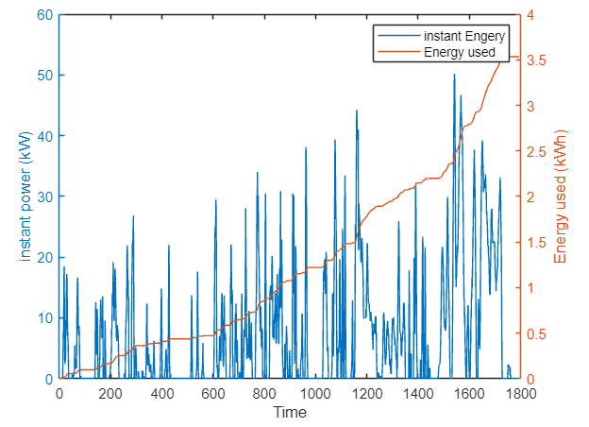
Figure 1. WLTP cycle energy consumption

Replace 50% of the battery capacity for Fuel Cell
The primary goal of this section is to replace at least 50% of the Tesla battery capacity with fuel cells and attempt to achieve similar WLTP requirements. At the same time, the vehicle powertrain should be compliant with post-2035 regulations. During the modelling and design process, the drive system of the original vehicle should remain unchanged, with the energy provided by the battery system reduced by half, and a hydrogen fuel cell system added to provide 50% of the energy conversion.
The energy density of hydrogen is about 33.3 kWh/kg, which is the theoretical energy content of hydrogen as a fuel, and the actual energy conversion is in the range of 40-50%. Setting the fuel cell efficiency at 45%, to provide 37.5 kWh of energy, the required fuel cell energy is 83.3kWh. The required mass of hydrogen is 2.5kg. 1kg of hydrogen occupies approximately 11.12 cubic metres. However, in practice, hydrogen is usually compressed and stored in high pressure cylinders, commonly at pressures such as 700 bar. the actual volume of hydrogen is 39L. with reference to the fuel cell vehicle mirai, the hydrogen volume of this design is 40L, the mass is 2.51kg, and the pressure is 700 bar. the overall fuel cell system mass is 130kg.
The battery system of Model 3 adopts LG21700 M50 battery cells, with a single weight of 68g, and the overall layout is 96s46p. In this design, the battery layout is 96s23p, which reduces the battery capacity by half, and the overall mass is reduced by 150kg.
Figure 2. Model 3 Battery pack
In summary, the mass of the new powertrain with batteries and fuel cells proposed in this paper is about 1960 kg. Based on the verified cyclic drive in Section I, the mass of the vehicle is changed to 1955 kg, and the WLTP is recalculated.
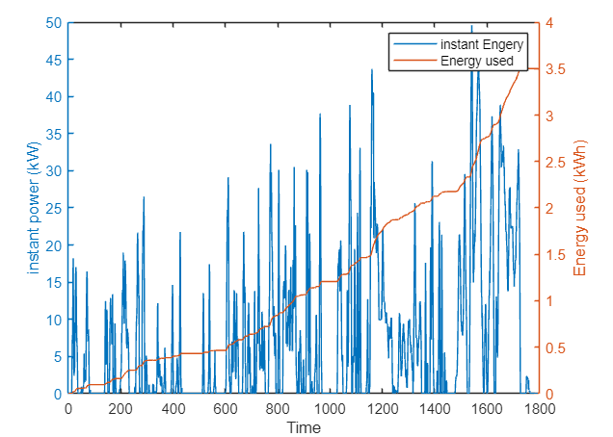
Figure 3. WLTP cycle energy consumption
Figure 3 is the instantaneous power and energy consumption graph for the WLTP cycle. From the graph, it can be seen that the total energy consumption for a single cycle is 3.5 kWh. The final calculated range is 535km and the energy consumption is 140.1 Wh/km. Compared to the original vehicle, the range of the hybrid vehicle is improved and the energy consumption is basically unchanged.
Comparison of the results of simulation calculations shows that the conversion design, the vehicle mass is reduced by 25kg, to enhance the vehicle lightweight, which is conducive to reducing energy consumption and reducing the cost of each kilometre of the vehicle. At the same time, the vehicle performance has not changed significantly, and can meet the user's driving needs. At the same time, the increase of fuel cell can greatly reduce the difficulties such as slow battery charging and poor service performance in extreme environments.
In addition, WLTP driving cycles are conducted under specific environmental conditions (usually indoor and at constant temperatures), which do not fully reflect the actual driving environment under various climatic conditions. WLTP does not cover situations with high traffic loads, such as traffic jams and frequent stops, which have a significant impact on fuel efficiency and emissions in real life. Although WLTP tries to simulate different types of roads, in practice it still cannot fully cover the various road conditions that may be encountered in real-life driving, such as gradient and road surface condition. Therefore, the above simulation results can only be used as a reference, and the real vehicle performance performance for experimental study.

Detailed Specifications
From the simulation results, it can be seen that this design meets the requirements of the drive cycle. This section mainly focuses on the overall description and provides a detailed description of the added fuel cell system. The overall layout of the vehicle power system of this design is shown in Figure 4.
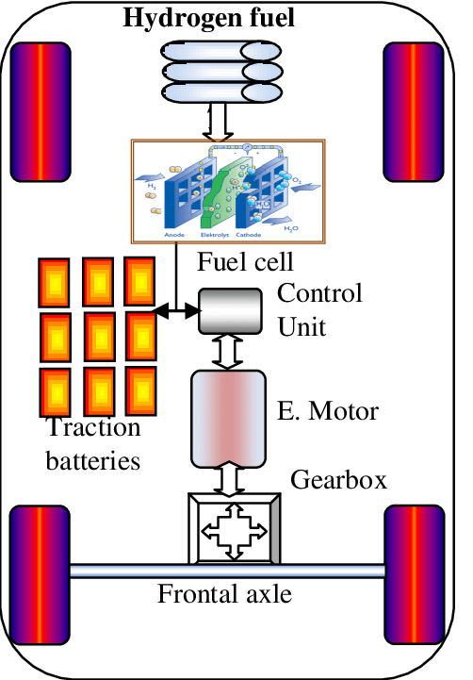
Figure 4. Vehicle Layout
The hydrogen fuel system in this design mainly includes: the hydrogen fuel cell power generation system mainly consists of a hydrogen supply system, an air supply system, a proton exchange membrane (PEM) fuel cell stack, as well as a thermal management system and a corresponding control system (including pumps, valves, sensors and controllers).

Hydrogen supply system
The hydrogen storage system uses a 70 MPa high-pressure hydrogen tank made of carbon fibre-reinforced composite material, which not only withstands high pressures, but also significantly reduces weight and improves the vehicle's energy efficiency. A hydrogen circulation pump is used to recycle the excess hydrogen. Excess hydrogen ensures that the electrochemical reaction is fully carried out on the one hand, and takes away the water and impurity gas from the anode on the other. After the vapour-water separation device, most of the hydrogen is recycled through the hydrogen recycling pump, and a small amount of hydrogen, impurity gas and water are discharged out of the system through the hydrogen discharge valve and drain valve. Equipped with hydrogen leakage detection system
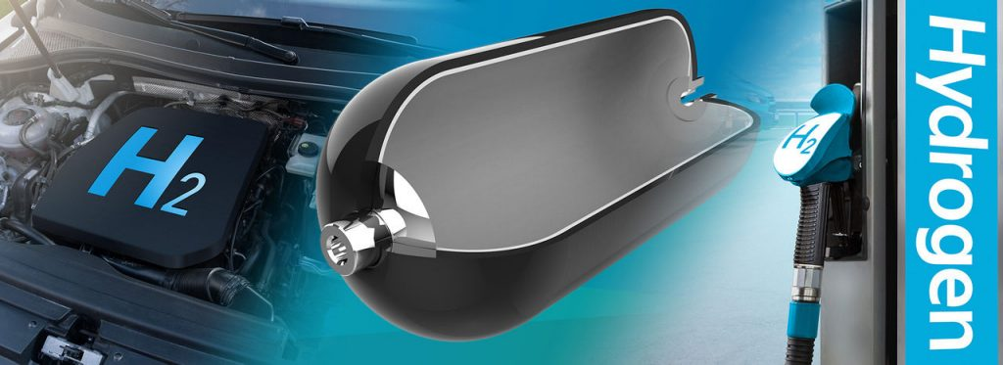
Figure 5. Hydrogen storage tank for vehicles

Air supply system
The air compressor compresses the air and transfers the air with certain pressure to the air supply line, and then transfers it to the cathode of the fuel cell through the cooling and humidifying process. The air compressor is the core component of the on-board fuel cell system, and the centrifugal air compressor is the widely used air compressor at present. The centrifugal air compressor has the advantages of high efficiency, low noise, large flow rate, small structure and volume, etc. It has obvious influence on the efficiency of the system, and the compression ratio has a non-linear relationship with the flow rate of the gas, therefore, it is regarded as the most ideal air compressor in the on-board fuel cell system.
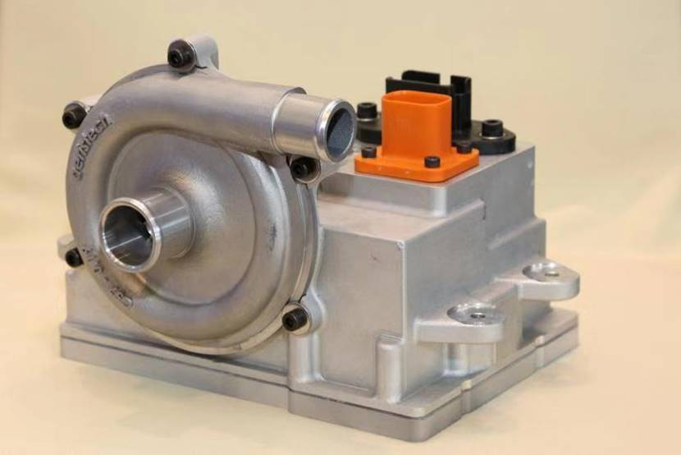
Figure 6. 空压机

Proton Exchange Membrane Fuel Cell Reactor
The core of fuel cell power generation is its internal electric stack, the basic fuel cell stack assembly is composed of proton exchange membrane, catalyst (commonly used platinum/carbon catalyst), gas diffusion layer (conductive fibre), flow field plate (graphite), gaskets and end plates, and the assembly of the proton exchange membrane, the gas diffusion layer and the catalyst layer together is known as Membrane Electrode Assembly (MEA). Electrode Assembly (MEA). Membrane Electrode Assembly (MEA): A proton exchange membrane is used, which is usually made of fluorine-containing ion-exchange material (e.g. Nafion) with good chemical and thermal stability. The anode and cathode of the MEA use platinum or platinum alloys as catalysts to facilitate the electrochemical reaction between hydrogen and oxygen. Liquid cooling is employed, using water as the coolant. Specific cooling channels are provided in the EPR to ensure temperature control of the EPR during operation to avoid overheating that would affect performance and lifetime.
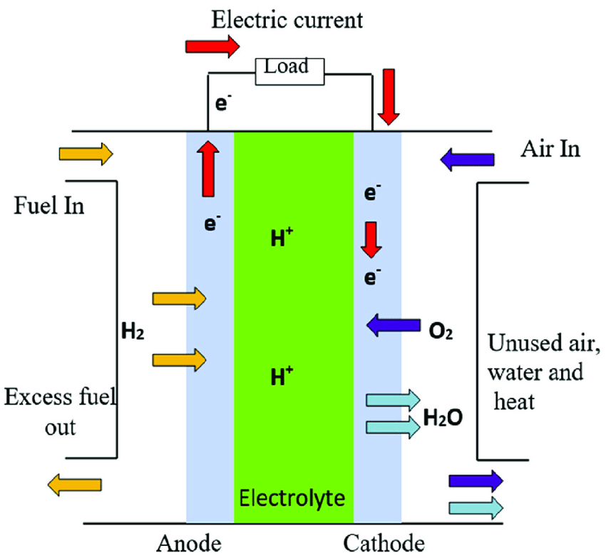
Figure 7. PEMFC Working Principle

Control System
The hardware part of the electronic control scheme mainly includes the main controller (FCU), sensors, actuators and the connection of communication lines. The information sampling and control of the sensors are done by the main controller, which is connected to the controller through the wiring harness, and the controller communicates with the components and the host computer through CAN network to achieve the control and monitoring of the fuel cell system start-up and operation status, and carry out the dynamic energy management and fault handling during the operation process.

Conclusion
Fuel cells, particularly proton exchange membrane fuel cells (PEMFCs), have continued to evolve, with their energy efficiency increasing from 40 per cent to about 60 per cent today. Moreover, as the production volume of fuel cells has increased, the manufacturing cost of individual cells has decreased significantly, with the International Energy Agency (IEA) reporting that the cost of fuel cells has fallen by about 80 per cent since 2000. Conventional fuel cells have a lifetime of about 1,500 to 5,000 hours, and improvements in the design and materials of modern fuel cells have led to further improvements in their lifetime. This paper validates the model 3 WLTP cycle in terms of range and energy consumption, designs and describes the important components of the added fuel system and auxiliary systems, and recalculates the WLTP to complete the conversion of the model 3 battery to a fuel cell. This is of great significance to the development of electric vehicles and fuel cell vehicles.

Referencen
- Pacella D, Donateo T, Masciullo A, et al. A Fuel Cell Hybrid Powertrain for the Volksbot Mobile Robot [J]. 2009.
- Candusso D, Rullière E, Toutain E. A fuel cell hybrid power source for a small electric vehicle[C], Proc. Universities Power Engineering Conf. 2001.
- Hwang J J, Wang D Y, Shih N C. Development of a lightweight fuel cell vehicle[J]. Journal of Power Sources, 2005, 141(1): 108-115.
- Corbo P, Migliardini F, Veneri O. Performance investigation of 2.4 kW PEM fuel cell stack in vehicles [J]. International Journal of Hydrogen Energy, 2007, 32(17): 4340-4349.
- Fontela P, Soria A, Mielgo J, et al. Airport electric vehicle powered by fuel cell[J]. Journal of power sources, 2007, 169(1): 184-193.

