

RESULT

ASSIGNMENT DETAILS AND FEEDBACK
SOUTH WEST WALES CENTRE FOR TEACHER EDUCATION
Sections marked with * should be completed by module lead
Student name: | Daniel Williams | Student P number: | 1700262
Programme: * | Secondary Post Graduate Certificate in Education
Module: * | Curriculum Development and Enhancement | Module Level (6 or 7): | Level 7
Module code: * | ECSP7002 | Contribution to Overall  Module Assessment (%): * | 100
Module Lead:* | Jan Barnes
Assignment Title:* | Reflections on Teaching and Learning | Assignment No (x of x): | 1
Start date:* | N/A | Submission deadline:* | 14th May 2018 –full submission
Return date of provisional marks & written feedback:* | 11th June 2018

Referencing: | In the main body of your submission you must give credit to authors on whose research your work is based. Append to your submission a reference list that indicates the books, articles, etc. that you have read or quoted in order to complete this assignment (e.g. for books: surname of author and initials, year of publication, title of book, edition, publisher: place of publication).
Submission: | All assignments must be submitted to Turnitin unless otherwise instructed by the Lecturer.  Note: the Turnitin version is the primary submission and acts as a receipt for the student. Late submission of the electronic version of the assignment will result in a late penalty. Penalties for late submission: Up to one week late, maximum grade D. Over one week late, Refer. Only the Extenuating Circumstances Panel may grant an extension. | Date: | 14.5.18

Research Question: What effect does the writing intervention of Slow Writing have on the writing attainment outcomes of KS4 pupils?
Introduction
School X is an English medium comprehensive school situated in South Wales which caters for pupils aged 11-18 (Estyn, 2013, 1). The school is a high-performing secondary school with 100% of pupils that study English Language and English Literature at GCSE achieving within the Level 2 threshold of A*-G (Appendix A). From this we can see that on the whole, School X is enabling learners to achieve within the subjects of English Language and English Literature as well as their wider literacy skills.
This research project specifically focuses on a Key Stage 4 (KS4) Year 10 class within School X and investigates how learners’ writing attainment levels can be positively affected by the implementation of Slow Writing, a writing intervention outlined and introduced by Didau (2014, 161). Despite there being 11 learners within the class, this research paper will only focus on 10 of those, as 1 learner did not completely finish either of the required writing tasks set due to being absent from the lessons.
In School X’s latest Estyn report, it is outlined that the majority of pupils within the school write well for a number of “purposes in different contexts and subjects” yet some remain dependent on planning sheets and other scaffolding resources even after their writing skills have already been developed (2013, 5).
However, for the specific Year 10 class in question, which is a mixed ability class, the writing attainment levels are not at the standard of the ‘majority’ outlined by Estyn and instead are relatively low in comparison to other Year 10 pupils (2013, 5). To aid with this, School X has a number of provisions already in place for the learners within the class, with 6 of the 11 pupils using laptops for any written work due to additional learning needs within the class. These pupils will ultimately have a laptop to work on and use to sit their GCSE examinations. In addition to this, in School X’s English Departmental Improvement Plan (DIP), the English department has outlined a key priority of developing “strategies that focus on the improvement of pupils’ writing skills” (School X, 2018, 9) which further allows the department to aid the learners’ writing attainment outcomes.
In my preparation for the intervention lessons with this class, I observed the class' pace of working, their quality of writing and attainment in writing throughout a number of lessons. Through these observations I found that the class works at a slower pace than a typical Year 10 class within the school and struggle overall with embellishing and extending their writing to make the content more focused and detailed (Appendix B). These observations allowed me to further integrate the use of Slow Writing as an intervention with this class in an attempt to discover the effect of Slow Writing on the writing attainment outcomes of KS4 pupils.

Literature Review
In recent years there has been a shift in education within Wales and in an attempt to raise literacy attainment levels, an embedded structure of literacy within schools in Wales has come in the form of the National Literacy and Numeracy Framework (LNF) (Welsh Government, 2013). The LNF is a statutory curriculum framework introduced to develop literacy and numeracy on a whole-school basis with a wider and more cross-curricular focus on transferrable skills (Welsh Government, 2013, 7). The LNF sets out to raise attainment in the different strands outlined within the framework, with one of the many focusses being “writing across the curriculum” (Welsh Government, 2013, 4). With this focus on writing attainment already present within education in Wales, it was necessary to ensure that the use of the intervention of Slow Writing for the purpose of this research was thoughtfully and extensively researched beforehand.
As outlined by Dauncey (2018, 2) for the National Assembly for Wales Research Service, attainment levels in GCSE English, and therefore KS4, in both the English Language and English Literature qualifications decreased from 2016 to 2017 with a 3.1% decrease from 69.3% to 66.1%. It could be suggested that a writing intervention such as Slow Writing could assist in improving these results and bring them back up and into the steady increase that has been ongoing since 2012 until the recent drop (Dauncey, 2018, 2).
Due to the recent coining of the term Slow Writing by Didau (2012), there is little research on the writing intervention itself. However, Slow Writing is essentially a form of scaffolding, a form of support outlined by Wood et al. (1976) as providing learners with support and guidance in order to have a positive impact on their work (89-100). Therefore, alongside the literature surrounding Slow Writing, it is also appropriate to investigate and examine literature concerning scaffolding.
Didau (2012) first outlined the writing approach of Slow Writing as a tool that can be used in a number of ways with writing skills and tasks, specifically drafting and improving. This outline of Slow Writing remains true even in Didau’s later publication (2014, 161), but Didau then offers a further explanation of why and how it can be used. Didau explains that even though learners will most likely produce less writing through a Slow Writing approach, the benefit will be that the writing they will produce will be “beautifully wrought and finely honed” and therefore will improve their attainment outcome (2014, 161-162). This slowing down and greater attention to detail that learners will have as they write should also allow them to improve their examination performance and should instill a greater sense and feeling of confidence in their own writing abilities (Didau, 2014, 163).
Didau (2014, 161) states that a successful use of Slow Writing would see a teacher plan a writing task with a number of cue cards or writing prompts to ensure a fixed focus on the writing. These writing prompts can be used by learners in a number of ways, either randomly, to provide a more sporadic and creative piece of writing more suited to a fiction piece, or specifically ordered and detailed to ensure each sentence is in a specific order, a method more suited towards a non-fiction piece of writing (Didau, 2014, 161-163).
Literacy Shed (2017) has tried and tested Slow Writing as a writing intervention and ultimately found that it is successful in improving writing and the writing quality of pupils. Literacy Shed (2017) also explained that various schools that had provided feedback following the use of a Slow Writing intervention had said that it began to “transform” learners’ writing From this we can already see that Slow Writing can have a great positive impact on the writing attainment outcomes of learners.
On the other hand, Literacy Shed (2017) also outlines potential negative aspects of Slow Writing as an intervention and explains that this type of scaffolding may be criticized by a senior leadership team or inspectors within a school as being too teacher dependent and not allowing for the most successful and useful teacher assessment. However, as Slow Writing is not outlined by Didau (2014, 161) as one specific way of writing and instead outlined as an approach that can be developed and adapted to suit a number of writing tasks and classes, these concerns can be quickly addressed by ensuring that learners are specifically catered for by their teacher using a class-specific approach to using Slow Writing (2014, p161-163). This method of adapting towards individual learner and class also highlights the ease at which Slow Writing can be differentiated for different learners and abilities (Literacy Shed, 2017). From this it could be suggested that using Slow Writing, as a method of scaffolding learners, would be a successful one due to its differentiation capabilities.
Further support for Slow Writing comes from Allison and Tharby (2015, 148), who discuss Slow Writing as a means of allowing learners to practice their writing in a way that helps them to “self-regulate”, meaning they will therefore have to spend time thinking more carefully about what they are writing. Allison and Tharby (2015, 148) go onto explain that Slow Writing as a form of scaffolding lends itself well to English lessons, but can also be used in other subjects, the skills and procedures learned can be easily transferred. At present, this kind of cross-curricular approach to learning particular skills such as writing is essential in any school in Wales. With the recent introduction of the LNF (Welsh Government, 2013) and the upcoming National Curriculum change (Welsh Government, 2017, 10-11) based on Donaldson’s Successful Futures (2015), it could be argued that using Slow Writing as an intervention could possibly promote and allow for such cross-curricular learning to take place.
There is a risk with using a scaffolding tool such as Slow Writing as it can be said to have a negative effect on pupils’ learning if it is not used in the most beneficial and appropriate way (Wood et al., 1976, 89-100). In order to ensure that any scaffolding is its most effective, it needs to be removed after an appropriate period of time to allow learners to work more independently (Wood et al., 1976, 89-100). This suggests that if scaffolding is not removed, a fragile dependency can be developed where learners cannot work without the use of a scaffolding tool.
This view of removal of scaffolding compliments social-constructivist theory even further as it places emphasis on the role of “structured intervention” in learning and working (Bartlett and Burton, 2015, 229). By ensuring that the use of Slow Writing or any scaffolding tool is useful, it must be developed into a structured and focused series of lessons (Bartlett and Burton, 2015, 229). From this we can gather that if Slow writing is used as a scaffolding tool, it must be, as Wood et al. (1976, 89-100) state, removed once learners have developed their writing skills which would allow for the gained confidence in their own writing that Didau states will occur (2014, 163). In support of this, Allison and Tharby (2015, 129) outline Nuthall’s views on how to learn a new concept by stating that in order for learners to learn something completely, they must revisit it “at least 3 times over a few days”. It is essential then that learners are given the time to learn and to develop through repetition and the thoughtful removal of the scaffolding to allow for this greater amount of independence (Allison and Tharby, 2015, 153-154). It may be difficult however to fit this into a school setting due to the often planned and prescribed ways of teaching that are already in place within schools.
With Slow Writing taking a slow approach to learning, examining the wider views of slowing down teaching and learning allows for a greater overview of Slow Writing as a whole. Thom (2018, 25-26) advocates this slower approach to learning and outlines the process of completely slowing down teaching and states that a slower pace can equal better results for learners. Thom (2016, 50-51) goes onto explain that by slowing down the content that is delivered, teachers can increase learner productivity. This increase in learner productivity links to Vygotsky’s notion of the Zone of Proximal Development (ZPD), defined by Newman and Holzman (1993, 52-53) as the process of further attainment of a learner through the assistance of a teacher or facilitator. Pound (2014, 54) and Wellington (2006, 187) further outline that the ZPD places a great emphasis on the notion of scaffolding and therefore can be said to come into play with the use of a writing scaffolding tool such as Slow Writing.
Vygotsky’s notion of the ZPD can also be closely linked to the notion of the ‘struggle zone’, outlined by Tharby (2017, 217) as the point at which the most learning takes place. In order for the ‘struggle zone’ to be the most effective, it must provide appropriate challenge in order for learners to thrive and achieve the maximum potential of any lesson (Tharby, 2017, 217). If learners are not challenged appropriately, they may remain within the ‘comfort zone’ where progress may not take place and tasks will be easily completed by learners as they do not present any challenge to the learner (Tharby, 2017, 217). McGill (2017, 83-84) supports this view and suggests that by keeping learners in the ‘struggle zone’ and providing the appropriate challenge, a teacher can allow for maximum learning but the lowest amount of stress.
There is a concern that can be raised from this that if Slow Writing is not removed after an appropriate period of time as Wood et al. (1976, 89-100) suggest, can soon lack in any challenge for learners. Allison and Tharby (2015, 16) also explain that useful learning will cease to occur if there is too much new information for our working memory to comprehend. As Thom (2018) further explains, if learners are challenged too much within a lesson and are, for example, exposed to too much writing or reading at one time, they may become overwhelmed (50-51). If this overexposure does occur, learners may be pushed into their ‘panic zone’, the point in which learners can no longer learn effectively and are unable to process the amount of information they are being exposed to (Tharby, 2017, 217). In further support of this, Cooze (2007, 140) explains that many learners find it difficult to follow and read large pieces of writing on a board and so it could be said to support the use of Slow Writing prompts as they give minimal information to learners which allows a greater focus and attention span on the particular prompts and therefore may increase learner productivity.
In order to tackle these problems and make such scaffolding the most successful it can be, Didau (2014, 40-41) states that “teachers need to know their pupils really well.” Didau (2014, 40-41) continues by explaining that it is necessary to have a clear and established picture of learners’ prior attainment and the goal they are working towards. By doing this, teachers are therefore able to have the best impact of pupils by carefully scaffolding them to their goal, something that Slow Writing can be used to do (Didau, 2014, 40-41). There is a further risk that can be raised here which is that Slow Writing can potentially remove the authentic and natural experience of writing for learners. Both New London Group (1996, 84) and Purcell-Gates et al., (2007, 12) discuss how learners must be exposed to “authentic” versions of writing in order to develop successful writing skills, something that is at risk when using such a potential rigid form of scaffolding such as Slow Writing.
A further positive impact that Slow Writing can have on learners’ writing is on learners’ attitude towards writing. If successfully undertaken, a Slow Writing intervention could see learners’ confidence boosted and therefore could impact their attitude towards writing in general. As Rhodes and Shanklin (1993, 63) discuss, attitudes towards writing amongst pupils can vary greatly and affect both individuals and a general school cohort. If Slow Writing has a positive impact on the writing of learners, it could be suggested that learners’ wider attitudes towards writing in general will be positively affected. If this is the case, and Slow Writing assists in improving learners’ attitudes towards writing in general, it could be argued that this helps to develop a ‘Hidden Curriculum’ within the school and classroom, where learners are implicitly taught specific views, behaviors and attitudes without the realization (Timan, 1994, 55).
Similar approaches and scaffolding techniques such as Slow Writing have also been devised to improve writing attainment outcomes such as ‘Talk for Writing’ (Corbett and Strong, 2011, 1-2). The ‘Talk for Writing’ approach instead focuses on learners of mainly a primary school age and sees them using speech and oracy skills to develop their writing by reading out what they have written to ensure it is coherent and correct (Corbett and Strong, 2011, 1-2). Similarly to Slow Writing, this approach sets out to embellish and improve the writing quality and attainment levels of learners by slowing down the process of writing into a more specific and focussed process (Corbett and Strong, 2011, 3). One of the main problems with ‘Talk for Writing’ however, is that it is specifically catered and designed to be used with primary school age learners unlike Slow Writing which can be adapted and changed to suit any age or ability (Corbett and Strong, 2011, 1-2).
Overall, Slow Writing as a scaffolding tool has the potential to be successful for all pupils but as discussed, needs to be carefully and selectively planned for each learner and class by a teacher that knows the learners well.

School Policy and Practice
Following this research into Slow Writing and scaffolding, it was also necessary to research School X’s current usage of the intervention Slow Writing and other specific scaffolding techniques for writing. Currently, School X does not have a specific policy, either whole school or department level, covering the intervention of Slow Writing. However, many daily teaching practices within the school’s English department do correspond with and compliment the Slow Writing techniques and methods. The use of sentence starters and sentence prompts feature heavily throughout lessons and throughout many English classes teachers use ‘structure strips’ (Appendix C) which see learners following along a specific structure to follow when writing an answer.
Similarly to Slow Writing, ‘structure strips’ are a form of scaffolding and help to scaffold learners’ work in a number of different ways. In using ‘structure strips’, teachers at School X are directing learners through the structure of a piece of writing, usually a 5 paragraph answer, as well as providing sentence starters and sentence prompts for each paragraph within the specific strip (Lockyer, 2015, 77). The use of scaffolding with ‘structure strips’ is similar to Slow Writing due to the heavy focus on scaffolding learners through a piece of writing in more focused and minute detail.
A scheme of work (SOW) from School X demonstrates the use of ‘structure strips’ for less able learners (Appendix D). Here we can see that teachers within School X’s English department use these when preparing learners to answer extended writing questions covering a range of different writing tasks in preparation for their GCSE English Language Unit 2 and Unit 3 examinations (WJEC, 2015, 10-11). This use of ‘structure strips’ to scaffold learners towards their examinations is supported by Tharby (2017, 126-127) and Didau (2014, 163) who both claim that the use of such scaffolding tools for learners increases performance in examinations. The use of ‘structure strips’ within a scheme of work such as this at School X has also been shown to enable learners to develop increasingly more independent learning, especially for less able learners, and the work produced has shown that once learners are able to use ‘structure strips’ as scaffolding, they begin to build a confidence within their writing which further supports Didau’s (2014, 163) explanation. More specifically, within School X the use of ‘structure strips’ has shown to place an emphasis on the 5 paragraphs learners need for their exam answers, which as a result, has allowed this structure to become embedded within learners’ writing even without the use of the ‘structure strips’.
In addition to the use of ‘structure strips’, School X also uses writing frames where appropriate to scaffold learners’ writing. For writing tasks in Key Stage 3 (KS3) learners are often provided with a writing frame, explained by Lewis and Wray (2002, 3) as a support which can help to structure and support learners’ writing to enable them to further develop into independent writers. For example, in a poetry writing task in a Year 7 SOW at School X (Appendix E), learners are provided with a writing frame to enable them to write a poem with a specific rhyme scheme. This could allow for most scaffolding techniques to be implemented successfully in School X as pupils are already used to working with such heavy scaffolding tools from previous key stages and classes.
In light of these specific school practices at School X, I felt that ultimately, a Slow Writing intervention would work well as an additional scaffolding method for learners to work with and in using, learners would also increase their level of understanding of the particular topics looked at.

Methodology & Ethics
When conducting any form of research, it is vital that the purpose and focus of the research project is precisely planned and well thought out (Burton and Bartlett, 2005, 59). When beginning to do this, Burton and Bartlett (2005, 60) suggest turning initial research ideas into a research outline, which for this research paper was in the form of a research proposal form (Appendix F) which was submitted to and later green-lit by the senior leadership team at School X where the research was conducted.
It was also necessary at this starting point to form my key research question in order to highlight the research focus and title (Burton and Bartlett, 2005, 61). After choosing the class and intervention to focus on for the research project my question became finalised as the following: What effect does the writing intervention of Slow Writing have on the writing attainment outcomes of KS4 pupils? Once this research question had been decided, I then ensured I considered a variety of methodologies in undertaking the research and data collection before continuing with the project and conducting any research.
From the very beginning the study and due to the nature of the research project, with only myself planning, putting it into practice and writing, as well as the fact that only 10 learners’ data was ultimately going to be used, it could be said that the project already lacked in providing an extensive coverage of the topic and intervention. Nevertheless, as Bell (2010, 118) explains, it is still good practice and useful to carry out such small-scale research despite it seeming like a rather negative approach to limit it early on. This kind of small-scale research has been proven to have its benefits, as Hackshaw (2008, 1141-1143) suggests, a research project which looks at a small number of participants is, in comparison to larger sample sizes, relatively quick to undertake. The sample size of 10 in this research project and the fact that it would be extremely quick to conduct meant that a undertaking this project as a small-scale project complimented a usual school timetable both for teachers and learners.
Cohen et al.’s (2013, 481) suggestion of a pre-intervention test to acquire baseline data for the learners involved also allowed this research to fit within the demands of School X’s normal timetable. Cohen et al. (2013, 481) also suggest the use of a summative style of assessment to acquire this baseline data, something that is already widely used within School X as a means of garnering a final grade or level for learners once they have worked their way through and completed a SOW. This summative form of assessment was also appropriate for the final set of data collection within the research project at the very end of the intervention lessons to provide a post-intervention set of data on the learners’ progress in their writing. This final summative assessment was also suggested by Cohen et al. (2013, 421) as one that would allow for a post-test measure of achievement for the research project.
Bell (2010, 118) further supports the use of such data collection and explains that the smaller the scale of the research, the fewer methods of data collection there will be. It is due to the size that this research only used 2 methods of data collection, 1 which provided quantitative data with the final marks of the 2 written pieces produced by the learners and 1 which provided qualitative data with observation notes taken pre-intervention written by myself. The quantitative data collected is arguably the most important of all the data collected as it is the data that is directly sourced from the learners participating in the study.
As well as considering the various methodologies and data collection that I needed to use within the research project, it was also necessary to explore any risks that this research could carry. Despite the fact that many educationalists agree that teachers need to be at the forefront of educational research in order for curriculum progress to be made (Bartlett and Burton, 2012, 58), it is important that teachers as researchers are able to take a step back and “critique research” as said researchers and not teachers. Denscombe (2007, 129) also highlights the issue of distinguishing the difference between the “personal” and the “practice”. This raised many other important ethical risks that surround a research project that needed to be considered as it is vital that any ethical risks identified need to be considered and dealt with before a project is undertaken (Punch, 1994, 89).
Further to creating a clear-cut difference between me as a teacher, and me as a researcher, I also ensured that the implications of the project on participants and whether any harm would come to those involved was evaluated in detail. As Hammersley and Traianou (2012, 2-3) explain, it is important to minimize any harm that could come to participants within a piece of research. The possibilities of harm that could come to participants in this study were minimal in terms of physical risks as they were participating in the study as a normal part of their daily school routine.
However, the use of an intervention such as Slow Writing could be said to have a detrimental impact on the wider learning of participants. As outlined previously, the motives for this project were to look at the impact of Slow Writing on the attainment outcomes of KS4 pupils preparing to sit their GCSE examinations. For this it was important, as Bruner (1978, 17) states, that the motives for such learning must be stopped from becoming passive. This is true for any learning that takes place, but especially within a study such as this where learners are at risk of being involved in a possible detrimental intervention. This risk was tackled by a detailed analysis of Slow Writing as a method of scaffolding in a literature review contained within this paper. This literature review allowed for all possible negative and positive impacts to be addressed, as well as the appropriate manner in which to use it.
Once all ethical considerations had been made and addressed, I drew up an ethics form which was submitted to and approved by the University of Wales Trinity Saint David ethics committee. Once this had been approved, I then distributed consent forms to the learners of the Year 10 class I was conducting the intervention with in order to obtain informed consent from participants. As Hammersley and Traianou (2012, 7-8) explain, consent forms are a common strategy that are used by educational researchers to obtain this informed consent. Hammersley and Traianou (2012, 7-8) go onto explain that despite consent forms offering a way of informing participants about the research and gaining their consent, they are not simple and do not provide a complete solution to ethical risks.
However, as Koshy (2010, 81) highlights, there is a real importance placed on obtaining permission from any participants who are children within a study and explains that in order to do this properly, children must be told everything they will be expected to do for the study. Children must also be reminded that they have the option to leave the study at any time. Prior to the intervention taking place, the consent forms were distributed, read and signed by each individual learner that participated in the study to ensure they were aware of the various low risks and what would happen with their data regarding privacy and confidentiality, another important aspect of research that both Hammersley and Traianou (2012, 3) and Punch (1994, 89) discuss. As is shown from the consent forms distributed (Appendix G), I was able to ensure that all of these guidelines were followed.
In order to further ensure this privacy and confidentiality I also ensured that the school and any participant names involved were anonymised and kept confidential in line with the British Educational Research Association (BERA) guidelines (2011) which further allowed for any ethical risks to be minimised. The fact that I ensured participants had their privacy and their right to withdraw secured also allowed me to ensure that I adhered to both Article 12, the “right to choice”, and Article 16, the “right to privacy”, of the United Nations Convention on the Rights of the Child (UNCRC). Ultimately, even though the risks were minimal, by having each participant’s informed consent I was able to ensure that the ethical considerations of this research project were dealt with and minimized as much as possible.

Evaluation
Once the research project had been fully planned in terms of the methodology, data collection and ethics had been considered, I then planned both the pre-intervention and intervention lessons.
Firstly, in order for the intervention to be as successful as possible, I ensured that the intervention lessons took place with the start of a new topic, ‘Crime and Punishment’. For this I planned a series of 8 lessons which consisted of 4 pre-intervention lessons which led the learners to writing a formal letter of argumentation and 4 intervention lessons which saw learners working their way through the Slow Writing intervention to write a persuasive speech. Both of these writing tasks were planned in order to assist learners towards their English Language GCSE examinations, more specifically the WJEC Unit 3 Section B writing tasks of argumentation and persuasion (WJEC, 2015, 10-11). By planning the lessons around a new topic and essentially creating a new SOW, I was able to ensure that I was able to control as many variables as possible, as well as seamlessly fit the intervention into School X’s normal teaching timetable.
The pre-intervention lessons were essentially planned in order to achieve a baseline of learners’ writing attainment outcomes. The writing task set for these pre-intervention lessons was a formal letter in which learners were asked to argue the case for what they believed the age of criminal responsibility should be in the UK in order to fit in with the new topic of ‘Crime and Punishment’. Cohen et al. (2013, 421) emphasise that pre-testing needs to take place in order for a research project to be successful. Therefore, in order to ensure that this baseline data obtained was as accurate as would be from a regular teaching session with the learners, I provided the usual scaffolding for the learners as I would for a regular lesson. This included the use of ‘structure strips’ (Appendix D), a form of scaffolding that, as already mentioned, School X uses regularly and so learners were accustomed to, as well as an ambitious word bank created by the learners themselves during the lesson (Appendix H). The use of ‘structure strips’ during these pre-intervention lessons allowed me to, as Didau (2014, 39) suggests, pitch high expectations to the learners but then scaffold them towards that goal using appropriate methods.
However, by using scaffolding techniques for this pre-intervention task it could be said that it did not provide a fair baseline of the learners writing outcomes and could be seen to contradict the suggestion by Cohen et al. (2013, 421) that sees learners perform a task “cold” without any form of support to achieve a baseline. Yet, if learners were to complete this writing task without any prior knowledge or assistance, it may have been the case that their writing outcomes and the teaching techniques would have turned out to be inconsistent with a normal method of teaching within the English department at School X, which regularly includes some form of scaffolding. It was by using this scaffolding that the most learning was able to take place by pushing learners into their ZPDs, and as Wellington (2006, 186) outlines, this would then allow learners to begin to work independently and show a truer level of performance as learners have been suitably prepared. It could be said that if learners had not completed this pre-intervention task with the support they were given then the validity of this baseline level may have not been so true to School X’s teaching practice.
Once learners had completed this formal letter writing task, I then marked them using the WJEC GCSE English Language Unit 3 writing mark scheme and banding criteria, which both the argumentation and persuasion writing tasks are marked with for the GCSE examination (WJEC SAMS, 2015, 65). This provided me with my first data collection and set of quantitative data which I could later compare with the quantitative data obtained from the intervention persuasive writing task.
Following this pre-intervention data collection, I introduced the first of my 4 planned lessons which would firstly see learners progress through a further preparation lesson about the ‘Crime and Punishment’ topic they would ultimately be writing a speech about using Slow Writing. The decision to keep the intervention lessons within the same topic as the pre-intervention lessons was due to Tharby’s suggestion that if teachers dedicate more time to the direct teaching of a topic that learners will be writing about, learners are then more likely to respond positively and perform well in any writing tasks they may have to complete (2017, 82-83).
The chosen topic of ‘Crime and Punishment’ also allowed for the intervention lessons to build up a knowledge of worldly concerns and issues as the SOW work looked at various countries and their laws from around the world. By doing this the SOW was, in addition to building learners’ knowledge in preparation for the intervention, able to promote the National Curriculum standard of developing an Education for Sustainable Development and Global Citizenship (ESDGC) (Welsh Government, 2008, 4) by promoting knowledge of gobal issues and as a result 1 of Donaldson’s (2015, 30) 4 purposes set out in the new curriculum for Wales, “ethical, informed citizens”.
The intervention lessons began with 1 lesson of regular teaching, where learners developed their knowledge of the death penalty, and then 3 lessons following that which saw learners progress through the Slow Writing method to write a persuasive speech. The 3 lessons which saw learners writing using the Slow Writing intervention each took the same approach with learners writing a sentence at a time using a Slow Writing slideshow which provided sentence starters, prompts and a challenge for each sentence to ensure differentiation for learners. By doing this I was able to ensure that all learners got what they needed within the lesson, something which Alber (2010) explains is essential as teachers are then able to meet the needs of individuals.
As can be seen from the slideshow (Appendix I), each of the Slow Writing slides in the slideshow contained minimal information for learners to digest in order not to push learners into their ‘struggle zones’. By doing this, I was able to ensure that learners did not become overwhelmed with information where they could, as Cooze (2007, 140) explains, “find it difficult to follow and read”.
Once learners had completed the writing task using the Slow Writing intervention, I then marked them according to the WJEC GCSE English Language Unit 3 writing mark scheme (WJEC SAMS, 2015, 65) which gave me my final set of data from the participants. At the end of the series of 8 lessons, split 4 for pre-intervention and 4 for intervention, I had obtained 2 sets of data and was able to compare the writing attainment outcomes of the learners in the 2 writing tasks.

Conclusions
As can be seen from the graph displaying both the pre-intervention and post-intervention data (Appendix J), the impact of the Slow Writing intervention overall was extremely positive. If we compare the 2 sets of data we can see that each individual learner achieved a higher mark in the second writing task and therefore progressed to the next band in the mark scheme. In the pre-intervention writing task, all participants achieved a Band 2 (WJEC SAMS, 2015, 65). The increase in attainment as a result of the Slow Writing intervention in the second writing task saw all learners achieve and progress to a Band 3 (WJEC SAMS, 2015, 65). From this it could be said that the writing intervention of Slow Writing has a positive effect on the writing attainment outcomes of KS4 pupils.
Solely from these results it can be initially concluded that Slow Writing overall is a successful use of a scaffolding technique, and does as Didau (2014, 161) suggests, improve the writing outcomes of learners. However, there are a number of other factors could have had a role to play in the learners’ performance in the intervention writing task which need to be addressed. Even though both the 4 pre-intervention lessons and the 4 intervention lessons took place over the course of 2 sets of 4 consecutive days, it is possible that extraneous variables may have had an impact on the learning and performance of learners due to this split. For example, each lesson was on a different day and at a different time which could have impacted the success of the intervention due to the inconsistency of the lesson times. It is difficult to state what exactly may have happened due to such extraneous variables, but such risks must be kept in mind when evaluating the results.
As well as this, throughout the lessons, unplanned factors that may have had a further impact come with the use of modelling the correct conventions of writing by myself as the teacher. As Didau (2014, 36) explains, the use of modelling can have a positive impact on learners as they garner a greater understanding of the tasks they are set. McGill (2017, 124) supports this and outlines that modelling correctly in any form of literacy teaching, in this case writing, is essential. By modelling correctly, teachers enable learners to see exactly what they are expected to do and as a result learners tend to “respond more effectively to the tasks” that teachers set for them (McGill, 2017, 124). From this it could be said that the seemingly positive effect of Slow Writing on writing outcomes could be partly due to the correct modelling of writing that learners were exposed to in the intervention lessons. On the other hand, Didau (2014, 36) also states that learners do not successfully learn by just watching and being taught by an ‘expert’ but also need successful explanations and teaching, so caution with modelling needs to be taken.
As well as this, during my pre-intervention observations of the class, it was quite clear that a number of the learners within the class were working within a ‘fixed’ mindset (Appendix K). Dweck (2006, 6) outlines a ‘fixed’ mindset as a mindset where you constantly feel the need to prove yourself as capable of completing a task and showing your ability to do something to its maximum potential. This ‘fixed’ mindset can also see a learner not even attempt a task or activity due to their reluctance and often, refusal to fail (Dweck, 2006, 6).
During the implementation of the Slow Writing intervention, I found that learners were developing more of a ‘growth’ mindset, outlined by Dweck (2006, 7) as possessing a mindset where you believe that your already established qualities and skills are things that can be improved with time and effort. When adopting more of a ‘growth’ mindset, learners within the class seemed to be open to more experimentation with their writing and were more willing to attempt the differentiated challenges that each of the Slow Writing prompts offered them (Appendix I). From this it could be said that the use of a Slow Writing intervention could help a school or teacher to promote more of a ‘growth’ mindset, something that, as a further positive of this research project, has assisted School X in promoting a ‘growth’ mindset which is outlined in their School Improvement Plan (SIP) as a key priority to promote schoolwide (Appendix L).
With this promotion of a ‘growth’ mindset, learners begin to build more resilience to learning (Didau, 2014, 51) and also begin to accept that intelligence and learning are not ‘fixed’, but malleable and changeable through hard work and determination (Didau, 2014, 49). This could also be said to link to Donaldson’s new curriculum for Wales (2015, 29) where learners will begin to strive to attempt new, more difficult challenges and consistently set high standards for themselves. As the introduction of this new curriculum for Wales grows nearer, Slow Writing could offer a method of allowing such skills and new proposals for learners in Wales to be achieved.
Nevertheless, even with the promotion of a ‘growth’ mindset, it is possible that this project’s use of Slow Writing over the course of a series of lessons goes against the notion of scaffolding on the whole. For instance, for scaffolding to be of the most benefit and success, it is suggested that it include a variety of techniques and methods (Didau, 2014, 40). Due to the lack of variety within these intervention lessons, with only Slow Writing being used, it could be said that this form of scaffolding does not stay true to the notion of scaffolding and set out to make learners more independent.
In addition to this, in order to get a clearer and truer result of what an intervention or a scaffolding method such as Slow Writing can do, it needs to be removed for learners to work more independently, something that was not done during the series of lessons for this research project. There is a risk when analysing the data produced from this project due to this factor as again, for scaffolding to be the most successful it must be removed (Allison and Tharby, 2015, 153-154). It could be suggested that due to the scaffolding of Slow Writing not being removed during or even towards the end of the intervention lessons, that learners were simply working through a fill in the gaps exercise. There is a further risk with this as the possible dependency built on Slow Writing by the learners during this intervention may prevent learners from transferring these writing skills into their exams, something as outlined earlier, is one of the key reasons for using Slow Writing as an intervention (Didau, 2014, 163).
As well as this, a further limitation that became apparent was the learners’ prior knowledge before completing the written tasks, that they were part of a research project. Potentially, this could have influenced them to perform in a particular manner, either positively or negatively. As outlined by McCambridge et al. (2012), this would see participants developing “demand characteristics” where they may alter the way they perform and perform in a manner they feel they are expected to. This problem however, was unavoidable due to the ethical aspects of a study which state that for such research to take place, participants must be aware and give consent beforehand.
Further limitations can be found with the data collection and the use of qualitative data, in this case, observations and reflection notes. Despite the fact that these notes were written without any preconceptions or agenda in order to favour this research project, they are a possible limitation due to the subjective nature of the written comments which at times proved difficult to remain objective as it is essentially giving personal opinions and observations. This may have caused problems with the reliability of such notes and may cause them to appear merely anecdotal instead of objectively written notes.
Another limitation came with there being no room for a control group in this study, which would have eliminated the potential risk of the improved results just being a result of practice and not due to the implemented intervention of Slow Writing. Further to this, the sample size of participants in the study was extremely small which as Faber and Fonseca (2014, 27-29) outline, may stop any findings from being successfully evaluated. Due to the constraints of being within a school, increasing the sample size was not possible in this case, however, with the use of a larger sample size a researcher would still need to be careful. As Faber and Fonseca (2014, 27-29) go on to explain, if a sample size is too big, it can skew results by highlighting any differences between participants that may not be relevant to the study.
Due to the research project being conducted within a school setting, alongside the many benefits that this brought, such as ease of access to participants and resources, there were other barriers such as time constraints surrounding the intervention. As the intervention had to be completed during a regular teaching timetable, it was difficult to find a time where 4 lessons would be consistent enough for learners to achieve their maximum potential from the intervention. Despite Didau’s (2014, 161) suggestion that Slow Writing can help to work against the “rushed” writing that many learners do within schools, there is still the problem of the timetabling situations within schools which make planning a series of lessons for Slow Writing more difficult. Ultimately, the pre-intervention lessons were done 1 week, and then intervention lessons came the week later, where for both sets of lessons learners were able to work in a series of 4 lessons across 4 consecutive days. which proved useful.

Future Development
For future development, I believe there are a number of elements to this specific use of Slow Writing that would need to be altered in order for it to provide an even truer show of what the intervention is capable of.
I believe it would be necessary to create even more challenges for pupils with each of the writing prompts during the Slow Writing intervention, as at times learners were completing the task at varying paces. As unavoidable as differing pace is in a mixed ability class, if I carried out the intervention at another point during the future, I would ensure that I provide extension and challenge tasks for a number of the pupils in order to tackle this problem to ensure that learners had something to work on at all times. As McGill (2017, 83) outlines, challenge is essential in learners making progress within any form of teaching. In doing this, differentiation would also be a key element to consider in order to further meet the needs of all learners specifically. Weaving such challenge into these prompts would be, as Literacy Shed Blog (2017) explains, relatively easy as Slow Writing can quite easily be manipulated and differentiation for different purposes and learners.
In addition to this, to adhere to Wood et al.’s (1976, 89-100) explanation that scaffolding must be removed, I believe that to make a Slow Writing intervention such as this more reliable, anyone using it would also need to ensure that it was steadily removed from the learners’ lessons and learning. This would help to ensure that the learners begin to form the independent writing skills they need in order to achieve success in their GCSE examinations.
Further to this, I would also suggest that Slow Writing be used consistently but cautiously as a method of scaffolding to enable learners to practice their writing skills without becoming reliant on such scaffolding methods. This would further allow for learners to develop independent writing skills and remain within their ‘struggle zones’ where they will learn the most (Tharby, 2017, 217).
Overall, the use of a Slow Writing intervention has proven to be successful in improving KS4 learners’ writing outcome despite the various challenges and problems that may arise when implementing such an intervention.

Word Count: 7962
Reference List
Alber, R. (2010). Defining Differentiated Instruction. Website: https://www.edutopia.org/blog/differentiated-instruction-definition-strategies-alber. Date accessed: 05/05/18.
Allison, S. and Tharby, A. (2015). Making Every Lesson Count. UK: Crown House Publishing.
Bartlett, S. and Burton, D. (2012). Introduction to Education Studies. London: SAGE Publications Ltd.
Bell, J. (2010). Doing Your Research Project. England: Open University Press.
British Educational Research Associations. (2011). Ethical Guidelines for Educational Research. London: British Educational Research Associations.
Bruner, J. (1978). The Process of Education. London: Harvard University Press.
Burton, D. and Bartlett, S. (2005). Practitioner Research for Teachers. London: Paul Chapman Publishing.
Cohen, L., Manion, L. and Morrison, K. (2013). Research Methods in Education. 7th Ed. New York: Routledge.
Cooze, A. (2007). 100 Ideas for Teaching English. London: Continuum.
Corbett, P. & Strong. J. (2011). Talk for Writing Across the Curriculum. England: Open University Press.
Dauncey, M. (2018). Research Briefing: Key Stage 4 Attainment Data. Cardiff: National Assembly for Wales Research Service
Denscombe, M. (2007). The Good Research Guide: for small-scale social research projects. Maidenhead: Open University Press.
Didau, D. (2012). Slow Writing: how slowing down can improve your writing. Website: http://www.learningspy.co.uk/english-gcse/how-to-improve-writing. Date accessed: 02/05/18.
Didau, D. (2014). The Secret of Literacy. Carmarthen: Independent Thinking Press.
Donaldson, G. (2015). Successful Futures: Report on the Curriculum and Assessment Arrangements in Wales. Cardiff: Welsh Government.
Dweck. C. (2006). Mindset: How you can fulfil your potential. Great Britain: Robinson.
Estyn. (2013). School X Estyn Report: http://bit.ly/2EQrjH2. Estyn.
Faber, J. and Fonseca, L. M. (2014). How sample size influences research outcomes. D Press J Orthod. Vol. 19, No. 4.
Hackshaw, A. (2008). Small studies: strengths and limitations. European Respiratory Journal. Vol. 32.
Hammersley, M. and Traianou, A. (2012). Ethics and Educational Research. British Educational Research Association.
Koshy, V. (2010). Action Research for Improving Educational Practice. London: SAGE Publications.
Lewis, M. and Wray, D. (2002). Writing Frames: Scaffolding children’s non-fiction writing in a range of genres. UK: Reset.
Literacy Shed Blog. (2017). On Slow Writing. Website: https://www.literacyshedblog.com/blog/on-slow-writing. Date accessed: 02/05/18.
Lockyer, S. (2015). 100 Ideas for Primary Teachers: Outstanding Teaching. London: Bloomsbury.
McCambridge, J., de Bruin, M., and Witton, J. (2012). The Effects of Demand Characteristics on Research Participant Behaviours in Non-Laboratory Settings: A Systematic Review. US National Library of Medicine National Institutes of Health.
McGill, R. M. (2017). Mark. Plan. Teach. Bloomsbury: London.
New London Group. (1996). A pedagogy of multiliteracies: Designing social futures. Harvard Educational Review.
Newman, F. and Holzman, L. (1993). Lev Vygotsky Revolutionary Scientist. Routledge: London.
Pound, L. (2014). How Children Learn. Practical Pre-School Books: London.
Purcell-Gates, V., Duke, N. and Martineau, J. (2007) Learning to read and write genre-specific text: Roles of authentic experience and explicit teaching. Reading Research Quarterly Vol. 42, No. 1.
Punch, M. (1994). Politics and ethics in qualitative research. N. K. Denzin & Y. S. Lincoln (Eds.) Handbook of qualitative research (pp. 83–97). California: Sage.

Rhodes, L. K., & Shanklin, N. L. (1993). Windows into literacy: Assessing learners K–8. Portsmouth: Heinemann.
School X. (2018). Departmental Improvement Plan (DIP).
Tharby, A. (2017). Making Every English Lesson Count. Carmarthen: Crown House Publishing Company.
Thom, J. (2018). Slow Teaching: On Finding Calm, Clarity and Impact in the Classroom. Woodbridge: John Catt Educational Ltd.
Titman, W. (1994). Special Place; Special People: The Hidden Curriculum of School Grounds. Surrey: Learning Through Landscapes WWF.
UNICEF. (2010). The United Nations Conventions on the Rights of the Child. London: UNICEF UK.
Wellington, J. (2006). Secondary Education: The Key Concepts. Routledge: Great Britain.
Welsh Government. (2008). Education for Sustainable Development and Global Citizenship: A Common Understanding for Schools. Welsh Government: Cardiff.
Welsh Government. (2013). National Literacy and Numeracy Framework. Cardiff: Welsh Government.
Welsh Government. (2017). Education in Wales: Our national mission: Action Plan 2017-21. Cardiff: Welsh Government.
WJEC. (2015). WJEC GCSE English Language Specification. Wales: WJEC.
WJEC SAMS. (2015). WJEC GCSE English Language SAMS. Wales: WJEC.
Wood, D, Bruner, J. & Ross, G. (1976). “The Role of Tutoring in Problem Solving.” Journal of Child Psychology and Psychiatry. 17: 89-100.
Appendices
Appendix A – School X GCSE Results 2017
Appendix B – Observation Notes
Appendix C – Structure Strips
Appendix D – Scheme of Work with Structure Strips
Appendix E – Poetry Writing Frame
Appendix F – Proposal Form
Appendix G – Consent Form
Appendix H – Ambitious Word Bank
Appendix I – Examples of Slow Writing Slideshow
Appendix J – Graph – Both sets of Quantitative Data
Appendix K – Observation Notes
Appendix L – School X SIP Extract

Appendix A

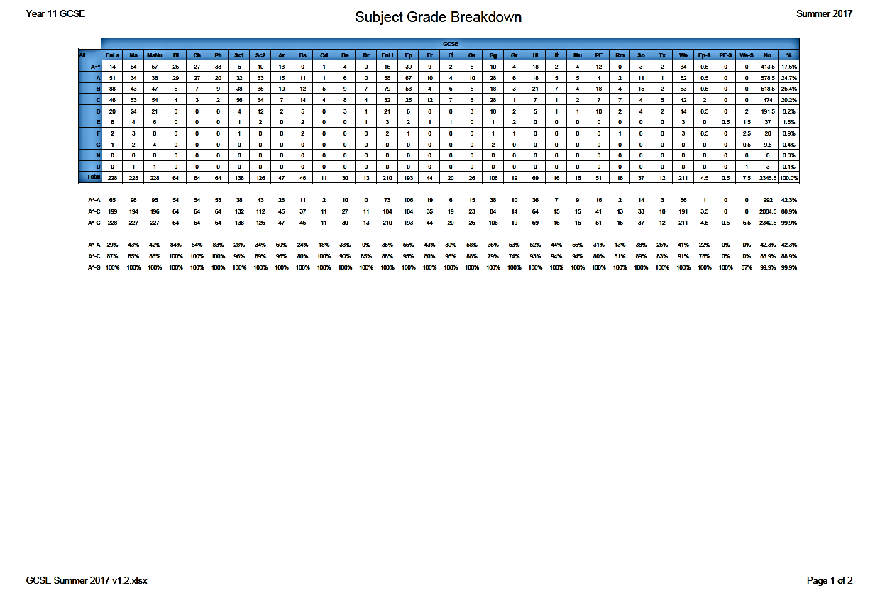

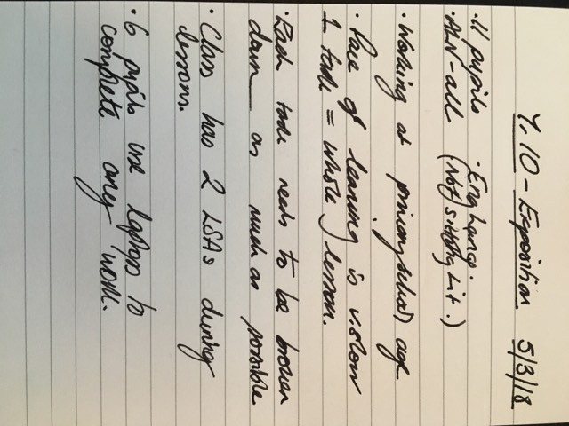
Appendix B

Appendix C
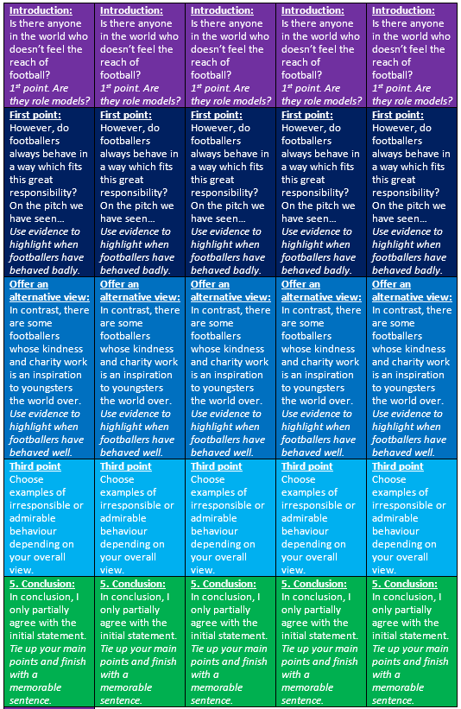

Appendix D

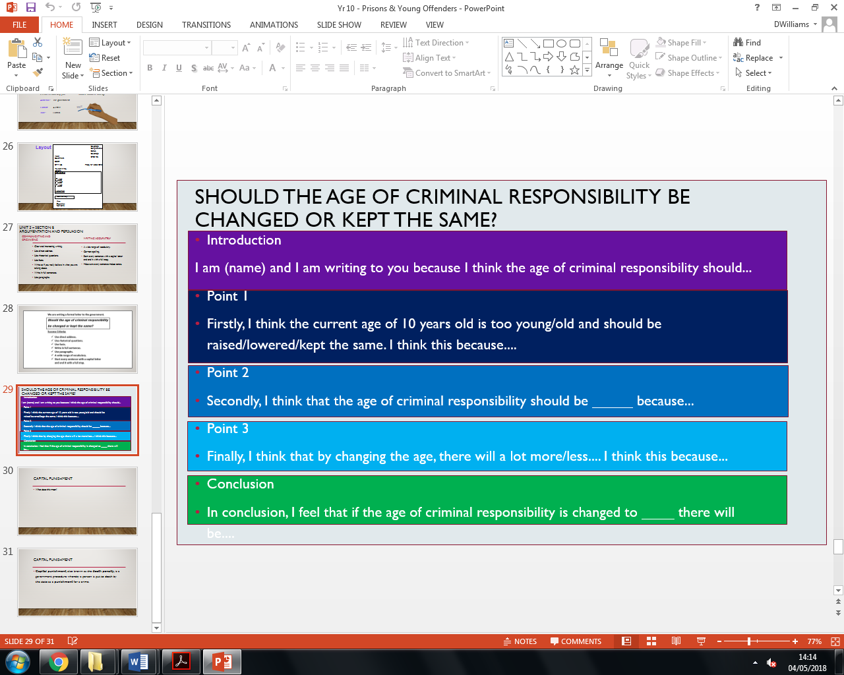

Appendix E
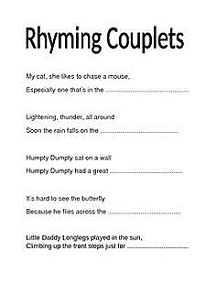

Appendix F

Swansea School of Education
Post-Graduate Certificate in Education

Proposal Form

Note: Your proposal for the School/College-Based Investigation must be approved by the PGCE Course Director via the use of this form. Please give due thought to your proposal, do some background reading and discuss the issues with your mentors. Do not begin work in earnest until your proposal has been approved.

Name: Daniel Williams

1 | Area of interest and problem to be studied: What are you intending to study and what sparked your interest in this?  - Low attainment levels in writing at KS3 and KS4.  - Slow Writing.  - My interest was sparked after reading about the various writing approaches than can be implemented by teachers within classrooms to improve the attainment levels of writing.  - For this research project I would like to investigate if ‘Slow Writing’ can help to improve the levels of writing attainment at KS3 and/or KS4.
2 | Investigative Questions: What two or three research questions are you intending to investigate?  - Primary Question: What effect does the writing intervention of ‘slow writing’ have on the writing attainment levels of KS4 pupils.  - Secondary Question: Does the gender gap in attainment have a role to play in the levels of attainment in writing. (Girls and Boys):
3 | Available literature: At this stage, what does the literature you have read suggest about the issues? (If you do not reference literature here your proposal will not be approved)  - That writing is the subject in which pupils perform less well compared to reading, mathematics and science (Department for Education, 2012, 7).  - The methods of ‘slow writing’ (David Didau, The Secret of Literacy, 2014).  - *Addition by Senior Mentor (Ruth Williams) – Check out Pie Corbett – not ‘slow’ writing exactly but techniques that will help with the process and done at a primary school level which will be about right for the pupils who will be involved.

4 | Methods: What main methods of investigation do you propose to adopt? Include a statement on Ethical Considerations here.  - Pre and Post intervention data – having pupils to write and then levelling their work.  - Reflective Journal  - Class teachers’ observations  - Ethical considerations: Will draw up an ethics form which will be reviewed by an ethics committee.
5 | Presentation: How do you propose to present the results of your investigation? Remember that this must include a procedure for presenting back your findings in your School or College.  - The investigation will be presented in the form of an 8000 word research paper.  - This paper will be anonymised to protect the data and identities of the pupils and/or school(s) involved.  - The paper will be stored electronically in the University of Wales Trinity Saint David system and will be encrypted within this system.

6 | Working Title: Propose here the working title of your investigation. Minor adjustments to the working title may be made, but any major changes will require a new proposal process.  - What effect does the writing intervention of ‘slow writing’ have on the writing attainment outcomes of KS4 learners?

7 | Reflecting upon the Investigation: How does your proposed investigation relate to the Standards for QTS? How will it relate to your continuing development as a teacher?  - S.3.4: Differentiating Teaching – Slow writing will act as a differentiating tool as well as scaffolding.  - S3.2.6: Recording Progress  - S3.2.4: Meeting Learners’ Needs  - S3.1.2: Planning Lessons  - CPD: This investigation will also allow me to perform my own piece of research which will help me in the future to carry out a similar style of research.

Signed: D.Williams [Trainee Teacher]
Signed: R. Williams [Senior Mentor]
Dated: 08.02.18

Appendix G
Learner Consent Form
For Participation in ‘Slow Writing’ Research Project

Learner Name: |  | Form Class:

Purpose of Study
- The purpose of the study is to see how slow writing can be used when writing.
- Ultimately, this research will be submitted to a university and will go no further.

Confidentiality
- This study is anonymous. We will not be collecting or retaining any information about your identity.
- The records of this study will be kept strictly confidential. Research records will be kept in a locked file, and all electronic information will be coded and secured using a password.

Right to Refuse
- The decision to have your information used is entirely up to you.
- At any point you can withdraw from the study.

Consent
- Your signature below indicates that you have decided to volunteer as a participant for this study, and that you have read and understood the information provided above.
Learner's Name:
Learner’s Signature: |  | Date:
Researcher’s Signature: |  | Date:

Appendix H
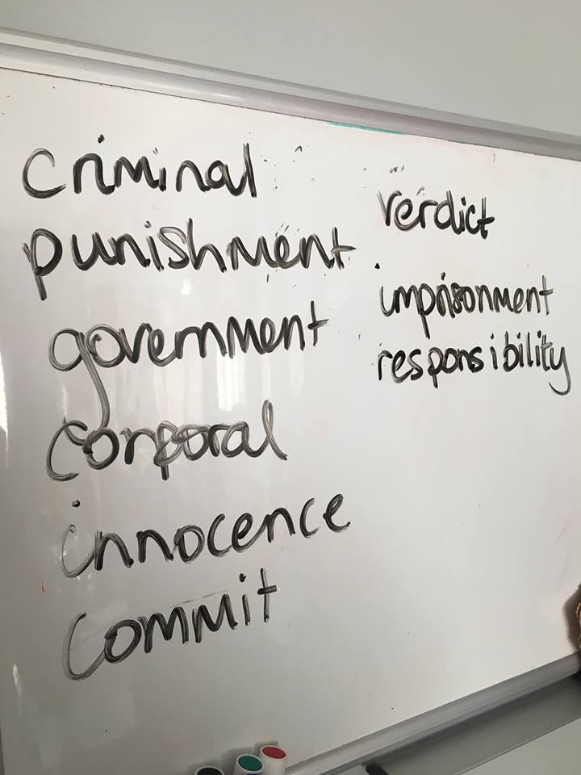

Appendix I
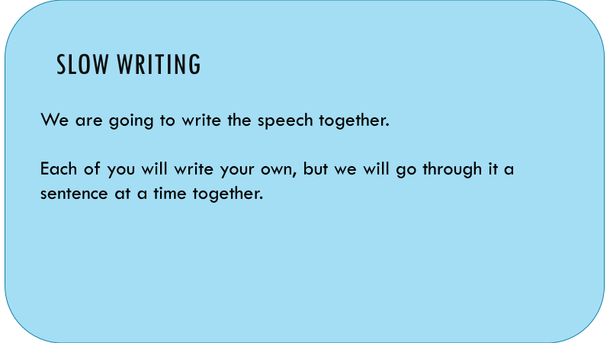

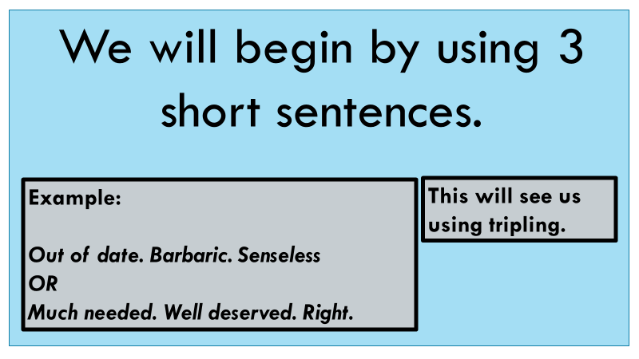

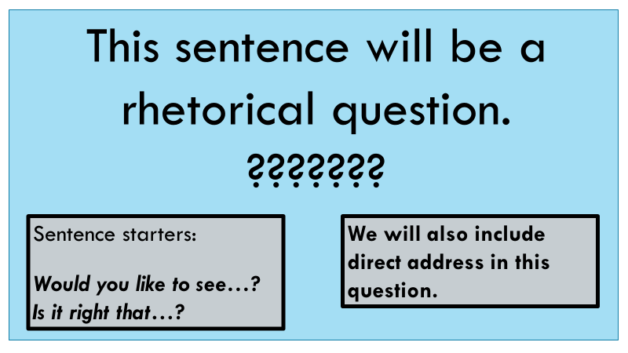

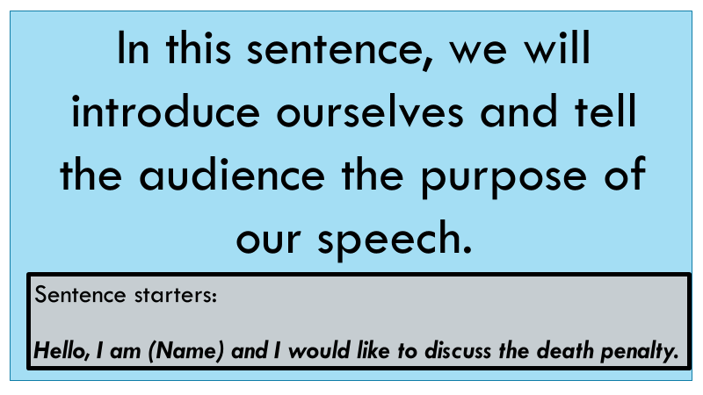

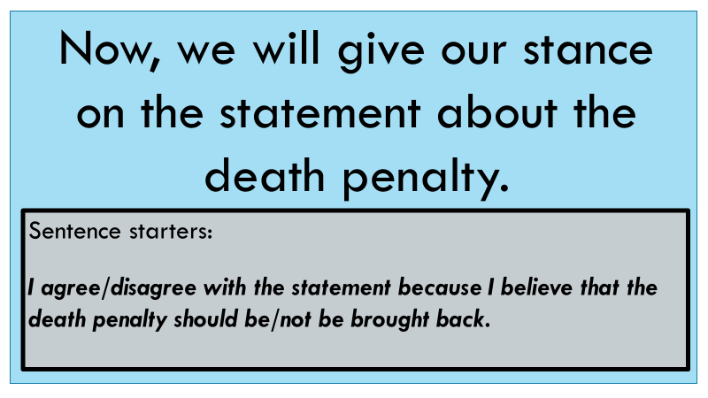

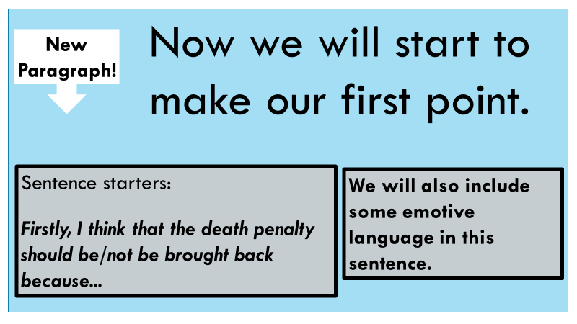

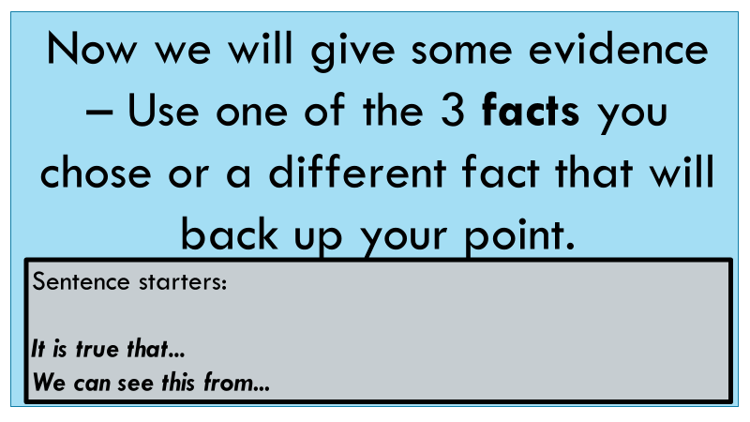

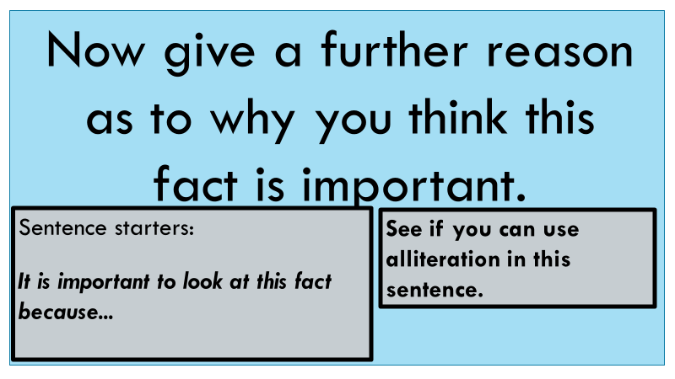

Appendix J

Appendix K
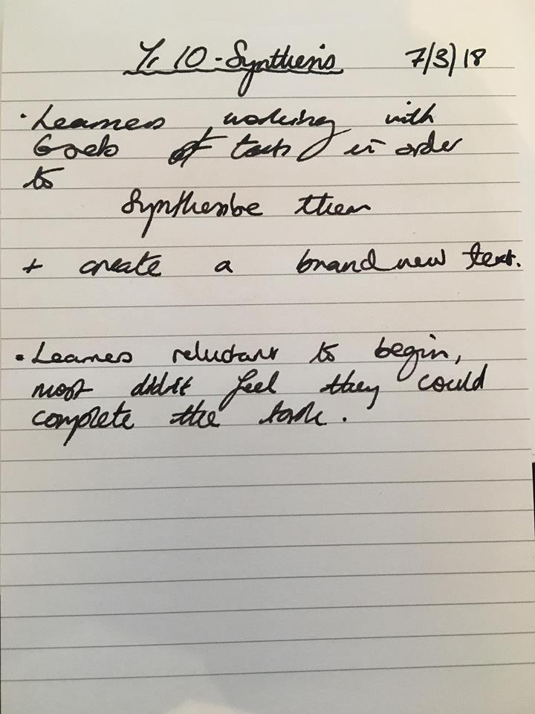

Appendix L



