University of Wales Trinity Saint David
Wales Institute of Science & Arts



Topic 3 - Storytelling and Self Confidence
Topic 4 - Measuring Success

A Reflective Journal
by Craig Worsley 2213643
​CertHE Skills for Engineering

ACMA4013 ​

04/07/2023
Table of Contents
1 Storytelling and Self Confidence Introduction 4
1.1 Literature review 5
1.2 My Personal Experience 5
1.3 Evaluating my storytelling experience 6
1.4 The value of Self-confidence 6
1.5 Conquering Confidence 6
1.6 Storytelling Competency and Confidence 7
1.7 Points to retain the Audience. 7
1.8 Conclusion 9
2 Introduction to measuring success. 10
2.1 How I gauge Success 11
2.2 The Little Wins 11
2.3 The Five Elements of Well-Being and me 12
2.4 The Pygmalion Effect 12
2.5 Gauging success 13
2.6 Conclusion 14
3 References 15
1 Appendices 17
3.1 Topic 3 17
3.2 Personal Contact Network Map 17
3.3 Identifying my Stakeholders 17
3.4 Stakeholder Matrix Analysis 18
3.5 Social Enterprise in my Local Area 20
3.6 Authenticity 21
3.7 Confidence 22
3.8 Topic 4 23
3.9 What Success looks like to me Poster? 23
3.10 Rethinking Success 24
3.11 My Speech on The Pygmalion Effect in Engineering 25
3.12 My Well-being Map 26
3.13 Success and Well-being 26
3.14 My Prominent Personality Traits 27
3.15 My Personality Attributes for Working Well in a Team. 28
3.16 Negative attributes for Team Collaboration 28
3.17 Maximising Strengths in a Team Environment 29
3.18 Mitigating Effects of less Useful Traits 29
3.19 Padlet 30

Storytelling and Self Confidence Introduction

Storytelling has been used since the dawn of civilization, it was used to share information and knowledge [1].
The Storytelling blueprint has evolved into a competent structure to deliver information efficiently in the digital era, I will be delivering my storytelling reflective journal by addressing the impact of evolving teaching strategies using the storytelling methods [1]-[6].
I will be divulging how the techniques I have research have helped my presentation, creation, and communication skills, how incorporating the storytelling blueprint into a teaching structure is advancing the way in which we communicate, learn, and express ourselves academically [6].

Literature review

Through analysing research papers, conferences, journal articles and websites [1]-[6], storytelling has widespread application advancements as well as teachable structures that have a wide age range applicability, demonstrating the system could evolve current teaching strategy standards, furthermore with advancing technology like augmented reality in teaching and training, the merging of technology and structures like storytelling are paving a revolutionary step towards intellectual acceleration through more inclusive and engaging teaching strategies, where artificial intelligence and human intelligence combine.
The adoption and integration of storytelling techniques are advancing not only our retention of information from presentations in academia but in the classroom also, with a vast range of applications the technique is excelling skills in communication, collaboration, academic development, and technology integration, the systematic structure of storytelling has helped to engage audiences, develop skills quicker, deliver information in a more digestible and retainable manor while integrating new technology smoother which aids education from primary schools to universities [6].

My Personal Experience

One of my personal experiences with the storytelling structure was delivering an integrated project presentation, I was not able to deliver the full systematic approach like in [3], [4], I did however follow a simplistic version of the structure, I streamlined information, kept the presentation flowing in a systematic order, stuck to key points, reduced data to a minimal per slide, used images to paint a picture and delivered a clear flow of information from introduction to conclusion.

Evaluating my storytelling experience

During my presentation I was given access to a great deal of information and support, I talked through my presentation with a friend, criticized my structure/layout, quantified slides and looked at how I was guiding the viewer with visual representations throughout the demonstration. My experience shaped my understanding of creating a better presentation, by understanding my presentation from the viewers perspective I created an appeal to innovators, suppliers and doers, I believe it captivated the audience in the intended way, implementing positives and negatives captured the audience’s attention within the first 60 seconds, then I slowly unveiled a solution while descriptively alliterating key information, I managed to create a clear informative story that had a problem/plot (beginning), product/information (middle) and a solution (end).

The value of Self-confidence

Confidence is key to deliver the perfect story, from enticing the audience to projecting the information in the best possible way, what I learnt through my research [2] is we can boost confidence while improving flow and deliver a pitch clearer.

Conquering Confidence

The first directive when battling confidence is self-confidence “say it till it’s true”[2], your belief is 50% of the battle so practice.
2) Deliver the story in your words, iron out imperfections, make it yours.
3) Make key notes, I wrote key points on my notes for each slide on a piece of paper, this helped to keep flow and retain key information to work off.
4) Be passionate, if you have a strong belief in what your story’s message is, the audience will see the value of what you are delivering.
5) Blood flow, stand or move but do not pace.
6) Create flow, a structured design helps to keep the audience engaged which will instil confidence in you also.
7) End on a high, don’t just drop off at the end of the presentation engage with the audience, ask for feedback, this will add context and promote self-confidence for future presentations.
These are the steps I found most useful when delivering my presentation.

Storytelling Competency and Confidence
The storytelling technique described in [5] shows how we use numerous tools to create digital stories while using intelligent technology, it not only expands user engagement but also assists us to acquire technical knowledge and develop better interpersonal skills.

Points to retain the Audience.

Having an agenda keeps the audience informed, highlights milestones and shows control and structure when timing presentations, another important point is interaction, keep the audience involved to retain focus and sum up key points, it is well documented that the longer the presentation is the higher probability micro sleeping occurs so illiterate using images, segregate topics into sections, try to stick to three main topics with sub topics if possible [2].

Conclusion

To conclude my reflective journal, I would like to say I thoroughly enjoyed the course, I found the information extremely helpful and interesting.
I will be using the information to develop my communication skills and competency in speaking and listening further by applying these skills to my next presentation.
The module has created a new perception on perspective, from structure of a presentation to engaging with an audience, it is an interesting skill that I am looking forward to evolving.

Introduction to measuring success.

In my reflections on success, I will be unravelling what I feel success is and how I interpretate success through experience and the importance of success for personal well-being, I will be reflecting on personal experience about the importance of the little wins and the link to the five elements of well-being, followed by the Pygmalion effect, descriptively acknowledging how through verbal and non-verbal communication we impact others, while reflecting on how I have learnt to appreciate success in myself and business with the knowledge I have collected in my studies.

How I gauge Success

I gauge success in several ways, from my son getting 10/10 on his spellings to me rebuilding my motorcycle engine, every achievement is important, some are more special than others, with some being celebrated in isolation and others not even being celebrated at all. However, they are all just as important for stimulation and growth, I believe we all need to achieve some level of success daily to stimulate a sense of achievement/accomplishment.
There are many ways we can feel successful from Financial, career, education, personal development, health and wellness, contributions, and impact [7].

The Little Wins

Success doesn’t have to be launching a company or getting a master’s degree, the little wins are what keep us going every day, to put this in perspective I had a friend ask me recently to help him with his finances, helping a friend in this way was a successful little win which warmed my heart, I have always been good with money but he complimented my competency, trusts me by give me full access and to take onboard my advice showing respect, not only am I proud of my financial success but also helping another person whose struggling is one of the most fulfilling successful personality attributes in society, this is because your selflessly helping another, you get to watch their success which is your success also, it is similar with our children, community outreach programs, volunteering and mentoring, to be successful is to have mental and emotional stimulation whether it’s business, family, hobbies, selfless acts or intellectual growth, the human mind needs stimulation for emotional well-being.

The Five Elements of Well-Being and me

An interesting perception about success and the five elements [8] is the biggest threat to our own happiness is ourselves, through a lack of self-control or strategic thinking, when looking from a statistical point of view balancing all five is extremely difficult, I find to appease one I sacrifice another however, in each of the five groups there is a general direction towards making mature responsible long-term decisions to the best of your abilities, growth is a huge part of success and I believe you must go through hard times to reap the rewards, to struggle dictates personal growth and there is an old saying that I believe is fitting towards personal growth “nothing worth having comes for free”.

The Pygmalion Effect

The Pygmalion effect [9] is a philosophy that shows the positive or negative impact we can have not only in a mentoring environment but social and parental, the impact we have on everyone around us shapes our world, our subconscious feelings impact through non-verbal communication and our verbal communication, this interaction shapes the subconscious thoughts and feelings of others around us, as much as we possess control there is a level of personality attributes like contrivance and altruism towards one to one mentoring, to understand the process on how to positively impact another person instilling confidence and guiding a specific individual in the correct way is extremely difficult, to be able to change the confidence and abilities of another through encouragement, support and challenges is extremely difficult but rewarding, in [10], [11] it shows how in the mentoring process it’s not just the student that gains perspective and insight, the mentor exhibits personal growth also, much like in parenting.

Gauging success

There are numerous ways to gauge success, in business ventures there are several parameters we would consider attributing to its success [12], social network, dedication, capital, the businesses acceptance publicly, how resources and people are managed/available, ability to thrive in a demanding market and the managers experience.
A considerable part of the success of a business is attributed to the staff and the way in which the business operates, in [13] we can see how promoting health and well-being is contributing to performance and the lives of employees, which in turn is successfully contributing on a national scale. Through this example we can gauge the success of implementing health and wellbeing towards national growth.
Success is a complicated endeavour to gauge which can be interpretated through a multitude of categories, from quantifiable outcomes to personal growth, views on success can have a negative impact with an obsession in comparison or competition often leading to stress and anxiety, which impedes on an individual’s uniqueness and hinders the importance of personal growth. Aligning values and passions to determine fulfilment and reflecting inwardly is important as success is subjective, develop your own milestones and avoid comparing your success to others.

Conclusion
To conclude my reflective journal on success I would like to illiterate we all see success differently, we all need to manage our own success and to be observant of how you impact others as success can be taught but so can failure, I would like to clarify that success is a necessary part of well-being [13] and through the course of rational thinking we can all achieve and sustain a happy successful life [7].

References

References
[1] B. Avsar et al, "Academic Presenter: a New Storytelling Presentation Software for Academic Purposes," 2016. . DOI: 10.48550/arxiv.1607.06979.
[2] C. Croft, "Master Confident Presentations," 2018.
[3] Nancy Duarte, "The Secret Structure of Great Talks," 05/02/, 2012.
[4] N. Duarte, "Creative Inspirations: Duarte Design, Presentation Design Studio," 2009.
[5] N. W. Kim, "From Exploration to Explanation: Designing for Visual Data Storytelling." , 2019.
[6] Ashraf Atta Mohamed S. Salem, "Multimedia Presentations Through Digital Storytelling for Sustainable Development of EFL Learners’ Argumentative Writing Skills, Self-Directed Learning Skills and Learner Autonomy," Frontiers in Education (Lausanne), vol. 7, 2022. . DOI: 10.3389/feduc.2022.884709.
[7] P. S. Kruger, "Wellbeing—The Five Essential Elements," Applied Research Quality Life, vol. 6, (3), pp. 325-328, 2011. . DOI: 10.1007/s11482-010-9127-1.
[8] (4/04/). The Five Essential Elements of Well-Being. Available: https://www.gallup.com/workplace/237020/five-essential-elements.aspx?thank-you-subscription-form=1 [Accessed 28/06/ 2023].
[9] P. Loftus, "The Pygmalion effect," Industrial and Commercial Training, vol. 27, (4), pp. 17, 1995. Available: https://www.proquest.com/scholarly-journals/pygmalion-effect/docview/214110328/se-2?accountid=130472 https://libkey.io/libraries/1422/openurl?ctx_ver=Z39.88-2004&ctx_enc=info:ofi/enc:UTF-8&rfr_id=info:sid/ProQuest&rft_val_fmt=journal&rft.genre=article&rft.jtitle=Industrial+and+Commercial+Training&rft.atitle=The+Pygmalion+effect&rft.au=Loftus%252C+Paul.&rft.aulast=Loftus&rft.aufirst=Paul&rft.date=1995-04-10&rft.volume=27&rft.issue=4&rft.spage=17&rft.isbn=&rft.btitle=&rft.title=Industrial+and+Commercial+Training&rft.issn=00197858&rft_id=info:doi/10.1108%252F00197859510087578 https://doi.org/10.1108/00197859510087578. DOI: 10.1108/00197859510087578.
[10] L. W. Howard, T. L. Tang and M. Jill Austin, "Teaching Critical Thinking Skills: Ability, Motivation, Intervention, and the Pygmalion Effect: JBE," J. Bus. Ethics, vol. 128, (1), pp. 133-147, 2015. Available: https://www.proquest.com/scholarly-journals/teaching-critical-thinking-skills-ability/docview/1671987609/se-2?accountid=130472 https://libkey.io/libraries/1422/openurl?ctx_ver=Z39.88-2004&ctx_enc=info:ofi/enc:UTF-8&rfr_id=info:sid/ProQuest&rft_val_fmt=journal&rft.genre=article&rft.jtitle=Journal+of+Business+Ethics&rft.atitle=Teaching+Critical+Thinking+Skills%253A+Ability%252C+Motivation%252C+Intervention%252C+and+the+Pygmalion+Effect%253A+JBE&rft.au=Howard%252C+Larry+W%253BTang%252C+Thomas+Li-ping%253BJill+Austin%252C+M.&rft.aulast=Howard&rft.aufirst=Larry&rft.date=2015-04-01&rft.volume=128&rft.issue=1&rft.spage=133&rft.isbn=&rft.btitle=&rft.title=Journal+of+Business+Ethics&rft.issn=01674544&rft_id=info:doi/10.1007%252Fs10551-014-2084-0 https://doi.org/10.1007/s10551-014-2084-0. DOI: 10.1007/s10551-014-2084-0.
[11] P. Martínez-Sanchis, C. Aragón-Amonarriz and C. Iturrioz-Landart, "How the Pygmalion Effect operates in intra-family succession: Shared expectations in family SMEs," European Management Journal, vol. 38, (6), pp. 914-926, 2020. . DOI: 10.1016/j.emj.2020.04.005.
[12] M. Sharir and M. Lerner, "Gauging the success of social ventures initiated by individual social entrepreneurs," Journal of World Business : JWB, vol. 41, (1), pp. 6-20, 2006. . DOI: 10.1016/j.jwb.2005.09.004.
[13] S. Bevan, "The Business Case for Employees Health and Wellbeing A report prepared for Investors in People UK The Business Case for Employee Health and Wellbeing 2," 2010.

Appendices

While I was creating my reflective journal, I was participating in a multitude of subjects that add value to my work. I will be listing the content below.

Topic 3

Personal Contact Network Map

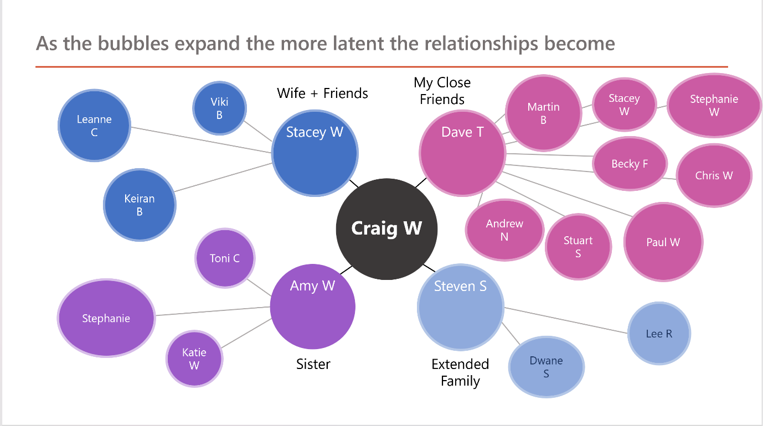

Identifying my Stakeholders
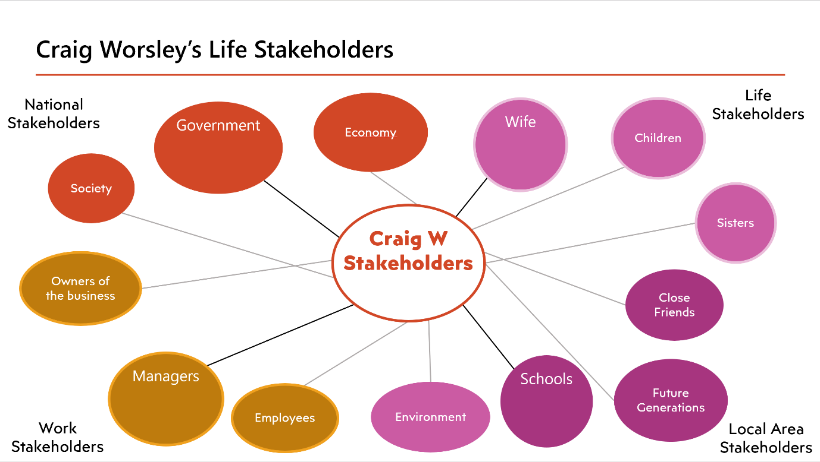

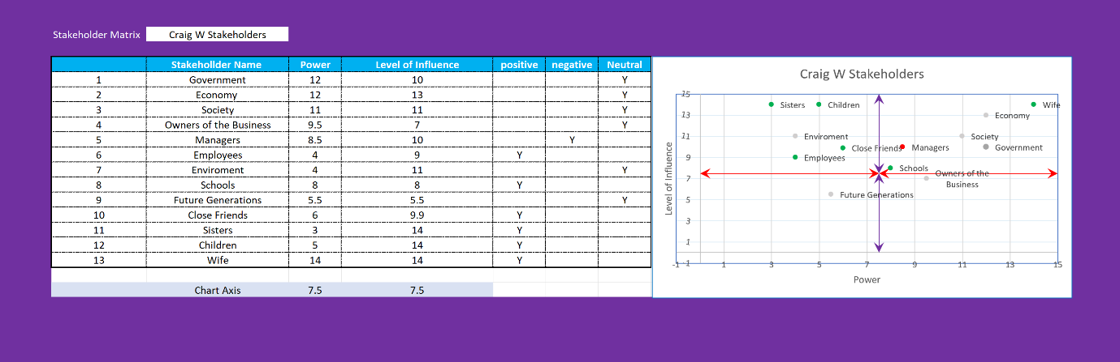

Stakeholder Matrix Analysis

The matrix analysis I provided was dependent on my own interpretation and assessment for scoring, I included the local authority but also included a local council liaison team or the councils Representative, this is because a particular team would integrate ownership and address issues throughout the transfer of ownership, the local authority would be providing some funding however, more funding could be haggled but this would be acquired through the communication redirected through the local authorities teams.
I assessed private businesses by rating them as a sole investor, these investors are not particularly interested in the future plans and programs for the park, only their own interests in upkeep, space allocation and sustainability.
Another key point to address is the scoring criteria which is on a perception I have created of the situation, stages of the transactions and how different entities would intercept proceedings, for example government bodies, I imagined these as a national trust or links for support to green initiative improvement programs or upkeeping grants, as well as other infrastructures parks etc., that share ideas on upkeep and sustainability.
I included a few different local bodies as there are different levels of involvement in the local community, local funding for example in youth initiative programs and institutional involvement crosses over as well as local community fundraising.
The criteria I created the numbers from was low, medium, and high (1,2,3) then separating what I believed the impact and involvement category it belonged to, for example, funding was in power and community involvement would be in influence, I then calculated the figures and created a scatter graph to display the stakeholder matrix analysis.

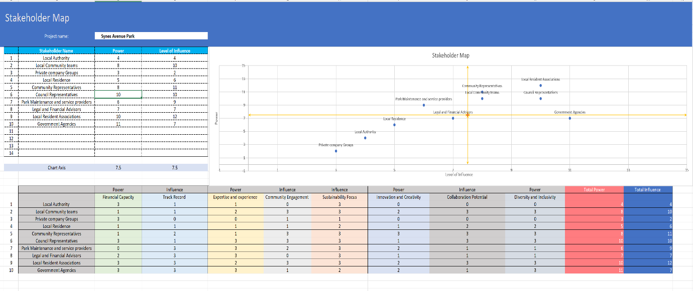

Social Enterprise in my Local Area

  - Identifying Local issues

In my local area there is unfortunately a substantial list of issues towards employment, homelessness, and supportive services, a local business aids in the development of structures to address these issues, who invests their own funds, collaborates with local business, and organises events, drop-in support centres and schemes to tackle homelessness, education, supportive services and programs for community outreach.

  - Bolton at home

In my local area is a housing association like no other, I say this because of the way the company has evolved its intrinsic values to become a very distinctive pillar of the community, to first explain how the company devised its unique perspective I have to explain its roots, the cross over began from a governmental body that transitioned into a business, holding its structure and evolving has helped develop Bolton at home into what it is today. The values the company upholds illiterate strong support and growth through community values with the added entrepreneurial business logic, intertwined to create what we see today, a business that has countless community outreach programs, with support networks and a strong communication ethic with the council and government services, this mixture of business and community support and ethics constitutes what I believe to be a true entrepreneurial vision and a credit to the local community.

Authenticity

Authenticity is a descriptive word to describe how real or not real something or someone is, it describes how true to the truth it is while having a skeptical stance.

Authenticity describes how true you are to yourself, we all change to match our situations and work compared to homelife is a good viewing point to how authentic we are, to ourselves.

  - Times I am Authentic.

I am more authentic at home however my passions bring out my true self.

  - Showing my Human side

This shows that my passions drive my personality and authenticity, so the more I embrace what I love doing the truer I can be to myself and in turn be more fulfilled in the life I create.

Confidence

  - Body language

People with confidence show this in their body language by standing up straight, giving good eye contact, smiling in a confident manner, and tone of voice [2].
  - Appearance

Confidence can be seen in appearance, when you are smartly dressed, clean shaven and wear confidence like in the examples above.

  - Manners

When speaking to a confident individual they will be assertive not dominant, respectful but not a push over, empathetic but not a charity case and poised to show they are comfortable in their own skin.

  - My Sister and confidence

My sister shows a great deal of confidence in the fact she is comfortable in who she is, does not shy away from anything, she is strait talking, makes eye contact and expresses herself without being dominant, I believe she wouldn’t agree with me because she does lack the very same qualities when it comes to interviews however, in general I think she is a very confident individual.

  - A List of Attributes when being Confident

- Eye contact
- Posture
- Feeling confident
- Appearance
- Personality and demeanor

Topic 4

What Success looks like to me Poster?

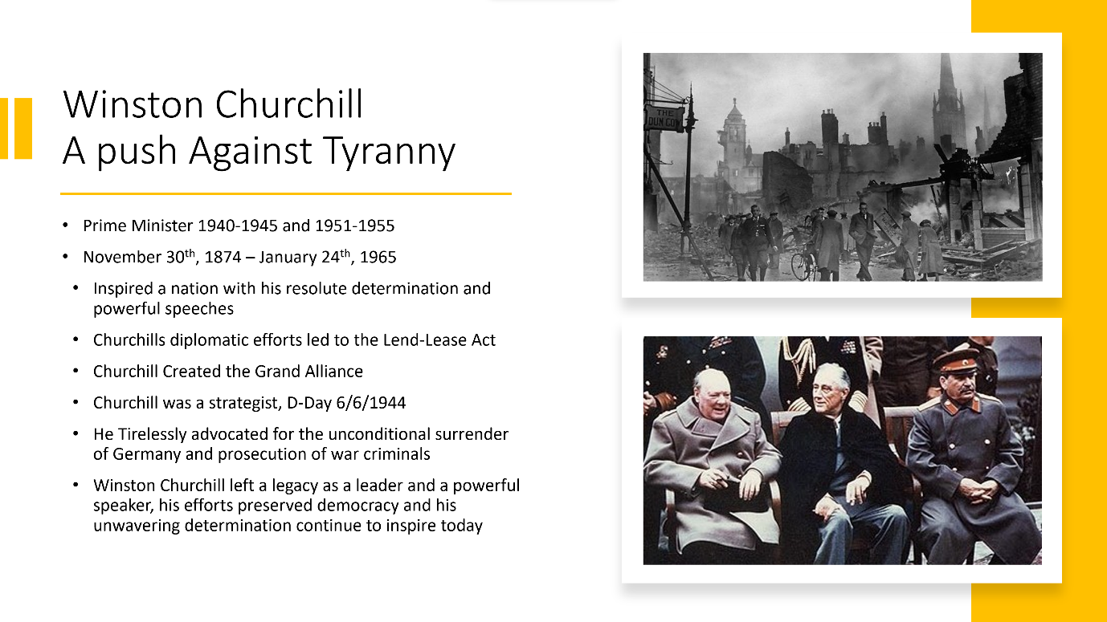

Rethinking Success

I chose someone famous because of how most of us think about success.
Chad Hurley, Steve Chen and Jawed Karim? most people would have no idea, yet they created YouTube.
The reason they were successful yet not famous I believe is, they were not the face of their product, I think some people fear fame because it can have a devastating impact for example kidnapping, social freedom and lack of privacy.
I chose Winston Churchill because his success and fame was noble and iconic, fame was not a driving factor in my choice.
Fame is in the public eye, it’s how a lot of people gauge success.
I do however believe we all achieve success in the little wins, getting that job or engineering degree, but unfathomable ones like string theory (Gabriele Veneziano 1969) or quantum theory (Niels Bohr and Max Planck and also Einstein who was skeptical), I was aware of the work not the creators, yet this work will change humanity.

My Speech on The Pygmalion Effect in Engineering

In the world of engineering, we engineers hold ourselves to a high standard, but how can we mentor trainees to develop this untapped potential and rise to the superseded level of an engineer, embracing complex thinking, critical analysis, and incomparable imaginative creation.
I introduce you to the Pygmalion effect, it is a fascinating psychological mentoring strategy that can unlock potential with comforting confidence, precursive admiration of intelligence and challenging intellect, we can develop a shy bundle of intelligence to a confident go getter whose admiration for the confidence and belief that has been instilled in them has evolved them into an inspirational role model for upcoming students.
To summarize, the Pygmalion effect is when individuals are treated with advanced intelligence and exceptional abilities, they will achieve higher standards than if they were not, the transformative power of the Pygmalion effect has amazing possibilities.
Professors and mentors for engineering students who believe in their students in this exceptional way can light a fire beneath a student to spark untapped potential. A student in a nurturing and high expectational environment are more likely to push their limits, explore more avenues and advance exceptionally quickly in their studies, this not only pushes the student to their capabilities in studies but promotes their technical skills, confidence, ambition, and innovative thinking.
The Pygmalion effect can revolutionise teaching in work environments, when managers exhibit belief in co-worker’s capabilities, they support growth in the workforce, by adopting a culture of high expectations and providing support, teams exhibit improved collaboration, increased motivation and a surge in creative problem solving. The Pygmalion effect has a unique effect where once a person has adopted to the encouraging environment, individuals start to challenge themselves bringing forward fresh ideas and exceed their own expectations.
In conclusion the Pygmalion effect has the power to unlock untapped potential by harnessing the psychological impact of high expectations, support, and belief in an individual, in turn this creates greatness, innovation and slingshots individuals to fulfil their potential.

My Well-being Map
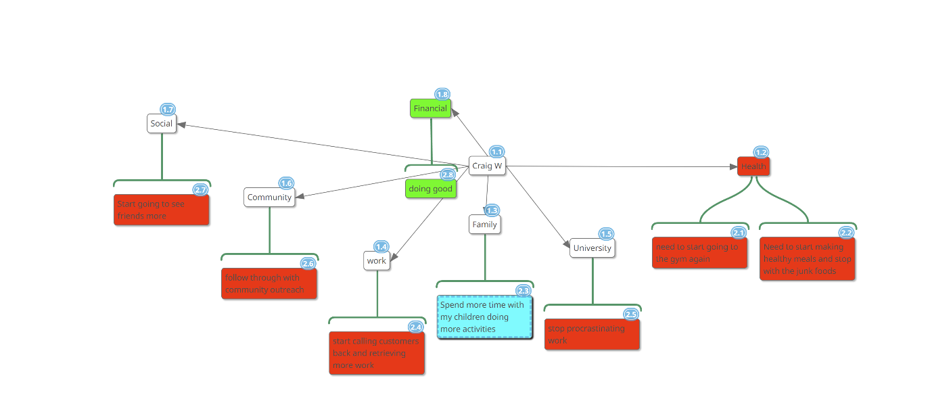

Success and Well-being

Success and well-being are interconnected in my mind, I have always been a firm believer in hard work and efforts drive progression, in work and out.
To achieve success we must first look at various aspects of our life, achievements, goals, happiness and well-being, if we just focus on external success such as wealth, fame and professional status we don’t always align ourselves with our core values or sense of purpose, when we look inwardly at what matters to us we find our own definition of success, which include elements of well-being therefore I believe, well-being is part of a hierarchy process to achieve a success life balance [7].
Career well-being
Social well-being
Financial well-being
Physical well-being
Community well-being.
In each of the topics above are subtopics, picking any one of these topics regularly to expand on will lead you to an improvement you can make to better your life and the people around you.

My Prominent Personality Traits

The information I received from the tests are that I am in the high functioning 23%, I am a little unclear on the information as I believe it is quite subjective and the questions are vague, the questions can be interpretated in a multitude of ways.
I will be spending some time digesting this information once I have completed my course, as I believe it’s my understanding of the information that’s the issue, it has been explained in a previous paper that the 5 factors are a guide not an exact science.

My Personality Attributes for Working Well in a Team.

In the personality test it concluded that I am a high functioning individual that works well in a team, I am friendly, approachable, conscientious, a creative problem solver, open minded, good natured and I enjoy direct leadership roles.
The attributes described in the personality test dictate that I would work well in a team for a vast number of reasons and I honestly feel this is correct, I do see that because I care about other perceptions, listen to outside opinions and grow well with others the greatest attribute of mine is my compassion, as it holds a host of other attributes for team collaboration skills.

Negative attributes for Team Collaboration

In the tests it shows that I worry and work well independently, which is true. I predictively assess things to solve problems before they arise, and I love socialising, but I can also put my head into my work for 12 hours without any interaction even while around others. One thing that I know of that isn’t addressed is putting up with toxic, negative people or bullying, I have cut off relationships before because of people demonstrating these traits in extreme circumstances. To put this into perspective I am reserved unless engaged then I can be very talkative, I can see who people are most of the time before knowing them through body language, the way they speak and are interacting with others, I will confront bullying or make that comment addressing a toxic statement no matter how uncomfortable. Intelligence is to be respected but does not give the right to demoralise others. However, I can be quiet when a manager is having a rant in a toxic manor (power trip – demoralising staff for no justifiable reason), I have a strong belief that we are all equal, we all excel in different ways, good people don’t always like each other but that doesn’t mean you have to dislike each other either.

Maximising Strengths in a Team Environment

I naturally flourish most of the time into what I believe my role is, however from the five factors assessment and because I help shy people have a voice and welcome others opinions and ideas, the way in which I believe I can add value is be myself and open up more, I have led a team yet I will always be the last to offer leadership, yet with my personality attributes its probably best if I step forward more as I seem to have a fitting persona for collective inclusion, respect and consideration for others.

Mitigating Effects of less Useful Traits

In the big five factors I was labelled as a yes man, prone to worrying and easily upset. I believe the easily upset was a mistake, because of my diabetes I answered a question slightly different from my personality, yet I can sometimes be emotional which has developed with my diabetes, but I am in full control and I believe this does not affect my interaction with others as I know if my bloods are high or low it causes these problems, I am very good at managing my emotions in any case. I could use my worrying in the same way I do in everyday life, to predict problems and assess solutions. The yes man statement is another that I do not agree with, I like to say yes but I am fully capable of saying no to someone in a more powerful position without care for the ramifications, as honesty is more important when working in a team, if there is no advantage only conflict, I am capable of just agreeing to not upset someone.

Padlet
I have also compiled a modest amount of work on Padlet, which I will be improving over the course of the next few weeks with the team exercises.


