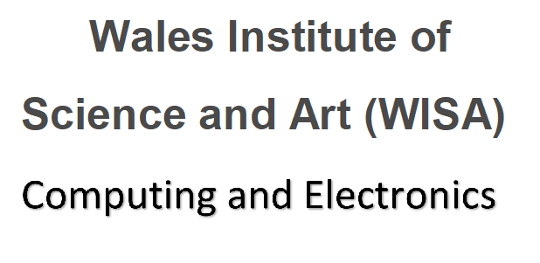
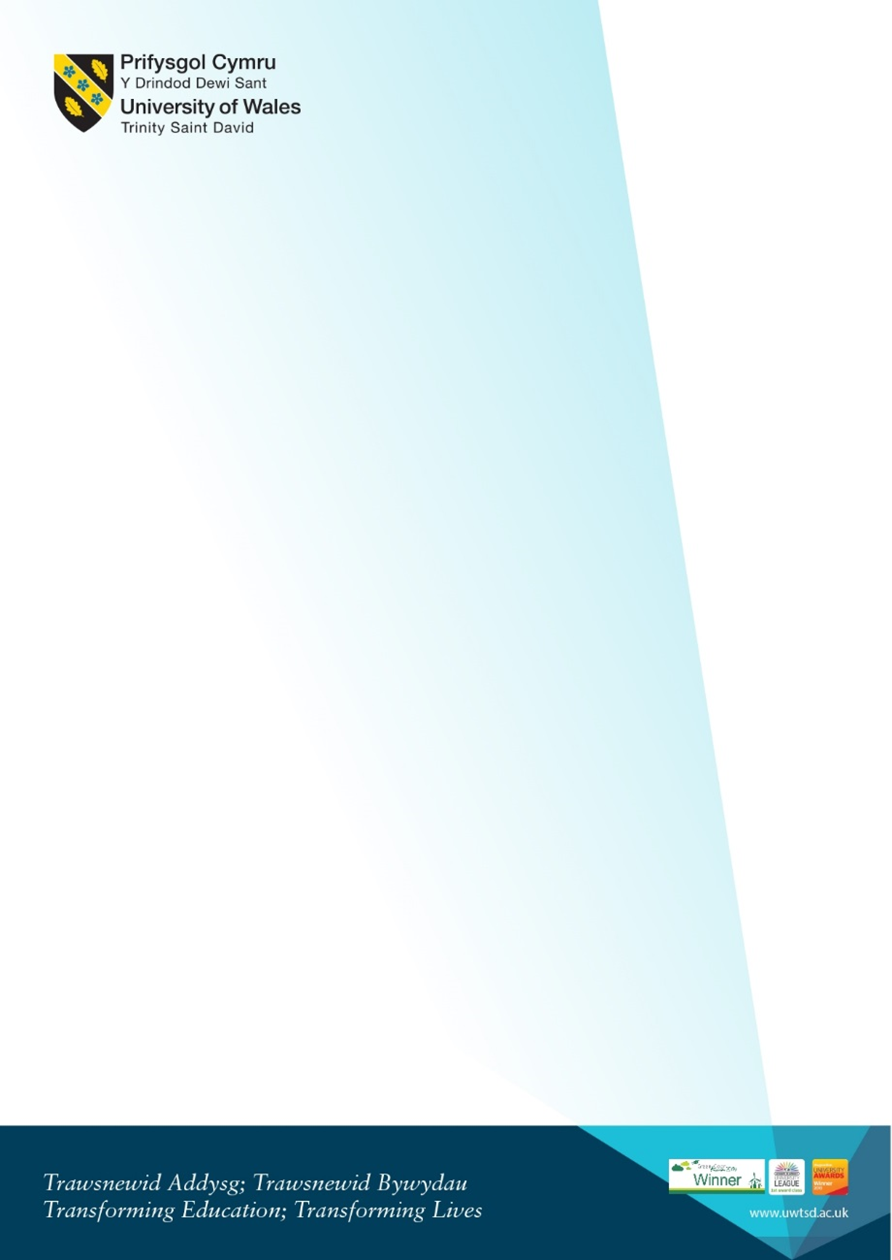

Welcome for new Digital Degree Apprenticeship Computing (DDA)
and other PT students
Monday 23rd January 2023 1pm

1pm – 1.30pm  IQ109  (first floor, IQ building) | Welcome from the programme team  Kapilan Radhakrishnan - Academic Director (Applied Computing)  Gaynor Thomas - Programme Manager DDA scheme  Bridget Moseley - Head of the Apprenticeship Unit  + Liaison Officers | Intro to the School of Applied Computing  Who we are, our roles. Who to contact.  Introduction to the Liaison officer team  (Dan, Emma M, Steve, Emma D)  Email for Gaynor (DDA) is:  gaynor.thomas@uwtsd.ac.uk
1.30 – 2.30pm ish  IQ109 | Gaynor Programme overview | - Introduction to the DDA course structure and overview of the modules.  - Logging in  - Accessing Email and Timetable (Hwb)  - Moodle and where to find information on Moodle. DDA Moodle Pages / SOAC Homepage  - Free software available – Microsoft Azure etc for all students  - Finer points of the timetable  - What is the SOAC domain?  - ID Cards – do you have one, where to get them
2.30-45 ish  IQ109 | Team Q and A session | - Opportunity to ask questions  Individual or small group chats with Gaynor/Liaison Officers etc as required
3pm-4.15pm (ish) | Apprentice Liaison Officers specific information | - Information on Student Services and procedures to follow.  Valerie Harding  - Student Union welcome  - Library tour
 | Self-guided:  University-wide videos and Campus safety presentations link.  Please take some time to look at the available videos. If you  have any questions please email a member of the team. | Including:  - Welcome from the VC  - Welcome from Provost  - Your Campus: Safety on Campus  - Campus Virtual Tour  - Parking  - Enrolment  Link to resources on Hwb:https://hwb.uwtsd.ac.uk/pages/student/resources_welcomeandinduction

MAP:
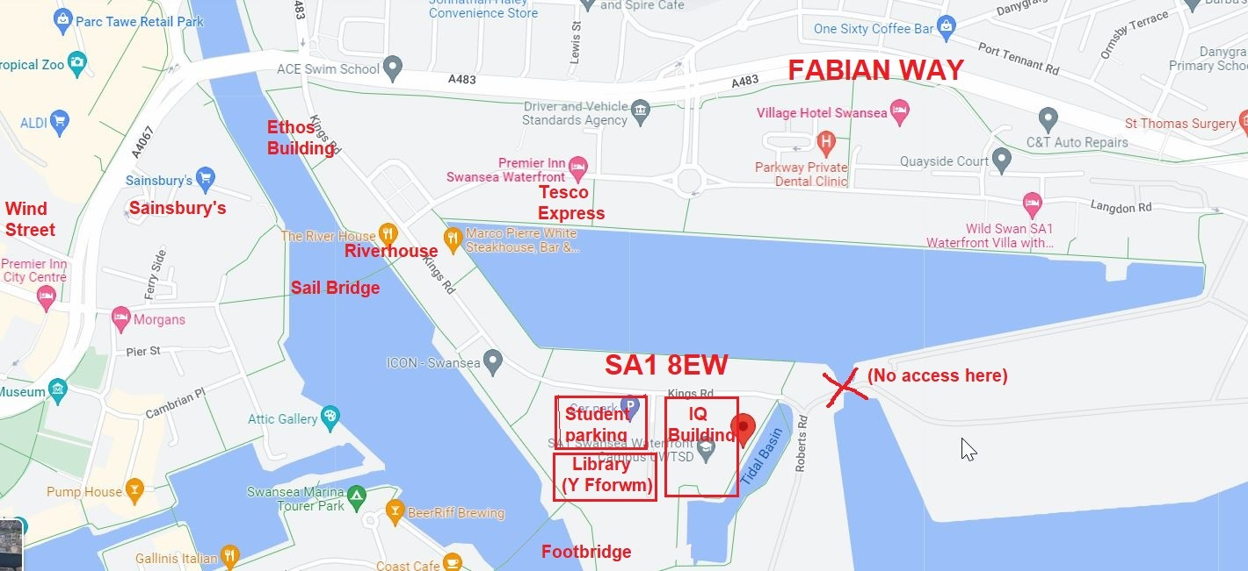
Link to Google Maps: https://www.google.com/maps/place/Swansea+SA1+8EW/@51.6186566,-3.9335031,15.5z/data=!4m5!3m4!1s0x486e8aacbcc83705:0xae10d016e8626d05!8m2!3d51.6173561!4d-3.9255004
Photo of area:


