Christopher Treseder (1701412)
Photojournalism & Documentary Photography
Title
[Draw your reader in with an engaging abstract. It is typically a short summary of the document.
When you’re ready to add your content, just click here and start typing.]
Independent Inquiry
(ADAD6001)

Contents
1 Introduction
2 Cultural Identity
3 Third Culture Kids
4 Acculturation and Immigration
5 Cultural Identity in the Arts
6 Conclusion
7 Illustrations
8 References

1 Introduction

2 Cultural Identity
Cultural Identity comprises the various attributes of any kind of social group with its own distinct culture. It summarises a variety of influences that create a shared meaning within a group. These influences can be tangible (e.g.: art, food, textiles & architecture) or non-tangible (e.g.: values, religions etc.). It is something which is learned by a group of people and simultaneously helps them identify other groups like themselves. (Ennaji, 2005)

‘‘Categorizations about identity, even when codified and hardened into clear typologies by processes of colonization, state formation or general modernizing processes, are always full of tensions and contradictions. Sometimes these contradictions are destructive, but they can also be creative and positive.’’ Paul James

Due to the subtle differences between the terms Cultural Identity and Ethnic Identity, this paper will primarily refer to the term Cultural Identity to avoid further distinction of the two. Cultural Identity plays an important role within modern society, as populations across the globe are connected more than ever by means of the Internet, Social Media and Global Marketing. But how exactly the information contained by the Cultural Identity of an individual is transmitted may lead beyond the active teachings of our ancestors.
One example of how human beings transfer information naturally from one generation to another is by the means of a phenomenon described as Cumulative Cultural Evolution (CCE).
Cumulative Cultural Evolution is a process by which information is stored genetically and passed down from one generation to another. Being part of the evolutionary cycle, this information is passed on by a rule of trial and error. According to American developmental and comparative psychologist Michael Tomasello, human beings have a unique cognitive ability to transmit cultural information from generation to generation by means of adaptation and imitation. The procedure describes an act by which an individual makes a slight adjustment to an item or practice which results in improvement. Other individuals adapt and copy this adjustment and eventually find a way to further improve the item or practice. This process of adaptation over time is argued to be what has allowed us to adapt to difficult environments around the globe, permitting us to inhabit even the most treacherous areas of the world. Though this procedure may also occur in animals, it is does not happen at the accelerated rate which it does in humans (Tomasello, M. 1999). It is this behaviour which has helped transfer cultural behaviours across generations, making us more alike in the process. This theory not only explains why human beings are so similar when restricted to a geographical area but may also help explain why the interaction between groups with differing cultural identities can have complex consequences.

3 Third Culture Kids

A single person can of course belong to many cultural groups simultaneously and may even change their cultural identity throughout their lifetime. One particular example of this sort of change can be observed within individuals showing cross-cultural identities. Much of the research found relating to this specific group within society has been provided by American sociologists Ruth and John Useem in the 1950’s. Whilst studying the children of American citizens who were living abroad with their families, the couple created a more palatable term, referring to these children as ‘Third Culture Kids’.

‘Besides the drawbacks of family separation and the very real adjustment on the permanent return to the [home country], a child growing up abroad has great advantages. He [or she] learns, through no conscious act of learning, that thoughts can be transmitted in many languages, that skin color is unimportant…that certain things are sacred or taboo to some people while to others they’re meaningless, that the ordinary word of one area is the swearword in another.
We have lived in Tulsa for five years. I am struck again and again by the fact that so much of the sociology, feeling for history, geography, questions [about] others that our friends’ children try to understand through textbooks, my sisters and I acquired just by living.’

-Rachel Miller Schaetti

The term Third Culture Kids refers to children and adolescents raised in a culture different to that of their parents. The struggles these children face, though they can be referred to as ‘first world problems’, can provide advantages as well as disadvantages throughout the lives of these individuals.

Although the children of refugees obviously fall into this category, TCK’s are not always the offspring of parents who are desperately trying to escape political persecution or violence in their country of origin. TCK’s are often the children of expatriates, sometimes moving to a country with a different culture for work purposes. The general characteristics of these children vary, bringing with them unique advantages as well as disadvantages when blending into society. The reason this group of people is so unique when it comes to a search for identity is because of their unique ‘three-dimensional’ perspective on a cross cultural experience. Multicultural Individuals such as TCK’s can face some existential hazards throughout their lives, which can lead to a situation which is referred to as cultural homelessness. Being raised in a household where the cultural norms differ from those in your otherwise everyday surroundings provides a situationally imposed developmental challenge for those involved.
In the long term, these situational circumstances can lead the affected person to accommodate contradictory and changing norms, traditions as well as verbal or non-verbal communication styles. Though the term ‘culturally homeless’ provides an air of negativity, culturally homeless individuals often enjoy a broader cognitive and social inventory, given their multiple cultural forms of reference. (Cultural Diversity & Ethnic Minority Psychology).

These multiple cultural forms of reference can act as a bridge between cultures, seen for example in the novels by author Khaled Hosseini.
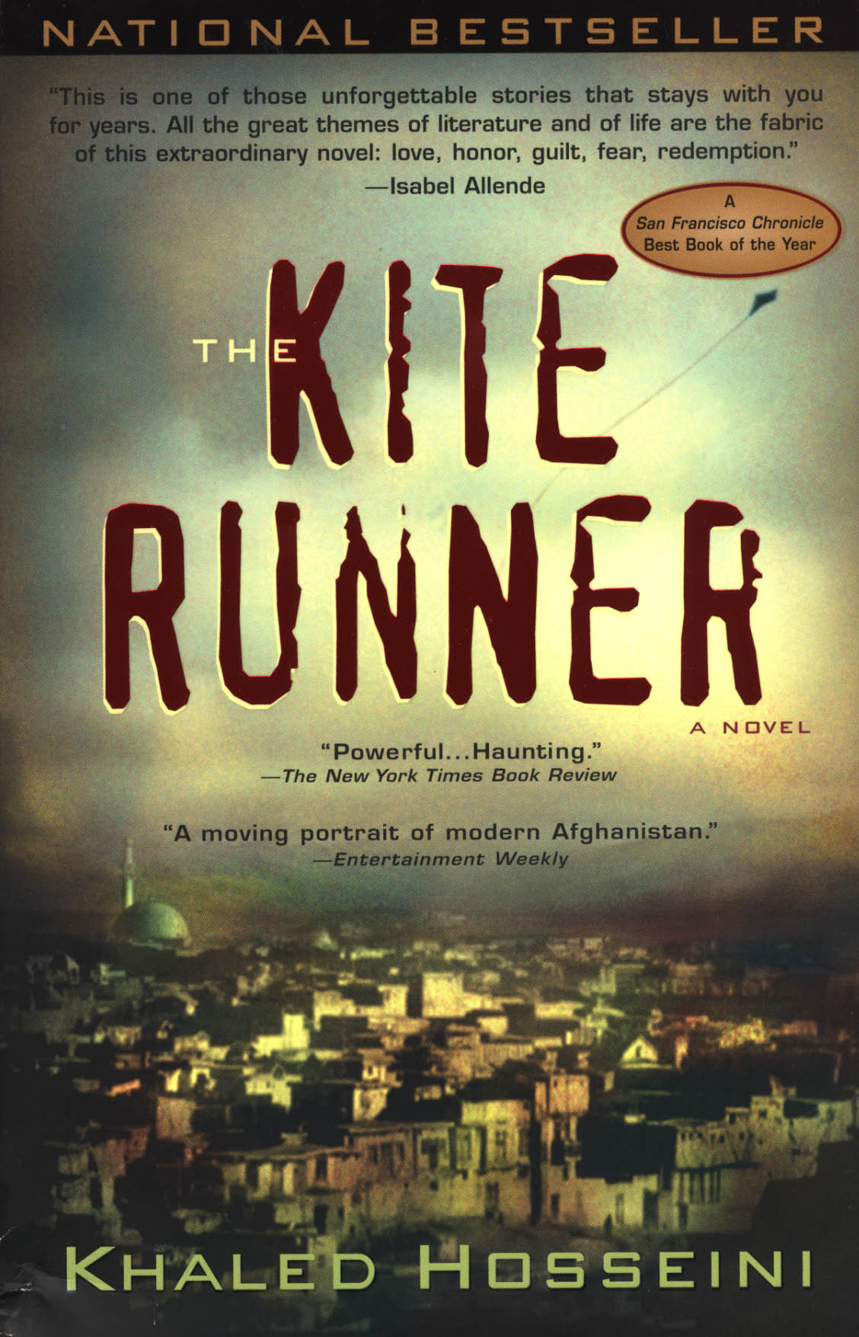
Image source: smithsonianapa.org

Khaled Hosseini was born in Kabul, Afghanistan in 1965 and spent most of his childhood years between Afghanistan and Iran (where his father worked as a diplomat for the Afghan Foreign Ministry). His family was later relocated to Paris, France by the same ministry and ultimately unable to return to Afghanistan due to the Soviet invasion. The family fled to San Jose, California where Hosseini would begin to pursue a medical career and eventually start writing the first of his publications ‘The Kite Runner’.

The novel ‘The Kite Runner’ follows a young boy named Amir throughout his childhood experiences within Afghanistan. The protagonist witnesses several traumatising events during his childhood in Afghanistan, living through Soviet occupation as well as the Taliban takeover and ultimately fleeing to the United States, similar to the Author himself. The unique insight Khaled Hosseini was able to share within his writing has provided him with multiple awards within the literary world as well as granting him the title of Goodwill Ambassador for the United Nations High Commissioner for Refugees. (Khaledhosseini.com)
Building these bridges between cultures is important for modern day society as it gives people a unique and genuine perspective of a way of life they are unfamiliar with and would otherwise not be able to relate to. Obviously, the literary skill of the author should not be discounted, however the personal bond and first-hand experience that the author has with the subject matter, having grown up in Afghanistan around the same time as his protagonists, creates an authentic emotional response from the reader.

Third Culture Kids are by no means a new phenomenon, but they are becoming more common in the modern world. Whereas in the past only few people would travel overseas for career purposes, even fewer did so with their partners and children in tow. However, these days it is quite common for professionals to be stationed abroad either temporarily or permanently and it is commonplace for them to bring their families. According to a 1990 census focusing on American citizens, an approximate 3 million Americans lived abroad either temporarily or permanently. In 2015, this number had increased from 3 million to 8 million. (The Absentee American)
Similar observations can be made in Australia, where an estimated 1 million citizens live and work abroad (advance.org), or Japan, where approximately 1.2 million people live abroad as expatriates. (www.stat.go.jp)

How can being raised in a foreign culture affect children developmentally?
Potential developmental issues that can occur throughout the life of a TCK is the feeling of rootlessness.
Alice Shu-Hsien Wu is a lecturer at Cornell University, Ithaca, New York with a particular interest in intercultural adjustment and families who have led internationally mobile lives. (thisdisplacednation.com)
Having lived in several different countries throughout her adolescence, and thus having first-hand experience in the field, Wu created a three-piece video series in 1994, 2001 and lastly 2014. The goal of this video series was to document the challenges faced by TCK’s when addressing inter-cultural transitions, identity and rootlessness.

One of the observations made throughout this study was the response to the question ‘Where is home?’. Many of the TCK’s described their families as being their ‘home’, rather than describing a geographic area. Over time, technology has helped these individuals maintain their relationships with family and friends in other countries far easier than older generations of TCK’s. Whereas in 1994 most students communicated across borders by telephone or handwritten letters, the gradual development of email, skype and social media has helped TCK’s keep in touch with their families to a greater extent and thus given them a greater feeling of being rooted, not necessarily to a place but to relationships. (TCK: Growing up among worlds. Chapter 10, Rootlessness and Restlessness)

The lack of a physical sense of home can result in a migratory instinct within many of these TCK’s. Though it can be beneficial to be willing to relocate as a result of a career choice, doing so as a direct response to restlessness can have negative effects on their academic life, professional career and even family relationships. This same feeling of a lack of belonging can result in the TCK’s moving from country to country in search of familiarity. (TCK)

4 Acculturation, Immigration and Acculturational Stress
What effects does the relocation of an individual or a societal group (whether it be for employment purposes or as an escape from political or religious persecution) have on those involved and the host country?
The following section will explore the various forms of acculturation in order to further understand the impact it can have on a group or individual during trans-national migration.

Firstly, it is important to discuss the concept of Acculturation: Acculturation refers to the socialization process which foreigners go through in order to assimilate to the dominant society’s cultural norms, values, religious traditions etc.
It is essentially a cultural interaction felt both within society and also on an individual level.
In average cases of acculturation, this process can happen naturally over long periods of time. Of course, this also depends on how different the assimilating cultures are in the first place or on the reasons for immigration. Alternatively, acculturation can happen rapidly by means of forced assimilation.

In his book ‘Immigration, Acculturation and Adaptation’ John Widdup Berry attempts to determine the long-term psychological effects experienced by individuals during cross-cultural acculturation. John W. Berry is a Canadian psychologist who specialises his work on the behavioural outcomes of intercultural experiences. Given the endless variables involved in the process of acculturation, he has listed four acculturation strategies in his so called ‘fourfold model’ (John Berry, 1997). This model describes the behavioural approaches from both the dominant society as well as the group attempting to integrate during the process of acculturation. In the following paragraphs, this paper will list the four strategies mentioned in the ‘fourfold model’ and give real-life examples of these strategies in motion.

The first of these strategies takes on the form of assimilation. This strategy occurs when a group successfully adopts the cultural values of the host country in place of their own. This process makes the migrating group indistinguishable from the dominant group. Again, this process can fall into the category of forced assimilation, a process during which the dominant society seeks to accelerate the natural process of assimilation by forcing the migrating group to adopt the language, traditions, religions and customs of the majority group.

Second comes the strategy of separation, a process by which the group rejects the cultural norms of their host country in the interest of preserving their own. This process can result in the formation of ‘ethnic enclaves’.
Ethnic enclaves are a form of voluntary segregation from a dominant society and consists of a geographical area within the dominant society where the values, norms and even language of the immigrating culture gain dominance. This process makes it easier for immigrants to make a social or economic impact within their new society by eliminating the need to learn the native language or adapting to the potentially differing social behaviours of the host country. (Disproving the Enclave Hypothesis. 1992)
Although the ability to provide social and economic stability within a society without having to integrate has its benefits early on, it can also limit the potential of immigrants who remain active within these enclaves and fail to acquire the skills required to create that stability on a broad scale. This can obviously slow down or even halt the process of acculturation altogether.

Number three among the fourfold model is integration. Successful integration occurs when a group has accepted the culture of a host country whilst at the same time maintaining their own. Integration, besides being a result of voluntary acculturation, can also be the direct result of successful desegregation policies put into place by the host culture. An example of this sort of implementation can be observed in Germany, where the Federal Ministry of the Interior (Bundesministerium des Innern, BMI) stresses that successful integration requires the full engagement of society on all levels and must be a reciprocal process. Successful integration therefore must be based on equality of opportunity and outcome, regardless of the persons race, religious background or culture and can result in what is referred to as cultural pluralism (BMI).

The fourth and final section of the ‘fourfold model’ discusses the concept of marginalization. Marginalization within society describes the withdrawal or denial of specific rights and opportunities based solely on the background of the individual. Marginalization can affect many levels of society, including the LGBT-community, drug addicts, the elderly and many more, though for the sake of this argument, it will focus primarily on the cultural aspects of marginalization. An extreme example of this sort of social exclusion exists in places such as Australia within the Aboriginal communities. In this particular situation, the marginalization of Aboriginal Australians was a direct result of colonialism, during which time they faced forced assimilation which led them to lose their lands, drove them from their homes and took away many of their working rights (Baskin, C 2003). Similar situations can be observed within the Indian caste system, a system which marginalizes minority ethnic groups based on their heritage (Times of India, 2018).

Once the nature of the acculturation method in question has been identified, the motivation behind the group or individual seeking to emigrate must also be established.

According to Seth J. Schwartz, Professor of Public Health Services at the University of Miami, there are four categories of migrants:

Voluntary Migrants: Migrants who leave their country of origin for work, education, relationships or simply to reunite with family members who have already immigrated

Refugees: Migrants who have been involuntarily displaced by conflict, natural disasters or persecution

Asylum seekers: Migrants who have voluntarily left their country of origin in order to flee conflict or persecution

And Sojourners: Migrants who have re-located to another country with the intention to return to their country of origin after a specific amount of time. (Schwartz, 2010)

Researchers for the Journal of Population Economics (Springer, 2015) were able to identify an association between significant, positive assimilation of a migrating group and their overall life satisfaction. The research was completed using information provided by the German Socio-Economic Panel. The German Socio-Economic Panel is a system which collects data based on the immigrant’s economic status (i.e. earnings and employment status) and non-economic status (demographic, education, religious background etc.) while also allowing immigrants to give personal feedback regarding their relationship to the host country (in this case Germany) and their own native identity.

The reason Germany has been able to provide such consistent information regarding migration data is its history with migration dating back to the end of World War 2. Rebuilding Germany relied heavily on the assistance from migrant workers. Throughout the second half of the 20th Century, Germany experienced the highest numbers of immigration in Europe as a result of recruitment treaties signed with countries such as Turkey, Greece and former Yugoslavia.

Acculturation can have both physical and psychological effects on the group attempting to assimilate to the dominant society. The struggle to maintain a native language and specific social behaviours whilst attempting to adapt to a new culture are just some examples of stressors facing those in the process of acculturation. The severity of these effects can be distinguished by determining the situational characteristics of the acculturation in question. Voluntary migrants

5 Cultural Identity in the Arts

The impact of Cultural Identity as a search for belonging has been the driving force among artists throughout a broad spectrum of mediums. The following section will explore some of the different works created by artists in the pursuit of vocalising their cultural identity and the struggles a group or individual can face whilst trying to find belonging within society.

One such struggle was portrayed in the 2018 film ‘Green Book’ by director Peter Farelly. The motion picture, based on a true story, takes place in the year 1962 and follows a working class Italian doorman by the name of Tony ‘Tony Lip’ Vallelonga and African-American classical pianist Donald Walbridge Shirley (referred to as ‘Don Shirley’ or ‘Doc’ in the film) on a concert tour through the racially segregated south. The historical significance behind the title ‘Green Book’ lends itself from ‘The Negro Motorists Green Book’, a guide published by a postman/travel writer named Victor Hugo Green between the years 1936 and 1966 (CNN.com, 2011). The goal of this guide was to advise African-Americans on where to eat, sleep, fill up on gas and generally avoid any racial discrimination whilst travelling throughout the United States during their racial segregation under the Jim Crow laws (David Fremon, 2000).


Image source: imdb.com

The film itself builds strongly on the relationship between Tony Lip (portrayed by actor Viggo Mortensen) and pianist Don Shirley (played by Mahershala Ali) and although the film has a primary focus on the overall effects of racism in mid 20th Century America, the internal identity struggles of Don Shirley, relating to race, societal status and sexuality, are made apparent throughout the story. One important moment of this is witnessed shortly after the duo are released from a wrongful arrest which they are able to get out of thanks to the political connections of Shirley. In this scene Don Shirley is lecturing Mr Vallelonga on how his wrongful behaviour towards an officer was the direct cause for their initial arrest. The behaviour in question was a violent reaction to the comparison of Italian American to African Americans made by the officer. Shirley continues to argue that if he can withstand a lifetime of discrimination, Tony should be able to withstand a single instant. This lecture sparks an interesting argument between the two, one in which Tony Lip argues that Don Shirley has experienced less discrimination than himself, given his elevated position within society as a well-educated, wealthy musician. The response given by Don Shirley is an outburst which describes his loneliness and lack of similarity to both his black, white and heterosexual counterparts. Given his ability as a pianist, he experiences the perks of admiration by the dominant culture, however, he lacks the recognition and personal value as an individual and instead falls victim to stereotypical racism.

Falling into the realm of racism and forced assimilation are the works of Daniella Zalcman and the photographs she produced in light of her ‘Signs of your identity’ project. The project focused on the forced assimilation of native Americans in Canada by means of so-called ‘Indian Residential Schools’. These schools followed a system which made the attendance of First People children compulsory, with the end goal of separating them from their indigenous culture in order to aid assimilation (TIME, 2016). Schools were deliberately located beyond the proximity of other indigenous communities and forbid the use of indigenous language and the cultivation of any indigenous traditions. According to the Pulitzer Center on Crisis Reporting, an approximate 150.000 indigenous people suffered abuse under the

Within her work, which was funded by means of a grant by the Pulitzer Center on Crisis Reporting, Zalcman interviewed and photographed survivors of this forced assimilation, creating double exposed images comprising of survivors’ portraits and locations relating to their stories (New Yorker, 2015).

In an interview with TIME, Daniella Zalcman explains that she had come across the case of these boarding schools by accident while she was doing research in 2014 regarding the increased rate of HIV infection within communities of First Nation People in Canada. One thing the people affected seemed to have in common was their experience within these boarding schools. This lead her on a returned trip to Canada in 2015, but this time her goal was to capture the personal stories and experiences of these indigenous people during their time at these institutions. (TIME, 2016)
The work itself consists of composited images blending portraits of survivors with landscapes and items that have an important connection to their story.

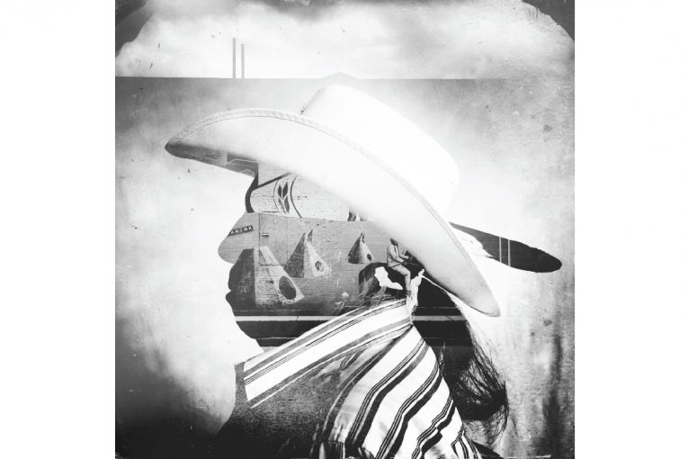
Image source: pulitzercenter.org
Mike Pinay, the model for the portrait pictured above, described how his experience within the Indian Residential School system as the worst years of his life, leaving him with long lasting issues regarding relationships and a lack of understanding of the meaning of family or belonging.

Conclusion

Illustrations
Mike Pinay Portrait
https://pulitzercenter.org/reporting/bitter-legacy-canadas-forced-assimilation-boarding-schools

References
CCE
Tomasello, M. (1999). The cultural origins of human cognition. Cambridge, MA: Harvard University Press

Cultural Identity
Moha, Ennaji. (2005). Multilingualism, Cultural Identity and Education in Morocco, Springer Science & Business Media

Ethnic Identity
Aponte, J. F., & Johnson, L. R. (2000). The impact of culture on the intervention and treatment of ethnic populations. In J. F. Aponte & J. Wohl (Eds.), Psychological interventions and cultural diversity (2nd ed.; pp. 18-39). Boston, MA: Allyn and Bacon

Cultural Identity Quote
James, Paul (2015). ‘Despite the Terrors of Typologies: The Importance of Understanding Categories of Difference in Identity’ Interventions: International Journal of Postcolonial Studies. 17 (2): 174-195.

Aboriginal Marginalization
Baskin, C. (2003). Structural social work as seen from an Aboriginal Perspective. In W. Shera (Ed.), Emerging perspectives on anti-oppressive practice (pp.65-78). Toronto: Canadian Scholar’s Press

Indian Caste System
https://timesofindia.indiatimes.com/india/from-buddhist-texts-to-east-india-company-to-now-dalit-has-come-a-long-way/articleshow/65678182.cms

Bundesministerium des Innern, fuer Bau und Heimat
https://www.bmi.bund.de/DE/themen/heimat-integration/integration/integration-bedeutung/integration-bedeutung-node.html;jsessionid=445DF99484D2FDD20D55A1F0A7ADDB96.2_cid287

Disproving the enclave hypothesis
Portes, Alejandro & Leif, Jensen. (1992). ‘Disproving the Enclave Hypothesis: Reply’. American Sociological Review

Ethnic enclaves may impede integration
Edin, Per-Anders, Peter Fredriksson, and Olof Aslund. "ETHNIC ENCLAVES AND THE ECONOMIC SUCCESS OF IMMIGRANTS—EVIDENCE FROM A NATURAL EXPERIMENT." The Quarterly Journal of Economics. no. 1 (2003): 329-357.

Spielberger, Charles (2004). Encyclopedia of Applied Psychology. New York: Academic Press. P.615. ISBN 9780126574104

Abe, David K. (2017-07-19). Rural Isolation and Dual Cultural Existence: The Japanese-American Kona Coffee Community. Cham: Palgrave Macmillan. pp. 17–18. ISBN 9783319553023.

Benefits and Challenges opening quote
Schaetti, Rachel Miller. (1994). ‘Great Advantages,’ in Notes from a Traveling Childhood, edited by Karen Curnow McCluskey. Washington, DC: Foreign Youth Service Publication. P. 9.

Third Culture Kids: Growing Up Among Worlds
David C. Pollock, Ruth E. Van Reken, Michael V. Pollock. (Third Edition 2017). Third Culture Kids: Growing Up Among Worlds

Americans living abroad
Smith, Carolyn D. (1994). The Absentee American. New York: Alethia Publications

Australians living abroad
https://advance.org/australians-abroad-preliminary-findings-on-the-australian-diaspora

Japanese living abroad
www.stat.go.jp/english/data/nenkan/1431-02.htm

The Kite Runner Cover Image
http://smithsonianapa.org/bookdragon/the-kite-runner-by-khaled-hosseini/

Khaled Hosseini Bio
https://khaledhosseini.com/bio/

Alice Shu-Hsien Wu
https://thedisplacednation.com/2014/06/25/tck-talent-alice-shu-hsien-wu-cultural-bridge-builder-and-global-nomad-videographer/

Fourfold models of acculturation
Berry, John W. (1997). ‘Immigration, Acculturation and Adaptation’. Applied Psychology.

Journal of Population Economics
Angelini, V., Casi, L. & Corazzini, L. J Popul Econ (2015) 28: 817. https://doi.org/10.1007/s00148-015-0552-1

Ethnic Enclaves provide immigrants with a social foundation
Massey, Douglas S. "Annals of the American Academy of Political and Social Science." Annals of the American Academy of Political and Social Science. Vol. 510. World Population: Approaching the Year 2000 (1990)

Davis; Carlo; Schwartz; Unger; Zamboanga; Lorenzo-Blanca; Martinez (2016). The longitudinal associations between discrimination, depressive symptoms and prosocial behaviours in US Latino/a recent immigrant adolescents. Journal of Youth and Adolescence

Green Book
Green Book. (2018). [Online]. Directed by Peter Farrelly, Dreamworks. Available from Amazon Prime

Green Book Image
https://www.imdb.com/title/tt6966692/mediaviewer/rm2461296640

Jim Crow laws
Fremon, David (2000). The Jim Crow Laws and Racism in American History. Enslow. ISBN 0766012972

Daniella Zalcman-The New Yorker
https://www.newyorker.com/culture/photo-booth/the-bitter-legacy-of-canadas-forced-assimilation-boarding-schools#

Daniella Zalcman-Pulitzer Center
https://pulitzercenter.org/reporting/bitter-legacy-canadas-forced-assimilation-boarding-schools

Daniella Zalcman-Time
https://time.com/4543672/signs-of-your-identity/

