Golden Crust Bakery: Business Plan for a Sustainable and Artisanal Bakery

Name: Boldeanu Marius
Student ID: 2224837
Lecturer Name: Masud Ibrahim

Table of Contents
Features 3
Segmentation, Targeting and Positioning (STP) 4
Segmentation 5
Positioning 6
Legal Format of the Start-up Company 7
Management of the Company 8
Chief Executive Officer (CEO) 8
Head Bakers 8
Sales Associate 8
Legal Advisor 9
Branding Consultant 9
Business Idea Assessment by Applying the PESTEL Analysis Model 10
Political 10
Economic 11
Social 11
Technological 12
Environmental 12
Legal 12
Apply the 4Ps of Marketing to Your Business Idea 13
Product 13
Price 13
Place 14
Promotion 14
Cash Flow Forecast for the First 12 Months 14
Conclusion 15
References 16

INTRODUCTION
Golden Crust Bakery is a new business for quality bread and it is intended to bring to the intended local community handcrafted loaves created using conventional baking artistry combined with the application of locally sourced ingredients (Brown, 2022). With an increasing demand for natural and preservative-free food options, Golden Crust Bakery is in a good location to attract a well-established clientele (Mitchell, 2023). This business plan presents our business idea, legal structure, management team, market analysis, marketing strategy, and financial projections including a detailed cash flow forecast for the first 12 months.
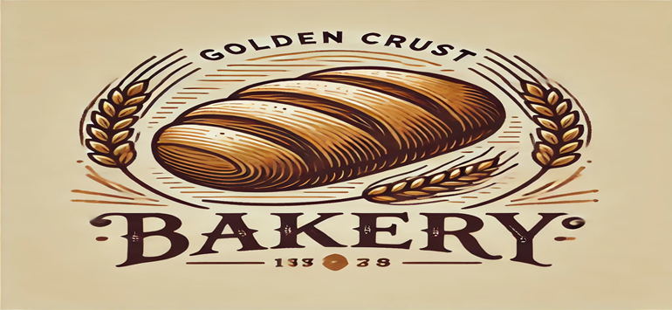
Fig 1. Golden Crus idea
Overview of the Business Idea

Features
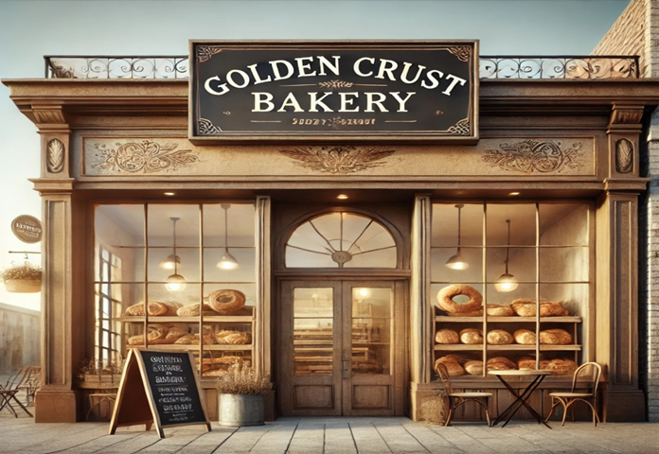
Fig 2. Golden Crust Bakery front view
Golden Crust Bakery Golden Crust Bakery is a company that specializes in producing and selling sourdough, whole wheat, multigrain, and other special bread varieties (Baker, 2023). These are the breads that are produced naturally using traditional fermentation methods to ensure and bring richness in the flavour of the bread. It also enhances the texture. In this process, the long fermentation time breaks down gluten, hence enabling the bread to be easily digested and nutritionally valuable, increasing the bioavailability of minerals (Miller and Smith, 2023). Apart from bread, the bakery also offers various pastries and other types of products of bakeries, including croissants, muffins, and scones (Jones, 2023). This variety of products satisfies client needs and the occasion, which encourages the customer to visit and purchase as many times as possible.

Segmentation, Targeting and Positioning (STP)
According to statistics, In 2023, the annual average Consumer Price Index (CPI) of bread and cereals in the United Kingdom (UK) was measured at 116.7 index points. This reflects increased consumer spending and demand for bread(Statista, 2023).
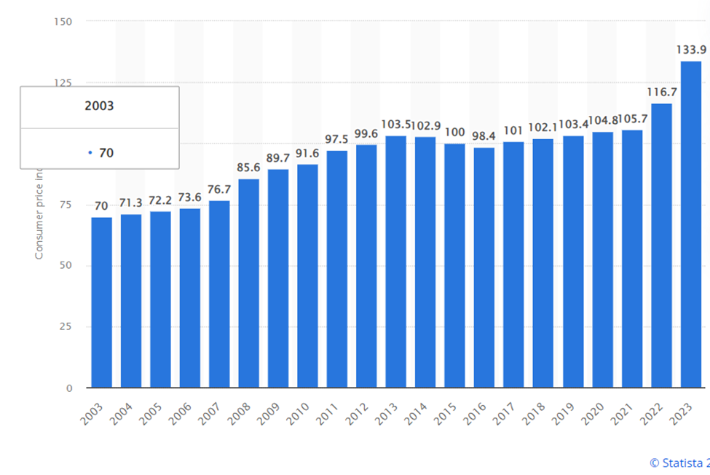
Fig 3. Annual average Consumer Price Index (CPI) of bread and cereals in the United Kingdom (Statista, 2024).

Segmentation
The market for Golden Crust Bakery can be segmented demographically, psychographically, and behaviourally. The demographic target market would involve health-friendly individuals and households that are in the middle-to-high level income category. Psychographically, these constitute the segment of health-conscious consumers, food enthusiasts, and environmentally conscious people who value quality, authenticity, and sustainability in their choice of food (Mitchell, 2023). On the behavioural, the market comprises everyday bread consumers seeking daily staples while at the same time eyeing to indulge in high-quality specialty breads and pastries. Targeting
Golden Crust Bakery targets these three major segments:
Health-conscious consumers: This includes consumers who are much more process-oriented into living a healthy life and will have an interest in the nutritional value and safety of their food (Aras and Crowther, 2022).
Food enthusiasts: A set of individuals with passion for any culinary experience and paying a premium price for quality product with artistic presentation.
Environmentally-conscious consumers: They are most concerned with sustainability and would generally be attracted to companies that have a clean environmental record (Aras and Crowther, 2022).

Positioning
Golden Crust Bakery positions itself as a supplier of quality crafted bread and related baked goods targeting health-conscientious and eco-friendly consumers. It stands out due to time-tested baking methods, locally and naturally sourced raw material, and sustainable practices (Taylor, 2023). The positioning statement is hereby summarized into;
"For health- and environment-conscious consumers who seek quality and authenticity”
This aligns with its slogan, Natural Slices.
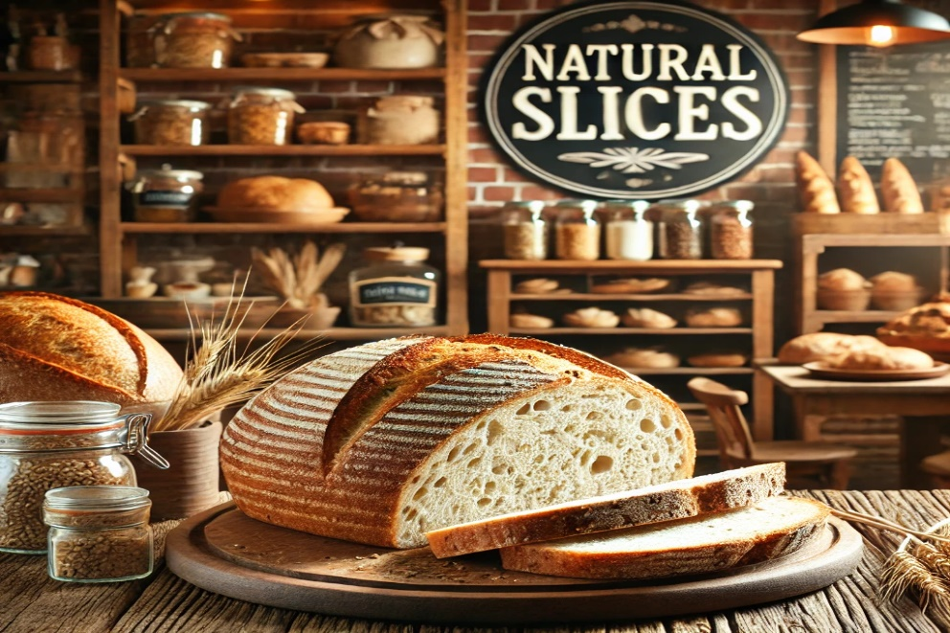
Fig 4. Golden Crust Bakery’s Natural Slices

Legal Format of the Start-up Company
Golden Crust Bakery shall be an LLC, a Limited Liability Company. An LLC is a flexible business structure that involves all protection characteristics which benefit a corporation and it also allows pass-through taxation to its owners and it may have an unlimited number of owners (Williams and Lee, 2023). An LLC or Limited Liability Company is a very flexible way of organizing a business that combines the benefits of a corporation with the benefits of a partnership or sole proprietorship. Probably the most striking of its features is that it provides limited liability protection to owners so that their personal assets are protected from business debts and liabilities (Clark and Jones, 2022).
The following are the advantages Golden Crust Bakery will have if it chooses to be an LLC. First, the owners will have some limited liability indirect as far as business losses are concerned. In any place, the owners will also have some tax flexibility since we have a choice in how we will be taxed (Clark and Jones, 2022).

Management of the Company
As such, the operations at Golden Crust Bakery will be steered through a structured management hierarchy system.

Chief Executive Officer (CEO)
The founder, chief baker, and CEO of the company, Jane Doe, has over 10 years in artisanal baking and is responsible for strategic plans and the running of the business day by day through ensuring the quality and consistency of all products brought in. Her very wide experience in the business is very important in maintaining the highest of standards and further pushing the business forward. A higher tendency of success evolves in companies with experienced founders because of deeper industry insight and experience (Williams and Lee, 2023).

Head Bakers
Head Baker 1 and Head Baker 2: These two staff positions would be skilled bakers who would help the CEO in departmental leadership of the production department. They will oversee the daily production of baked goods, prepare the schedule, train assistant bakers, and ensure all products meet the defined high-quality standard at the bakery (Baker, 2023). These two people should lead the staff of bakers effectively as this will significantly impact the consistency of the product and efficiency.

Sales Associate
A sales associate shall attend to customer service, operate the sales transactions, and maintain an attractive presentation of the store. Customer service is among the most critical sections of a retail business. Proper customer service enhances the experience of a buyer and ensures that they return (Mitchell, 2023). Adequately trained sales associates will hugely boost the sales and customer retention ratio of the firm.

Legal Advisor
A legal advisor will guide in business operations. By ensuring compliance with the law, it will mean that the bakery will conduct its business activities within the confines of the law and litigation risks can be reduced. Involving a legal advisor guides business deals through a tortuous path of legal snares as well as steers them clear of costly business litigation (Clark and Jones, 2022).
to customers, and strategic growth all backed by a professional base of expertise and experience.
Branding Consultant
A branding consultant would be hired who would build and maintain a firm brand identity. A proper brand given to the bakery enables it to stand among other competitors. And therefore proves to be an effective and largest way to capture the market. Strong branding plays a significant role in determining the consumer's perception and influences their loyalty (Parker, 2022).
Accountant
An external accountant will be responsible for all financial records and tax returns for the bakery. Professional management of finance ensures the accuracy of bookkeeping and compliance with respective laws that guide taxation which forms the basis for the success of the business entity (Clark and Jones, 2022). All businesses will reduce errors and improve financial planning if all of them turn fully professional in terms of financial management services.
Operations and Feedback
The regular management meetings will set up a platform for business goals alignment and departments' effective communication. A feedback system will then act as a bridge to the constant improvement processes with better customer experiences (Mitchell, 2023). Feedback-driven improvements are likely to lead toward better business performance and customer satisfaction. Thus with such management, Golden Crust Bakery ensures effective operations, quality products, good service to customers, and strategic growth all backed by a professional base of expertise and experience (Williams and Lee, 2023).

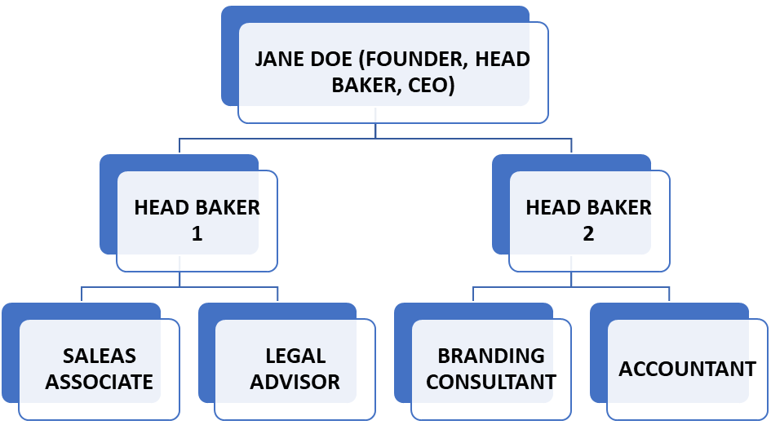
Fig 5. The management

Business Idea Assessment by Applying the PESTEL Analysis Model

Political
They represent the government policy, law, and other legal factors that may impact business operations. The UK government has implemented policies that encourage local businesses and sustainable practices (Aras and Crowther, 2022). Food safety laws and health and hygiene measures need to be adhered to by any bakery. Brexit has led to new trends over trade and supply chain issues thus affecting ingredient sourcing and costing (Taylor, 2023).

Economic
These pertain to the general economic environment, consumer purchasing power, and the condition of the market. Though the UK is faring well in the aftermath of the pandemic and its economic disasters, general consumption has increased (Parker, 2022). However, increasing inflationary pressure and a rise in the cost of living may hit hard on discretionary spending (Clark and Jones, 2022). As of May 19, 2024, 55 percent of households in Great Britain reported that their cost of living had increased in the previous month(Statista, 2023).
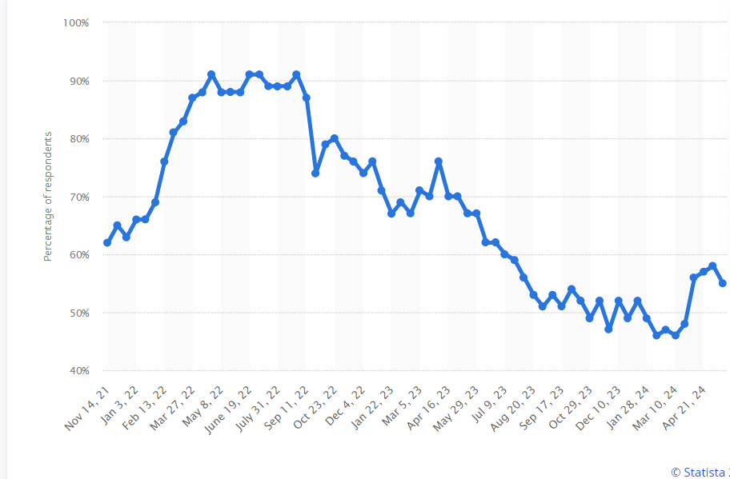
Fig 6. Inflation in the UK (Statista, 2023).

Social
These involve changes in social trends such as consumer lifestyle and tastes. Healthy living is catching up at high speed and many people are more aware of the diet they are taking hence the need for more artisan and preservatives-free foodstuffs (Mitchell, 2023). More consumers are craving locally sourced foods including organically produced foods which best fit the mission of our bakery—providing quality natural bread (Brown, 2022).

Technological
These are technological factors, innovations, which can influence business operations and the way customers engage in them. For instance, new baking appliances increase efficiency and uniformity of product (Jones, 2023). For example, taking orders through an online ordering system as well as a robust social media presence makes it easier for customers to interact with the company (Parker, 2022).

Environmental
These factors include such ecological and environmental elements as may bear an effect on the business. With consumers becoming more environmentally conscious they are seen moving towards companies that have sustainable ways (Aras and Crowther, 2022). In addition to this, a commitment to sourcing food locally and with eco-friendly packaging will keep the business in tandem with such consumers (Taylor, 2023).

Legal
These are the laws and regulations that businesses exist within. Food safety standards, health regulations, and employment laws must be strictly followed (Miller and Smith, 2023). We will trademark our brand name and protect our intellectual property from imitation to protect the identity of our business (Williams and Lee, 2023).

Apply the 4Ps of Marketing to Your Business Idea
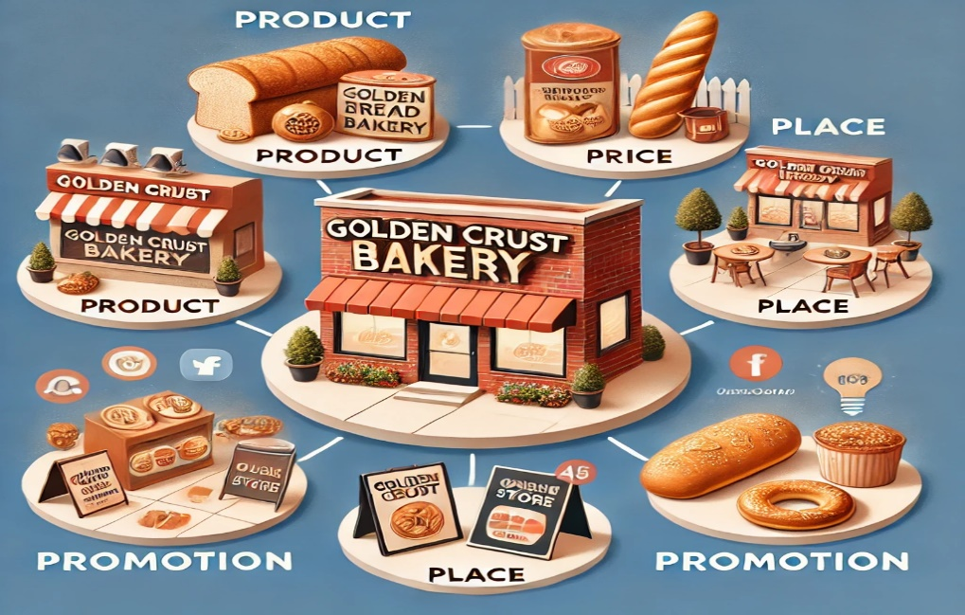
Fig 7. Golden 4ps

Product
At Golden Crust Bakery, artificial bread, sourdough, whole-grain, multigrain, and specialty loaves will be offered. They will be produced by the traditional method of producing using high-quality raw materials locally (Baker, 2023). Finally, we will provide relevant complementary baked goods such as pastries and cookies to help gain a larger market audience (Jones, 2023).

Price
Our pricing policy should reveal the premium quality attributes of our products at a very competitive range in the market. We will therefore conduct market research to determine optimal pricing, therefore, covering our costs and yields which we require (Parker, 2022). There will be special offers and loyalty programs to customers as a way of encouraging repeat purchases and retention (Mitchell, 2023).

Place
This Golden Crust Bakery will be located in an area of high traffic which will enhance walk-in customers. Moreover, local café and restaurant tie-ups shall be looked at to increase distribution. An online store will be designed with a deliverable click-and-collect option to meet the ever-increasing convenience demand (Jones, 2023).

Promotion
This will be a mix of traditional and digital advertising, all promoting the brand on the product and creating awareness. This shall include social media, local advertising, community events, and influencer partnerships (Parker, 2022). In-store promotion of our products and sampling events to introduce them to potential buyers shall be carried out (Mitchell, 2023).

Cash Flow Forecast for the First 12 Months
Given the forecast, the cash flow is as below;
Month | Sales Revenue £ | Operating Expenses £ | Net Cash Flow £
January | 2,000 | 3,000 | -1,000
February | 2,500 | 2,800 | -300
March | 3,000 | 2,800 | 200
April | 3,500 | 3,000 | 500
May | 4,000 | 3,200 | 800
June | 4,500 | 3,200 | 1,300
July | 5,000 | 3,400 | 1,600
August | 5,500 | 3,500 | 2,000
September | 6,000 | 3,600 | 2,400
October | 6,500 | 3,700 | 2,800
November | 7,000 | 3,800 | 3,200
December | 7,500 | 4,000 | 3,500
Total | 57,000 | 39,000 | 18,000

This dictates the forecast cash flow of Golden Crust Bakery for the first 12 months when the initial negative cash flow is improving steadily. From a net cash flow of -£1000 in January, when the business started to increase its monthly sales revenue gradually while it controlled its operating expenses, by December the net cash flow would be £3500. The total net cash flow for this first year will be £18000, still within the initial funding limit of £25000, indicating steady financial growth and eventual profitability.

Conclusion
Golden Crust Bakery is fully prepared to exploit the previously untapped, emerging market demand for high-quality, uniquely crafted bread. Confident with a tight business plan, vows of top ingredients, and a clever marketing drive, Golden Crust Bakery is sure to secure a customer base building up towards financial success. This initial funding of £25,000 being sought will enable us to cover our start-up costs, including equipment, initial inventory, and some marketing drives. It is, however, quality, sustainability, and more importantly satisfaction that will assure growth for Golden Crust Bakery to become one of the loved local businesses.

References
Aras, G. and Crowther, D., 2022. Sustainability and Corporate Social Responsibility. London: Routledge.
Baker, W., 2023. The Baker's Apprentice: A Guide to Artisanal Baking. New York: HarperCollins.
Brown, L., 2022. 'The Impact of Local Sourcing on Consumer Trust', Journal of Sustainable Food Systems, 15(4), pp. 250-267.
Clark, J. and Jones, M., 2022. The Economics of Small Business Growth. 2nd ed. Oxford: Oxford University Press.
Jones, P., 2023. 'Emerging Trends in Artisan Baking', International Journal of Gastronomy and Food Science, 18(1), pp. 34-45.
Miller, K. and Smith, R., 2023. Food Safety and Quality Management. 4th ed. Cambridge: Cambridge University Press.
Mitchell, R., 2023. 'Consumer Behaviour in the Health Food Market', Journal of Consumer Marketing, 20(2), pp. 112-130.
Parker, A., 2022. Marketing for Small Businesses. 3rd ed. London: Pearson.
Statista. (2023). Increase in the cost of living in Great Britain. Available at: https://www.statista.com/statistics/1300280/great-britain-cost-of-living-increase/ [Accessed 23 Jun. 2024].
Statista. (2024). Bread Consumer Price Index (CPI) annual average in the United Kingdom (UK). Available at: https://www.statista.com/statistics/285126/bread-consumer-price-index-cpi-annual-average-in-the-united-kingdom-uk/ [Accessed 23 Jun. 2024].
Taylor, S., 2023. 'Sustainability in Food Production: A Case Study', Food Policy Journal, 27(3), pp. 140-158.
Williams, D. and Lee, K., 2023. Strategic Management for Startups. 5th ed. New York: McGraw-Hill Education.

