Build, Deploy, Configure, and Manage a Type 2 Hypervisor Platform Based Virtualized Network
  - Network Operating Systems and Services - ACCA5023
James Frew – 2108660@student.uwtsd.ac.uk

Name of the Team: Team NOS
Team Members
Student Name | Student ID
Alexander Tzafos | 2104846
James FREW | 2108660
Josh naylor | 2114259
daniels zelinskis | 2104718

Team Evaluation (Self Evaluate your Team)
 | Student 1 | Student 2 |  | Student 3 |  | Student 4 |  | Student 5
Student 1 | 4 |  | 5 |  | 3 |  | 3
Student 2 | 5 |  | 5 |  | 3 |  | 3
Student 3 | 5 |  | 5 |  | 3 |  | 3
Student 4 | 5 |  | 5 |  | 3 |  | 3
Student 5
Rate your Teams Contribution with a scale of 1 to 5 (1 No Contribution and 5 Excellent Contribution)
Add your comments on Team Evaluation: (Justify your evaluation)
Student 5:
Student 3: Josh was ill and missed a session, but still managed to provide some screenshots.
Student 4: Daniels was ill for a few sessions, but still managed to provide some screenshots.
Student 2: I worked hard and contributed many screenshots to the project.
Student 1: Alex worked hard and contributed many screenshots to the project.

Contents
A. Introduction 3
B. Part 1 4
C. Part 2 34
1) Hypervisors 34
2) DHCP 34
3) Active Directory 35
4) Terminologies 36
5) Task Reflection 37
D. Conclusion 37
E. Reflection on Collaborative Work 37
F. References 37

Abstract- This report has documented the creation of four virtual machines – two servers and two clients, with each step in their creation screenshotted. It then goes on explain the pros and cons of type 1 and 2 hypervisors, and why type 2 was chosen for the task. An explanation for the Dynamic Host Configuration Protocol is given and active directories hierarchical structure is explained with an illustration. The different terminologies – ping, server management, etc. are explained in regard to both Windows and Mac Operating Systems. Finally, a brief reflection on the tasks completed here are discussed.

Introduction
This report will document the steps of creating four virtual machines – two servers and two clients. Server 1 will be configured to function as a domain controller as well as the network’s DHCP server, whilst Client 1 will allow created user accounts to use it. Admin and user accounts will be set up with relevant permissions and forests set up. The report will finalize with an explanation of hypervisors, DHCP, Active Directory, and terminologies (with their use in both Windows and Mac OS).

Part 1
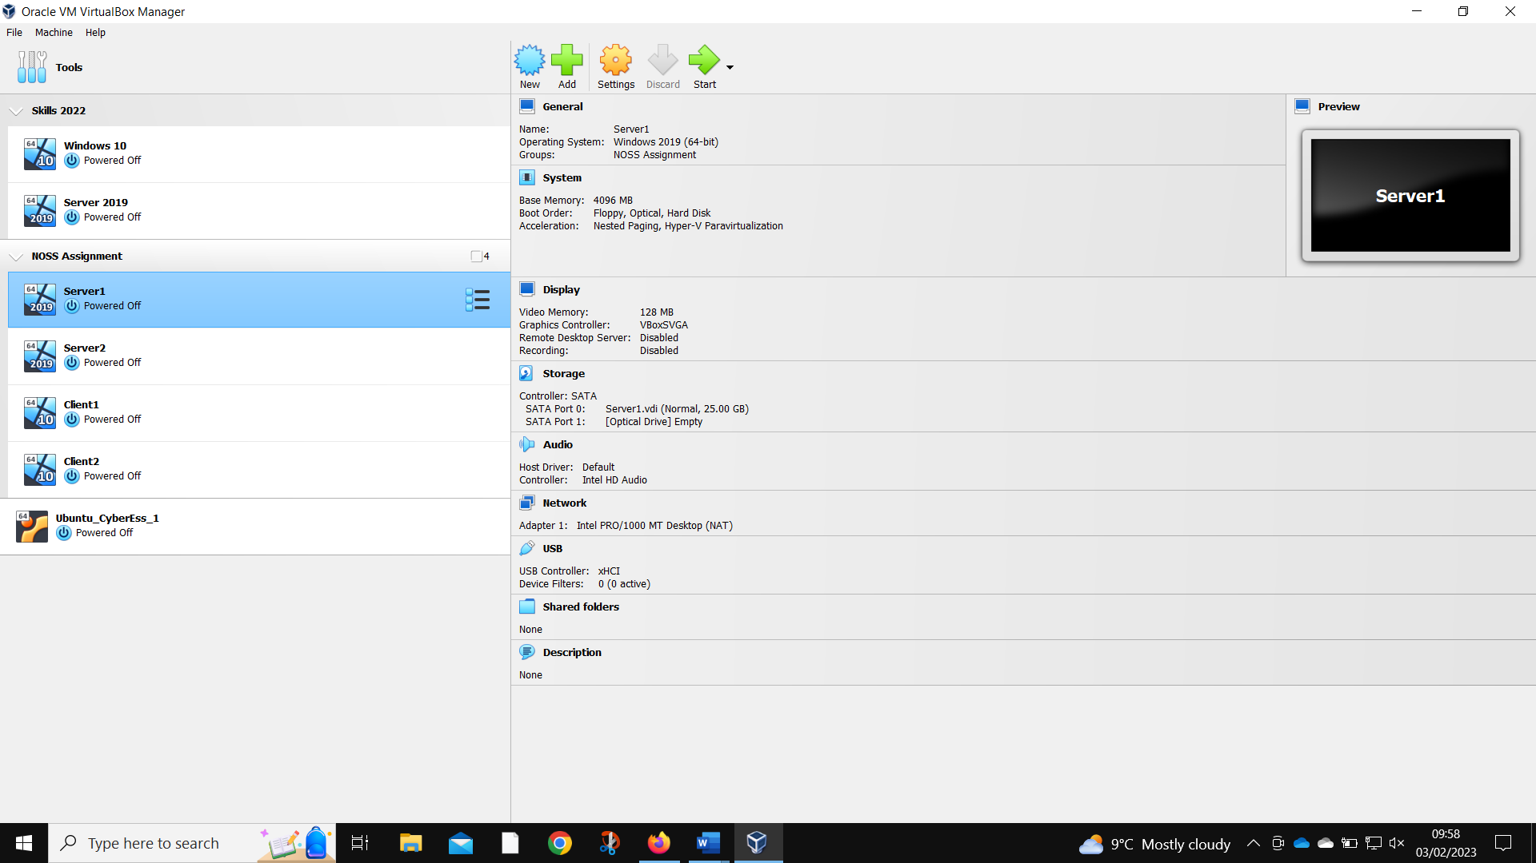
Server 1 created
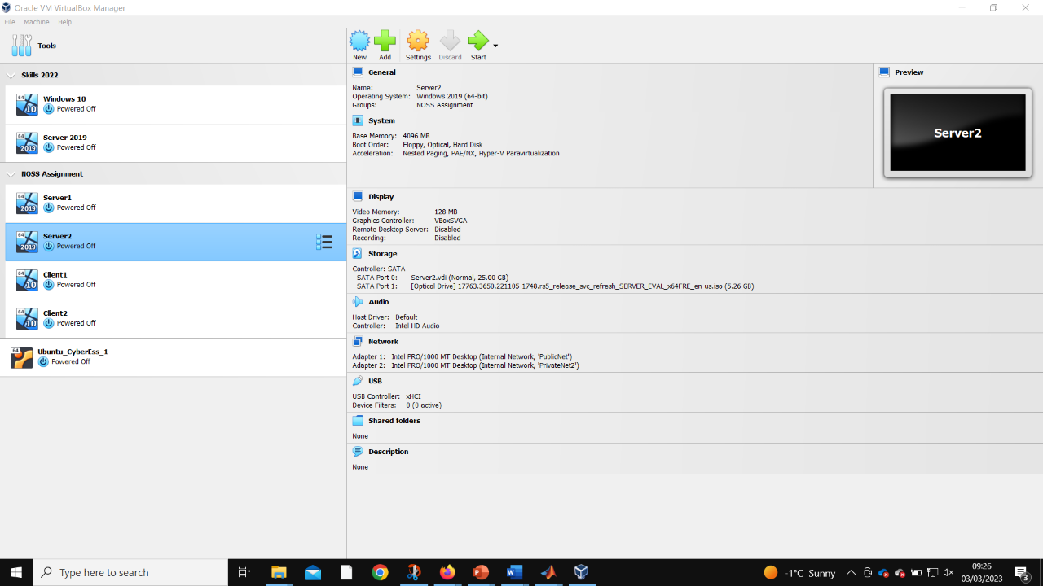
Server 2 created
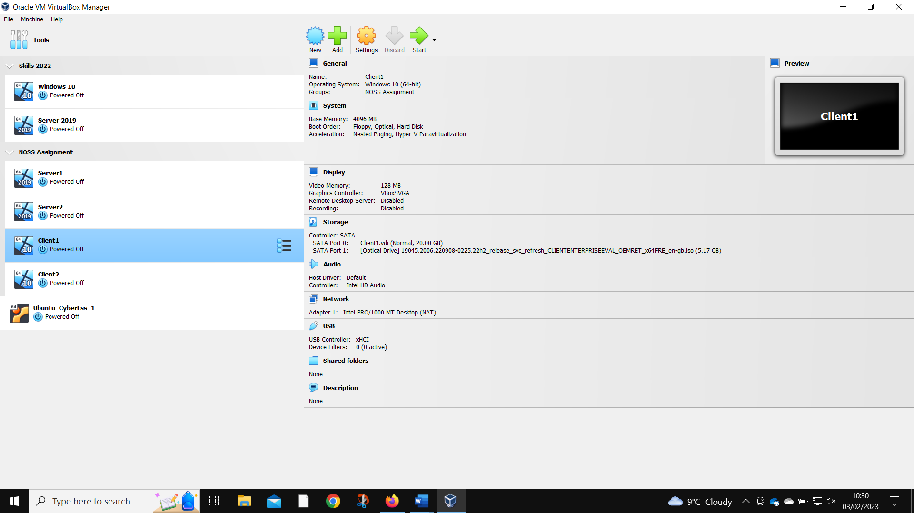
Client 1 created
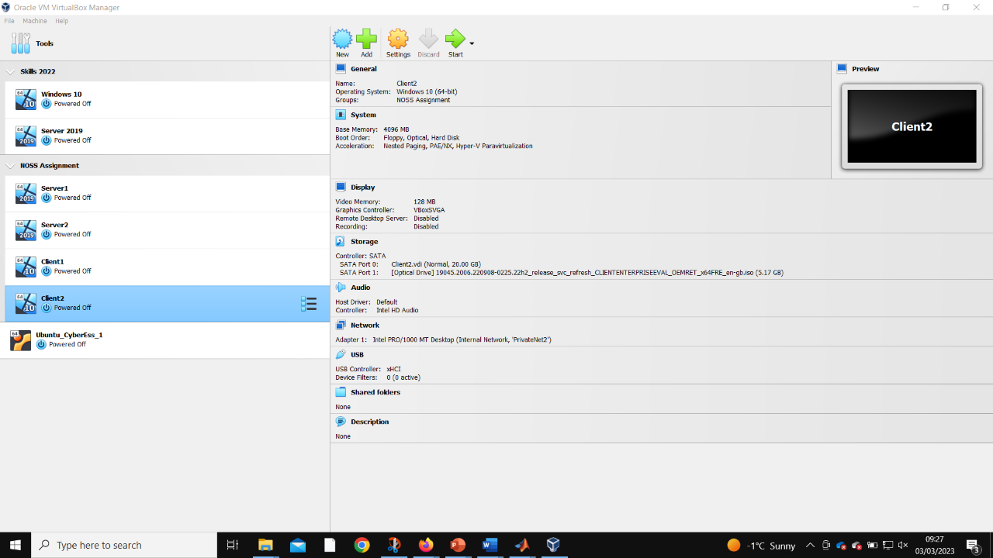
Client 2 created
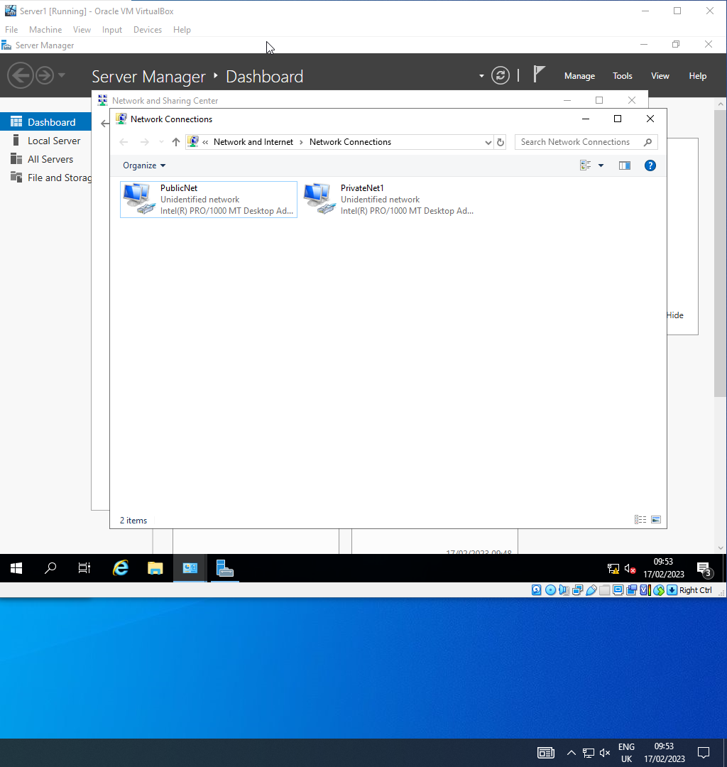
Server 1 networks named
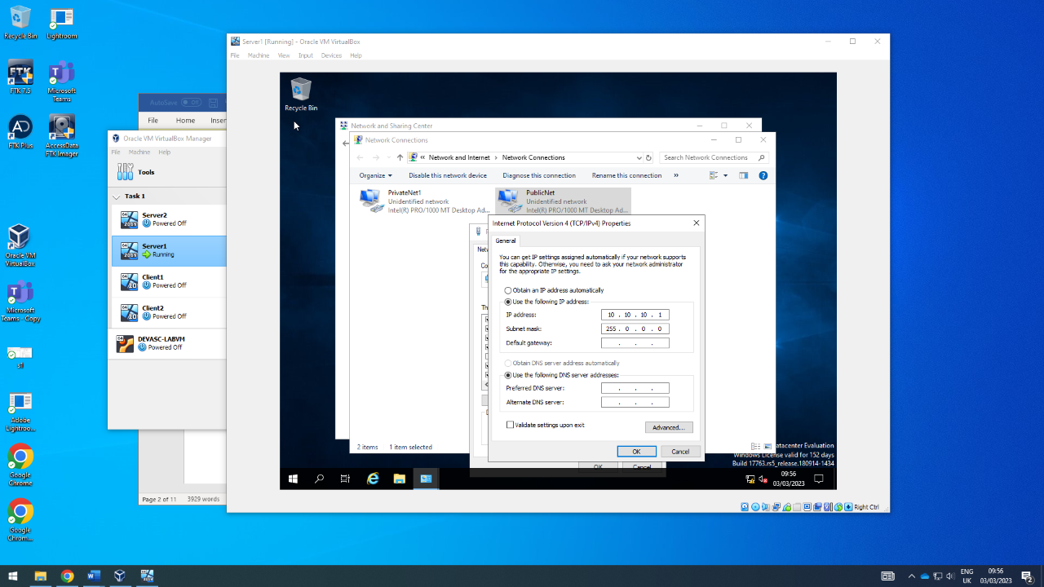
Server 1 PublicNet IP set
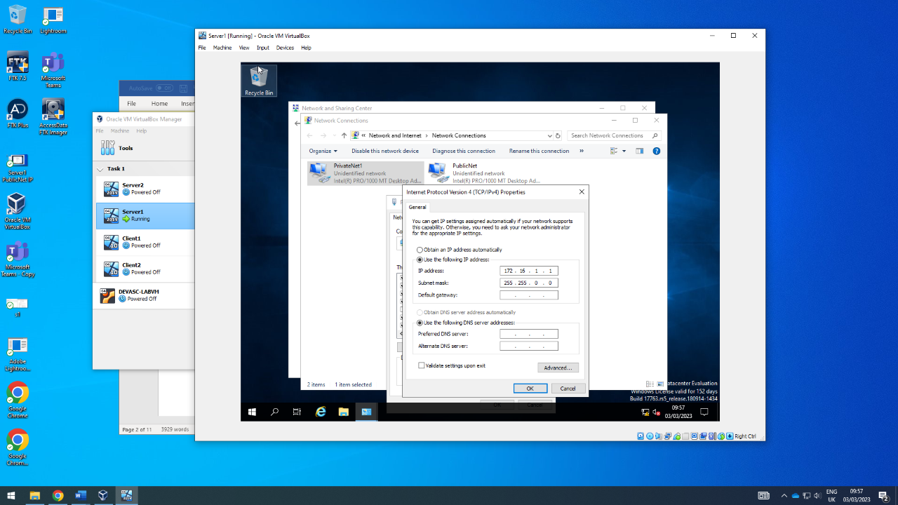
Server 1 PrivateNet1 IP set
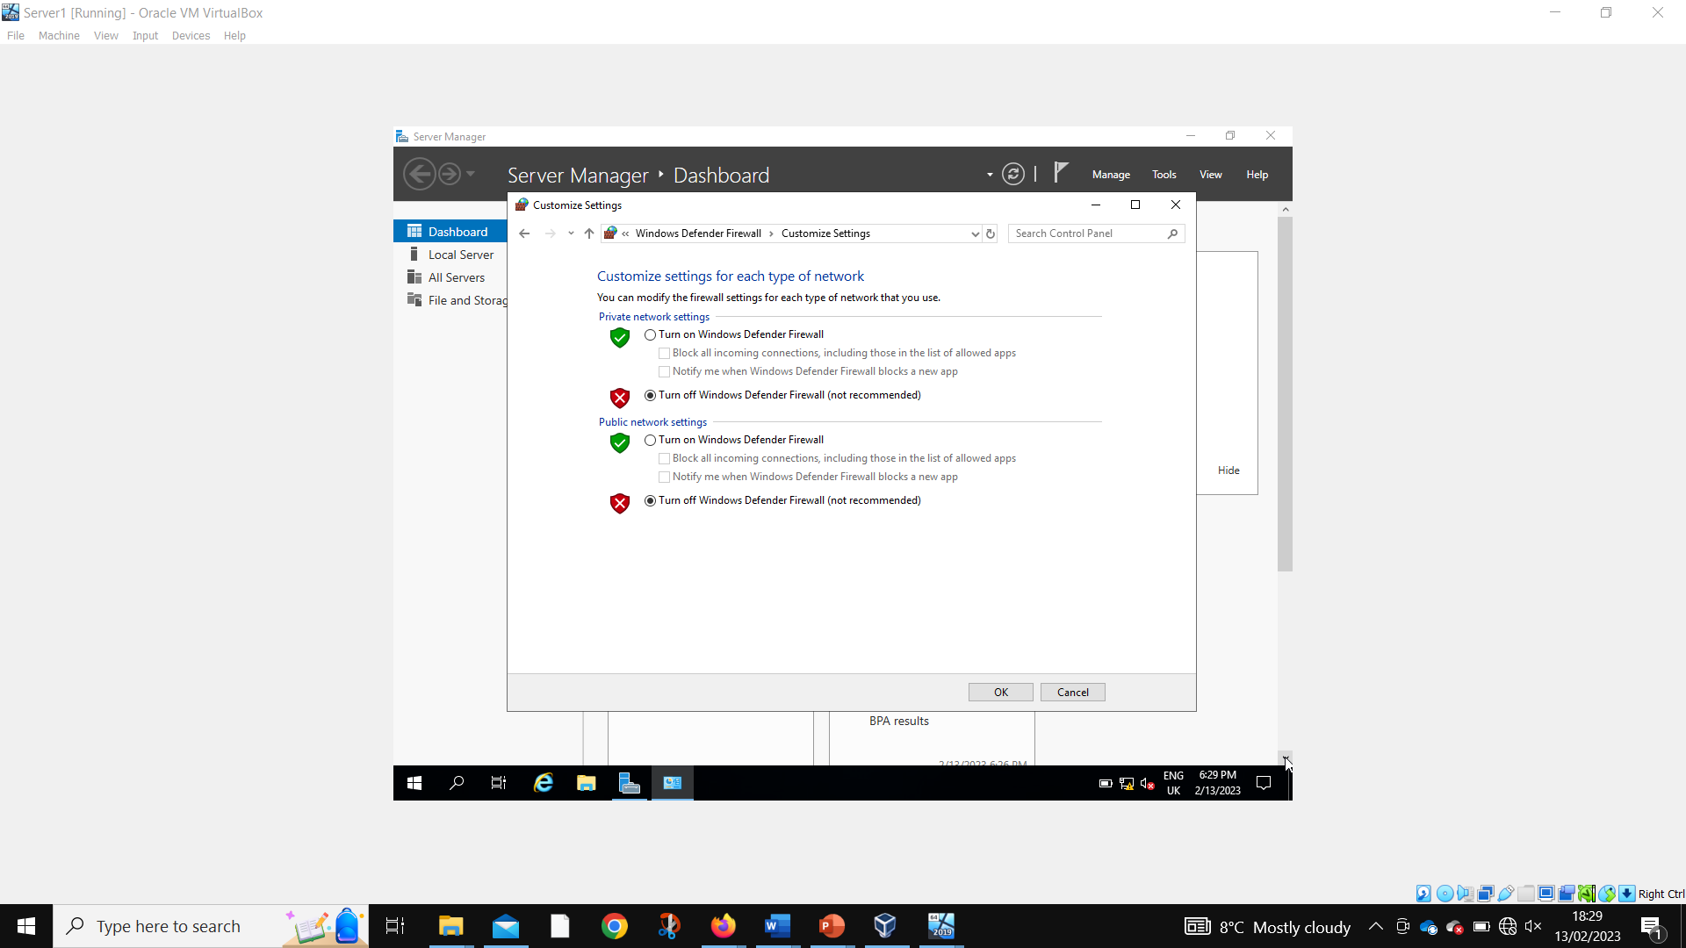
Server 1 disabling firewalls

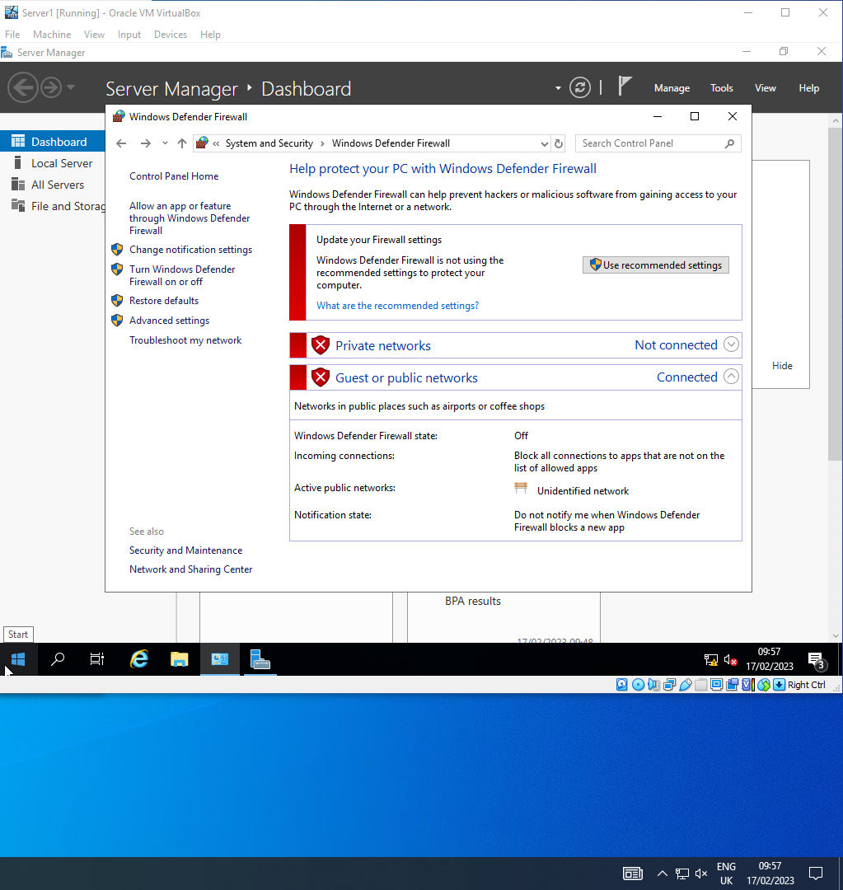
Server 1 firewalls disabled

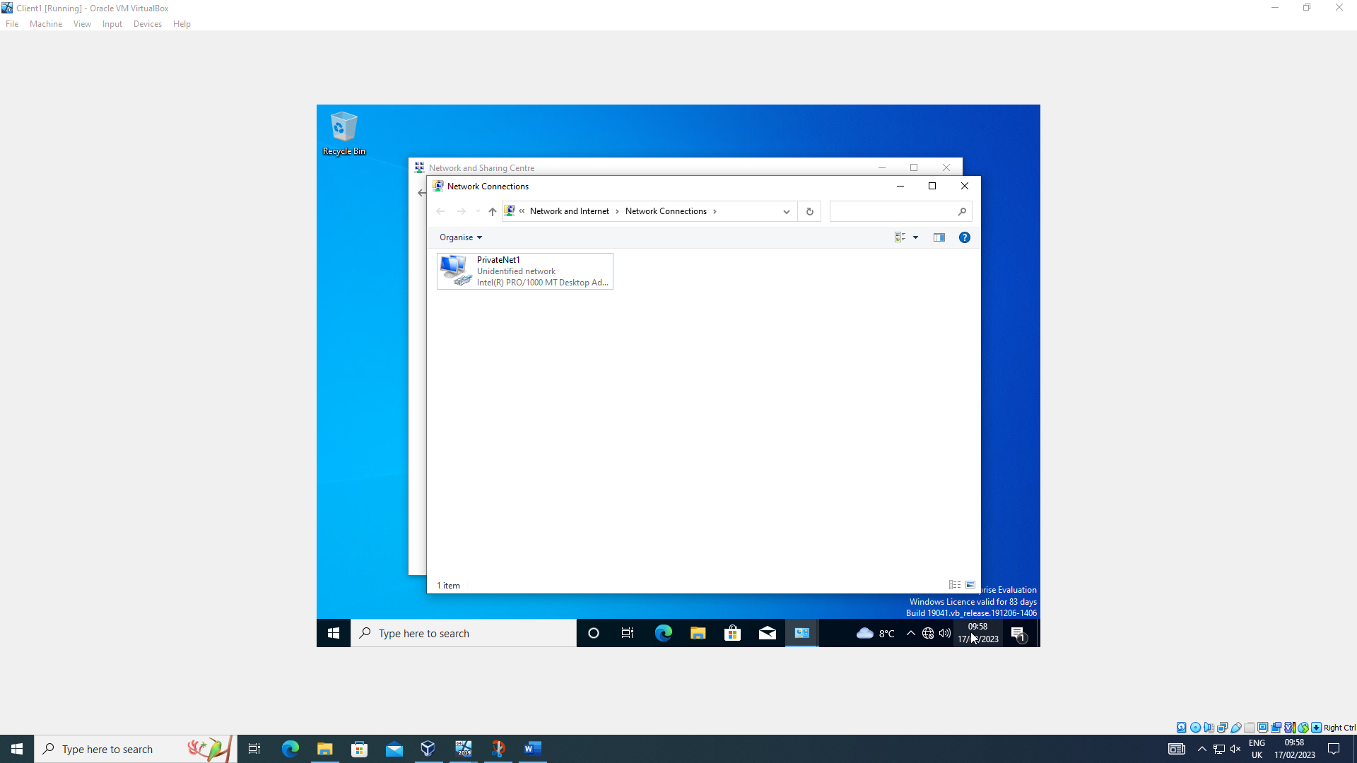
Client 1 network named
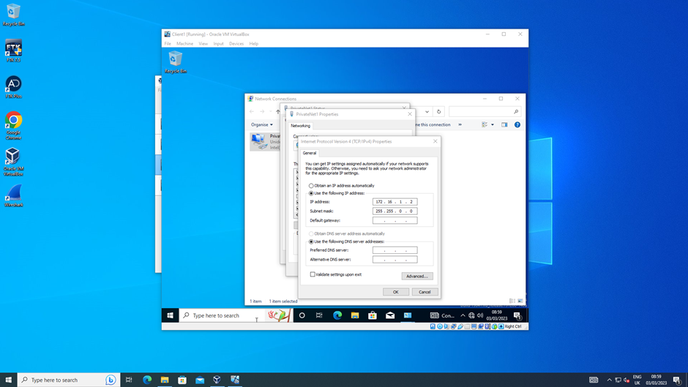
Client 1 PrivateNet1 IP set
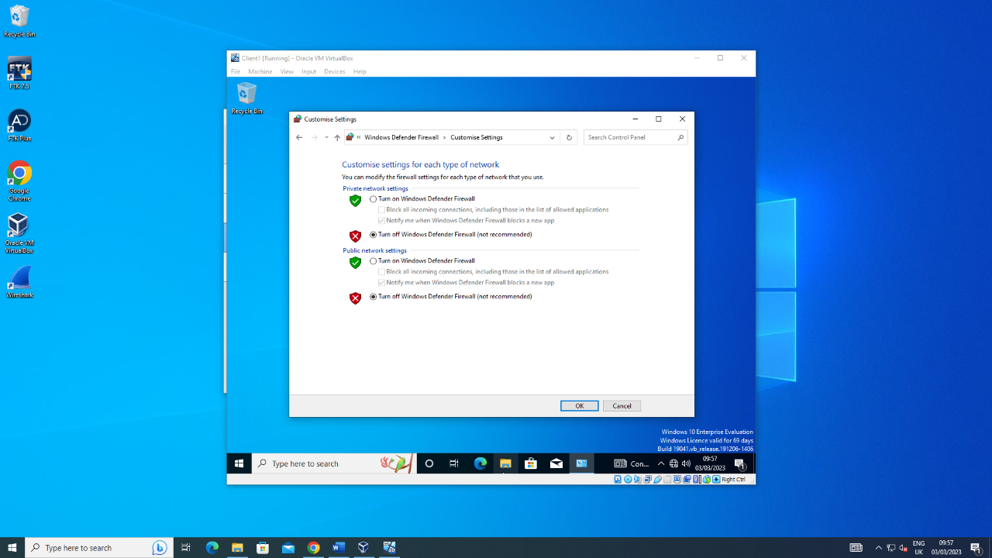
Client 1 firewalls being disabled
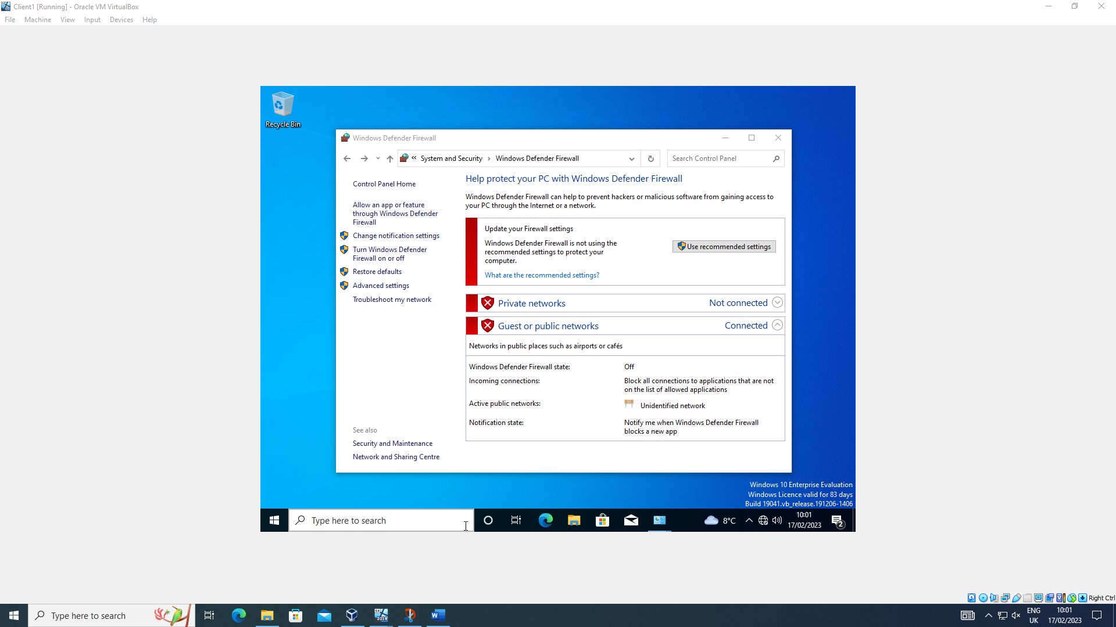
Client 1 firewalls disabled
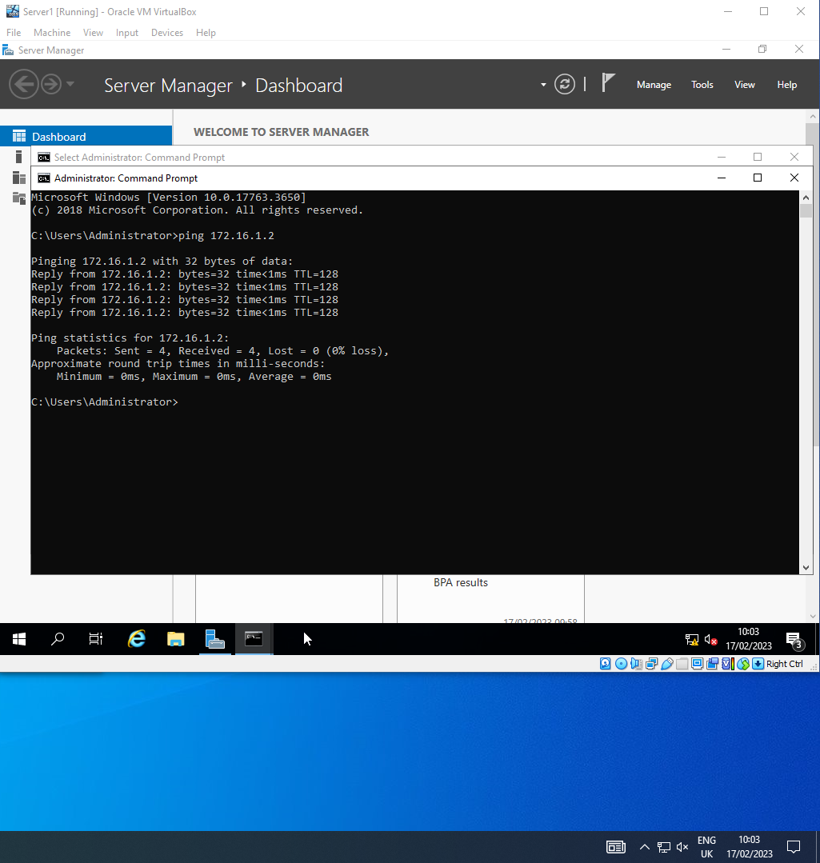
Server 1 successfully pinging Client 1
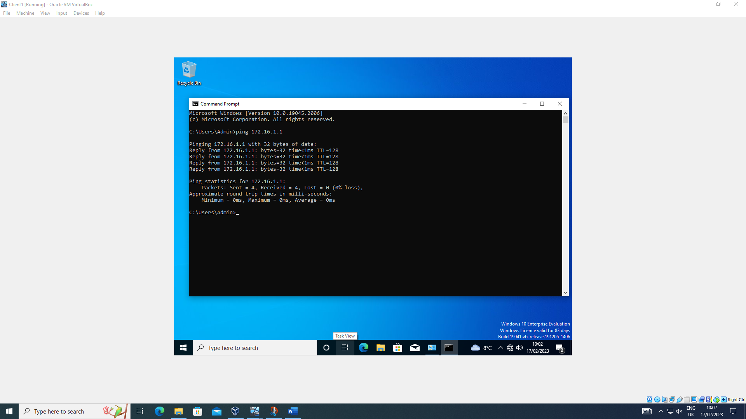
Client 1 successfully pinging Server 1
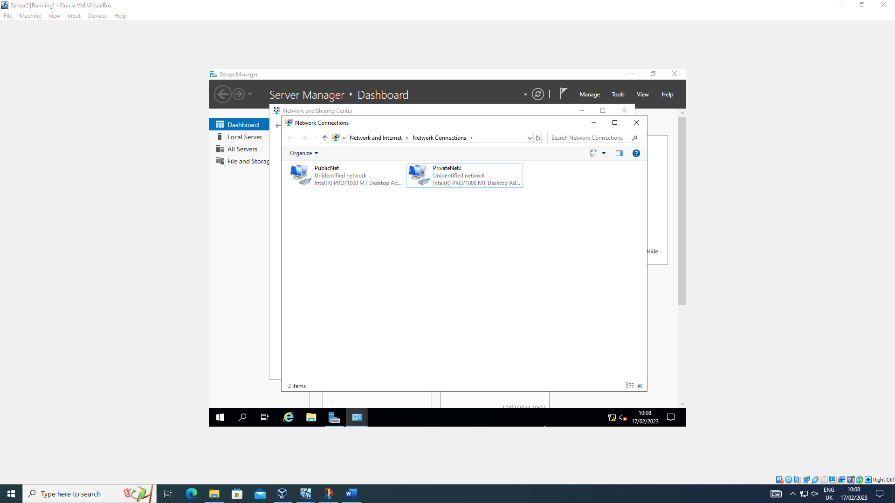
Server 2 networks named
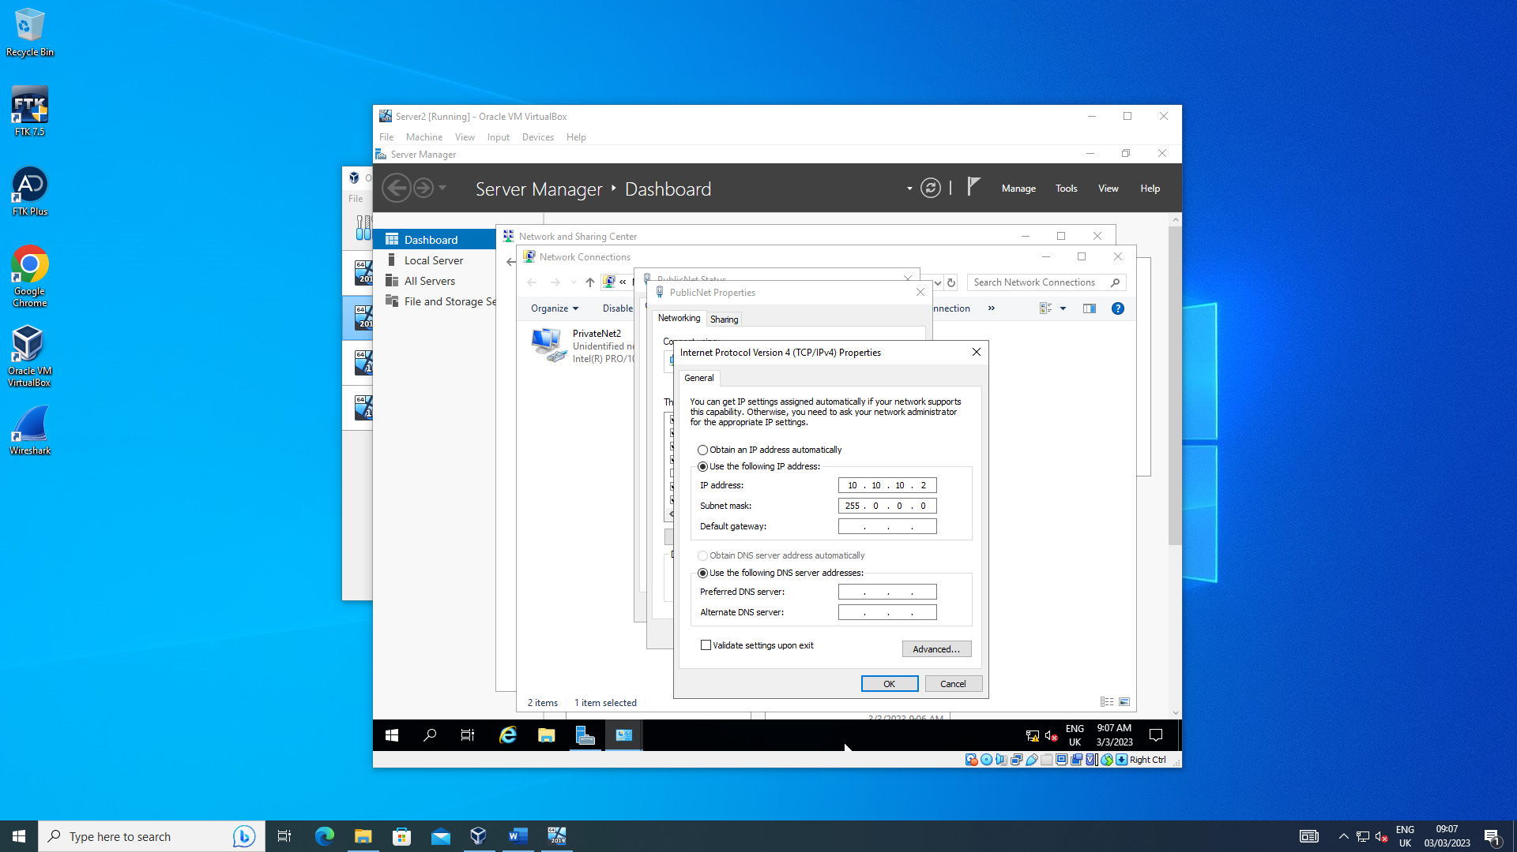
Server 2 PublicNet IP set
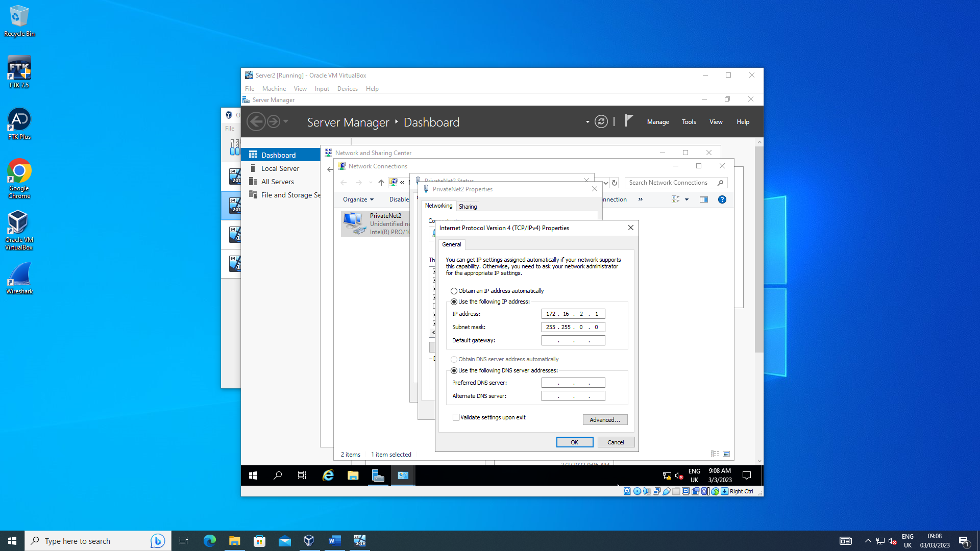
Server 2 PrivateNet2 IP set
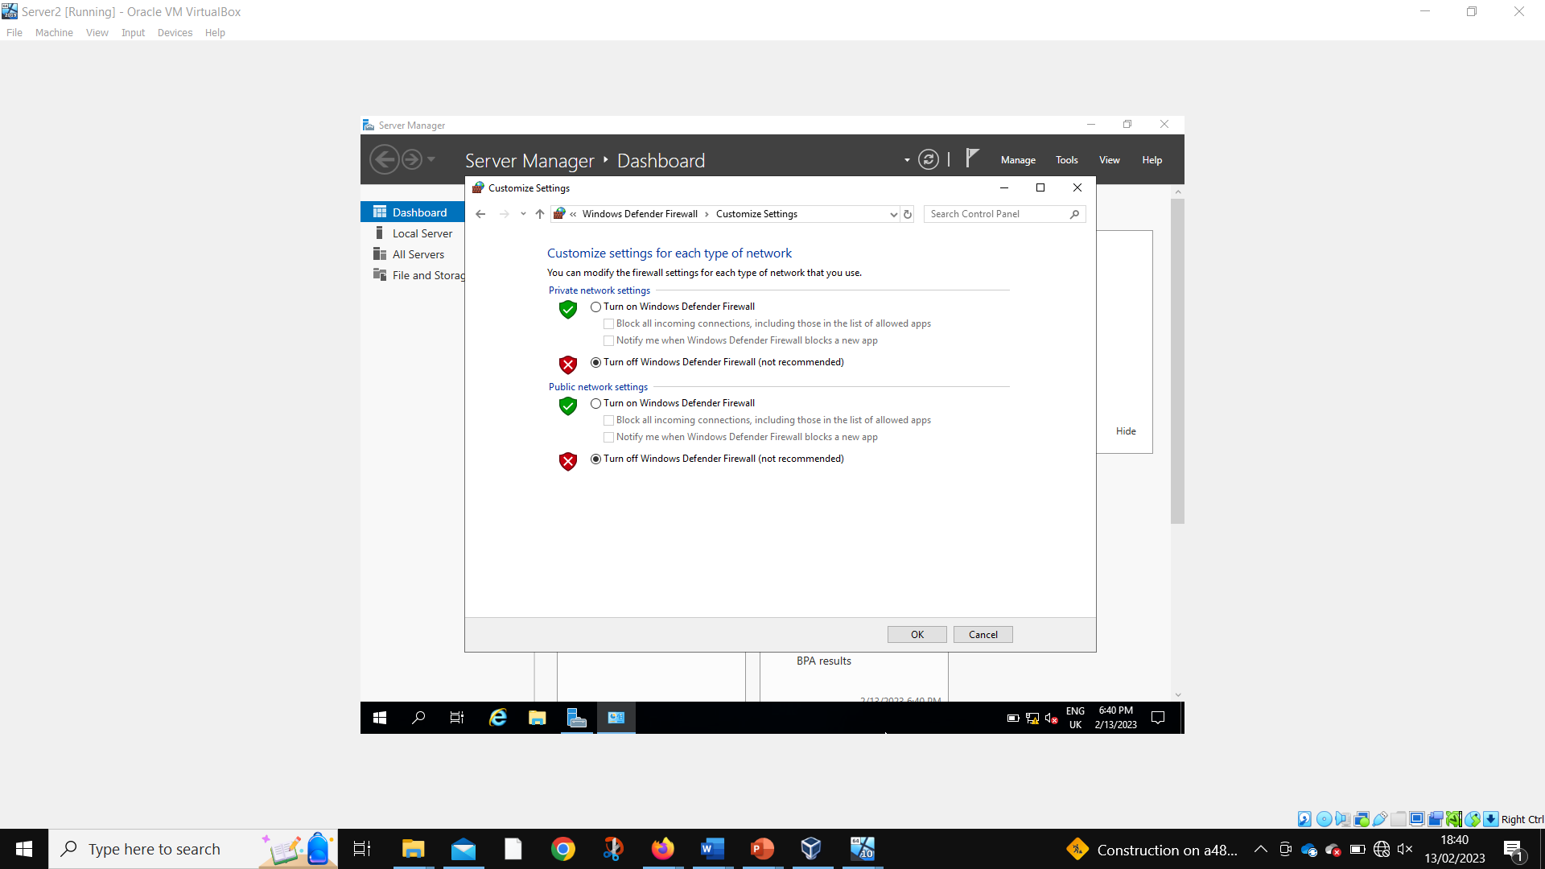
Server 2 disabling firewalls
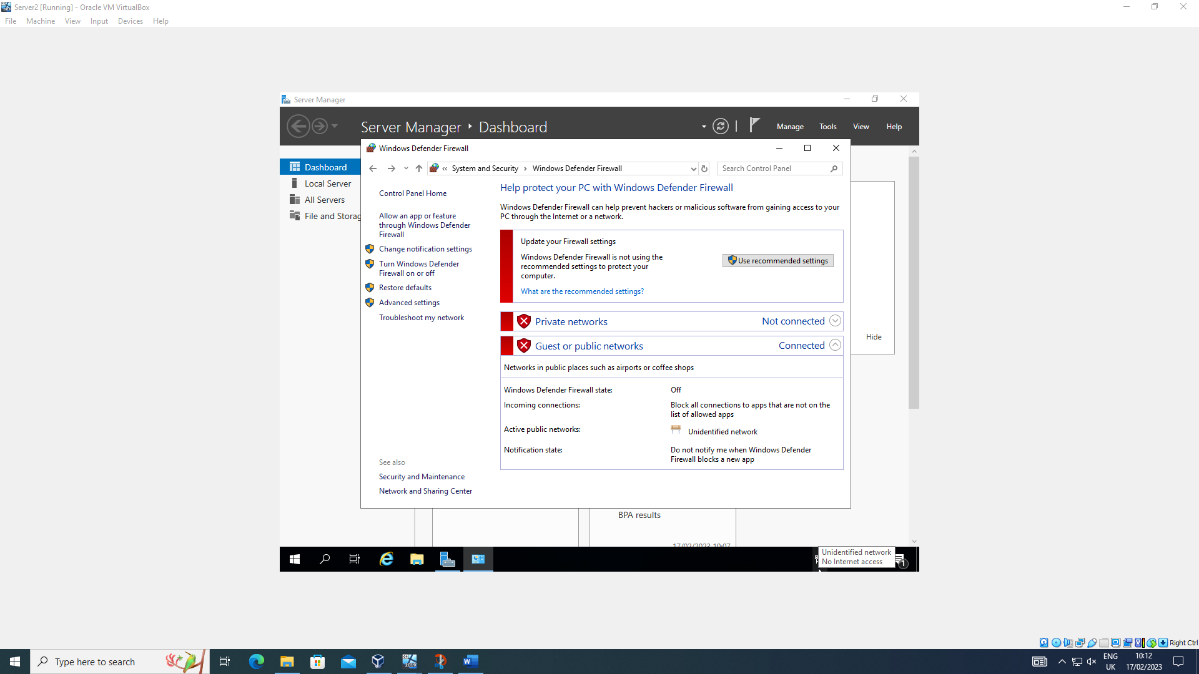
Server 2 firewalls disabled
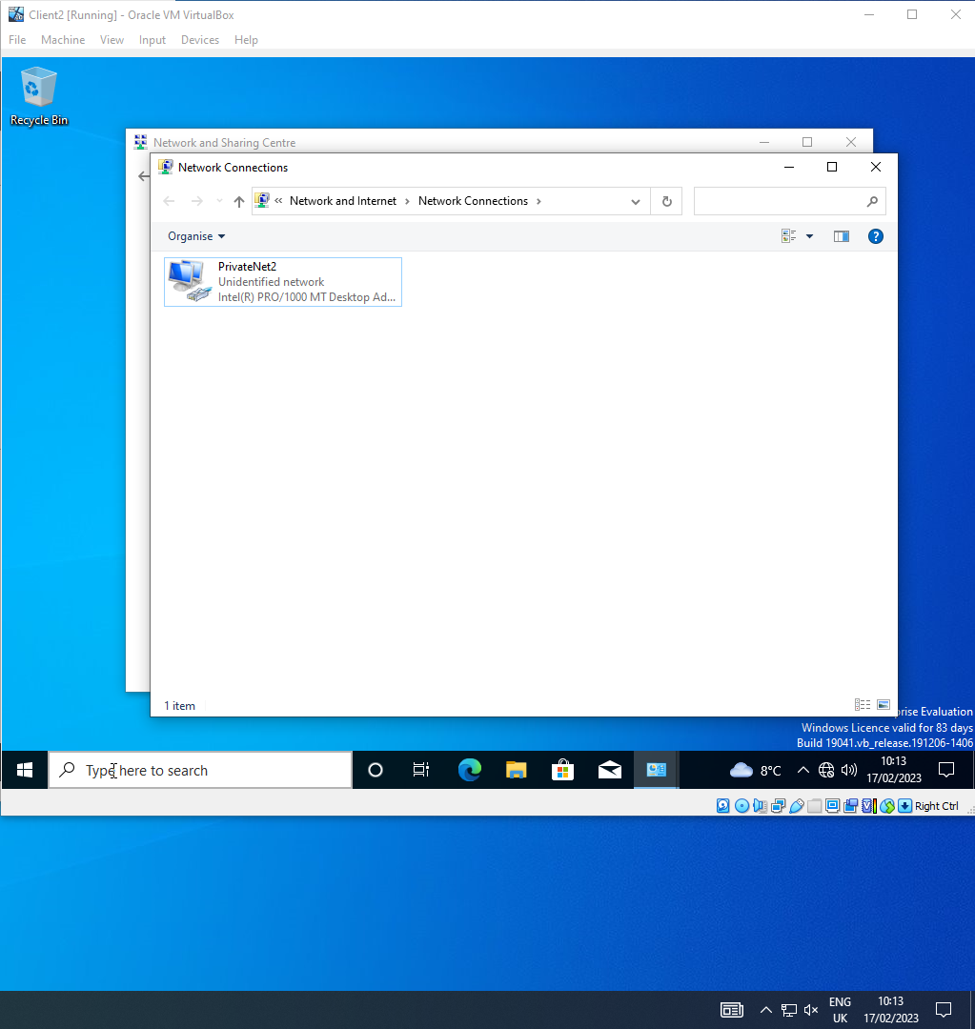
Client 2 network named
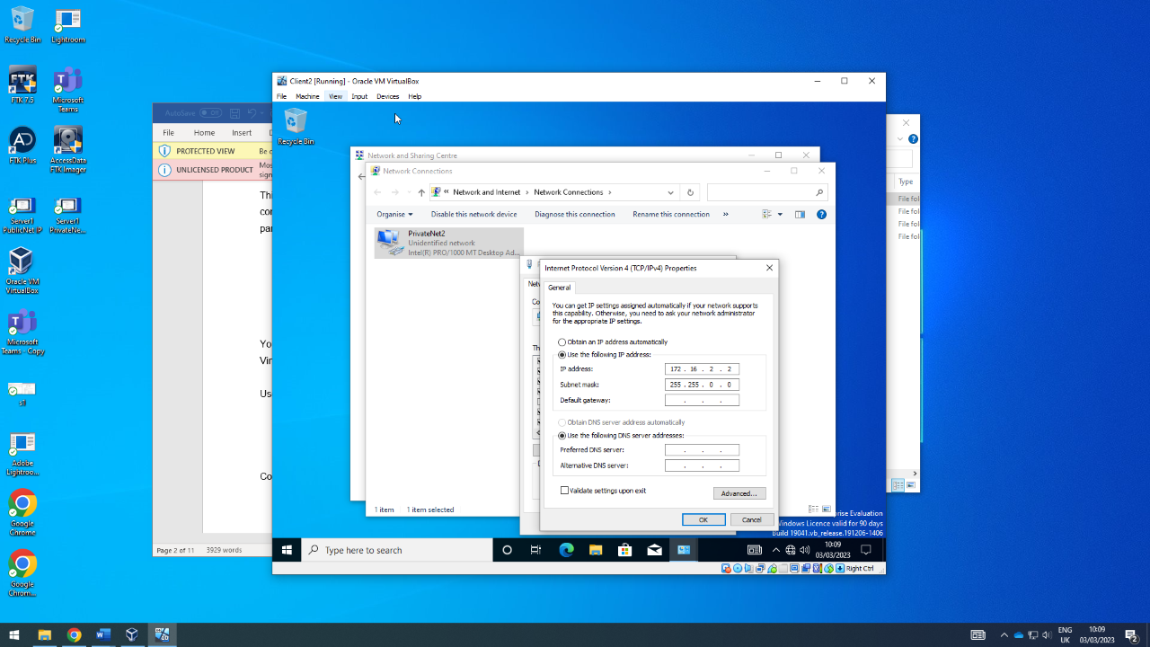
Client 2 PrivateNet2 IP set
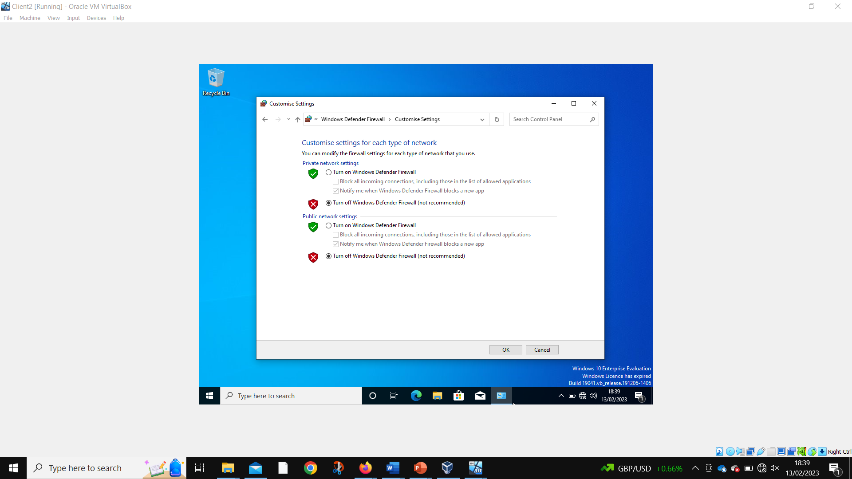
Client 2 disabling firewalls
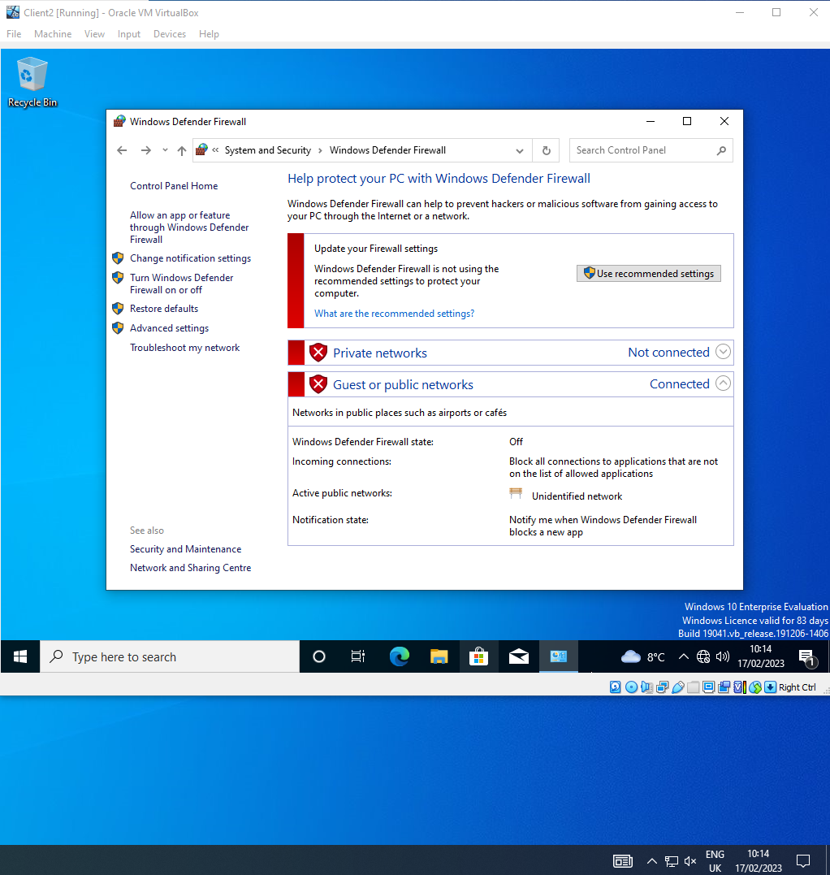
Client 2 firewalls disabled
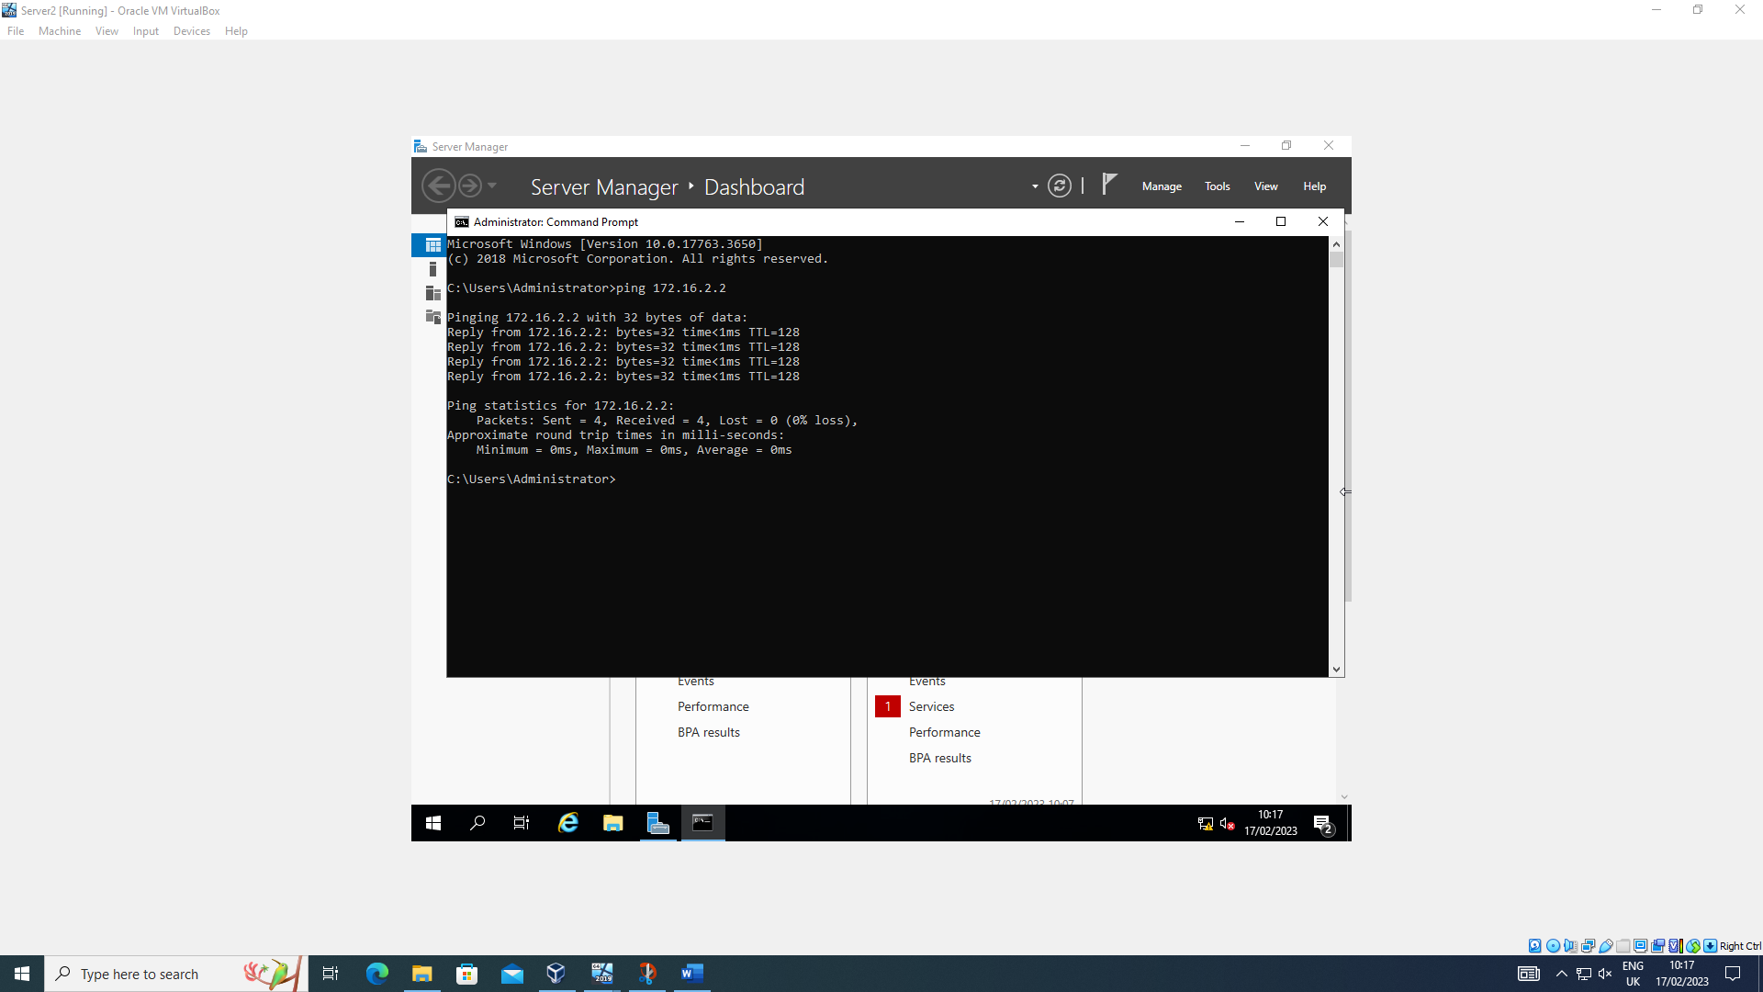
Server 2 successfully pinging Client 2
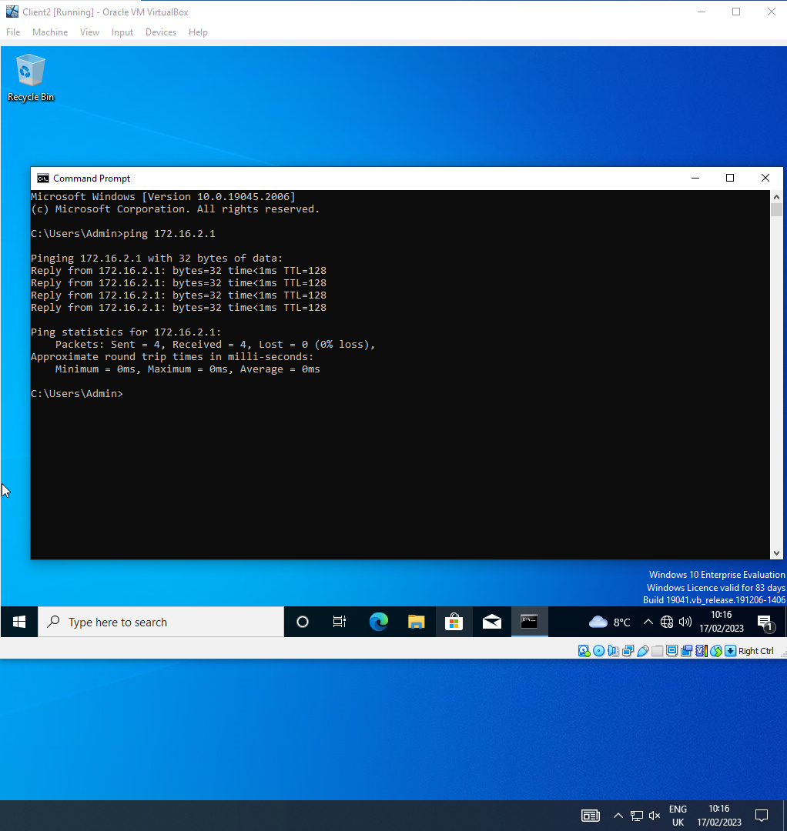
Client 2 successfully pinging Server 2

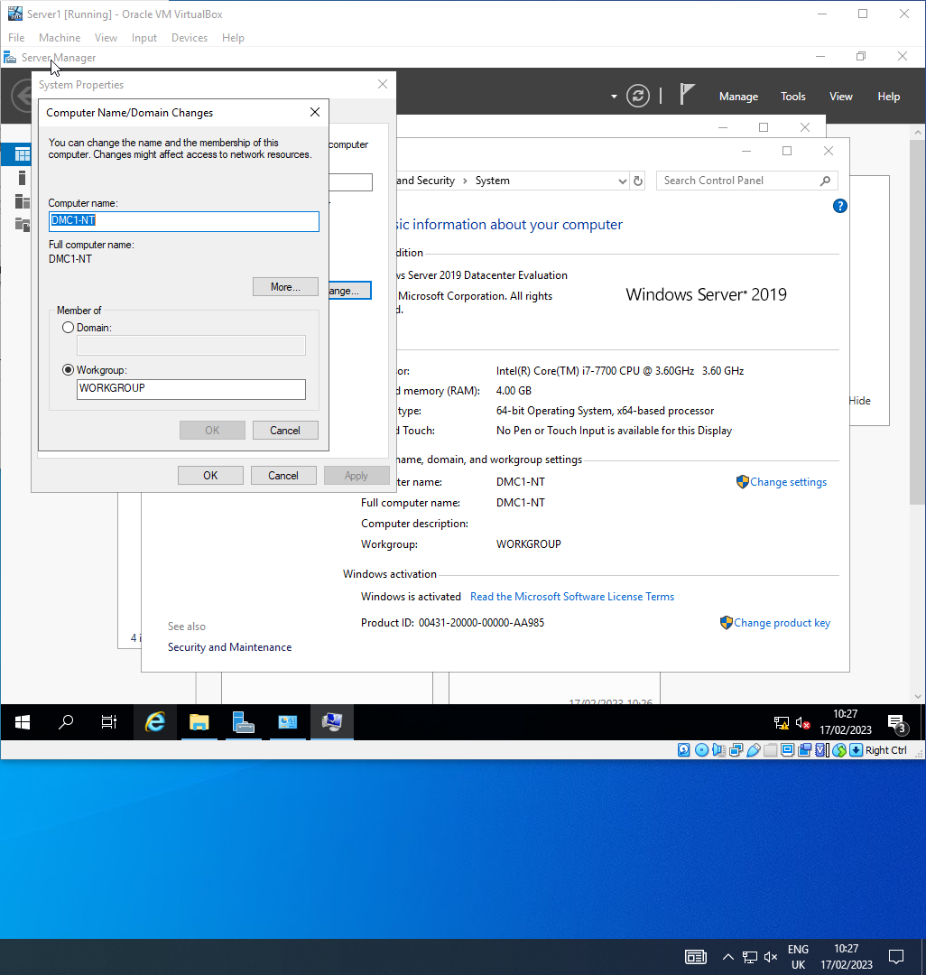
Changing Server 1 computer name
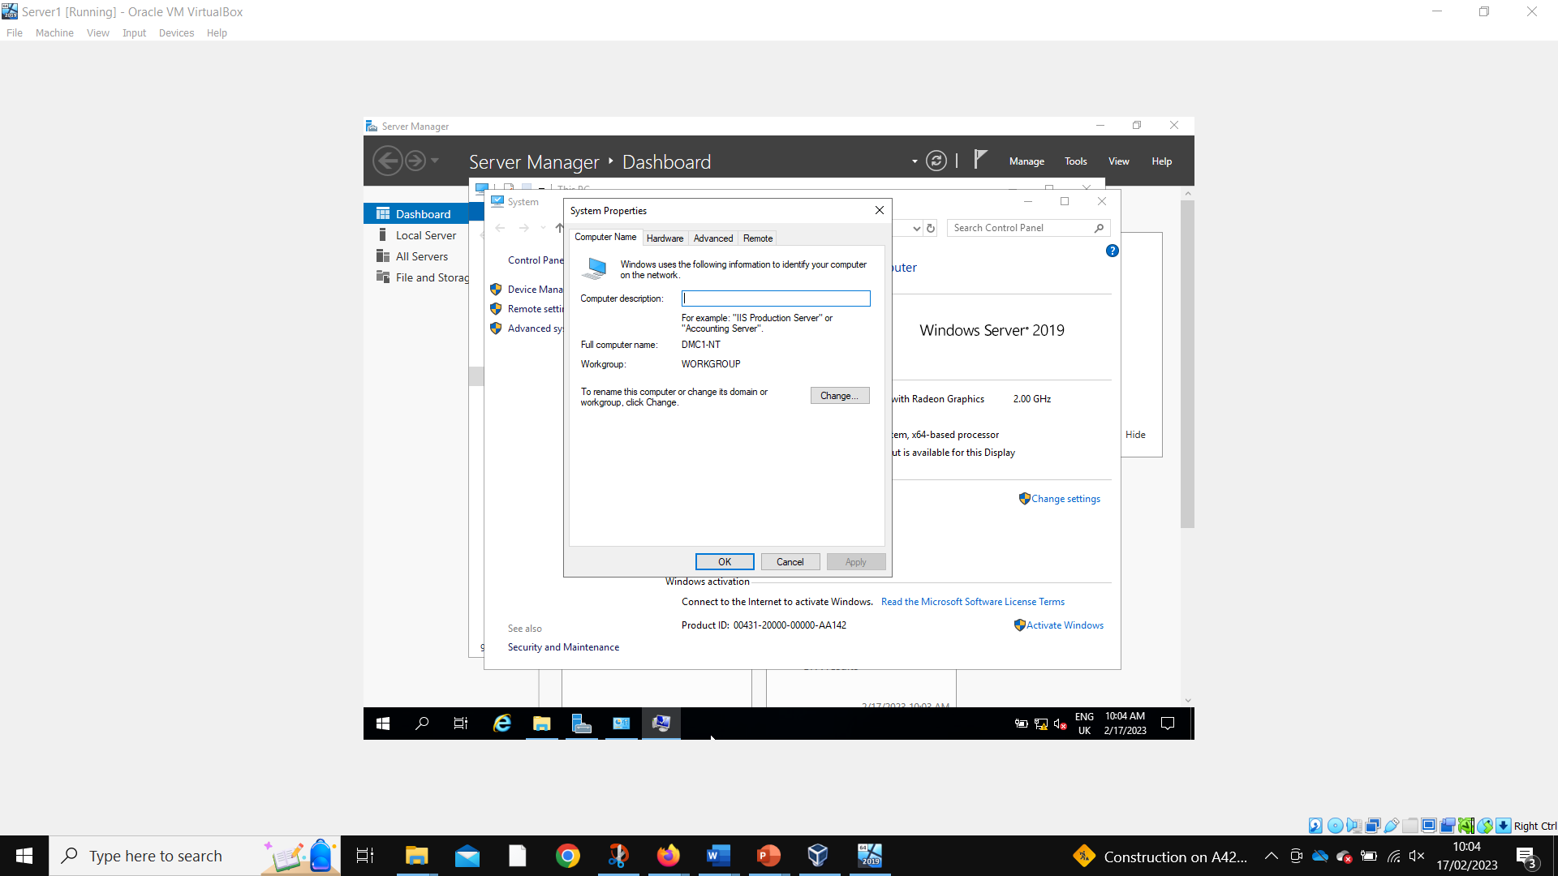
Server 1 computer name successfully changed
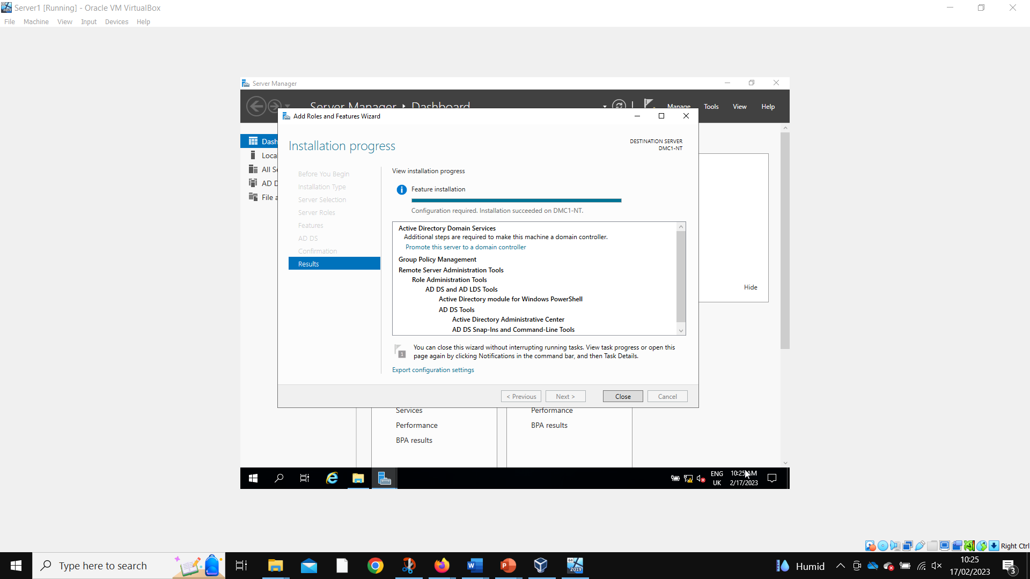
Server 1 adding active directory domain services
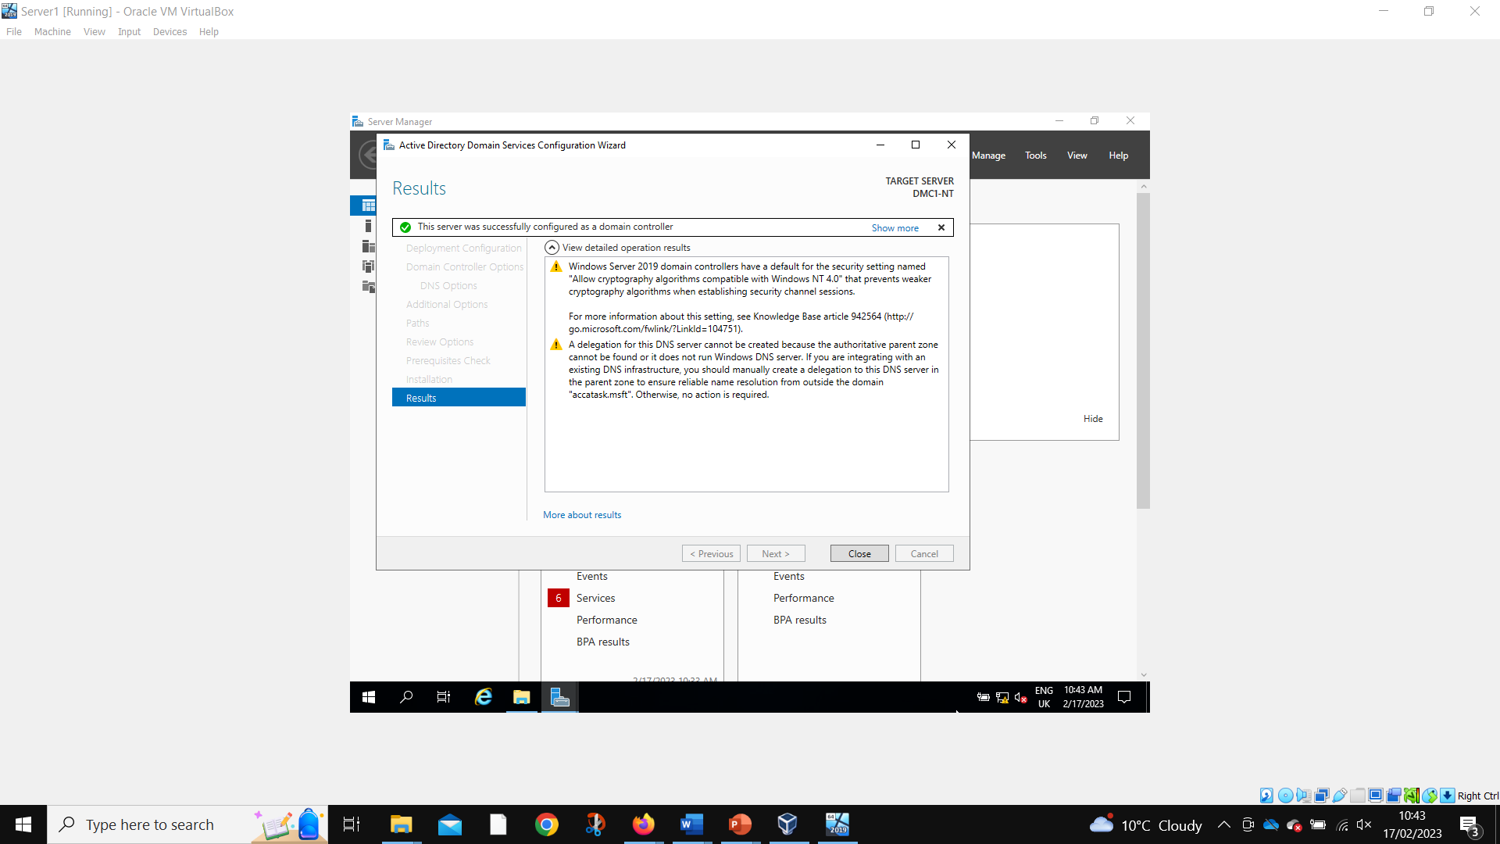
Server 1 active directory domain services successfully installed
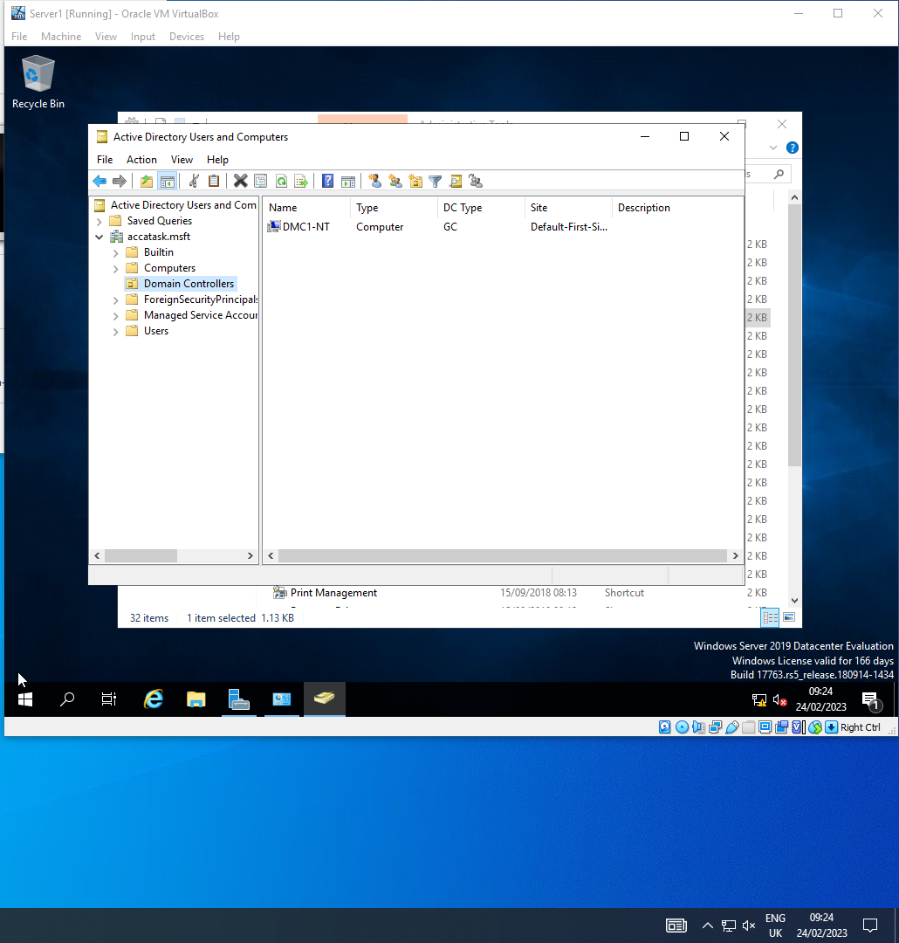
Server 1 DMC1-NT present in domain controllers
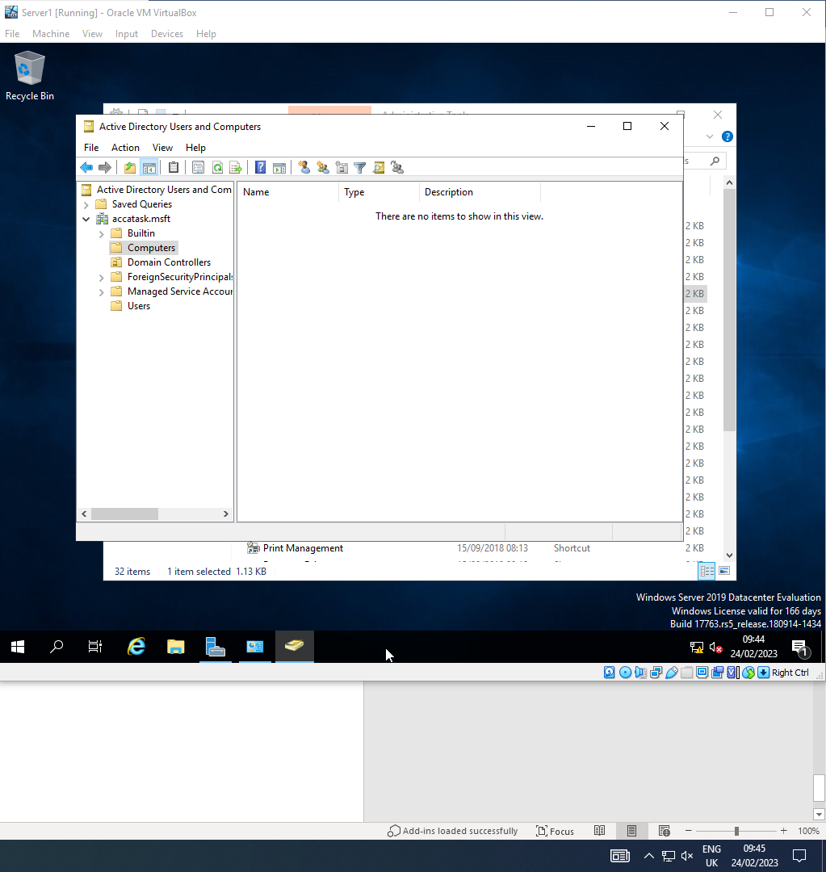
Computers folder empty
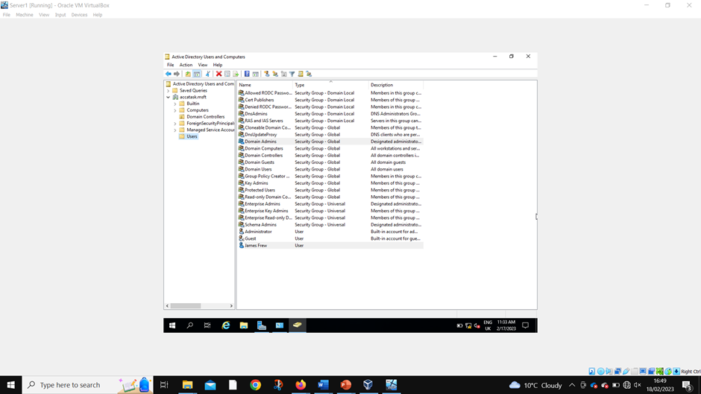
Admin account created
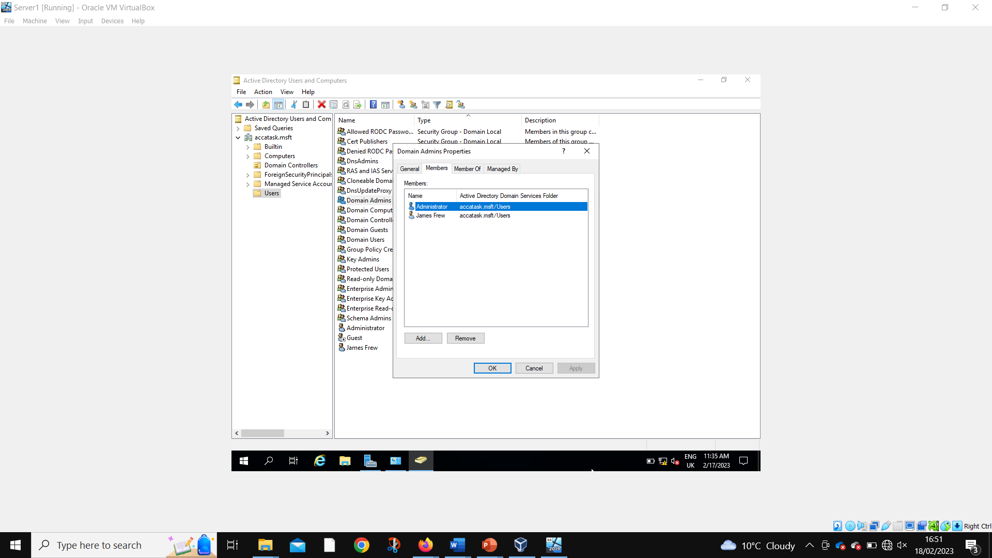
Admin account added to admin group
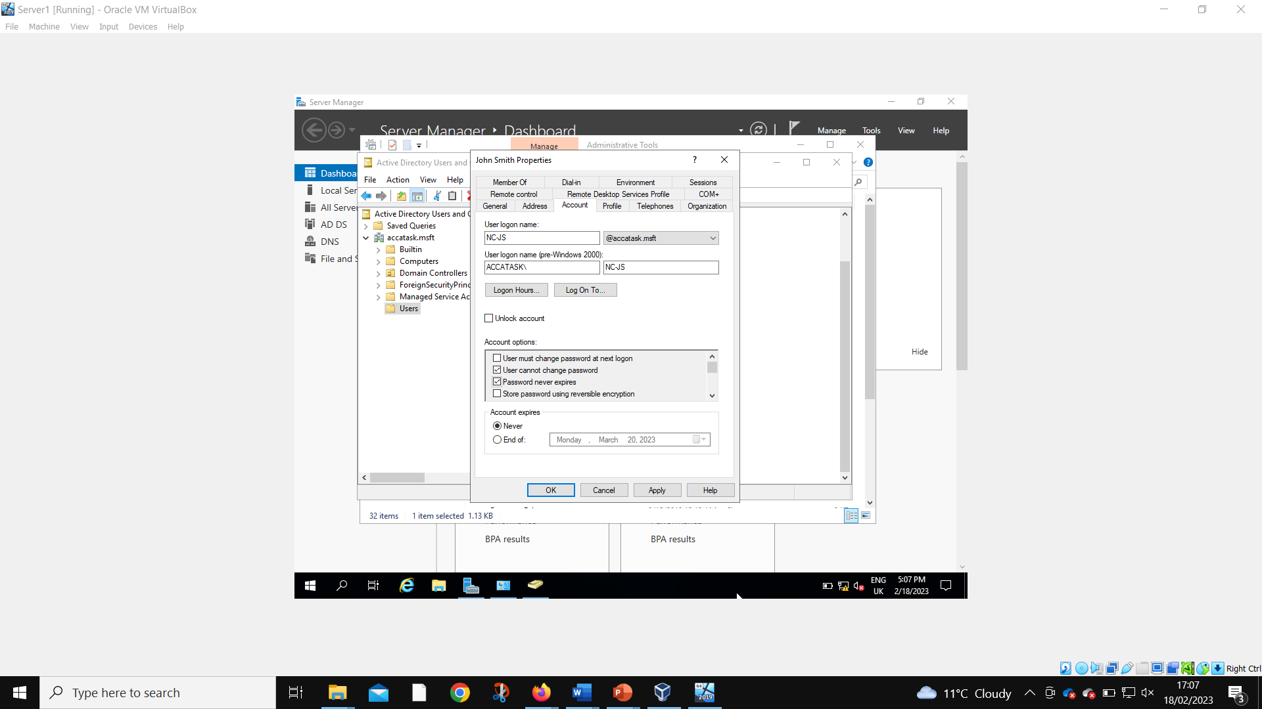
User account created
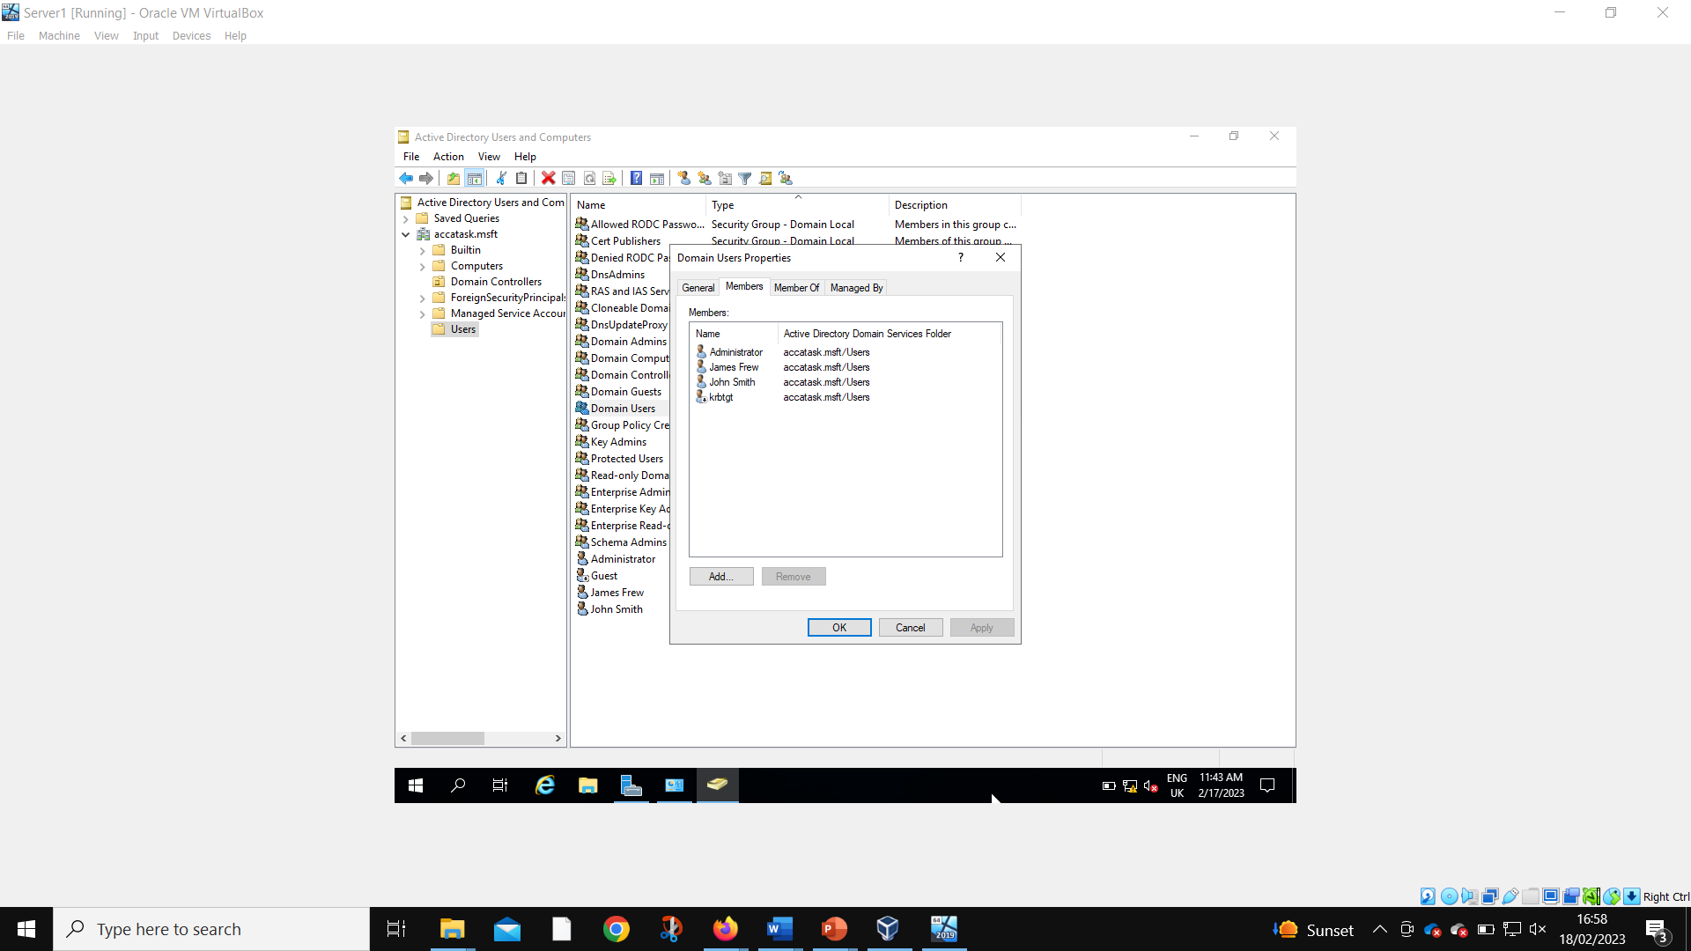
User account added to user group
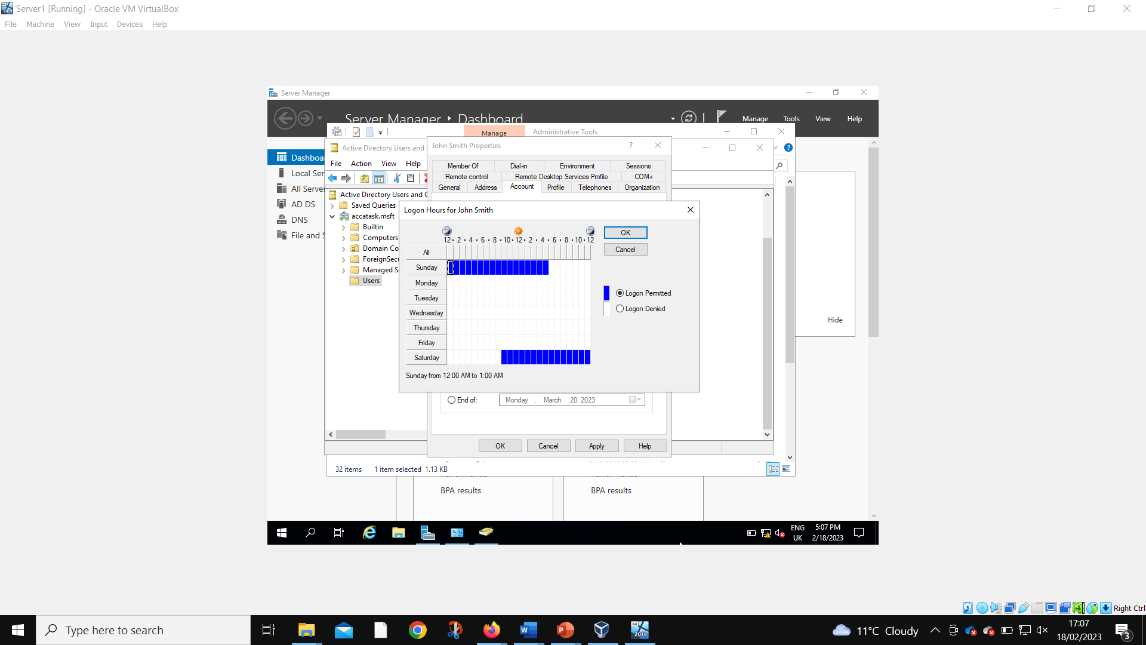
Access time restricted for user account
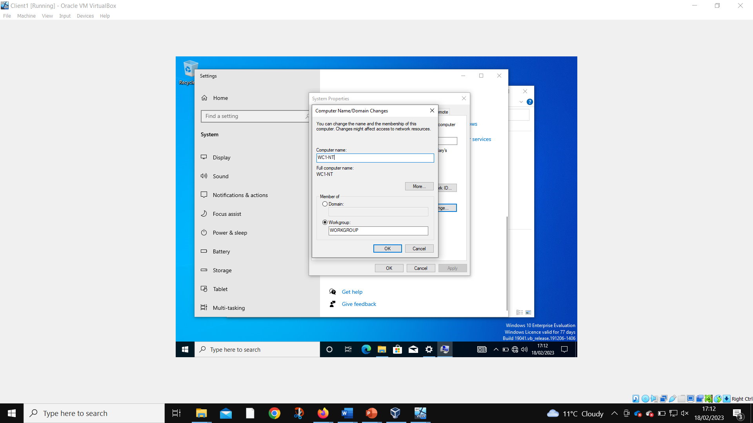
Client 1 computer name changed
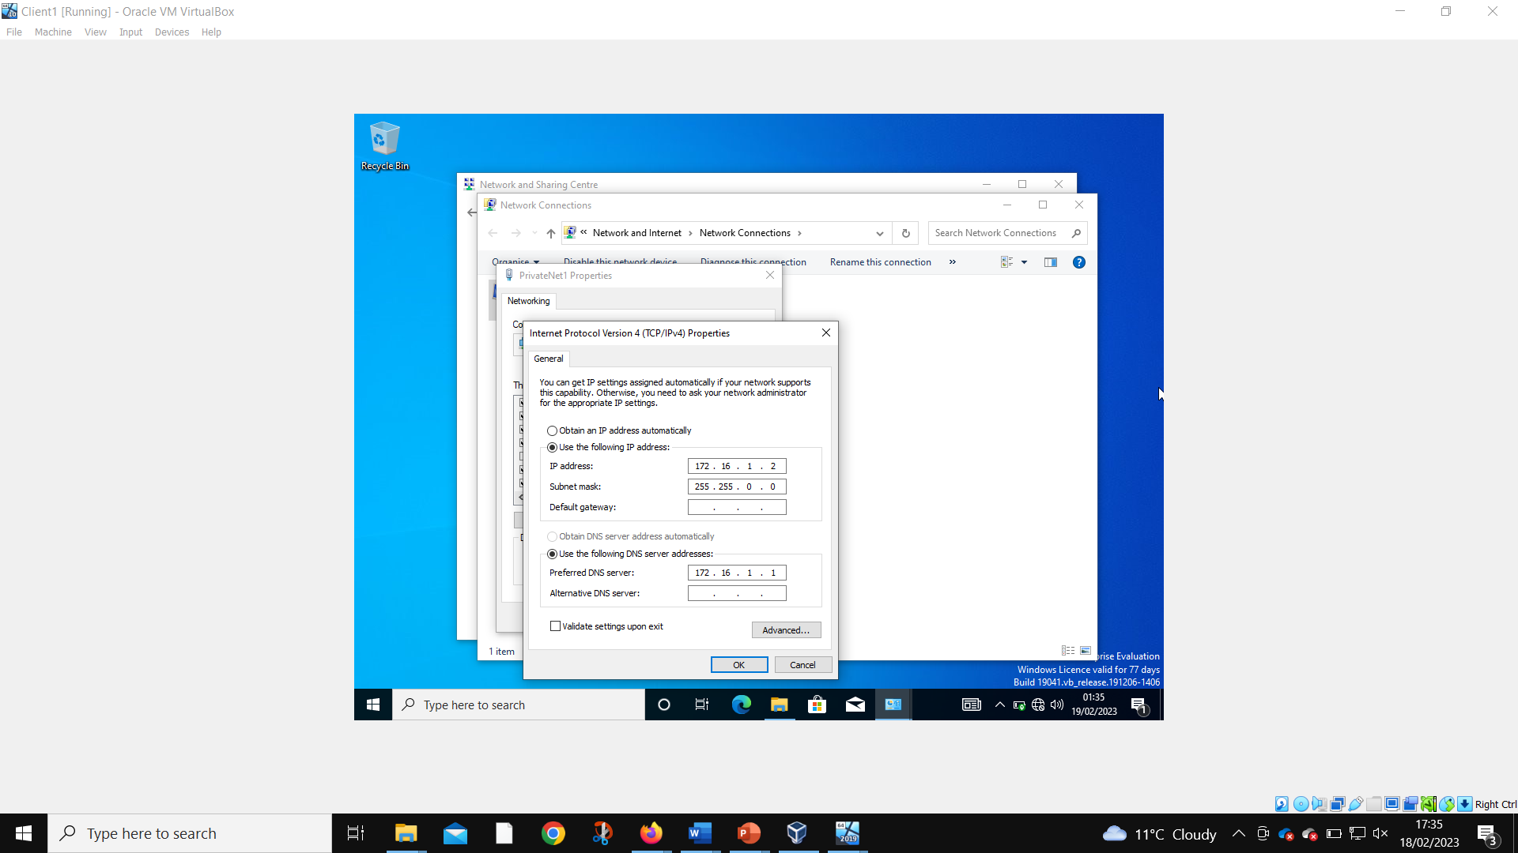
DNS IP assigned as 172.16.1.1. Instructions were to assign 10.10.10.1, but this is the address of the public network, and therefore wouldn’t work for the local DNS server connection.
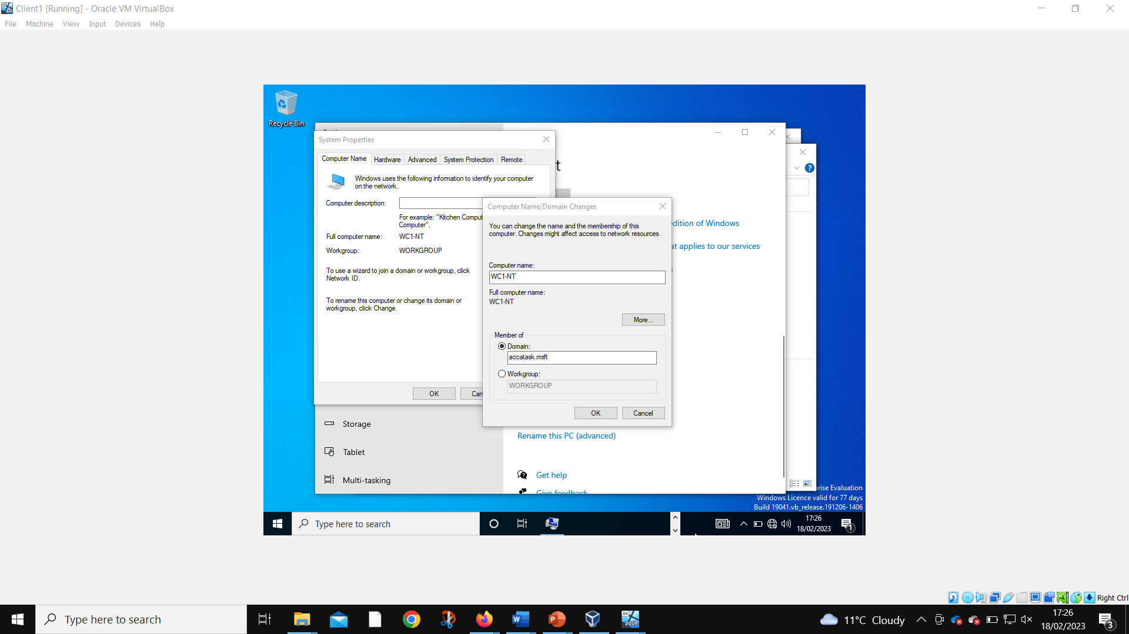Client 1 member of domain changed
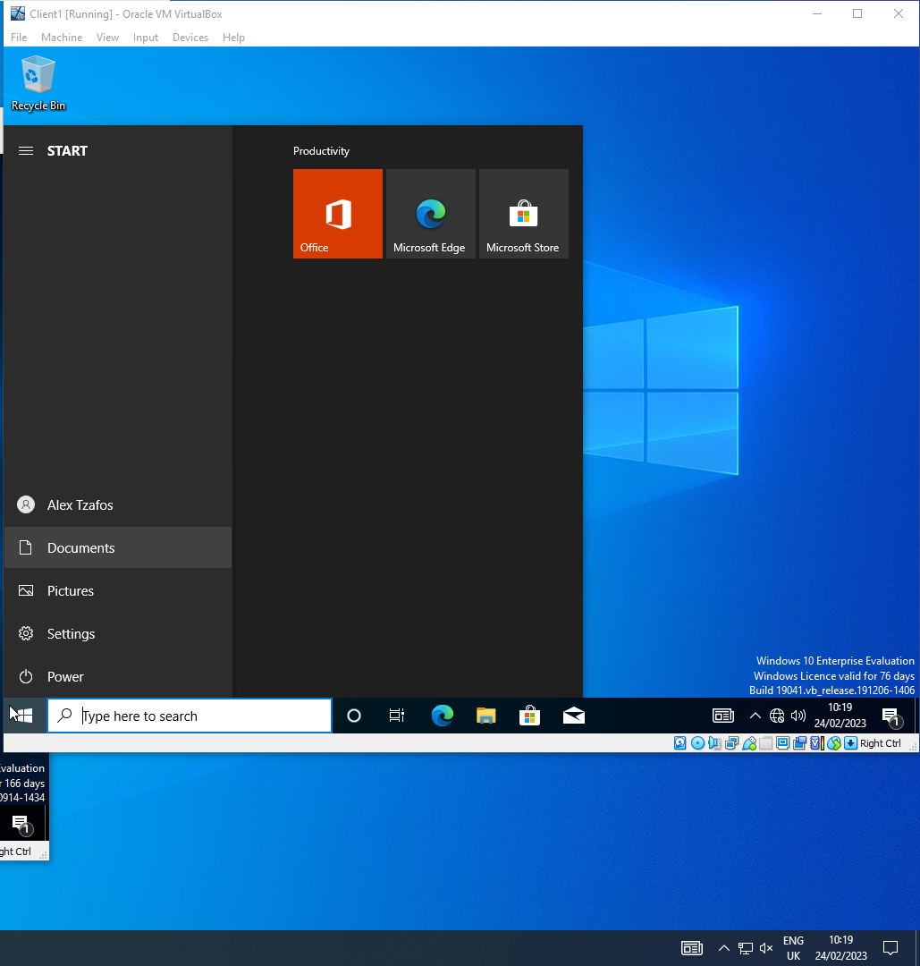
Admin account successfully logged into to Client 1
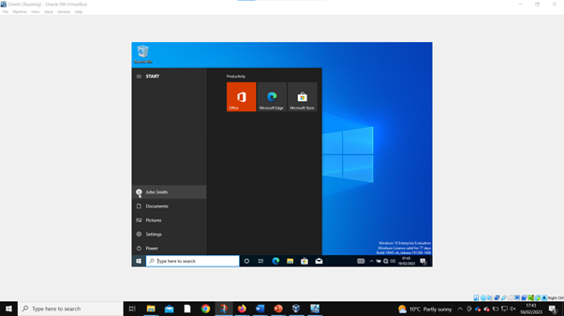
User account successfully logged into Client 1

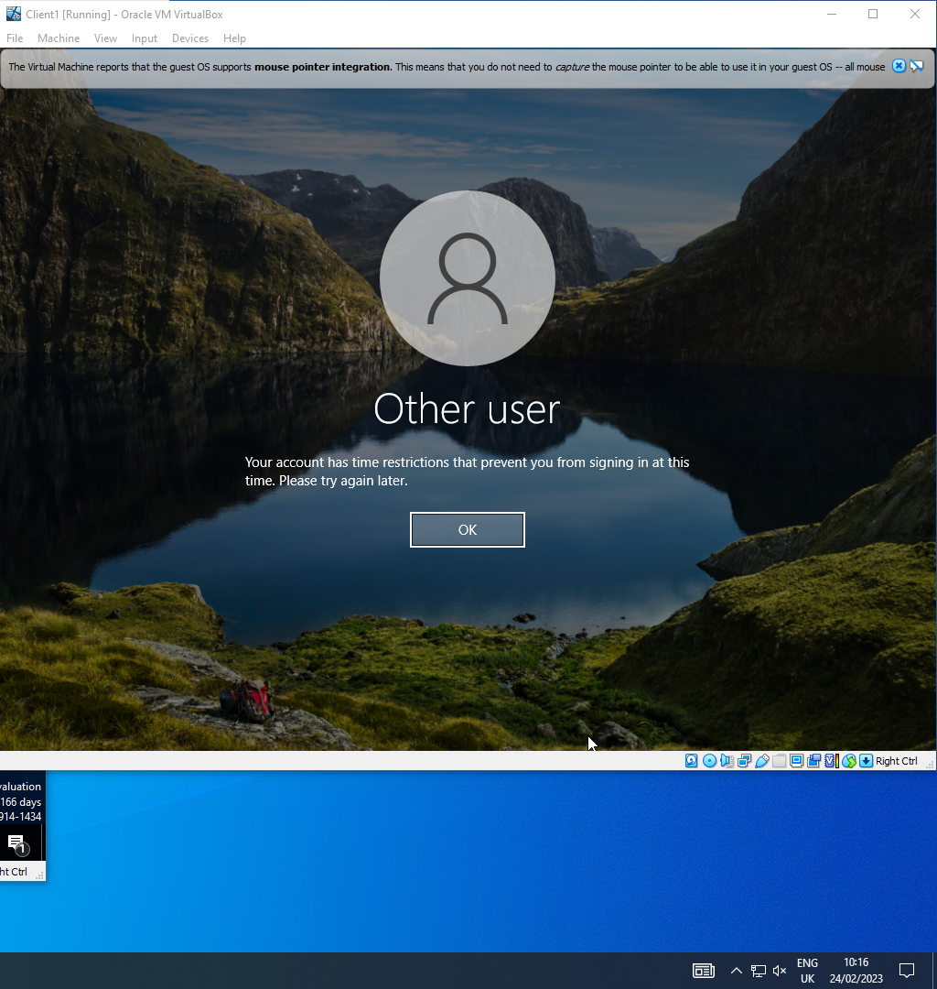
User account unable to log in to Client 1 due to time restrictions

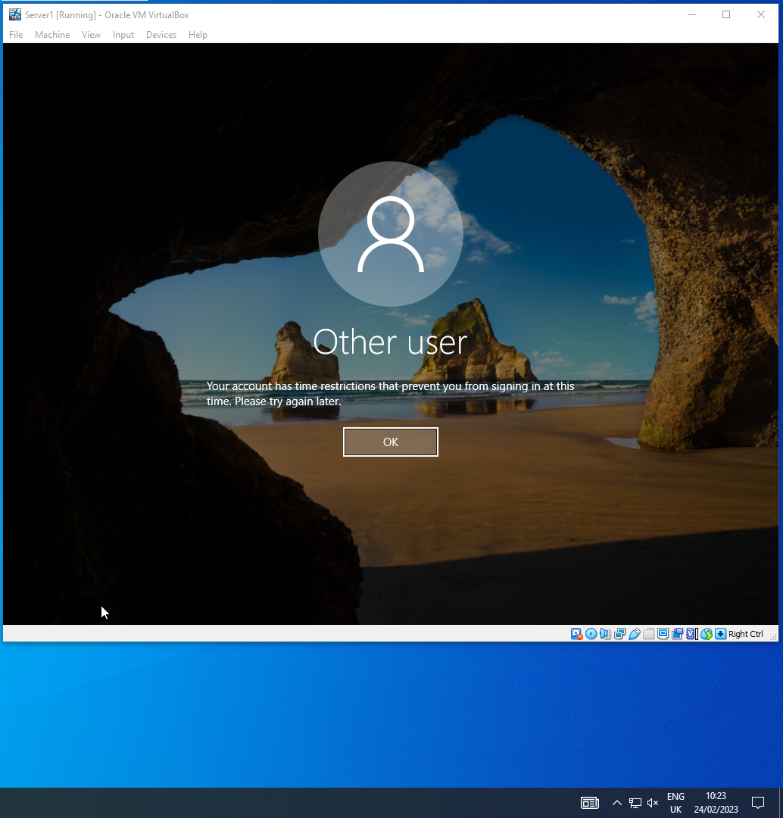
User account prevented from accessing/logging into Server 1

Part 2

Hypervisors
A type 1 hypervisor is installed directly onto the hardware that runs it and is therefore most commonly used on data center networking devices and enterprise servers. These areas need maximum efficiency, scalability, and reliability – a feat which is gained by installing directly onto hardware. A type 2 hypervisor uses a virtual machine so can be run using any system powerful enough for its needs. A type 2 hypervisor was used here for multiple reasons, primarily being cost, energy usage, and space.[1] Type 2’s can be tacked onto currently existing machines without having to purchase specialized hardware for them to function. This hardware is expensive – both to purchase, and to run (as they require more energy) – and takes up more space than using virtualization. Type 1’s can also have the drawback of being hard to change after being mapped to hardware. This would mean any changes might require new hardware – resulting in even more costs. Furthermore, virtualization allows experimenting with different operating systems (thanks to easy removal) as well as running multiple virtual machines on the same single system. Type 2’s ability to be easily exported and imported onto different machines allows for easier backups and group work. They also don’t require any management console software to operate (like type 1 does). They are, however, slower than using type 1s, but speeds at that level are not important here [2].

DHCP
A Dynamic Host Configuration Protocol (DHCP) is protocol for assigning IP addresses to devices on a network. DCHP (which originated from BOOTP) is predominately placed on servers but can also be configured on routers. The main features of the DHCP are:
- Assigning IP addresses,
- Reserving IP addresses,
- Assigning the main DNS server,
- And assigning the default gateway [3].
When a device joins a network, it sends out a request for an IP address. The DHCP server receives this request then allocates an IP address to the device. The device must respond to the DHCP server to acknowledge that it is happy with this address before the DHCP can officially assign it that IP. This is to prevent multiple IPs being assigned to the same device (in the case of multiple DHCP servers). One DHCP server can cover multiple networks, assigning different IPs to each network – devices on one network might start “192.168.1” whilst the other network could start “192.168.2”. The DHCP does however have to have a layer 3 device (such as a router) to communicate with networks outside of its own. As layer 3 devices don’t broadcast the signals the devices send when asking for an IP, a relay agent is needed. This relay agent functions as if it were a server – so that the layer 3 device will broadcast the IP request to the DHCP on the other network.
Attackers can create fake DHCP servers on networks that secretly route all IP requests through them (allowing them to create invisible area of networks). Alternatively, attackers can act as devices on a network and spam DHCP servers with fake requests to exhaust the available IP addresses [4]. This can be prevented by forcing the DHCP server to be acknowledged by the domain controller before IPs are sent to it.
DHCP servers can also lease out IP addresses in the event of large networks that are constantly adding and removing devices. A time limit is set (usually two hours) within which the device must request another IP or be removed from the network. DHCP is able to reserve ranges of IP addresses to prevent them automatically being assigned to devices. This allows network administrators to assign these addresses to specific devices as is required. It can also assign the IP addresses of the main DNS server and the default gateway of a network.

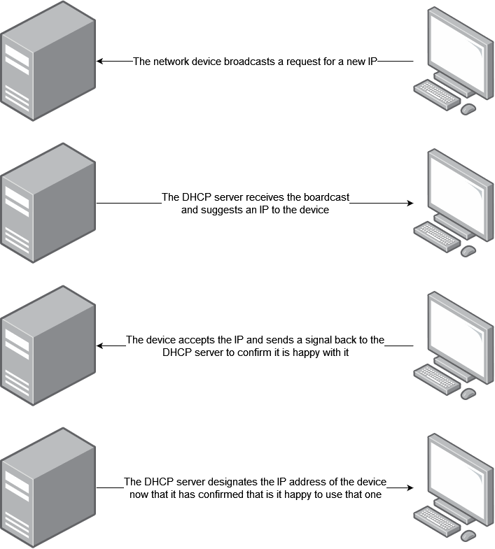

Active Directory
One of Active Directory’s (AD) functions is that of a domain controller. This manages different domains and the policies that govern each [5]. It does this using a forest and tree hierarchical structure [6]. Forests are a group of one or more domains that have a similar/the same logical structure. Domains in a forest are linked with a two-way, transitive trust relationship. Each forest is made up of at least one tree (child). This tree will have the same logical structure as its parent (forest) but will have additional / different features as well. This allows grouping similar items into sections for easy management and organization. The child will have the name of the parent included in its own name – to signify its forest domain. Trees can communicate with other trees inside the domain if given permission to do so. They can also communicate with trees in other domains if the two forests have an adequate trust relationship (either one-way or two-way).

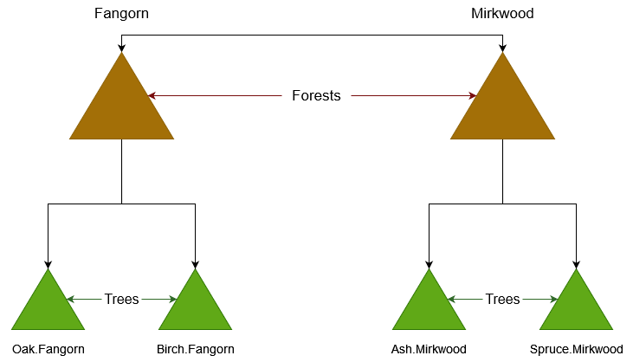

Terminologies
The “ping” command in windows server 2019 is used to check the connection between two machines that are connected to each other – either in the same, or different networks. The command sends 4 packets from the host machine to the destination IP address to see if they will be received correctly. It then tells the user how many of these packets were received or lost, and how long it took each to do it [7]. The Mac Operating System has the same ping function, with the only difference being the number of packets sent. With Mac, the ping will not stop until the user has told it to – using Ctrl + C. After this it will give the number of successful packets and average ping time – just like with Windows [8].
Server management is a feature within windows server 2019 that allows a network administrator a wide array of control over a network’s servers. It is used to set up DNS, DHCP, domain services, user rights management and many more important administrative features for networks [9]. The Mac OS has its own variation of the Windows server management – Server Admin Tools [10]. This tool possesses many of the same features as the Windows Server Management tool, such as the following:
- Server preferences,
- Workgroups,
- Server monitoring,
- Account creation and management,
- Etc.
Windows server 2019 contains the Windows Firewall. This firewall is used to block unsafe communications from external networks that might seek to do harm to your network [11]. Disabling it will allow any network available to send packets to the network. Doing so is unadvised if an internet connection is present at either the main network or any connected. Mac systems also come with a firewall, but unlike with Windows, is disabled by default. Otherwise, this firewall functions the same as the Windows Firewall does [12].
Physical Address Extension No-Execute (PAE/NX) is a feature of VirtualBox that allows virtual machines to access the processing power/other system specs of the machine that is running it. This allows for more powerful servers, etc. which can then fully function correctly [13].
OOBE stands for Out Of the Box Experience. In Windows 10, this asks users to select written and keyboard languages, region, network connections, and many more features such as configuring Cortana. It is also the location in which Microsoft’s End User License Agreement (EULA) is presented to the user. The point of OOBE is to break up required user setup tasks into smaller sections, rather than dumping large amounts of requests all at once [14]. In Mac, the OOBE startup options are almost identical – language selection, region, accessibility options, and network selection, followed by Apples Data & Privacy information (similar to Windows EULA). It then includes a feature Windows does not currently have – Migration Assistant. This feature allows users to transfer all their data from another Mac, or even a Windows PC to the new machine. It then continues with the standard features that both Operating Systems have – location services, logging in with email accounts, etc. [15]

Task Reflection
The first part of task 1 undertaken was to create the Virtual Machine and set up the required operating systems – Two copies of Windows Server 2019, and Two of Windows 10. This involved choosing specific memory, storage, and VRAM sizes. The operating system installation involved creating an administrator account on each machine, whilst also going through the OOBE settings. The second part of task 1 involved configuring the different networks that the setup required – two local and one public network. IPs were set on each machine and firewalls were disabled.
In task 2 part 1 the Server 1 machine was named, whilst in part 2 Active Directory was set up. This involved creating a new forest and assigning Server 1 as the domain controller. Part 3 of task 2 was to create an administrator and a user account using active directory, and in part 4, the user account had their login hours restricted to between Saturday 9am and Sunday 5pm. Finally in part 5, Client 1 was added to the domain and both Server 1 and Client 1 were tested to check login abilities. The user account wasn’t able to log into the Client 1 machine outside of the allotted time, and couldn’t log into Server 1 at all. The administrator account was able to get into both at any time.

Conclusion
To conclude, four virtual machines have been set up. Two of these have now been configured, with the other two still available for customization. Future work would include this, as well as configuring the second network to work alongside the first – syncing DHCP server, connecting both clients together, etc.

Reflection on Collaborative Work
The group worked well together on the whole, and communication function well. Unfortunately, student three missed one session, and student 4 missed two. This led to a slightly slower workflow than could have been achieved if they were both present for all sessions. These absences were unavoidable as they were down illnesses – food poisoning, etc. Otherwise, work was completed on time and a good collaborative effort was made by all.

References
[1] K. Taylor. (). What s the Difference Between Type 1 and Type 2 Hypervisor?. Available: https://www.hitechnectar.com/blogs/hypervisor-type-1-vs-type-2/ [Accessed Mar 6, 2023].
[2] Q. Ain and M. A. Mehmood, "Runtime performance evaluation and optimization of type-2 hypervisor for MIPS64 architecture," Journal of King Saud University - Computer and Information Sciences, vol. 34, (2), pp. 295-307, 2022. Available: https://www-sciencedirect-com.ezproxy.uwtsd.ac.uk/science/article/pii/S1319157819308390. DOI: 10.1016/j.jksuci.2019.11.006.
[3] Anonymous ("Jul 29, "). Dynamic Host Configuration Protocol (DHCP). Available: https://learn.microsoft.com/en-us/windows-server/networking/technologies/dhcp/dhcp-top [Accessed Mar 6, 2023].
[4] H. Mukhtar, K. Salah and Y. Iraqi, "Mitigation of DHCP starvation attack," Comput. Electr. Eng., vol. 38, (5), pp. 1115-1128, 2012. Available: https://www-sciencedirect-com.ezproxy.uwtsd.ac.uk/science/article/pii/S0045790612001140. DOI: 10.1016/j.compeleceng.2012.06.005.
[5] N. C. Iyer, A. M. Kabbur and H. G. Wali, "Implementation of Active Directory for efficient management of networks," Procedia Computer Science, vol. 172, pp. 112-114, 2020. Available: https://www-sciencedirect-com.ezproxy.uwtsd.ac.uk/science/article/pii/S1877050920313399. DOI: 10.1016/j.procs.2020.05.016.
[6] Anonymous ("Jul 29, "). Understanding the Active Directory Logical Model. Available: https://learn.microsoft.com/en-us/windows-server/identity/ad-ds/plan/understanding-the-active-directory-logical-model [Accessed Mar 6, 2023].
[7] Anonymous ("Feb 03, "). ping. Available: https://learn.microsoft.com/en-us/windows-server/administration/windows-commands/ping [Accessed Mar 6, 2023].
[8] Anonymous ("Jan 25, "). How to Do a Ping Test on a Mac Computer. Available: https://www.hellotech.com/guide/for/how-to-do-a-ping-test-on-mac [Accessed Mar 6, 2023].
[9] Anonymous ("Jun 08, "). Server Manager. Available: https://learn.microsoft.com/en-us/windows-server/administration/server-manager/server-manager [Accessed Mar 6, 2023].
[10] Anonymous ("May 26, "). Server Admin Tools 10.5.7. Available: https://support.apple.com/kb/dl831?locale=en_US [Accessed Mar 6, 2023].
[11] Anonymous ("Feb 24, "). Best practices for configuring Windows Defender Firewall. Available: https://learn.microsoft.com/en-us/windows/security/threat-protection/windows-firewall/best-practices-configuring [Accessed Mar 6, 2023].
[12] Anonymous ("Feb 18, "). Firewall security in macOS. Available: https://support.apple.com/en-gb/guide/security/seca0e83763f/web [Accessed Mar 6, 2023].
[13] Anonymous ("Jan 07, "). Physical Address Extension - Win32 apps. Available: https://learn.microsoft.com/en-us/windows/win32/memory/physical-address-extension [Accessed Mar 6, 2023].
[14] Anonymous ("Sep 29, "). Customize OOBE. Available: https://learn.microsoft.com/en-us/windows-hardware/customize/desktop/customize-oobe [Accessed Mar 6, 2023].
[15] Anonymous (). Set up your MacBook Pro. Available: https://support.apple.com/en-gb/guide/macbook-pro/apd831707cb3/mac [Accessed Mar 6, 2023].

