

Student name: Salina Begum
Student ID:2437215

Module name: Introduction to Health and Social Care
Module code:LCHS4003_LON
Lecturer name DR Christoher Mafuva

Content page

Element 1 …………………………………………………………….. page

EXPLANATION OF SERVICE
The main purpose for Ambulance service is to provide emergency medical care to patients 24 hours a day.
Ambulance responds to emergency 999 calls and plays a vital role in the community. They respond to urgent needs to peoples most vulnerable times.

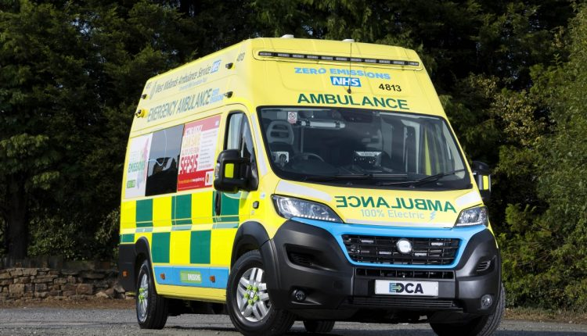
HISTORY OF SERVICE
- The NHS was established in 1948, which included the Ambulance services across the country.
- 1937: the 999-emergency number was introduced in the UK
- World war I: The first motorized ambulances to transport wounded soldiers.

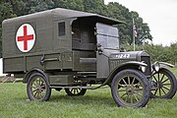

CHALLENGES FACED BY SERVICES
- Ambulances face challenges such as staff shortages, due to this staff are required to work long hours, and have high work pressure this leads to burnout and stress. This influences the staff crisis and is a struggle to recruit and keep qualified staff
- the number of calls is on the rise and not enough resources to keep pace or handle the situation.

CURRENT FUNCTION OF SERVICE
- Ambulance services respond to priority and sickest person, which is life threatening and requiring the fastest response.
- Trained paramedics are dispatched and are equipped to perform diagnostic tests, basic procedure’s and provide adequate treatment at the scene before taking patients to the hospital.

AMBULANCE SERVICES

Element 2
According to the NHS website the NHS was established in 1948, providing free healthcare services to everyone. Before the NHS was established in 1948 treatment was not free. Not everyone was able to afford adequate healthcare. People who were unemployed and middle-class people also struggled to access Affordable Care.
There was limited private care such as doctors and nurses were available to who can afford to pay for their treatments. Employed workers were covered by the National Insurance act Of 1911, to receive medical care. However, their wives and families were not free to access any medical treatment. The doctors would carry out home visits or in the surgery. He would attend in childbirth.
After the World War people were suffering led to formation to poverty. The war put a strain in the country and left many people on hardship. Due to loss of life and destruction or damages to millions of homes and workplaces. People were suffering from depression and social deprivation. The first and Second World War had left its mark.
The five giants needed to be tackled for Britain to succeed economically and socially. The five big problems were want: Poverty and deprivation, disease: inadequate healthcare provision, ignorance: lack of education, squalor: poor housing conditions, and idleness: lack of jobs or employment opportunities.
The Beveridge report released in November 1942 to plan and remake Britain after the War to end “want.” Also, Beveridge said that everyone would be entitled to free healthcare.
NHS was established on July 5th, 1948, by the labour Government. After the launch, 95% public had registered before it begun, and demand for doctor's visits and prescriptions increased suddenly in the first few years.
The number of doctors prescription issued per month was 7 million in 1947 to 19 million by 1951. Due to the increase a lot of pressure was put on the resources.
Due to NHS being established the doctors were not happy thinking they would lose independence and would have to become employees of the government. The government allowed doctors to remain independent and to continue with private practise within the NHS.
NHS provided GP services which included opticians, dentists and pharmacists but integrated into the new system to provide better healthcare services across the country. Hospitals were nationalised and was controlled by the Minister of Health. Health centres were created for vaccinations; maternity care and visiting nurses. The goal was that everyone in the UK to access free healthcare services regardless of their ability to pay. This was all funded by general taxation.
The NHS bought doctors, nurses, hospitals dentists under a single national service for the first time. But it is not a “charity” you are all paying for it, mainly as taxpayers. It will be a huge relief not having to worry about money during your illness.
The NHS was one of the first universal healthcare system established anywhere in the world. A leaflet was sent out to every household in June 1948 to explain that everyone is entitled to free healthcare services. It doesn't matter if you're rich or poor, man, woman or child.
It is important to note that the NHS is not a single organisation, and its structure varies between the four UK nations England, Scotland Wales and Northern Ireland. Organisations like the Department of Health and social care provide leadership and funding.
NHS England provides national leadership sets strategic direction and overseas the health service.

Currently NHS structure is complex and is made-up of hundreds of different organisations including various healthcare providers and national bodies.

References:

Gov.uk blogs
https://history.blog.gov.uk (13 July 2023)
NHS England
https://www.england.nhs.uk( 9thNovember 2022)
Royal College of Nursing
https://www.rcn.org.uk (4 July 2023)

