Part A - Poster
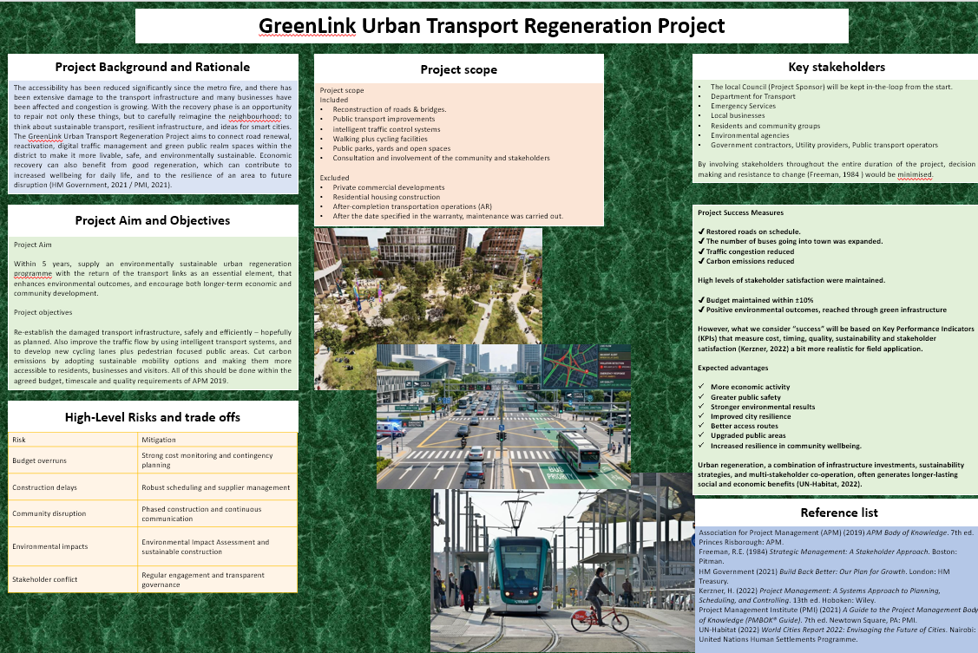

Part B – Reflection on Feedback

The feedback provided to me by my lecturer and peers was constructive and it provided very valuable inputs which I could use to adjust my project management plan. For sure in hindsight the comments did show that there is still a sound foundation in the project proposal, particularly the reasons for the need for a regeneration project and of course the aims clearly stated within the proposal. However, as the feedback suggested, there are certain project management tools and processes that could be given a bit more if the presentation were to be final, and it would be a lot more professional.
One of the key strong points that emerged was the project background and rationale, you just knew that it was solid. In the eyes of the lecturer, the proposal had shown why a need for a dedicated regeneration project was justified instead of a routine job of infrastructure maintenance. Making a convincing business case is a key part of getting a project started, because it shows the strategic merit of the work and backs up stakeholder decision making (APM, 2019). There was also a good reception for the project aim and objectives, largely because they kept the aim away from what actions are needed to achieve it. Moreover, the project map did a decent job in outlining the scope, which helps lower risk of scope creep throughout the entire project lifecycle (PMI, 2021).
Despite such qualities, the lecturer noted that there are some areas that require further development, such as they feel unfinished. Currently the stakeholder section refers to the key stakeholders but does not evaluate the importance or interests of the stakeholders. The final report will therefore include a stakeholder Power–Interest Matrix, to ensure that actions for engagement and communication strategies are prioritised in a more transparent fashion. This aligns with Freeman's (1984) stakeholder theory and the PMBOK® Guide with its emphasis on project success occurring only when different management approaches are utilized with different stakeholder groups (PMI, 2021).
Also, she recommended expanding the project objectives and benefits, adding more detail and by putting in a complete Quad Chart. This will allow stakeholders to see briefly its goals, constraints, benefits, and measures of success and will provide added strength for the project governance (Kerzner, 2022).
Risk management also became a subject that received a lot of attention as this area that needs to be done a lot more. Although the first risk register has identified risks and the risk mitigation work, the last risk register, considering all risks by risk likelihood, impact, risk priority and related contingency actions will be reviewed. A more structured risk assessment assists the project managers in concentrating effort and resources in the right places and acting quickly to contain uncertainties as outlined by Hillson (2009).
Finally, the lecturer concluded that it was beneficial to incorporate a Work Breakdown Structure, as well as a Gantt Chart and the RACI Matrix. The goal of these tools should be to explicitly define "who does what, when" as well as define the project activities including task dependencies while enhancing oversight throughout the project. Taken together, they help the planning, scheduling, and accountability, more than when they are missing (Kerzner, 2022; PMI, 2021).

Reference List
Association for Project Management (APM) (2019) APM Body of Knowledge. 7th ed. Princes Risborough: Association for Project Management.
Freeman, R.E. (1984) Strategic Management: A Stakeholder Approach. Boston: Pitman.
Hillson, D. (2009) Managing Risk in Projects. 2nd ed. Farnham: Gower.
Kerzner, H. (2022) Project Management: A Systems Approach to Planning, Scheduling, and Controlling. 13th ed. Hoboken: John Wiley & Sons.
Project Management Institute (PMI) (2021) A Guide to the Project Management Body of Knowledge (PMBOK® Guide). 7th ed. Newtown Square, PA: Project Management Institute.

Part C – Project Management Plan (Part 1)
Introduction
To restore transport services after extensive damage to infrastructure by a metro fire, the GreenLink Urban Transport Regeneration Project was introduced, which also supports the urban regeneration and sustainable development in the long term. The programme is not solely to repair the existing broken roads and transport assets, but to create a newer and more environmentally friendly transport network. This will facilitate improved mobility and contribute to the economic recovery in a more resilient manner and to the resilience of communities. The reason we need a structured approach to project management in such kind of projects, is that many stakeholders are involved, financial commitments are significant and there are critical technical challenges at stake. (PMI, 2021).
Project management provides a more systematic method for managing all the people, resources and everyday activities throughout the project for its entire life cycle. To achieve results, projects must have clear governance, stakeholder involvement, proper planning, and regular monitoring, aiming to fulfil the organization's goals, as stated by The Association for Project Management (APM 2019). In the same way, Kerzner (2022) contends that big infrastructure programmes call for wide reaching planning tools which help project managers line up cross functional teams while also keeping risks in check and sustaining stakeholder confidence.
This project management plan outlines project management principles and how they are being applied in the delivery of the GreenLink Urban Transport Regeneration Project. The report also builds on this initial proposal, with the addition of a Work Breakdown Structure WBS, a Quad Chart, a Gantt Chart, as well as a stakeholder analysis and a resource allocation strategy and a complete risk assessment. The general goal is to restore degraded transport infrastructure also to improve accessibility but to reduce environmental costs and to promote more sustainable economic growth.

2. Project Description

The GreenLink Urban Transport Regeneration Project is a public infrastructure regeneration project, established to rebuild and modernise an urban transport network that suffered severe damage due to a fire in the metro. sustainable mobility projects combined with digital development and management, and reconstruction of critical infrastructure result in a more comprehensive, high-quality and efficient city transport for the city and its surrounding region, putting sustainable mobility at the centre of sustainable urban development.
In addition to repairing damaged infrastructures, the programme will incorporate into the overall regeneration effort intelligent transport systems, environmentally friendly building and improving public spaces. More major work that needs doing will be road and bridge reconstruction, public transport facilities improvements, smart traffic management system installation and the construction of better cycling/bike routes, as well as pedestrian routes. Moreover, it emphasizes on enhancing green public areas as well. These all relate to the current transport policies, strategies and priorities in the UK which support sustainable mobility, low carbon infrastructure investment and investment in the UK supply chain (HM Government, 2021).
Digital technology is key to the overall regeneration plan – and it definitely does count. Smart traffic control systems will be used to optimize the traffic flow, as well as alleviate traffic congestion and real-time track the traffic situation. They also support evidence-based transport management, enhance the capability for emergency response, and reduce journey time down by cutting down. (PMI, 2021).
A major part of the project is also related to environmental sustainability. Things such as green infrastructure, better walking networks and increased cycling infrastructure they enable people to travel actively (on foot and by bike) and reduce private vehicle dependence. These environmental improvements will help to reduce carbon emissions, improve local air quality and will contribute to national climate targets. According to UN-Habitat (2022), a blend of sustainable transport and urban regeneration brings continued returns to the economy, the environment, and society long after the construction works are complete.
A side-benefit of the project is engagement with the community as you have to. Through the project's entire life cycle, all local stakeholders including residents, businesses, environmental stakeholders and transport operators will be consulted to ensure its redevelopment work truly reflects community needs, while minimising impacts as much as possible. Getting stakeholders involved early boosts project acceptance and helps with cooperative or joint decisions. (Freeman, 1984)

3. Project Scope

Clearly articulating the project scope establishes the bedrock for effective project management, as it details what will be delivered – and what won't. When scope isn't clearly communicated, it can lead to scope creep – additional features added, budgets become strained, timelines extend and stakeholders are disappointed (PMI, 2021). As a result, the GreenLink Urban Transport Regeneration Project establishes detail inclusions and exclusion prior to the commencement of implementing.
So, the project scope involves repairing compromised roads and bridges, upgrading public transport provisions, adding smart traffic control systems, plus building walk and cycle infrastructure. All of this work promotes the programme's aim of making the urban transport network safer, more sustainable and more resilient at the same time there is environmental landscaping and we engage in community consultation actions. In addition, there will be environmental monitoring and quality assurance activities validated through all elements of the construction process to ensure it complies with statutory obligations and meet sustainability expectations.
Specific carve outs have been put in place to ensure that the budget and manpower is focused on meeting the project strategies objectives of the project and to avoid unnecessary scope creep due to private commercial projects, housing developments and long-term operational management after the project, as well as utility work unrelated to transport infrastructure.
The projects' performance will be tracked by Key Performance Indicators (KPIs) to include budget completion, meet project timelines, decrease traffic congestion, lower carbon emissions, increase public transportation usage and increase stakeholder satisfaction (Kerzner, 2022).

4. Work Breakdown Structure (WBS)

A Work Breakdown Structure (WBS) is a very important tool in planning and one that is used to divide the entire scope of work into smaller more work packages which can be handled easily. The WBS is based on the PMBOK® Guide and assists project managers to structure their project activities logically, ascribe ownership to them and make better estimates for cost and schedule (PMI, 2021). The WBS ensures that each element of a GreenLink type, complicated, regeneration programme is planned and tracked efficiently and decreases the risk of missing aspects of the programme or duplication of effort.
The GreenLink Urban Transport Regeneration Project is divided into seven key phases, ok. The first is about project initiation activities, when you might be dealing with business case, regulatory project approvals and establishing project governance. Then it is the second phase where you're getting into all the details of engineering design and then the environmental assessments and then you're going for your statutory permissions but little by little. Next is procurement – procurement is undertaken through a competitive tendering process, and the usual tendering procedure is followed to select the contractors, suppliers and specialist consultants.
The largest component of the programme is the build phase, which includes road reconstruction, bridge repairs, junction enhancements as well as utility coordination works. Once a sufficient amount of civil engineering has been carried out, intelligent mobility systems, such as intelligent traffic light systems and digital traffic monitoring equipment, will be installed. Subsequent sustainable transport upgrades will be completed before the end checks, commissioning and project handover, such as pedestrian, bike and environmental landscaping.

Figure 1. High Level Work Breakdown Structure
Level 1 | Level 2 | Level 3
GreenLink Regeneration Project | Project Initiation | Business case, approvals, governance
 | Planning and Design | Engineering design, surveys, environmental assessment
 | Procurement | Tendering, contractor selection, supplier contracts
 | Infrastructure Construction | Roads, bridges, junctions, drainage works
 | Smart Transport Systems | Intelligent traffic signals, digital monitoring
 | Sustainable Infrastructure | Cycle lanes, pedestrian areas, landscaping
 | Testing and Closure | Commissioning, inspections, final handover

5. Quad Chart

Project key information is summarised in the Quad Chart which will also provide the top-level management a brief overview of all the projects. By bringing objectives, deliverables, timelines and performance indicators under a single roof, stakeholders will be better able to understand the health of the project at an instant glance and subsequently make better decisions (APM, 2019).

Figure 2. Project Quad Chart
Objectives | Deliverables
Restore damaged transport infrastructure. Improve sustainable mobility. Reduce congestion and emissions. Enhance long-term community resilience. | Reconstructed roads and bridges. Intelligent traffic management systems. Improved public transport facilities. New cycling infrastructure and public spaces.

Project Schedule | Success Measures
24-month implementation programme with defined milestones covering planning, procurement, construction, commissioning and project closure. | Completion within approved budget (±10%), reduced congestion, improved public transport reliability, increased cycling and walking, reduced emissions and high stakeholder satisfaction.

The Quad Chart will be continually developed throughout the project life cycle as part of the governance reviews that occur during the project. It is a quick snapshot view into the project for the project's sponsors, and a tool for assisting with strategic decision-making and communications of progress (PMI, 2021).

6. Gantt Chart

Gantt Chart is one of the most popular time management planning tools in project management because it helps to effectively visualize project activities, duration, milestones, and task relationships. Gantt Charts are also beneficial for communication among project team members, and as Kerzner (2022) highlights, scheduling slippages are quickly identified by leaders, before they become a significant problem.
It should take about twenty-four months to complete the GreenLink project. Activities are programmed in a technical dependency order such that construction can proceed only after the activities such as planning, design, and procurement have been completed – and not earlier.

Figure 3. High Level Gantt Schedule
Activity | Duration
Project initiation | Months 1–2
Stakeholder consultation | Months 1–4
Engineering design | Months 2–5
Procurement | Months 4–6
Road and bridge reconstruction | Months 6–18
Smart traffic systems | Months 12–19
Cycling and pedestrian infrastructure | Months 11–20
Environmental improvements | Months 13–21
Testing and commissioning | Months 21–23
Project closure and handover | Month 24

On the same time period there will be various project milestones that will be examined during implementation, such as planning approval, procurement, commencement of construction, installation of intelligent transport technologies and final handover. (PMI, 2021).

7. Stakeholder Involvement

Stakeholder management is one of the greatest effects on whether a project really succeeds, as infrastructure regenerations programmes have a broad impact on many organisations as well as community groups. Freeman (1984) argues that involving the needs of stakeholders can lead to a better project outcome as opposed to merely 'noticing' them. Therefore, the GreenLink project will adopt a transparent approach to so involve the stakeholders as is done in a Power-Interest-Matrix.
High power and high interest stakeholders (Local Council, Department for Transport and project sponsor) will participate in monthly governance meetings and receive detailed progress reports, to enable timely strategic decisions to be made. Construction work will follow the milestones set in the programme, although construction schedules may slip a little, contractors, transport and utility providers will attend regular co-ordination meetings. Local businesses and environmental groups will attend to provide public input for consultations; Community workshop(s) and periodic communications will be held throughout the entire project delivery.
This communication plan will be more straightforward and consistent, which will improve transparency, decrease misunderstandings among stakeholders and assist in common resolution. Continuing involvement also contributes to faster decision making and increases the public trust in the regeneration programme (APM, 2019; PMI, 2021).

8. Allocation of Resources

Getting resource allocation right is the foundation to ensuring project activities are completed in an efficient manner whilst maintaining constraints on costs, quality and the project schedule. Human resources, financial investment, equipment and specialist knowledge must be considered carefully and coordinated throughout the whole life cycle of infrastructure regeneration projects. Weak resource planning is mentioned by Kerzner (2022) as one of the most frequent causes of delays due to clashes between activities with a decrease in the total productivity. As a consequence, the GreenLink Urban Transport Regeneration Project will implement a structured management of the available resources, with the goal of maximising the use of already existing resources.
The project team in reality will comprise a Project Manager supported by civil engineers, transport planners, environmental consultants, procurement specialists, quantity surveyors, health and safety officers and digital systems engineers. Will have defined duties—the responsibility of each specialist will be clear, to ensure effective decision-making and a lack of confusion over duties. The construction side of work will be done by appointed contractors, whereas specialist suppliers will bring forward intelligent traffic management systems and sustainable transport technologies, together with the required supporting services.
Financial resources to be managed through a staged budget along with the main stages of the project. The funds will be allocated over planning, design, procurement, construction, commissioning and then project closing, and even with a contingency reserve available to deal with unpredictable or increased costs due to inflation, supply chain disruption to those projects or unforeseen engineering issues that always crop up. Continuous financial monitoring will also ensure that the funding is used within the agreed amounts and, at the same time, it can support good expense control while on implementation (PMI, 2021).
Physical resources include construction machines, measuring instruments, building materials, digital traffic control technology and equipment for the environment monitoring. (APM 2019).

9. Risk Analysis

Risk management is at the heart of making sure that big infrastructure projects get completed on time, because uncertainty can impact the way that the project is performed, and this is not always easy to predict at the outset of the project. Common risks that emerge in transport regeneration programmes are technical failures, financial uncertainty, environment issues and even stakeholder resistance. According to the PMBOK® Guide, managing risks needs to be an ongoing activity throughout the project lifecycle and not a standalone activity (PMI, 2021). In line with this ISO 31000 (2018) emphasizes that organisations should incorporate risk management into project planning and daily decision-making, and that organisational resilience should be enhanced.
A few important risks have been noticed for the GreenLink Urban Transport Regeneration Project. One of the highest risks will be construction delays since the right weather conditions or ground or contractor factors might move the completion date even farther out. One of the major issues is budget overruns which may result from potential increases in labour, material and energy expenses (Kerzner, 2022).
There's community disruption too, as it's roads could close, noise could impact neighbours and local businesses, or access might be temporarily restricted. Though some inconvenience is inevitable, careful management of stakeholder participation, a staged construction programme and simple public communications will help to lessen the impact and ensure community support for the project. After all, Freeman (1984) proposes that securing buy-in and involvement early on in the process truly minimises resistance to change in the organisation, and can actually increase project acceptance, even when people are sceptical to begin with.
There are also environmental risks, such as pollution issues, habitat disturbances and failure to comply with environmental laws. These risks will be mitigated through Environmental Impact Assessments, more environmentally friendly construction practices, ongoing environmental monitoring and compliance inspections and audits.
The project risk register will be reviewed once a month and will be updated if any new risks are identified or existing risks change in some way. using a risk matrix, each risk identified will be considered in terms of the probability of the risk occurring and impact if it does, to prioritize the risks for action appropriately. A structured risk management process provides the project team with a larger opportunity to respond in a proactive manner prior to the risk spiralling out of control with uncertainty and allows for increased potential for the project to be delivered successfully within the agreed parameters of time, cost, and quality (Hillson, 2009; PMI, 2021).

10. Conclusion

The GreenLink Urban Transport Regeneration Project demonstrates, in practice, the application of well-known project management principles to help a complex urban transport regeneration programme be delivered successfully. By using structured planning aids, including a Work Breakdown Structure, a Quad Chart, a Gantt Chart, stakeholder analysis, resource allocation, and careful risk management the project sets up a solid structure for keeping control over scope, cost, timing, and quality. Furthermore, cooperation between sustainable transport and smart technologies can contribute to the achievement of other environmental and economic targets and can increase urban resilience in the long run.

Reference List
Association for Project Management (APM) (2019) APM Body of Knowledge. 7th ed. Princes Risborough: Association for Project Management.
Freeman, R.E. (1984) Strategic Management: A Stakeholder Approach. Boston: Pitman.
Hillson, D. (2009) Managing Risk in Projects. 2nd ed. Farnham: Gower.
HM Government (2021) Build Back Better: Our Plan for Growth. London: HM Treasury.
ISO (2018) ISO 31000:2018 Risk Management – Guidelines. Geneva: International Organization for Standardization.
Kerzner, H. (2022) Project Management: A Systems Approach to Planning, Scheduling, and Controlling. 13th ed. Hoboken: John Wiley & Sons.
Project Management Institute (PMI) (2021) A Guide to the Project Management Body of Knowledge (PMBOK® Guide). 7th ed. Newtown Square, PA: Project Management Institute.
UN-Habitat (2022) World Cities Report 2022: Envisaging the Future of Cities. Nairobi: United Nations Human Settlements Programme.

