Advanced Software Development
Lecturer: Gordon Dickers
Module: ACCA5011

Ruzy Aktar |1708215| 28/05/2020
Q1. Look at the 3 example functions in appendix A. They are aFunc1(), aFunc2() and aFunc3(). Analyse these functions in the context of the calling program, main() and state their time complexity using big O notation. In each case explain the reasoning behind your choice.

Q2. The student will be using a table provided as a guide that holds records of the performance time of 3 C++functions, First(), Second() and Third(). All these functions have been timed in milliseconds. Therefore, assembling a wide range of data called arrays, these data are a size of 1000 data elements, 2000 data elements, 4000 data elements, 8000 data elements and 12,000 data elements.

 | Data size in array elements
 | 1000 | 2000 | 4000 | 8000 | 12,000
First() | 20.05ms | 80.1ms | 320.3ms | 1290.0ms | 2700ms
Second() | 10.0ms | 19.8ms | 41.0ms | 83.0ms | 12.0ms
Third() | 120.1ms | 120.2ms | 119.5ms | 122.1ms | 121.1ms
Table 1
The student will create a graph showing the correspondence amidst time and data size. From table 1 above. The student will also be calculating the time complexity of all functions using big-O notion and explaining the answer
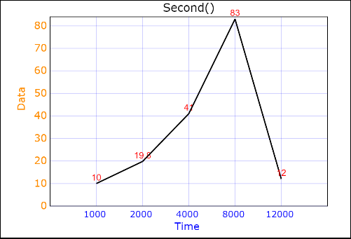
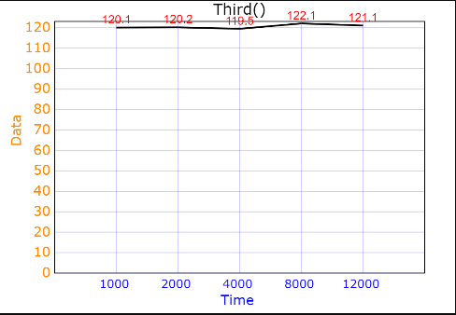
ANS Q2 The Graphs

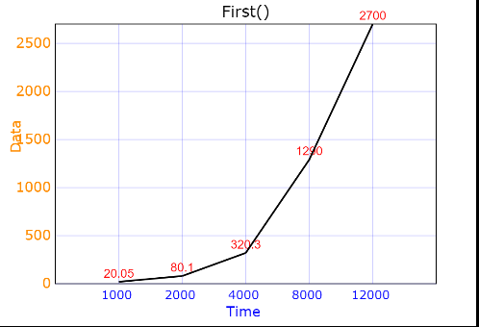

ANS Q2 Explanation
The time complexity of the first function is quadratic, the second function is linear. The data for the first function is doubled and the time is multiplied by 3. Although noting down that there is an outlier in the data which could initially cause a wrong estimation for the Big-O notion. And the time complexity for the third one is constant. The reason being the time remains the same.

Time complexity of any algorithm calculates the mass of time that is taken by an algorithm to perform as a function of the length of the input. O(V + E), this is when the V is the number of vertices and the E is the number of edges in the graph

Q3. The Student will be using the figure 1 image of the binary tree and find the pre-order traversal of the tree. And will be noting down the data in the order in which the nodes are visited. The student will be noting which is the first that is visited and will do the same for a post-order and in-order traversal.
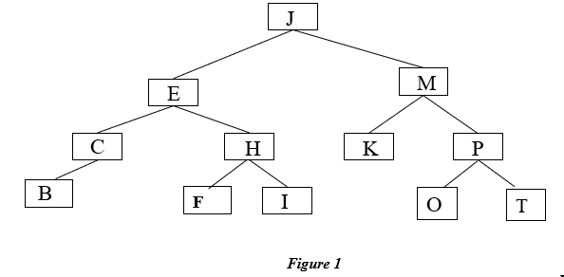

ANS Q3
Pre - order: First node is J, then E C B H F I M K P O T.

In order traversal: First node is B, then C E F H I J K M O P T

Post order traversal: First node is B, then C F I H E K O T P M J

Q4 . The student will be inserting the letter L into the binary search tree from image figure 1. And the student will be explaining the steps to complete this for each step of the traversal. However , the student will be assessing the implementation and discussing the best and worst case of the running times using Big-O notation. The student will be showing examples of the circumstances that can occur.

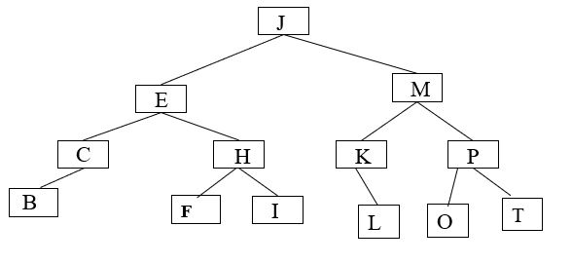

ANS Q4
To insert the letter L to the tree you start at the top first letter is J, L comes after J so you follow the tree to the right. So now the M is reached , L is less than M so you stem left to the branch to K. L is greater than K so You stem it under K pointing to the right .

Q5. The student will be explaining how the letter E is to be deleted from the image Figure 1 and will re draw the result.

ANS Q5
In order to delete the letter E from the binary search tree, as you can see below in this image the student deleted the letter E by finding the minimum value or letter to the letter E. in this case it is the letter C. so what has been done is the letter E has been successfully deleted and the letter C has been placed successfully balancing the tree.

The tree is successfully balanced in the sub tree on the left the letter B is lower than the letter C. And the sub tree on the right the letter H is higher than the root letter C. followed by F and I.

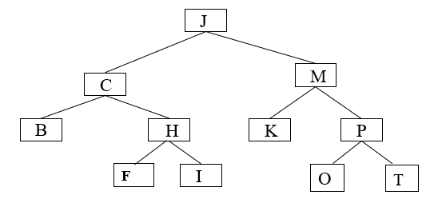

Q6. The student will be describing how a stack structure and while loop may be used to perform a Depth First Search algorithm. The student will be applying their own algorithm to the graph in image figure 2. Therefore, demonstrating the belongings of the stack following the recurrence of the loop. However, the student will also be listing the node items in the correct order the nodes were passed by specifying any conclusions made by the student.

ANS Q6
Depth First Search Algorithm approach
Depths first search (DFS) is an algorithm used for traversing or searching tree also used for data structures. The way this algorithm works is by starting at the root node. This is done by appointing a constant or other quantity of an unspecified root node e.g. a graph. This analyses deep into each branch before backtracking. The student would do this by starting from the root or any unspecified node therefore marking the node then moving towards its neighboring unmarked node. Thus, creating an ongoing loop up till there is no unmarked neighboring node. The student would then need to backtrack and examine for any other unspecified node and traverse them. This would then show the nodes on the path.
However, ‘The only difference between iterative DFS and recursive DFS is that the recursive stack is replaced by a stack of nodes’[1].
DFS stack structure
There are a few steps that need to be considered when created a stacked DFS, the student has acknowledged this and will be following these steps such as.
- Visiting the adjacent/ neighboring inaccessible vertex, the student will need to mark it as being visited , thus publishing and push it into a stack
- But if there is no adjacent / neighboring vertex discovered , pop up a vertex from the created stack. This will initiate pop up on every vertices from the given stack that have not got an adjacent vertices.
- To then empty the stack the steps would need to be done over and over until the initial goal is complete.
Stack
A stack is known as an Abstract Data Type (ADT) . stacks are based on how human’s interact with objects it is a behavior used to stack plates or groceries etc. this same method is used for programming languages. Stack ADT lets every data operations towards the end. Thus, only enables to let entry to the top element of a stack. This method creates LIFO data structure. LIFO stands for last in first out. When an object is introduced last it is then available first. There is another method within data structure called PUSH known as an insertion/installing. And a removal/transferal operation is known as POP.
Stacks are done by using Arrays, structure , pointer, and a linked list. The student has acknowledged that a stack may be a fixed size or a dynamic resizing.
Push() – pushing and conserving an element in the stack
Pop() – removing and given access to an element from the stack.
When there is any data pushed onto the stack.
To use stack correctly, the student will need to check the condition of stack too. for the same event, it is required to use
Peek() – allows to access the top data element , this is done without touching and extracting it.
isFull() - allows to examine if it is full
isEmpty – allows to examine if it is empty.
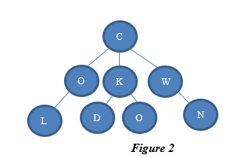

The implementation for a stack operation
Push(int x) ; { // check no stacks overflow
Sp++;
myStack[sp] = x ;
}
int pop(); {
int+ pop; // always check for an empty stack first
temp , myStack[sp];
sp -- ;
return temp[sp];
}
In order L , C, R
L O C K D O W N
Pre – order
C O L K D W N
Post order
LO D O K N W C

#include<iostream>
#include<string>
Class stack {
Private
int top;
int arr[8]
public;
stack ()
{
top = 1;
for(int i = 0; i<8;i++)
{
arr[i]=0;
}
{
Bool i<Empty()
{
If(top==<1)
Return true;
else
return false;
}

};

Reference
- https://www.geeksforgeeks.org/iterative-depth-first-traversal/

