INTERNATIONAL FINANCIAL MANAGEMENT
Student Name: Mirela Maria Dolca
Student Id: 2112412
Module Code: LCBB6002

Executive Summary
This report mainly outlines different types of risk factors in foreign exchange policies and also some theoretical applications for mitigating those risk factors. The principal objective of this exchange is to restore the equilibrium of payments and it also allows the importing process as necessary. Different types of exchange risk factors are seen in foreign currency such as “transaction risk, economic risk, and translation risk”. In terms of mitigation policy, “Matching or Natural Hedging Technique and optimum currency area theory” can be applied.
Table of Contents
Introduction 3
Foreign exchange risks 3
International Financial Management (IFM) theories to mitigate risk factors 4
Conclusion 6
References 8

Introduction
Foreign exchange is a type of exchange of currency of a particular country for another with a prevailing rate of exchange. In terms of the globalised business operation process, this exchange rate is very important and guides maintaining transparent financial transactions with different countries for business operations. In terms of foreign trips, this exchange process is also required. This study focuses on different risk factors in foreign exchange and the “international financial management theories” for the mitigation of these issues.

Foreign exchange risks
Risk factors in foreign exchange are also known as exchange rate risk which have a financial impact because of fluctuation of exchange rates in different countries. Similarly, the financial performance of the organisations is also significantly affected by the exchange rates between multiple currencies (Trade.gov, 2023). In that case, financial stability can also be affected by this higher fluctuation of foreign change. In this aspect, the importer and exporter faced huge problems in maintaining their business activities in the global marketplace. In general, three different types of exchange risk factors are seen in foreign currency such as “transaction risk, economic risk, and translation risk” (Pellegrino et al. 2023). It is seen that risk factors mainly occur when the companies are involved in financial transactions as well as maintain financial statements within a particular currency rather than its headquarters. For example, the Indian rupee and the UK dollar would be at risk because one is foreign currency and the other is domestic.
In addition, foreign exchange risk factors can also be created because of appreciation or depreciation of the basic as well as foreign current along with a combination of the two. In the global marketplace, these people or organisations associated with import and export business, also face similar issues which create a barrier to maintaining a smooth operation process (Kuikel et al. 2023). Transaction risk is a significant type of “foreign exchange risk” which is faced by an organisation during making economic transactions between two different jurisdictions. This risk is mainly seen before the settlement of the transaction and it delays the transaction process (Mbzibain et al. 2023). For example, in case a US-based company is dealing with an Indian company with the exchange rate of USD = 83.076581 INR, but when this INR value increases, then the organisation faces difficulties in financial transactions as the US-based company needs to pay more (Nobanee et al. 2022). This type of risk can be mitigated with “forward contracts and options”.
Economic risk is another risk factor which is commonly seen in foreign risks and it is also called forecast risk. In this risk, the market value of an organisation is mainly affected by unavoidable exposure to a higher fluctuation rate of foreign exchange. This risk mainly emerged because of macroeconomic factors including regional instability along with the government regulatory changes (Skabeeva et al. 2022). In this case, when a UK-based company sells a product in the domestic market, it faces lower risk factors than in the international business market. Translation risk is another important factor of risk which is commonly called translation exposure and it is generally faced by an organisation when a domestic business organisation starts to operate in the global marketplace (Islam et al. 2021). In this case, the economic performance is greatly affected because of domestic currency fluctuation. It is also seen that these risk factors are affected severely when an organisation consumes a higher portion in terms of “assets, liabilities, or equities in a foreign currency”.

International Financial Management (IFM) theories to mitigate risk factors
“International Financial Management (IFM)” is commonly called global finance, which plays an important role in a global business environment, which is mainly related to “trading and making money through the exchange of foreign currency”. Global economic activities guide companies in making a strong connection with international parties like “overseas business partners- customers, suppliers, lenders”. There are different types of IFM for maintaining a business with foreign countries with different methods such as “licensing, franchising, subsidiaries, acquisitions, strategic alliances as well as exporting” (Taskinsoy, 2022). In this aspect, the management process has great significance in terms of the “specialisation of some goods and services, the opening of new economies and the emergence of new form of business”.
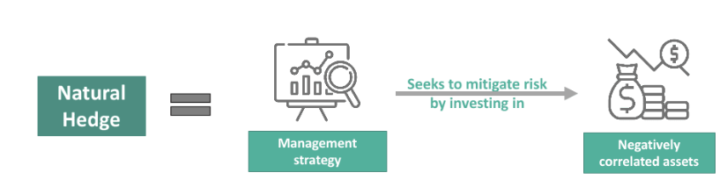
Figure 1: Matching or Natural Hedging Technique
(Source: Tiwary, 2019)
“Matching or Natural Hedging Technique” is an important strategy that can be implemented by the global organisation to mitigate different risk factors in terms of foreign risks. This technique includes the liabilities with receipts which are denominated in a similar currency to eliminate the net exposures. A clear currency is also offered by this technique which helps to mitigate “multi-currency transactions” and secure the payment process by making the financial transaction process more transparent (Tiwary, 2019). In this method, the forward contracts are also very important to maintain a firm commitment to accuracy in the buying and selling process at the predetermined rate of exchange on a particular future date. This method also eliminates any kind of uncertainty in foreign exchange for a better financial exchange process.
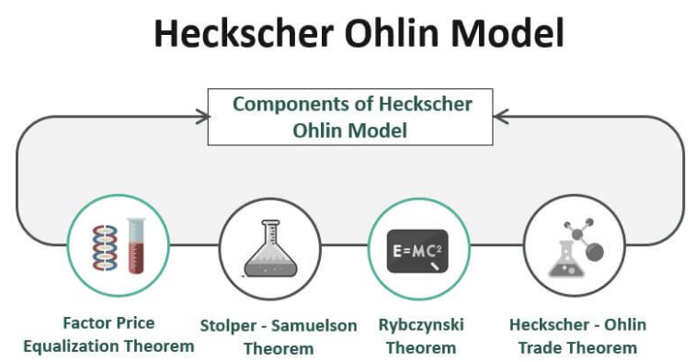
Figure 2: Heckscher-Ohlin theory of foreign exchange
(Source: Akther et al. 2022)
This particular theory mainly evaluates the equilibrium of the trading process between two different countries which varies on specialisations and different kinds of natural resources. This theory also explains the entire operation process of national trade and the resources which are imbalanced all over the world. Apart from that, with the application of this theory, an organisation can able to predict the conditions of different nations for exporting goods. It mainly focuses on the stability of the exchange rate of the nation in terms of foreign trading activities (Akther et al. 2022) With the help of this theory, the organisation can able to make some assumptions about the trading process in different aspects such as “no transportation costs or trade barriers” with the implication of the identical commodity price in each country with free trading options. Apart from that, this theory is also very effective for making assumptions in the context of “perfect competition in both commodity and factor markets” (Spirin, 2022). Therefore, it is seen that this theoretical application is very effective for the global organisation to make perfect assumptions in terms of foreign exchange rates and the norms of foreign trading options. In this aspect, an organisation can implement this theoretical application into trading activities for a smooth business operation with fewer risk factors.
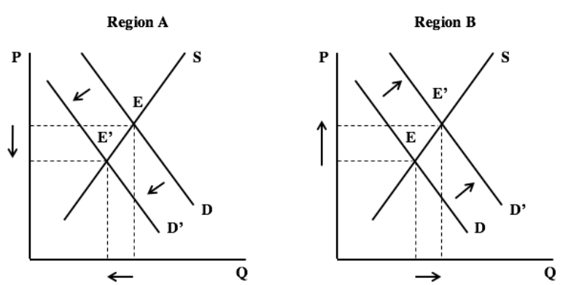
Figure 3: Optimum currency area theory
(Source: Goldberg, 2019)
According to this theory, “an optimal currency area” refers to a geographical area over a single or unified currency to provide an effective balance in the economic transaction of a scale of currency. The effectiveness of this macroeconomic policy in the foreign trading policy guides the organisation for better promotion in the growth of foreign trading activities and maintains stability in the business operation process (Goldberg, 2019). In this aspect, the organisations also get benefits in the removal of uncertainty during the fluctuation of exchange rates and it also guides to improvement of the flow of trade in different countries (Alamad, 2019). With the application of this theoretical application, the organisations also get some competitive advantages in terms of “specialization in production; stability in prices, and a reduction in costs”.

Conclusion
Taking into consideration the overall discussion, it can be concluded that in this current situation, all organisations are focused on the global expansion of business with the help of technological advancement. In this case, risk factors associated with foreign exchange create significant barriers to the development of foreign trading activities. In order to mitigate these risk factors, a “Matching or Natural Hedging Technique” can be applied for the development of security and safety in terms of the international exchange process. Apart from that, application of the “optimum currency area theory”, an organisation can able to predict the conditions of different nations for exporting goods.

References
Trade.gov, (2023), Foreign Exchange Risk, Available at: https://www.trade.gov/foreign-exchange-risk [Accessed on: 20th December 2023]
Pellegrino, R., Gaudenzi, B. and Zsidisin, G.A., 2023. Mitigating foreign exchange risk exposure with supply chain flexibility: A real option analysis. Journal of Business Logistics.
Kuikel, B., Maemura, Y. and Ozawa, K., 2023. Management of Foreign Exchange Risk for Build–Own–Operate–Transfer Hydropower Projects in Nepal: A Good-for-All Approach. Journal of Infrastructure Systems, 29(2), p.05023002.
Nobanee, H., Dilshad, M.N., Alzaabi, F., Alkindi, S., Alhammadi, J. and Alnaqbi, M., 2022. Bibliometric analysis of foreign exchange risk. Nobanee, H., Shanti, HZ, Dilshad, MN, Alzaabi, F., Alkindi, S., Alhammadi, J., & Alnaqbi, M.(2022). Bibliometric analysis of foreign exchange risk. Journal of Governance and Regulation, 11(1), pp.86-99.
Skabeeva, L., Shaliapina, M., Panova, N., Nikolskaya, E. and Lebedeva, O., 2022. Improvement of Foreign Exchange Risk Management in Tourism and Hospitality Industry Enterprises. Anais Brasileiros de Estudos Turísticos.
Islam, S., Mamun, A., Islam, K.A., Uddin, M.R. and Sultana, T., 2021. Issues and Challenges of Financial Management Practices in Islamic Financial Institutions: Empirical Evidence from Bangladesh. Indian Journal of Finance and Banking, 5(1), pp.38-55.
Mbzibain, A., Niyrenda, R., Soh, L.W. and Djiegni, F.K., 2023. Govering independent monitoring: from theory to practice. In Power dynamics in African forests: The politics of sustainability (pp. 109-131). Routledge, Taylor & Francis.
Alamad, S., 2019. Stress Testing and Reverse Stress Testing: An Approach for a Resilient Islamic Financial Industry. Islamic Monetary Economics and Institutions: Theory and Practice, pp.137-157.
Taskinsoy, J., 2022. Stress Testing Financial Systems: Macro and Micro Stress Tests, Basel Standards and Value-at-Risk as Financial Stability Measures. Basel Standards and Value-at-Risk as Financial Stability Measures (February 11, 2022).
Tiwary, A.R., 2019. Study of currency risk and the hedging strategies. Journal of Advanced Studies In Finance (JASF), 10(19), pp.45-55.
Akther, T., Voumik, L.C. and Rahman, M.H., 2022. The pattern of international trade between Bangladesh and USA: Heckscher–Ohlin and Rybczynski analysis. Modern Supply Chain Research and Applications, 4(3), pp.162-176.
Goldberg, L.S., 2019. Is Optimum Currency Area Theory Irrelevant for Economies in Transition?. In Exchange-Rate Policies For Emerging Market Economies (pp. 45-60). Routledge.
Spirin, V., 2022. Factor price divergence in Heckscher-Ohlin model when countries have different technologies: a simple numerical illustration.

