

Name – Chay Williams
Student number -2407081
Course – Quantity Surveying HND
Module – Fundamentals of Construction Technology
Assignment title – Swansea Mumbles Road Development
Lecturer – Alan Nantel
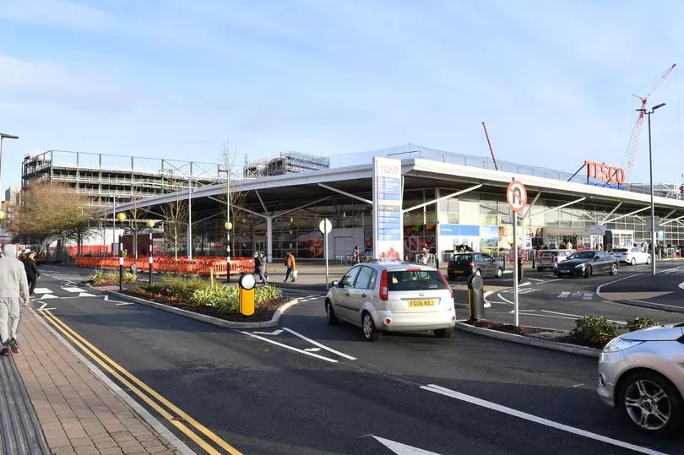
(Marsh, 2021)

Introduction
Jarvis Hotels have won a tender with the County of Swansea to go ahead with plans for a brand new 5-star hotel, bar and restaurant holding up to 400 rooms in the place of what is now a Tesco supermarket and carpark.
In this report I will be undertaking an appraisal of various factors that could be impacted by or have an impact on the project as it progresses.
The report will be structured as follows:
- Site Details
- ﻿﻿Historical Appraisal
- ﻿﻿Geological Appraisal
- ﻿﻿Environmental Appraisal
- ﻿﻿﻿Archaeology Appraisal

Site details
As mentioned above, the site where this project is set to be located is in the city centre of Swansea. The exact location of this is Albert Row, Oystermouth Road, Swansea, SA3 3RA.
Swansea is lacking in quality hotel options, and this development is situated in a prime location near many popular attractions, tourist destinations, businesses, industry and educational locations and new developments. The hotel will be located within walking distance of the city centre, Swansea Marina, Meridian Tower and seafront, new Swansea Arena facility, Swansea Grand Theatre, SA1, LC2 Leasure Centre, Waterfront Museum, Wind Street, Park Tawe, various University campuses and the new home of the Ospreys Rugby franchise, St Helens Rugby Ground.
In addition to the above, the location of this project would also see the hotel near the famous Swansea beaches, the Mumbles and Gower.
This would make the hotel an ideal option for tourists and businesspeople alike, with it being both in a convenient location for the city and surrounding areas served by convenient walking and cycling routes, roads and public transport links. 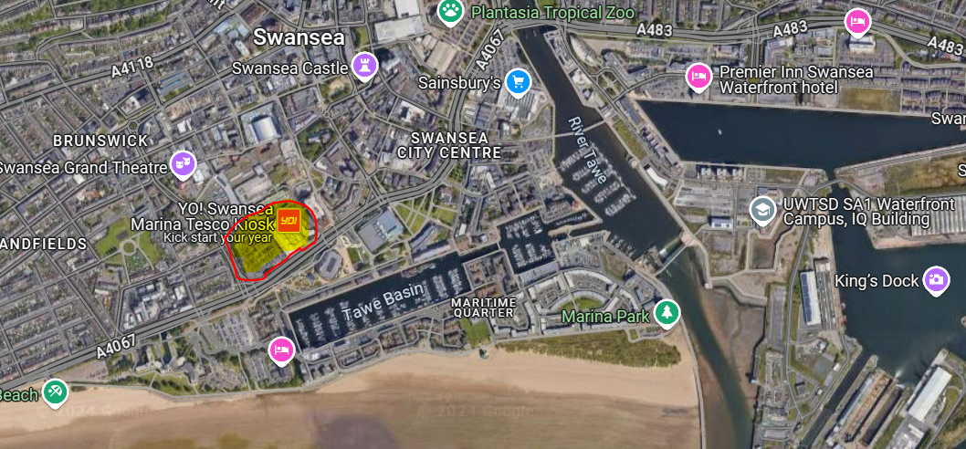
(Maps, 2022)
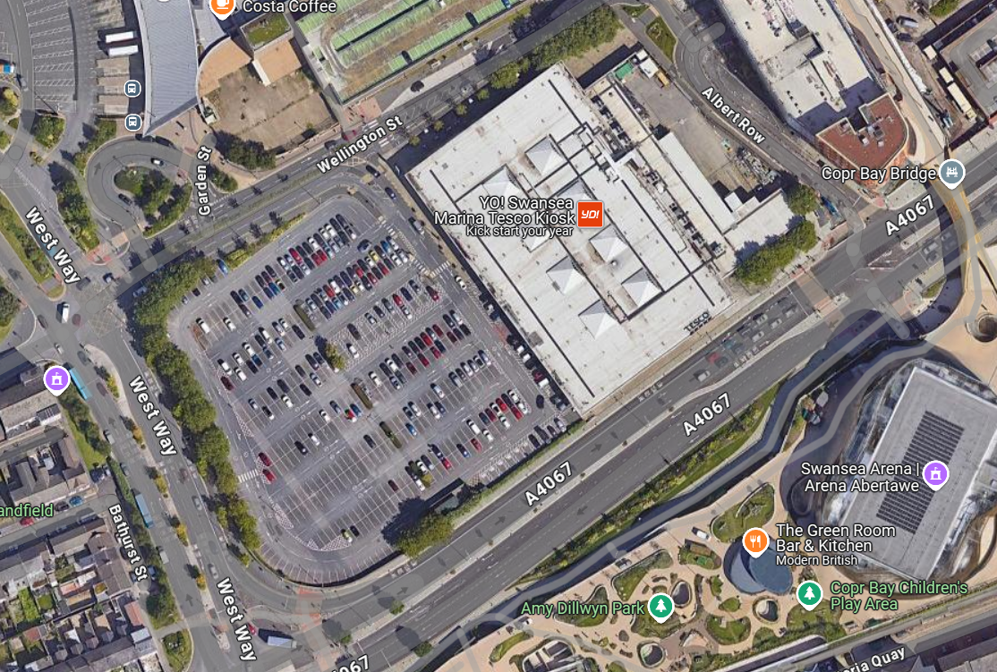
The site is currently occupied by a large Tesco Superstore and adjoining carpark. The site has pre-established boundaries that can be relatively easily secured with site access possible from all surrounding roadways (A4067, West Way, Wellington Street and Albert Row) with establishment of basic traffic management options.
(Maps, 2022)
The relatively large area of the site is beneficial for some parking, materials storage, construction management office and worker welfare facilities siting. Additionally, there are convenient public parking facilities and public transport services for worker access.
After a brief walk over survey inspection which I completed at the site some of the main takeaway points were, firstly, how flat the area was of the whole area including both where the current Tesco supermarket is placed along with the car park. Secondly, regarding how close the area is to the beaches and mouth of the river Tawe, it is likely that the ground material and geology of where the building is, will be sedimentary, possibly soft layers of strata, mud and sand as suggested on the borehole survey below.
It also appears that the car parking area is used by the public as a walkway. Due to this, when the plans come to light and work begins, this would be required to be investigated. As for obvious reasons, it would be unsafe for the area to be open as a public footpath so there would need to be a safe route for the public to take instead.
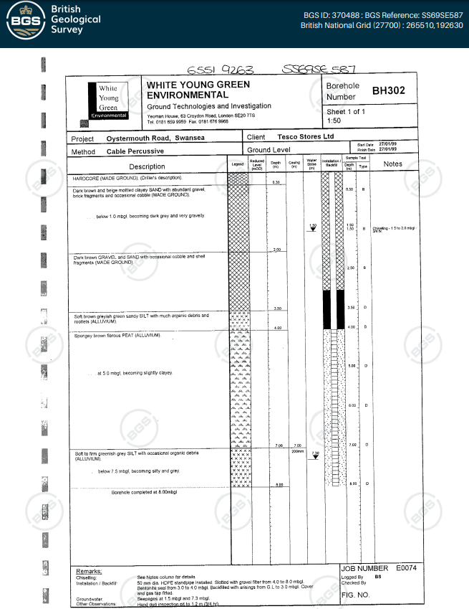
(BGS, 1999)
Historical Appraisal
With the area being part of the Swansea marina, the area of SA13RA was heavily involved in the shipping industry. Going back to the time from the 1700s through to the 1800s the town drastically grew down to this as the town was so well known for its work producing multiple different materials for example, copper, lead, pottery, zinc, tinplate and most famously coal. Because the town and local was producing so much of this, the ports were used as a transport pod for the materials which they would later sell on to different places (Unknown, 2021).
It is very possible that contamination may remain in the ground from past industrial land use and waste disposal operations.
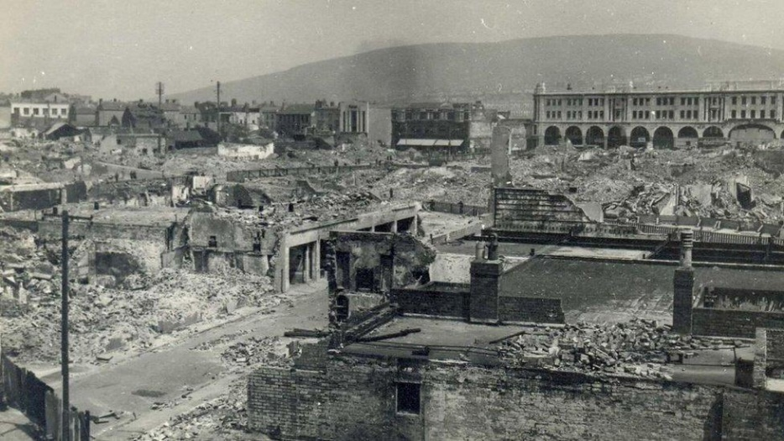
Later then, the second world war come around. Like most other major ports in the UK, Swansea and its surrounding area was specifically targeted by the Nazi’s. From the 19th to the 21st of February 1941, Swansea came under a major attack in the “Swansea Blitz” from the Luftwaffe with a series of bombing attacks over the 3 days turning Swansea from a happy working town into a destroyed mess and leaving 230 people killed and over 400 people injured. This would then continue in further separate attacks on Swansea with over 1250 explosive bombs being dropped on the place in total (Williams, 2021).
As expected, this deeply affected the area after 41 acres of land being targeted, 857 buildings being destroyed and over 11,000 buildings being damaged. This meant that after all the hard work that was done in the previous years to build a successful place to live, it all had to be rebuilt in the later 1960s, hence the newer feel to the city in today’s world (Unknown, 2021).
(Archives, 2016)
As with all heavily bombed areas there is the possibility that unexploded bombs and munitions may be uncovered by significant civil excavation works.
Since this, Swansea has slowly built back up, after the reopening on the docks, the business started the thrive again and the start of a new ferry crossing over to Cork in Ireland with the last passenger trip taking place in 2011 (Unknown, Unknown). Since then, Swansea has continued to grow with more tourists visiting the area than there has before, with all things like the Meridian Tower, the Mumbles, the shopping centre and museums. This all bring in the demand for a new hotel, which could push Swansea to its next step.
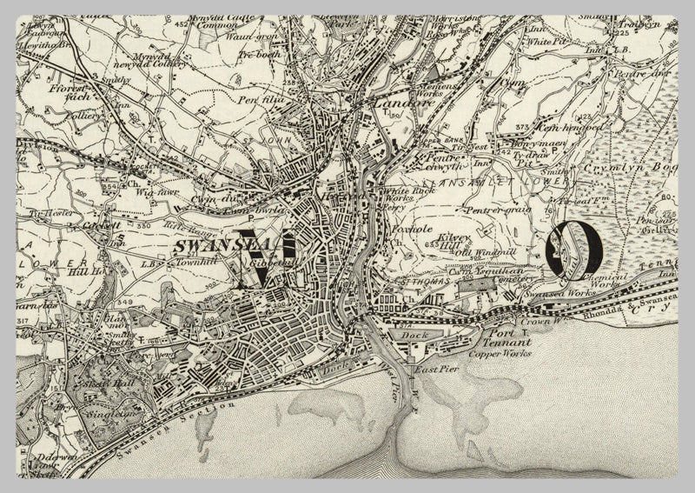
(maps, 1890)
Geological and environmental appraisal
In the grounds of both the Tesco supermarket and carpark, the ground there in primary made up of both concrete tar mac. The car park outside the shopping centre is made of full tar mac and hardcore which attached to the incoming road (BGS, 1999). The building itself is a steel framed building which would need to be safely deconstructed ready for the new hotel to be put in place. This would be a big job to dismantle due to the size of the building itself and there would need to be a clear out job to offload the materials and rubble off site.
Going through Swansea’s history, you can see that the city has a rich past in the mining industry with it being a main transportation port. However, after looking into the area there are no mines directly under the area which would cause any risks in the construction process for both dismantling and constructing the new 5-star hotel in the city.
However, as mentioned in the segment above talking about the area’s history, you can see that the area was heavily attacked in the second world war. This has the potential to cause some issues moving forward with the construction and deconstruction of the planned works. Before any works or even started on the deconstruction of the building, it is vital for the correct and thorough testing to be done to ensure that the work you are set to start is not going to disturb any unexploded bombs or anything else in the process. Due to the damage that was made in the war, it is likely that some remnants are found while at this project. Especially when foundations and other groundwork is being completed. Below is a site plan that was created in place of the construction of the current Tesco supermarket. 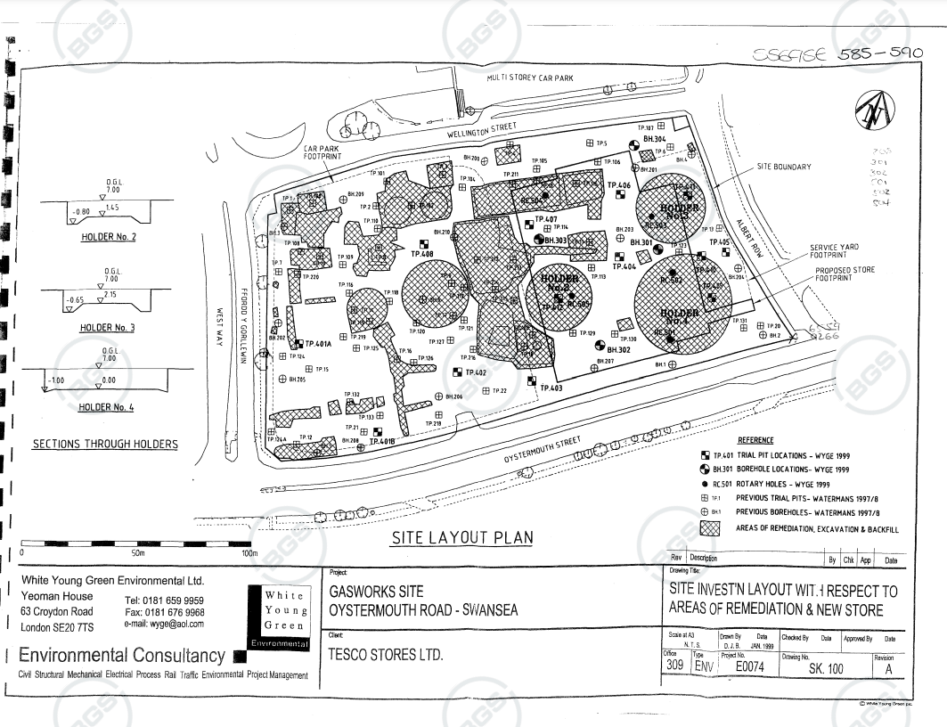
(BGS, 1999)
Due to the industries and history that the area and that Swansea has been involved in, it is also a possibility that there may be hazardous substance risks. All forms of asbestos were banned by the time of construction of the current Tesco Store in 2000 however given the nature of the historical industrial use of the lower Swansea Valley asbestos soil/ground contamination or waste burial may be possible.
Additionally, there may be other ground contamination in the area from the past industrial use, including heavy and base metals and petroleum-based materials. Exposure to this could not only be hazardous to human health but also could be liberated into the areas ground and surface water systems and have a significant environmental impact.
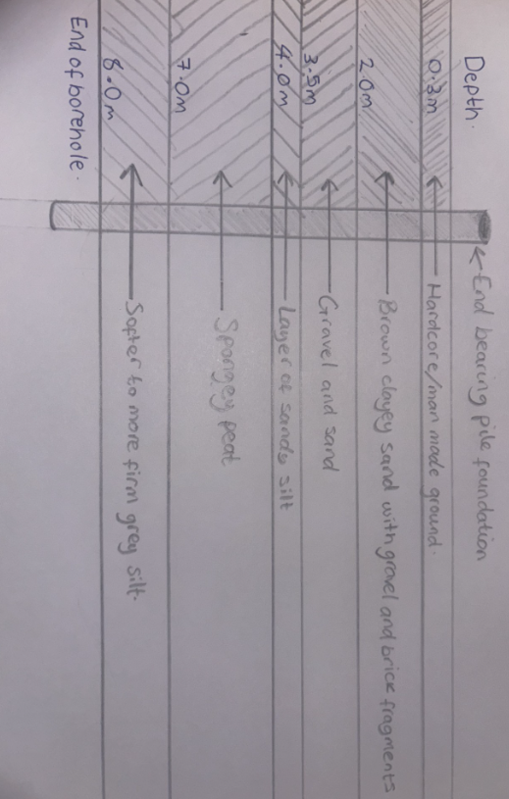
Regarding the subsidence risks of the location, as shown in my plan of foundation plan below the grounds are good grounds to build on. Other than the hardcore on the surface, the is majority made up of both sand and silt which are unlikely to open and cause any problems, especially with the correct foundations fitted which I will go into more information later.
(Williams, 2025)

Local features
Due to the location of the planned hotel, it is important for the design of the building to fit in with the local area and surroundings. With the location of the project being near the beaches and in a generally more modern side of the city with buildings like the Meridian Tower, the brand-new Swansea arena, the Copr Bay Bridge and the marina itself, it is important that this hotel is in keeping with all these landmarks and the character of the area. Some ways in which they could look into doing this are below.
- Look into the materials that are set to be used on both the inside and outside of the building. For example, if you are going to have large panes of glass, the colours of the building and what kind of frame is going to be used regarding if it is going to be an open planned hotel or something different.
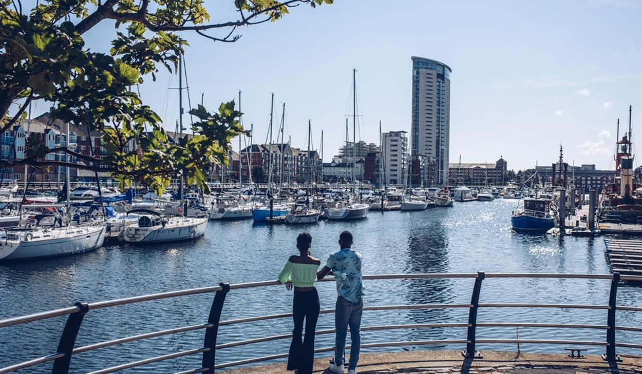
- Look at the shapes and the design structure of the building. For example, is the building in a high-rise area of the city and what shapes of the building are planned.

(Bay, Unknown)
Flood risks
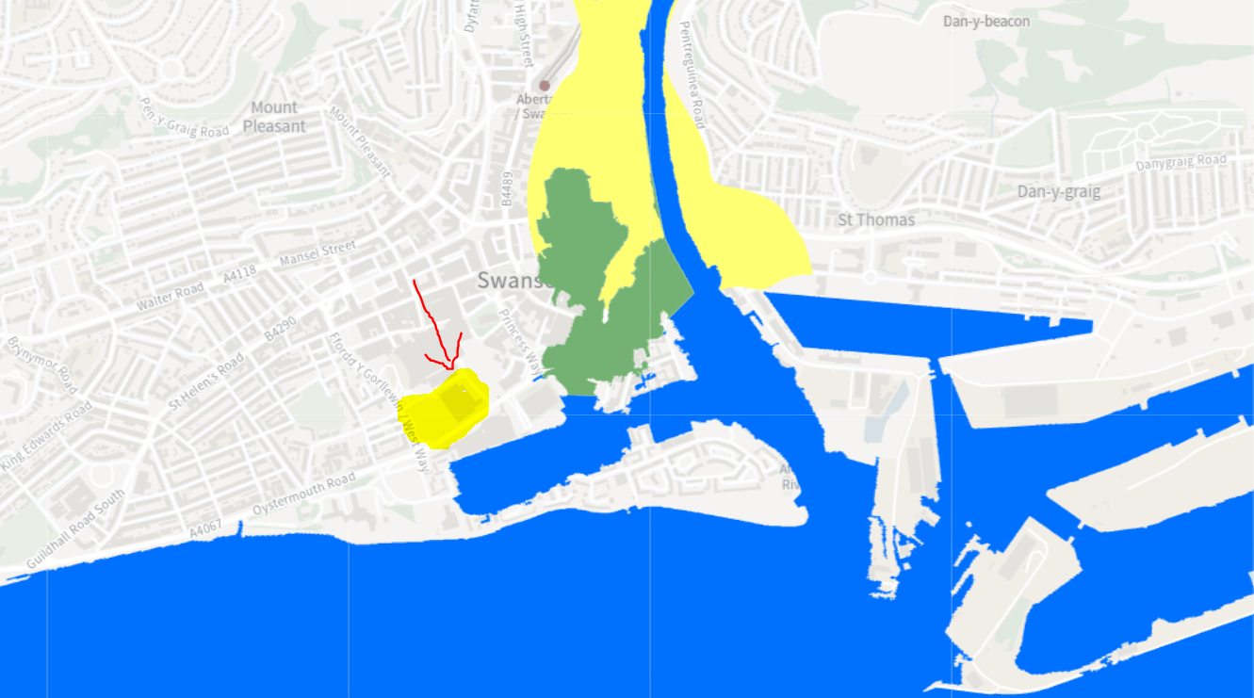
With the space that the project is set to take place being 100s of yards away from the famous marina, there is going to be a level of flood risk. As shown in the photograph below, the area where this 5-star hotel is set to be built after planning is rated at a “Rivers and Sea – flood zone 3” for a flood risk. This means that there is a 1% risk of flooding from either any rivers or the sea (Wales, 2020).
(Wales, 2020)
In the image above you can see that...
- The current Tesco supermarket is highlighted in yellow with a red arrow.
- The blue areas are either the sea or rivers.
- The area highlighted in green is an area in which is protected by severe flooding protection.
- The yellow at the top of the image are areas which are known to have a risk of flooding and have experienced floods before.
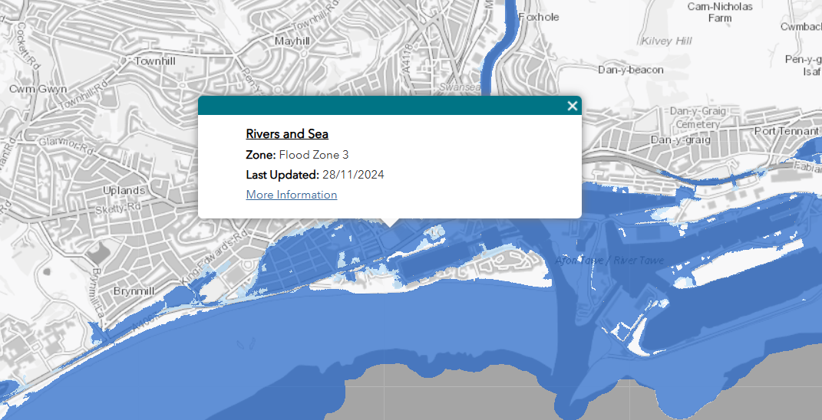
(Wales, 2024)
This means that if all the ideas are passed by the local authorities for Jarvis hotels to go ahead with contractors to start planning works for the future hotel, then there is a need to put in some flood defence options into the building to prevent and lower the risk of any future floods.
Some ways that the designers of the future hotel could put in place are below.
- Flood barriers and gates. By installing these into the main areas on the lower levels of the hotel allows the hotel to have a safety which does not necessarily affect or get in the way of everyone on a day-to-day basis.
- Stepped up construction. When building the hotel there is a possibility that the architect could add a step-up level for the lower floor. For example, in they could make a step up to the entrance of the hotel where the first-floor acts as the second floor with a basement underneath which could be used for storage and act as a safety from the main hotel spaces getting damaged
- Extra drainage and safety pumps. When planning the hotel, the contractor could put in place some extra drainage spaces. There are many way that this can be done for example, for commonly, extra aco drains put in place with underground pipes leading to the rest of the drainage facilities. They should also install emergency pumping systems on the first floor of the building, where in case of emergency they are able to pump out water from the first floor through the sides of the building before worsening.

Foundations
When thinking about the foundations that would be suitable for the new Swansea hotel, it important to think about multiple factors including the location of the project, the grounds at the site of the project, the size/height of the proposed project and as well look at what other similar sized buildings in the area have used and whether they have been successful or not.
In this case, the area in which the project is set to be located does not give you much option when it comes to what foundation is best, the only suitable option is a form of pile foundation. Due to the grounds underneath the current Tesco superstore and future hotel being vastly made up of soft materials for example, as shown in the previous borehole logs, underneath the hardcore floor level, due to it being so close to the sea and river it will be made up of a lot of sandy areas going down to 4m deep before moving into a deep layer of spongey peat to as far as 7m deep and going into a firm grey silk to as far as 8m deep.
Due to these materials being softer and more likely to cause movements from deep underground it is important for a deep set of pile foundations to be used so they can reach a solid enough level of surface to where it can make a secure enough foundation.
I have created a drawing below of what the future foundation could look like.

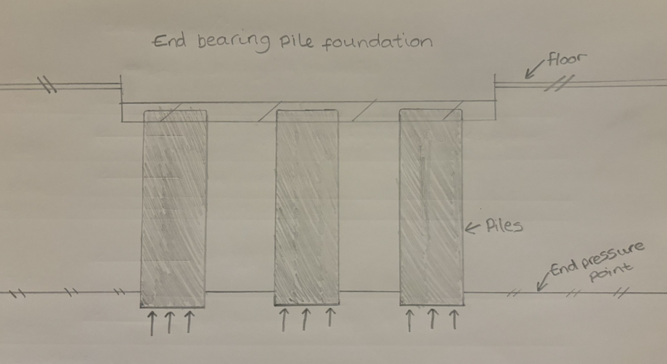
(Williams, 2025)

References
Archives, W. G., 2016. BBC News. [Online]
Available at: https://www.bbc.co.uk/news/uk-wales-south-west-wales-35494885
[Accessed 10/01/2025 January 2025].
Bay, V. S., Unknown. Visit Swansea Bay. [Online]
Available at: https://www.visitswanseabay.com/listing/swansea-marina/48558101/
[Accessed 10/01/2025 January 2025].
BGS, 1999. BGS, discovering geology. [Online]
Available at: https://api.bgs.ac.uk/sobi-scans/v1/borehole/scans/items/370488
[Accessed 10/01/2025 January 2025].
Maps, G., 2022. Google Maps. [Online]
Available at: https://www.google.co.uk/maps/@51.6166006,-3.944603,273m/data=!3m1!1e3?entry=ttu&g_ep=EgoyMDI1MDEwOC4wIKXMDSoASAFQAw%3D%3D
[Accessed 10/01/2025 January 2025].
maps, I. l., 1890. I love maps. [Online]
Available at: https://www.ilovemaps.co.uk/products/swansea-ammanford-os-map?variant=5933750190109
[Accessed 10/01/2025 January 2025].
Marsh, G. (. O., 2021. Wales Online. [Online]
Available at: https://www.walesonline.co.uk/news/wales-news/swansea-tesco-marina-parking-free-20943954
[Accessed 10/01/2025 January 2025].
Unknown, 2021. Digs Swansea. [Online]
Available at: https://www.digsswansea.biz/the-history-of-swansea#:~:text=The%20town%20of%20Swansea%20was,grew%20up%20by%20the%20castle.
[Accessed 10/01/2025 January 2025].
Unknown, Unknown. Swansea docks. [Online]
Available at: http://www.swanseadocks.co.uk/docksnewsite/ferries.html
[Accessed 10/01/2025 January 2025].
Wales, N. R., 2020. National Flood Hazard and Risk Maps. [Online]
Available at: https://gisgeoext.cyfoethnaturiolcymru.gov.uk/Geocortex/Viewers/Html5Viewer_4145/index.html?viewer=FloodRisk
[Accessed 10/01/2025 January 2025].
Wales, N. r., 2024. Flood maps for planning. [Online]
Available at: https://flood-map-for-planning.naturalresources.wales/
[Accessed 10/01/2025 January 2025].
Williams, C., 2025. Grounds diagram. Swansea: Chay Williams.
Williams, R., 2021. BBC News. [Online]
Available at: https://www.bbc.co.uk/news/uk-wales-56115198
[Accessed 10/01/2025 January 2025].

